OMB Control Number: 1910 – 5160 Expiration: 2/28/2026

Paperwork Reduction Act Burden Disclosure Statement
This data is being collected to gather information regarding individual participants of the CyberForce® Program’s Professional Virtual Career Fair. The data you supply will be used to help understand the background and career fair impact on individuals, overall exposure to companies and organizations which participated in the career fair, and to identify strengths and areas for improvement to implement future events.

Public reporting burden for this collection of information is estimated to average 5 minutes per response, including the time for reviewing instructions, searching existing data sources, gathering and maintaining the data needed, and completing and reviewing the collection of information. Send comments regarding this burden estimate or any other aspect of this collection of information, including suggestions for reducing this burden, to Office of the Chief Information Officer, Enterprise Policy Development & Implementation Office, IM-22, Information Collection Management Program (1910-5160), U.S. Department of Energy, 1000 Independence Ave SW, Washington, DC 20585; and to the Office of Management and Budget (OMB), OIRA, Paperwork Reduction Project (1910-5160), Washington, DC 20503.

Notwithstanding any other provision of the law, no person is required to respond to, nor shall any person be subject to a penalty for failure to comply with a collection of information subject to the requirements of the Paperwork Reduction Act unless that collection of information displays a currently valid OMB control number.

Submission of this data is voluntary.

CyberForce® Program – Professional Virtual Career Fair Participant Feedback

Purpose of the survey:

- To combine both qualitative and quantitative measures to implement consistent improvements to the CyberForce® Program Career Fairs
- To understand the impact of the CyberForce® Program career fair events on participants

The survey is mostly multiple choice and open-ended. It should take about 5 minutes to complete.

Survey responses will be collected and examined by the CyberForce® Program staff. If you have any questions or comments, please reach out to us via email at cyberforcecompetition@anl.gov

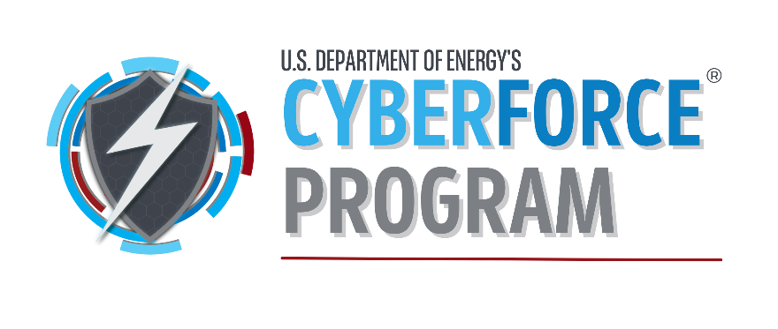

- What booths did you attend? (all active booths will be inserted)
- Did you interview with anyone from one of the booths at the virtual career fair?
  - Yes
  - No
  - Unsure
- If yes, how many interviews did you have during or after the career fair?
- Did you get a position from one of the booths at the virtual career fair?
  - Yes
  - Currently Interviewing
  - Pending company decision
  - No
- What type of position?
  - Internship
  - Apprenticeship
  - Part-time
  - Full-time
  - Other __________________
- Did the virtual career fair impact your interest in applying to one of the companies/organizations that had a booth?
  - Yes
  - No
  - Unsure
- Did the virtual career fair impact your knowledge of the companies/organizations that were showcased?
  - Yes
  - No
  - Unsure
- How satisfied were you with the overall virtual career fair?
  - Very satisfied
  - Somewhat satisfied
  - Neither satisfied nor dissatisfied
  - Somewhat dissatisfied
  - Very dissatisfied
- What suggestions do you have to better your experience for the virtual career fair?
________________________________________________________________________
- Would you find value in having more than one CyberForce Professional career fair being held per year?
  - Yes
  - No
  - Unsure
- Any other comments or suggestions.
____________________________________________________________________________

