OMB Control Number: 1910-5160 Expiration: 2/28/2026

Paperwork Reduction Act Burden Disclosure Statement

This data is being collected to gather feedback and test knowledge of attendees for their understanding of the topic during the training session. The data you supply will be used for understanding where more training is needed and how to shape the content for future training sessions. The data will be collected through Menti, which is an online tool that is free for users and easy to use. This tool is also interactive, which is one of the goals of the training team to spark discussion and engagement with the content presented in the training.

Public reporting burden for this collection of information is estimated to average 1 minute per response, including the time for reviewing instructions, searching existing data sources, gathering and maintaining the data needed, and completing and reviewing the collection of information. Send comments regarding this burden estimate or any other aspect of this collection of information, including suggestions for reducing this burden, to Office of the Chief Information Officer, Enterprise Policy Development & Implementation Office, IM-22, Information Collection Management Program (1910-5160), U.S. Department of Energy, 1000 Independence Ave SW, Washington, DC 20585; and to the Office of Management and Budget (OMB), OIRA, Paperwork Reduction Project (1910-5160), Washington, DC 20503.

Notwithstanding any other provision of the law, no person is required to respond to, nor shall any person be subject to a penalty for failure to comply with a collection of information subject to the requirements of the Paperwork Reduction Act unless that collection of information displays a currently valid OMB control number.

Submission of this data is voluntary.


OMB Control Number: 1910-5160
Expiration: 2/28/2026
Polling: Mentimeter
1



Set-Up Instructions:

Do not enter any PII
(ex: full name).
- Open your preferred web browser on your workstation or mobile phone.
- Go to Menti.com.

- Enter code.

Tips for Participating in Activities:
  - Keep Menti open in the background for quick access.
  - Adjust your screen to view both Teams & Menti (on workstation).
  - Follow Menti prompts to participate!

Need Assistance?

Use Teams Chat to send a direct message to the CSAT Team

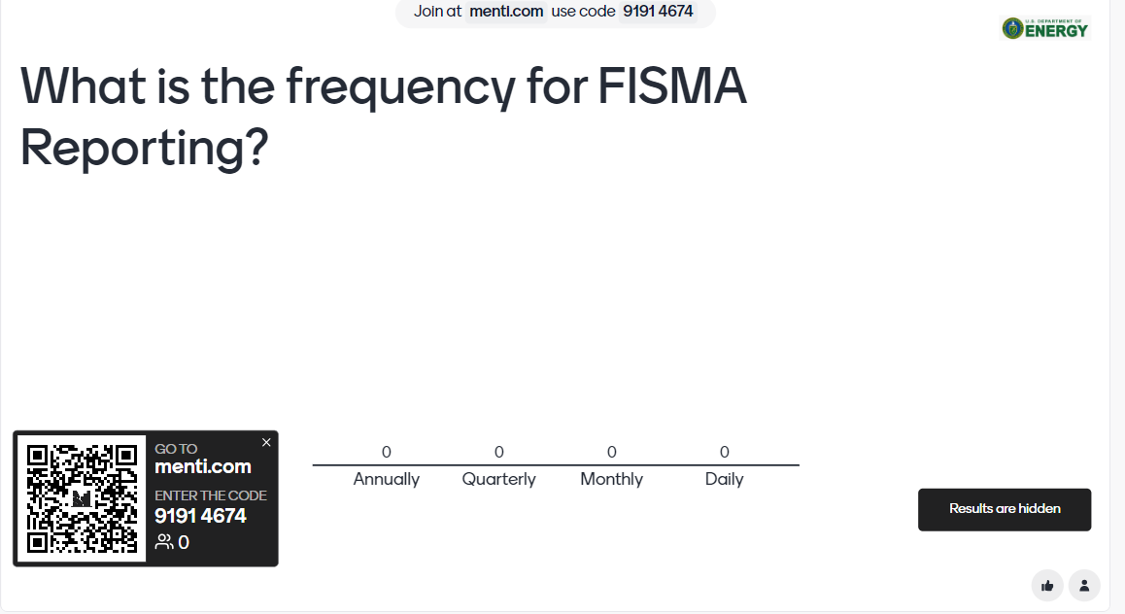

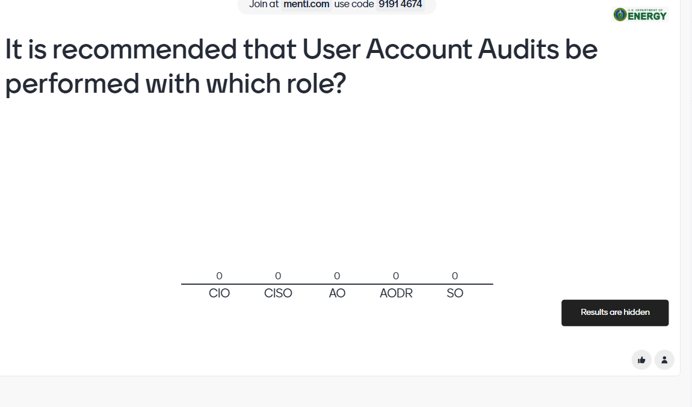

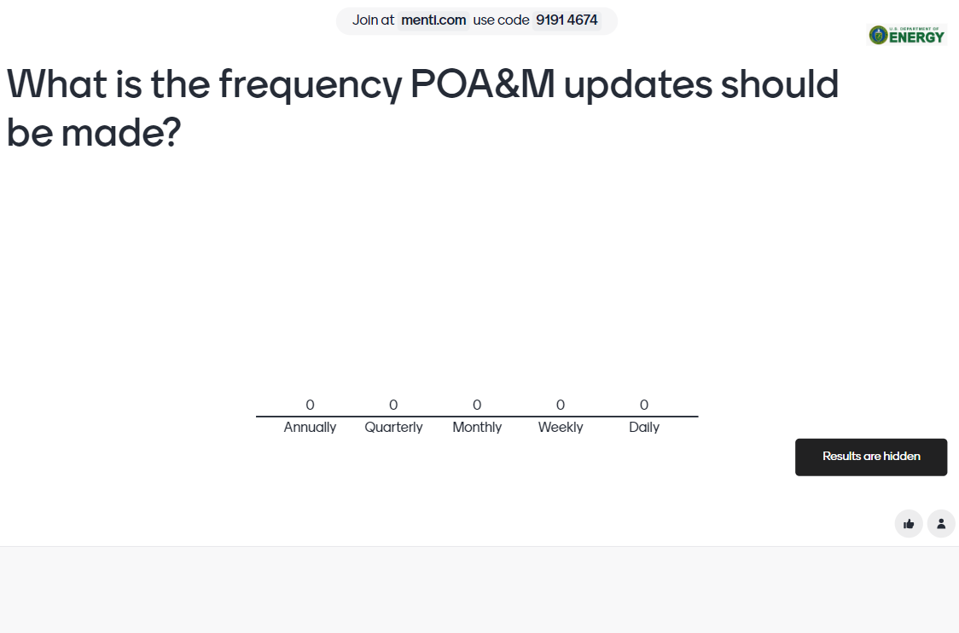

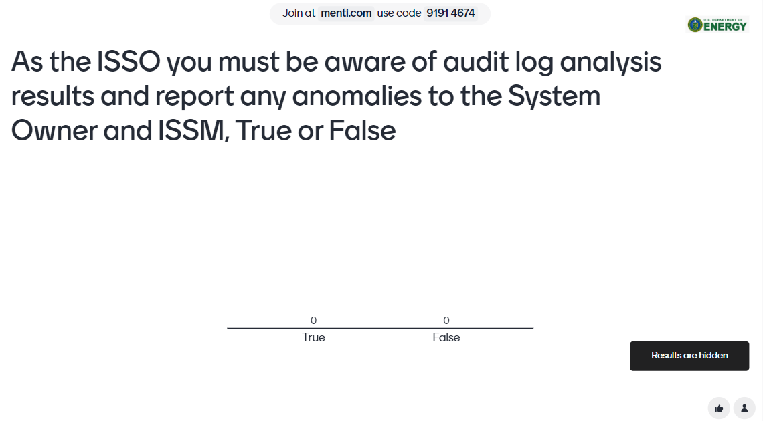

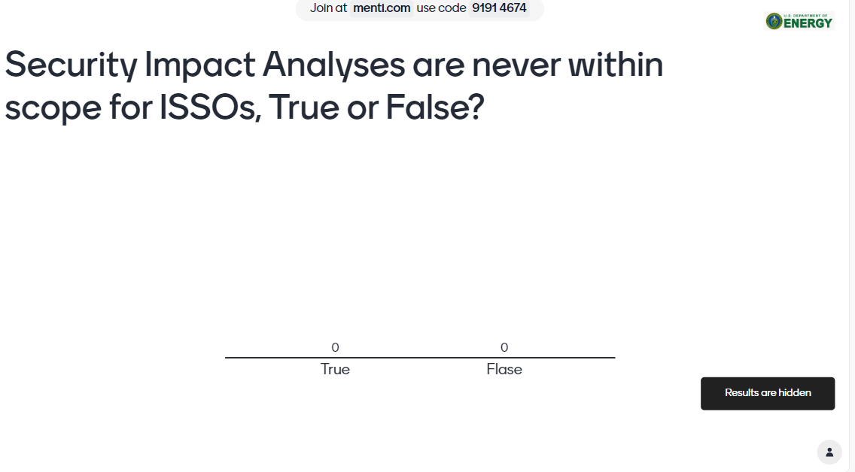

Menti Questions:

- What is the frequency for FISMA Reporting? (Slide 11)
Annually
Quarterly
Monthly
Weekly
Daily

- It is recommended that User Account Audits be performed with which role? (Slide 11)
CIO
CISO
AO
AODR
System Owner

- What is the frequency POA&M updates should be made? (Slide 12)
Annually
Quarterly
Monthly
Weekly
Daily

- As the ISSO you must be aware of audit log analysis results and report any anomalies to the System Owner and ISSM, True or False (Slide13)
True
False

- Security Impact Analyses are never within scope for ISSOs, True or False? (Slide 14)
True
False

