ACS Number:
AIR723-2024-01-S-7603-ACS
Issue Date: | August 16, 2024 | Requested Response Time: | 10 days

Subject: Loss of Thrust Control due to Power Level Failure

Purpose and Use of the Airworthiness Concern Sheet:
This Airworthiness Concern Sheet is intended as a means for FAA Aviation Safety Engineers to coordinate airworthiness concerns with the U.S. aviation community. At this time, the FAA has not made a determination on what type of corrective action (if any) should be taken. The resolution of this airworthiness concern could involve Airworthiness Directive (AD) action or a Special Airworthiness Information Bulletin (SAIB), or the FAA could determine that no action is needed at this time. The FAA’s final determination will depend in part on the information received in response to this ACS.

The FAA encourages dissemination of this technical information to anyone who has information to share with the FAA as relevant to the issue described in this Airworthiness Concern Sheet.
FAA Point of Contact
Name: Kristi Bradley
Email: Kristin.Bradley@faa.gov
Telephone: 817-222-5485
Office of Primary Responsibility (OPR): AIR-723
OPR Email: OperationalSafety@faa.gov

Aircraft or Engine Information
Product Type: Aircraft
Product Subtype: Small Airplane
Make: Cirrus

Model: SR20/SR22/SR22T

Type Certificate Data Sheet (TCDS) Number: A00009CH
Supplemental Type Certificate (STC) Number: Not Applicable
Other Relevant Aircraft Information:

Joint Aircraft System/Component (JASC) Code: 7603
Description of Airworthiness Concern:
The FAA recently received a report of a power lever failure on a Cirrus SR20 airplane. While advancing to full throttle in preparation for takeoff, the power lever sheared and the pilot quickly cut fuel to the aircraft and aborted the takeoff. The fleet operator subsequently inspected the remainder of their aircraft and found cracks in 24 of the levers through visual and dye penetrant inspections. Time in Service for the fleet ranged from 2900 to 3900 hours. The aircraft are utilized in a training environment and contained on average 12,000 to 15,000 landings. The failure and cracks were noted to occur at the region of the lever that has the smallest cross section.

Photos of the failed power lever and crack indications from others in the fleet are shown on the following page.

The FAA and Cirrus are currently investigating this concern.
☒ Check here if attachment(s) included.

Request for Information:
The FAA is interested in receiving any information on damage, cracks, or known failures observed on the power levers in Cirrus SR20/SR22/SR22T airplanes. We recommend operators inspect this area and please provide information including description of damage, available photos, airplane serial number, time in service, and any prior replacement of the throttle assembly or power lever.

Please provide any other information you feel may be helpful for us to consider as part of our evaluation.

Distribution Guide (other organizations may be included as needed)
Every ACS: | Issue Dependent:
FAA Safety Team (FAAST) | Experimental Aircraft Association (EAA)
Aircraft Owners and Pilots Association (AOPA) | Type Clubs
Design Approval Holder (DAH) | Vertical Aviation International (VAI)

Paperwork Reduction Act Burden Statement
A federal agency may not conduct or sponsor, and a person is not required to respond to, nor shall a person be subject to a penalty for failure to comply with a collection of information subject to the requirements of the Paperwork Reduction Act unless that collection of information displays a currently valid OMB Control Number. The OMB Control Number for this information collection is 2120-0731. Public reporting for this collection of information is estimated to be approximately 30 minutes per response, including the time for reviewing instructions, searching existing data sources, gathering and maintaining the data needed, and completing and reviewing the collection of information.

All responses to this collection of information are voluntary. Send comments regarding this burden estimate or any other aspect of this collection of information, including suggestions for reducing this burden to: Information Collection Clearance Officer, Federal Aviation Administration, 10101 Hillwood Parkway, Fort Worth, TX 76177-1524.

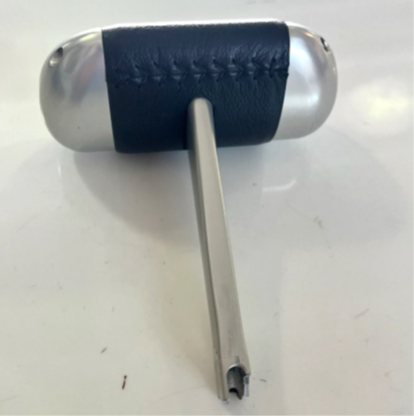
Figure 1. Upper power lever failure

Figure 2. Sample cracks found with visual and fluorescent penetrant inspection.

