This screenshot replaces the screenshots of pages 1 and 2 of the current OMB approved FCC Form 500 screenshots:
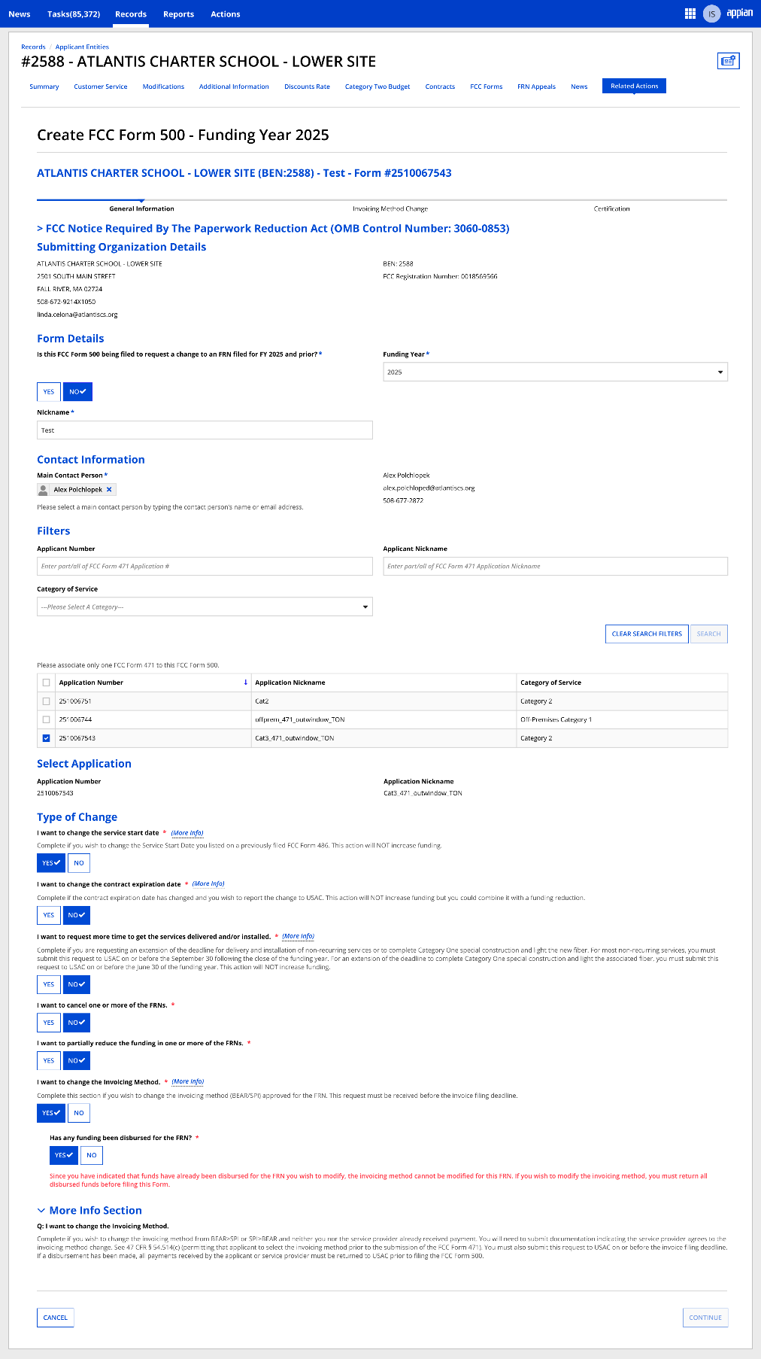

This page replaces page 5 of the current OMB approved FCC Form 500 screenshots:
Invoicing Method Change

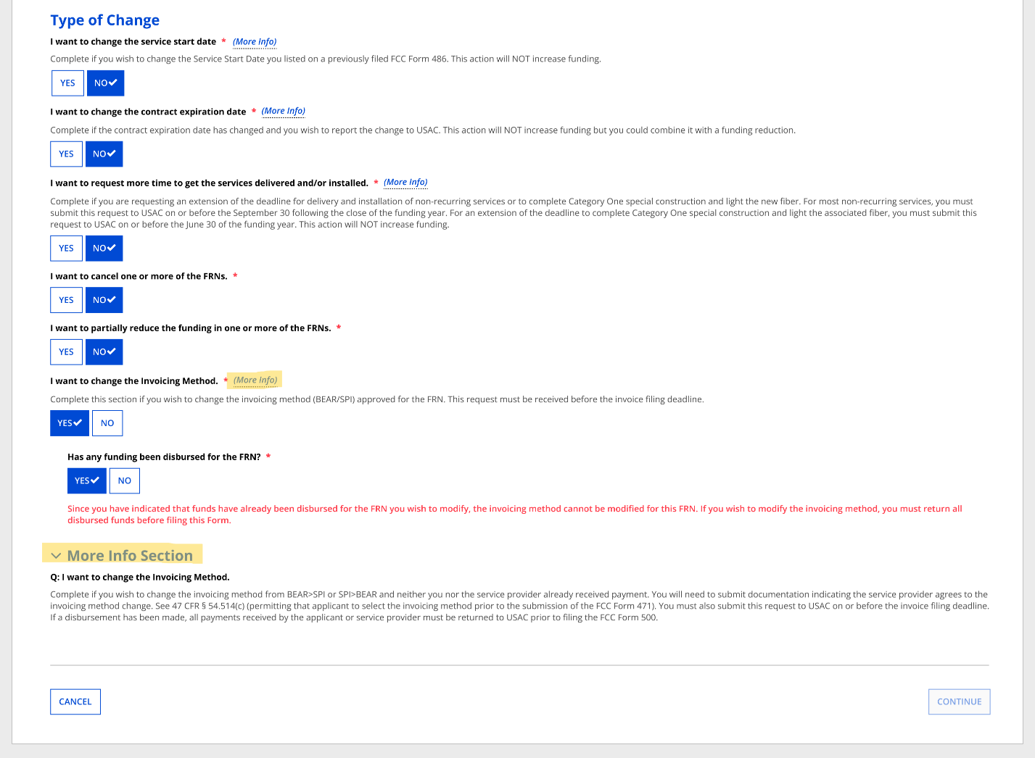

This page replaces page 22 of the current OMB approved FCC Form 500 screenshots:
If respondents use the FCC Form 500 to request invoicing method change, they will be prompted to provide additional information in the below screens in EPC
