TTAB Center Workflows

Petition for Cancellation (PTC) – Started and submitted by a US Attorney user
Last Update: 08/19/2026

----BEGIN OF TEST FOR US Attorney---
- As a Prose User (testuser.USAattorney-ttab@etc.uspto.gov), Petition for Cancellation (PTC).
On TTAB Center home page, click “My TTAB docket”
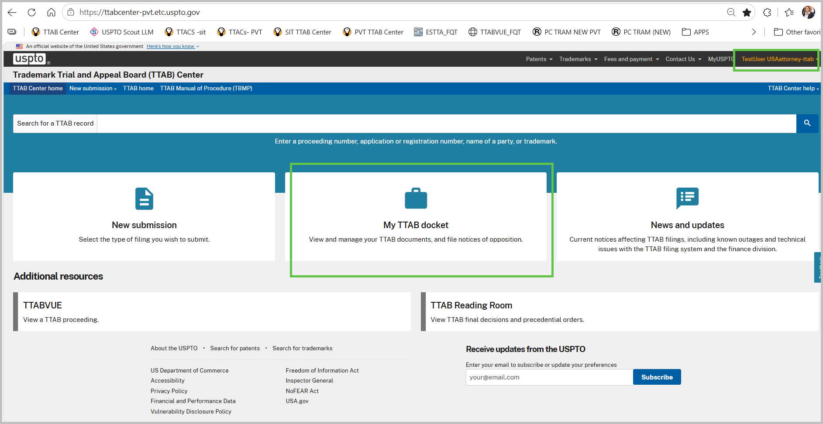
- On the “My TTAB Docket” page select “Create new” drop down, and select “Petition for Cancellation” option
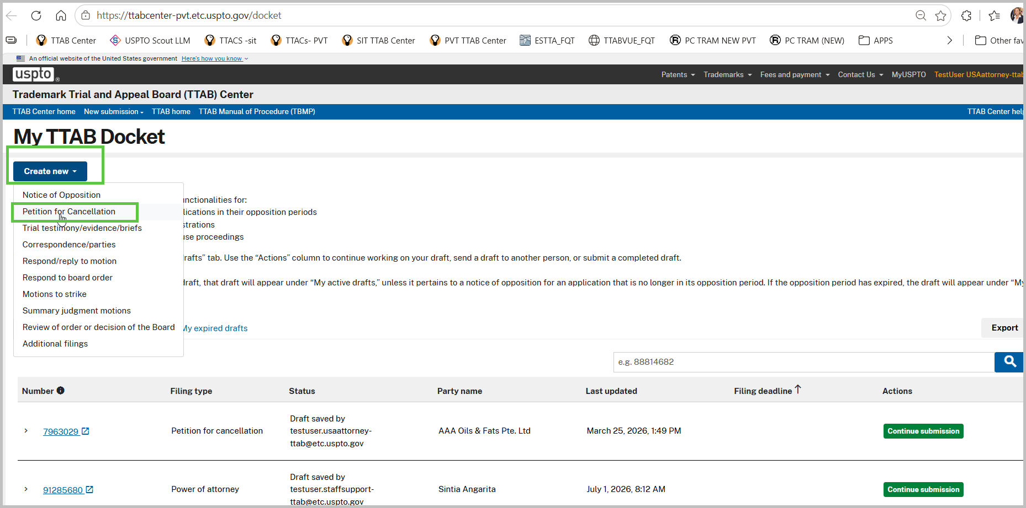
- On the Registration Data Page, type the Reg you wish to file PTC. Once the confirmation pop up appears click “Confirm” – this will add the Reg to the PTC filing. Repeat this process for as many registrations user wants to cancel. Once finished click “Continue” to proceed to next page.
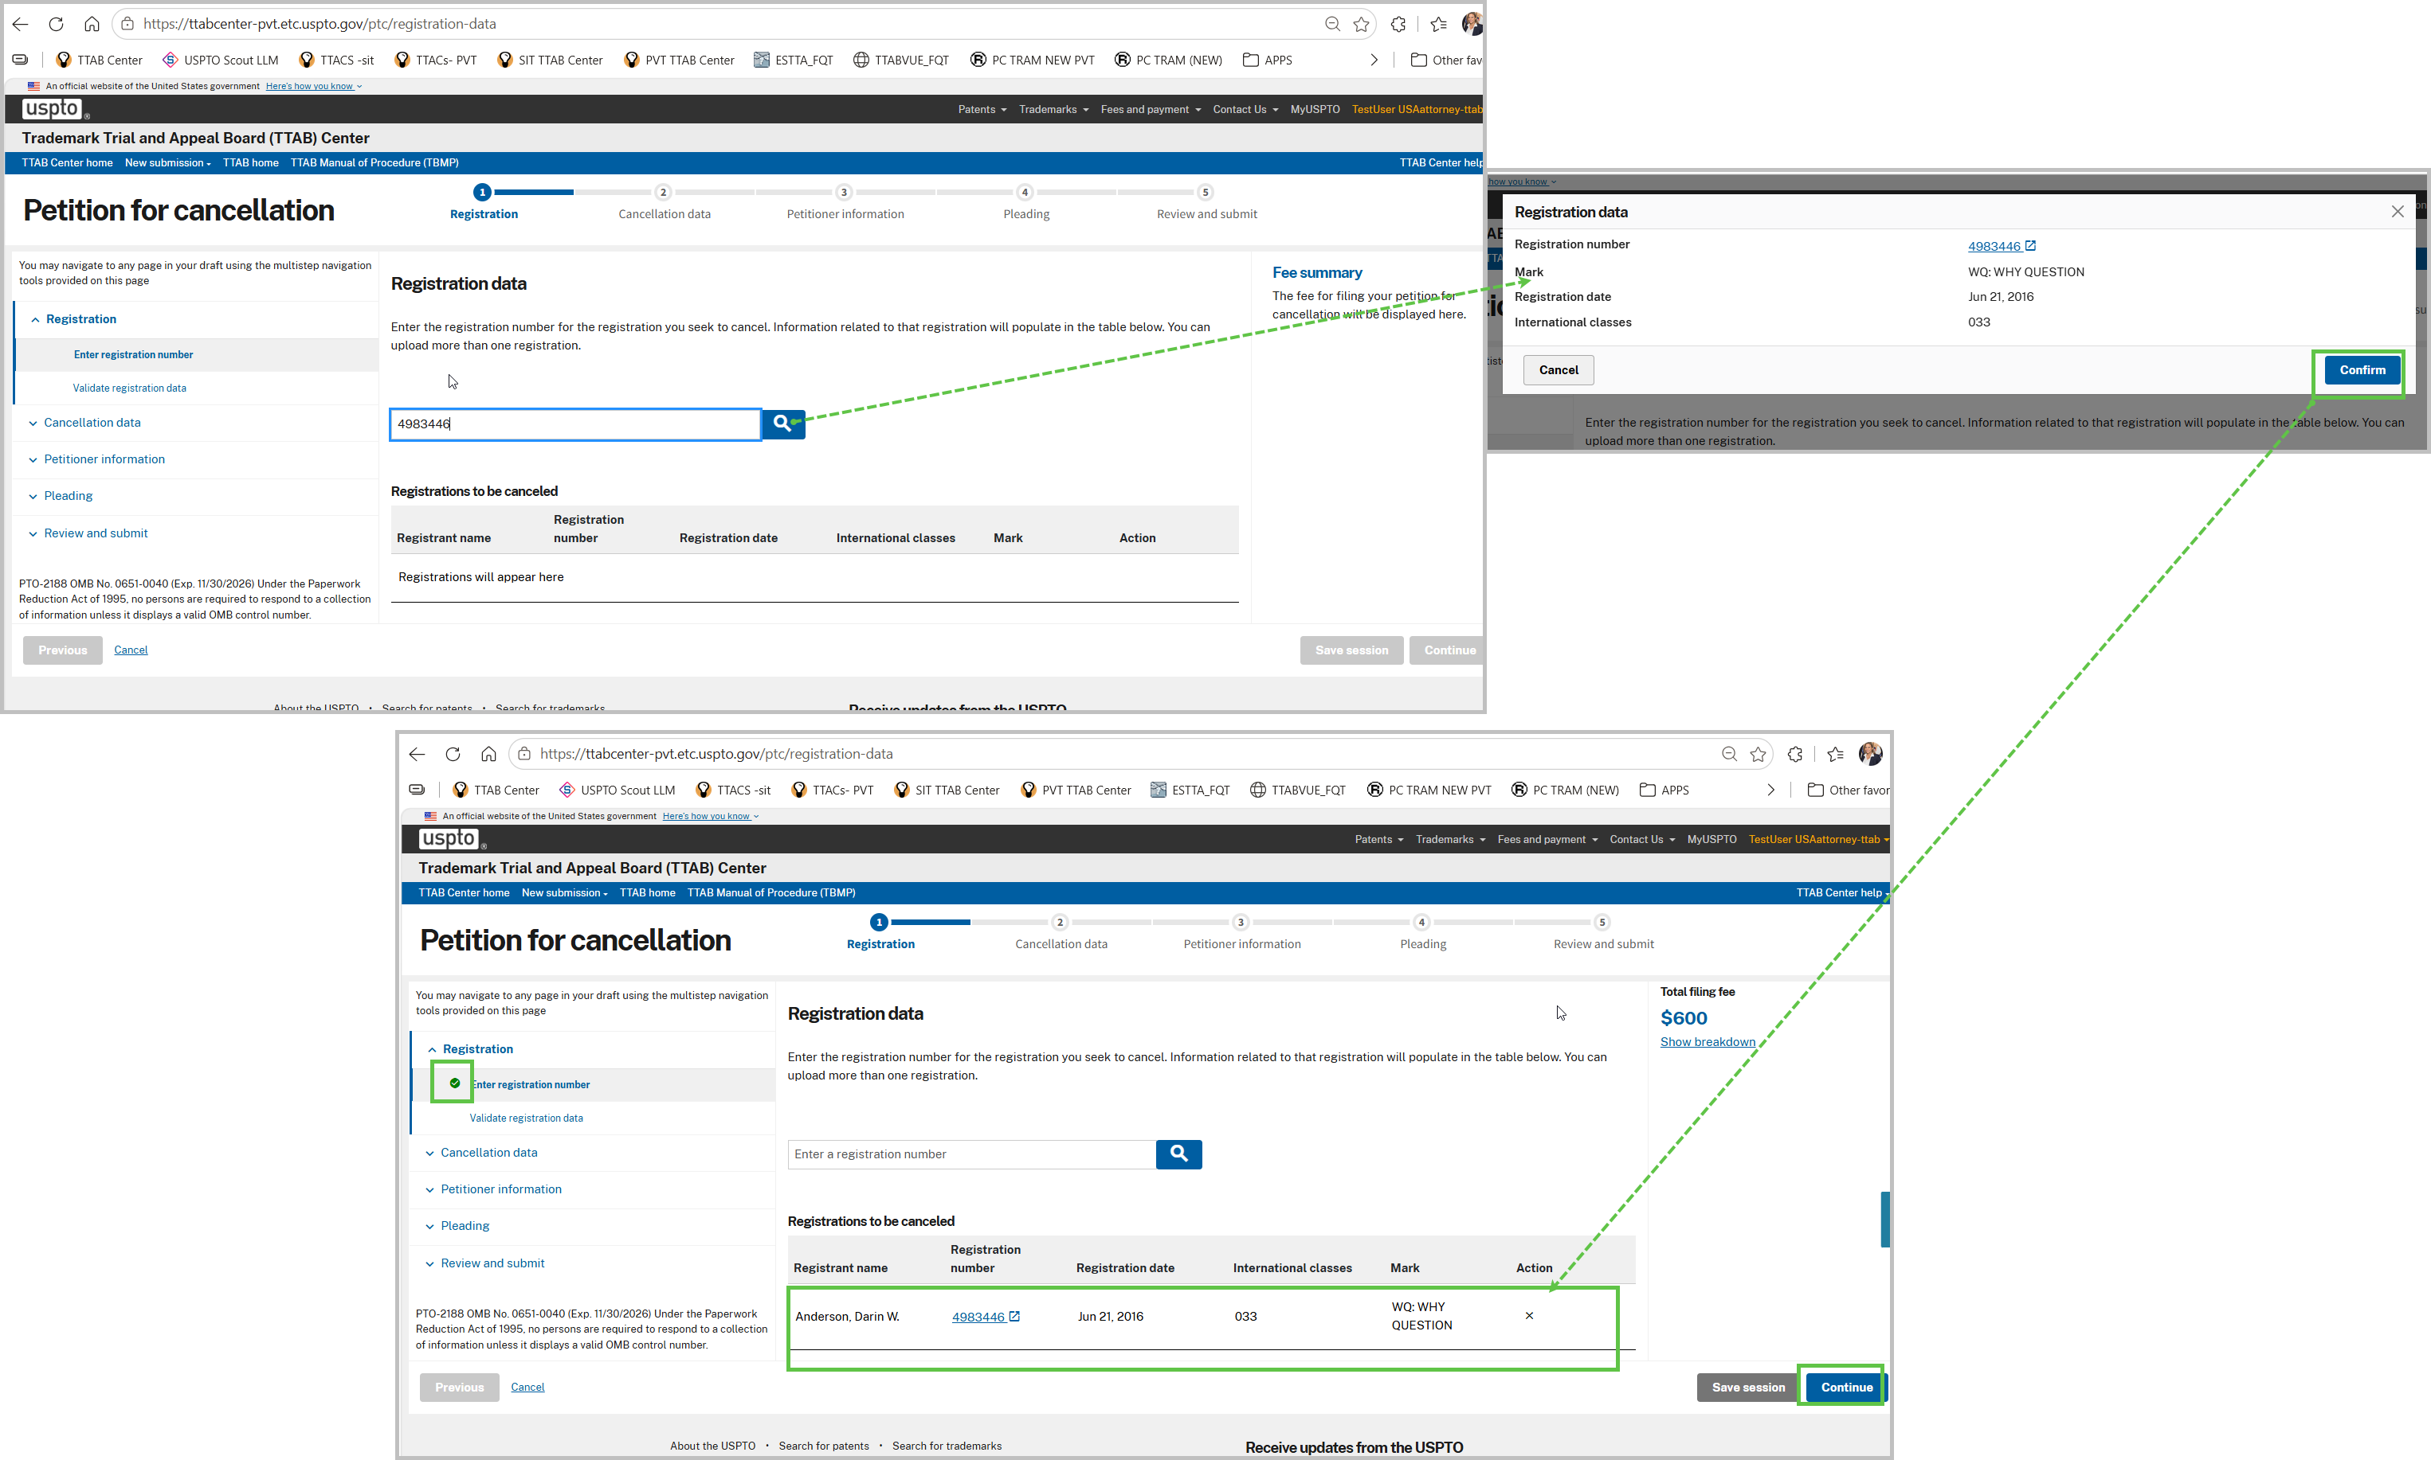

- On the “Validate registration data” page select “No” for question Are you aware of any name, address, or email address that differs from what is shown above? Repeat this process for as many registrations are in your application. Once finished click “Continue” to proceed to next page.
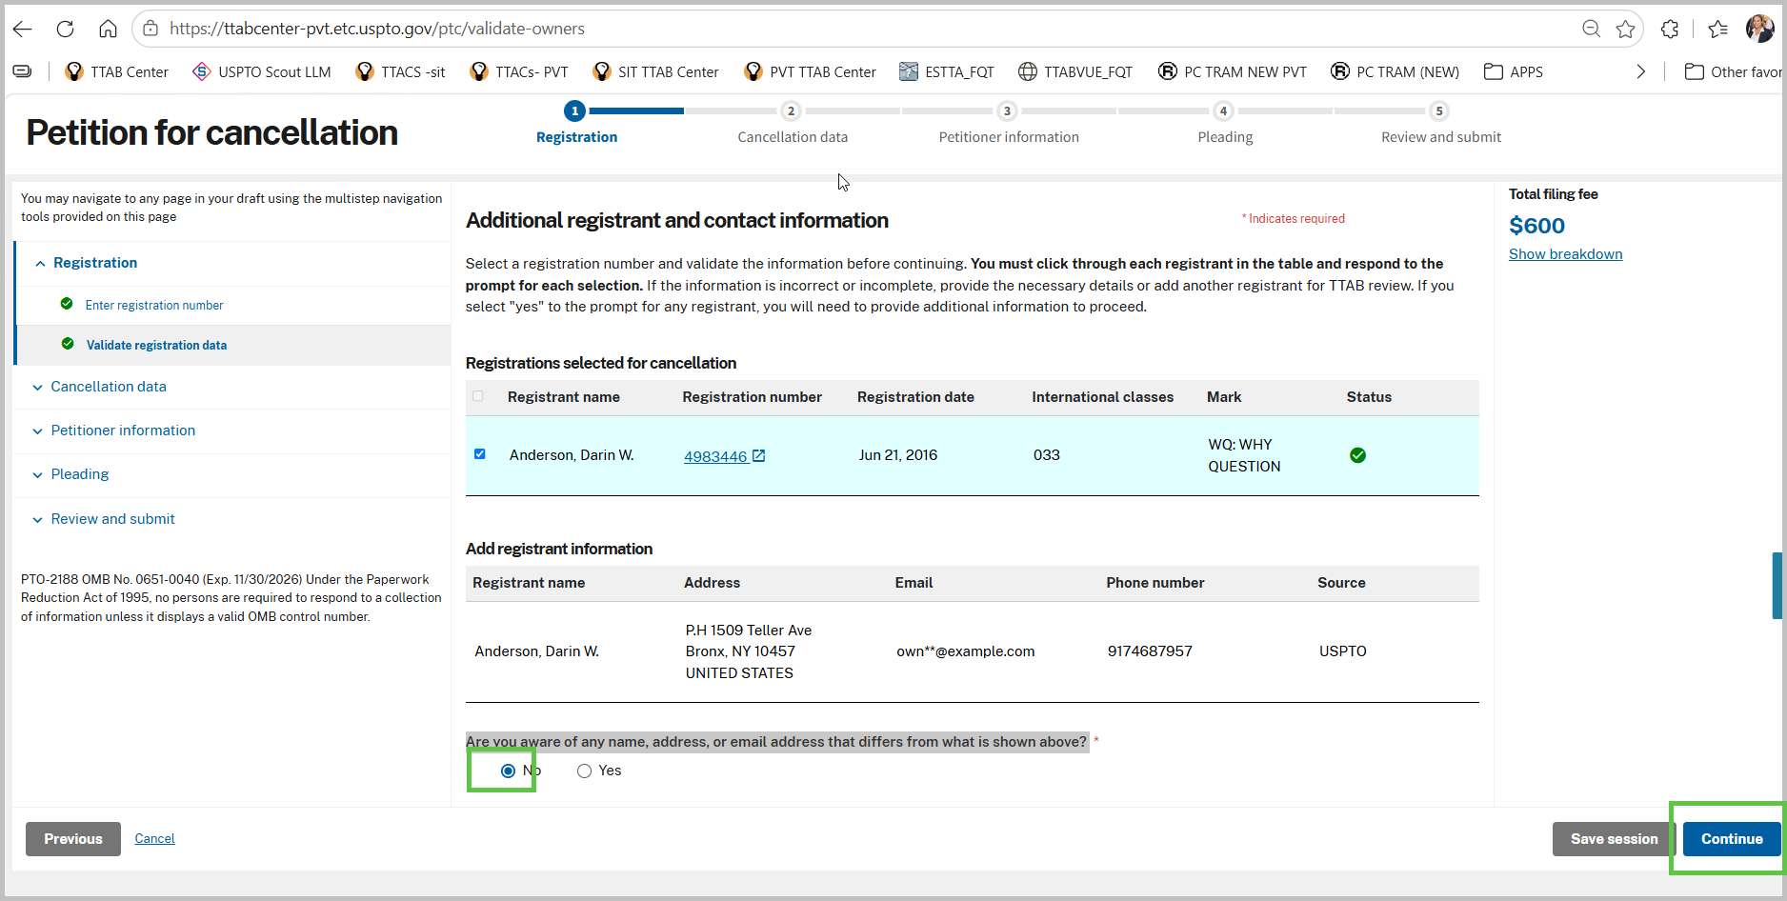
- On the “Goods/services opposed” page- for each Registration, select the good and services option of opposition. Once the selections are made then click “Continue” to proceed to next page.
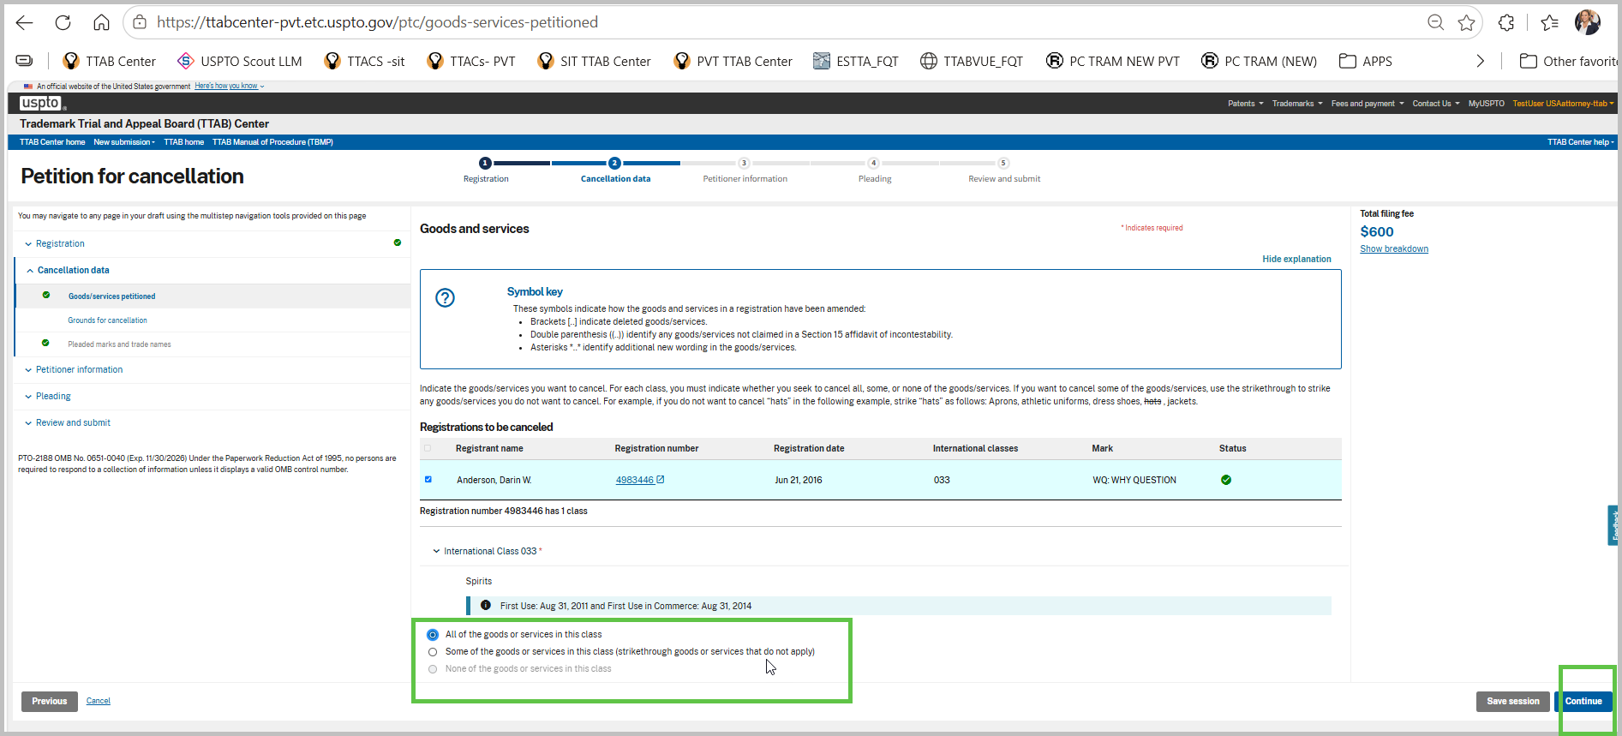
- On the “Grounds for opposition” page, select a ground for cancellation. In this scenario we will pick “The mark is or has become generic Trademark Act Section 14(3)”. Once the selections are made then click “Continue” to proceed to next page.
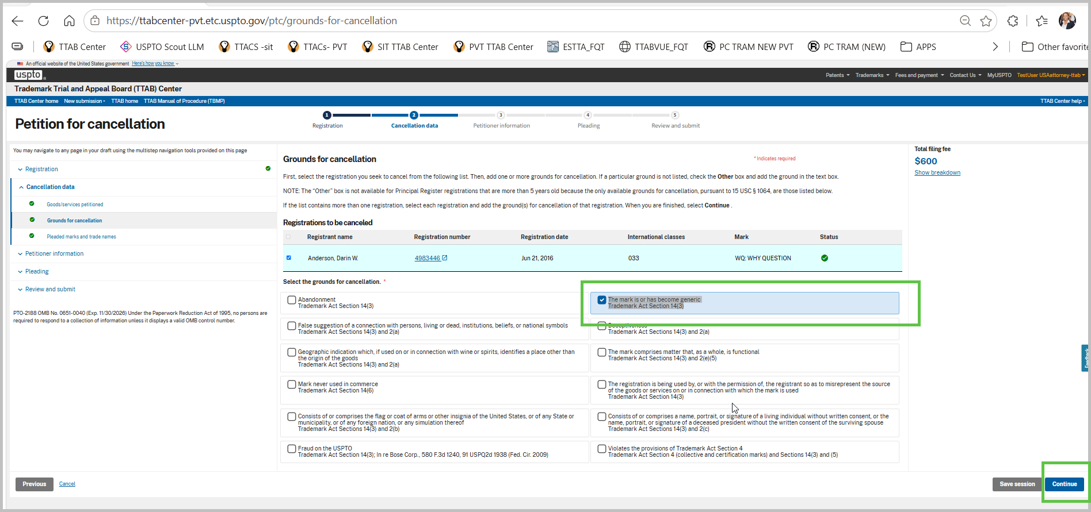
- On the “Pleaded marks and trade names” page, add a valid registration such as “3254899”, then click search. Verify the trademark information you wish to add and click “Add” button to add as part of the pleaded marks. Once the selections are made then click “Continue” to proceed to next page.
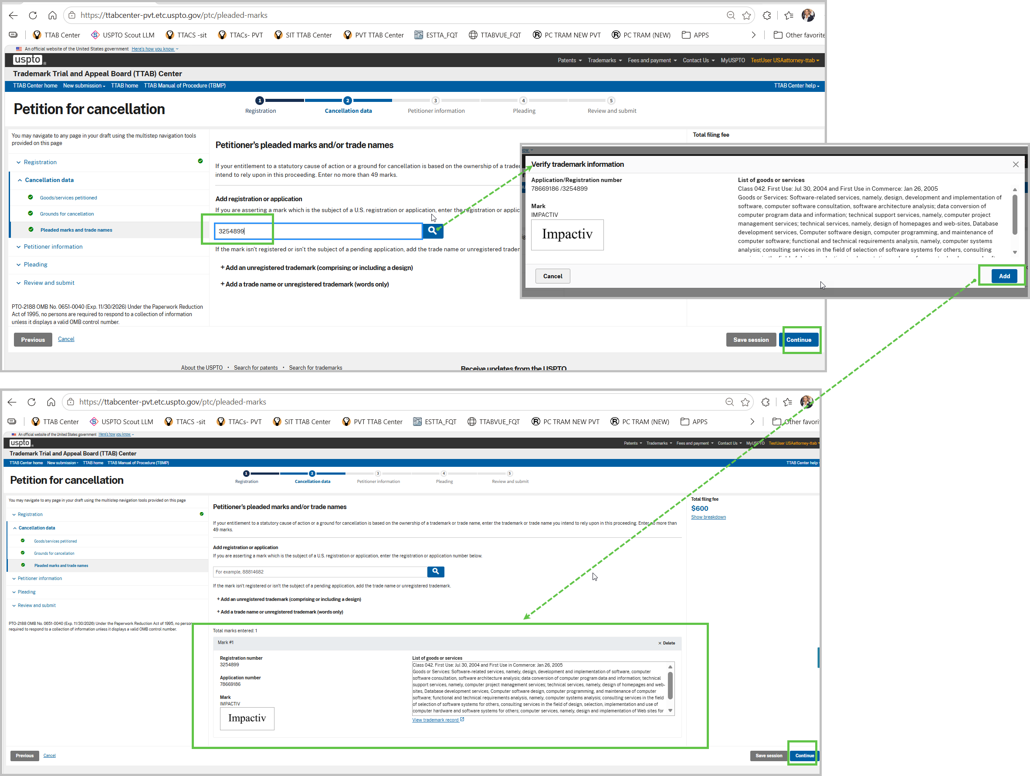

- On the “Petitioner information” page, click the “+Add petitioner information” button link. In the pop up “Add opposer information” add all required information. Once this form is complete, click “Add” button to enter opposer into the record. Repeat this process to add more opposers. Be aware the more opposers you add will increase the Total Filing fee. Once completed adding opposers, click “Continue” to proceed to next page.
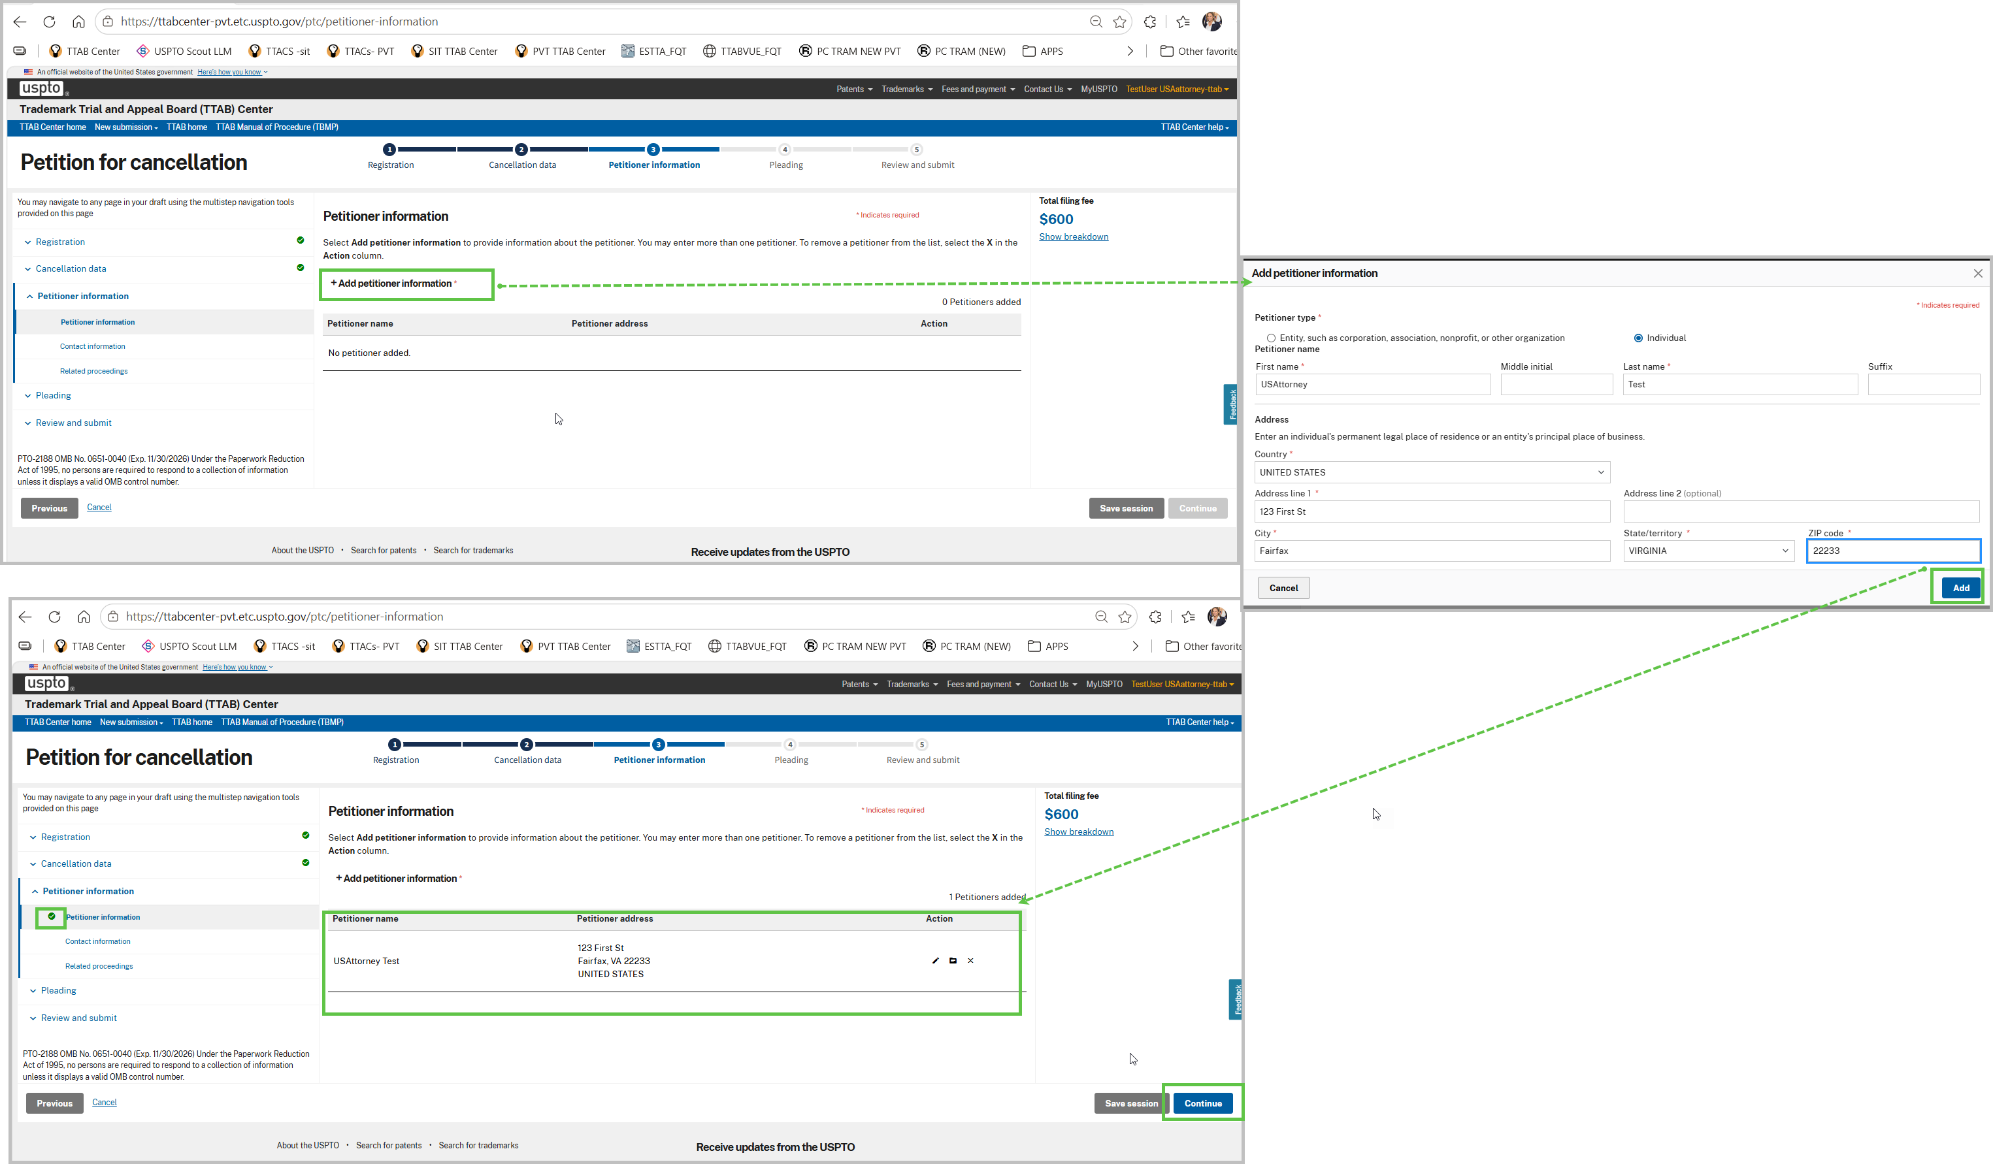

- On the “Contact information” page, for this filing select “MyUSPTO”. This will autopopulate the Contact information with data in MyUSPTO profile for logon user. Enter optionally docket number. Check the box for attorney of record. Once completed adding contact info, click “Continue” to proceed to next page.

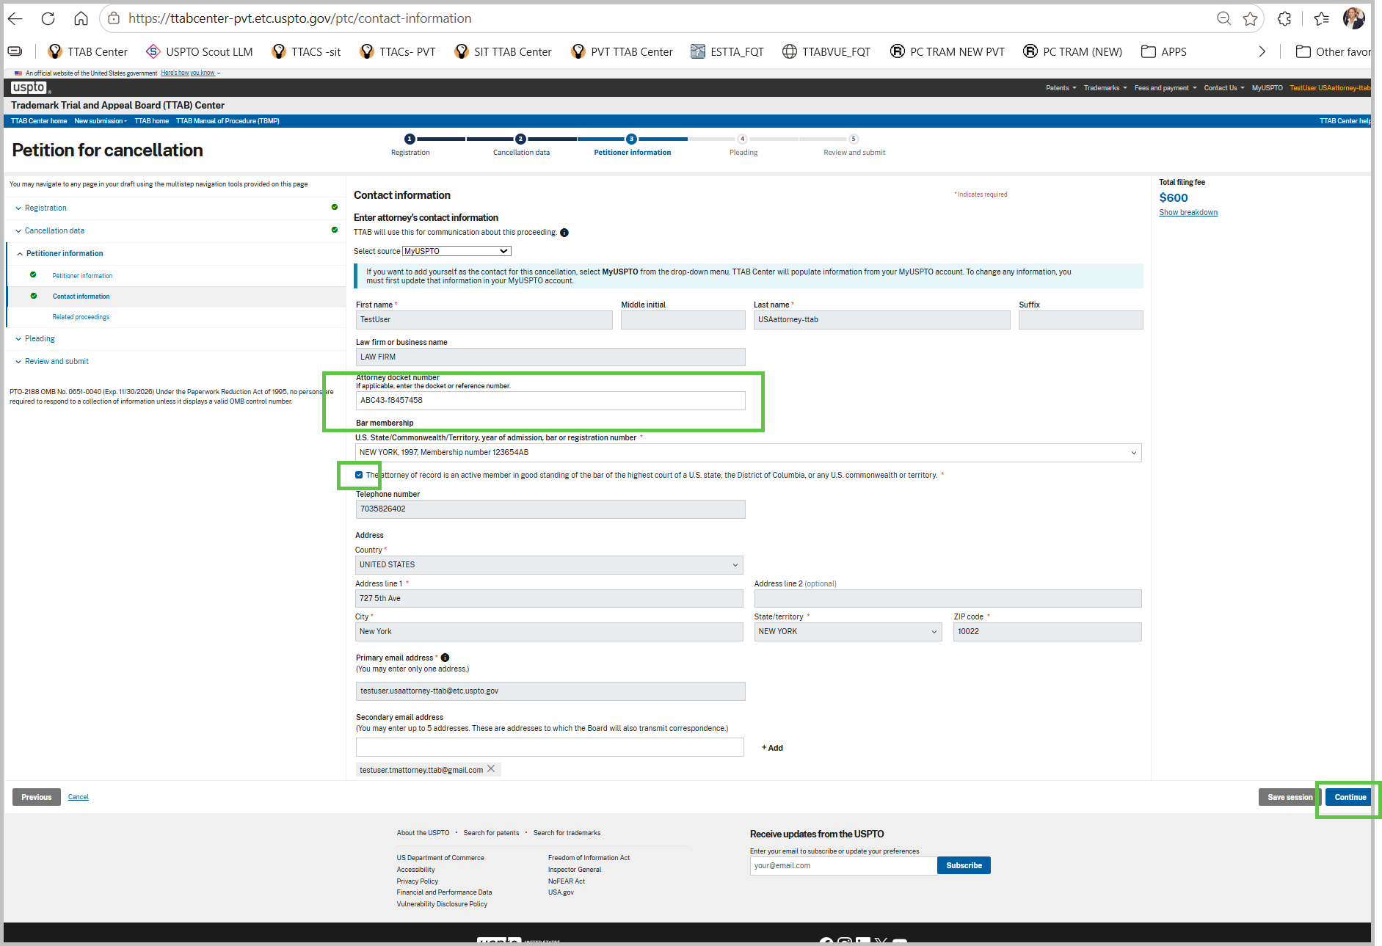
- On “Related proceedings page” skip data entry and click “Continue” to proceed to next page
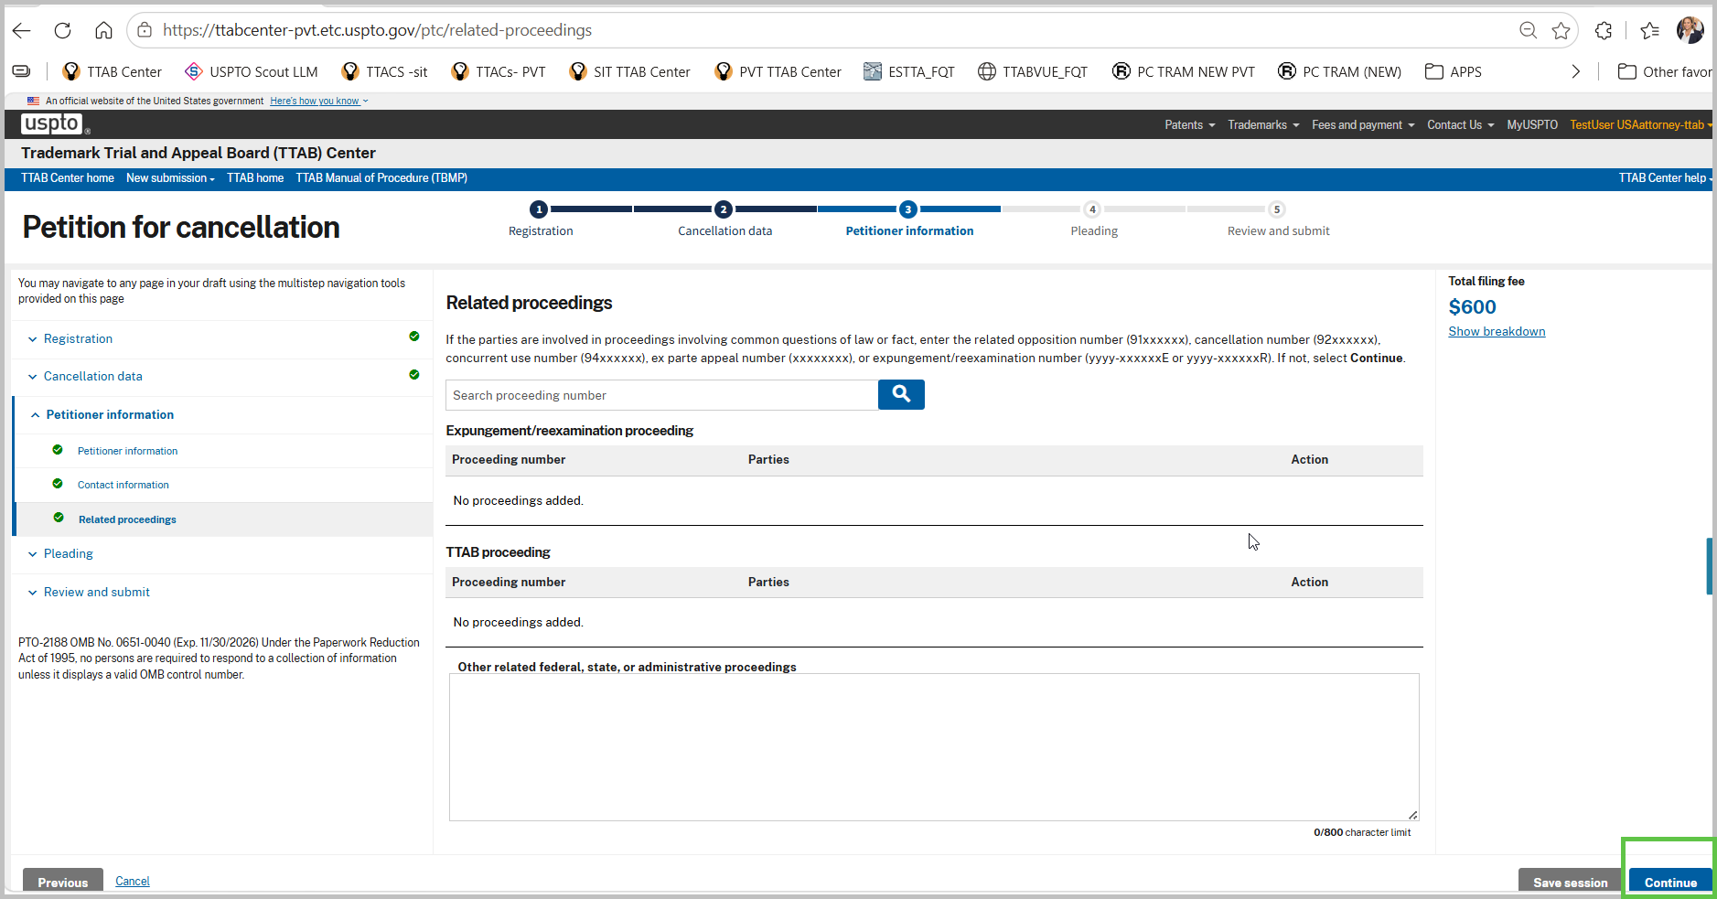
- On “Pleading and attachments” page, upload at least one test file and click “Continue” to proceed to next page.
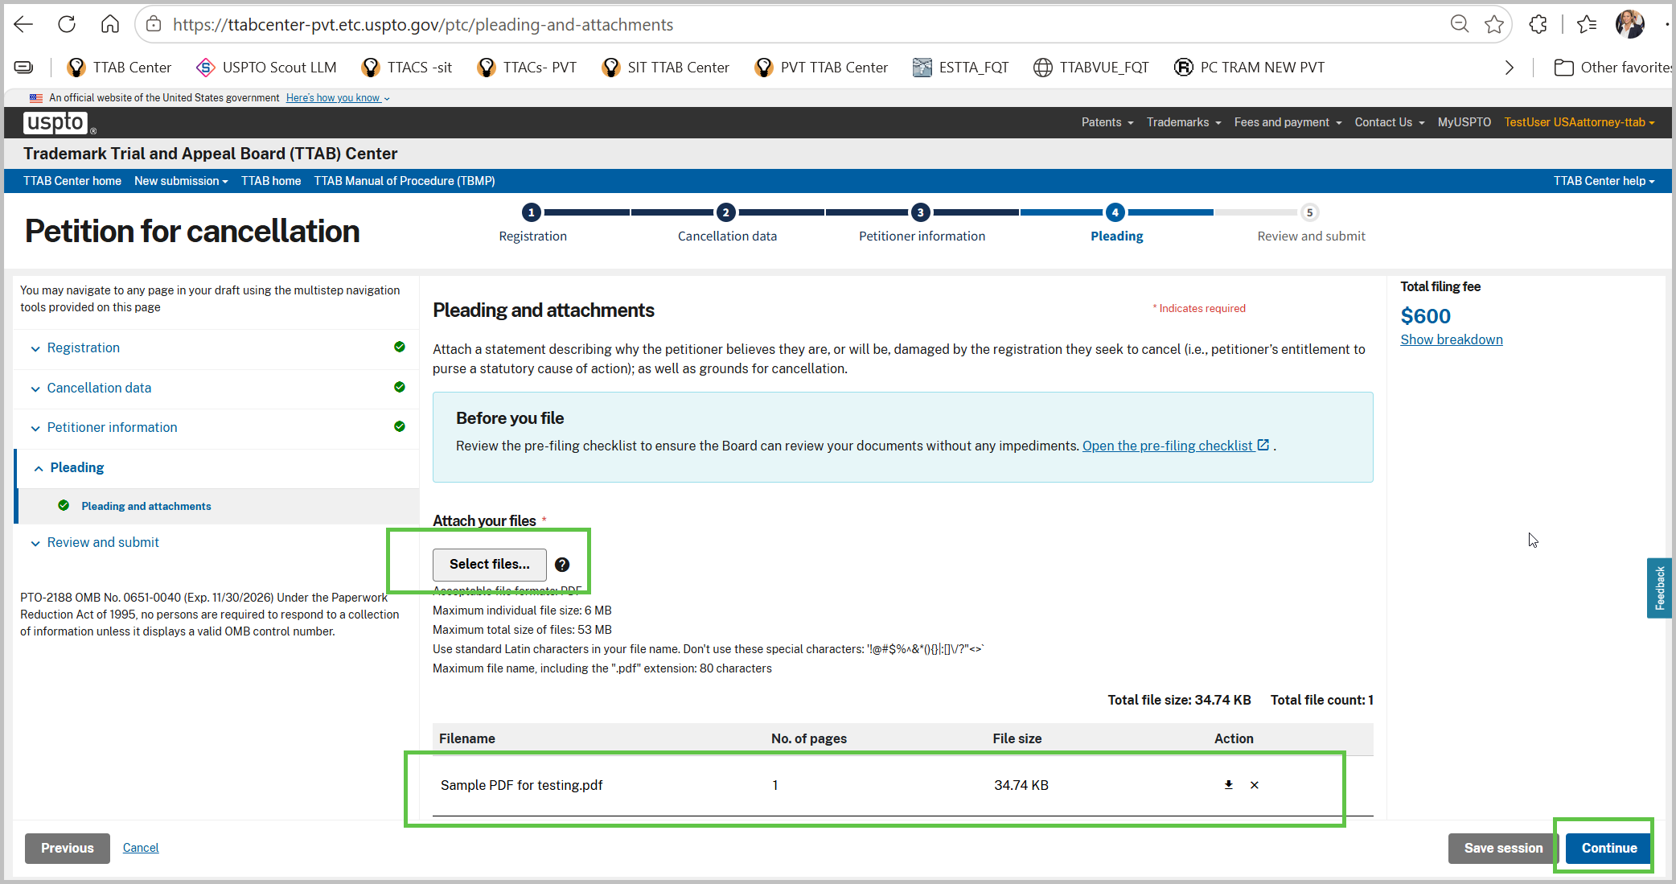
- On Validate page, ensure all form entry fieds display as valid, if not return to the sections incomplete any pending information input. When all fields are valid, the form “Continue” button wil be enabled. Click “Continue” to proceed to next page.
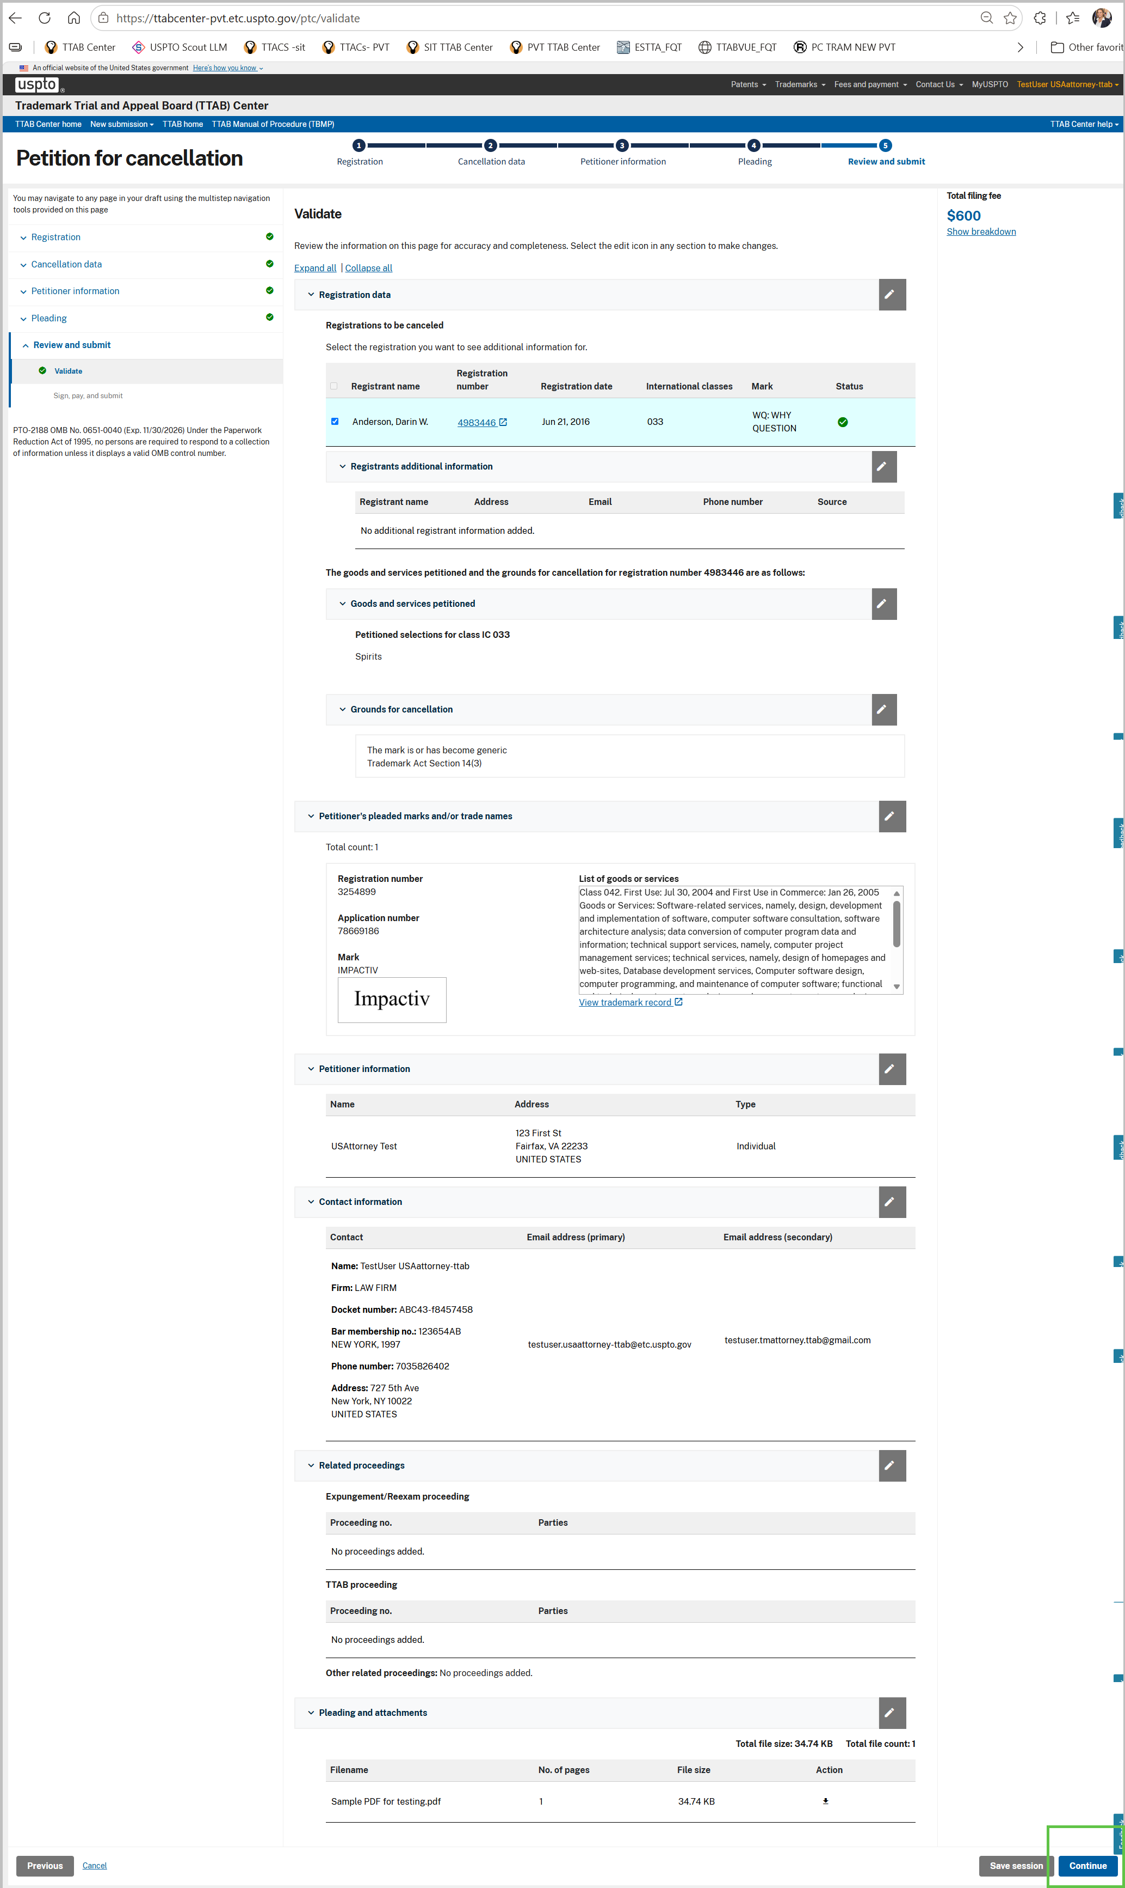
- On the “Sign, pay and submit” page, Fill the signature and submit form by clicking on the “Submit” button.
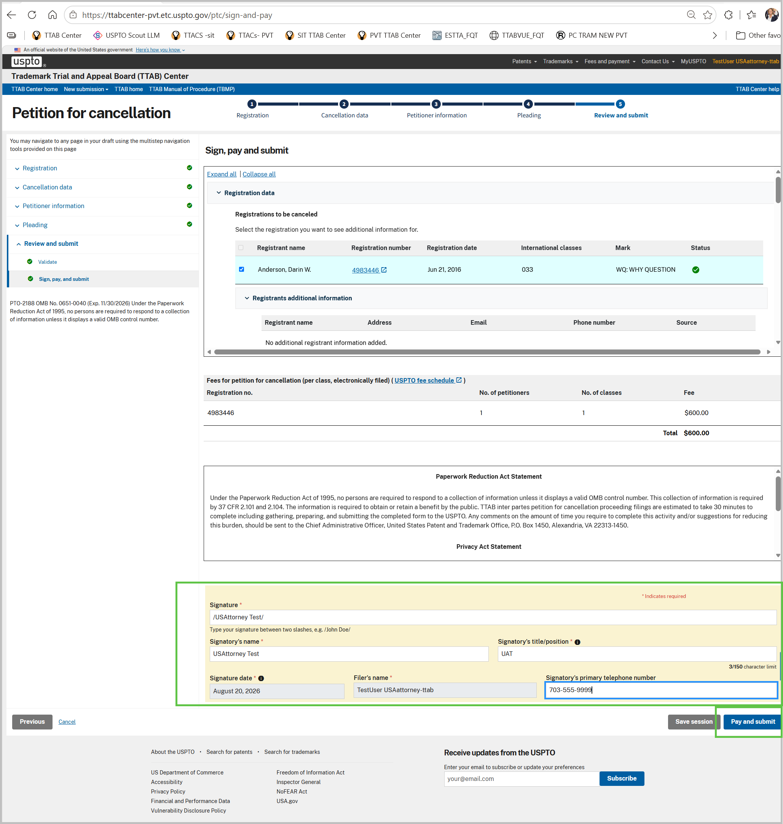

- A pop-up window will appear, click “Continue” to proceed to payment
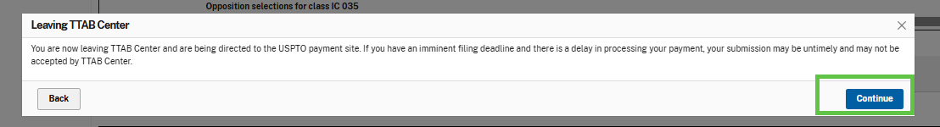
- Make payment in FPNG form and click ‘Submit Payment” button
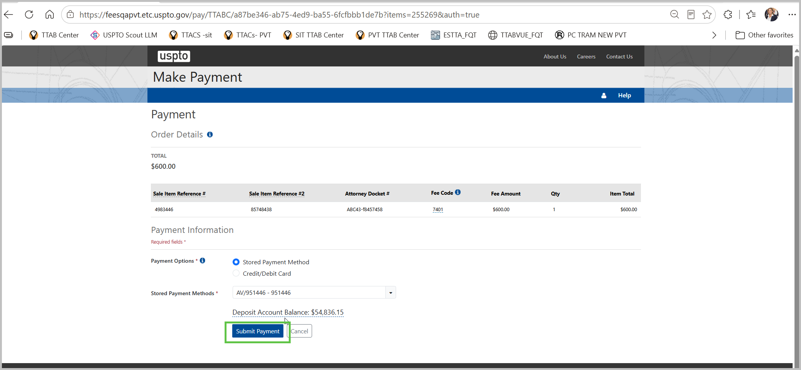

- The next page is a receipt page presented and this concludes your PTC submission.
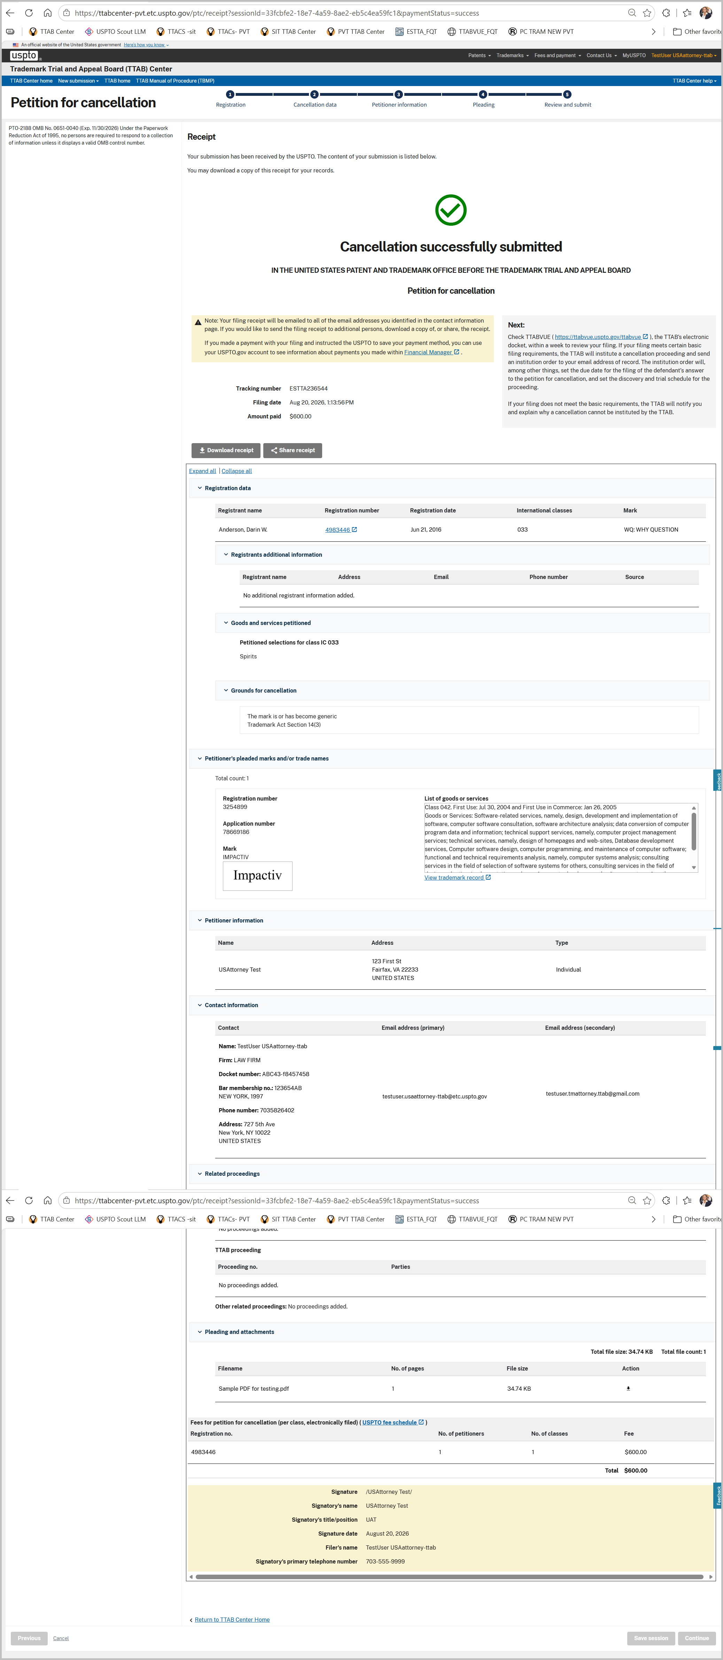

----END OF TEST FOR US ATTORNEY USER---

