TTAB Center Workflows

Notice of Opposition (NOO) – Started by a Prose and Sent to US Attorney for submission
Last Update: 08/19/2026

----BEGIN OF TEST FOR PROSE USER---
- As a Prose User (testuser.Prose-ttab@etc.uspto.gov), File a Notice of Opposition (NOO).
On TTAB Center home page, click “My TTAB docket”
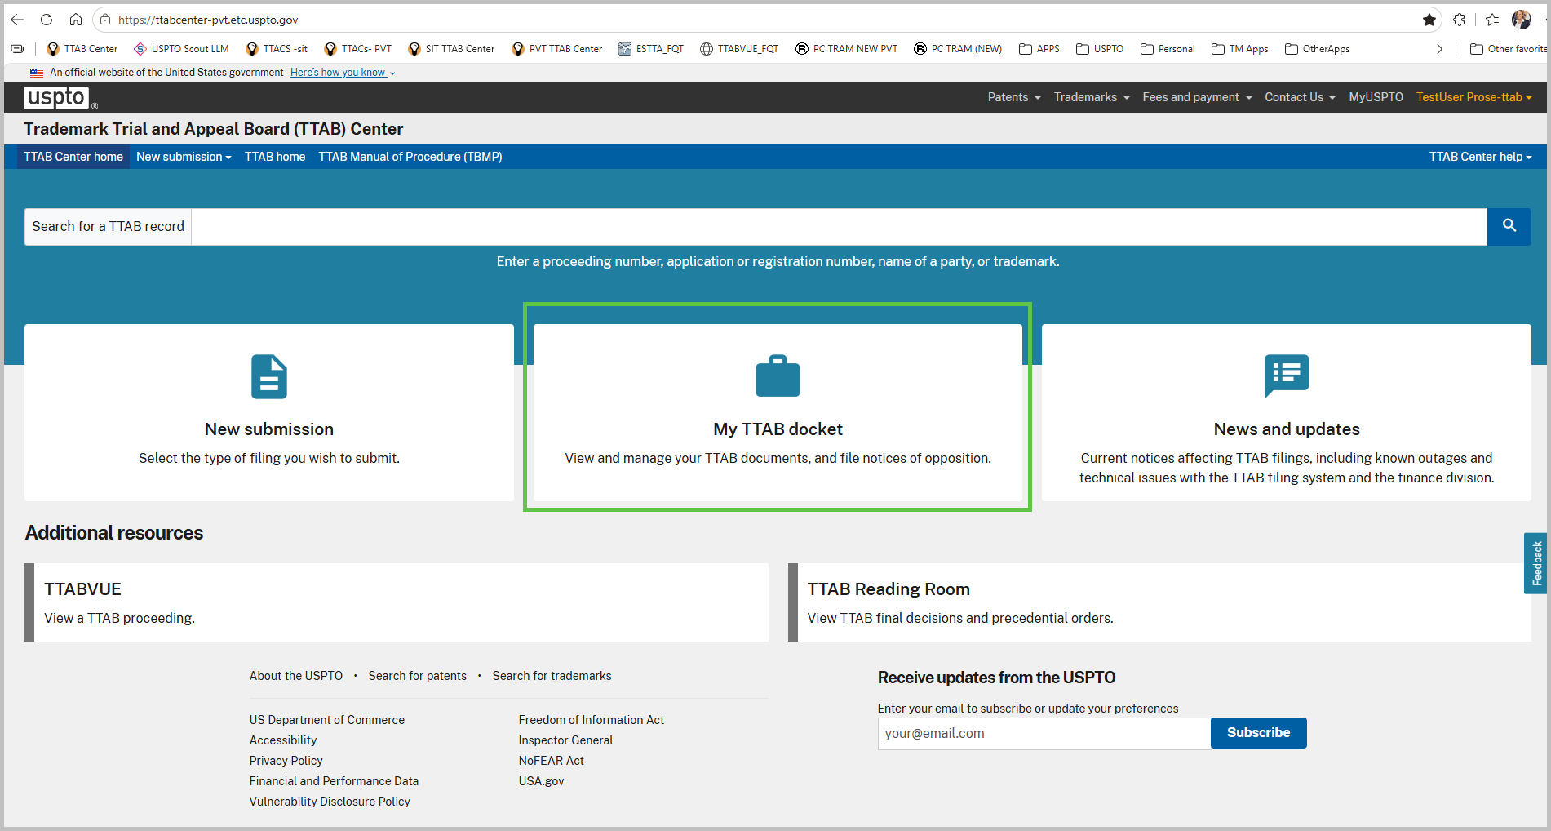
- On the “My TTAB Docket” page select “Create new” drop down, and select “Notice of Opposition” option
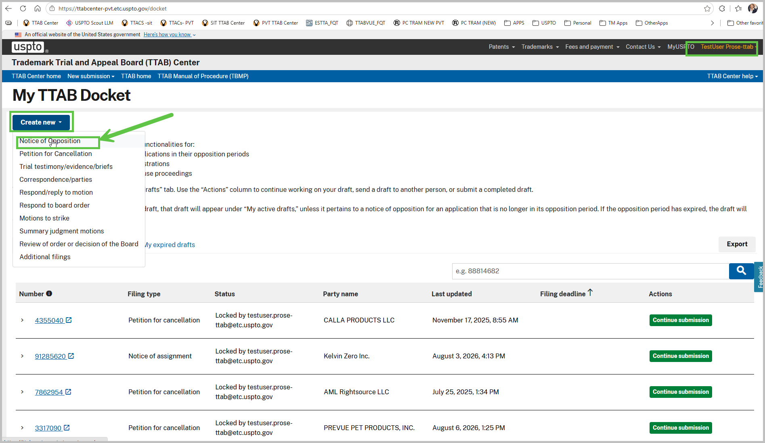
- On the Application Data Page, type the SN you wish to file NOO. Once the confirmation pop up appears click “Confirm” – this will add the SN to the NOO filing. Repeat this process for as many applications user wants to oppose. Once finished click “Continue” to proceed to next page.
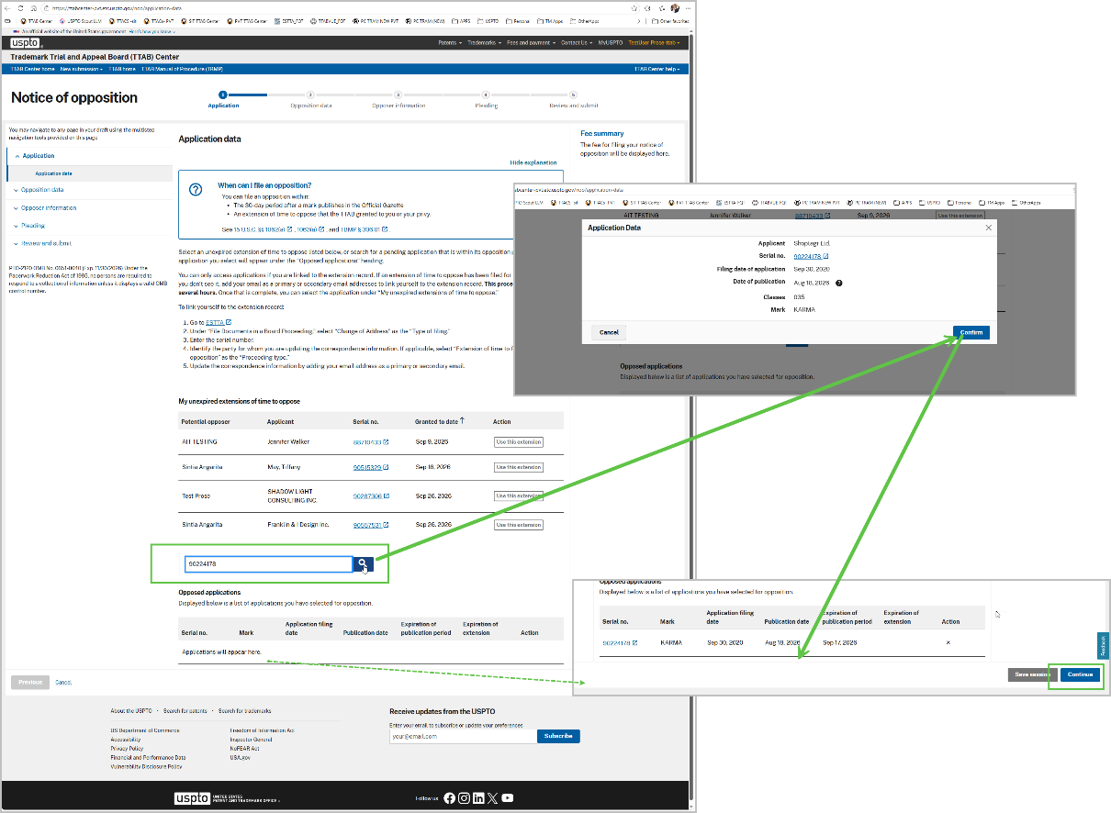

- On the “Goods/services opposed” page- for each Application, select the good and services option of opposition. Once the selections are made then click “Continue” to proceed to next page.
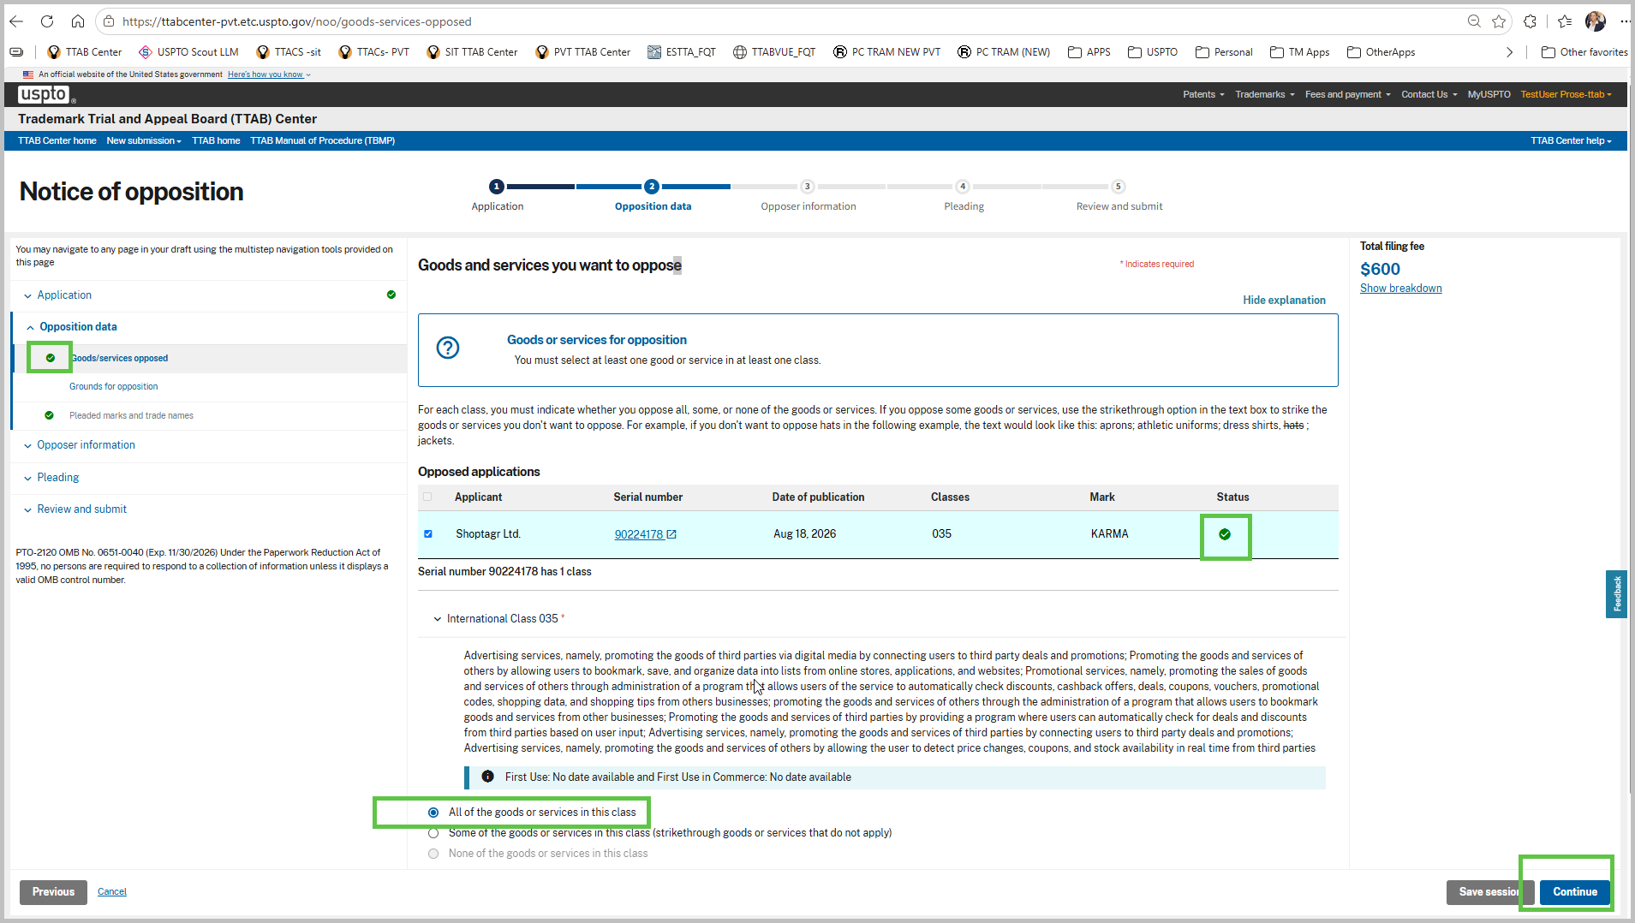
- On the “Grounds for opposition” page, select a ground for cancellation. In this scenario we will pick “The mark is generic Trademark Act Sections 1, 2 and 45”. Once the selections are made then click “Continue” to proceed to next page.
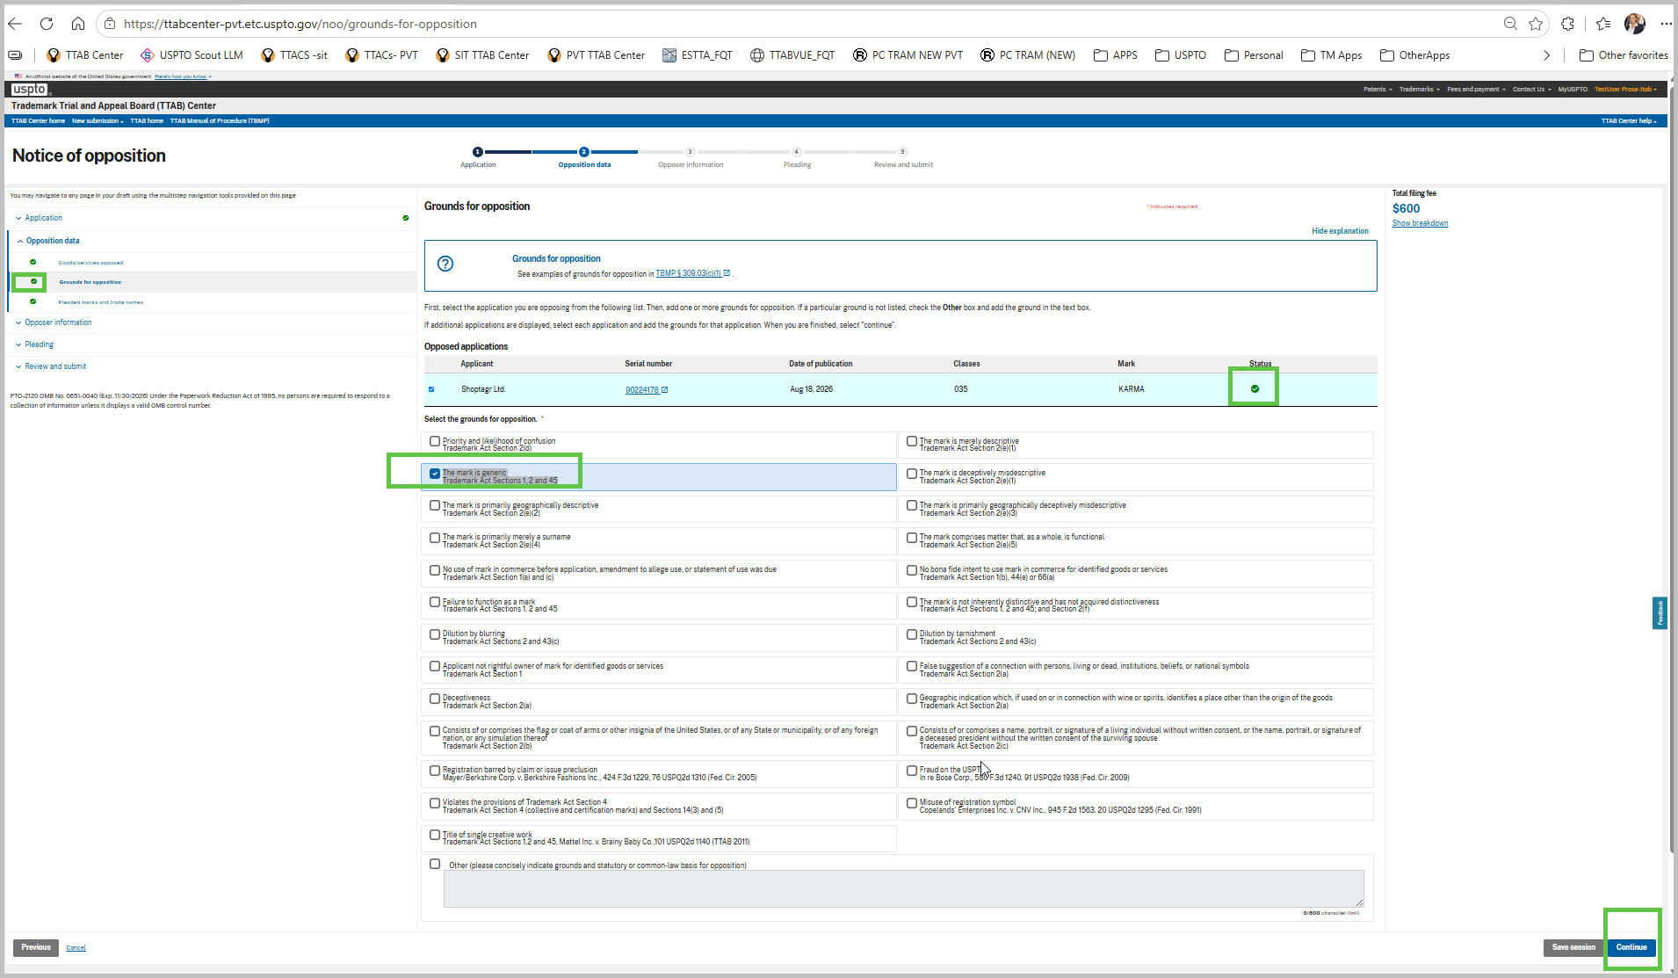
- On the “Pleaded marks and trade names” page, add a valid registration such as “3254899”, then click search. Verify the trademark information you wish to add and click “Add” button to add as part of the pleaded marks. Once the selections are made then click “Continue” to proceed to next page.
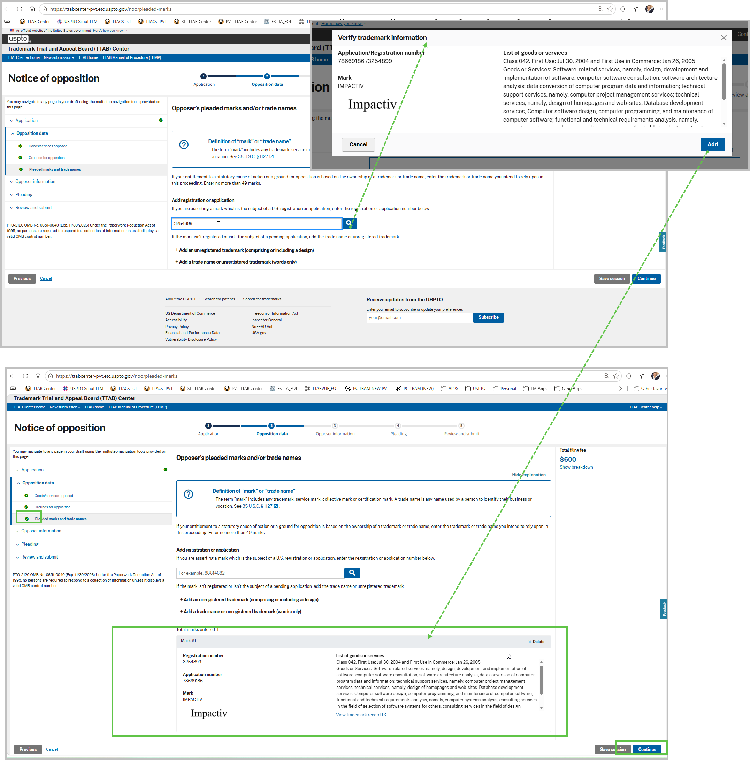
- On the “Opposer information” page, click the “+Add opposer information” button link. In the pop up “Add opposer information” add all required information. Once this form is complete, click “Add” button to enter opposer into the record. Repeat this process to add more opposers. Be aware the more opposers you add will increase the Total Filing fee. Once completed adding opposers, click “Continue” to proceed to next page.
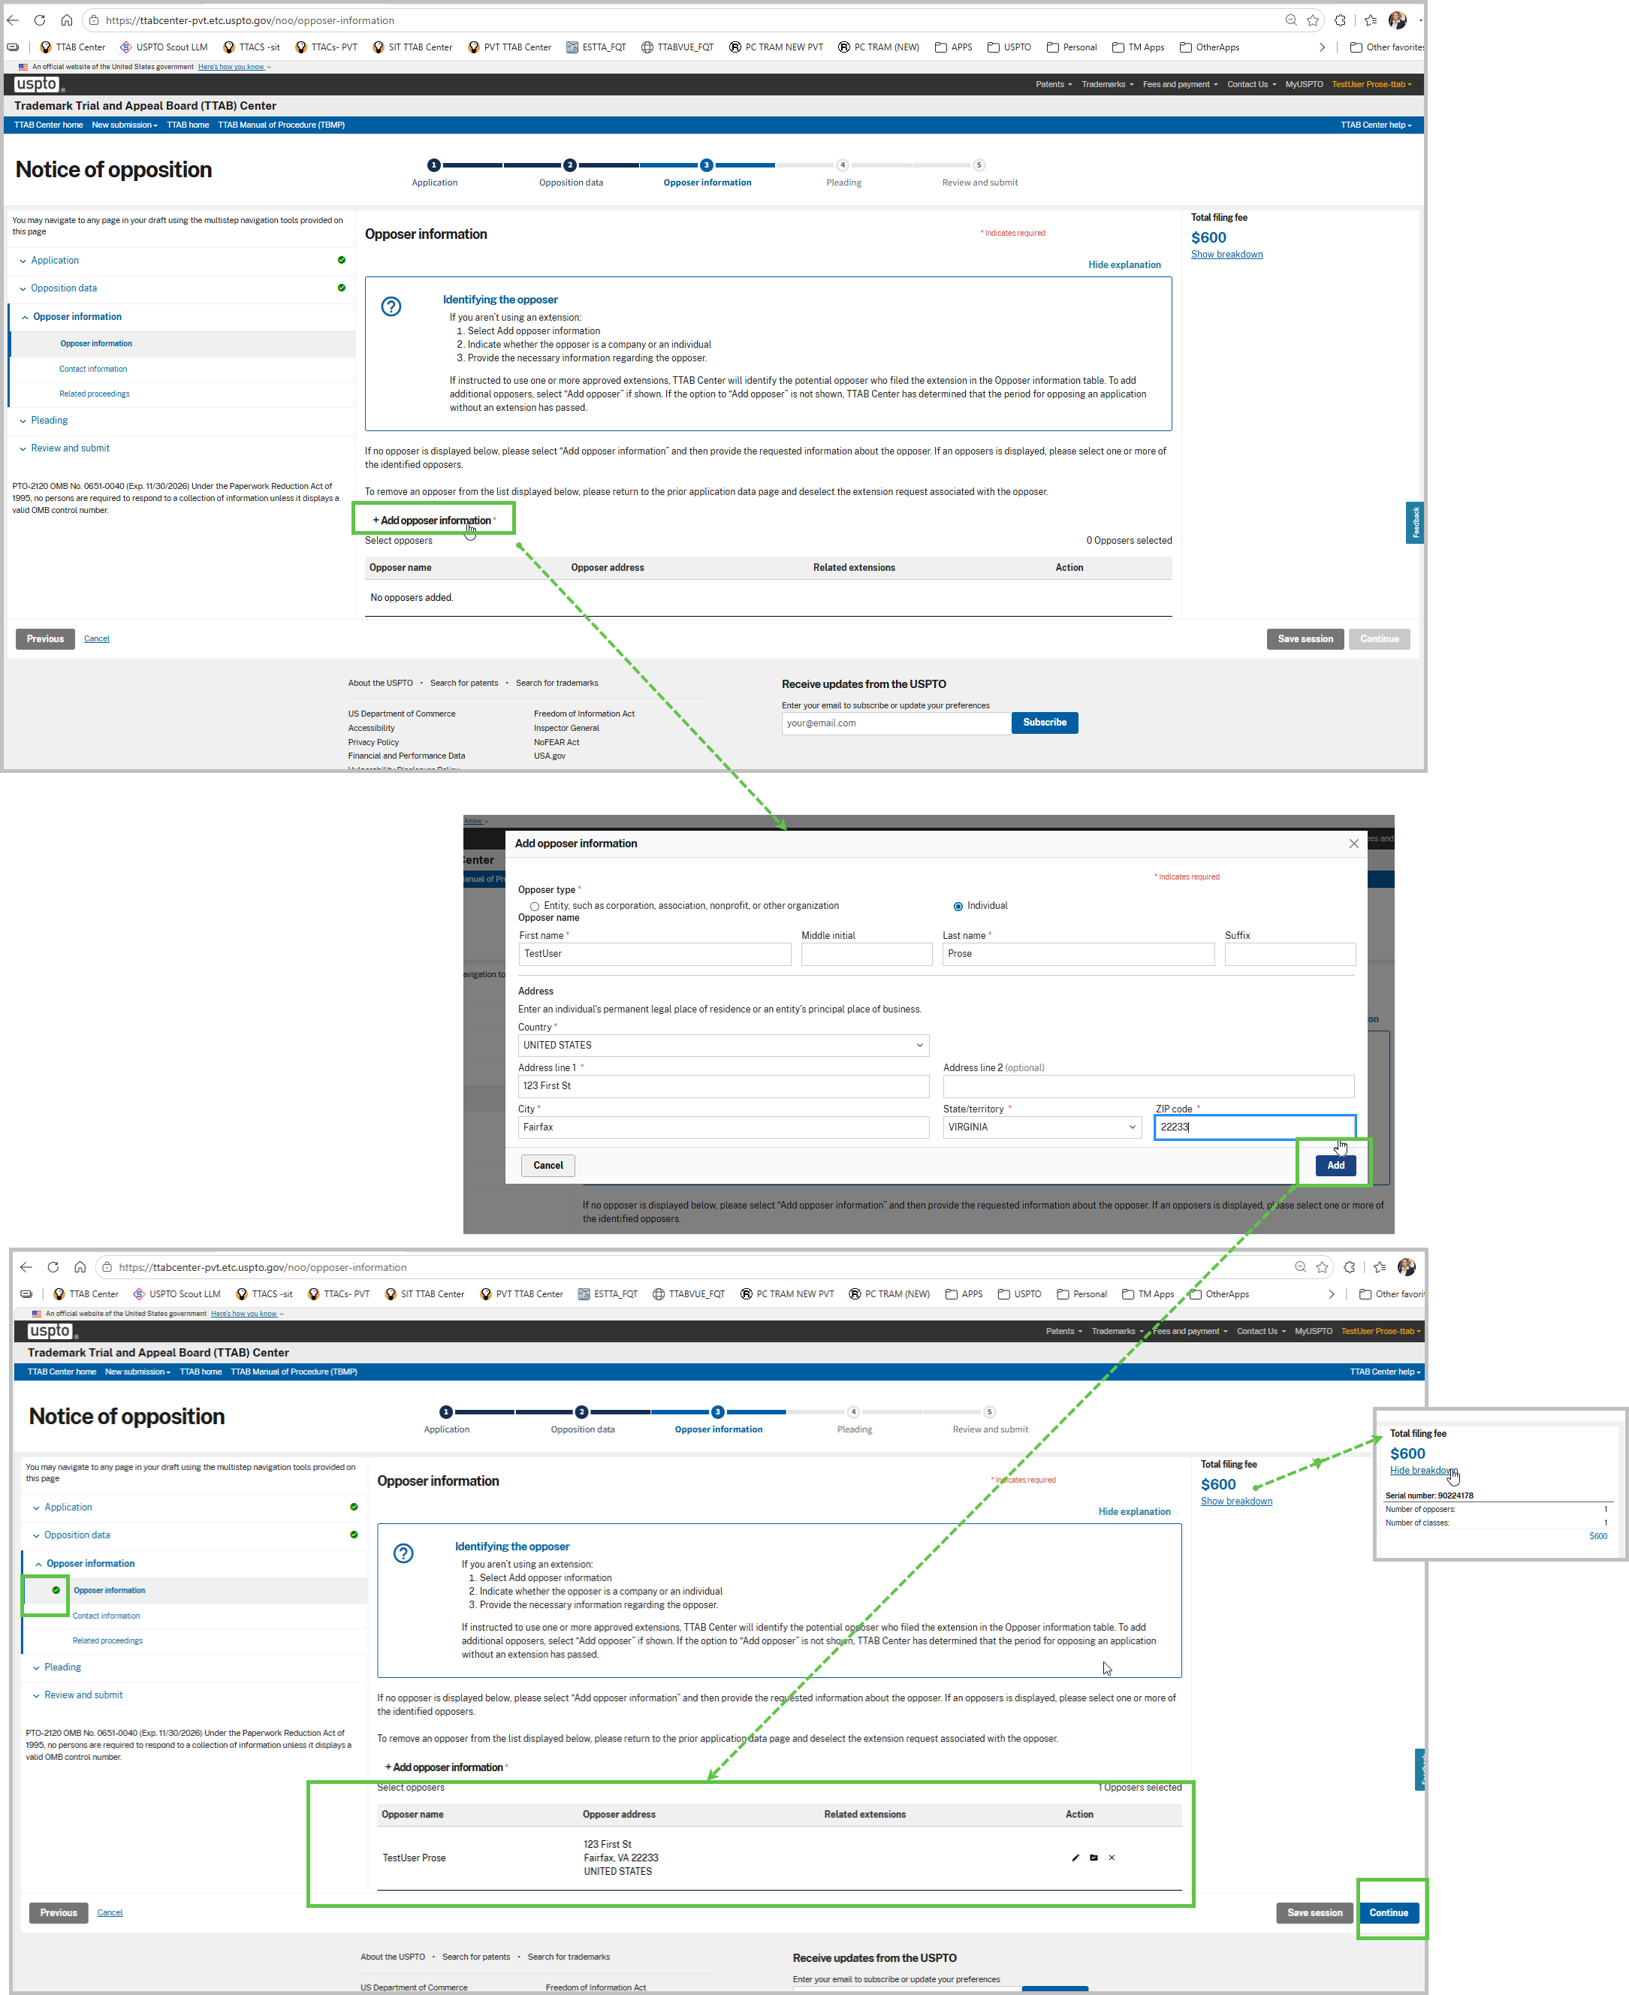

- On the “Contact information” page, for this filing select to be represented by US Attorney (testuser.USAattorney-ttab@etc.uspto.gov). In the select source drop down select “Add attorney”. After you select this option, the form is disabled to continue (by design) as only a user with valid attorney role can add official attorney information. To proceed you must select the link titled “Send a notification” to send this application to a valid attorney to proceed with the submission.
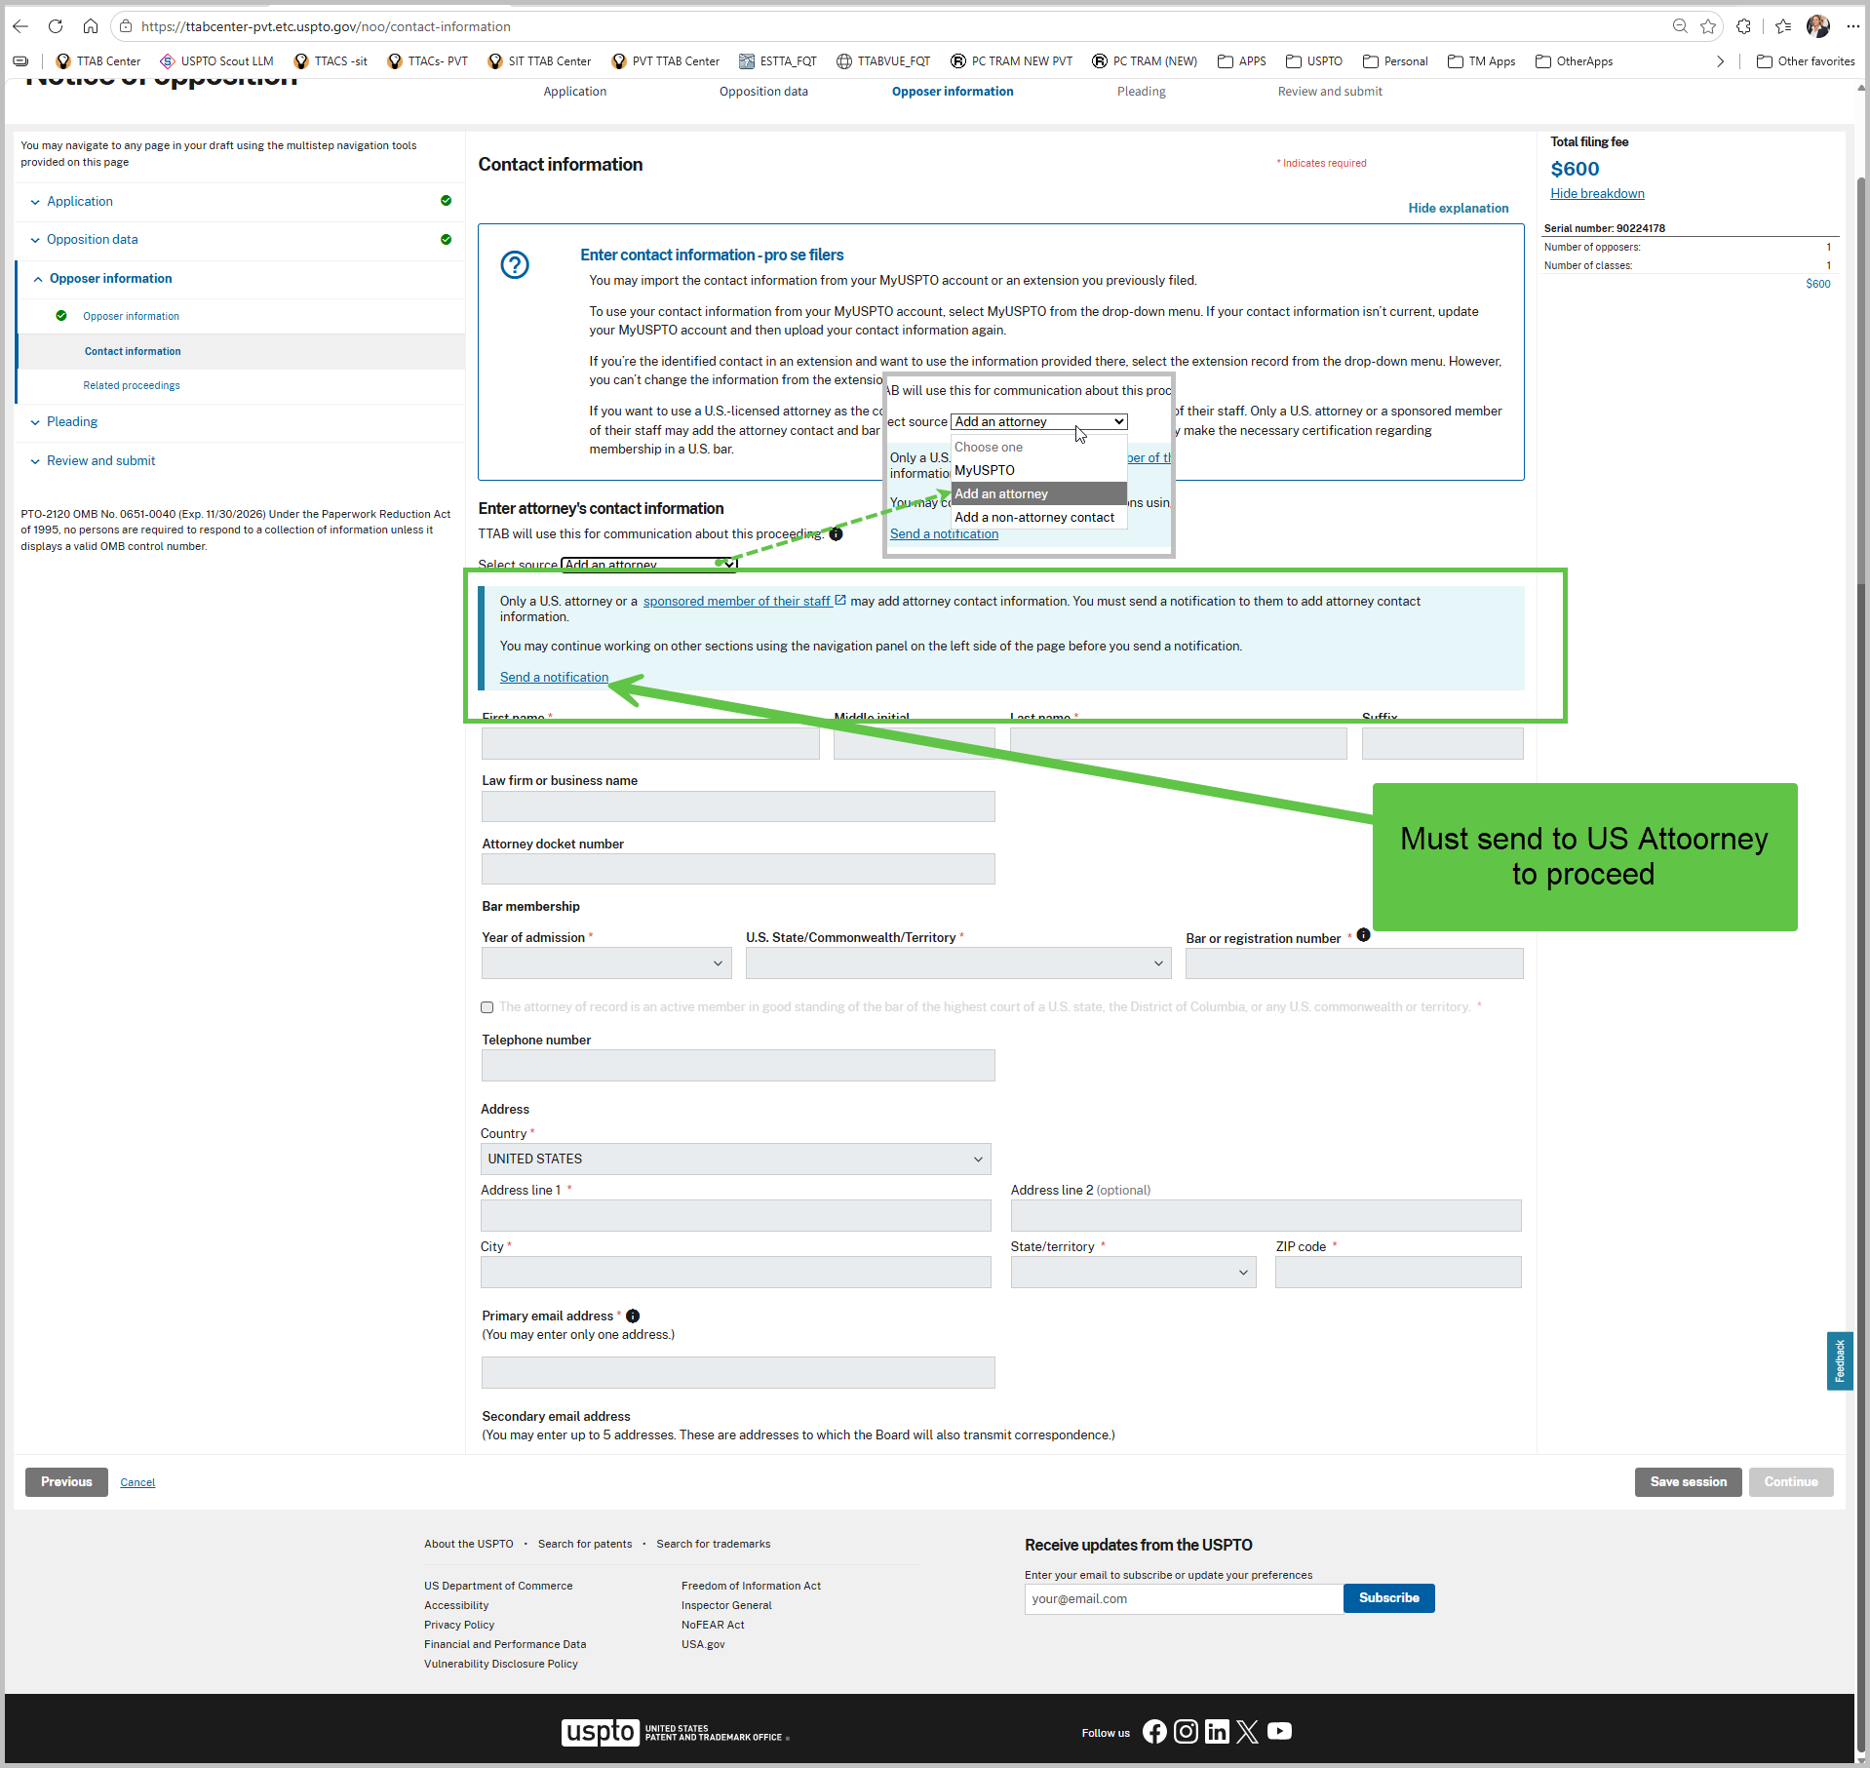
- In the “Save session”, enter a valid email address for US Attorney user and click “Add button”. Click Continue to close out the application and send email to the US Attorney.
----END OF TEST FOR PROSE USER---
----BEGIN OF TEST FOR US ATTORNEY USER---

- Log in TTAB Center as a US Attorney User (testuser.USAattorney-ttab@etc.uspto.gov). On TTAB Center home page, click “My TTAB docket”

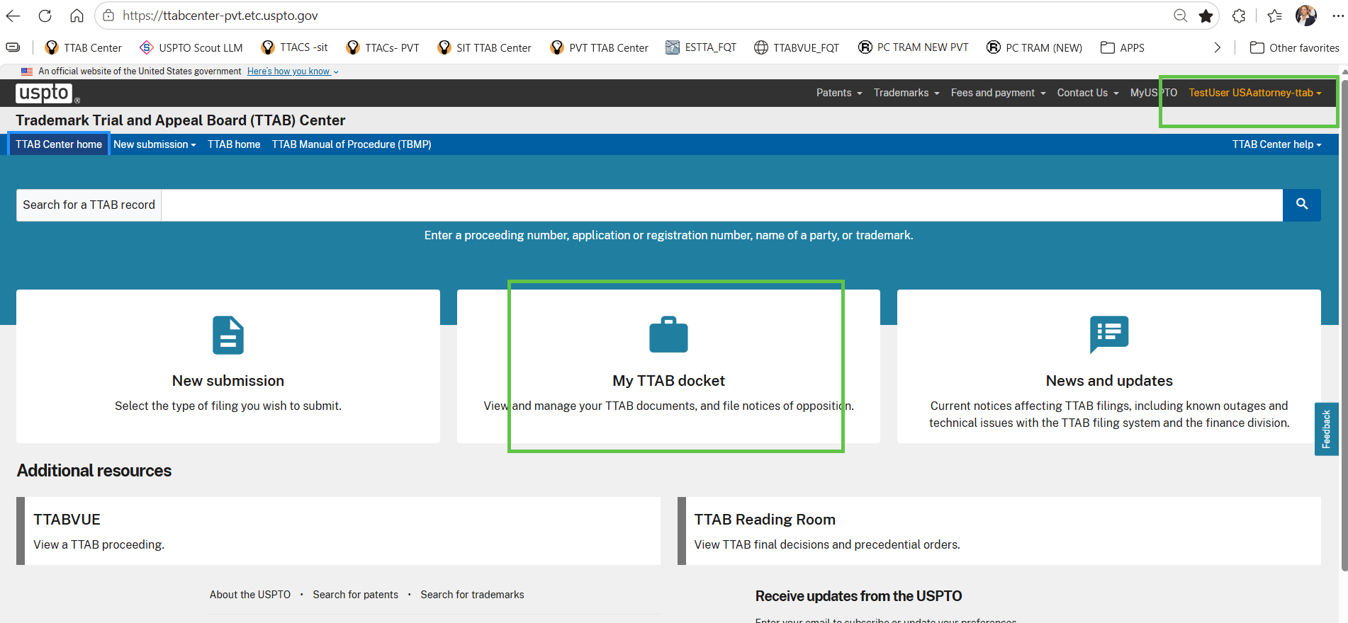

- On “My TTAB Docket”, sort the table by last updated descending order. Find record for NOO. Click on the “Continue” button to open the form
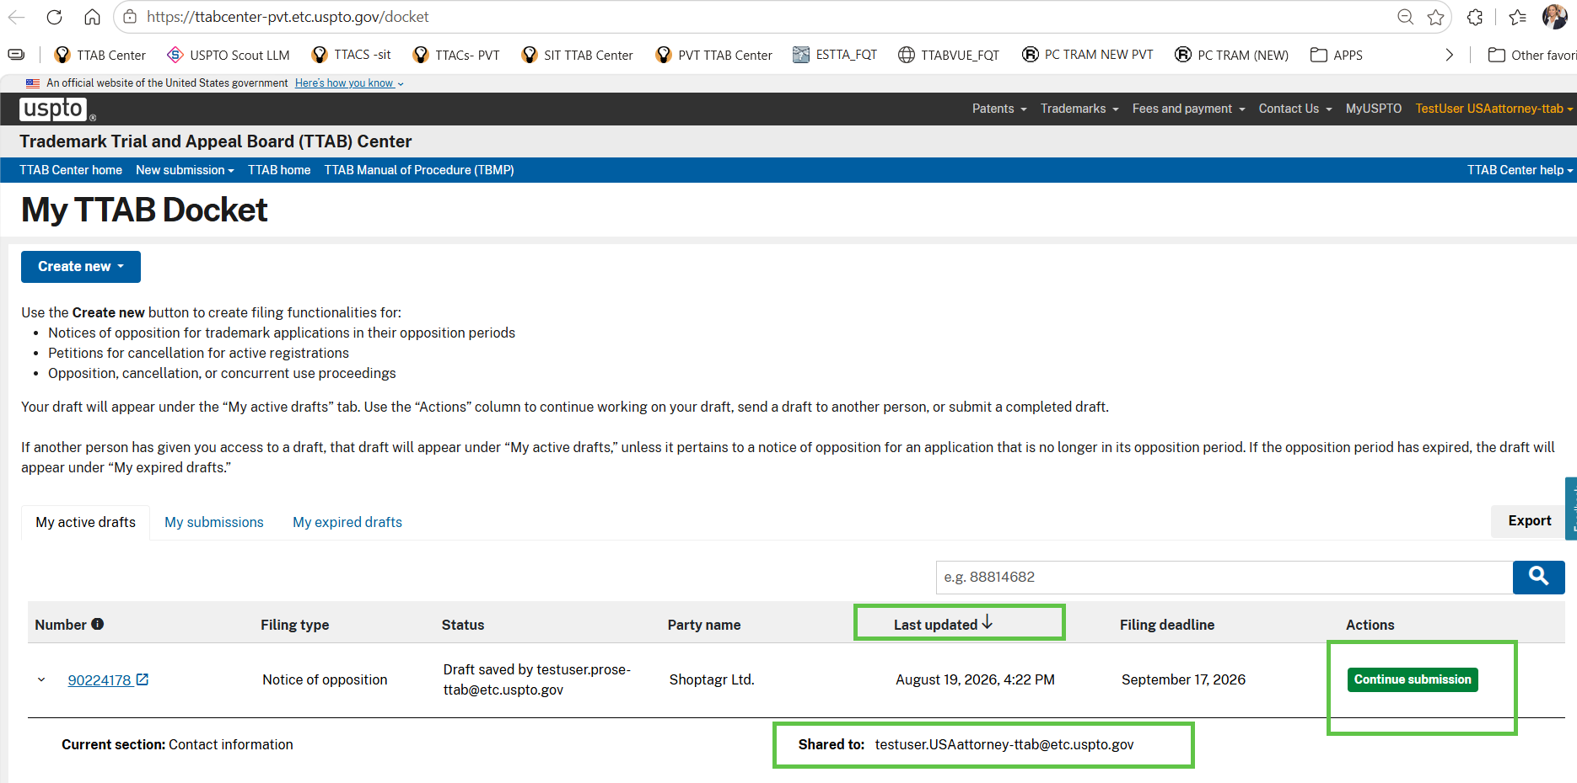
- On “Contact information” Enter optionally docket number. Check the box for attorney of record. Once completed adding contact info, click “Continue” to proceed to next page.

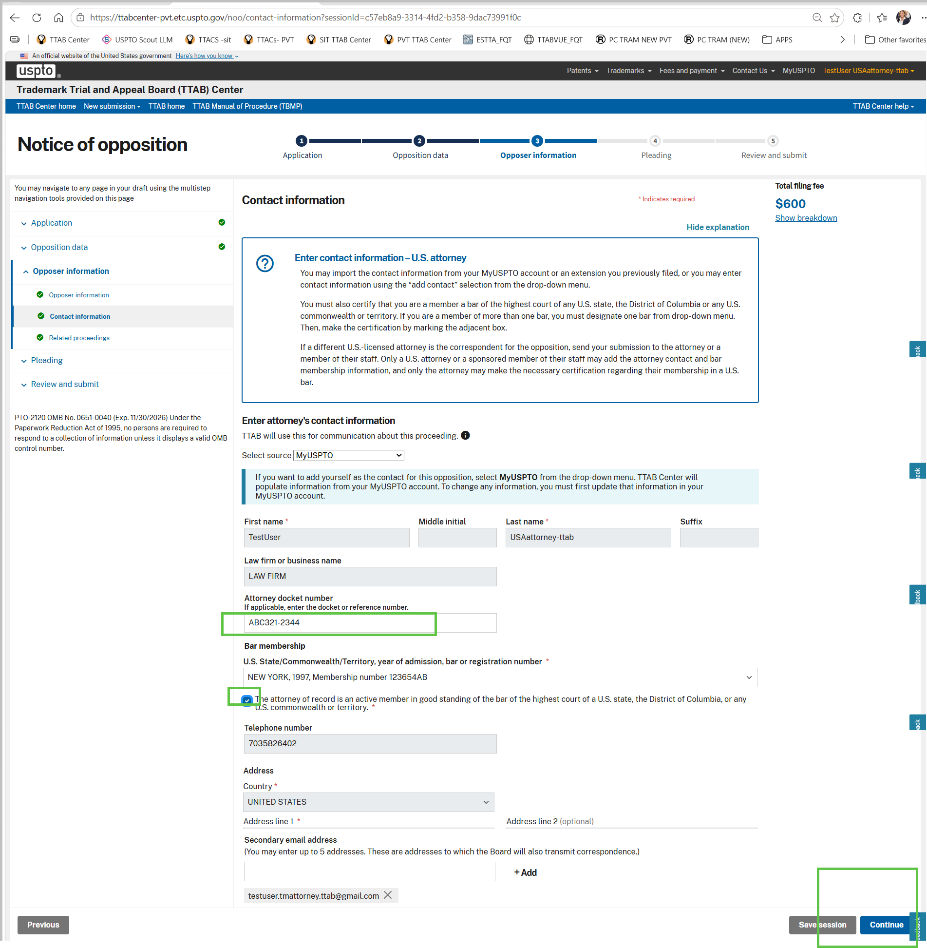
- On “Related proceedings page” skip data entry and click “Continue” to proceed to next page
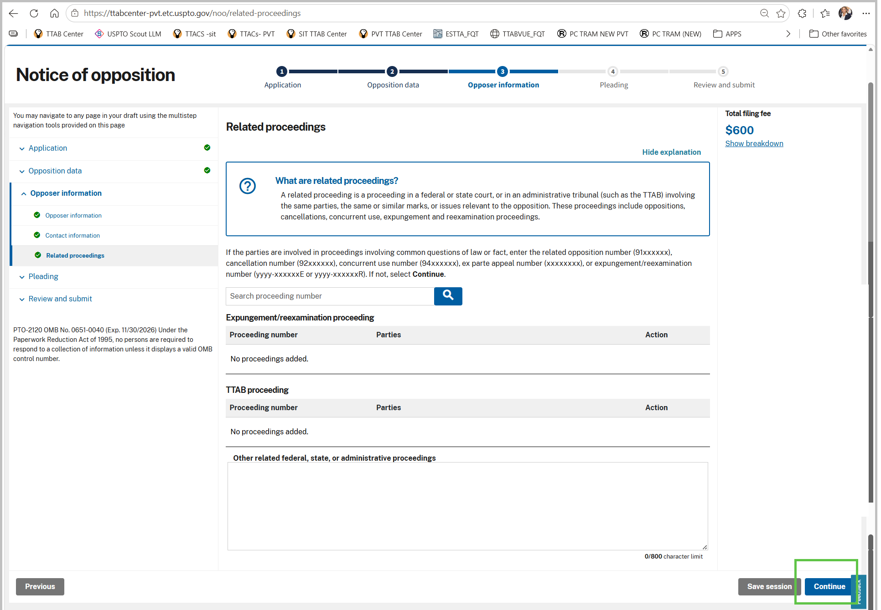
- On “Pleading and attachments” page, upload at least one test file and click “Continue” to proceed to next page.
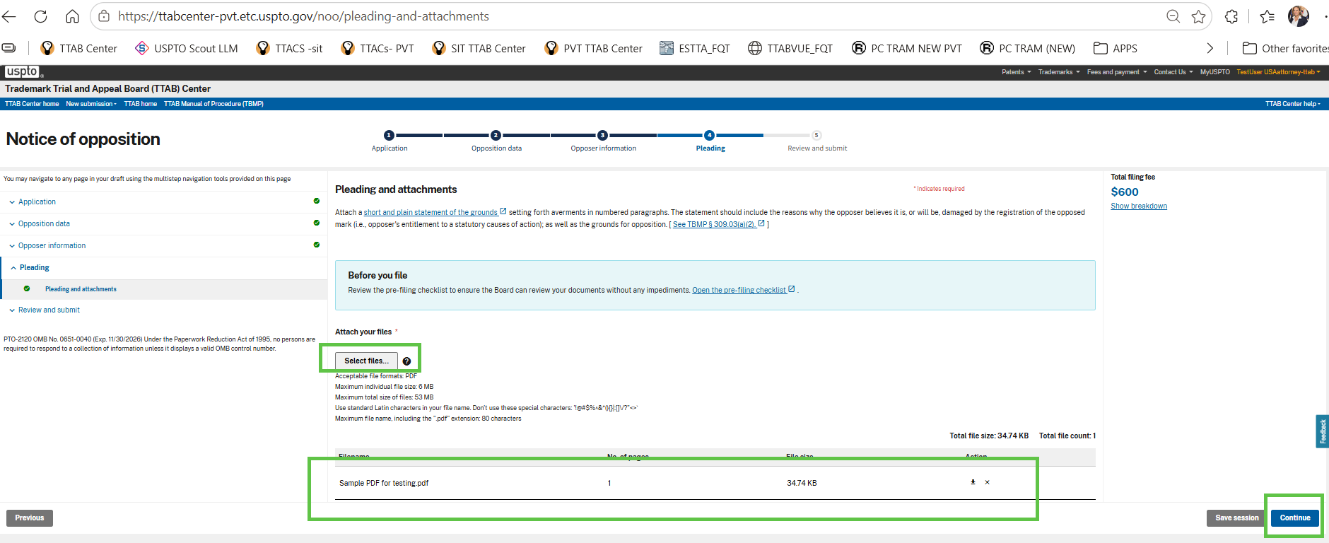
- On Validate page, ensure all form entry fieds display as valid, if not return to the sections incomplete any pending information input. When all fields are valid, the form “Continue” button wil be enabled. Click “Continue” to proceed to next page.
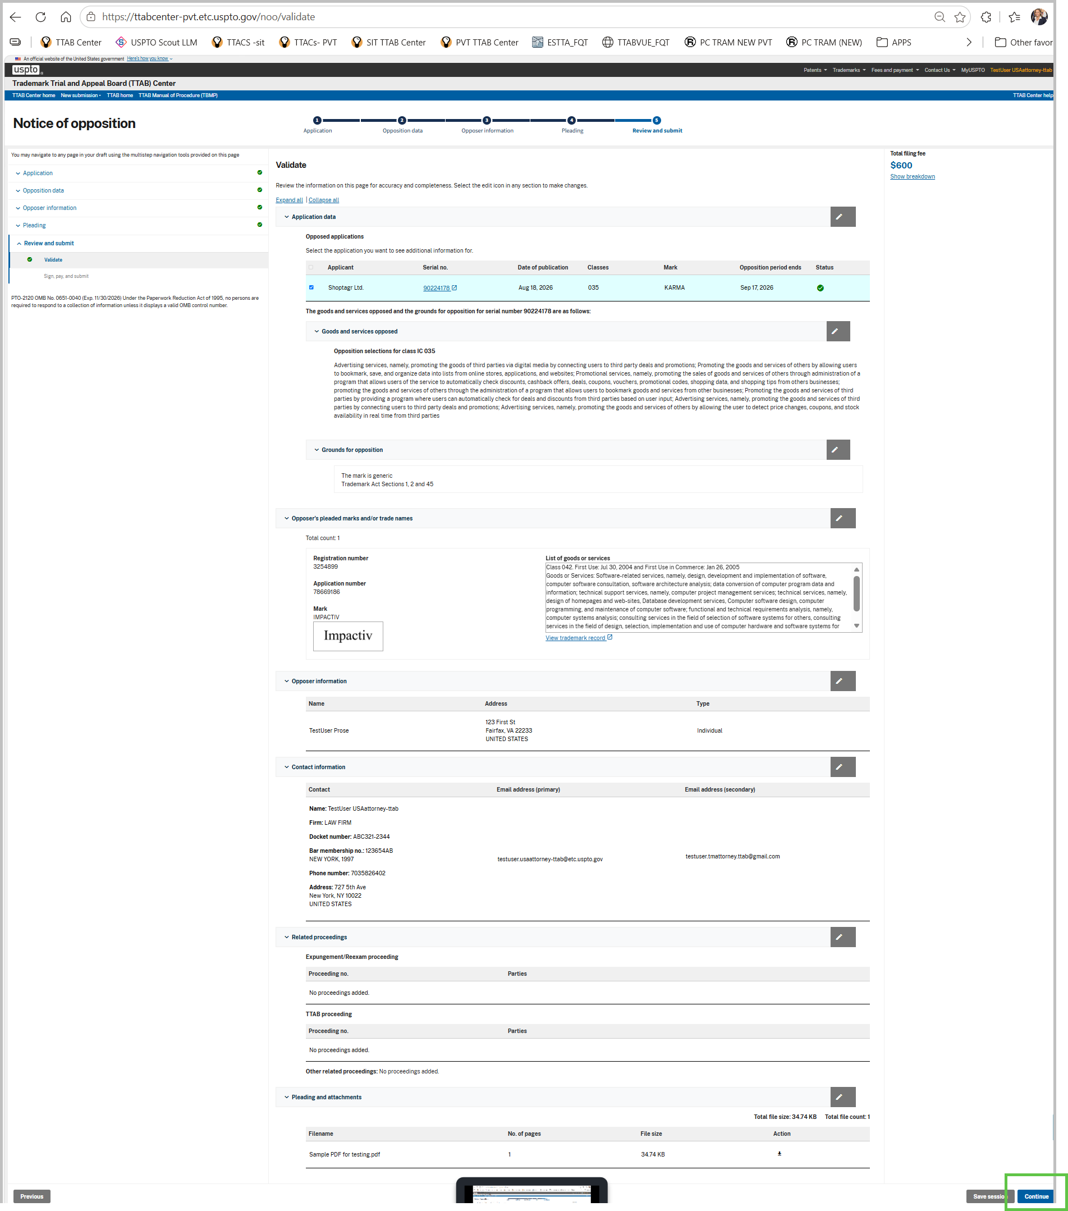
- On the “Sign, pay and submit” page, Fill the signature and submit form by clicking on the “Submit” button.
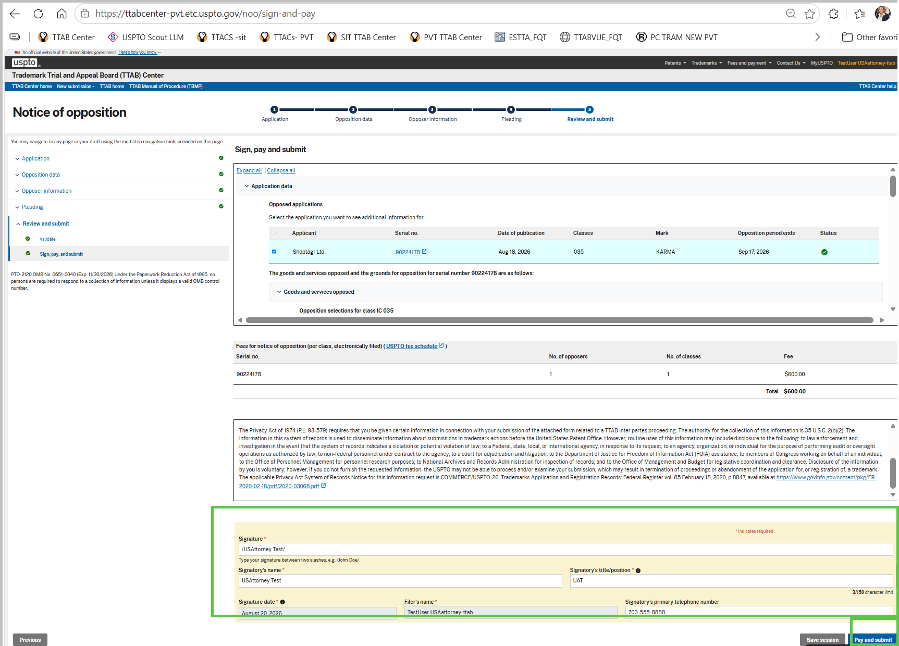

- A pop-up window will appear, click “Continue” to proceed to payment
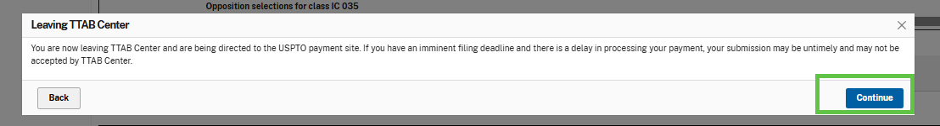
- Make payment in FPNG form and click ‘Submit Payment” button
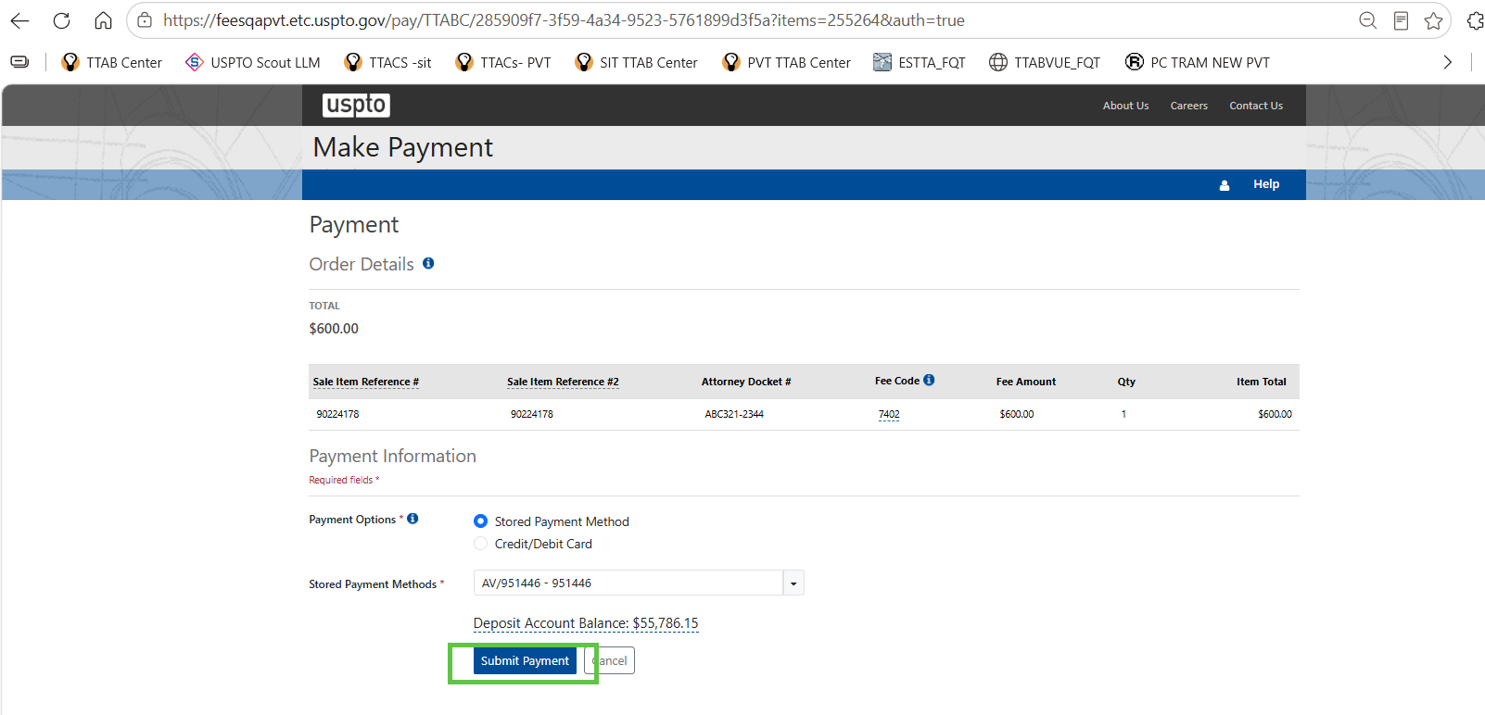

- The next page is a receipt page presented and this concludes your NOO submission.

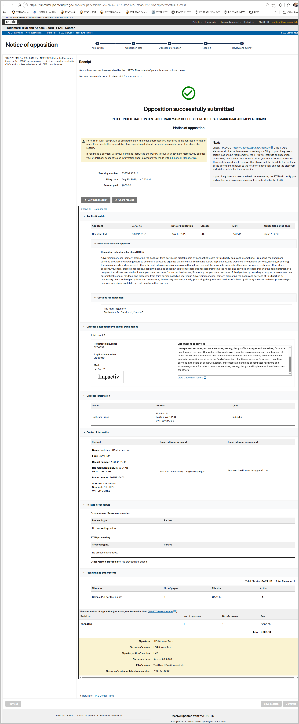

----END OF TEST FOR US ATTORNEY USER---

