Attachment 1 – MEC Examined Response Rates by Varying Incentives
August 2021 – August 2023 NHANES

Figure 1.
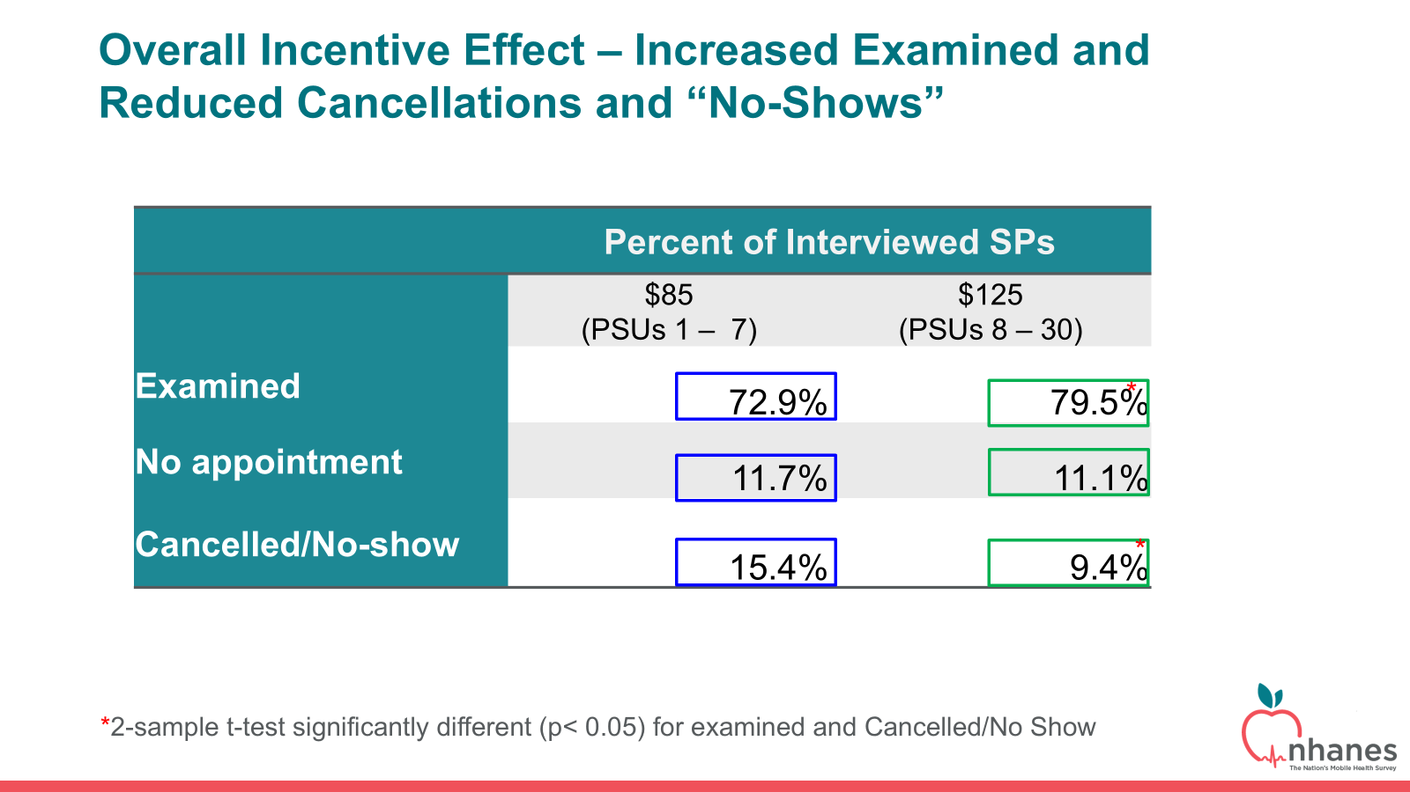

Figure 2.
