Date: M/Y
Dear Building Representative:
RTI International, a nonprofit research organization, is conducting a new national research survey, on behalf of the U.S. Bureau of Labor Statistics (BLS).

We would appreciate your help! A small number of households within this building have been chosen at random to potentially participate in this survey. We are requesting your assistance to access the building/complex so that we can make contact with only those specific households.

We understand your responsibility to protect the residents of this building and want to provide some important information about the survey:
- We are not selling anything. This is not a marketing survey.
- A limited number of household addresses across the United States were randomly chosen to take part in this survey.
- The selected households should have already received a letter from the BLS that explains the survey and indicates that an RTI interviewer will be visiting their address.
- RTI interviewers are well-trained professionals and have signed legally binding pledges of confidentiality.

- The RTI interviewer only needs a few minutes of the resident’s time to determine whether anyone in the household is eligible to participate in an interview.
- Participation in the survey is voluntary.
- The RTI interviewer should already have shown you their personal identification badge (an example is shown below). If not, please ask to see it.
Feel free to ask the interviewer any questions you have about the survey, or you may contact an RTI supervisor in your area, [FS FIRST & LAST NAME] at [FS PHONE].
Your assistance is extremely important to the success of this study, and we thank you in advance for your help.

Interviewer badge example:
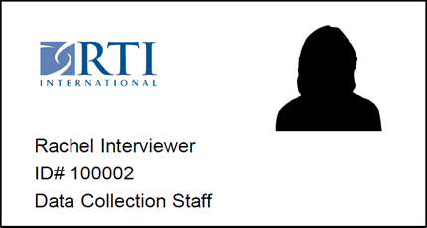
Sincerely,
Keenan Dworak-Fisher
Director, National Longitudinal Surveys
Bureau of Labor Statistics

