Partnering Activities: Part I Partnering List

The Paperwork Reduction Act Statement: Public reporting burden for this form is estimated to average 1 hour (See Supporting Statement) per response. The burden estimate includes the time for reviewing instructions, searching existing data sources, gathering and maintaining the data needed, and completing and submitting the form. This collection of information is voluntary. You are not required to respond to this collection of information unless it displays a valid OMB control number. Please send comments regarding the burden estimate or any other aspect of this collection of information to U.S. Department of Labor, Chief Evaluation Office, 200 Constitution Ave NW, Washington, DC 20210 or ChiefEvaluationOffice@dol.gov, and reference OMB control number 1290-0NEW. NOTE: Please do not send your completed partnering list to this address.

Instructions
The goal of this file is to create a list of organizations/agencies with whom you have worked to serve youth with disabilities who are eligible for Workforce Innovation Opportunity Act (WIOA) services, including youth who are justice-involved, homeless, and/or foster-care involved.
The definition of a partner is as follows:
A partner provides services and supports to address the individual needs and goals of youth and young adults with disabilities (Y&YAD), ultimately leading to competitive integrated employment.
Please do not include a partner that is ONLY a referral source to [insert name of local Employment Transition Model (ETM) program].
Step 1: Please list up to 15 partners you feel best meet the definition above at the current time to serve the [local program name] population of youth specifically. You can include a partner on this list even if they are not currently serving any [local program name] youth, for example, if you plan to work with them in the future.
Step 2: For each of these partners, please write a brief explanation of why you selected them. What makes them a partner you value?
Step 3: How long has your Local Workforce Development Area (LWDA)/Local Workforce Development Board (LWDB) had a relationship with this partner? Please provide the number of years to the best of your ability.
Step 4: Please indicate how many [local program name] youth are currently being served as of today through each of these partners. Please be sure to include only youth who are supported through the [local program name] program.
Step 5: Place a check in each box to indicate which activities/services are provided by this partner for ANY of the [local program name] participants whom they are serving. If the partner is not currently serving any [local program name] participants, you may use the checkboxes to indicate the services you hope they will be able to provide.
Please return this sheet to:
XX
no later than YY.

Partner Survey Listing Workbook
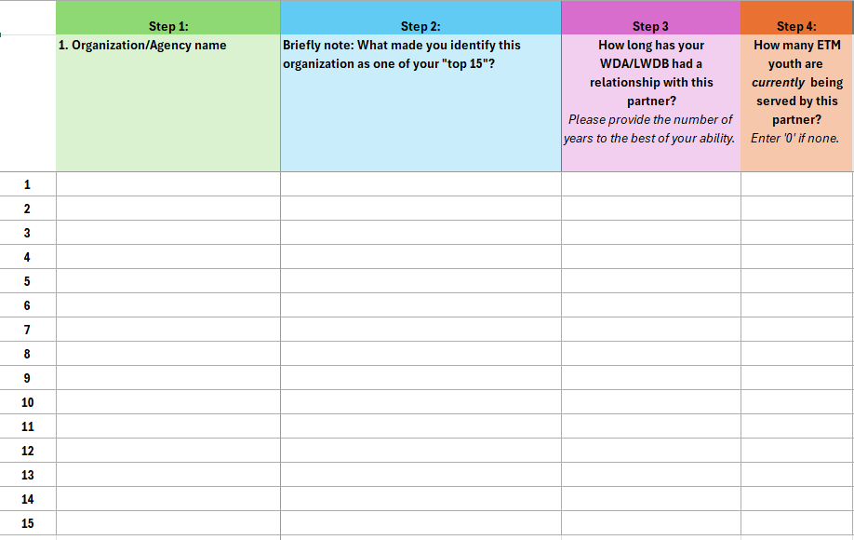
(In workbook, Step 5 continues to the right of Step 4)

