U.S. Department of Education
OFFICE OF POSTSECONDARY EDUCATION
Washington, DC 20202
http://www2.ed.gov/programs/triotalent/index.html

FY 20XX
PROGRAM-SPECIFIC APPLICATION FORMS FOR GRANTS
UNDER THE TALENT SEARCH PROGRAM

CFDA NUMBER: 84.044A

Form Approved OMB No. 1840-0818
Expiration Date: xx/xx/xxxx



DATED MATERIAL – OPEN IMMEDIATELY

CLOSING DATE: TBD

Contact Information
Team Lead: Antoinette Clark Edwards
Address: Talent Search Program
U.S. Department of Education
400 Maryland Avenue, S.W.
Washington, DC 20202
Telephone: (202) 453-7121
E-mail Address: Antoinette.Edwards@ed.gov

TALENT SEARCH PROGRAM PROFILE

Instructions: All applicants must complete this page. The completed page must be attached to the Other Attachments Form in the application package in Grants.gov (as a .pdf document) in the application. DO NOT MODIFY OR AMEND THE CONTENTS OF THIS PAGE.

1. Applicants currently funded under the Talent Search Program (FY 2021-2026) must provide their current grant award number. This can be found in Block 5 of the Grant Award Notification.

New applicants should leave this item blank.

PR/Award Number (Current Grantees Only): P044A (21) (22) (23)____ ____ ____

Application designated to receive prior experience: Yes___ No ___

Application addresses Competitive Preference Priorities (check all that apply):

___ Competitive Preference Priority 1

___ Competitive Preference Priority 2

2. Institution/Agency/Organization/School (Legal Name): ___________________________________________________ __

3. All applicants must indicate the address where this project will be physically located.

Project Address: ________________________________________________________ __
City, State, Zip Code

4. Multiple applications submitted: No: Yes: How many?

5. List the target schools and estimated number of participants to be served at each school:

(1) (8)
(2) (9)
(3) (10)
(4) (11)
(5) (12)
(6) (13)
(7) (14)
Note: The project must be located in a setting accessible to the individuals the project proposes to serve. Add an additional page to list target schools, if needed.

6. Provide the total number of proposed participants to be served each year: ________
(Note: Projects are expected to serve the same number of participants, each year. Two-thirds of the participants served must be low-income, first-generation college students).

7. Program Objectives:
Please fill in the proposed percent for each objective.
Note: These are the same objectives that MUST be stated in Part III -- Project Narrative section of your application when addressing the Objectives and the Evaluation criteria.

A. Secondary School Persistence: ____% of non-senior participants served each project year will complete the current academic year and continue in school for the next academic year, at the next grade level.

B. Secondary School Graduation (regular secondary school diploma): ___% of seniors served during the project year will graduate during the project year with a regular secondary school diploma within the standard number of years.

C. Secondary School Graduation (rigorous secondary school program of study): ___% of seniors served during the project year will complete a rigorous secondary school program of study and will graduate during the project year with a regular secondary school diploma within the standard number of years.

D. Postsecondary Education Enrollment: ___% of participants, who have graduated with a regular secondary school diploma, during the project year, will enroll in an institution of higher education by the fall semester immediately following high school graduation or will have received notification, by the fall semester immediately following high school, from an institution of higher education, of acceptance but deferred enrollment until the next academic semester (e.g., spring semester).

E. Postsecondary Attainment: ___% of participants served during the project year, who enrolled in an institution of higher education, by the fall semester immediately following high school graduation or by the next academic semester (e.g., spring semester) as a result of acceptance but deferred enrollment will complete a program of postsecondary education within six years.

Please note the following definitions:

Graduation in a standard number of years: means the attainment of a regular secondary school diploma at the conclusion of, before the conclusion of, or during the summer immediately following a participant’s fourth year of high school, unless a high school begins after ninth grade, in which case the standard number of years is the number of grades in the school.

Enrolled: a participant who has completed the registration requirements (except for the payment of tuition and fees) at the institution that he or she is attending.

Acceptance but Deferred Enrollment: a participant has received an acceptance letter from the institution that he or she will attend, but cannot enroll in the fall semester immediately following high school graduation for reasons determined by the institution. The institution defers enrollment until the next semester.

Regular Secondary School Diploma: means a level attained by individuals who meet or exceed the coursework and performance standards for high school completion established by the individual’s state.

Rigorous Secondary School Program of Study: means a program of study that is--
(1) Established by a state educational agency (SEA) or local educational agency (LEA) and recognized as a rigorous secondary school program of study by the Secretary through the process described in 34 CFR 691.16(a) through 691.16(c) for the ACG Program; or
(2) An advanced or honors secondary school program established by States and in existence for the 2004-2005 school year or later school years; or
(3) Any secondary school program in which a student successfully completes at a minimum the following courses:
(i) Four years of English.
(ii) Three years of mathematics, including algebra I and a higher-level class such as algebra II, geometry, or data analysis and statistics.
(iii) Three years of science, including one year each of at least two of the following courses: biology, chemistry, and physics.
(iv) Three years of social studies.
(v) One year of a language other than English; or
(4) A secondary school program identified by a State-level partnership that is recognized by the State Scholars Initiative of the Western Interstate Commission for Higher Education (WICHE), Boulder, Colorado; or
(5) Any secondary school program for a student who completes at least two courses from an International Baccalaureate Diploma Program sponsored by the International Baccalaureate Organization, Geneva, Switzerland, and receives a score of a “4” or higher on the examinations for at least two of those courses; or
TS Program Profile continued
(6) Any secondary school program for a student who completes at least two Advanced Placement courses and receives a score of “3” or higher on the College Board’s Advanced Placement Program Exams for at least two of those courses.

Postsecondary Attainment: completion of a program of postsecondary education that has led to a certificate, associate or baccalaureate degree.

Institution of Higher Education: means an educational institution as defined in sections 101 and 102 of the HEA.

Program of Postsecondary Education: a formal instructional program whose curriculum is designed primarily for students who are beyond the compulsory age for high school. This includes programs whose purpose is academic or vocational, and excludes avocational and adult basic education.

A note concerning the Postsecondary Attainment Objective:
Section 402A(f)(3)(A)(vi) of the Higher Education Act, as amended in 2008 by section 403(a)(5) of the Higher Education Opportunity Act, requires the Department to use postsecondary education completion, if practicable, to assess the success of a TS project. To implement this statutory requirement, §643.22(d)(6) of the TS program regulations states that an “applicant may determine success in meeting the objective by using a randomly selected sample of participants in accordance with the parameters established by the Secretary in the Federal Register notice
inviting applications or other published application materials for the competition.”

The following guidelines provide the required parameters for establishing a random sample of participants. Applicants should consider these parameters as they establish performance targets for the postsecondary completion standardized objective and as they develop participant tracking systems for that objective. Note that the purpose of §643.22(d)(6) is to reduce, not increase, the burden on grantees. A grantee must follow the sampling guidelines discussed below or a grantee may choose to track all participants that complete secondary schools and enroll in postsecondary education.

Determining Sample Size

Currently, TS grantees are serving between 600 and 2,000 students. For the FY 20XX competitions, the minimum number of participants to be served will be 500. To help determine the sample size needed to provide reliable data on the postsecondary attainment of project participants, we have used performance report data from existing TS projects. The data has shown us that, typically, 20 percent of Talent Search Participants are considered “college ready,” and out of those 78 percent enroll in postsecondary education. To that end, we are using those statistics to determine the sample size that each TS project should use, based on number of participants served.

The table below breaks down how we are determining the proper sample size for each project. For example, if your project is serving 1400 students, we can assume that 280 of those students are considered “college ready” and out those, 218 will enroll in postsecondary education. So, we determine that our sample size should be 140 students.

Total Participants Served | 20% College Ready | 78% Enrolling in Postsecondary Education | Sample Size (95% Confidence Level)
500 | 100 | 78 | 65
550 | 110 | 86 | 71
600 | 120 | 94 | 76
650 | 130 | 101 | 81
700 | 140 | 109 | 86
750 | 150 | 117 | 90
800 | 160 | 125 | 95
850 | 170 | 133 | 99
900 | 180 | 140 | 103
950 | 190 | 148 | 108
1000 | 200 | 156 | 112
1050 | 210 | 164 | 116
1100 | 220 | 172 | 120
1150 | 230 | 179 | 123
1200 | 240 | 187 | 126
1250 | 250 | 195 | 130
1300 | 260 | 203 | 134
1350 | 270 | 211 | 137
1400 | 280 | 218 | 140
1450 | 290 | 226 | 143
1500 | 300 | 234 | 146
1550 | 310 | 242 | 149
1600 | 320 | 250 | 152
1650 | 330 | 257 | 155
1700 | 340 | 265 | 158
1750 | 350 | 273 | 160
1800 | 360 | 281 | 163
1850 | 370 | 289 | 166
1900 | 380 | 296 | 168
1950 | 390 | 304 | 170
2000 | 400 | 312 | 173

Determining a Random Sample

Once a project has properly determined the sample size, the project needs to establish a process for randomly choosing the participants that make up the sample. As a reminder, we know that if we have a TS project of 1400 students, 218 will enroll in postsecondary education, which will give us a sample size of 140 students. So, we will in turn use the 218 students as the “pool” in which to choose the sample.

When establishing a random sample, each of the 218 students (in this case) has an equal chance of being chosen. We believe the best way to get a proper random sample is described below.
- The list you use to determine your sample size should be in random order. Your list should not be in alphabetical order, in order by gender, race or age.
- Once you have your list of students, you should assign each of them a random number. Please see example below.
ID Number | Last Name | First Name | Race | Gender
001 | Jones | Mary | W | F
002 | Frederick | Jonas | H | M
003 | Henderson | Jacob | AA | M

- Once your list has been established and you have randomly assigned students ID numbers, use a random number generator – for example http://www.randomizer.org/form.htm
As you can see from the screenshot below, the first screenshot shows how the numbers are entered into the form to determine your sample. The most important numbers entered were the numbers per set – which is the number of our sample size, and the number range – which is the total number of students that are enrolled in college.

The second screenshot shows the results (example) of the numbers that were generated.

- These numbers generated determine the students that you will track from your Talent Search project.
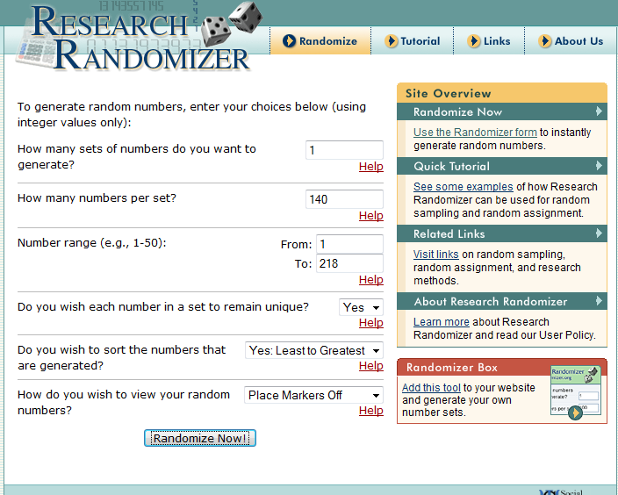

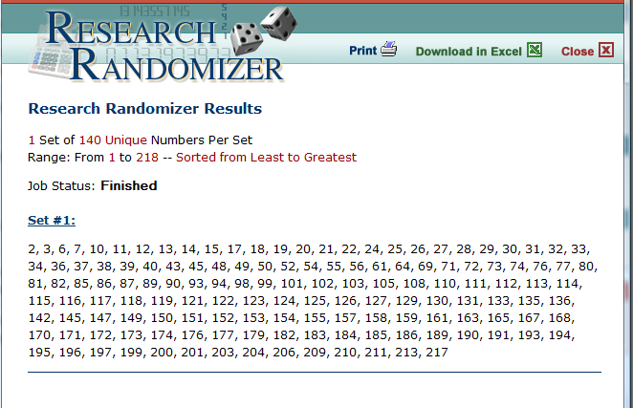

Attach this Profile sheet to the “Other Attachments Form” in the Grants.gov application package.

Attention Applicants: Applicants must copy and paste this page into a separate document, or recreate the page exactly as it appears. Then, complete the page, save it to your computer and attach it to the “Other Attachments Form” as a .pdf document. Do not modify or amend the contents of the form in any way.

TALENT SEARCH PROGRAM ASSURANCES

Attach this Assurance Form to the “Other Attachments Form” in Grants.gov. Applicants must copy and paste this page into a separate document or recreate the page exactly as it appears. Then complete the page, save it to your computer and attach it to the “Other Attachments Form” as a .pdf document. Do not modify or amend the contents of the form in any way.

As the duly authorized representative of the applicant, I certify that the applicant will comply with the following statutory requirements:

- The applicant assures that at least two-thirds (2/3) of the individuals it serves under its proposed Talent Search Program project will be low-income individuals who are potential first-generation college students;

2. The applicant assures that it will collaborate with other Federal TRIO projects, Gaining Early Awareness and Readiness for Undergraduate Programs (GEAR UP) projects, or programs serving similar populations that are serving the same target schools or target area in order to minimize the duplication of services and promote collaboration so that more students can be served.

3. The applicant assures that the project will be located in a setting or settings accessible to the individuals proposed to be served by the project; and

4. The applicant assures that if the applicant is an institution of higher education, it will not use the project as a part of its recruitment program.

___________________________________
Authorized Certifying Official’s Signature Printed Name of Authorized Certifying Official

___________________________________
Title of Authorized Certifying Official Name of Applicant Institution/Organization

___________________
Date Signed

Attach this Assurance Form to the “Other Attachments Form” in the Grants.gov application package.

Attention Applicants: Applicants must copy and paste this page into a separate document, or recreate the page exactly as it appears. Then, complete the page, save it to your computer and attach it to the “Other Attachments Form” as a .pdf document. Do not modify or amend the contents of the form in any way.

In the National Center for Education Statistics – Statistical Standard 5-1-3 – states that the criterion for judging statistical significance will be 0.95 for confidence intervals.

