
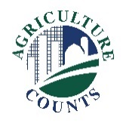
United States Department of Agriculture
National Agricultural Statistics Service

May 14, 2025

Enclosed is your 2026 Agricultural Resource Management Integrated Screening Survey. Your response is important and will help ensure farms in your state are accurately represented. This survey identifies farmers and ranchers in all sectors of U.S. agricultural production. It will help answer questions about the well-being of farm households, farm finances, chemical usage, and farm production characteristics.

The results of this survey will help your state Department of Agriculture, local banks, and input suppliers with decisions that affect you and other producers nationwide. The chart on the next page is an example of how these data can be used to understand farm income.




Please complete this survey at your earliest convenience. If we do not receive your completed questionnaire by June 5, we will contact you to arrange a telephone interview.
What should I do next?
Complete your survey in one of the following ways:
Online at agcounts.usda.gov. Online reporting is fast and secure.
All you need is the survey code on the enclosed form to begin.
By mail or fax. Complete the questionnaire and mail it back
in the prepaid envelope provided or fax it to 855-415-3687.

Your response is confidential by law.
The information you provide will be used for statistical purposes only. Your responses will be combined with others to ensure that no individual operation or producer can be identified, as required by federal law.

Thank you for supporting U.S. agriculture through your participation in our survey program. If you have any questions, please contact us at 888-424-7828. For more information about the 2025 Agricultural Resource Management Survey, visit nass.usda.gov/go/ARMS.

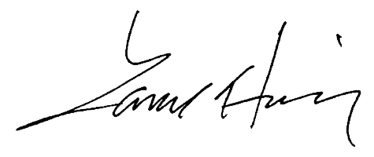
Sincerely,

Lance Honig
Chair, Agricultural Statistics Board
National Agricultural Statistics Service
U.S. Department of Agriculture

Here is an example of data from the Agricultural Resource Management Survey (ARMS) showing Nitrogen application timing on corn and cotton fields:
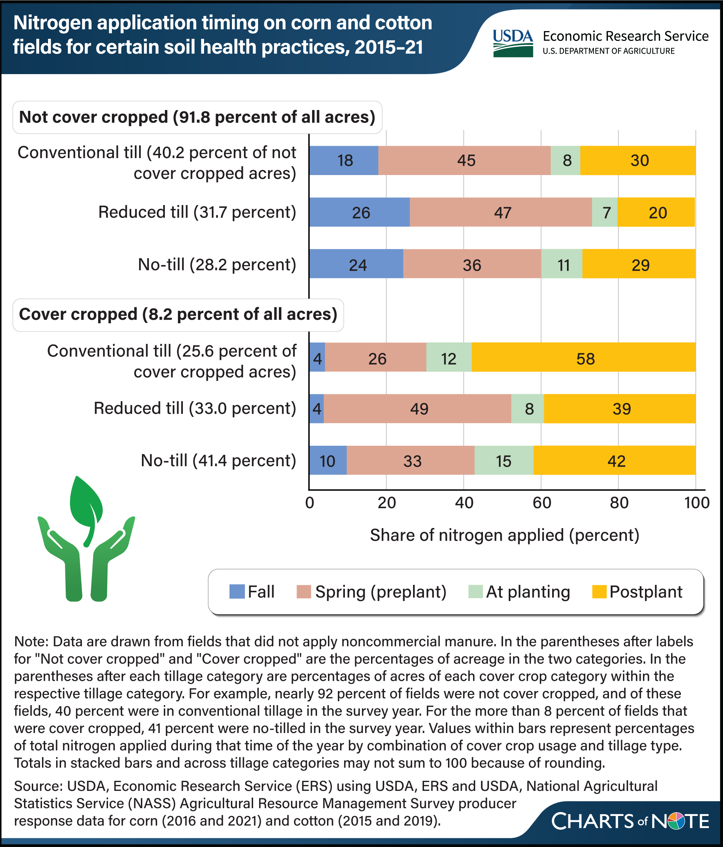
Source: https://www.ers.usda.gov/data-products/charts-of-note/chart-detail?chartId=113055

