National Agricultural Statistics Service National Operations Center
FIRST-CLASS MAIL PRESORTED POSTAGE & FEES PAID USDA
PERMIT NO. G-38
9700 Page Avenue Suite 400
St. Louis, MO. 63132-1547
OFFICIAL BUSINESS
Penalty for Private Use $300

FORWARDING SERVICE REQUESTED

OMB No. 0535-0218 Exp. Date 6/30/2026

Dear Sir/Madam,

You should have recently received your 2026 Agricultural Resource Management Integrated Screening Survey from USDA’s National Agricultural Statistics Service (NASS). Thank you, if you have already responded. If not, there is still time. You are encouraged to respond online at agcounts.usda.gov, by phone or mail.

This survey identifies active farm operations with commodities of interest needed to accurately represent the U.S. farm sector. Your response is very important.

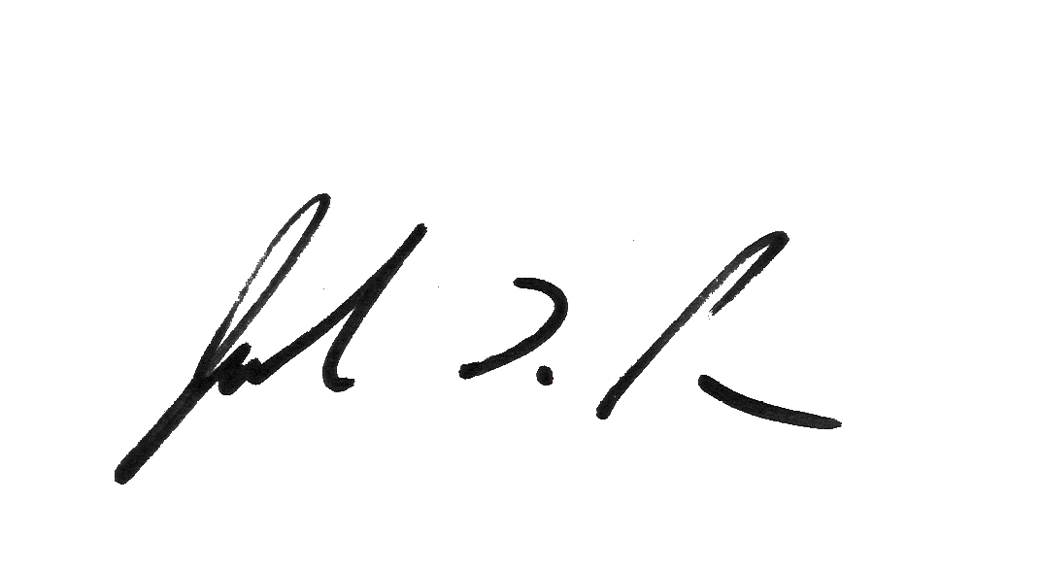
The information you provide will be used for statistical purposes only. In accordance with federal law, your responses will be kept confidential and will not be disclosed in identifiable form. For more information about this survey, visit nass.usda.gov/go/arms. If you have questions or difficulty completing your survey, please call toll-free 888-424-7828.

Sincerely,

Joseph L Parsons
Administrator, National Agricultural Statistics Service

Online reporting is fast and secure. All you need is your survey code to begin.
To complete your survey, follow these steps:

- Go to: agcounts.usda.gov
- Enter your Survey Code:
- Select Submit & Get Survey(s).
- Find the AGRICULTURAL RESOURCE MANAGEMENT SURVEY and select Start Survey.
- Follow the survey prompts.
- Complete the survey through the conclusion section and select Submit Survey.

According to the Paperwork Reduction Act of 1995, an agency may not conduct or sponsor, and a person is not required to respond to a collection of information unless it displays a valid OMB control number. The valid OMB number is 0535-0218. The time required to complete this information collection is estimated to average 15 minutes, including the time for reviewing instructions, searching existing data sources, gathering, and maintaining the data needed, and completing and reviewing the collection of information.

