National Agricultural Statistics Service National Operations Center
FIRST-CLASS MAIL PRESORTED POSTAGE & FEES PAID USDA
PERMIT NO. G-38
9700 Page Avenue Suite 400
St. Louis, MO. 63132-1547
OFFICIAL BUSINESS
Penalty for Private Use $300

FORWARDING SERVICE REQUESTED

OMB No. 0535-0218 Exp. Date 6/30/2026

Dear Producer,

You should have recently received your 2025 Agricultural Resource Management Survey instructions from USDA’s National Agricultural Statistics Service. A representative will call you to set up an interview to assist in the completion of the survey.

The survey asks questions about farm production practices. Please have your fertilizer and pesticide application records available to speed up the survey process. Your participation is important.

The information you provide will be used for statistical purposes only. In accordance with federal law, your responses will be kept confidential and will not be disclosed in identifiable form. For more information about this survey, visit www.nass.usda.gov/go/arms/. If you have questions, please call 888-424-7828.

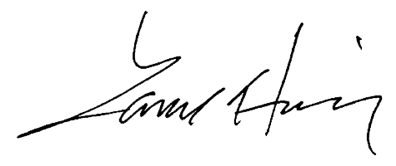
Sincerely,

Lance Honig
Chair, Agricultural Statistics Board
National Agricultural Statistics Service
U.S. Department of Agriculture

To make the interview process faster, it will be helpful to have the following types of records or information available:

- Nutrient and/or fertilizers used
- Biocontrols and/or pesticides used
- Pest management practices
- Machinery and other equipment used
- Commercial chemical company use records, if applicable
For more information about this survey, visit www.nass.usda.gov/go/arms/.

For analysis of the data from this survey, visit ers.usda.gov/arms.

According to the Paperwork Reduction Act of 1995, an agency may not conduct or sponsor, and a person is not required to respond to a collection of information unless it displays a valid OMB control number. The valid OMB number is 0535-0218. The time required to complete this information collection is estimated to average 35-65 minutes, including the time for reviewing instructions, searching existing data sources, gathering, and maintaining the data needed, and completing and reviewing the collection of information.

