OMB Control Number: 0560-0155, OMB Expiration Date: XX/XX/XXXX
Public Burden Statement (Paperwork Reduction Act): According to the Paperwork Reduction Act of 1995, an agency may not conduct or sponsor, and a person is not required to respond to, a collection of information unless it displays a valid OMB control number. The valid OMB control number for this information collection is 0560-0155, and the collection is voluntary. The time required to complete this information collection will vary per response as noted in each section. This includes the time for reviewing instructions, searching existing data sources, gathering and maintaining the data needed, and completing and reviewing the collection of information. Send comments regarding this burden estimate or any other aspect of this collection of information, including suggestions for reducing this burden by emailing to: askusda@usda.gov.

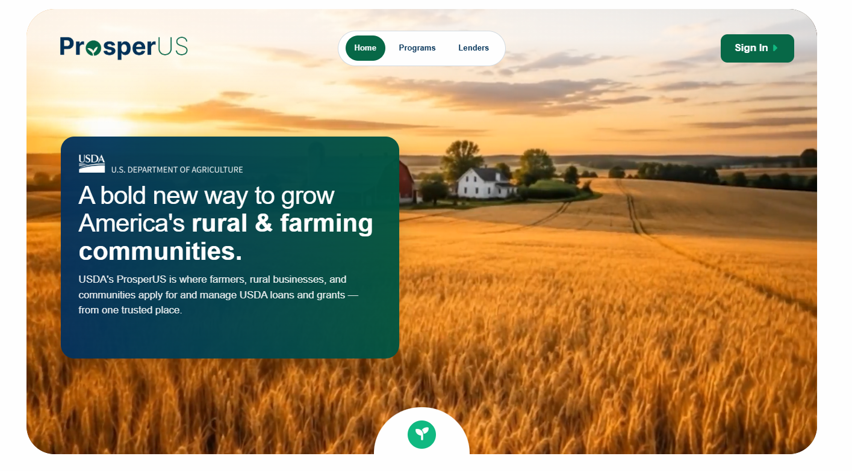

ProsperUS - Guaranteed Loan Making & Servicing
Paperwork Reduction Act Review Package

Prepared: October 1, 2026
Table of Contents
1. List of Acronyms 10
2. ProsperUS - Sign in Page 11
3. Process for Lender Enrollment 12
Lender Enrollment - PRA Burden Statement 12
Lender Enrollment - Landing Page 13
Lender Enrollment - Select Program 14
Lender Enrollment - Organization Search 15
Lender Enrollment - Select Organization 16
4. Digital Process for Completion of FSA-2201, “Lender’s Agreement” 17
Lender’s Agreement - PRA Burden Statement 17
Lender’s Agreement - Introduction 18
Lender’s Agreement - Lender Classification 19
Lender’s Agreement - Organization Information 20
Lender’s Agreement - Regulatory Information 21
Lender’s Agreement - Lending Experience & Capacity 23
Lender’s Agreement - Compliance Information 24
Lender’s Agreement - Office Locations & Servicing Areas 25
Lender’s Agreement - Office Locations & Servicing Areas - Adding Office Locations 26
Lender’s Agreement - Documents 28
Lender’s Agreement - Application Summary 29
5. Digital Process for Completion of FSA-2205, “Guaranteed Micro Lender Application” 30
Micro Lender Application - PRA Burden Statement 30
Micro Lender Application - Introduction 31
Micro Lender Application - Lender Classification 32
Micro Lender Application - Organization Information 33
Micro Lender Application - Regulatory Information 34
Micro Lender Application - Lending Experience & Capacity 36
Micro Lender Application - Capital & Financial Strength 37
Micro Lender Application - Staff Details 39
Micro Lender Application - Compliance Information 40
Micro Lender Application - Office Locations & Servicing Areas 41
Micro Lender Application - Office Locations & Servicing Areas - Adding Office Locations 42
Micro Lender Application - Documents 44
Micro Lender Application - Application Summary 45
6. Digital Process for PLP Credit Management System (CMS) Development 46
PLP CMS Development - PRA Burden Statement 46
PLP CMS Development - Credit Management System (CMS) Overview 47
PLP CMS Development - Credit Administration & Oversight 48
PLP CMS Development - Credit Policy & Underwriting 55
PLP CMS Development - Loan Servicing & Monitoring 68
PLP CMS Development - Documents 73
7. Digital Process for Completion of FSA-2211, “Application for Guarantee” (PLP Delegated Authority) 74
PLP Application Submission - PRA Burden Statement 74
PLP Application Submission - Lender Information 75
PLP Application Submission - About the Request 76
PLP Application Submission - Applicant Parties 77
PLP Application Submission - Applicant Details 78
PLP Application Submission - About the Farm Operation 79
PLP Application Submission - Loan Summary 81
PLP Application Submission - Add New Loan Request 82
PLP Application Submission - Add Collateral 87
PLP Application Submission - Link Collateral 90
PLP Application Submission - Environmental Review 93
PLP Application Submission - Financial Review 93
PLP Application Submission - Documents 99
PLP Application Submission - Signing Preference 100
PLP Application Submission - Lender Disclosure 101
PLP Application Submission - Application Summary 102
8. Digital Process for Completion of FSA-2211, “Application for Guarantee” (Non-PLP) 104
Non-PLP Application Submission - PRA Burden Statement 104
Non-PLP Application Submission - Lender Landing Page 105
Non-PLP Application Submission - Introduction 106
Non-PLP Application Submission - Lender Information 107
Non-PLP Application Submission - About the Request 108
Non-PLP Application Submission - Applicant Parties 109
Non-PLP Application Submission - Assign Collaborators 113
Non-PLP Application Submission - About the Farming Operation 114
Non-PLP Application Submission - Background & Delinquency 115
Non-PLP Application Submission - Request Details 116
Non-PLP Application Submission - Add Collateral 122
Non-PLP Application Submission - Link Collateral 123
Non-PLP Application Submission - Environmental Review 126
Non-PLP Application Submission - Financial Review 127
Non-PLP Application Submission - Documents & Submission 136
Non-PLP Application Submission - Signing Preference 137
Non-PLP Application Submission - Lender Disclosure 139
Non-PLP Application Submission - Application Summary 140
9. Digital Process for Completion of FSA-2232, “Conditional Commitment” 141
Conditional Commitment - PRA Burden Statement 141
Conditional Commitment - USDA Decision Summary 142
Conditional Commitment - Approved Loan Requests 143
Conditional Commitment - Review & E-Sign 146
10. Digital Process for Completion of FSA-2236, “Loan Closing Report & Lender Certification” 147
Loan Closing - PRA Burden Statement 147
Loan Closing - Closing Information 148
Loan Closing - Use of Proceeds 149
Loan Closing - Upload Documents 150
Loan Closing - Guarantee Fee Details 151
Loan Closing - Lender Certification 152
Loan Closing - Closing Summary 153
11. Digital Process for Completion of FSA-2241, “Guaranteed Farm Loan Status Report” 156
Lender Status Report - PRA Burden Statement 156
Lender Status Report - Loan Details 157
12. Digital Process for Completion of FSA-2242, “Assignment of Guarantee” 158
Assignment of Guarantee - PRA Burden Statement 158
Assignment of Guarantee – New Holder and Assignment Details 159
13. Digital Process for Completion of FSA-2248, “Guaranteed Farm Loan Default Status Report” 160
Default Status Report - PRA Burden Statement 160
Default Status Report - Default and Balance Details 161
Default Status Report - Documents 163
14. Digital Process for Completion of FSA-2254, “Guaranteed Loan Report of Loss” 164
Report of Loss - PRA Burden Statement 164
Report of Loss - About the Request 165
Report of Loss - Identifying Information 166
Report of Loss - Loss Code Options 167
Report of Loss - Loan Information 168
Report of Loss - Collateral 169
Report of Loss - Add Collateral 170
Report of Loss - Expenses & Advances 172
Report of Loss - Documents 175
Report of Loss - Summary 176
15. Digital Process for CLP to PLP Status Upgrade 177
CLP to PLP Upgrade - PRA Burden Statement 177
CLP to PLP Upgrade - Programs Landing Page 178
CLP to PLP Upgrade - Introduction 179
CLP to PLP Upgrade - Organization Information 180
CLP to PLP Upgrade - Regulatory Information 182
CLP to PLP Upgrade - Lending Experience & Capacity 185
CLP to PLP Upgrade - Capital & Financial Strength 186
CLP to PLP Upgrade - Compliance Information 189
CLP to PLP Upgrade - Office Operations 190
CLP to PLP Upgrade - Qualified Personnel 194
CLP to PLP Upgrade - Credit Management System (CMS) Overview 198
CLP to PLP Upgrade - Credit Administration & Oversight 199
CLP to PLP Upgrade - Credit Policy & Underwriting 206
CLP to PLP Upgrade - Loan Servicing & Monitoring 217
CLP to PLP Upgrade - Documents 222
CLP to PLP Upgrade - Application Summary 223
16. Digital Process for SEL to CLP Status Upgrade 224
SEL to CLP Upgrade - PRA Burden Statement 224
SEL to CLP Upgrade - Programs Landing Page 225
SEL to CLP Upgrade - Introduction 226
SEL to CLP Upgrade - Organization Information 227
SEL to CLP Upgrade - Regulatory Information 229
SEL to CLP Upgrade - Lending Experience & Capacity 231
SEL to CLP Upgrade - Capital & Financial Strength 232
SEL to CLP Upgrade - Compliance Information 234
SEL to CLP Upgrade - Office Operations 235
SEL to CLP Upgrade - Documents 243
SEL to CLP Upgrade - Application Summary 244
17. Digital Process for PLP Renewal 245
PLP Renewal - PRA Burden Statement 245
PLP Renewal - Programs Landing Page 246
PLP Renewal - Lender Information 247
PLP Renewal - Introduction 248
PLP Renewal - Organizational Information 249
PLP Renewal - Regulatory Information 250
PLP Renewal - Lending Experience & Capacity 256
PLP Renewal - Capital & Financial Strength 258
PLP Renewal - Servicing & Performance 260
PLP Renewal - Compliance Information 261
PLP Renewal - Qualified Personnel 268
PLP Renewal - Credit Management System (CMS) Overview 270
PLP Renewal - Credit Administration & Oversight 271
PLP Renewal - Credit Policy & Underwriting 278
PLP Renewal - Loan Servicing & Monitoring 289
PLP Renewal - Documents 293
PLP Renewal - Application Summary 294
18. Digital Process for CLP Renewal 296
CLP Renewal - PRA Burden Statement 296
CLP Renewal - Programs Landing Page 297
CLP Renewal - Introduction 298
CLP Renewal - Organization Information 299
CLP Renewal - Regulatory Information 300
CLP Renewal - Lending Experience & Capacity 301
CLP Renewal - Capital & Financial Strength 303
CLP Renewal - Servicing & Performance 306
CLP Renewal - Compliance Information 307
CLP Renewal - Office Locations & Service Areas 308
CLP Renewal - Qualified Personnel 312
CLP Renewal - Documents 315
CLP Renewal - Disclosure 316
CLP Renewal - Application Summary 317
19. Digital Process for SEL Renewal 319
SEL Renewal - PRA Burden Statement 319
SEL Renewal - Programs Landing Page 320
SEL Renewal - Introduction 321
SEL Renewal - Organization Information 322
SEL Renewal - Regulatory Information 323
SEL Renewal - Lending Experience & Capacity 324
SEL Renewal - Capital & Financial Strength 326
SEL Renewal - Servicing & Performance 329
SEL Renewal - Compliance Information 330
SEL Renewal - Office Locations & Service Areas 332
SEL Renewal - Qualified Personnel 335
SEL Renewal - Documents 338
SEL Renewal - Disclosure 339
SEL Renewal - Application Summary 340
20. Digital Process for MLP Renewal 341
MLP Renewal - PRA Burden Statement 341
MLP Renewal - Programs Landing Page 342
MLP Renewal - Introduction 343
MLP Renewal - Organization Information 344
MLP Renewal - Regulatory Information 345
MLP Renewal - Lending Experience & Capacity 347
MLP Renewal - Capital & Financial Strength 348
MLP Renewal - Staff Details & Experience 351
MLP Renewal - Compliance Information 352
MLP Renewal - Office Locations & Service Areas 354
MLP Renewal - Qualified Personnel 357
MLP Renewal - Documents 360
MLP Renewal - Disclosure 361
MLP Renewal - Application Summary 362
21. Digital Process for Guaranteed Servicing Requests 363
Servicing - Landing Page 363
Servicing - Request Selection 364
Digital Process for Subordination of Lien 365
Subordination of Lien - PRA Burden Statement 365
Subordination of Lien - Selection 366
Subordination of Lien - Request Details 367
Subordination of Lien - Documents 368
Digital Process for Substitution of Lender 369
Substitution of Lender - PRA Burden Statement 369
Substitution of Lender - Selection 370
Substitution of Lender - Request Details 371
Substitution of Lender - Documents 372
Digital Process for Release of Liability 373
Release of Liability - PRA Burden Statement 373
Release of Liability - Selection 374
Release of Liability - Request Details 375
Release of Liability - Documents 376
Digital Process for Partial Release 377
Partial Release - PRA Burden Statement 377
Partial Release - About the Request 378
Partial Release - Request Details 379
Partial Release - Documents 380
Digital Process for Emergency Advances 381
Emergency Advances - PRA Burden Statement 381
Emergency Advances - Selection 382
Emergency Advances - Request Details 383
Emergency Advances - Documents 384
Digital Process for Protective Advances 385
Protective Advances - PRA Burden Statement 385
Digital Process for Return of Guarantee 386
Return of Guarantee - PRA Burden Statement 386
Return of Guarantee - Selection 387
Return of Guarantee - Request Details 388
Return of Guarantee - Documents 389
Digital Process for Transfer & Assumption - Secondary Market Notification 390
Transfer & Assumption - PRA Burden Statement 390
Digital Process for Lender Request for Restructuring 391
Request for Restructuring - PRA Burden Statement 391
Request for Restructuring - Landing Page 392
Request for Restructuring - About Your Request 393
Request for Restructuring - Writedown - “No” 394
Request for Restructuring - Writedown - “Yes” 395
Request for Restructuring - All Options Considered - “No” 396
Request for Restructuring - Present Value Calculations 397
Request for Restructuring - Net Recovery Value Calculations 398
Request for Restructuring - Documents 399
Request for Restructuring - Lender Final Review - Accept 400
Request for Restructuring - Lender Final Review - Reject 401
Request for Restructuring - Writedown Loss Claim Calculations 402
Request for Restructuring - Writedown Loss Claim Details 403
Request for Restructuring - Writedown Loss Claim Details - Pre-Authorized Debit 404
Request for Restructuring - Writedown Loss Claim Details - Loan Information 405
Request for Restructuring - Writedown Loss Claim Details - Guaranteed Loan Items 406
Request for Restructuring - Documents 412

1. List of Acronyms

PLP – Preferred Lender Program
CLP – Certified Lender Program
SEL – Standard Eligible Lender
MLP – Micro Lender Program
CMS – Credit Management System

2. ProsperUS - Sign in Page

Lender representatives desiring to utilize ProsperUS platform to participate in FSA Farm Loan Programs will be required to verify identity using Login.gov.

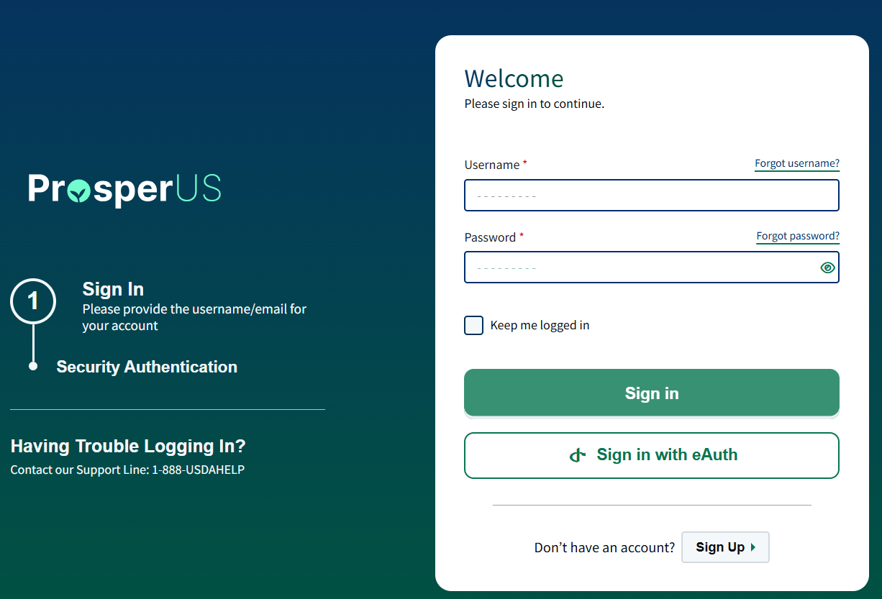

3. Process for Lender Enrollment

Lender Enrollment - PRA Burden Statement

Non-Form Enrollment for ProsperUS

Public Burden Statement (Paperwork Reduction Act):
According to the Paperwork Reduction Act of 1995, an agency may not conduct or sponsor, and a person is not required to respond to, a collection of information unless it displays a valid OMB control number. The valid OMB control number for this information collection is 0563-0155. The time required to complete this collection is estimated to average 1 hour per response, including reviewing instructions, gathering and maintaining the data needed, completing (providing the information), and reviewing the collection of information. Send comments regarding this burden estimate or any other aspect of this collection of information, including suggestions for reducing this burden by emailing to: askusda@usda.gov.

Lender Enrollment - Landing Page

Lender Enrollment - Select Program

Lender Enrollment - Organization Search

Lender Enrollment - Select Organization

4. Digital Process for Completion of FSA-2201, “Lender’s Agreement”

Lender’s Agreement - PRA Burden Statement

Public Burden Statement (Paperwork Reduction Act):
Public reporting burden for this collection is estimated to average 1 hour per response, including reviewing instructions, gathering and maintaining the data needed, completing (providing the information), and reviewing the collection of information. You are not required to respond to the collection, or FSA may not conduct or sponsor a collection of information unless it displays a valid OMB control number of 0560-0155.

Lender’s Agreement - Introduction

Lender’s Agreement - Lender Classification

SEL selection

MLP Selection

Lender’s Agreement - Organization Information

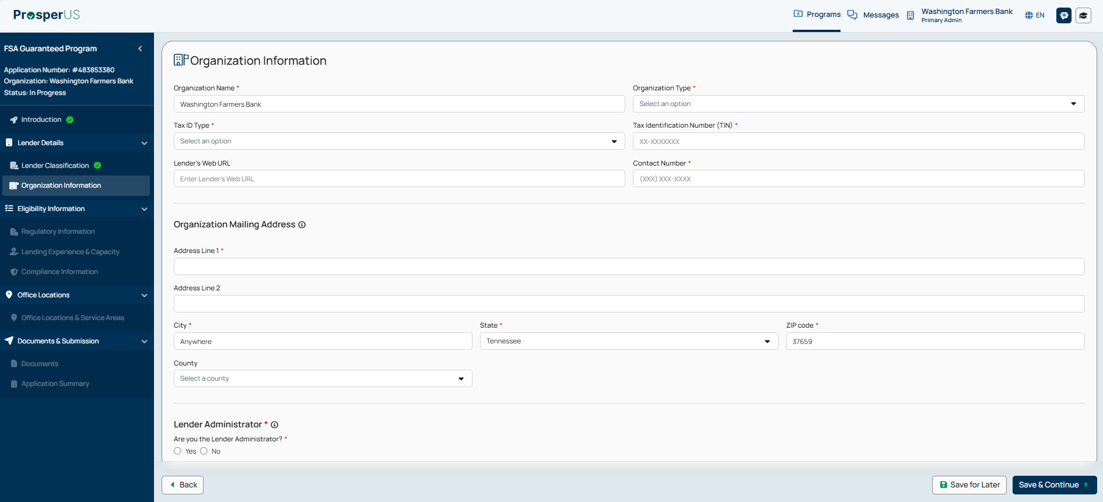

Organization Information (continued)
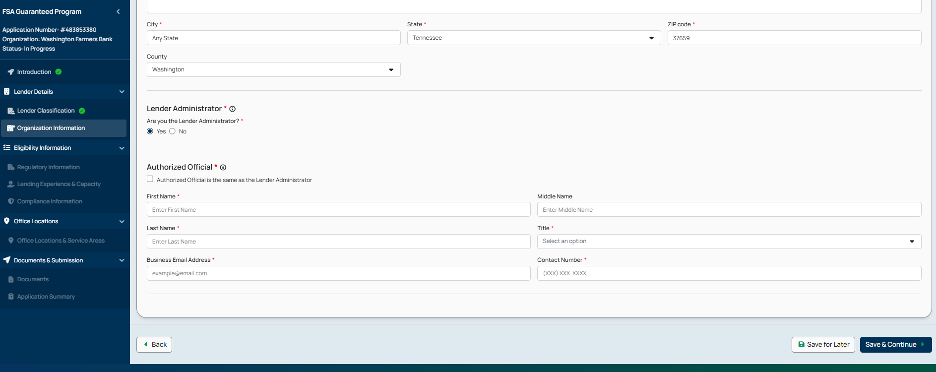

Lender’s Agreement - Regulatory Information

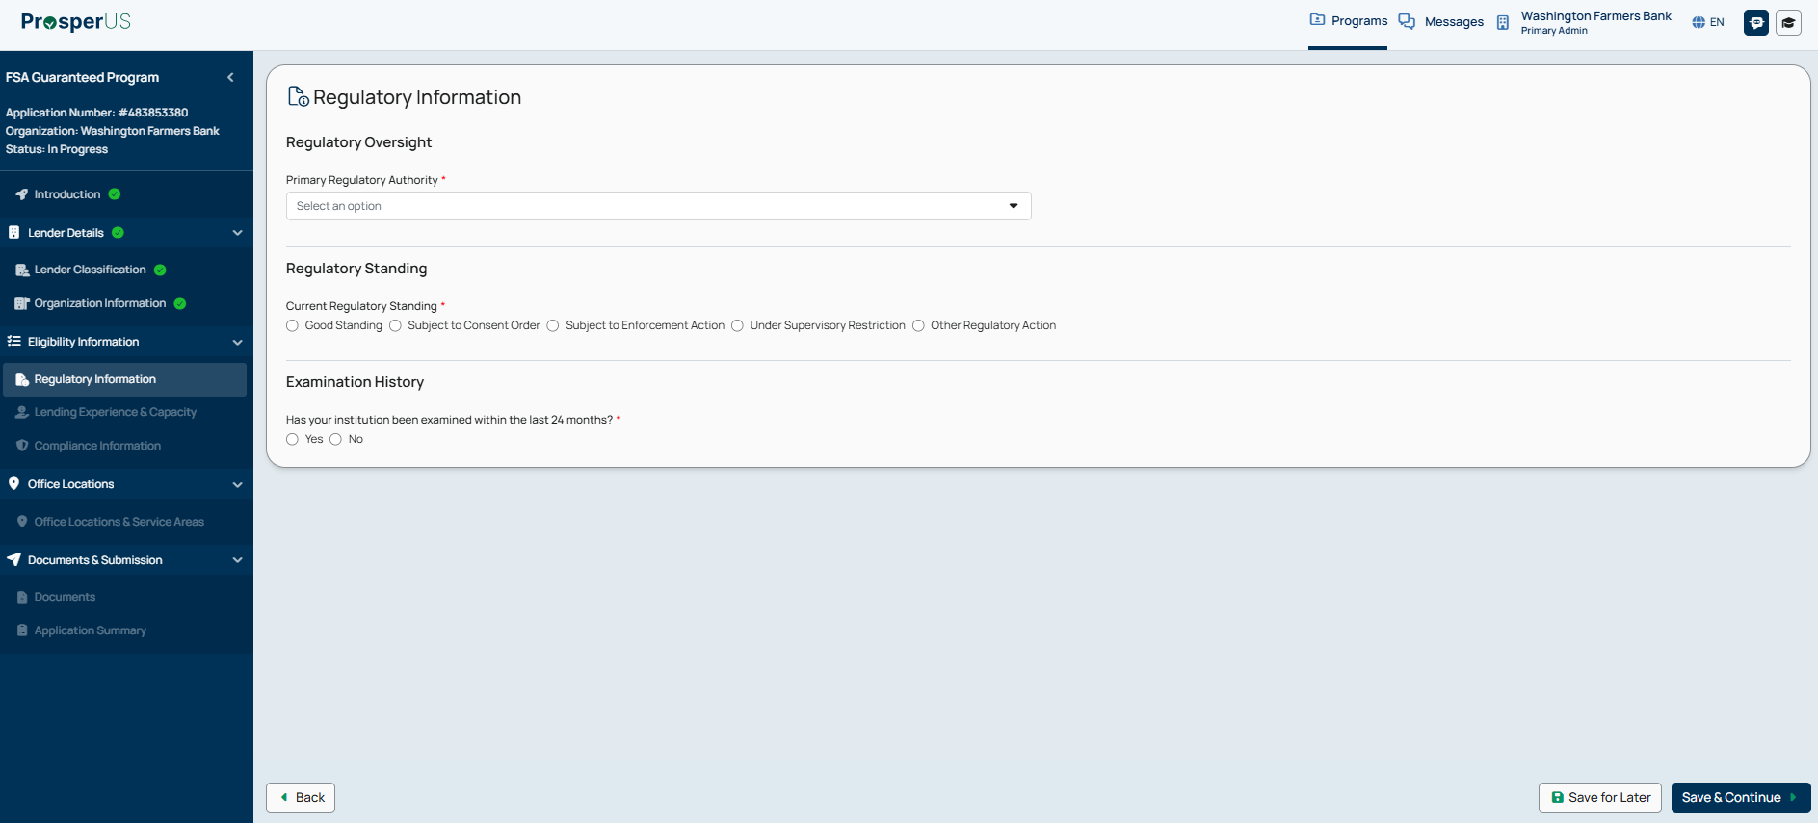

Lender’s Agreement - Regulatory Information - Regulatory Standing - Expanded
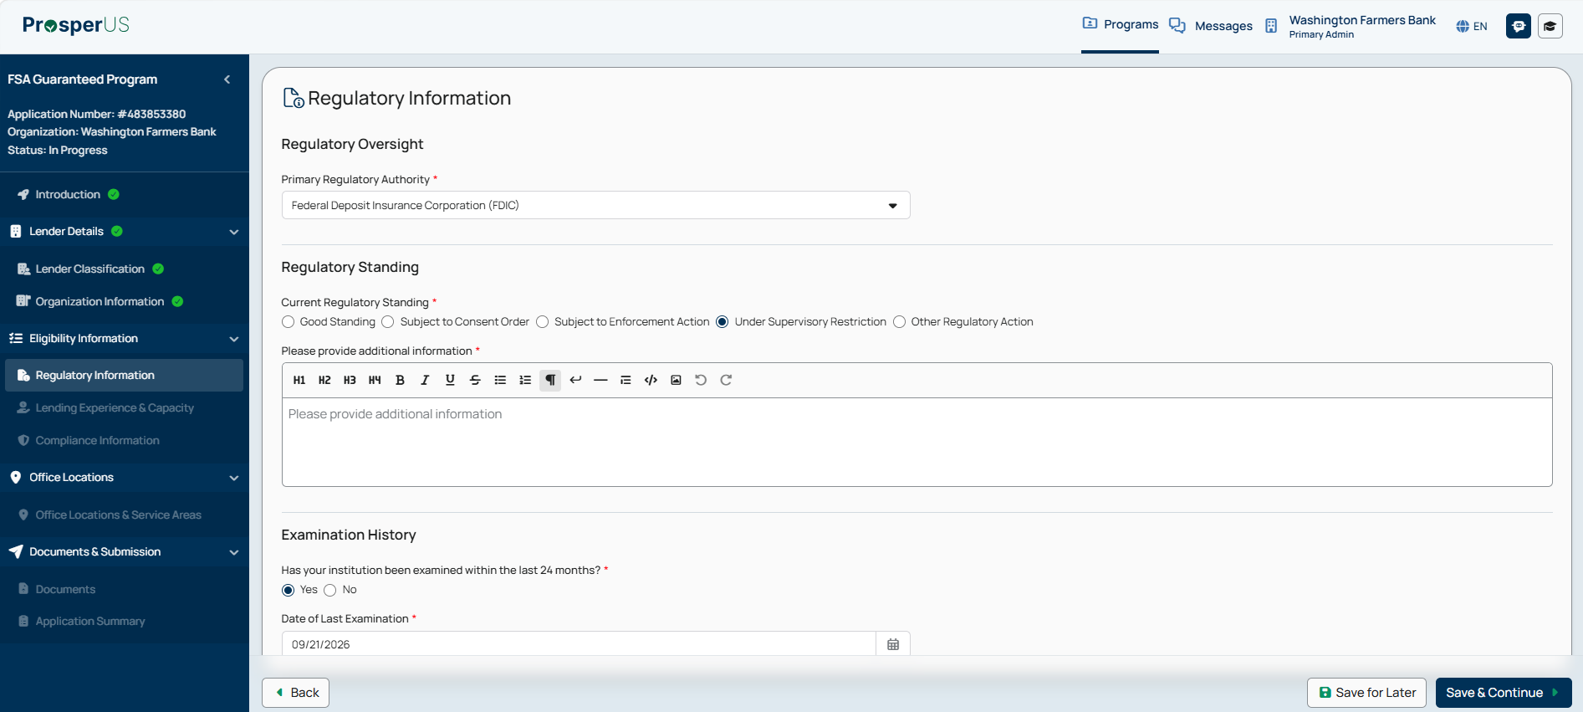

Lender’s Agreement - Regulatory Information – Examination History - Expanded “Yes”

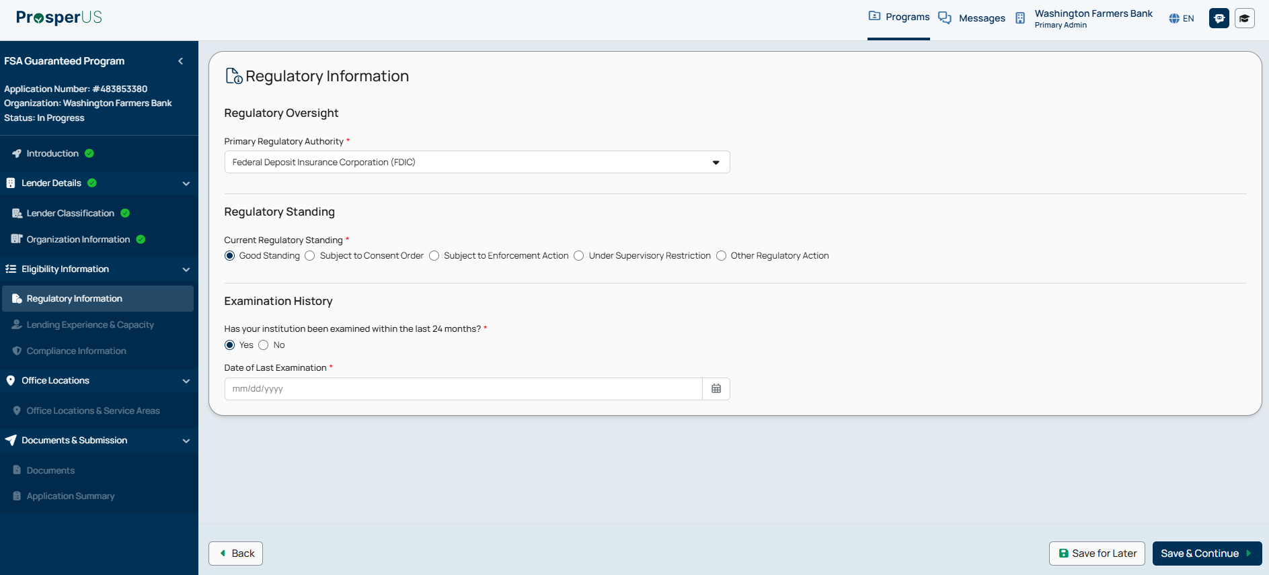

Lender’s Agreement - Regulatory Information – Examination History Expanded “No”
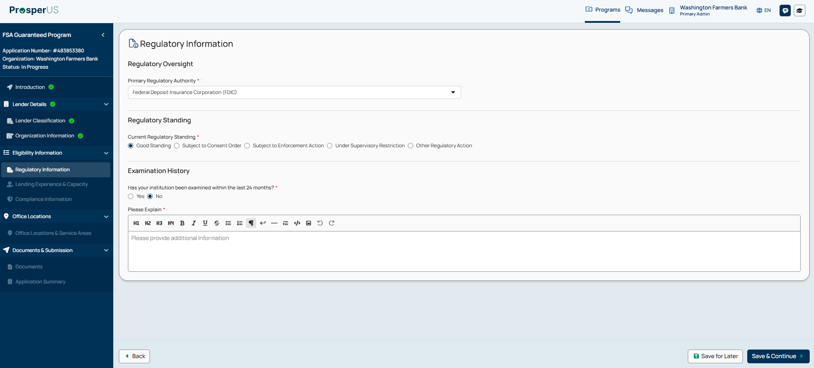

Lender’s Agreement - Lending Experience & Capacity

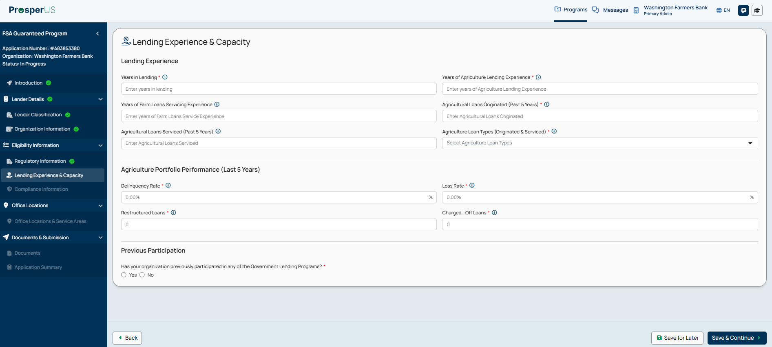

Previous Participation – “Yes” selections – Expanded
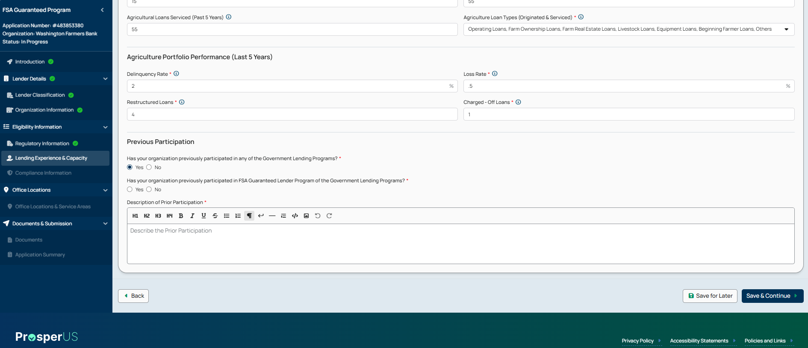

Lender’s Agreement - Compliance Information

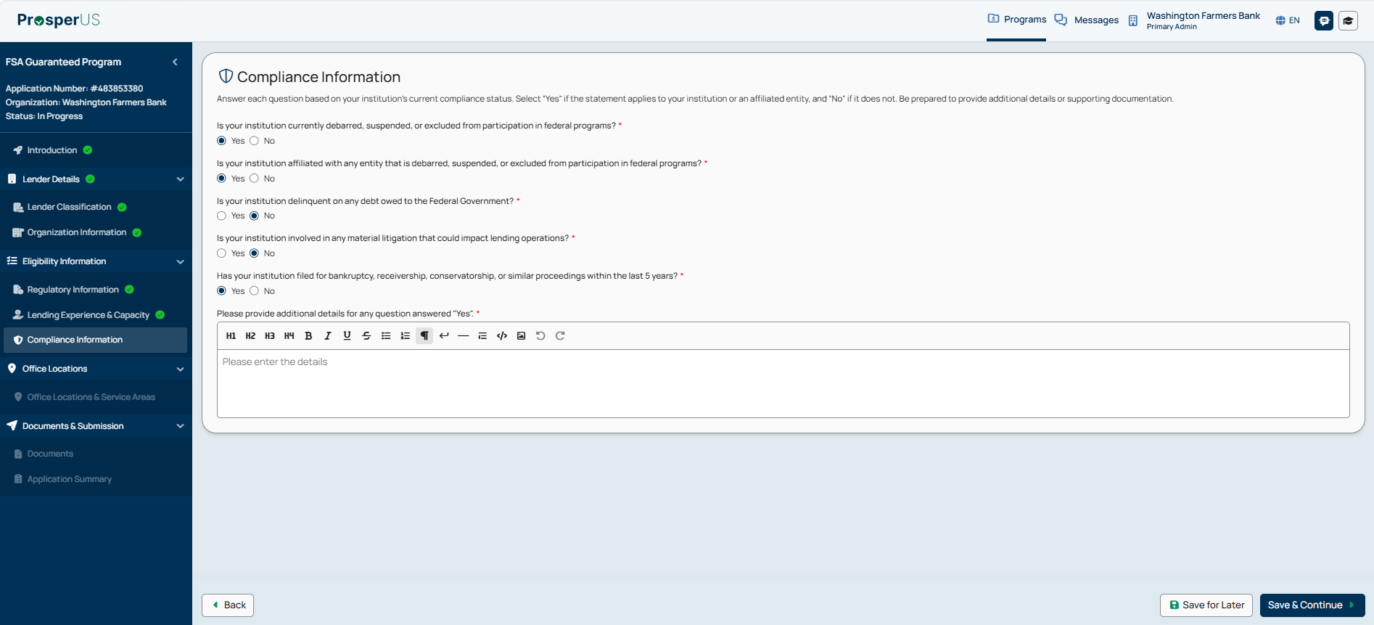

Lender’s Agreement - Office Locations & Servicing Areas

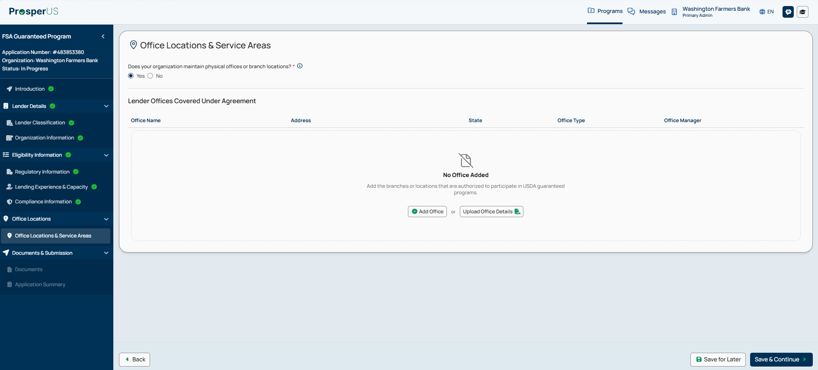

Lender’s Agreement - Office Locations & Servicing Areas - Adding Office Locations

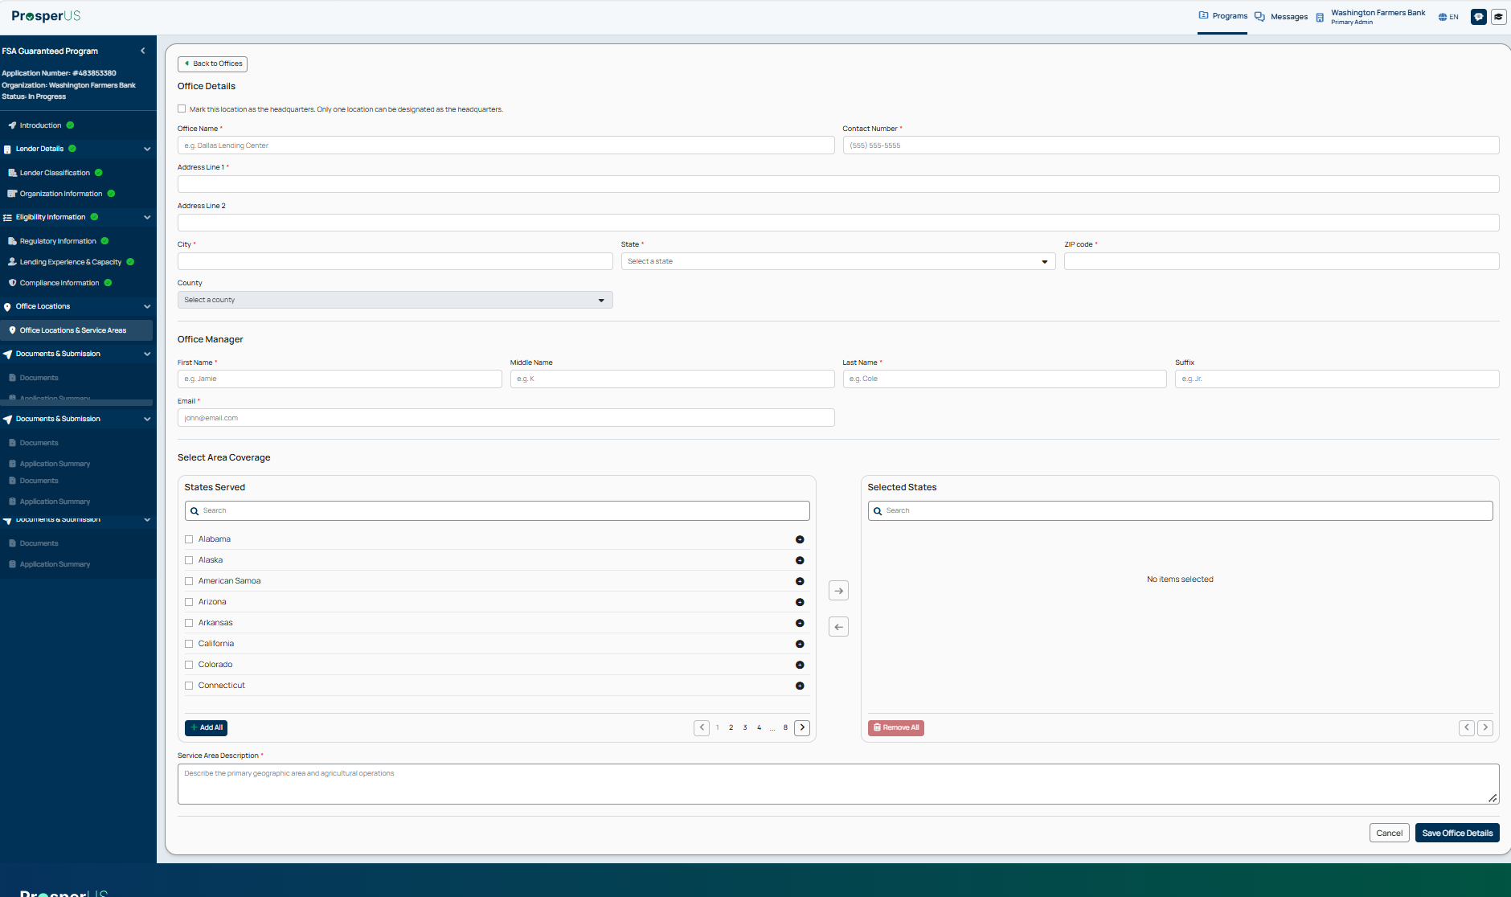

Lender’s Agreement - Office Locations & Servicing Areas – Added Office Locations (continued)

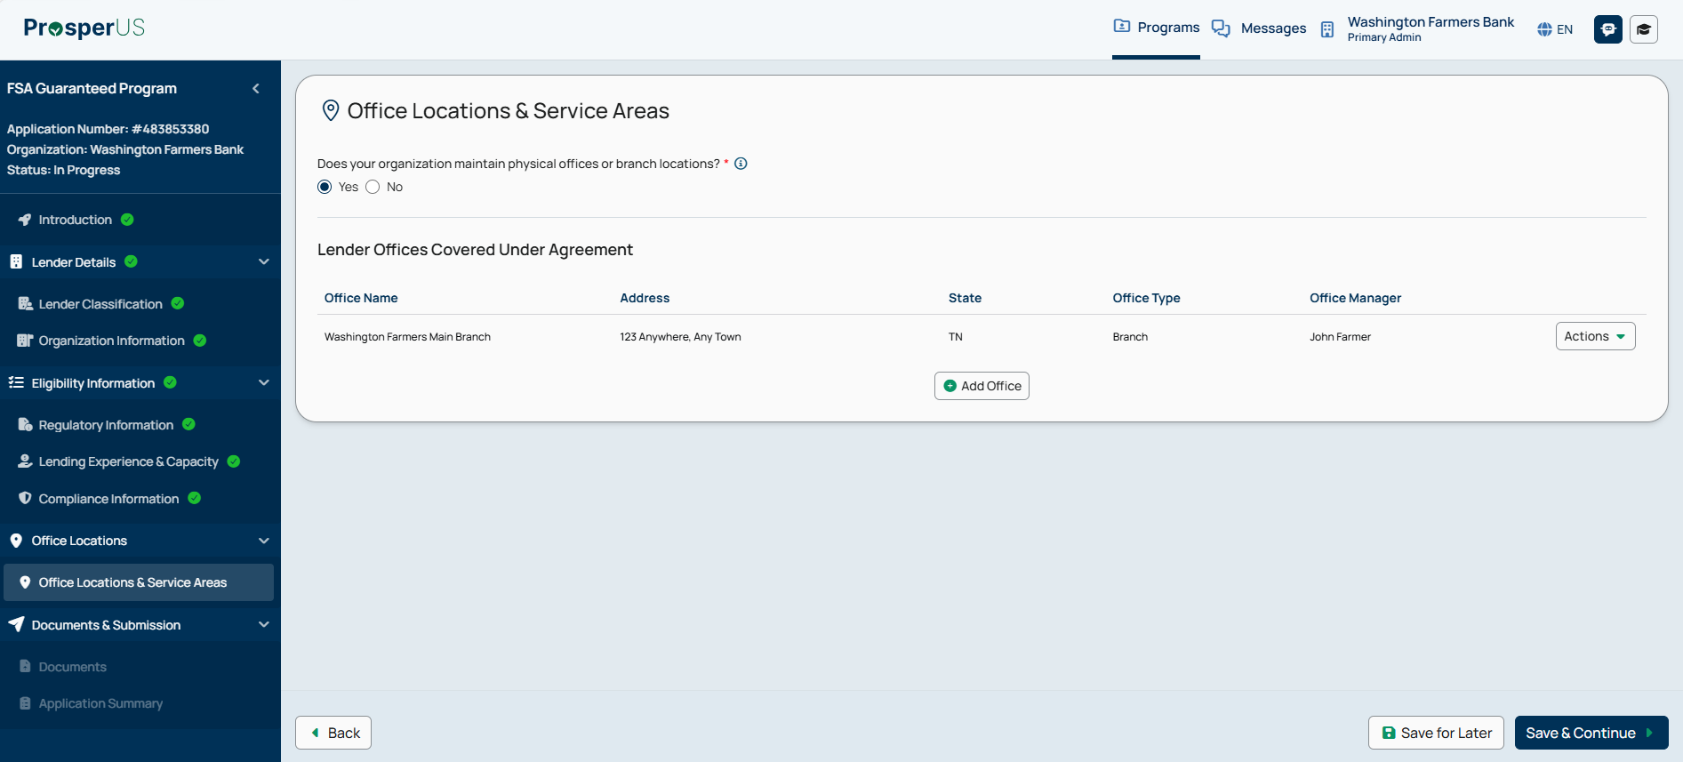

Lender’s Agreement - Documents

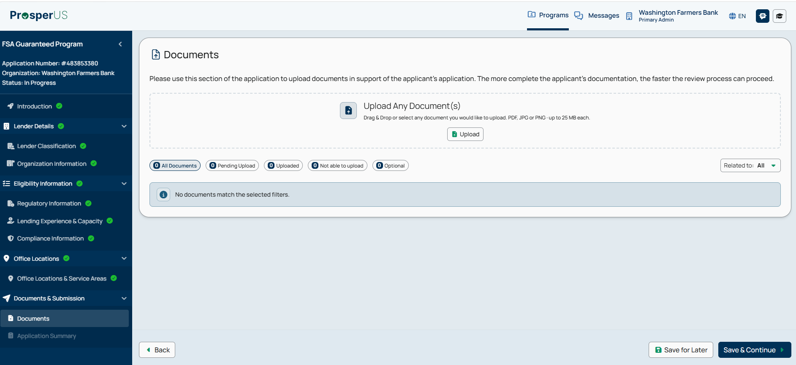

Lender’s Agreement - Application Summary

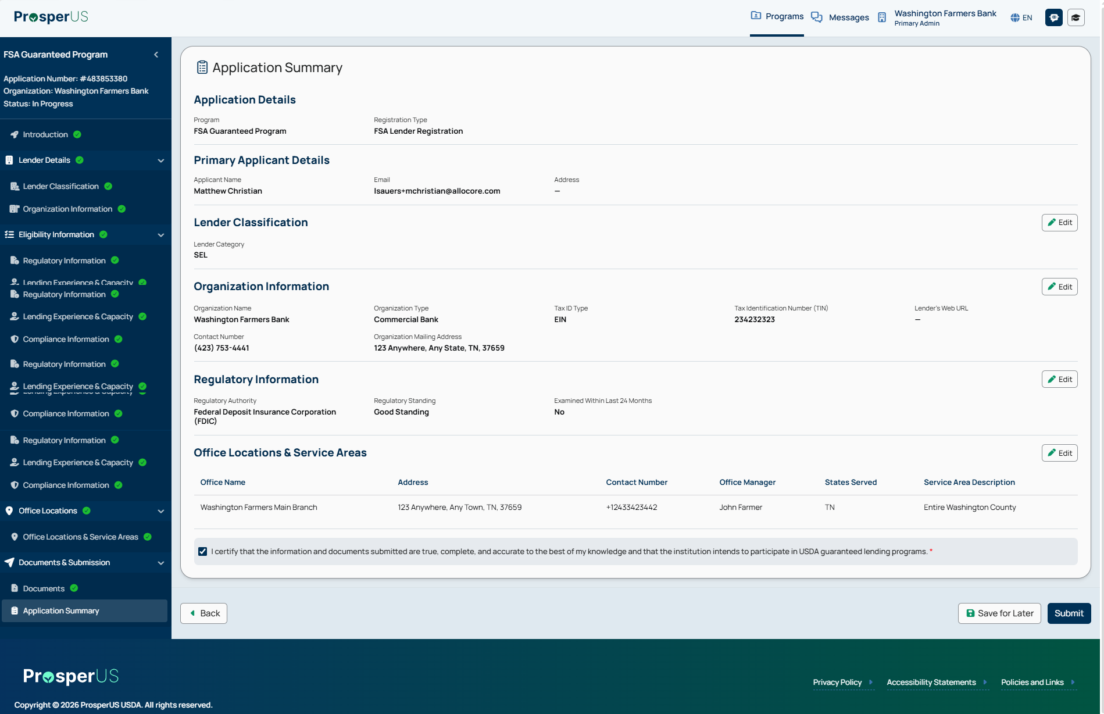

5. Digital Process for Completion of FSA-2205, “Guaranteed Micro Lender Application”

Micro Lender Application - PRA Burden Statement

Public Burden Statement (Paperwork Reduction Act):
Public reporting burden for this collection is estimated to average 1 hour per response, including reviewing instructions, gathering and maintaining the data needed, completing (providing the information), and reviewing the collection of information. You are not required to respond to the collection, or FSA may not conduct or sponsor a collection of information unless it displays a valid OMB control number of 0560-0155.

Micro Lender Application - Introduction

Micro Lender Application - Lender Classification

MLP Selection

Micro Lender Application - Organization Information

Micro Lender Application - Organization Information (continued)

Micro Lender Application - Regulatory Information

Micro Lender Application - Regulatory Information - Regulatory Standing - Expanded

Micro Lender Application - Regulatory Information – Examination History - Expanded “Yes”

Micro Lender Application - Regulatory Information – Examination History Expanded “No”

Micro Lender Application - Lending Experience & Capacity

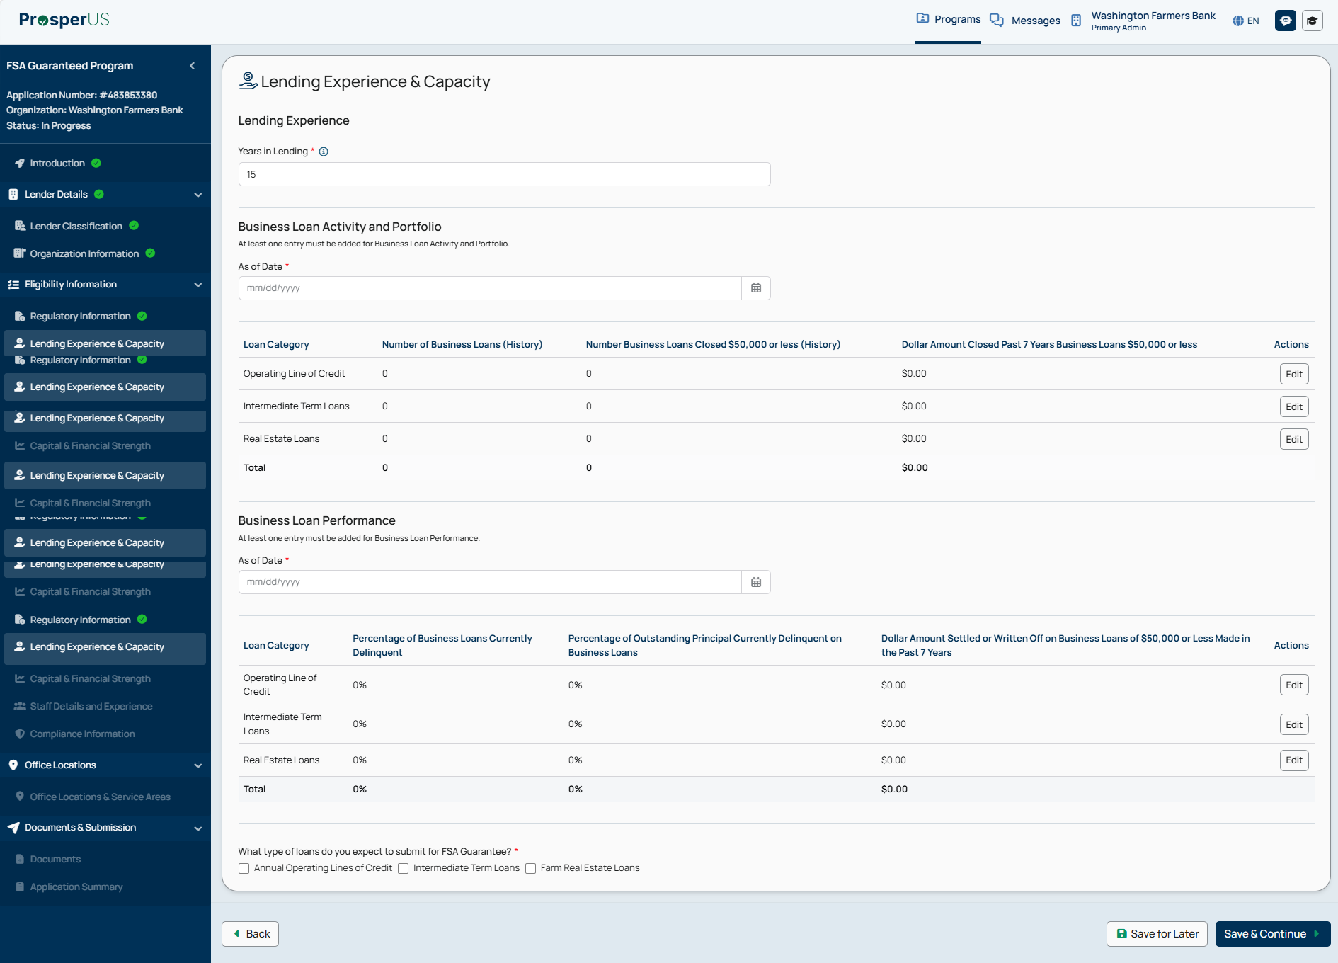

Micro Lender Application - Capital & Financial Strength

Micro Lender Application - Capital & Financial Strength (continued)

Micro Lender Application - Staff Details

Micro Lender Application - Compliance Information

Micro Lender Application - Office Locations & Servicing Areas

Micro Lender Application - Office Locations & Servicing Areas - Adding Office Locations

Micro Lender Application - Office Locations & Servicing Areas – Added Office Locations (continued)

Micro Lender Application - Documents

Micro Lender Application - Application Summary

6. Digital Process for PLP Credit Management System (CMS) Development

PLP CMS Development - PRA Burden Statement

Non-form

Public Burden Statement (Paperwork Reduction Act):
Public reporting burden for this collection is estimated to average 5 hours per response, including reviewing instructions, gathering and maintaining the data needed, completing (providing the information), and reviewing the collection of information. You are not required to respond to the collection, or FSA may not conduct or sponsor a collection of information unless it displays a valid OMB control number of 0560-0155.

PLP CMS Development - Credit Management System (CMS) Overview

PLP CMS Development - Credit Administration & Oversight

PLP CMS Development - Credit Administration & Oversight (continued)

PLP CMS Development - Credit Administration & Oversight (continued)

PLP CMS Development - Credit Administration & Oversight (continued)

PLP CMS Development - Credit Administration & Oversight (continued)

PLP CMS Development - Credit Administration & Oversight (continued)

PLP CMS Development - Credit Administration & Oversight (continued)

PLP CMS Development - Credit Policy & Underwriting

PLP CMS Development - Credit Policy & Underwriting (continued)

PLP CMS Development - Credit Policy & Underwriting (continued)

PLP CMS Development - Credit Policy & Underwriting (continued)

PLP CMS Development - Credit Policy & Underwriting (continued)

PLP CMS Development - Credit Policy & Underwriting (continued)

PLP CMS Development - Credit Policy & Underwriting (continued)

PLP CMS Development - Credit Policy & Underwriting (continued)

PLP CMS Development - Credit Policy & Underwriting (continued)

PLP CMS Development - Credit Policy & Underwriting (continued)

PLP CMS Development - Credit Policy & Underwriting (continued)

PLP CMS Development - Loan Servicing & Monitoring

PLP CMS Development - Loan Servicing & Monitoring (continued)

PLP CMS Development - Loan Servicing & Monitoring (continued)

PLP CMS Development - Loan Servicing & Monitoring (continued)

PLP CMS Development - Loan Servicing & Monitoring (continued)

PLP CMS Development - Documents

7. Digital Process for Completion of FSA-2211, “Application for Guarantee” (PLP Delegated Authority)

PLP Application Submission - PRA Burden Statement

Public Burden Statement (Paperwork Reduction Act):
Public reporting burden for this collection is estimated to average 1 hour per response, including reviewing instructions, gathering and maintaining the data needed, completing (providing the information), and reviewing the collection of information. You are not required to respond to the collection, or FSA may not conduct or sponsor a collection of information unless it displays a valid OMB control number of 0560-0155.

PLP Application Submission - Lender Information

PLP Application Submission - About the Request

PLP Application Submission - Applicant Parties

PLP Application Submission - Applicant Details

PLP Application Submission - Applicant Details (continued)

PLP Application Submission - About the Farm Operation

PLP Application Submission - About the Farm Operation (continued)

PLP Application Submission - Loan Summary

PLP Application Submission - Add New Loan Request

PLP Application Submission - Add New Loan Request (continued)

PLP Application Submission - Add New Loan Request (continued)

PLP Application Submission - Add New Loan Request (continued)

PLP Application Submission - Add New Loan Request (continued)

PLP Application Submission - Add Collateral

PLP Application Submission - Add Collateral (continued)

PLP Application Submission - Add Collateral (continued)

PLP Application Submission - Link Collateral

PLP Application Submission - Link Collateral (continued)

PLP Application Submission - Environmental Review

PLP Application Submission - Financial Review

PLP Application Submission - Financial Review (continued)

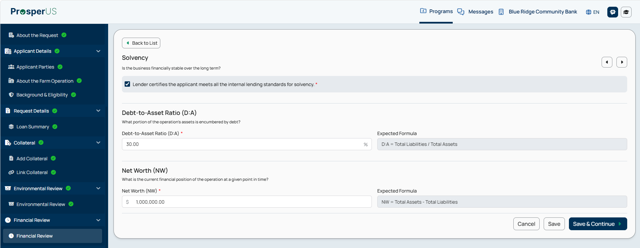

PLP Application Submission - Financial Review (continued)
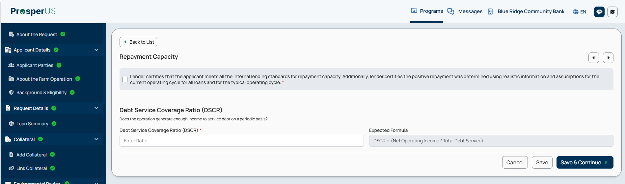
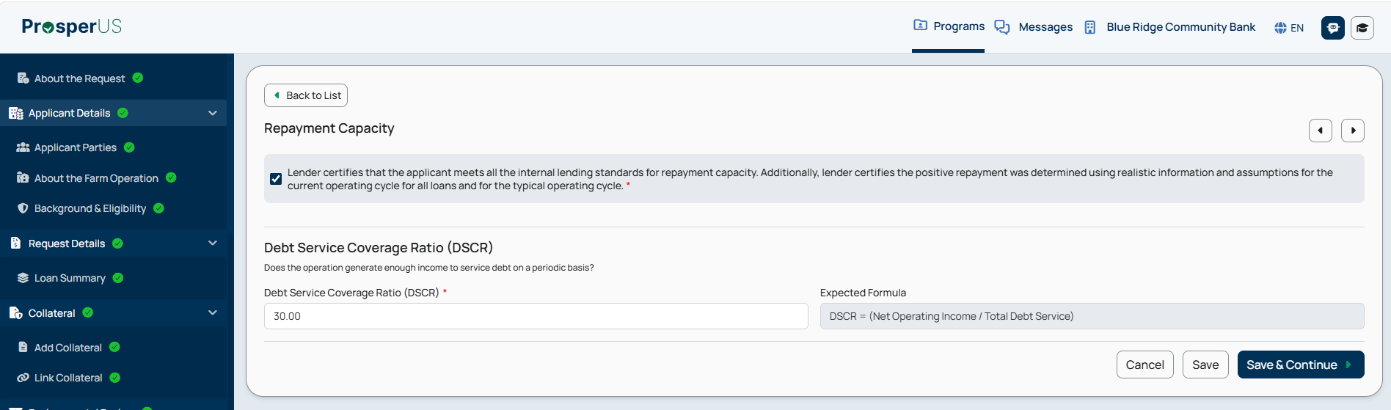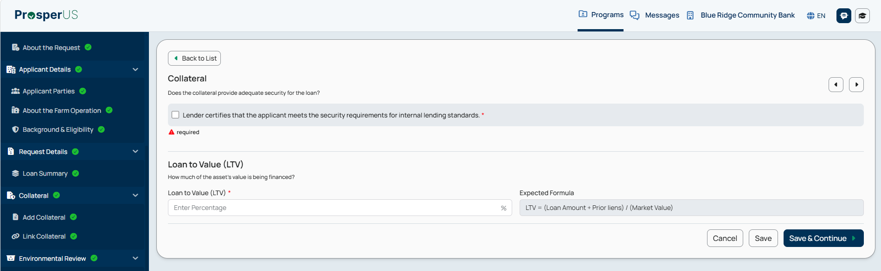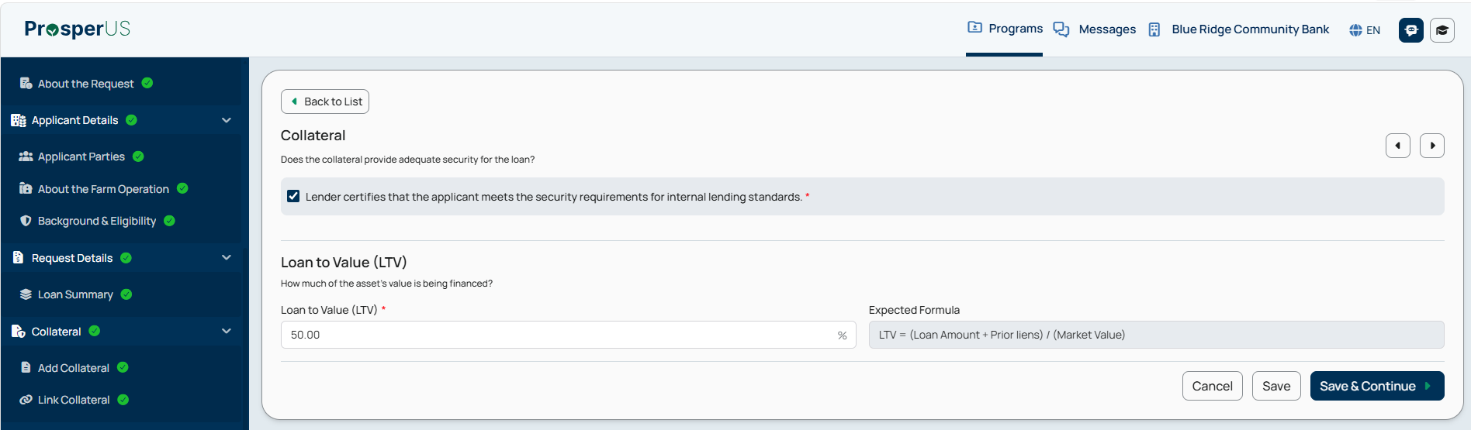

PLP Application Submission - Financial Review (continued)

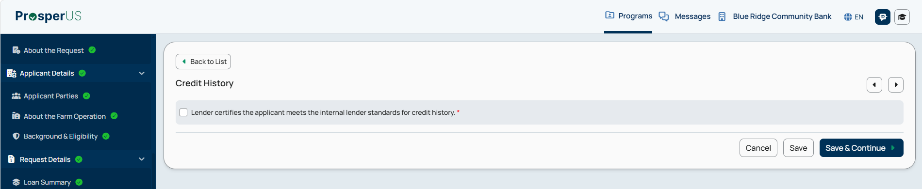
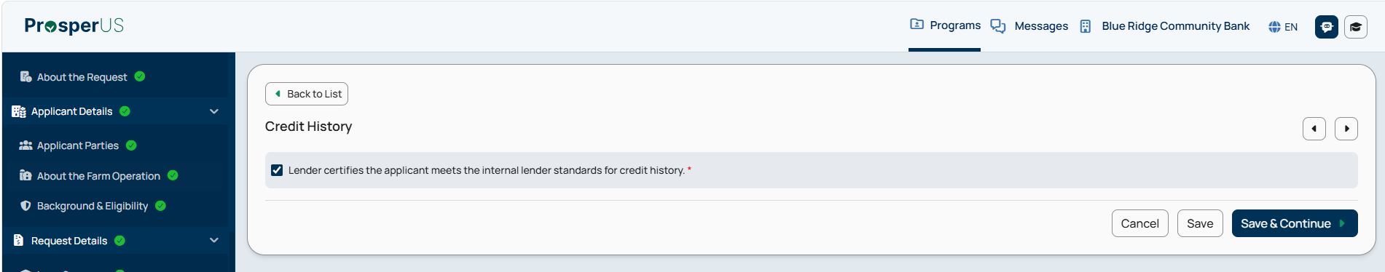
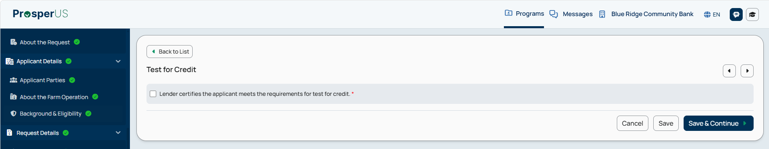
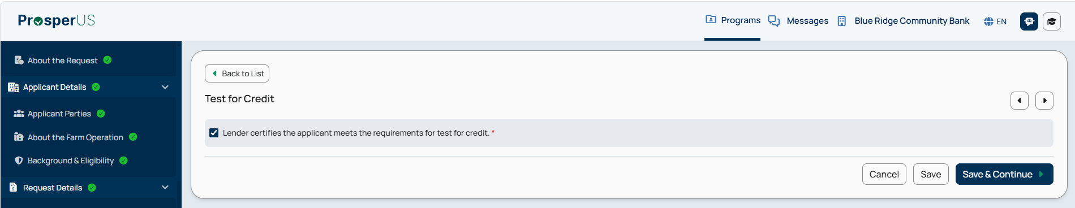

PLP Application Submission - Financial Review (continued)

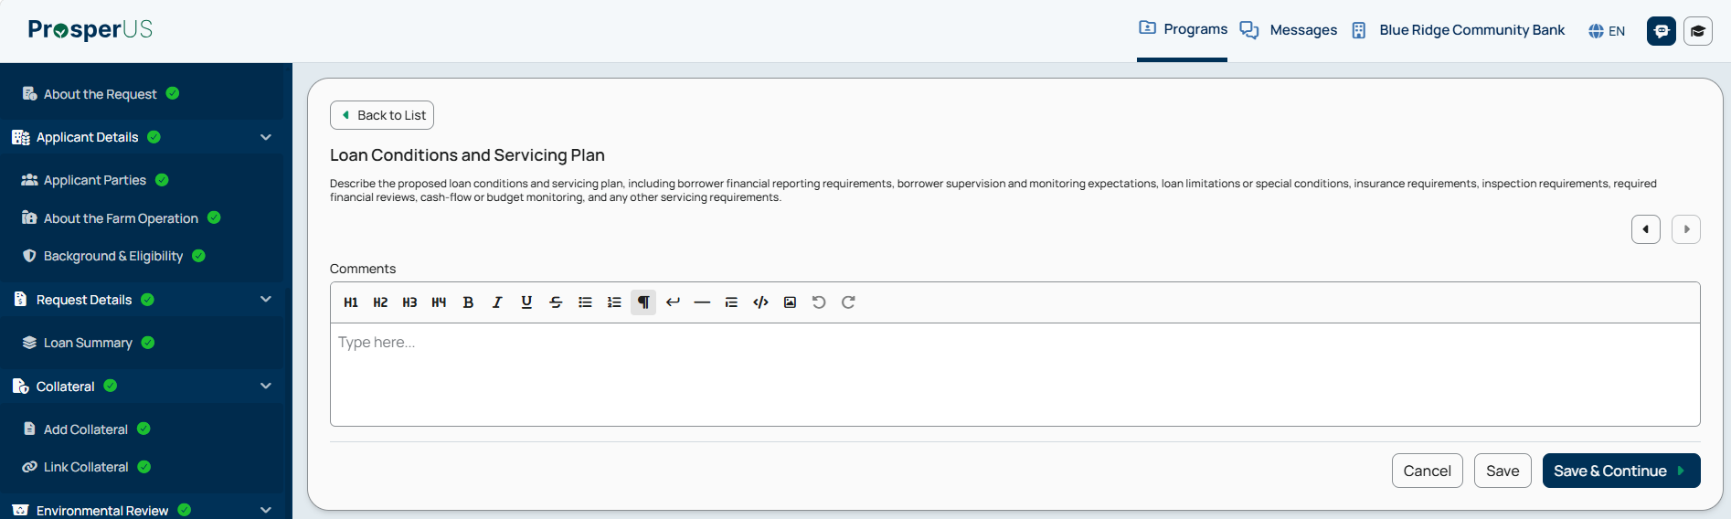
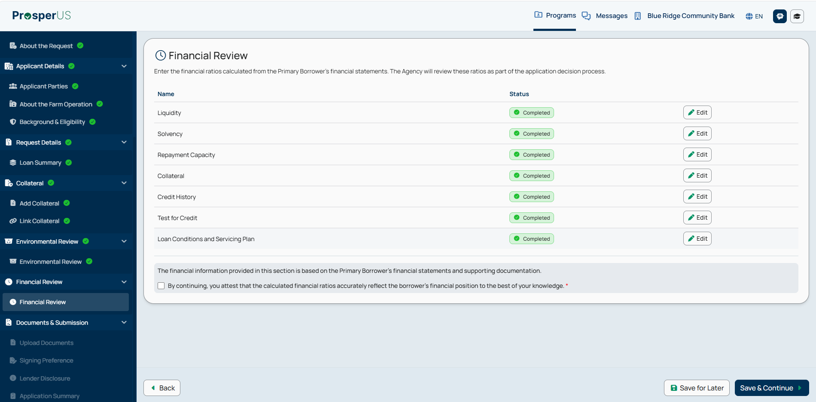

PLP Application Submission - Documents

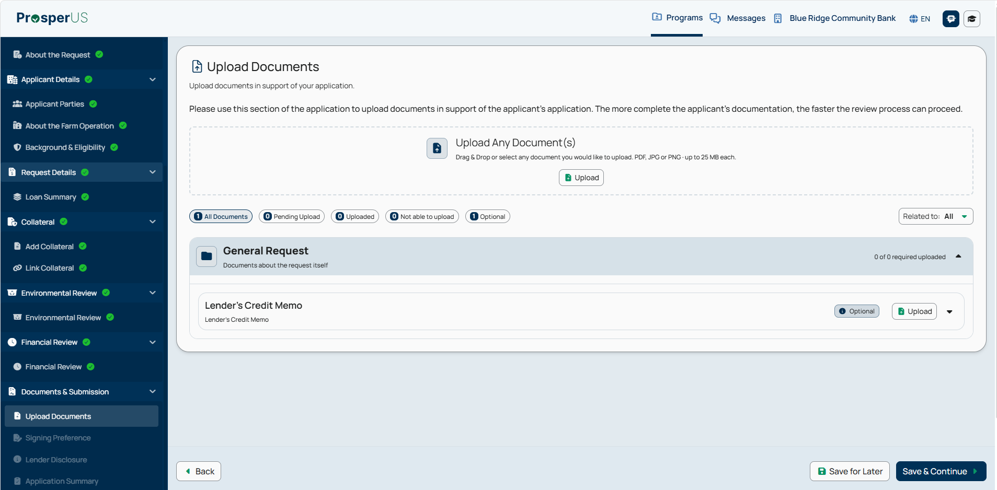

PLP Application Submission - Signing Preference

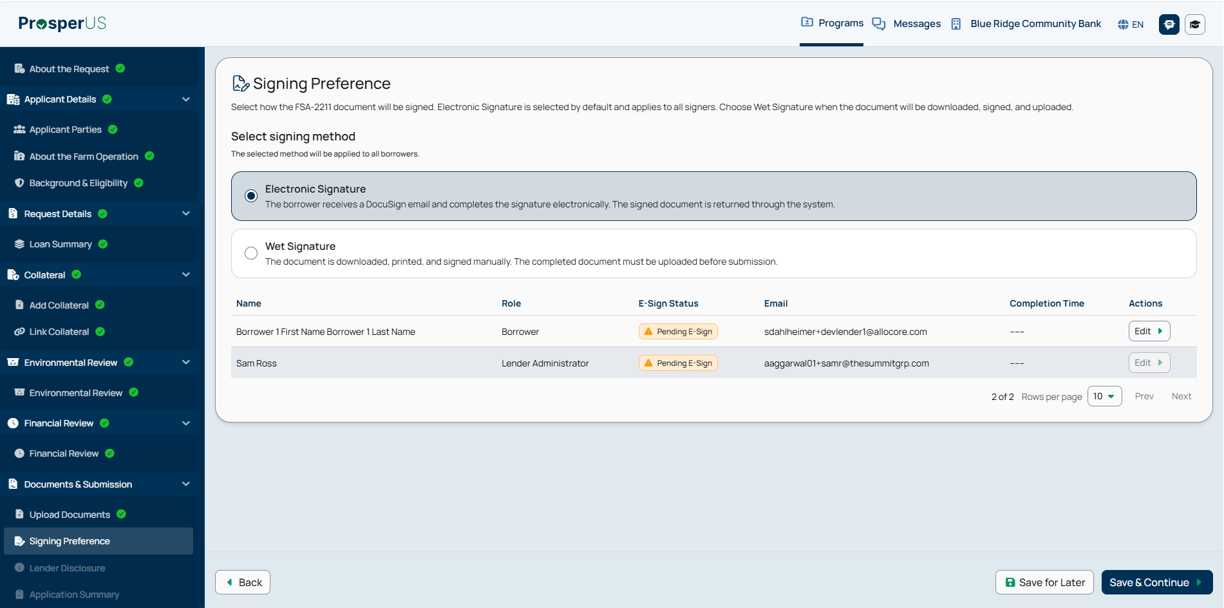
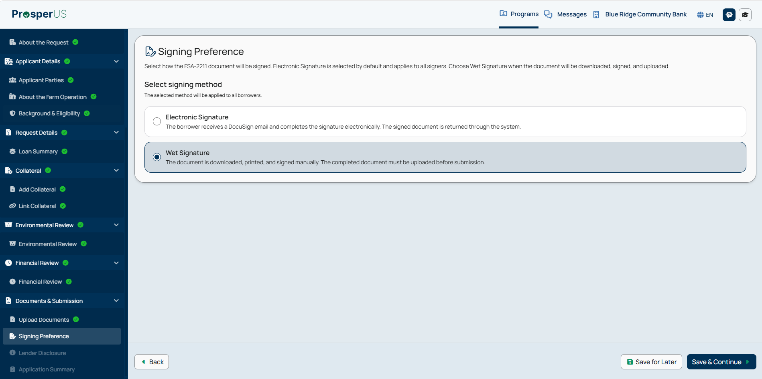

PLP Application Submission - Lender Disclosure

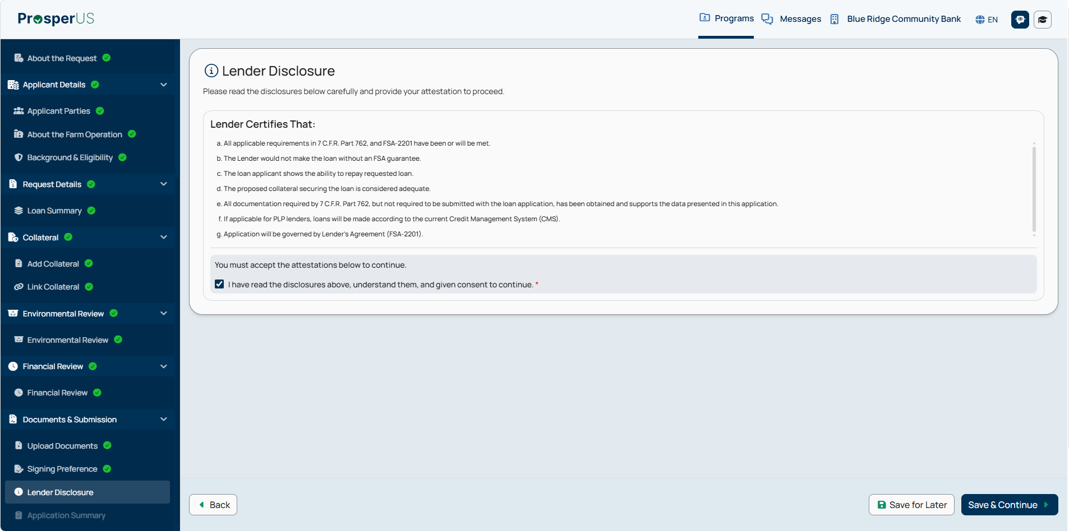

PLP Application Submission - Application Summary

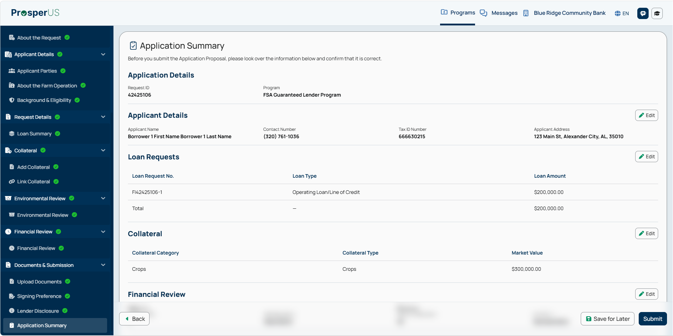
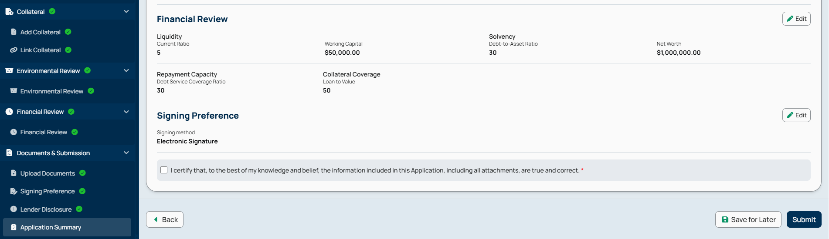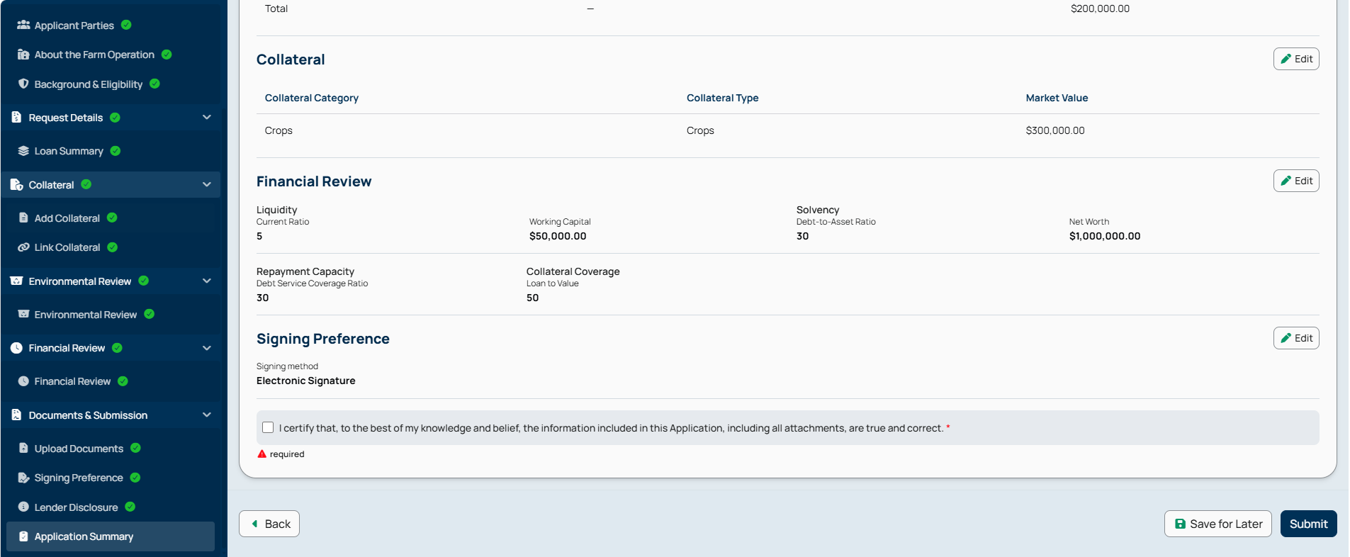

PLP Application Submission - Application Summary (continued)

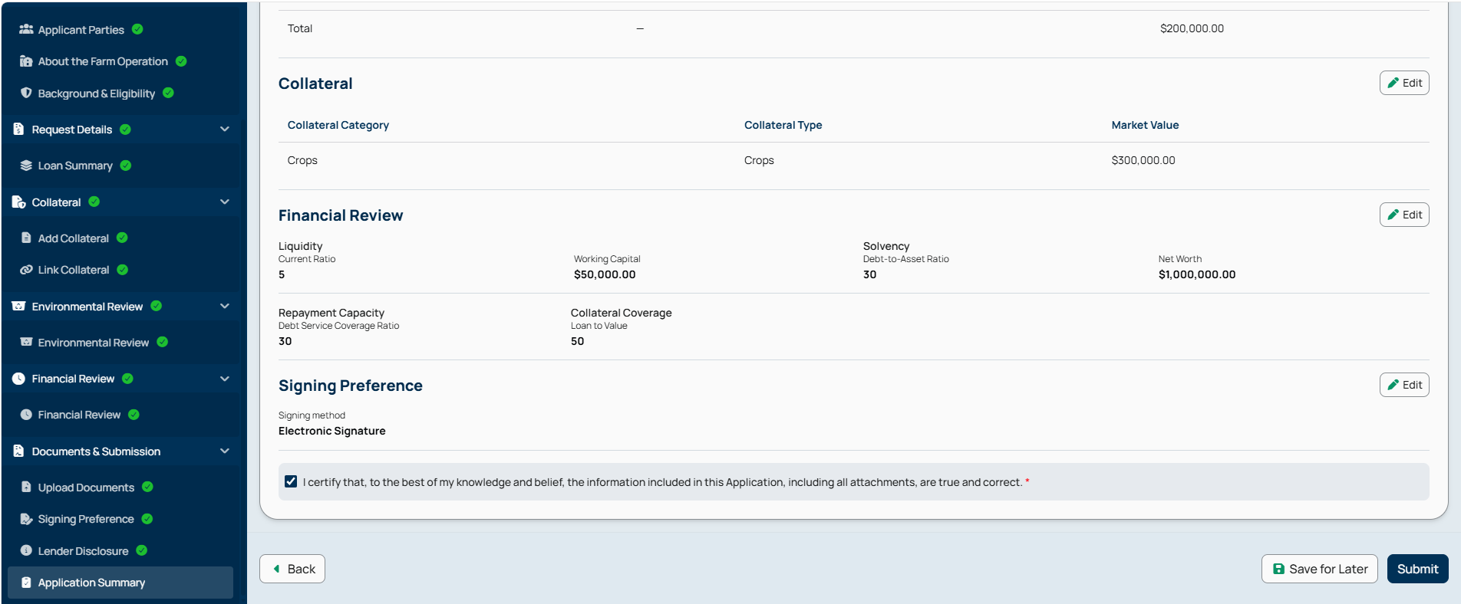
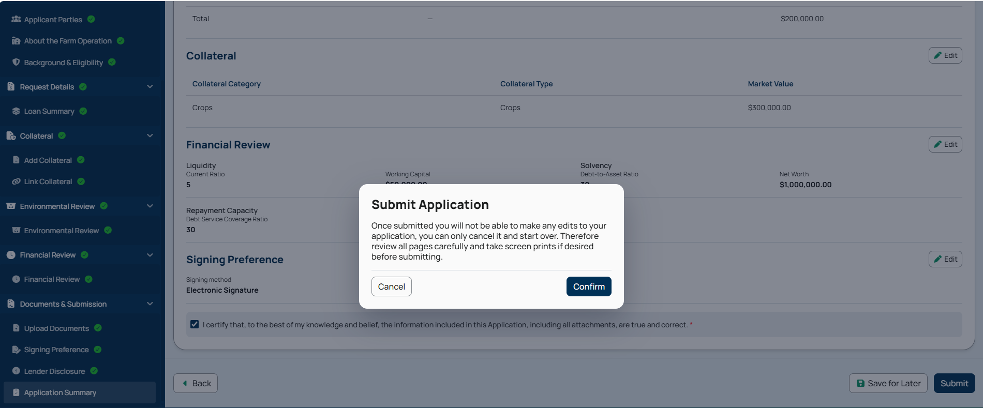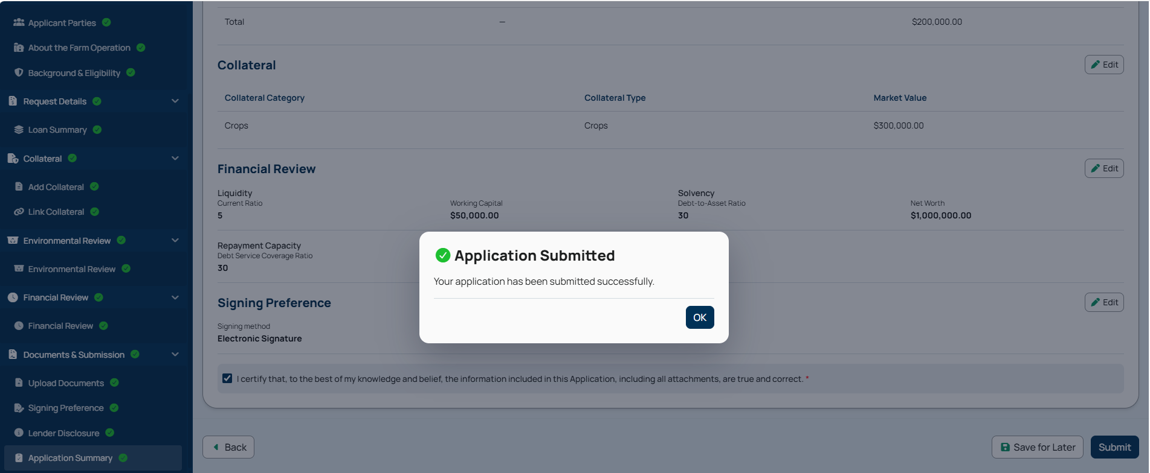

8. Digital Process for Completion of FSA-2211, “Application for Guarantee” (Non-PLP)

Non-PLP Application Submission - PRA Burden Statement

Public Burden Statement (Paperwork Reduction Act):
Public reporting burden for this collection is estimated to average 3.5 hours per response, including reviewing instructions, gathering and maintaining the data needed, completing (providing the information), and reviewing the collection of information. You are not required to respond to the collection, or FSA may not conduct or sponsor a collection of information unless it displays a valid OMB control number of 0560-0155.

Non-PLP Application Submission - Lender Landing Page

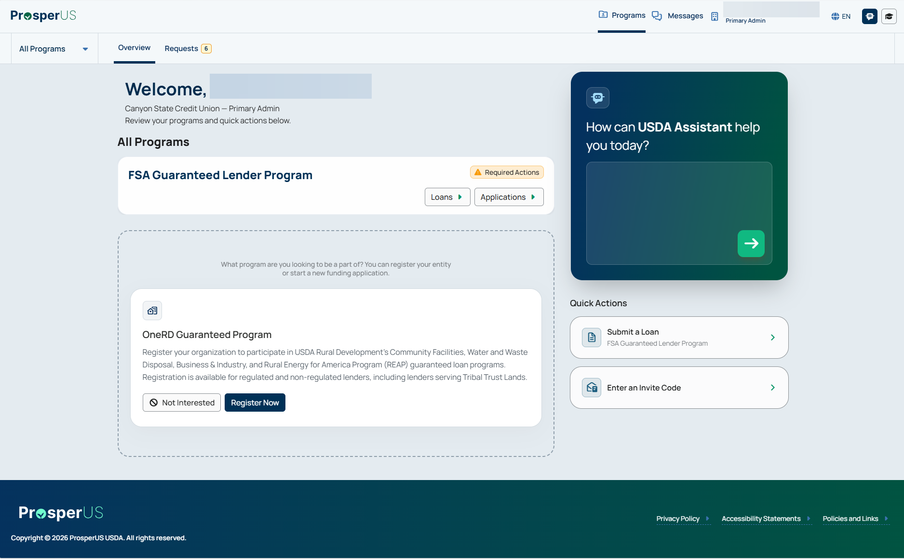

Non-PLP Application Submission - Introduction

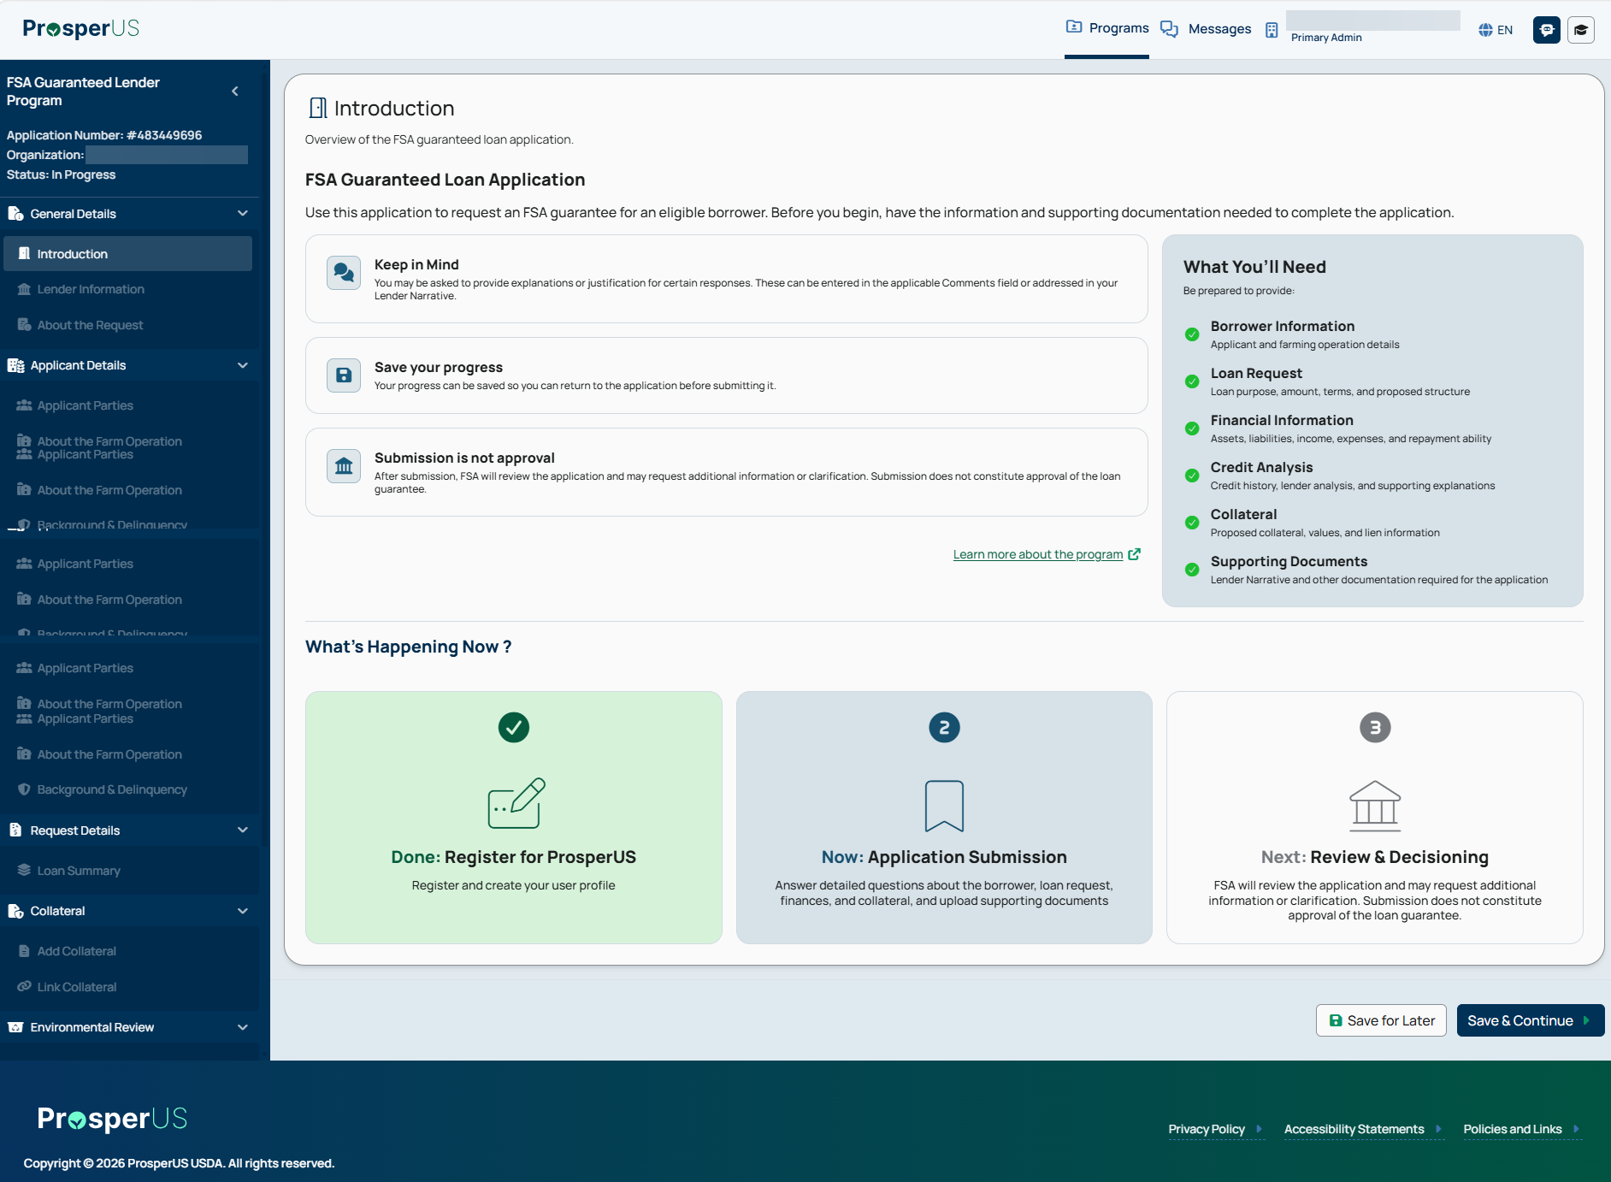

Non-PLP Application Submission - Lender Information

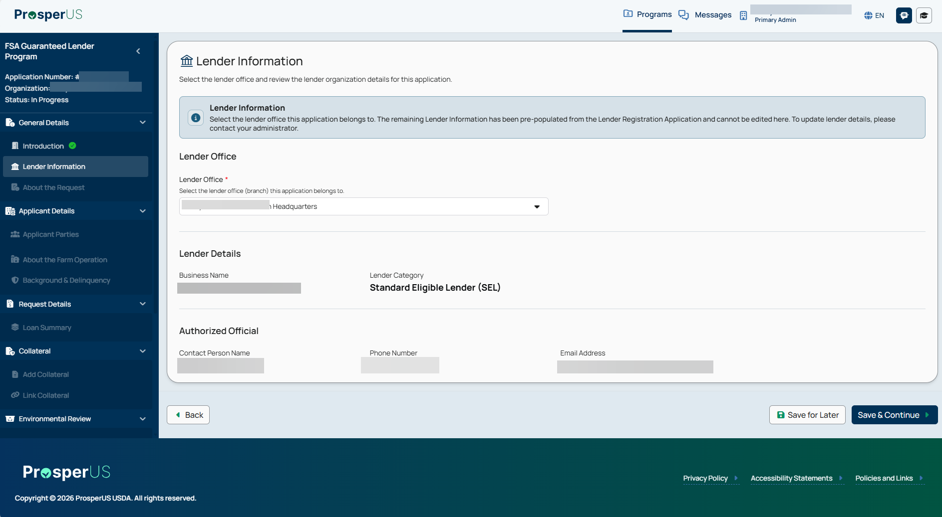

Non-PLP Application Submission - About the Request

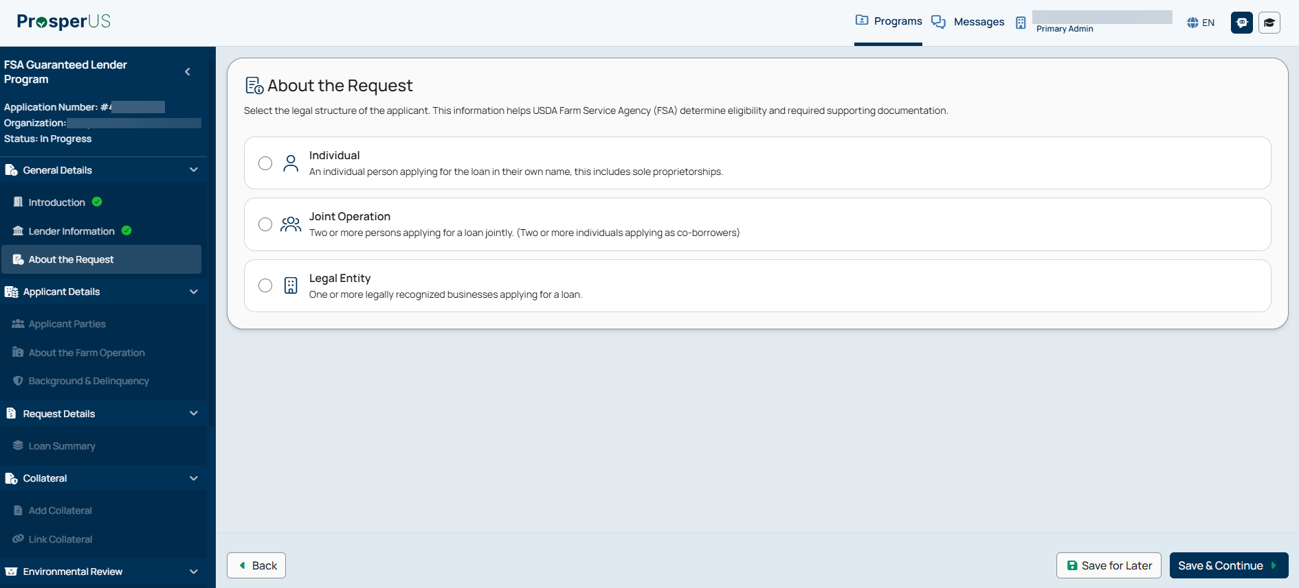

Non-PLP Application Submission - Applicant Parties

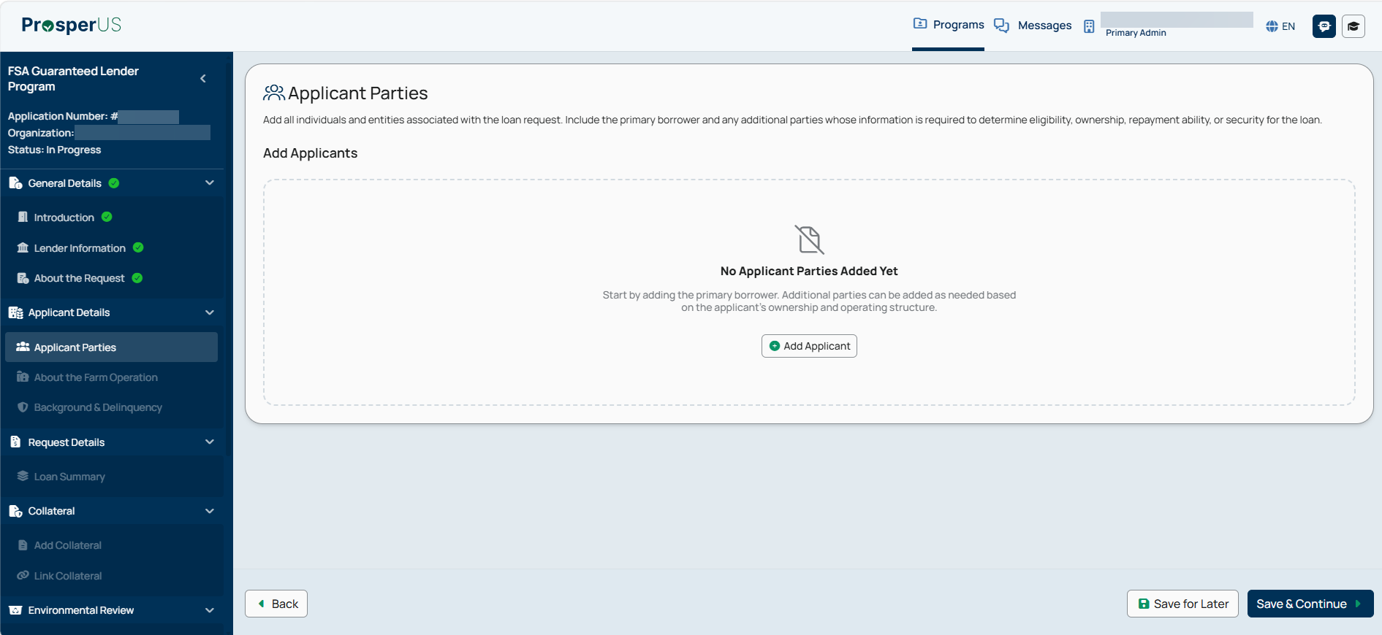

Non-PLP Submission - Applicant Parties - General Details - Add Individual Applicant
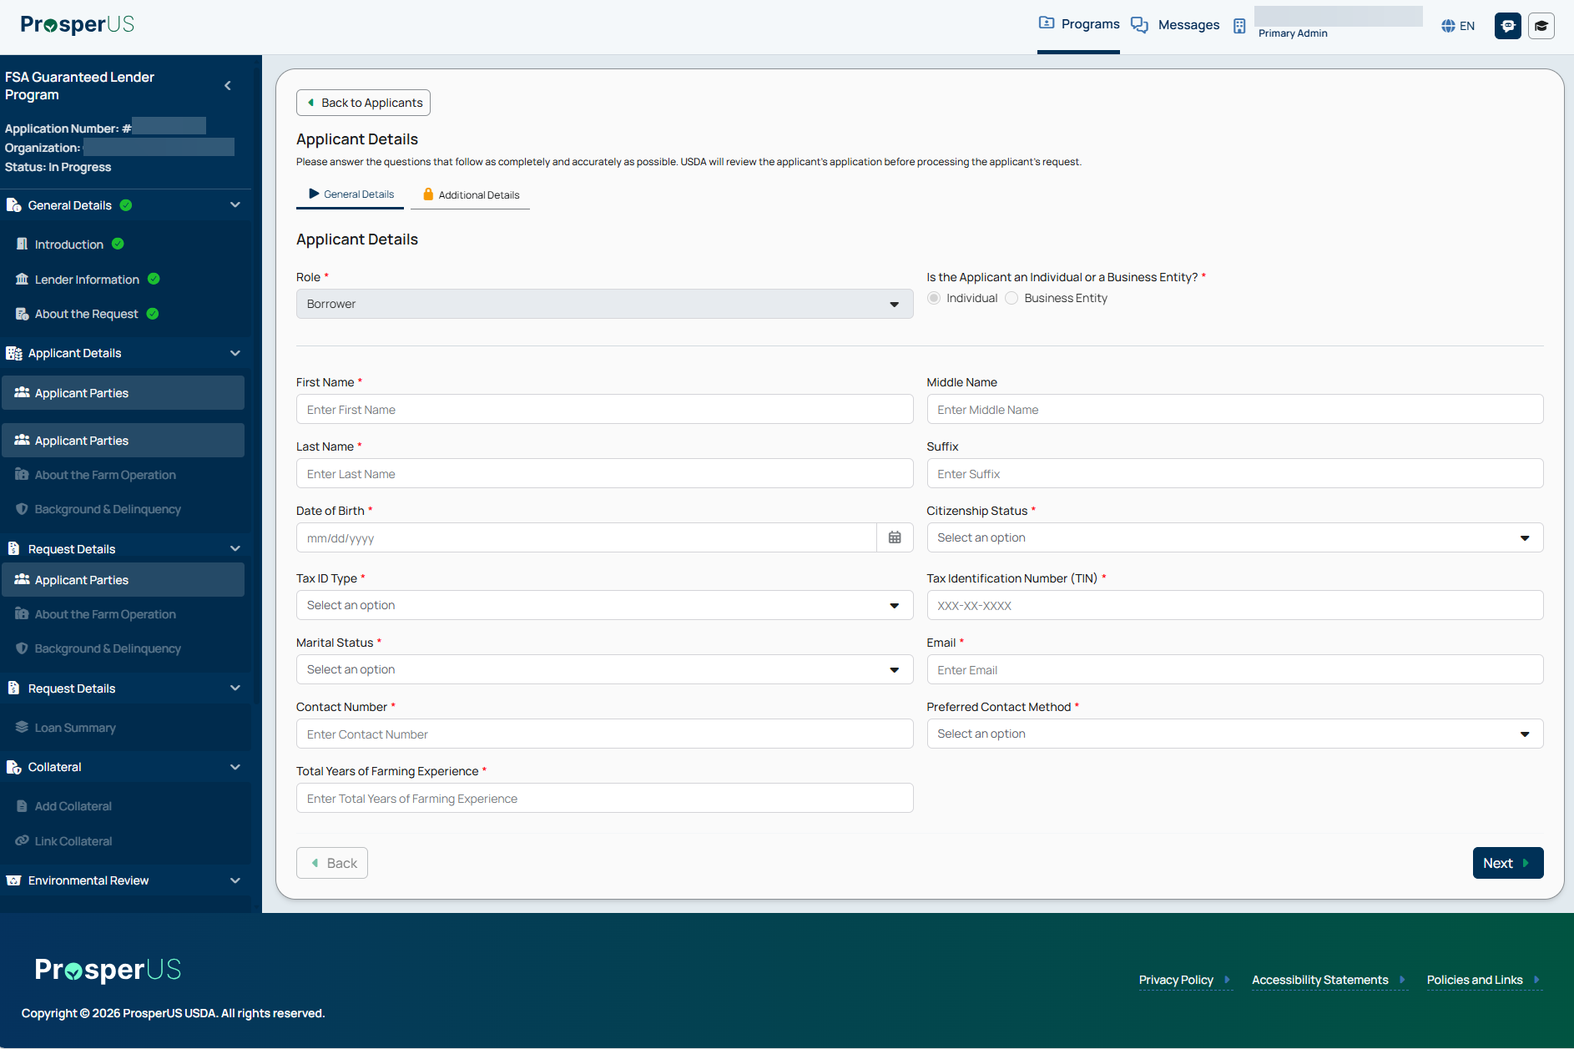

Non-PLP Application Submission - Applicant Parties - Additional Details

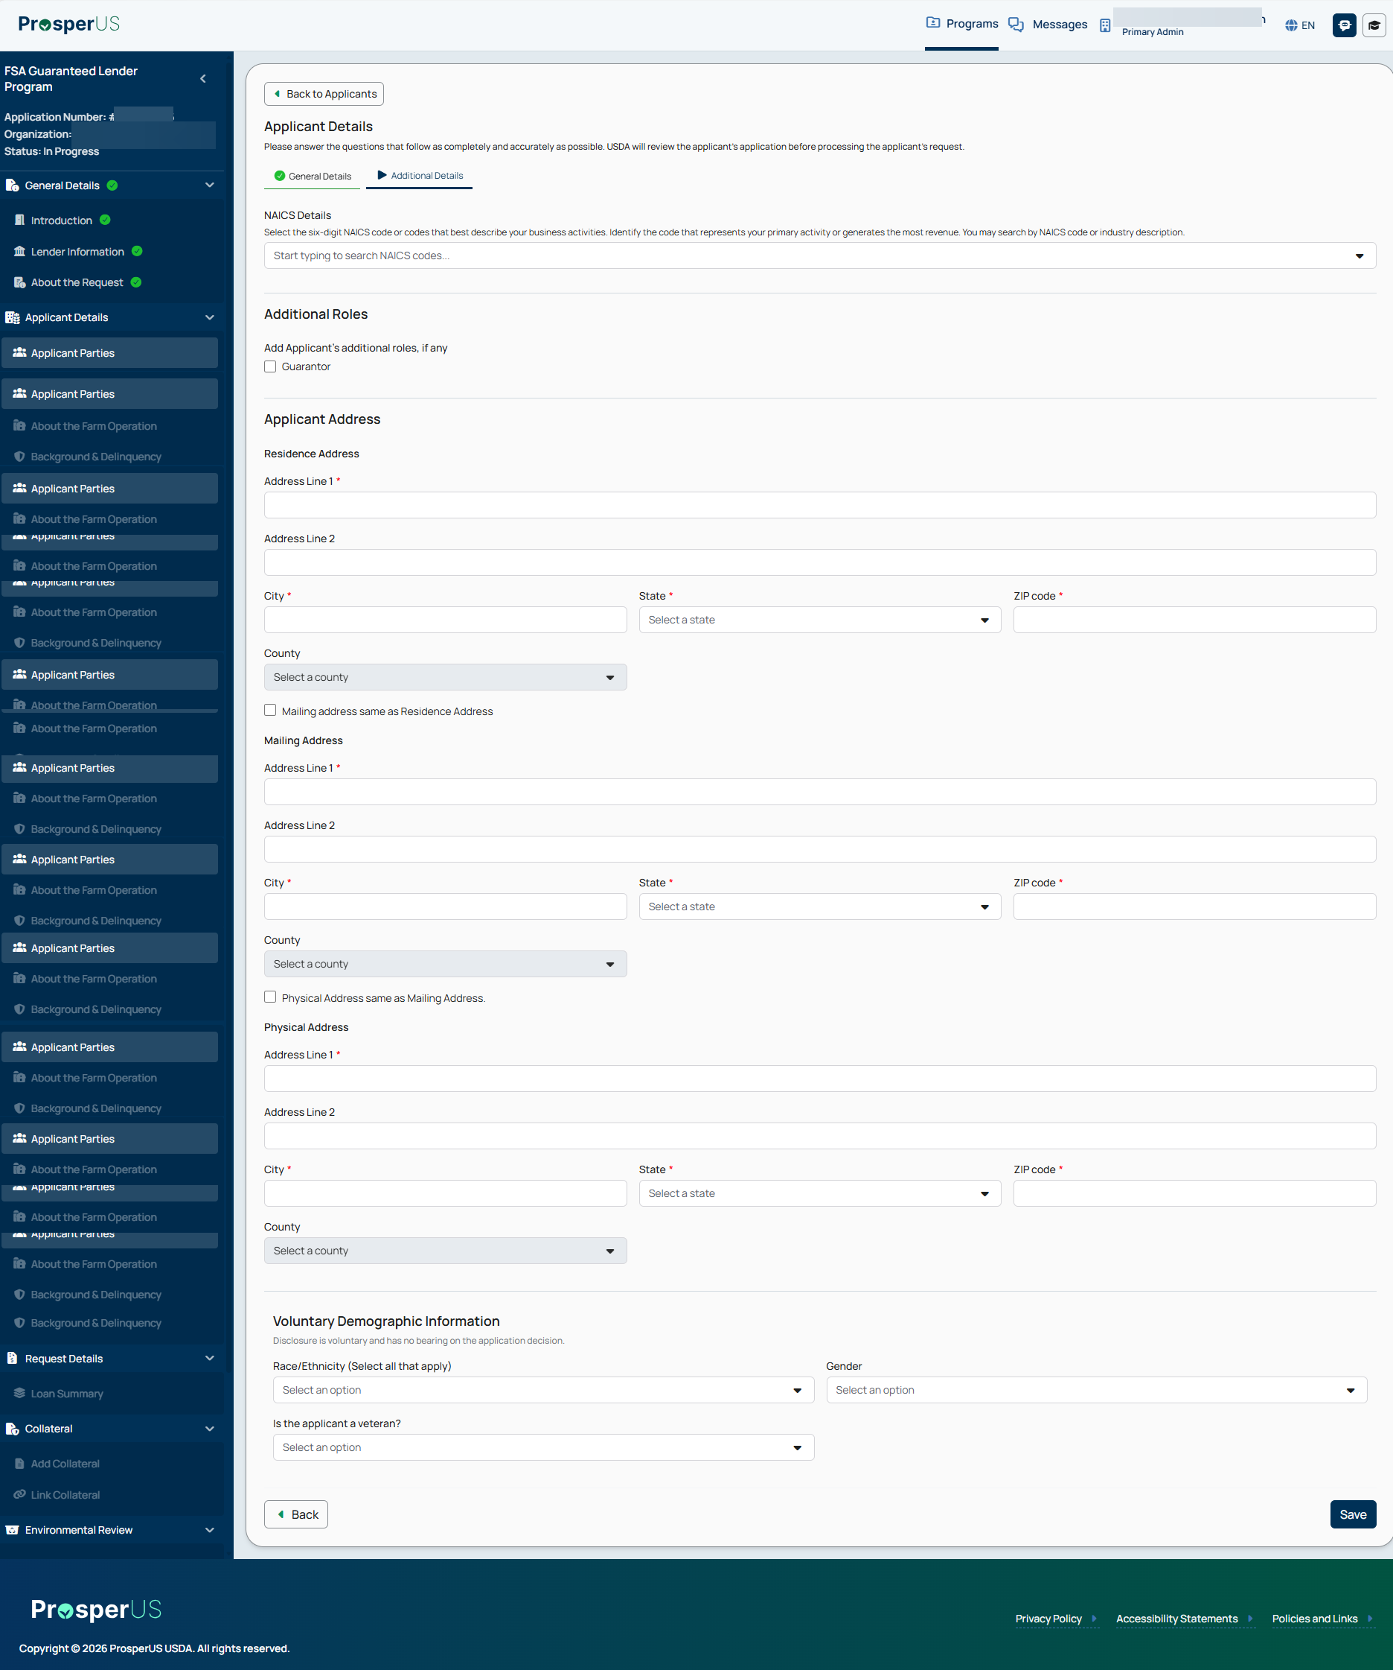

Non-PLP Application Submission - Applicant Parties - Added Applicants

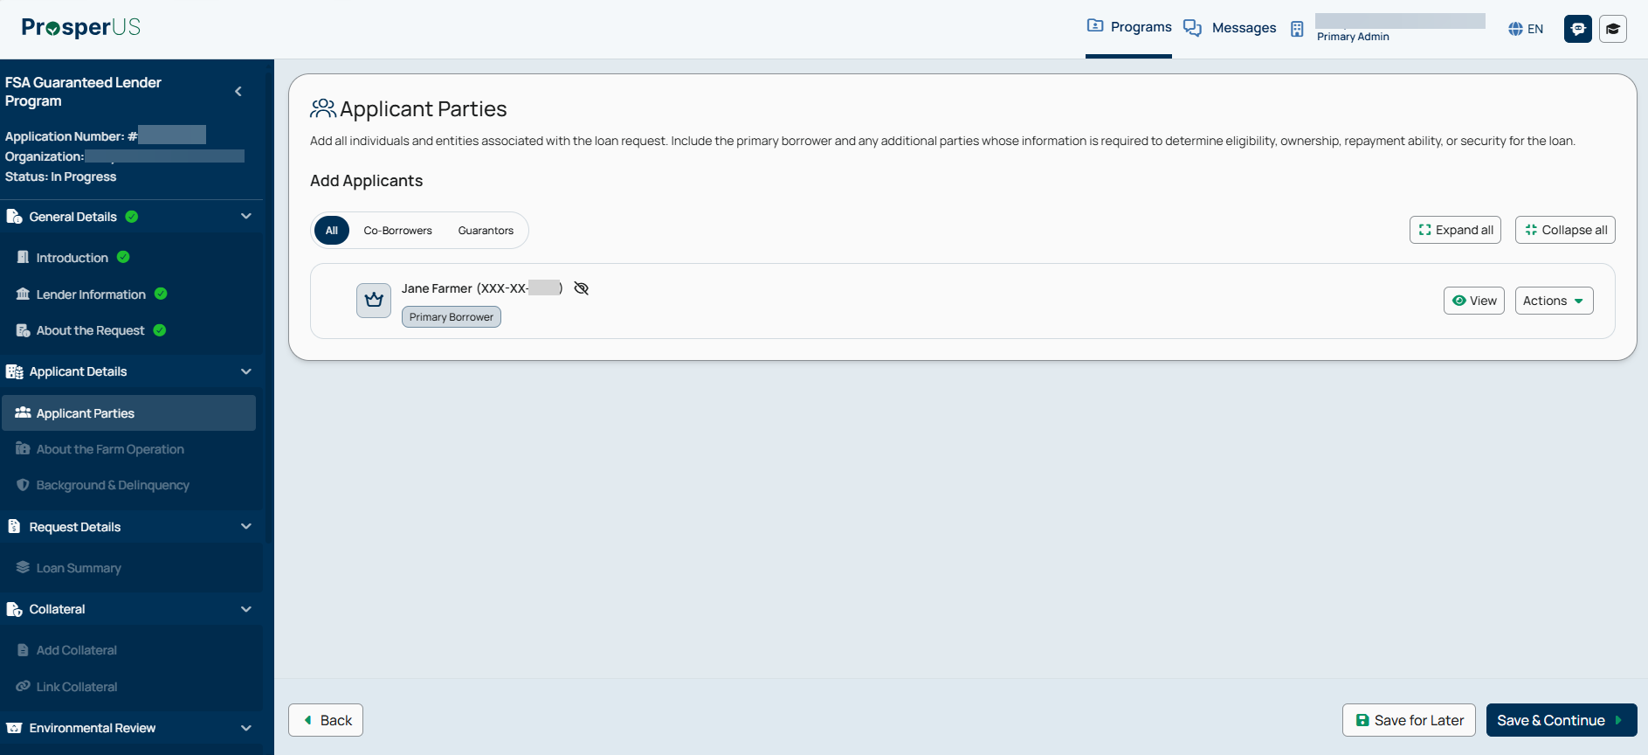

Non-PLP Application Submission - Assign Collaborators

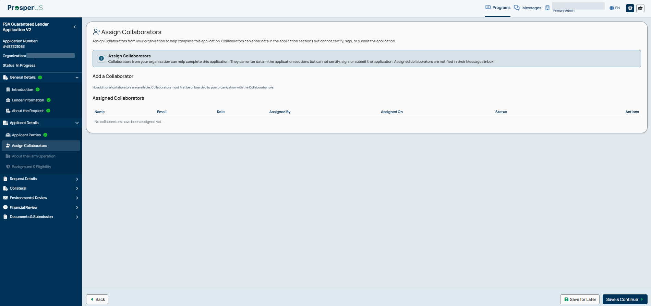

Non-PLP Application Submission - About the Farming Operation

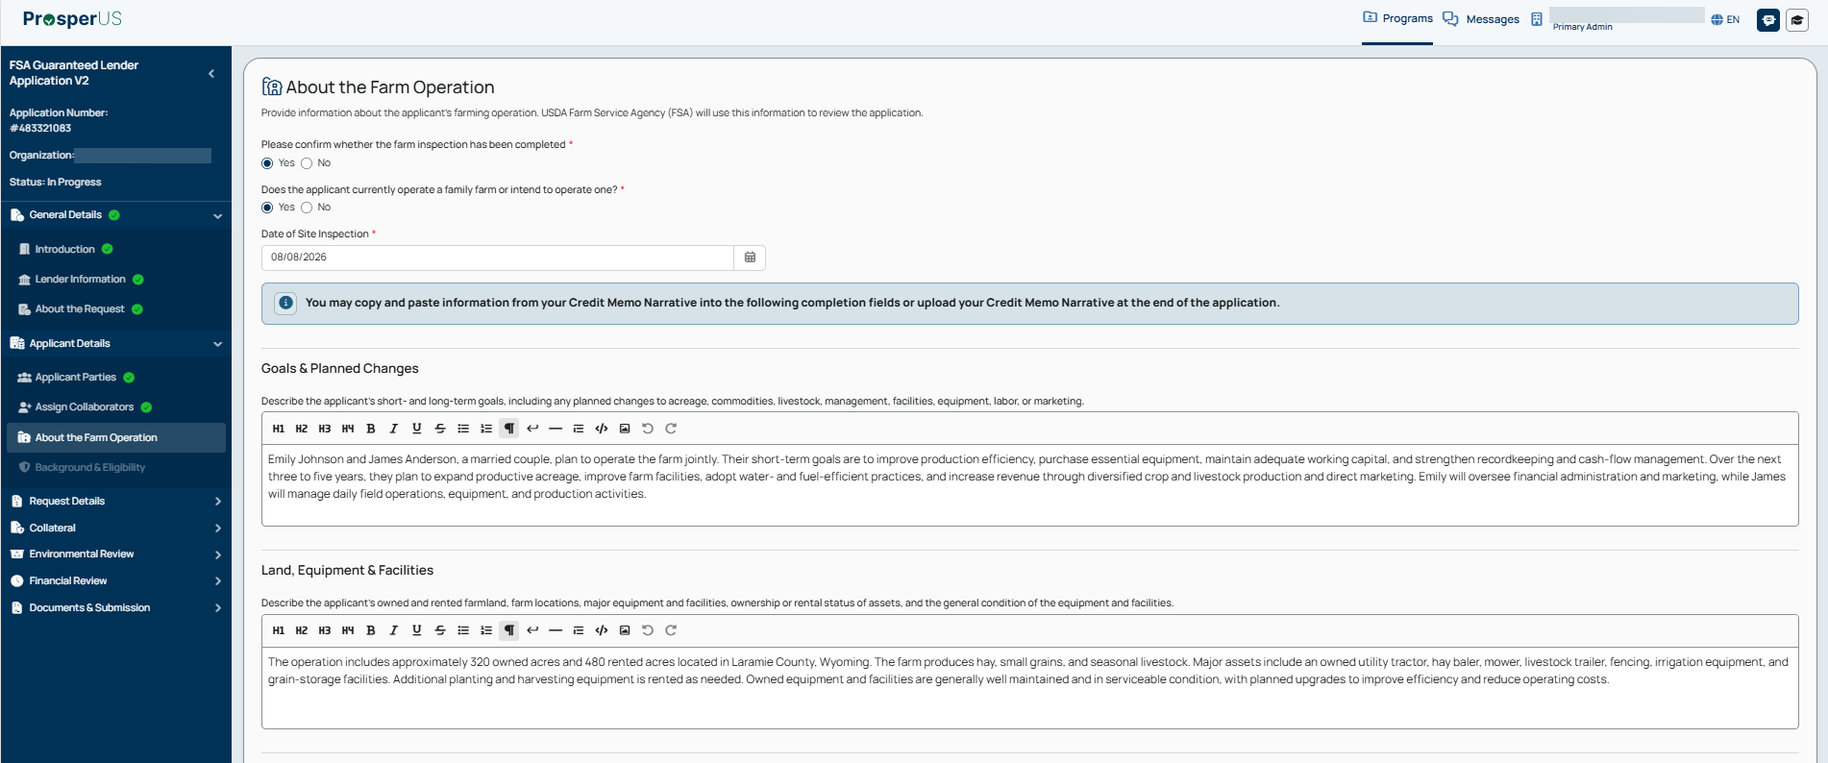

About the Farming Operation (Bottom Half)
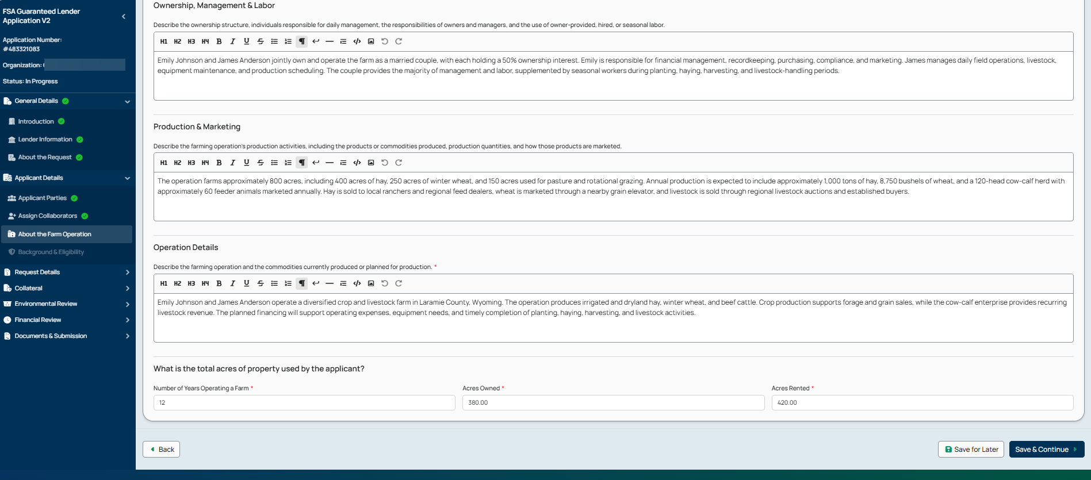

Non-PLP Application Submission - Background & Delinquency

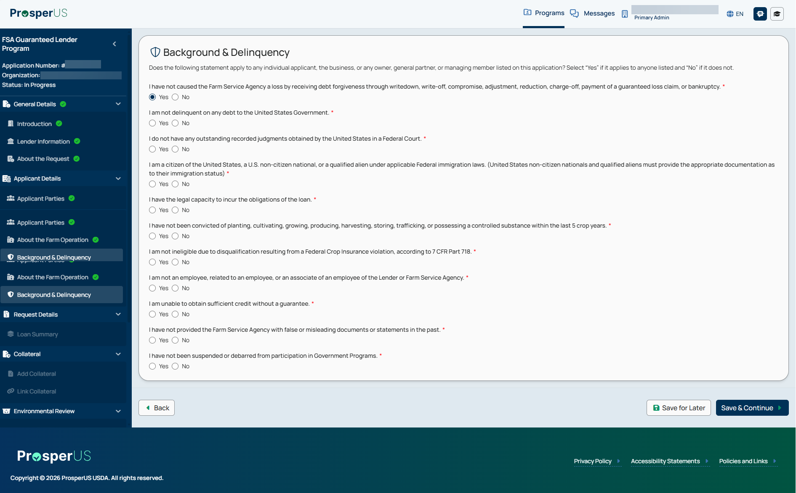

Non-PLP Application Submission - Request Details

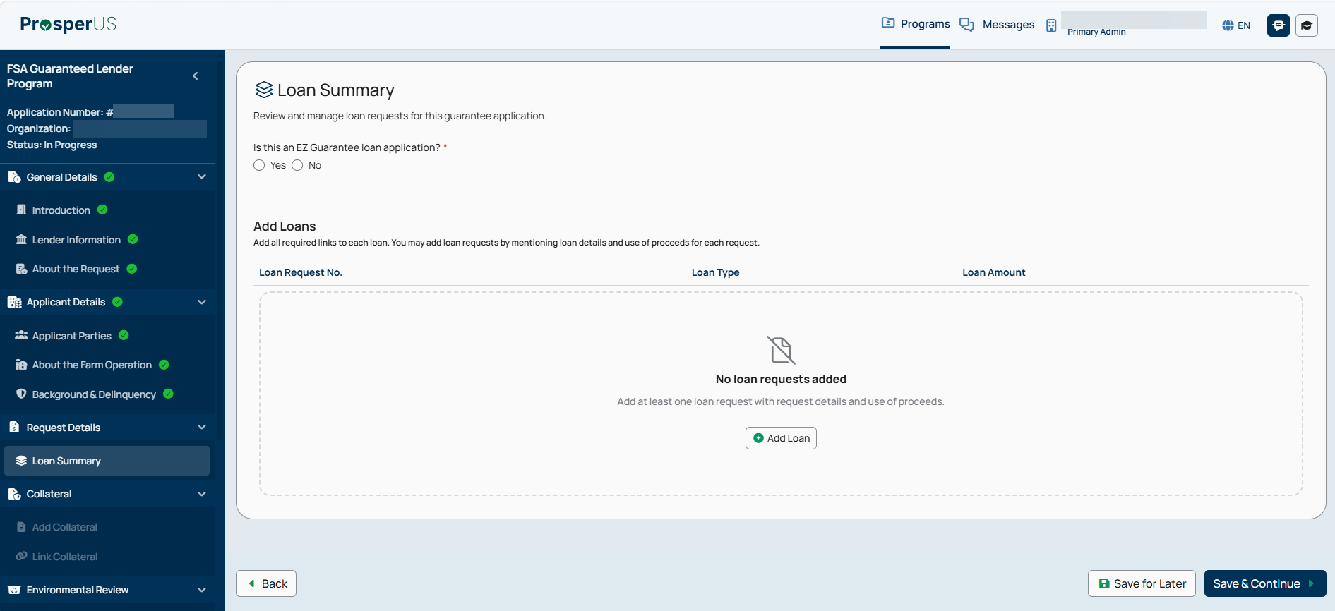

Non PLP Application Submission - Loan Summary - EZ Guarantee answered “YES”

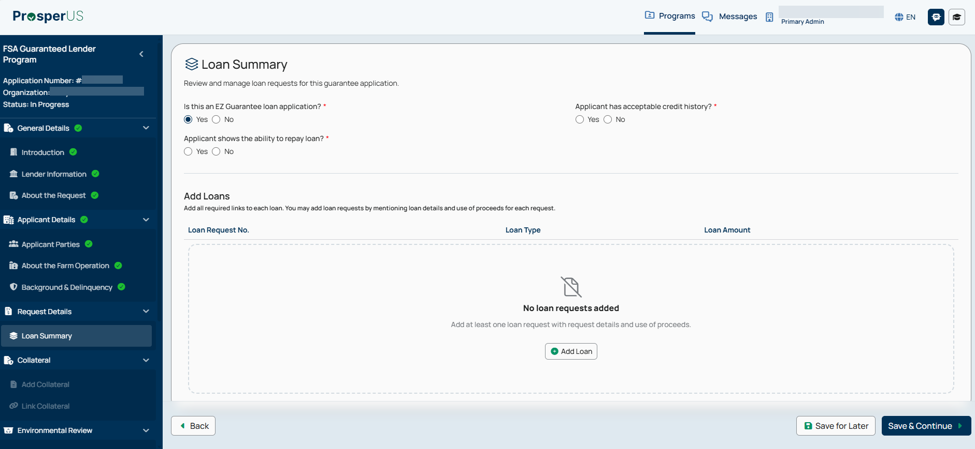

Non-PLP Application Submission - Loan Summary - Add Loan - Request Details - Expanded

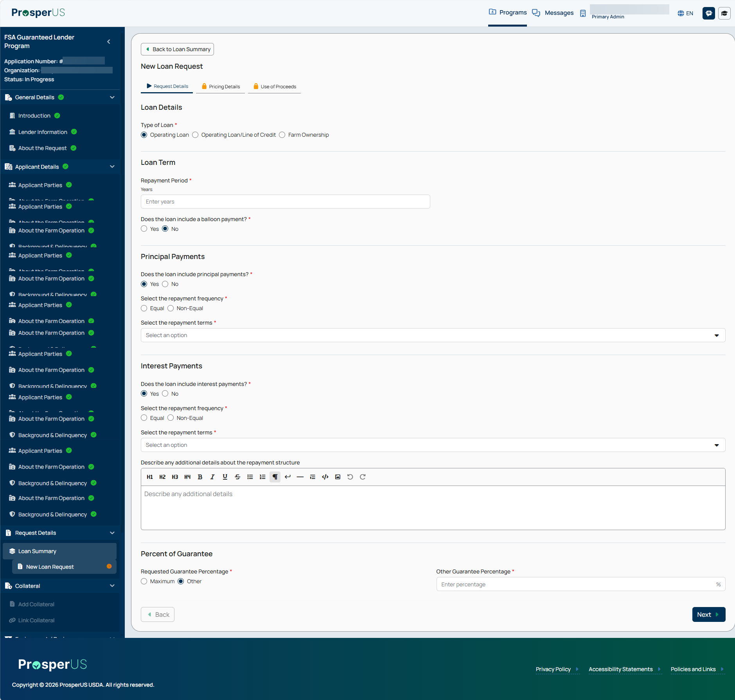

Non-PLP Application Submission - New Loan Request - Pricing Details - Expanded

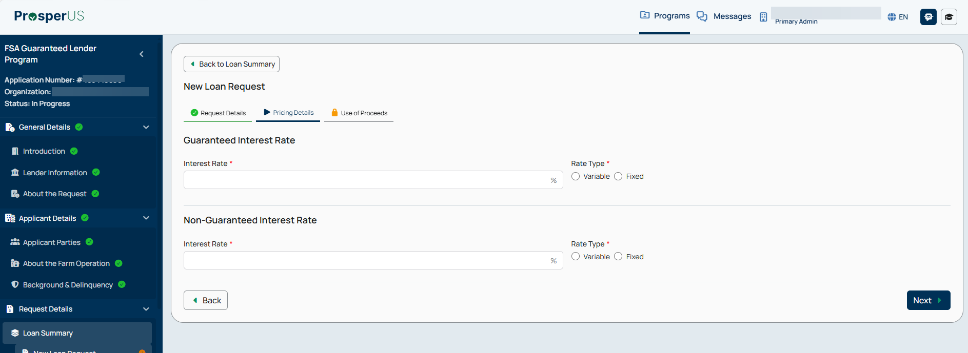

Non-PLP Application Submission - New Loan Request - Use of Proceeds

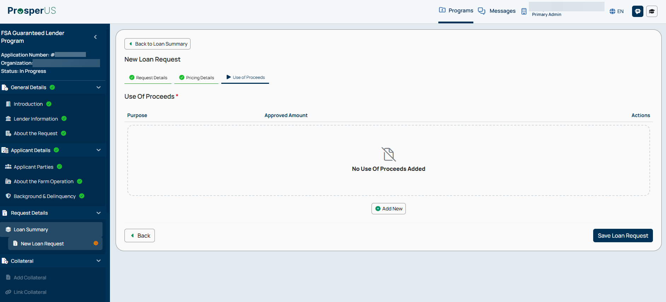

Non-PLP Application Submission - New Loan Request - Use of Proceeds - Add New

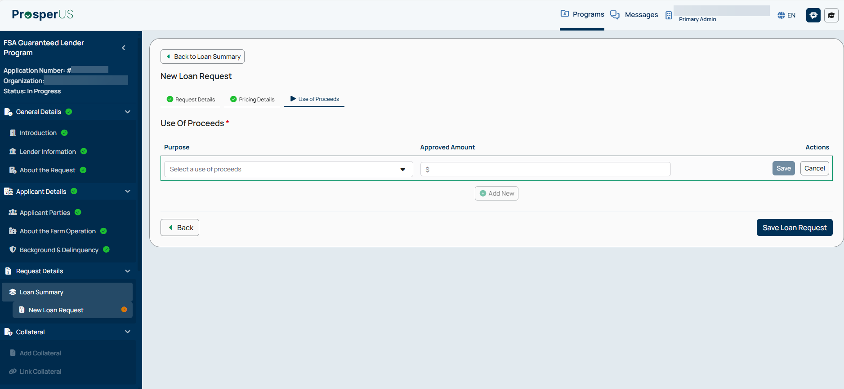

Non-PLP Application Submission - Add Collateral

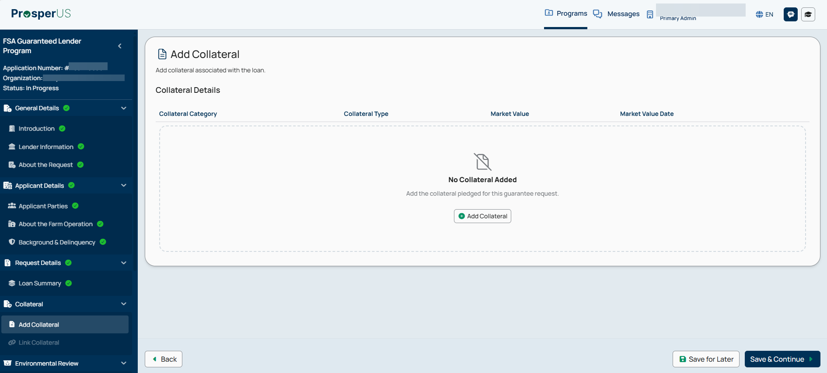

Non-PLP Application Submission – Add Collateral – Collateral Details (continued)
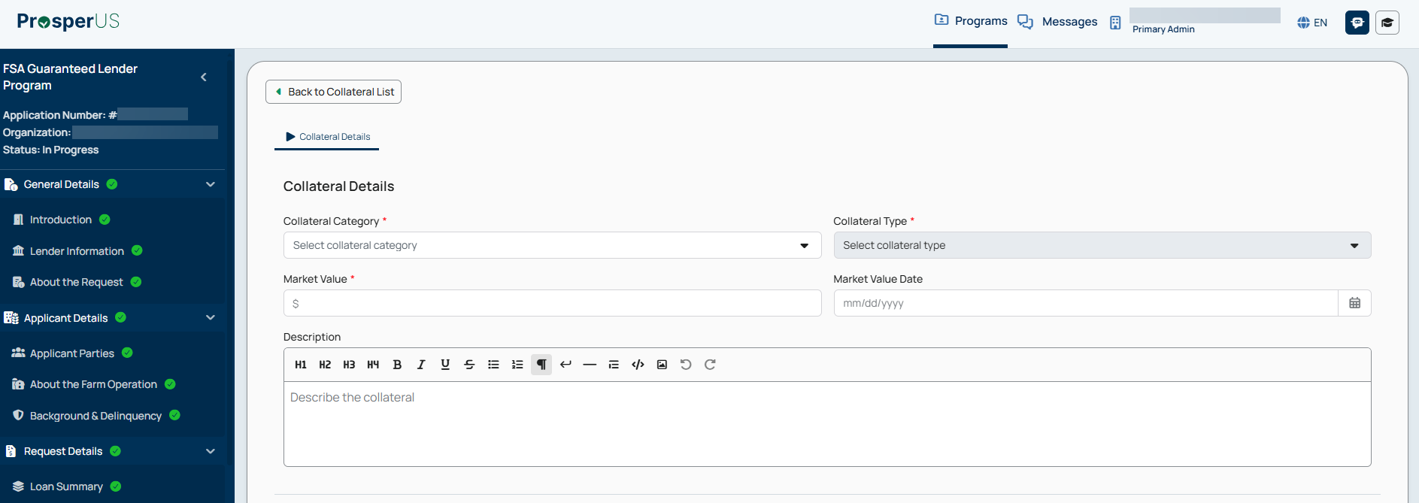

Non-PLP Application Submission - Link Collateral

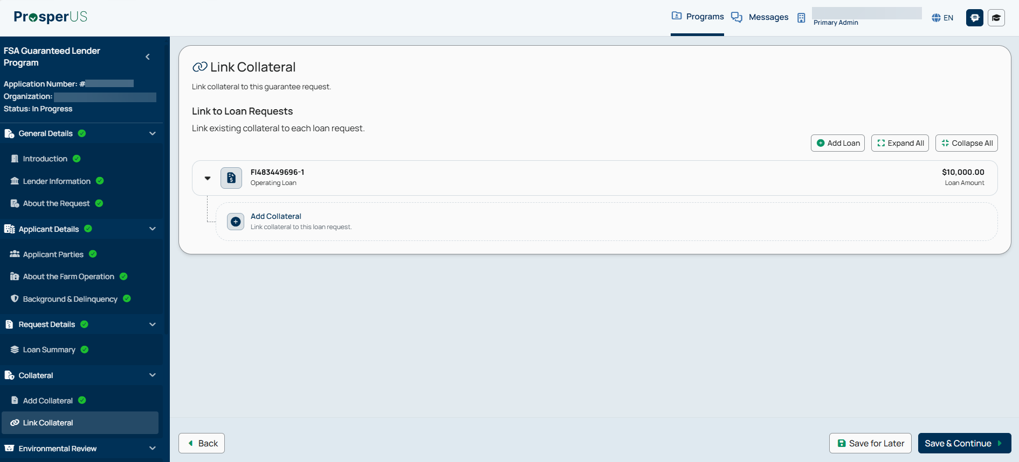

Non-PLP Application Submission - Link Collateral - Link Function

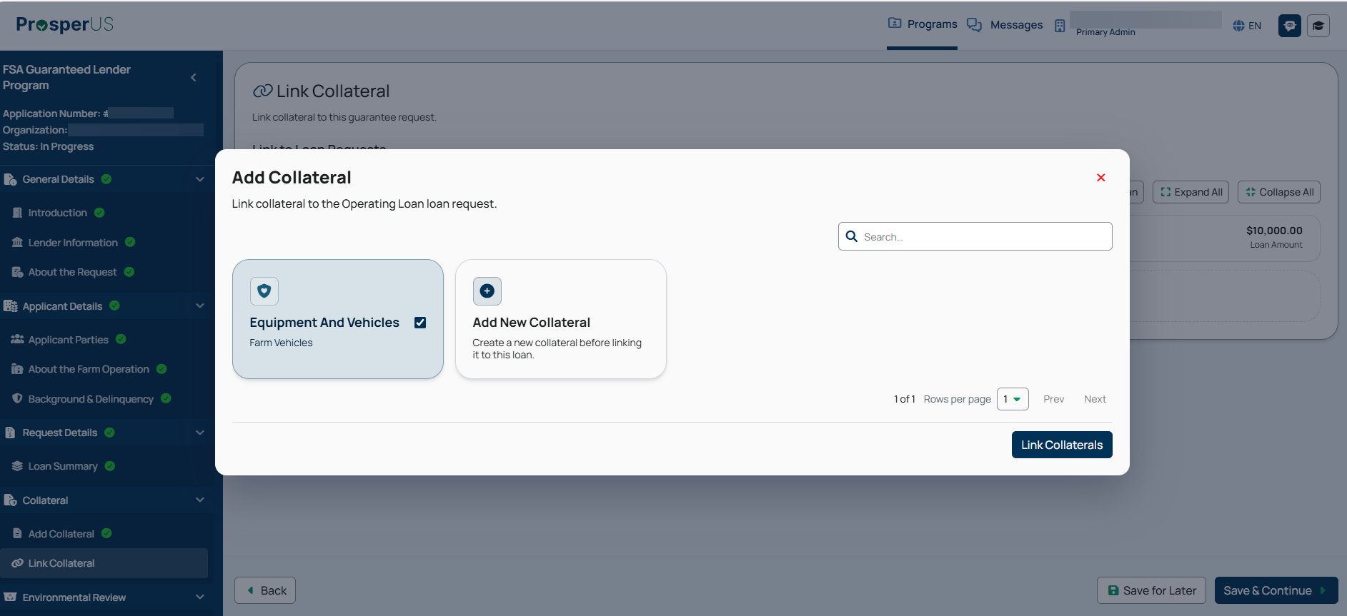

Non-PLP Application Submission - Link Collateral - Establish Lien Position

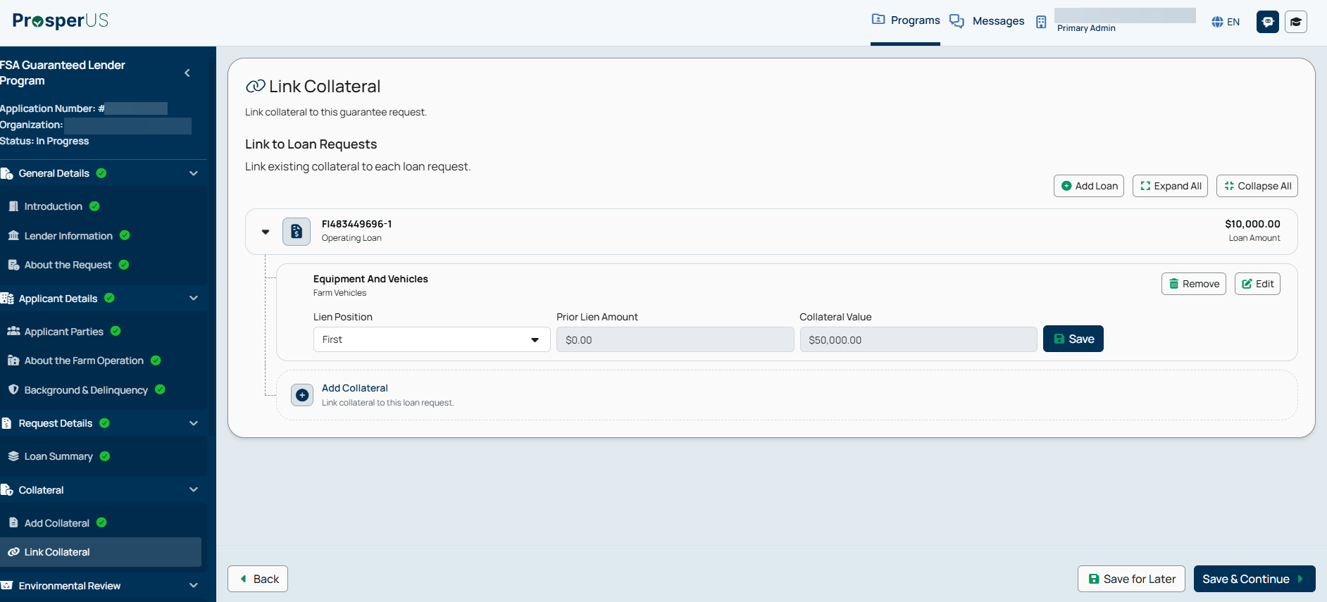

Non-PLP Application Submission - Environmental Review

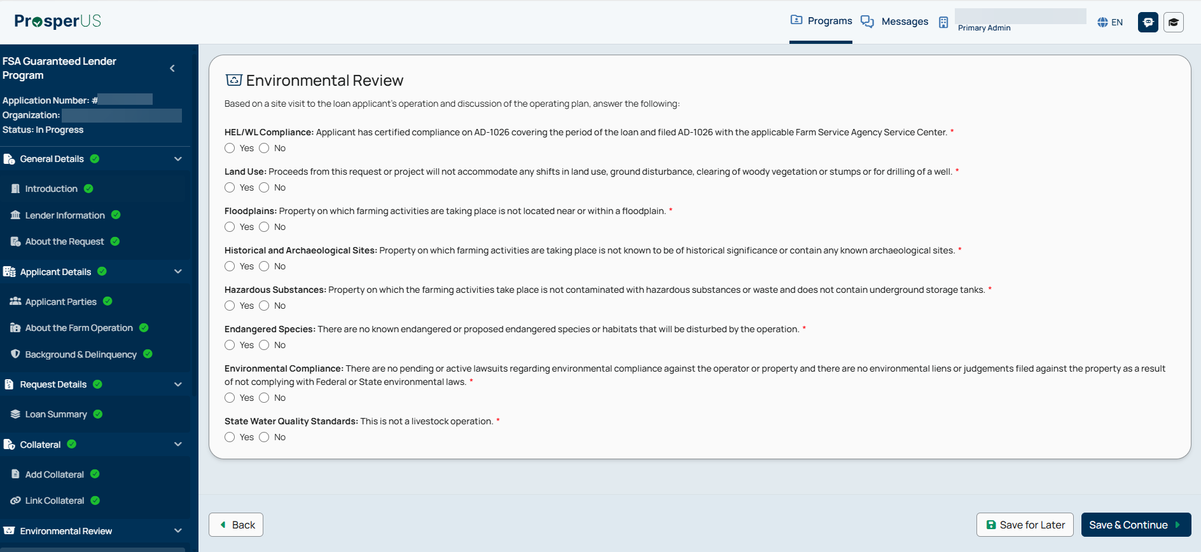

Non-PLP Application Submission - Financial Review

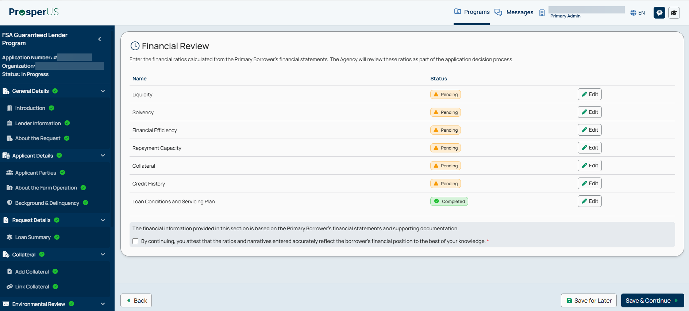

Non-PLP Application Submission - Financial Review - Liquidity - Expanded

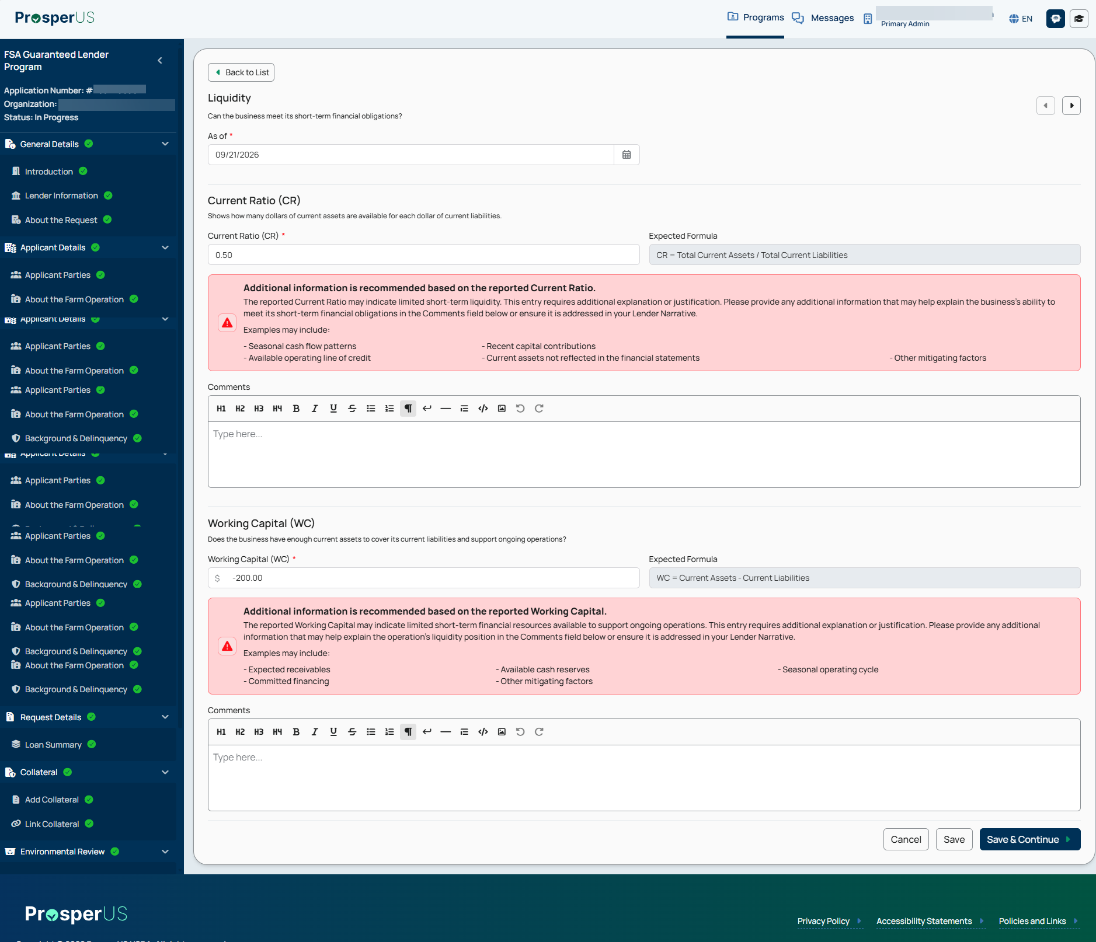

Non-PLP Application Submission - Financial Review - Solvency - Expanded

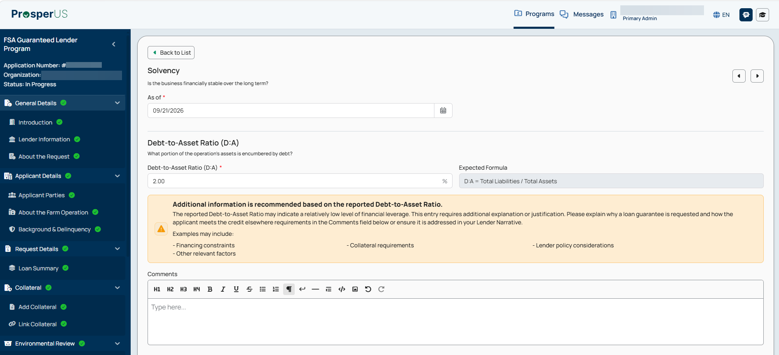

Non-PLP Application Submission - Financial Review - Financial Efficiency - Expanded

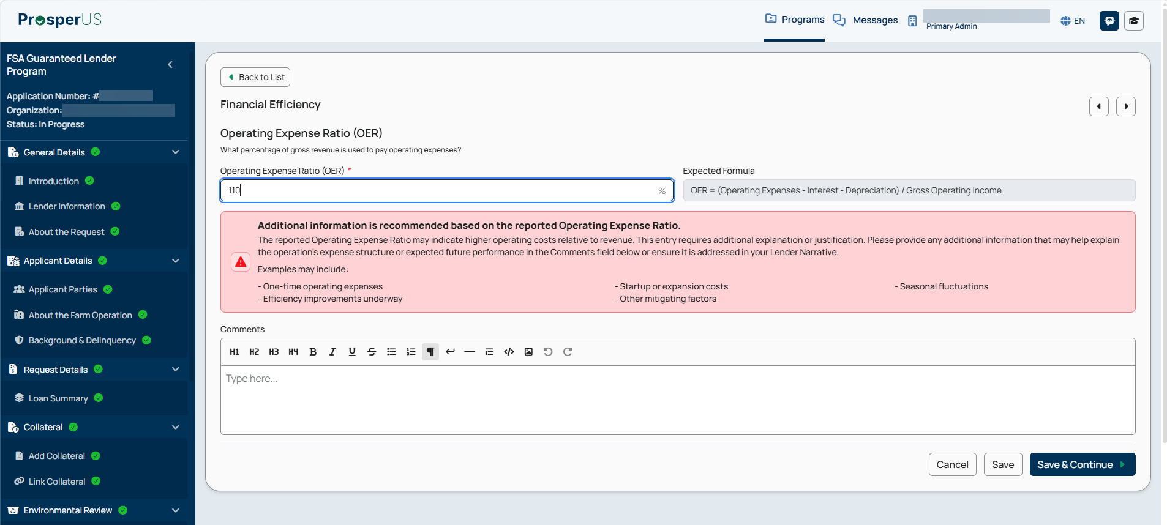

Non-PLP Application Submission - Financial Review - Repayment Capacity - Expanded

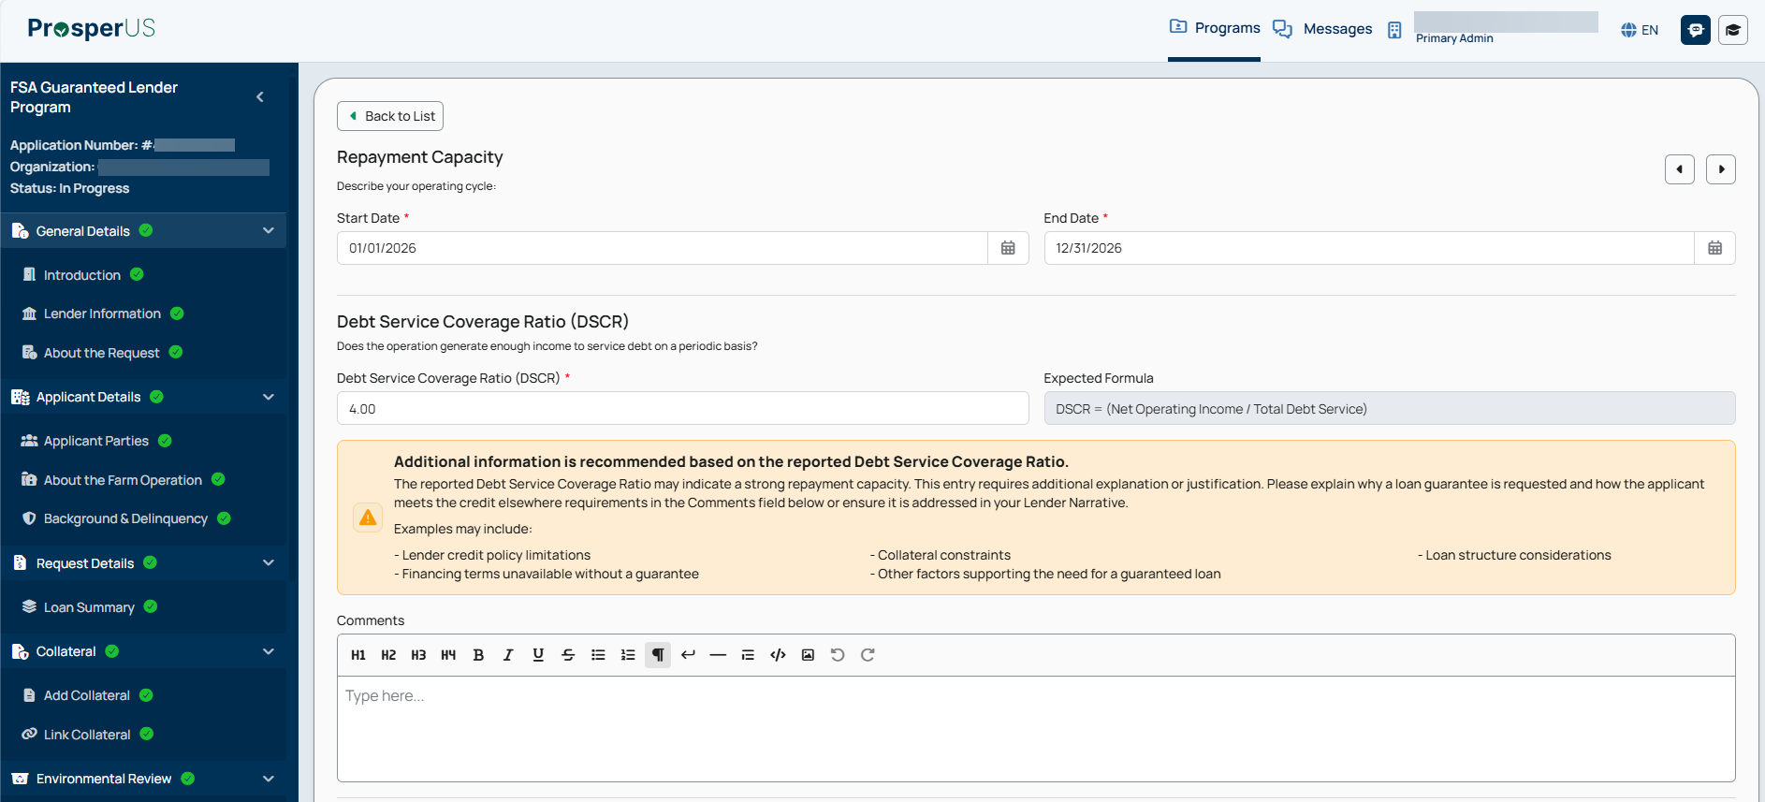

Non-PLP Application Submission - Financial Review - Collateral - Expanded
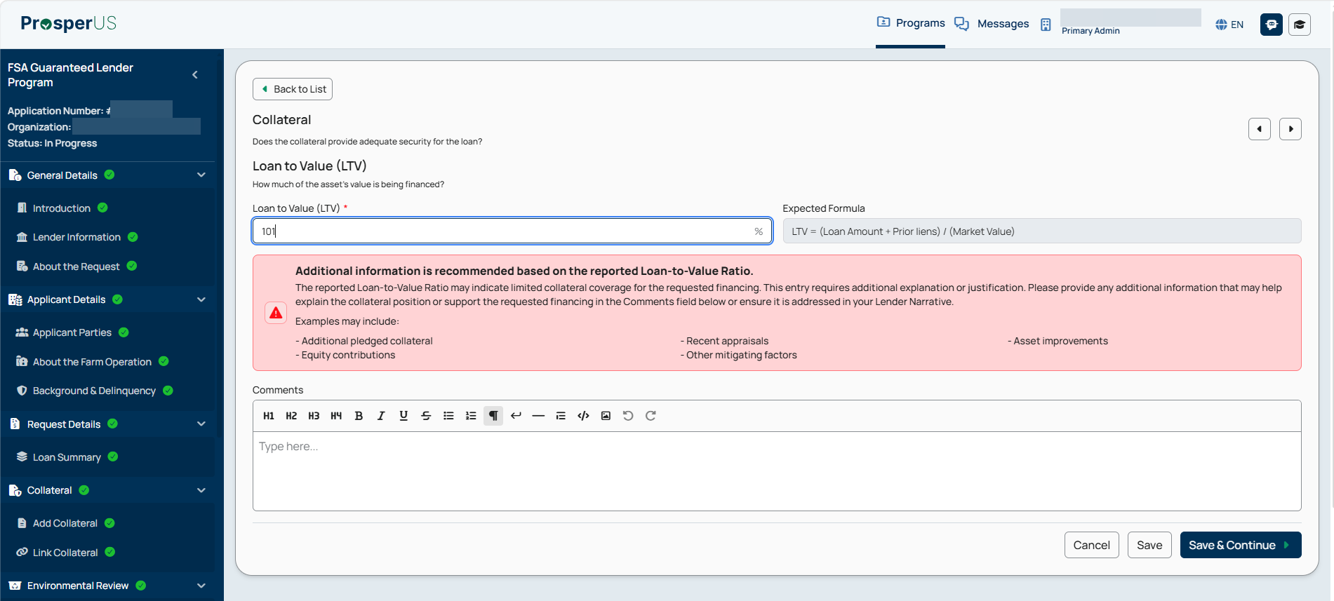

Non-PLP Application Submission - Financial Review - Credit History - Expanded

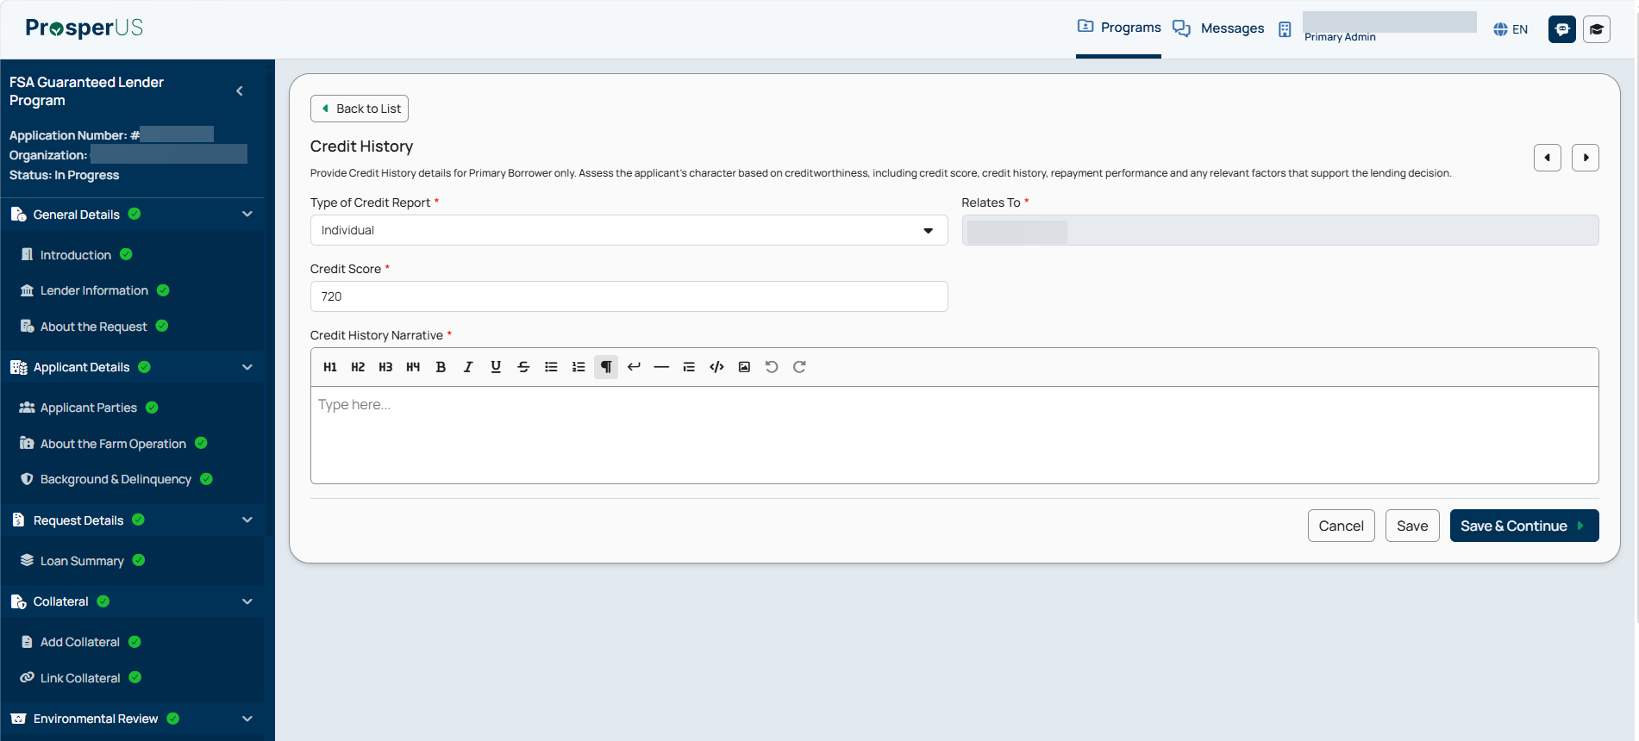

Non-PLP Application Submission - Financial Review - Loan Conditions and Servicing Plan -Expanded

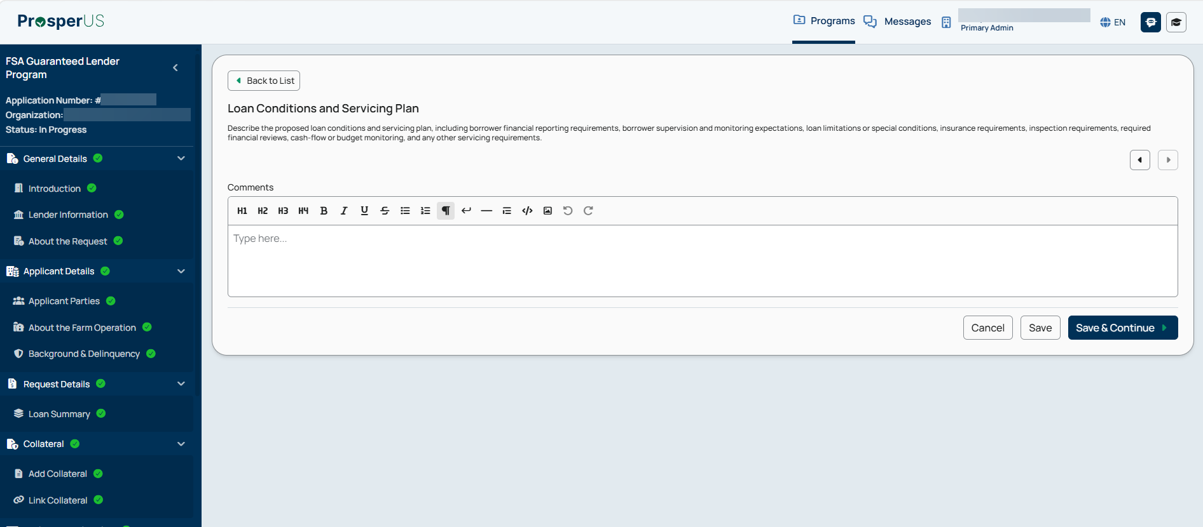

Non-PLP Application Submission - Financial Review - Complete
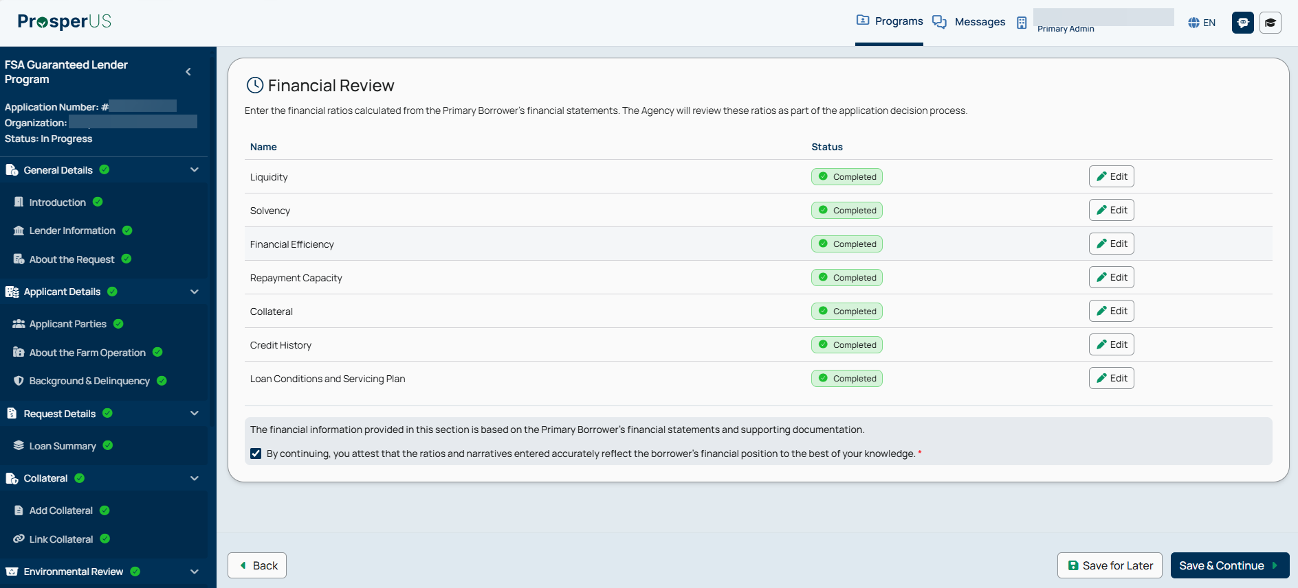

Non-PLP Application Submission - Documents & Submission

Note: Documents required to be submitted for a complete application are dynamically presented to the Lender based upon their Lender Status.

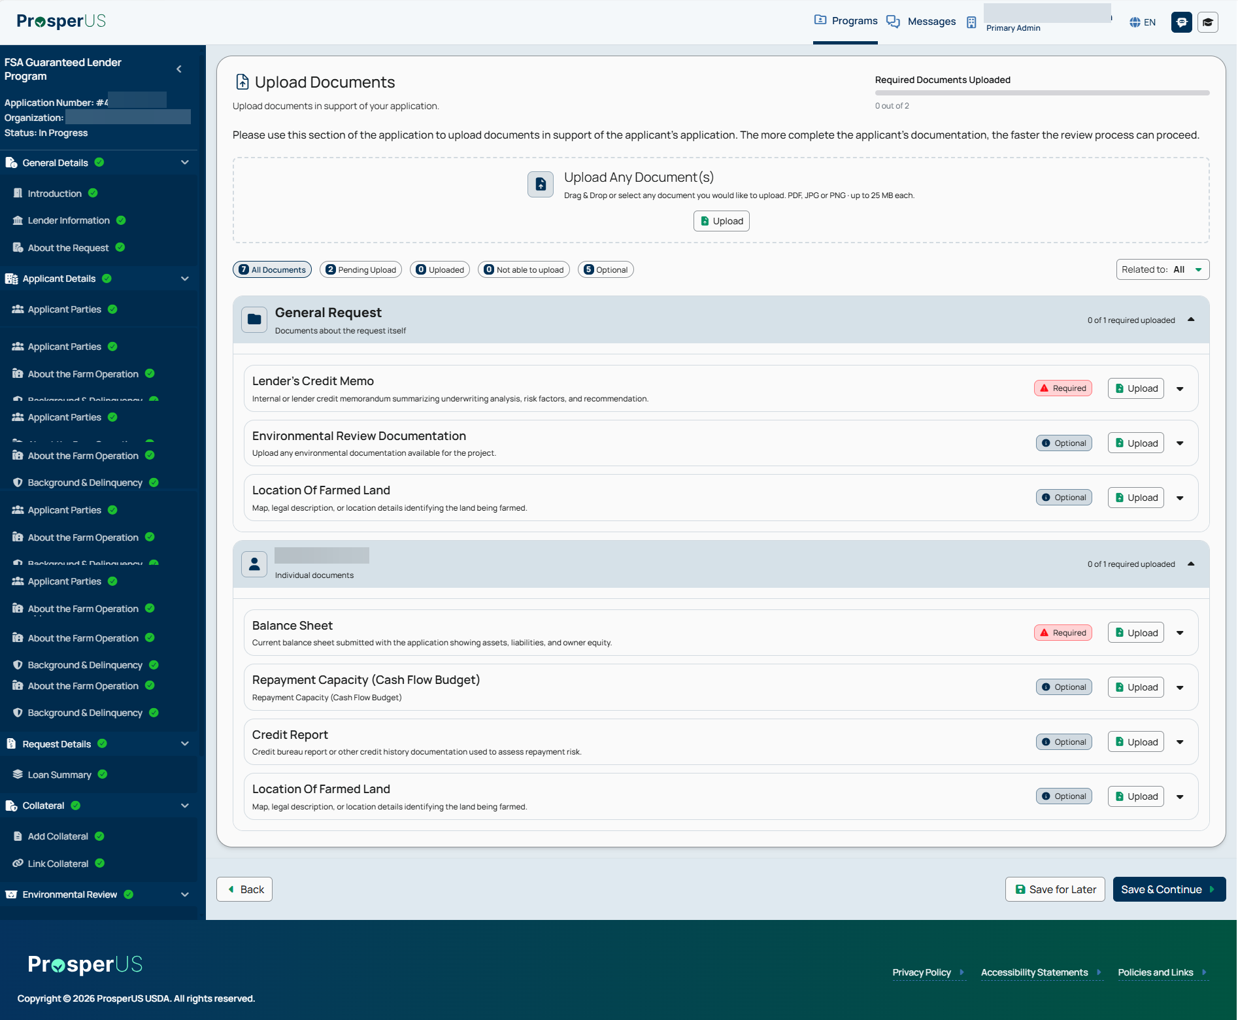

Non-PLP Application Submission - Upload Documents - Complete
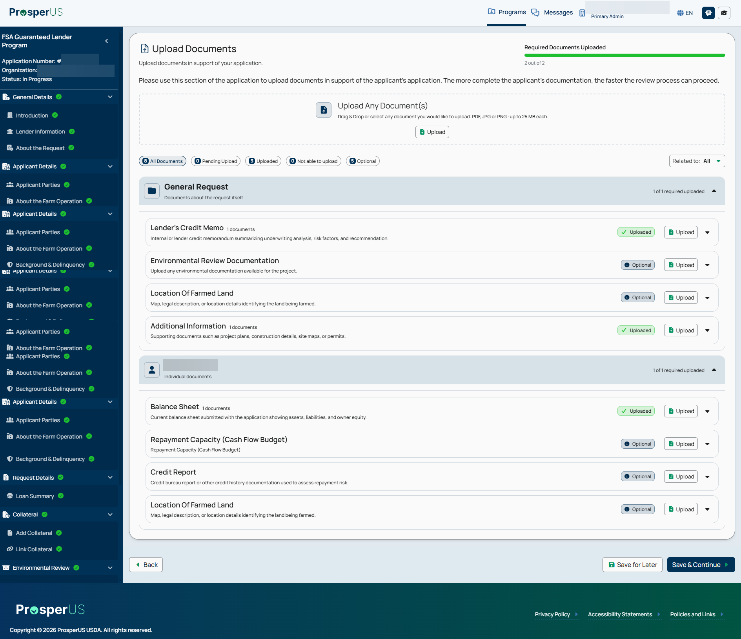

Non-PLP Application Submission - Signing Preference

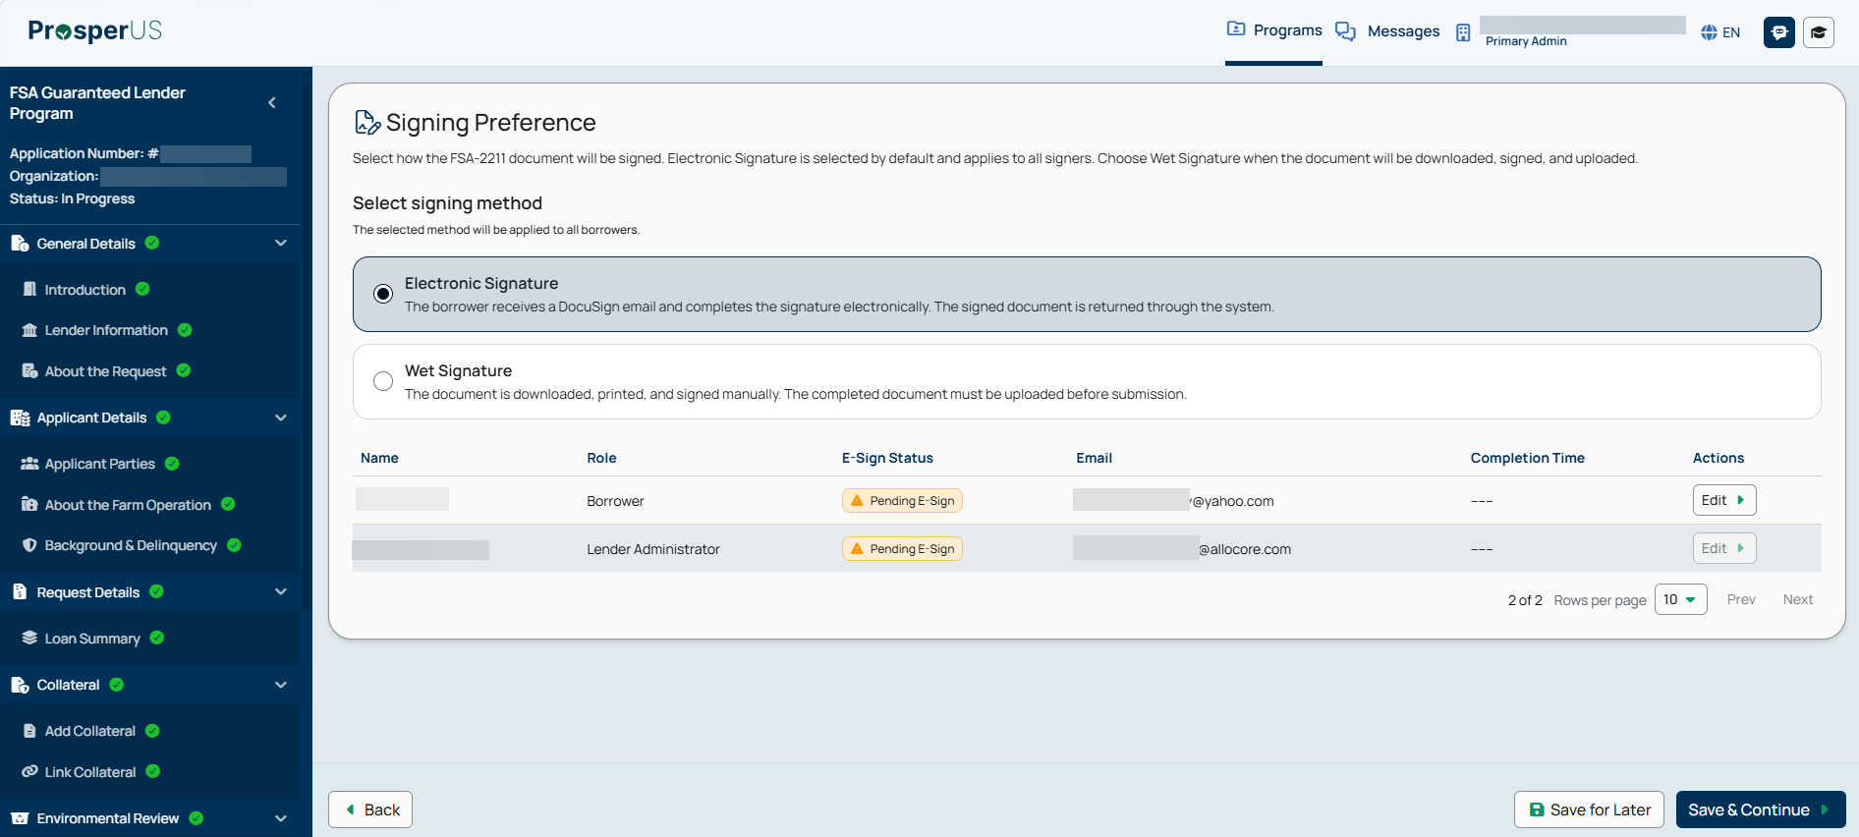

Non-PLP Application Submission - Lender Disclosure

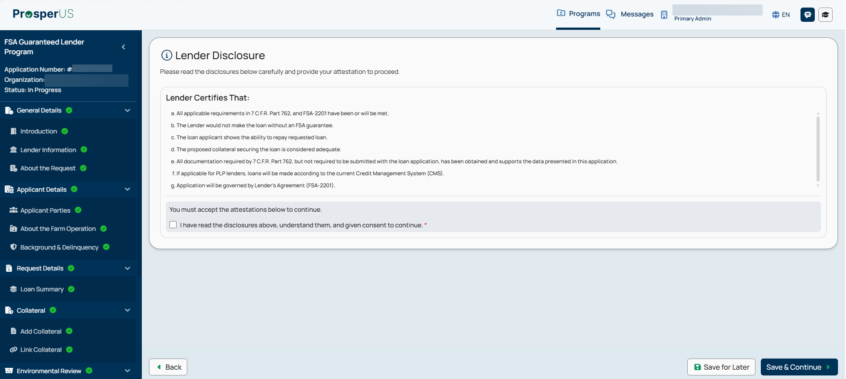

Non-PLP Application Submission - Application Summary

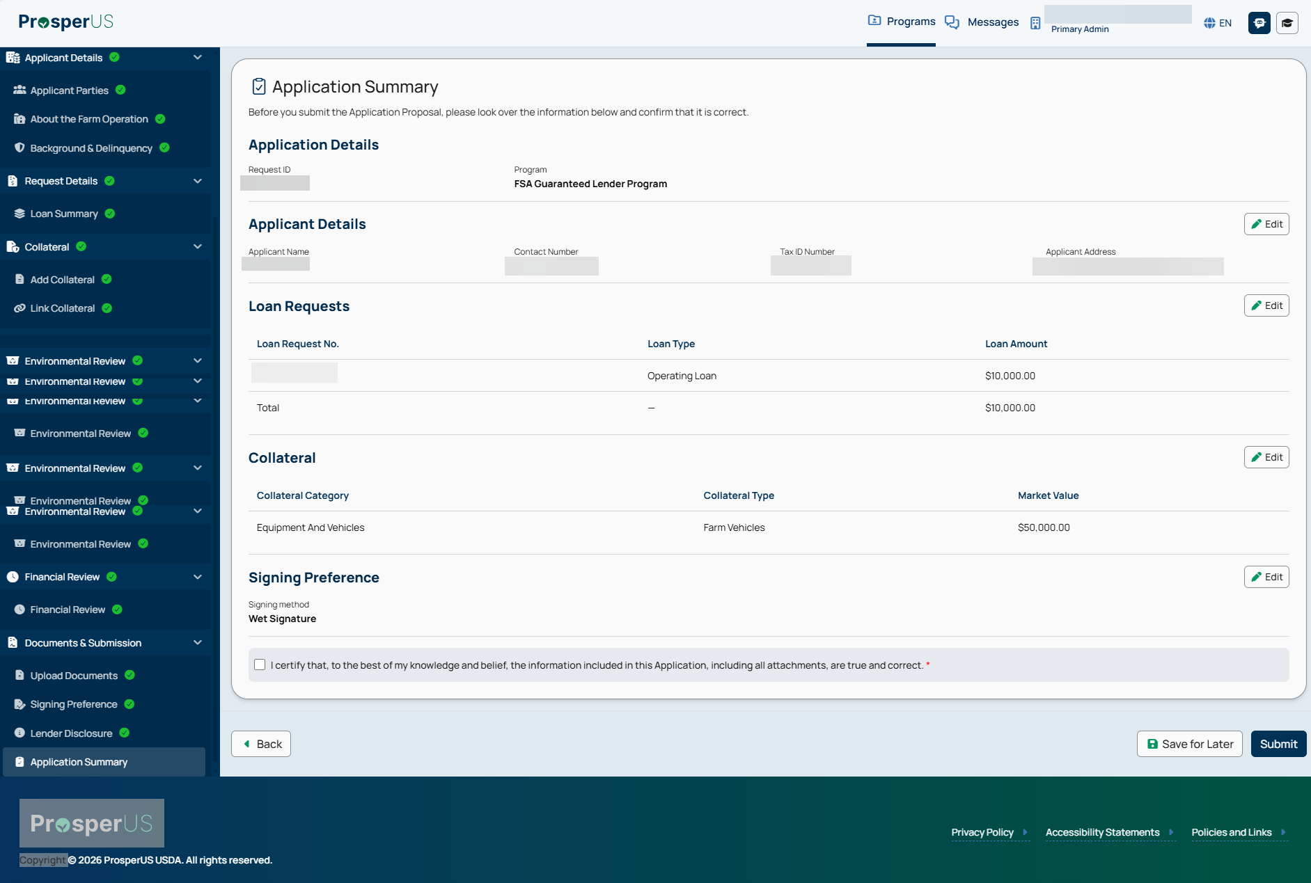

9. Digital Process for Completion of FSA-2232, “Conditional Commitment”

Conditional Commitment - PRA Burden Statement

Public Burden Statement (Paperwork Reduction Act):
Public reporting burden for this collection is estimated to average 15 minutes per response, including reviewing instructions, gathering and maintaining the data needed, completing (providing the information), and reviewing the collection of information. You are not required to respond to the collection, or FSA may not conduct or sponsor a collection of information unless it displays a valid OMB control number of 0560-0155.

Conditional Commitment - USDA Decision Summary

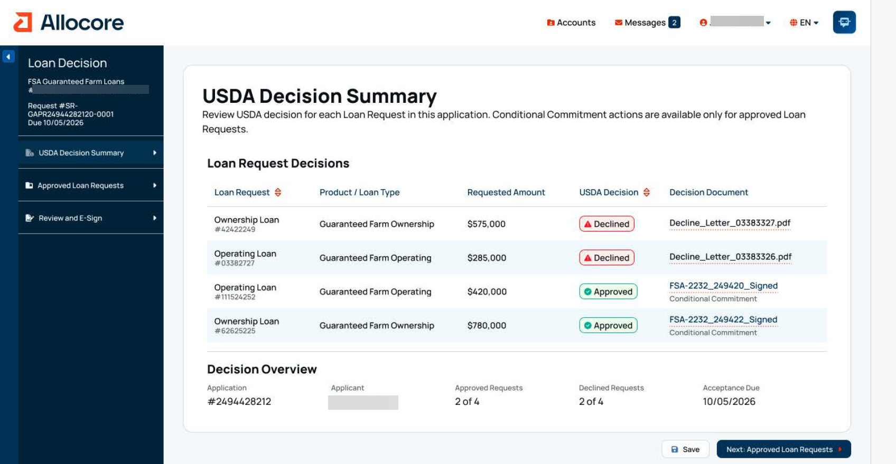

Conditional Commitment - Approved Loan Requests

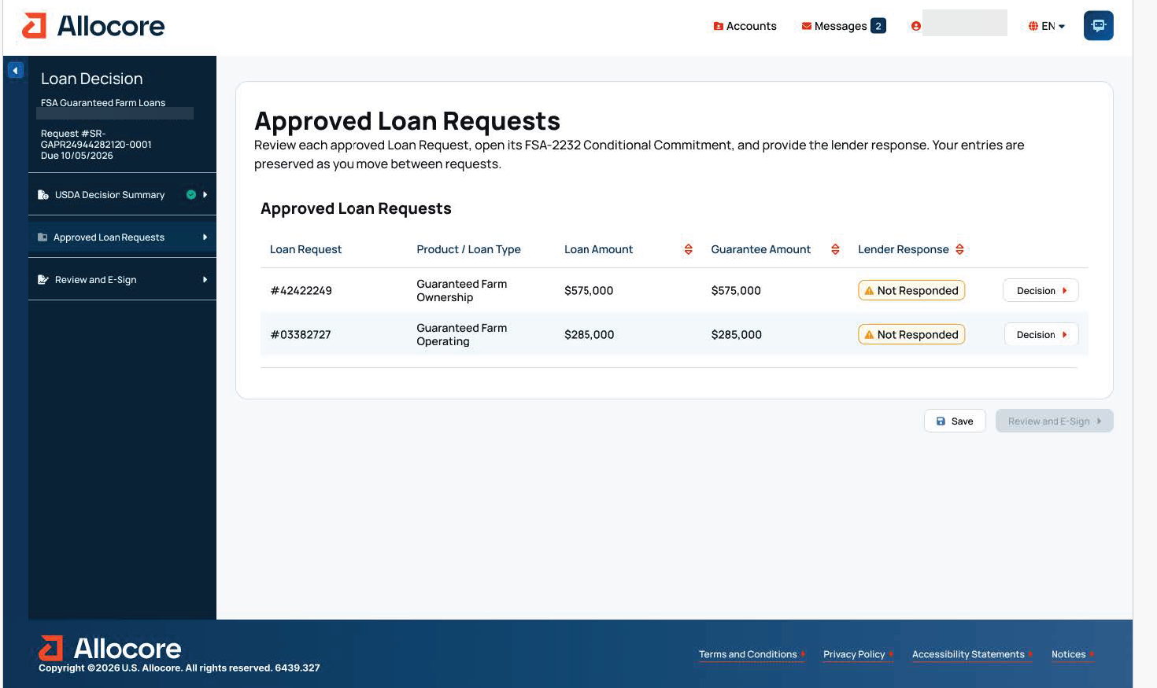

Conditional Commitment – Lender Options - “Yes” Selection
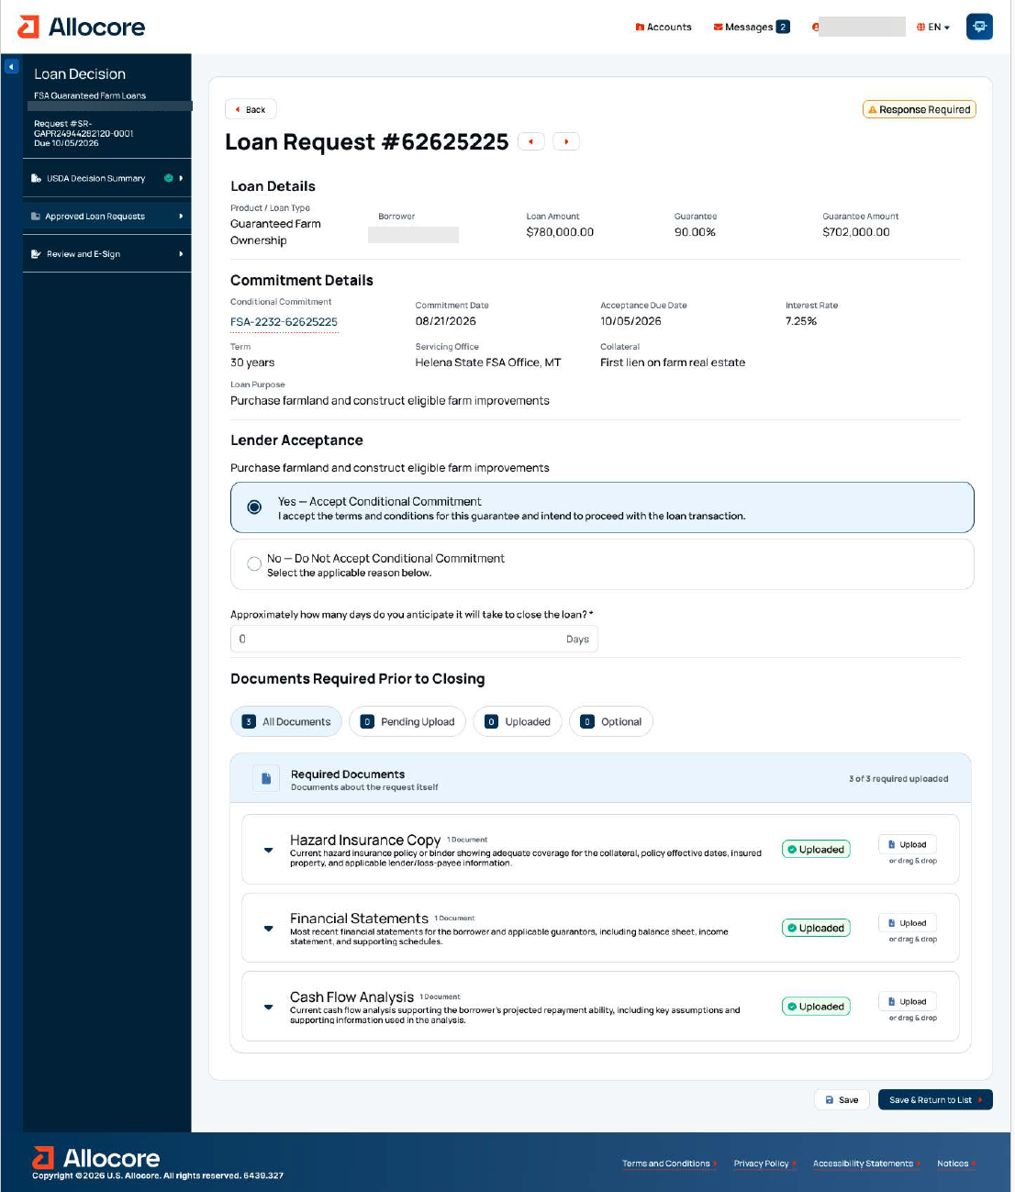

Conditional Commitment – Lender Options – “No” Selection
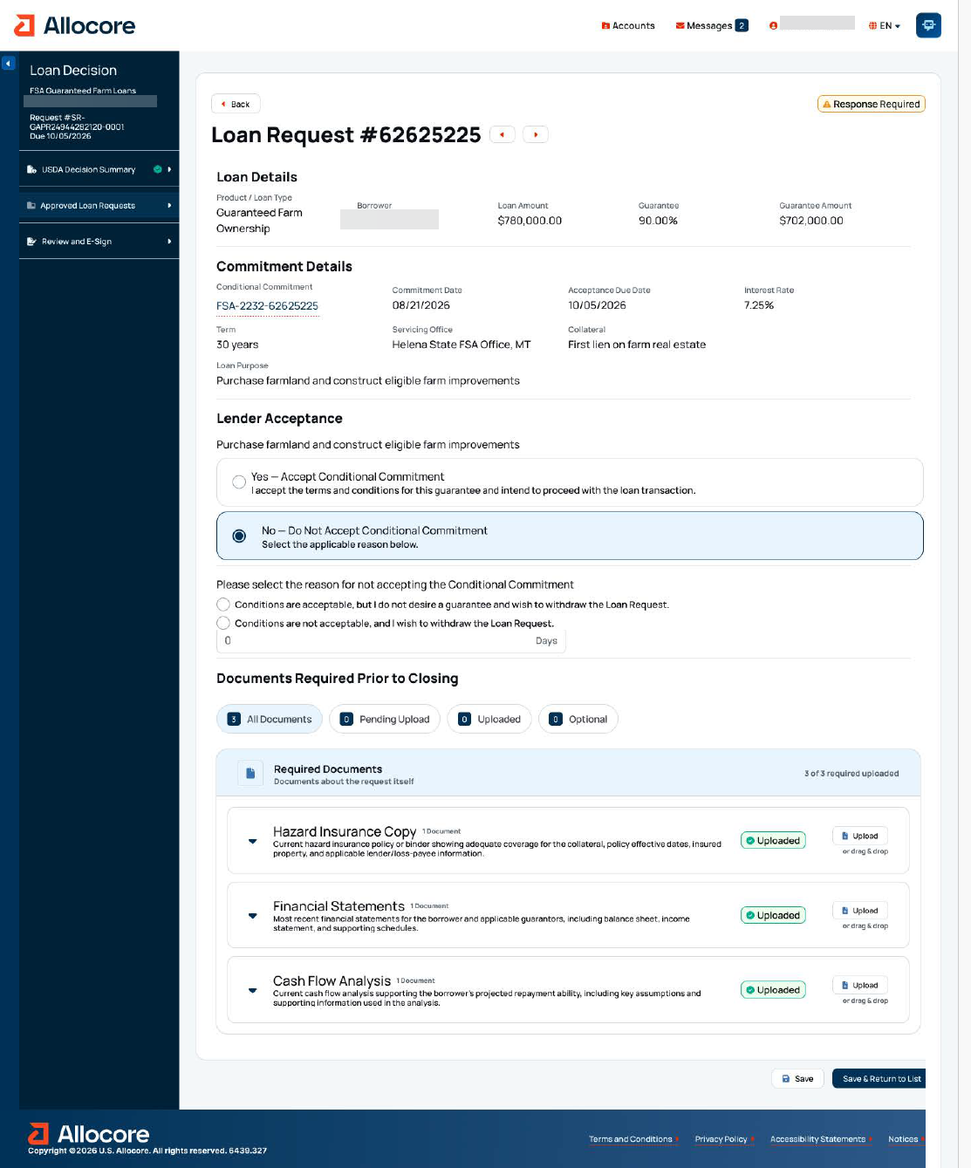

Conditional Commitment - Review & E-Sign

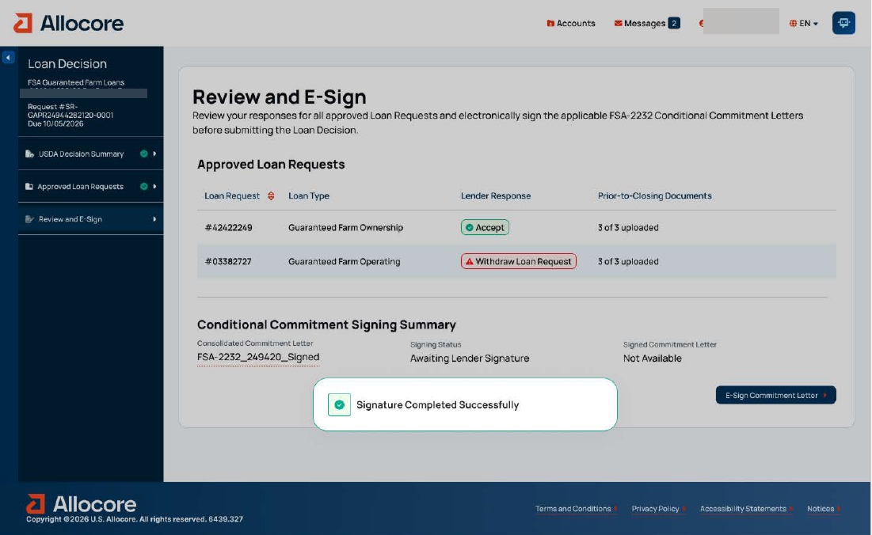

10. Digital Process for Completion of FSA-2236, “Loan Closing Report & Lender Certification”

Loan Closing - PRA Burden Statement

Public Burden Statement (Paperwork Reduction Act):
Public reporting burden for this collection is estimated to average 1.25 hours per response, including reviewing instructions, gathering and maintaining the data needed, completing (providing the information), and reviewing the collection of information. You are not required to respond to the collection, or FSA may not conduct or sponsor a collection of information unless it displays a valid OMB control number of 0560-0155.

Loan Closing - Closing Information

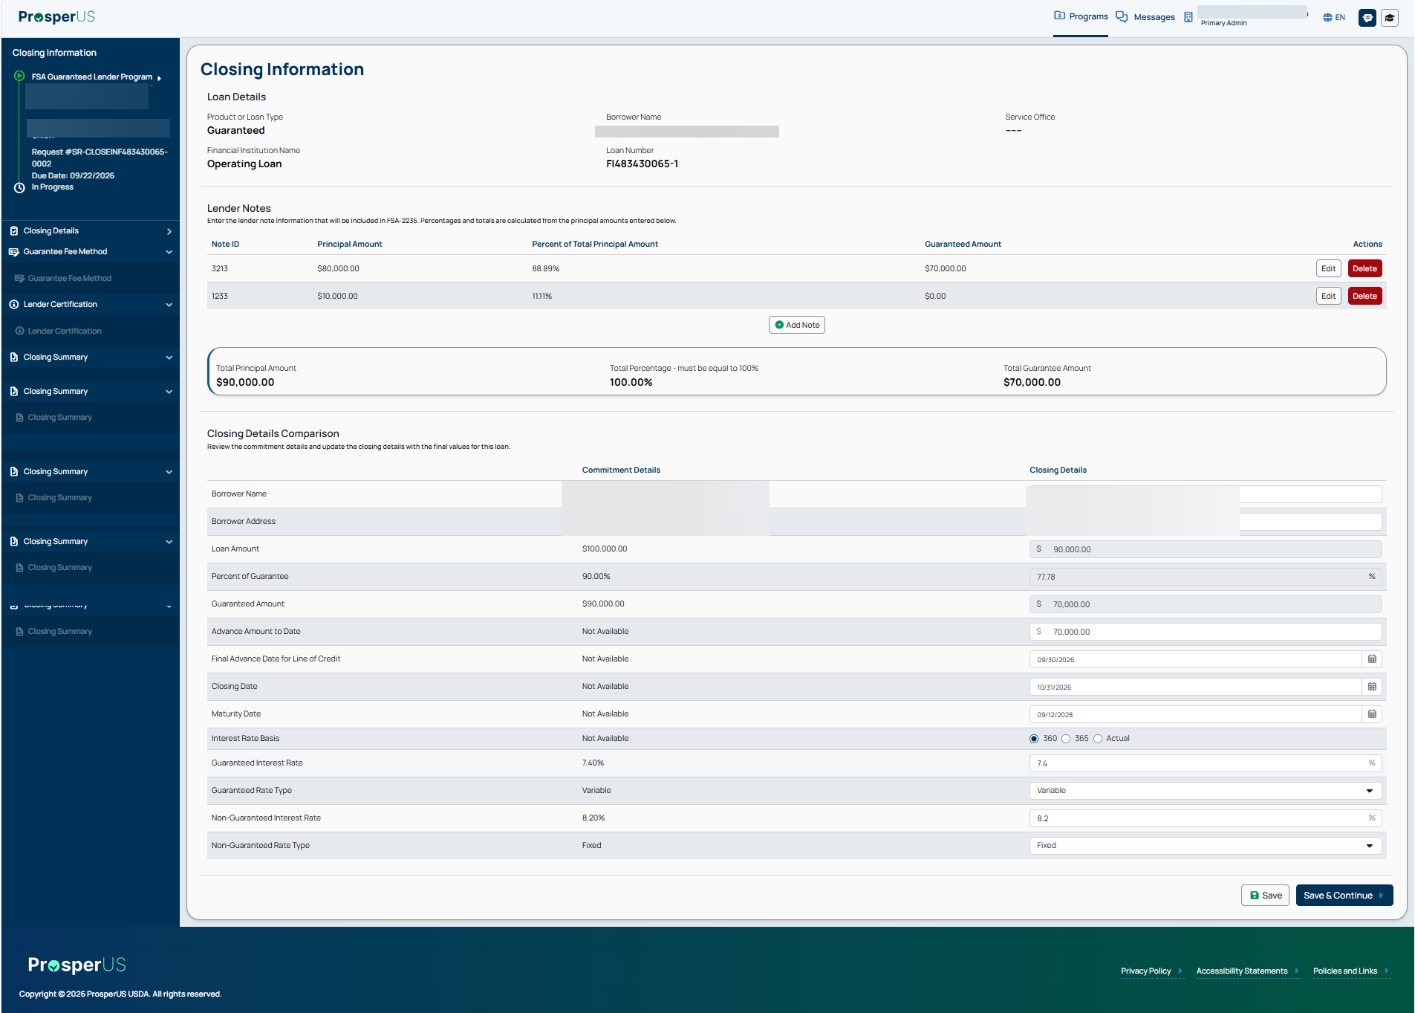

Loan Closing - Use of Proceeds

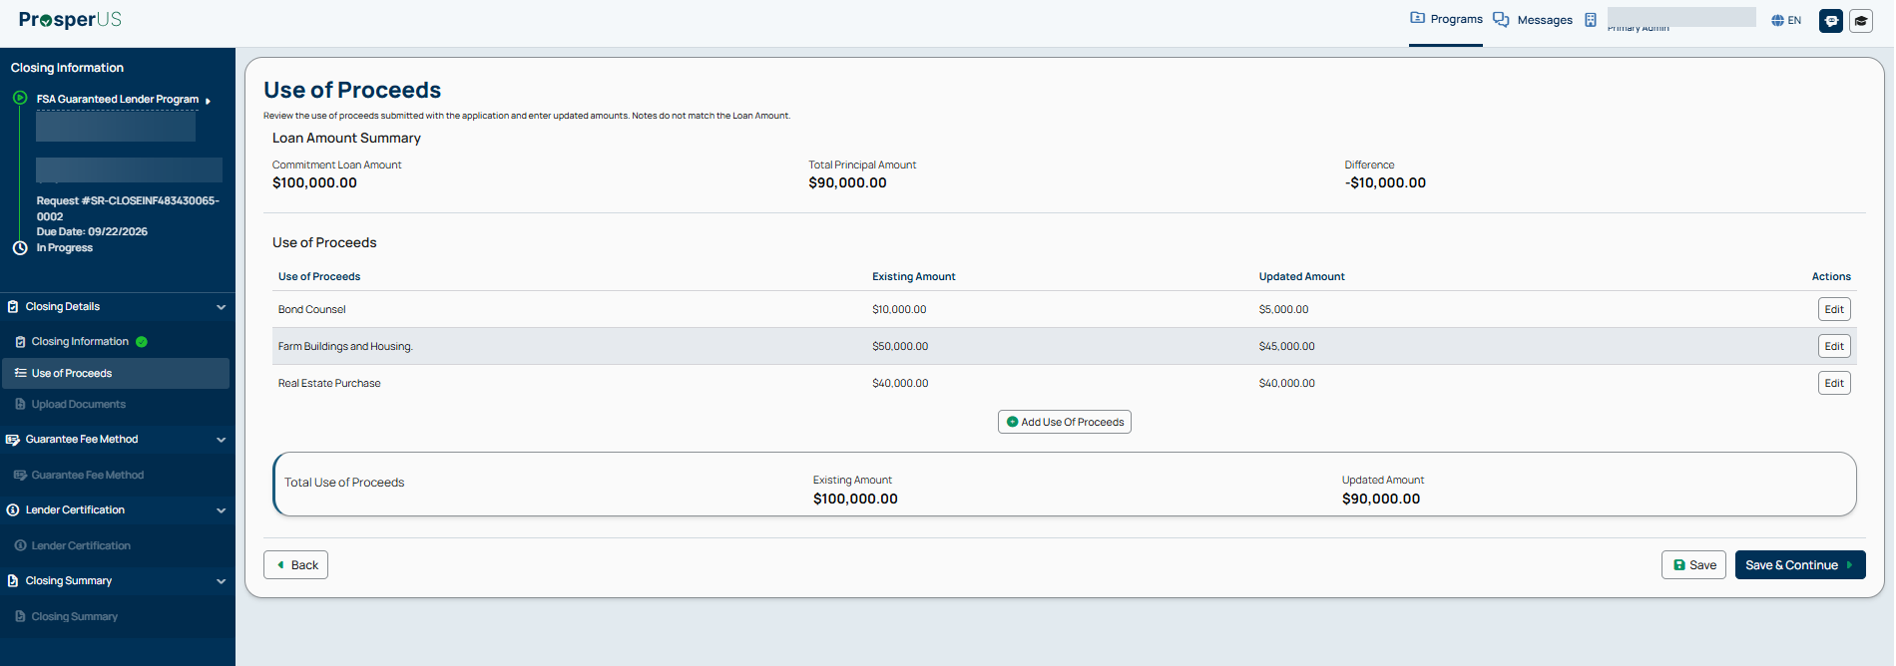

Loan Closing - Upload Documents

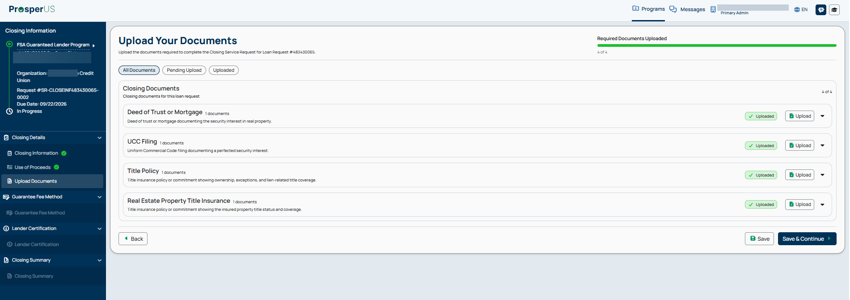

Loan Closing - Guarantee Fee Details

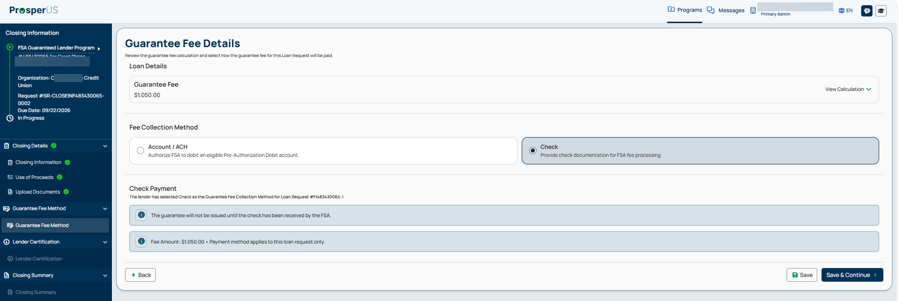

Loan Closing - Lender Certification

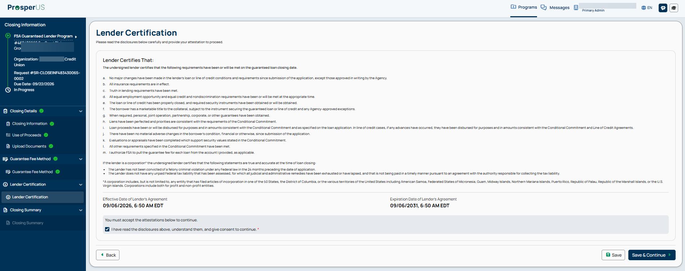

Loan Closing - Closing Summary

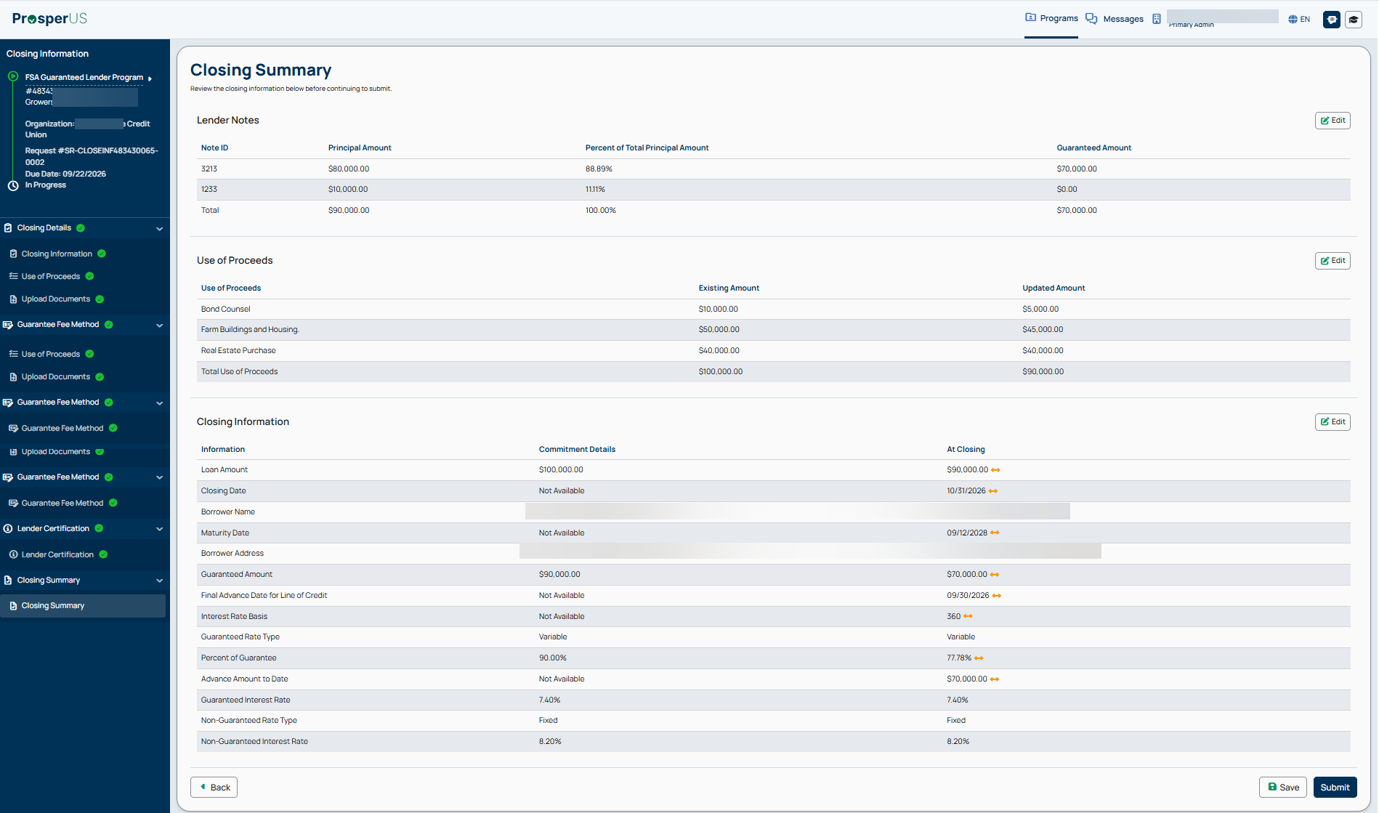

Loan Closing - Use of Proceeds – Change in Amount

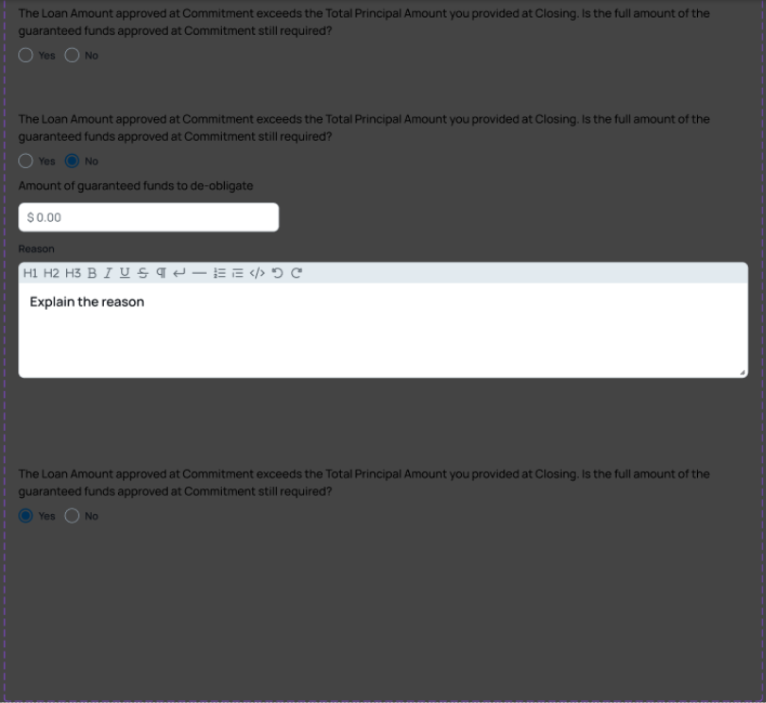

Loan Closing - Closing Confirmation Message

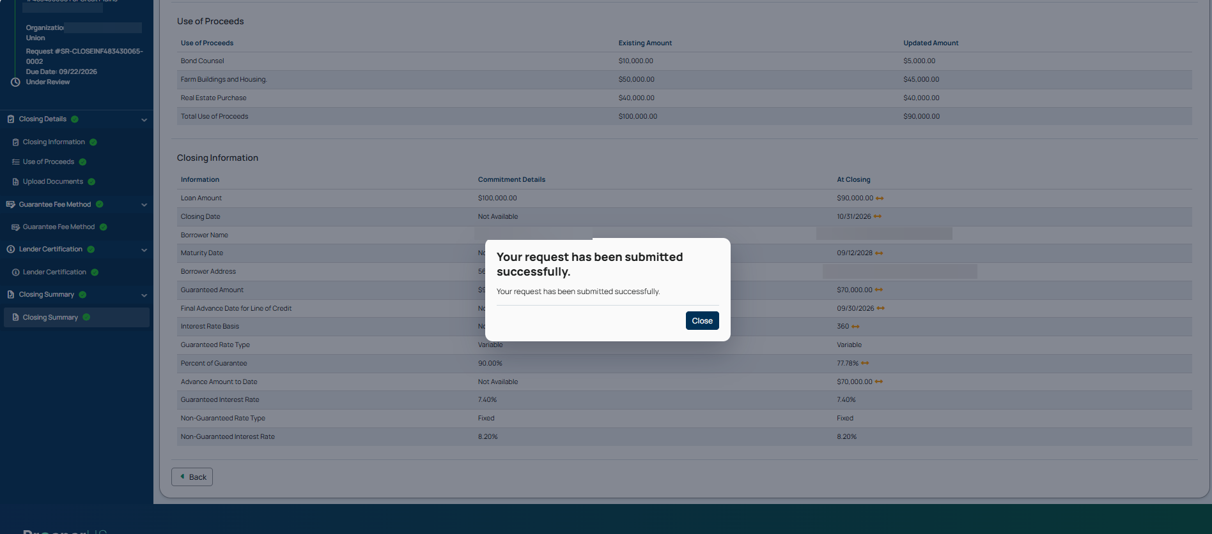

11. Digital Process for Completion of FSA-2241, “Guaranteed Farm Loan Status Report”

Lender Status Report - PRA Burden Statement

Public Burden Statement (Paperwork Reduction Act):
Public reporting burden for this collection is estimated to average 20 minutes per response, including reviewing instructions, gathering and maintaining the data needed, completing (providing the information), and reviewing the collection of information. You are not required to respond to the collection, or FSA may not conduct or sponsor a collection of information unless it displays a valid OMB control number of 0560-0155.

Lender Status Report - Loan Details

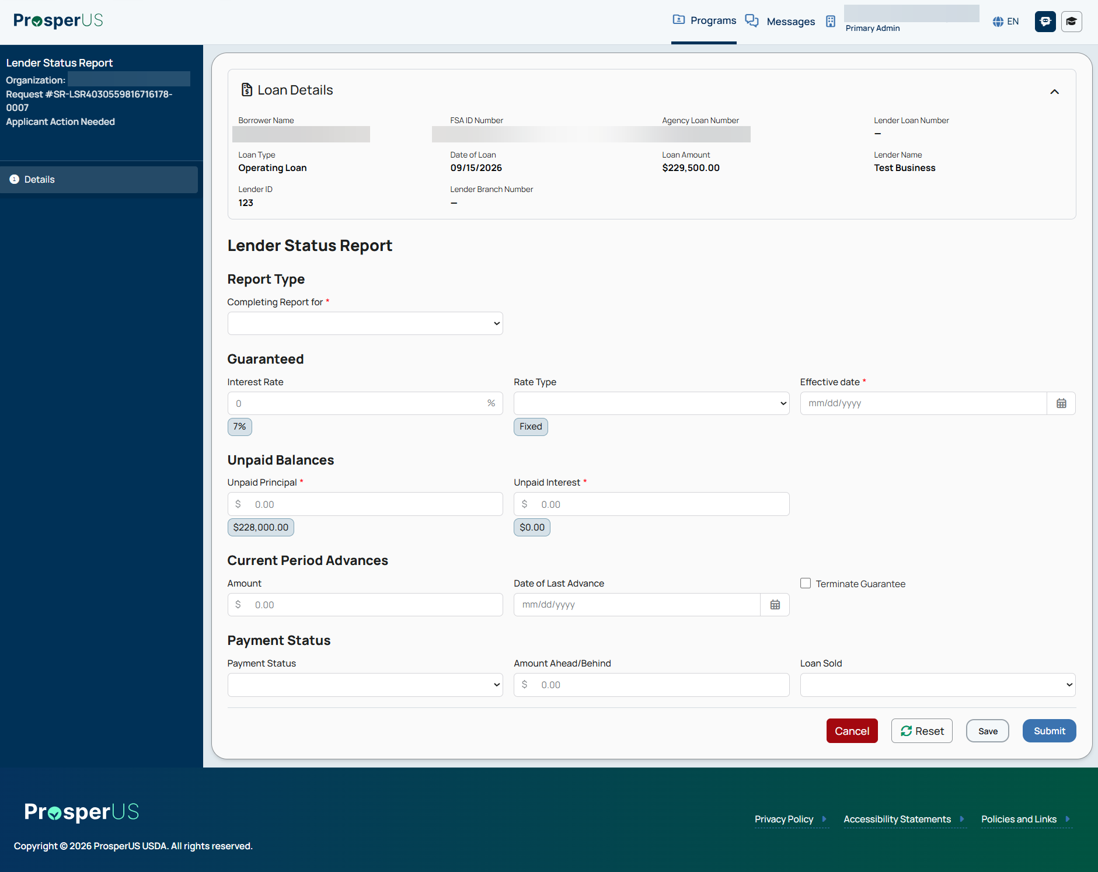

12. Digital Process for Completion of FSA-2242, “Assignment of Guarantee”

Assignment of Guarantee - PRA Burden Statement

Public Burden Statement (Paperwork Reduction Act):
Public reporting burden for this collection is estimated to average 30 minutes per response, including reviewing instructions, gathering and maintaining the data needed, completing (providing the information), and reviewing the collection of information. You are not required to respond to the collection, or FSA may not conduct or sponsor a collection of information unless it displays a valid OMB control number of 0560-0155.

Assignment of Guarantee – New Holder and Assignment Details

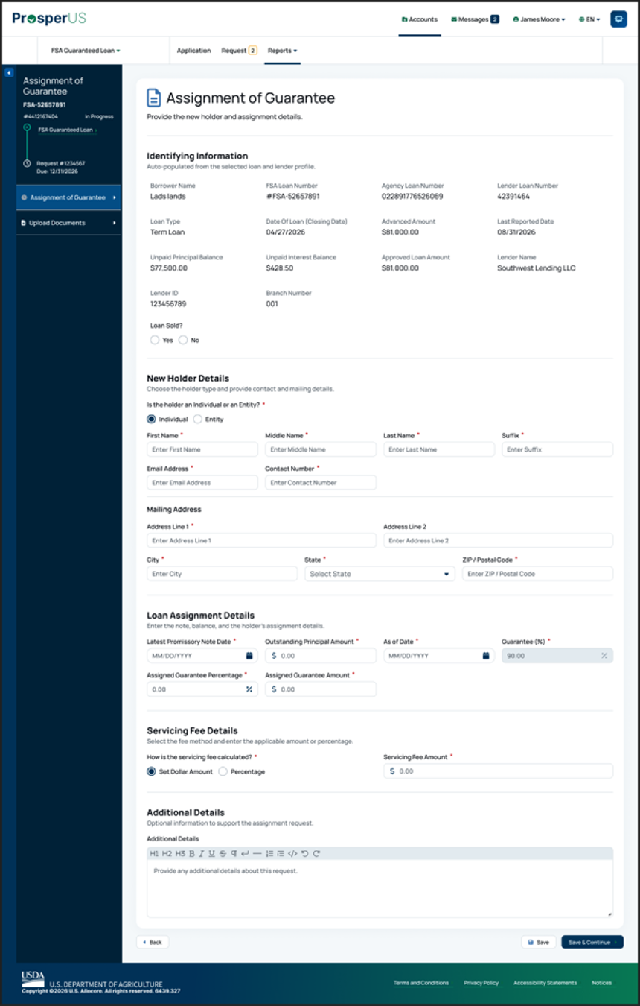

13. Digital Process for Completion of FSA-2248, “Guaranteed Farm Loan Default Status Report”

Default Status Report - PRA Burden Statement

Public Burden Statement (Paperwork Reduction Act):
Public reporting burden for this collection is estimated to average 20 minutes per response, including reviewing instructions, gathering and maintaining the data needed, completing (providing the information), and reviewing the collection of information. You are not required to respond to the collection, or FSA may not conduct or sponsor a collection of information unless it displays a valid OMB control number of 0560-0155.

Default Status Report - Default and Balance Details

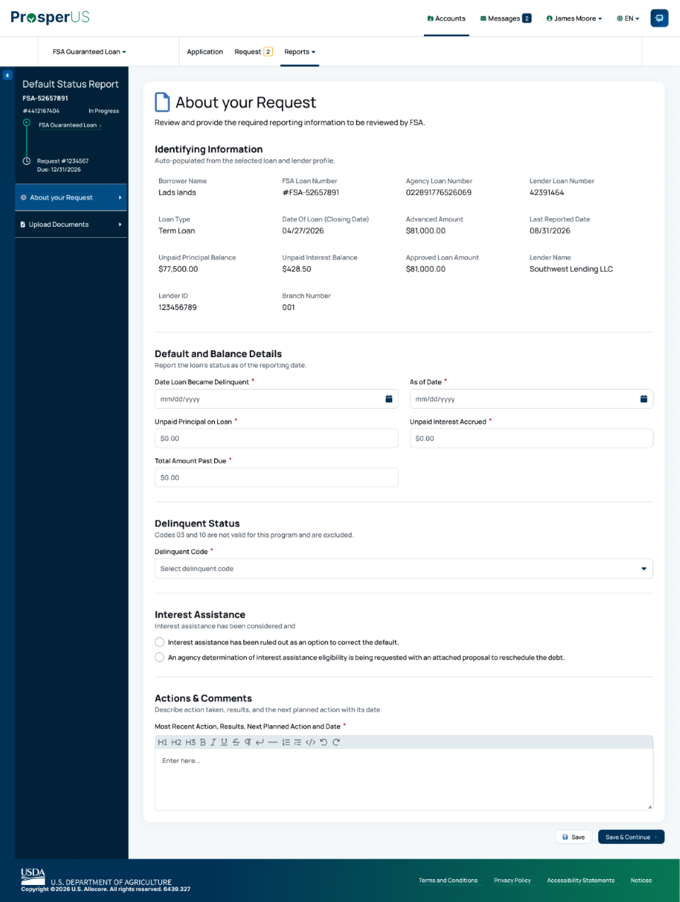

Default Status Report (continued)

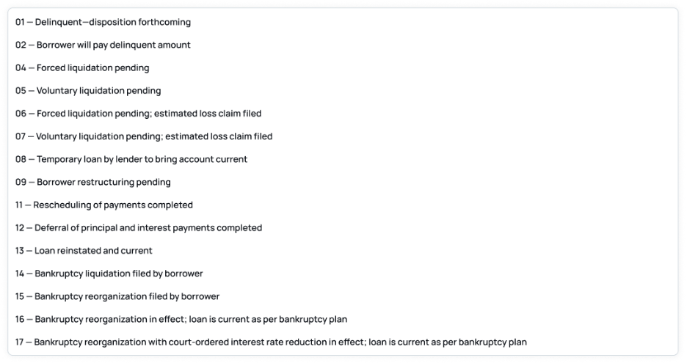

Default Status Report - Documents

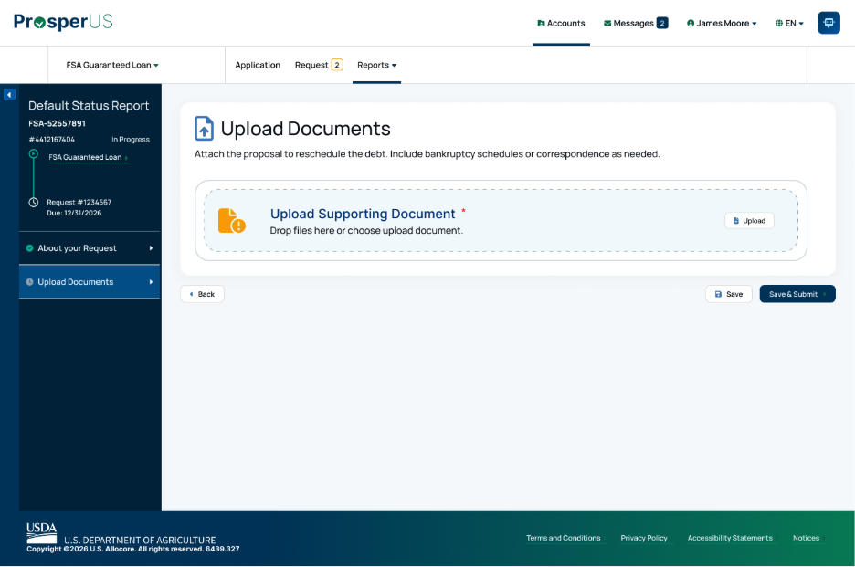

14. Digital Process for Completion of FSA-2254, “Guaranteed Loan Report of Loss”

Report of Loss - PRA Burden Statement

Public Burden Statement (Paperwork Reduction Act):
Public reporting burden for this collection is estimated to average 25 hours per response, including reviewing instructions, gathering and maintaining the data needed, completing (providing the information), and reviewing the collection of information. You are not required to respond to the collection, or FSA may not conduct or sponsor a collection of information unless it displays a valid OMB control number of 0560-0155.

Report of Loss - About the Request

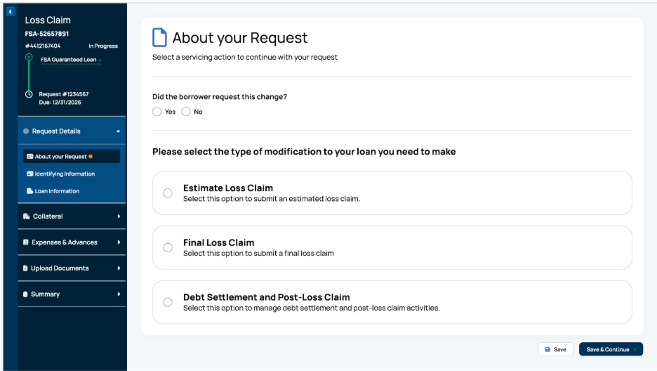
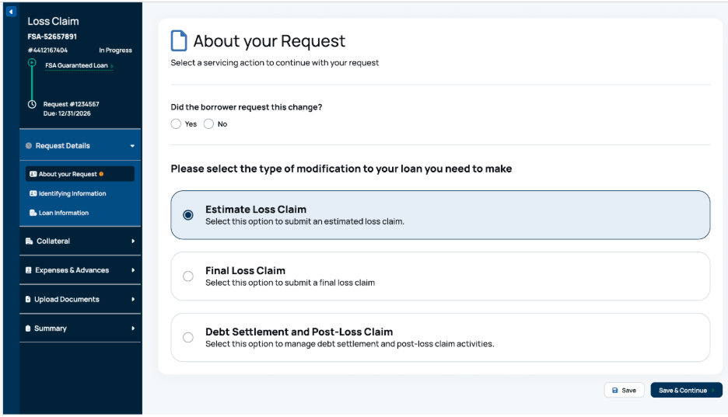

Report of Loss - Identifying Information

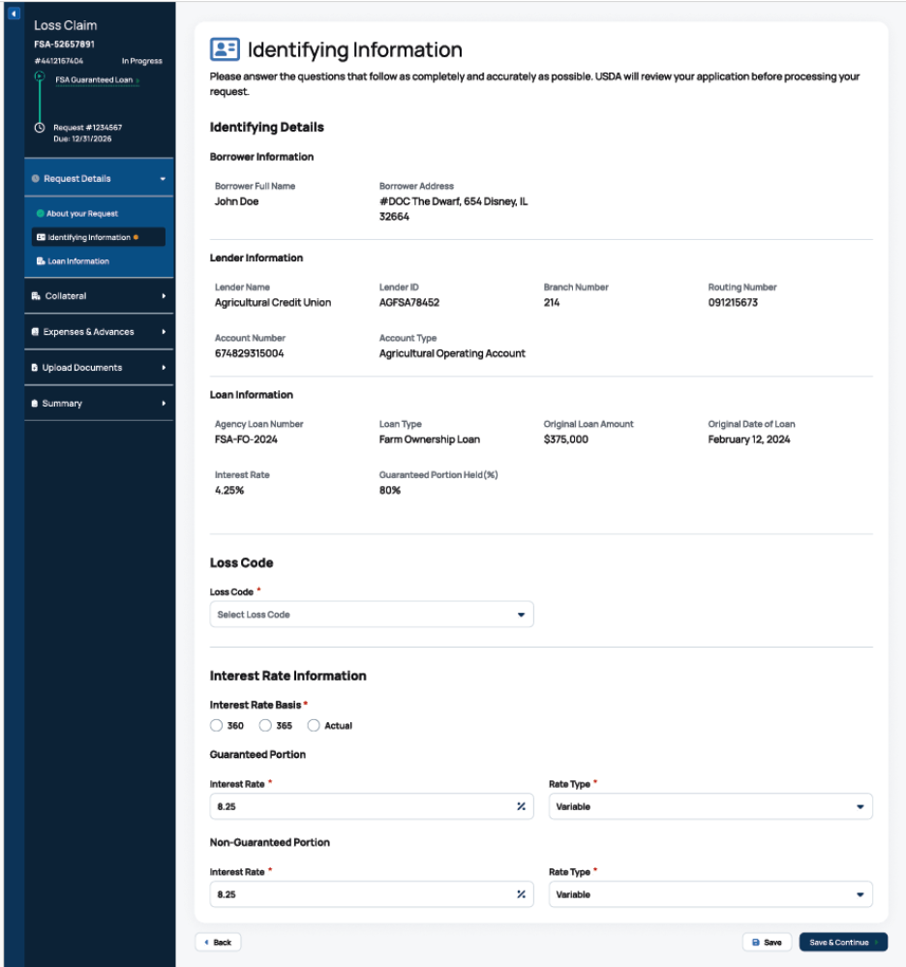

Report of Loss - Loss Code Options

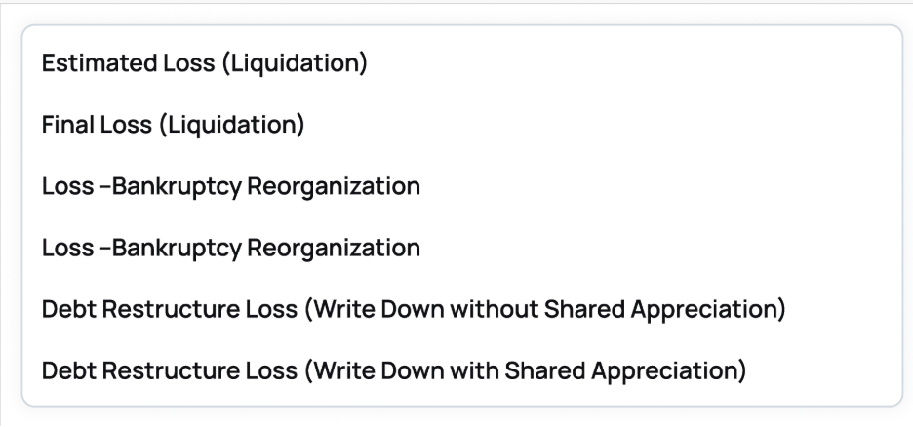

Report of Loss - Loan Information

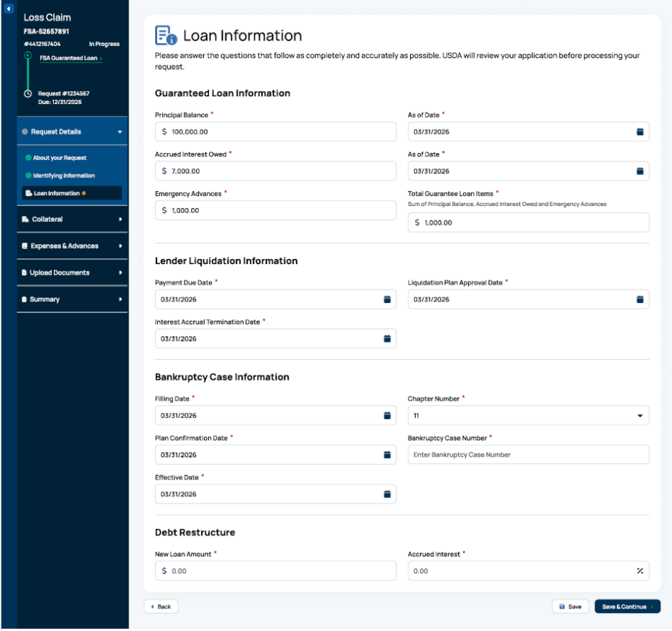

Report of Loss - Collateral

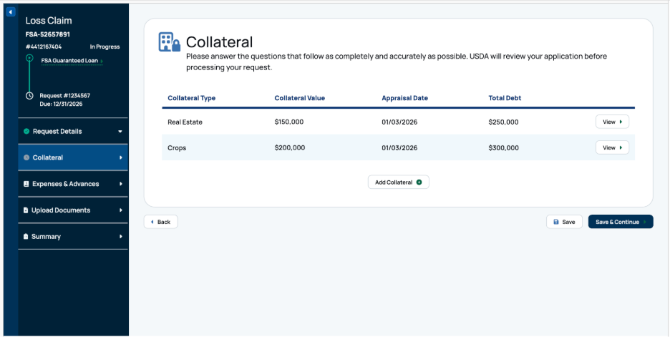

Report of Loss - Add Collateral

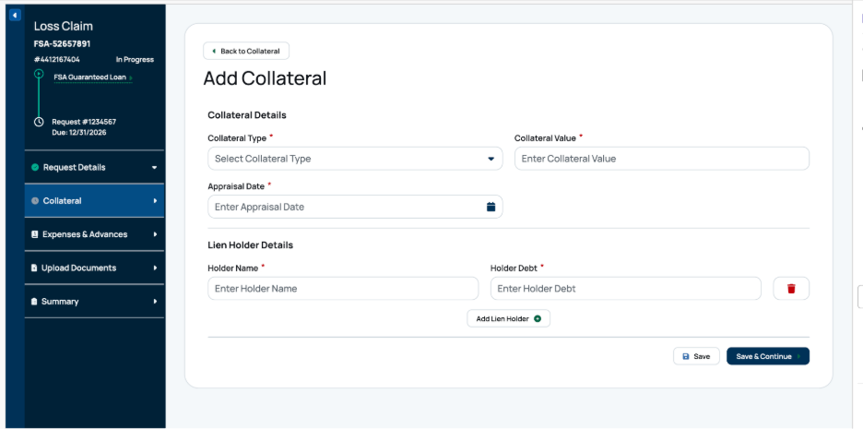

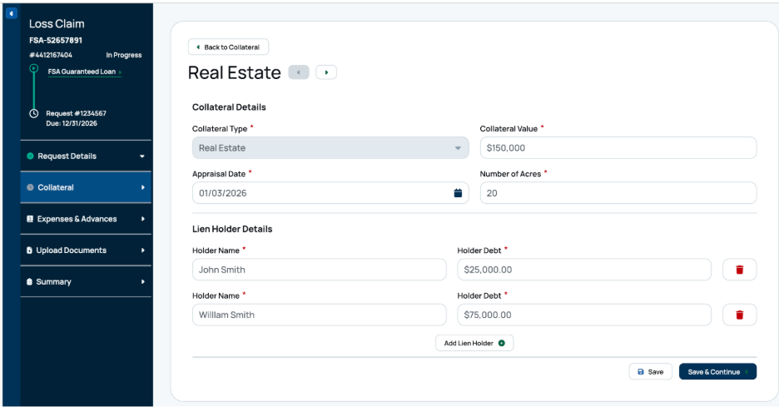

Report of Loss – Add Collateral (continued)

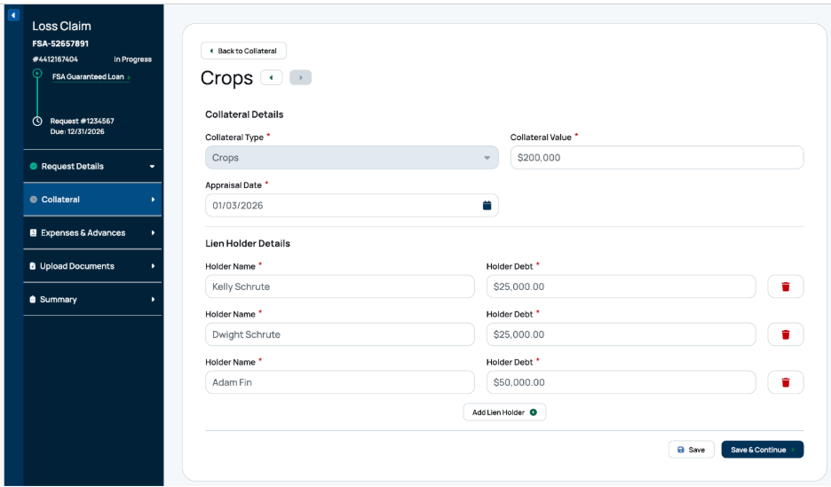

Report of Loss - Expenses & Advances

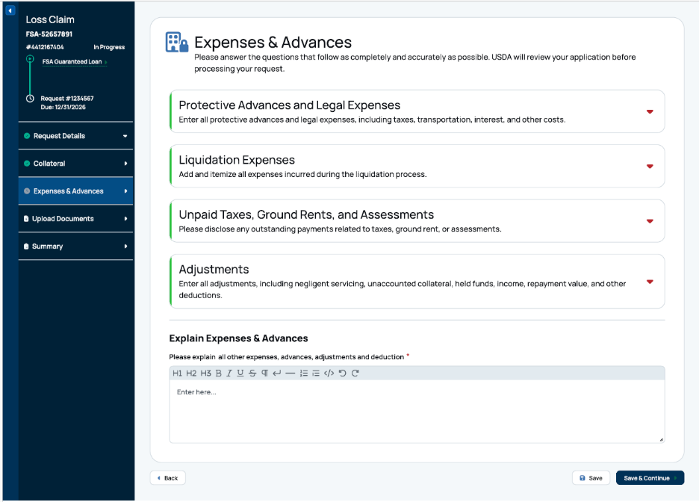
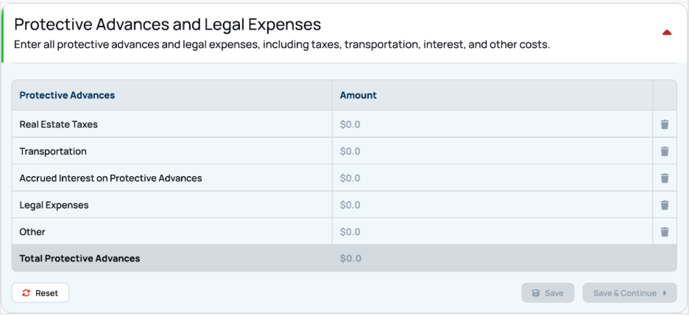

Report of Loss - Expenses & Advances (continued)

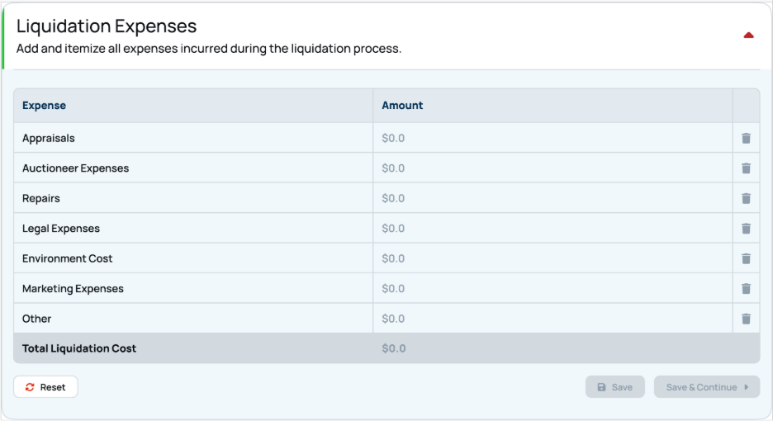

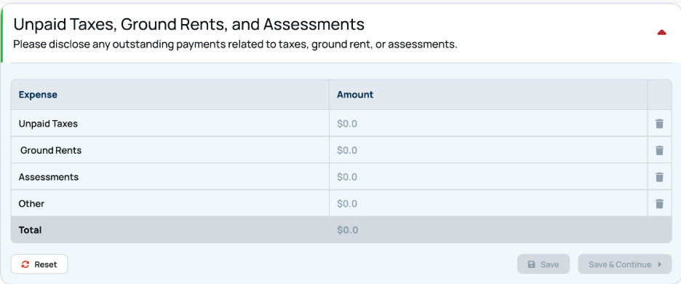

Report of Loss - Expenses & Advances (continued)

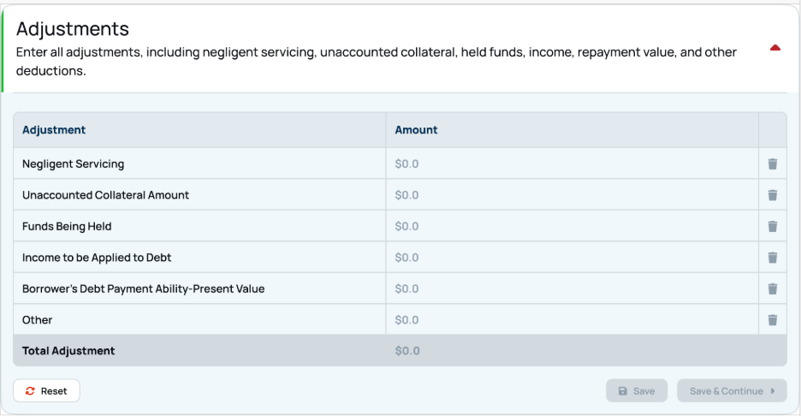

Report of Loss - Documents

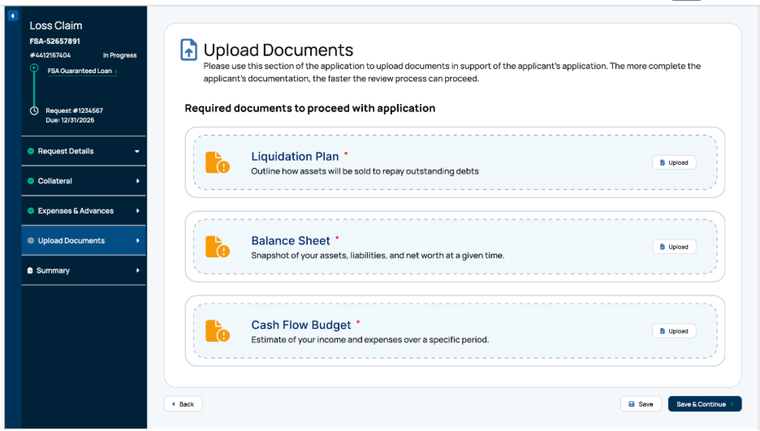

Report of Loss - Summary

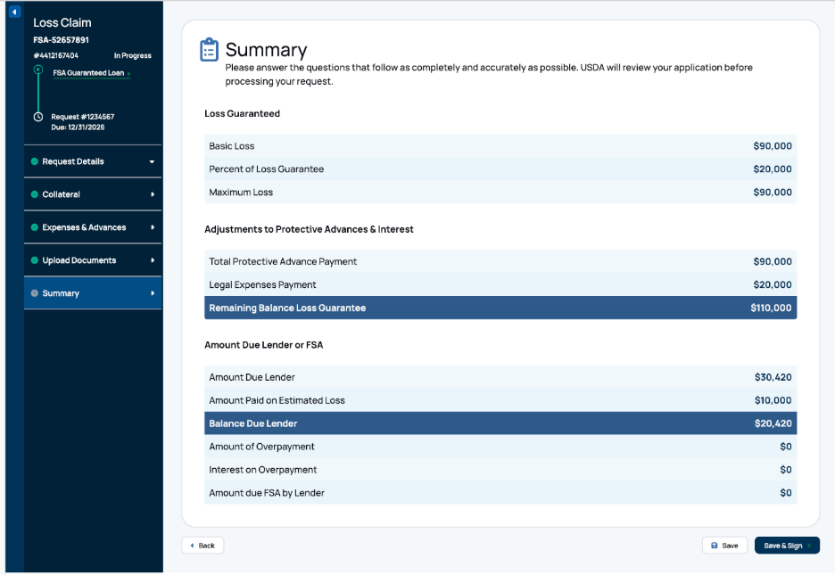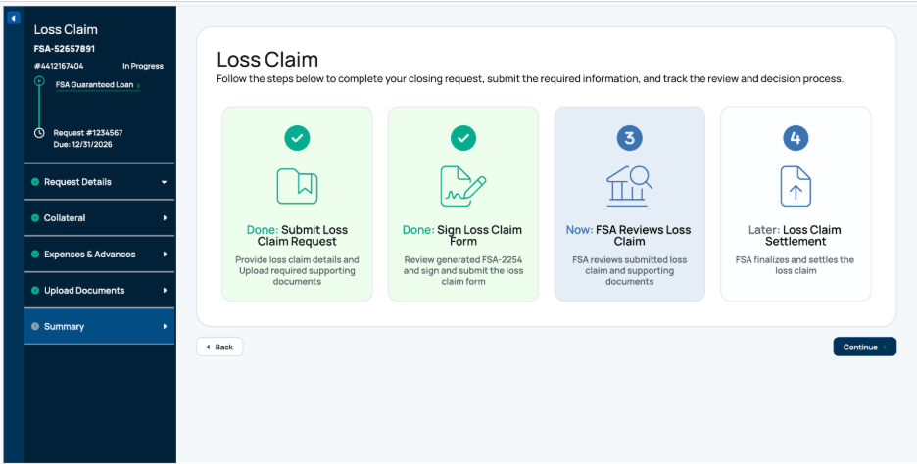

15. Digital Process for CLP to PLP Status Upgrade

CLP to PLP Upgrade - PRA Burden Statement

Non-form

Public Burden Statement (Paperwork Reduction Act):
Public reporting burden for this collection is estimated to average 5 hours per response, including reviewing instructions, gathering and maintaining the data needed, completing (providing the information), and reviewing the collection of information. You are not required to respond to the collection, or FSA may not conduct or sponsor a collection of information unless it displays a valid OMB control number of 0560-0155.

CLP to PLP Upgrade - Programs Landing Page

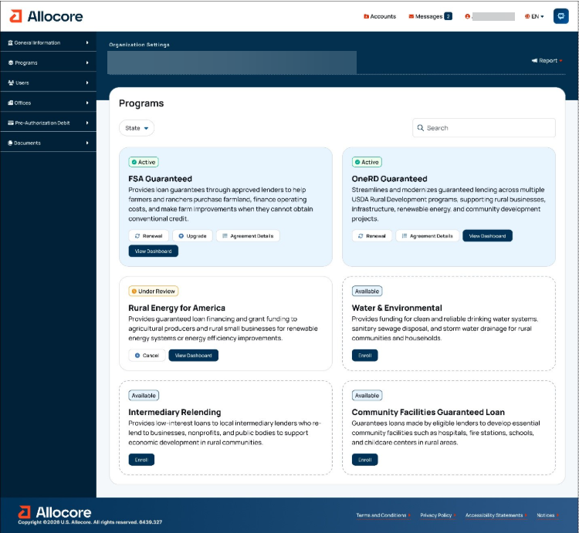

CLP to PLP Upgrade - Introduction

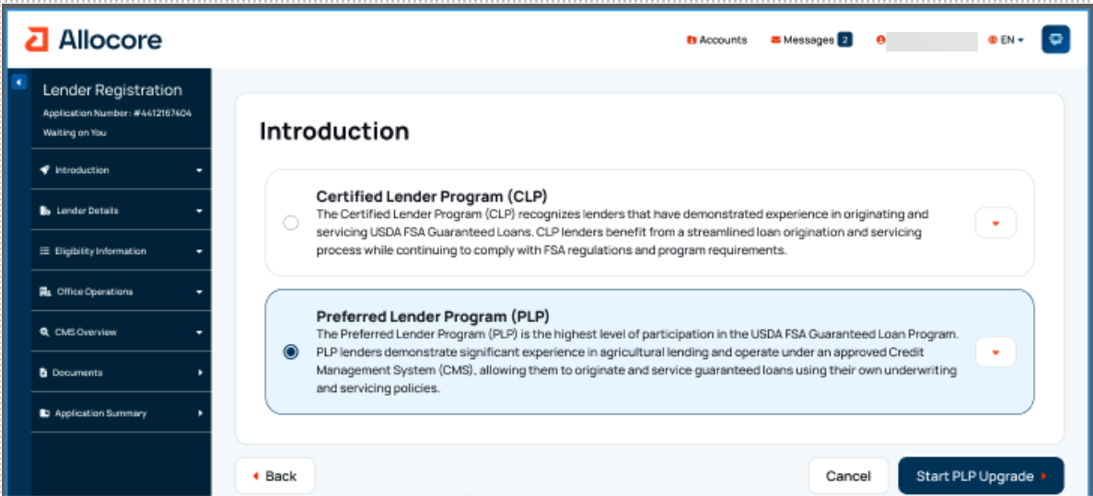

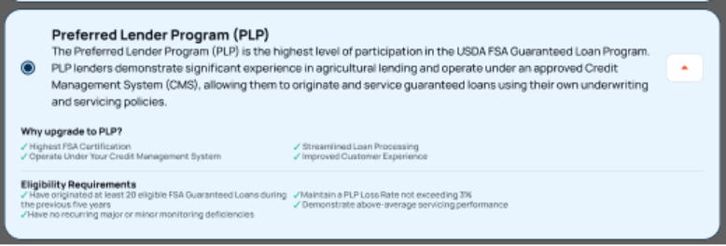

CLP to PLP Upgrade - Organization Information

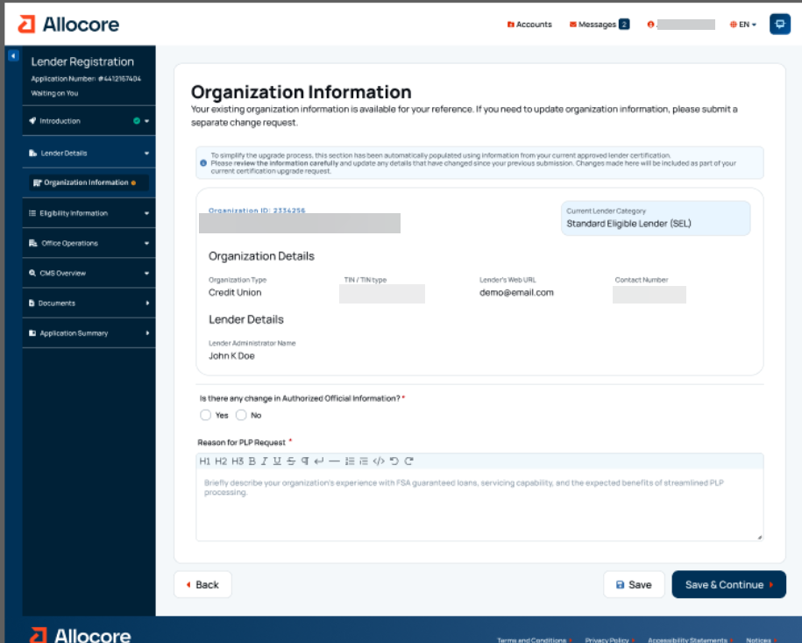

CLP to PLP Upgrade - Organization Information (continued)

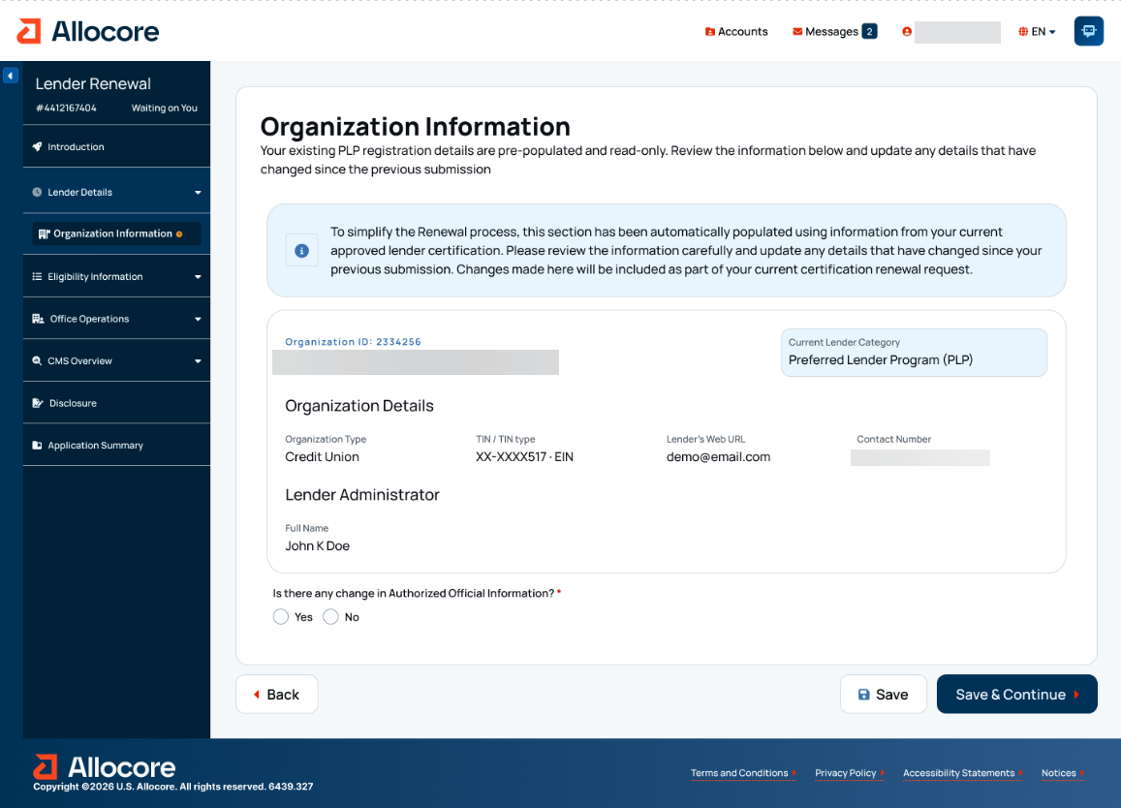
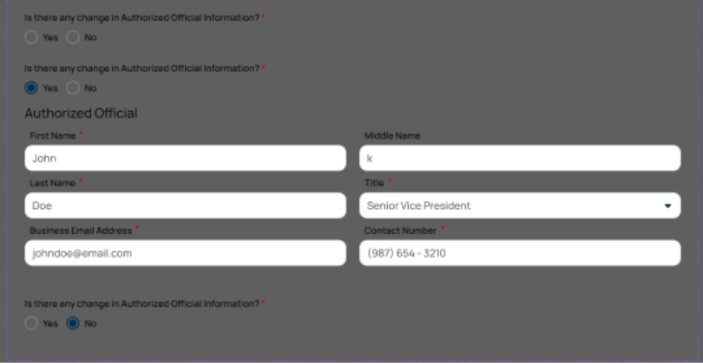

CLP to PLP Upgrade - Regulatory Information

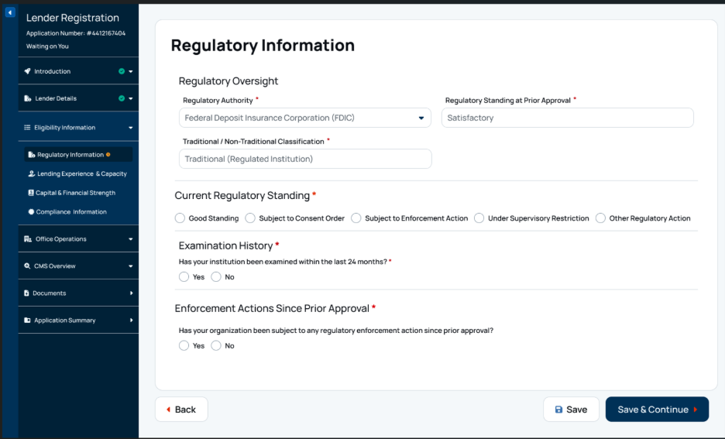

CLP to PLP Upgrade – Regulatory Oversight (continued)

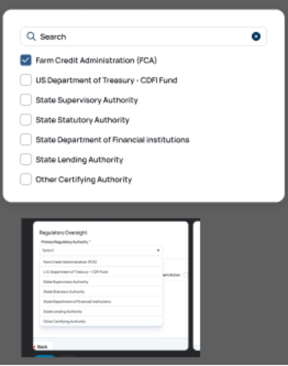
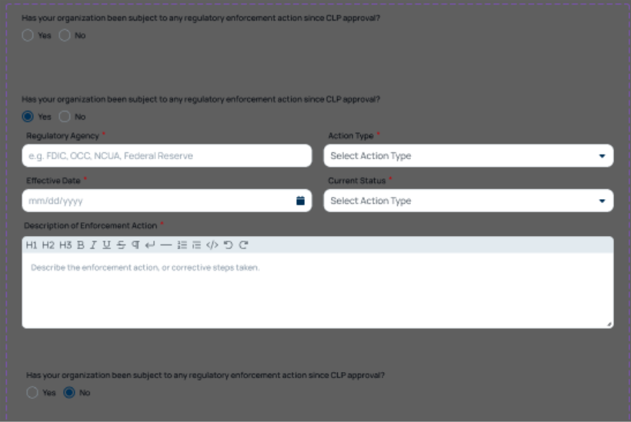

CLP to PLP Upgrade - Organizational Details – Regulatory Information (continued)
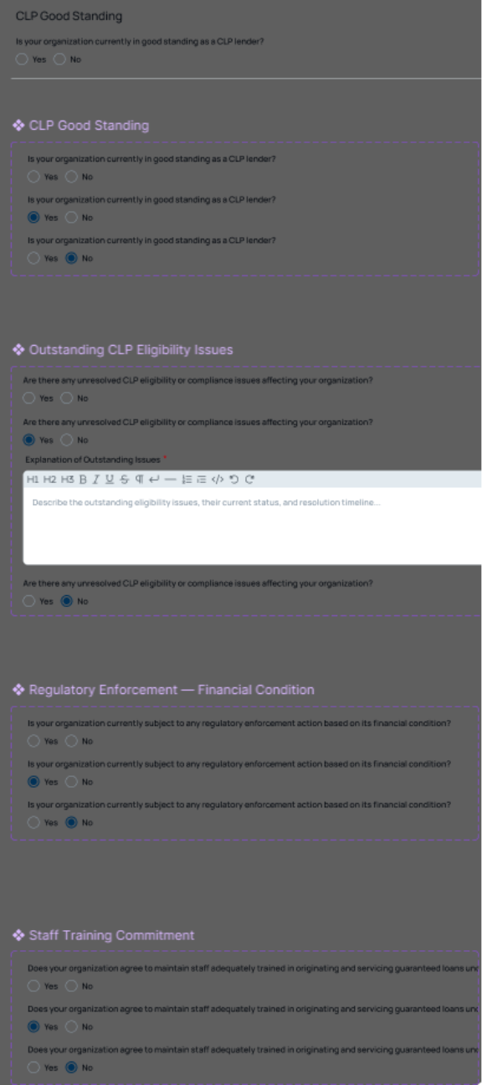

CLP to PLP Upgrade - Lending Experience & Capacity

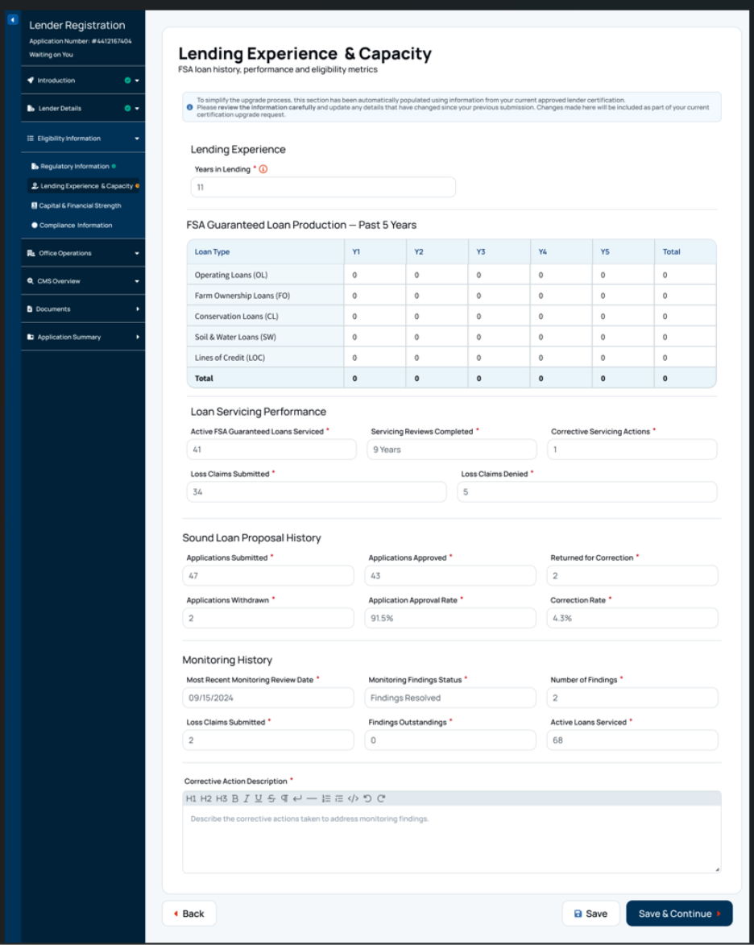

CLP to PLP Upgrade - Capital & Financial Strength

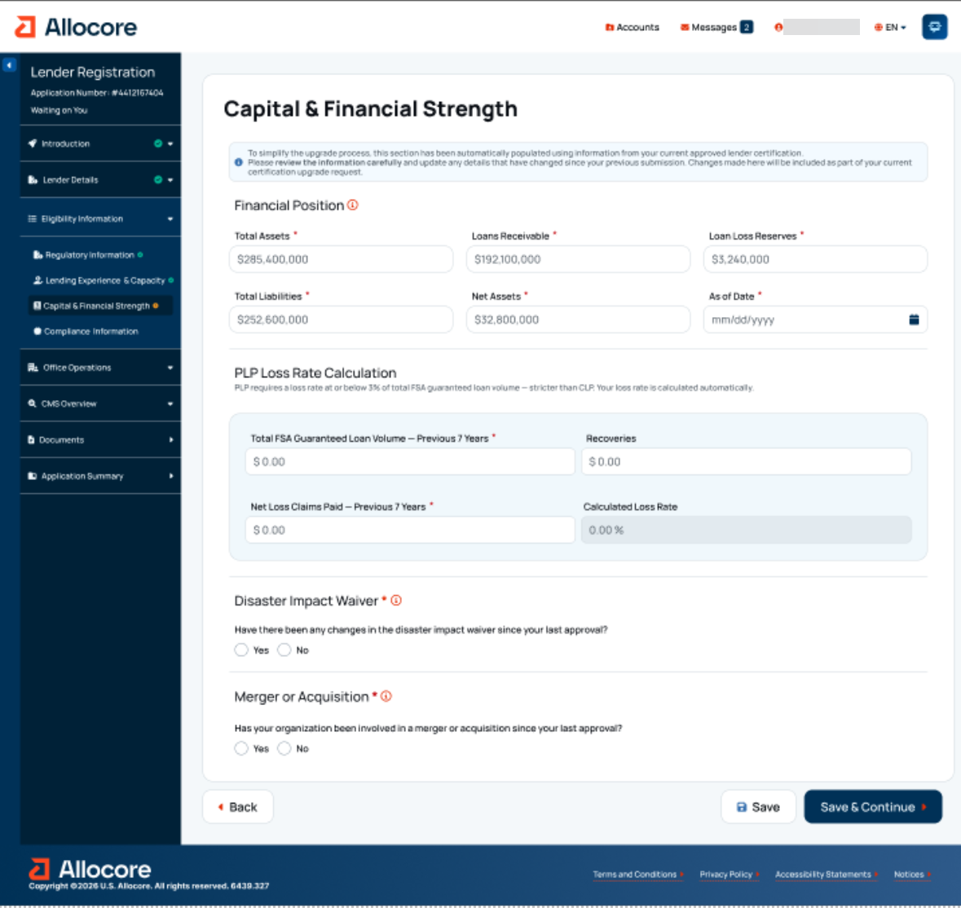

CLP to PLP Upgrade - Capital and Financial Strength (continued)
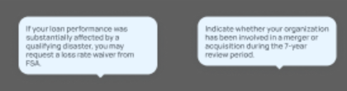
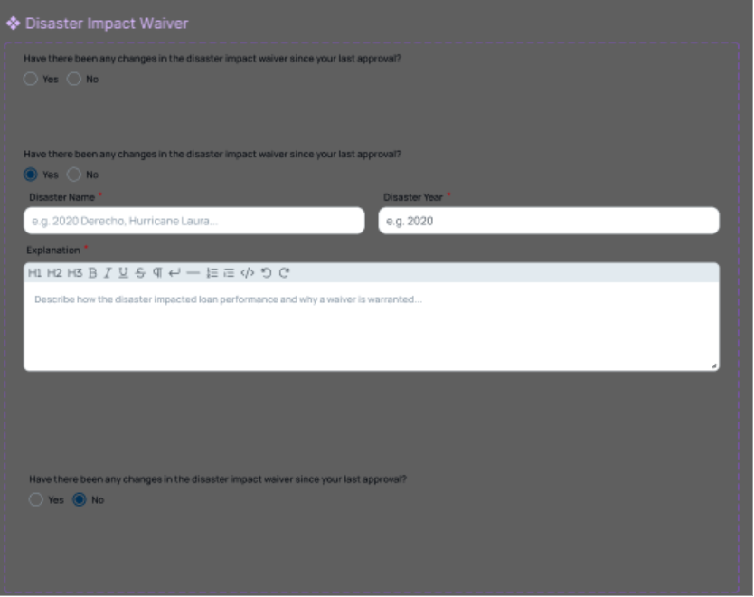
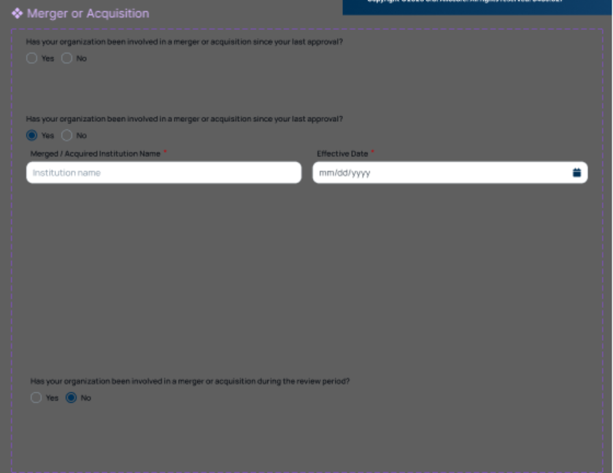
CLP to PLP Upgrade – Capital & Financial Strength (continued)
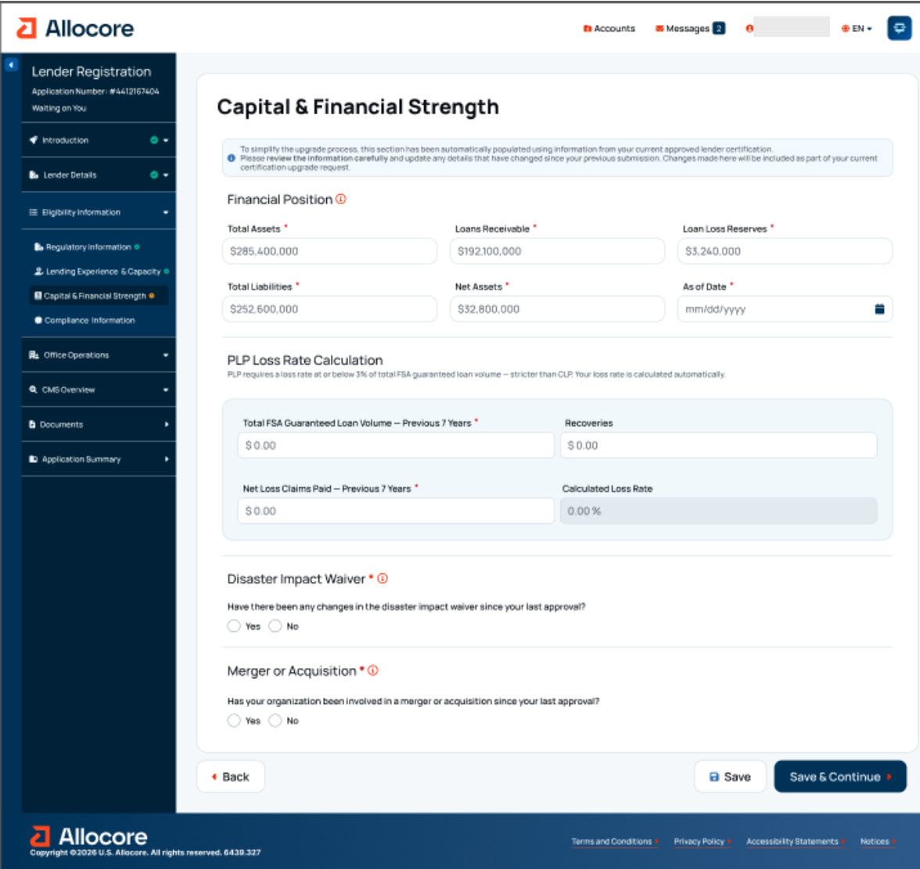

CLP to PLP Upgrade - Compliance Information

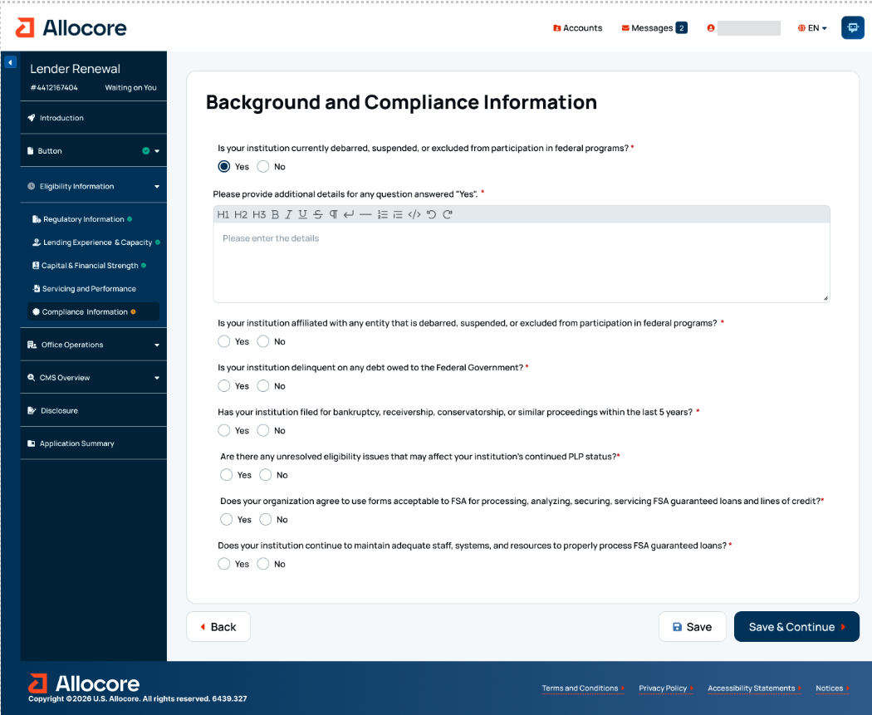

CLP to PLP Upgrade - Office Operations

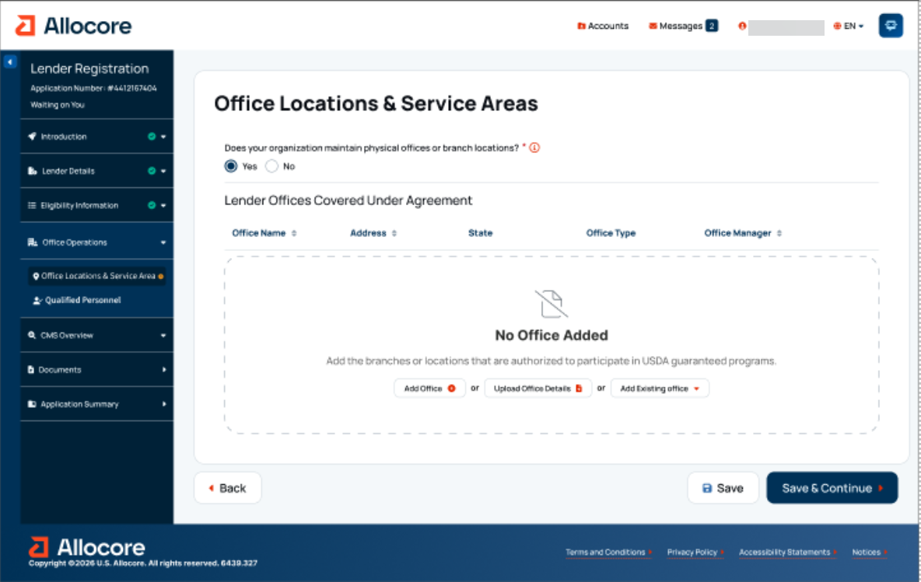

CLP to PLP Upgrade – Office Locations & Service Areas (continued)

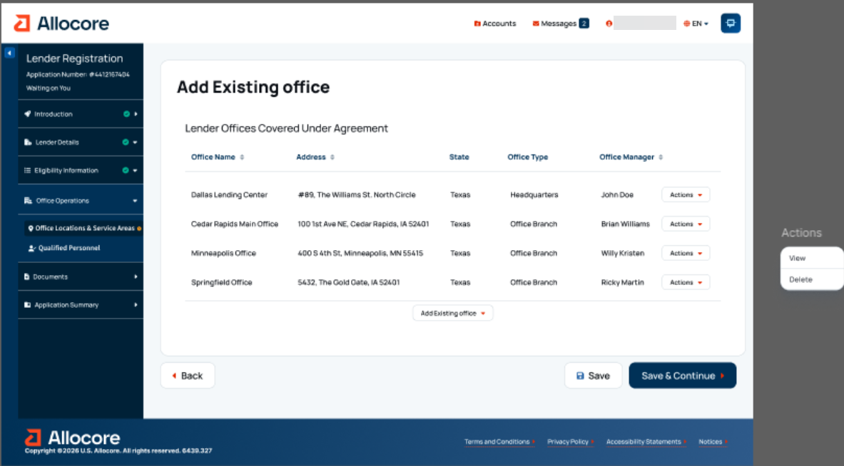

CLP to PLP Upgrade – Add Existing Office

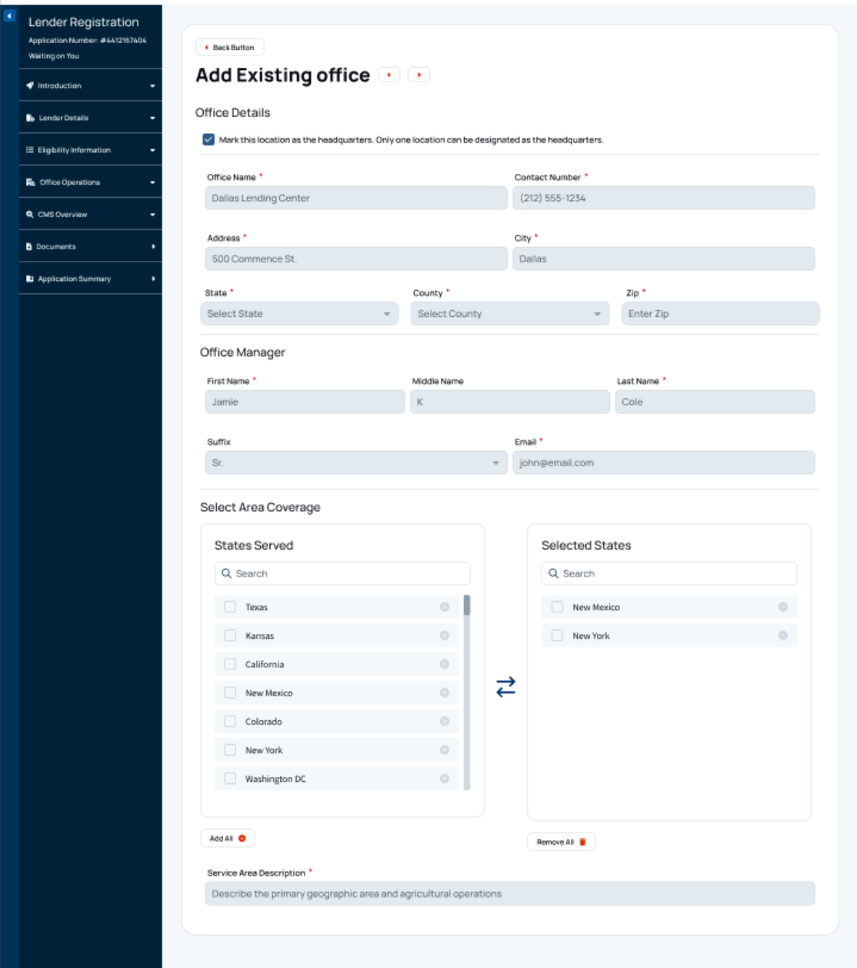

CLP to PLP Upgrade – New participating office

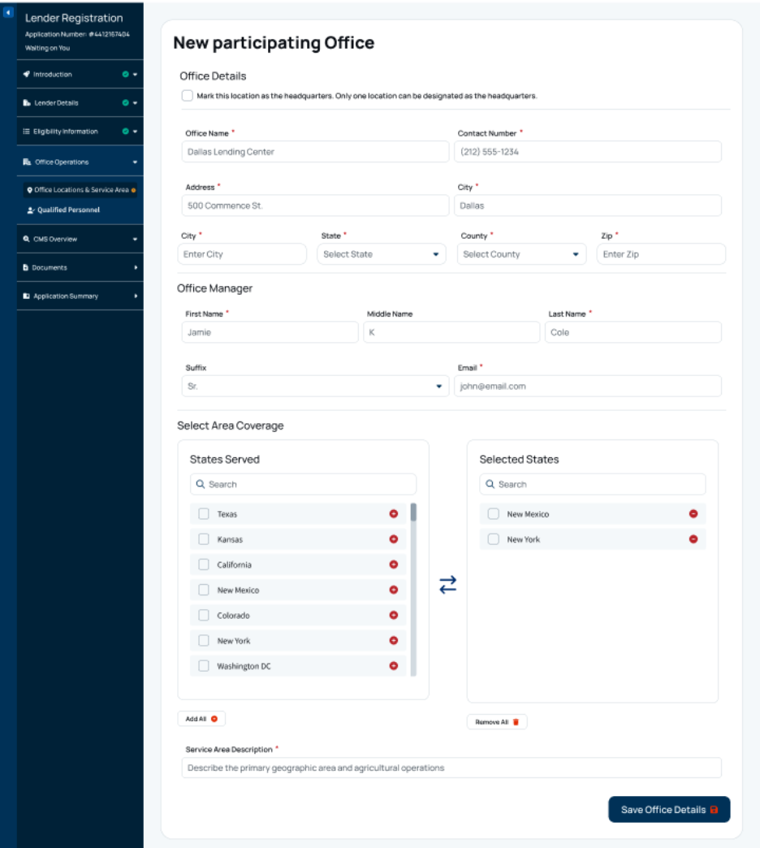

CLP to PLP Upgrade - Qualified Personnel

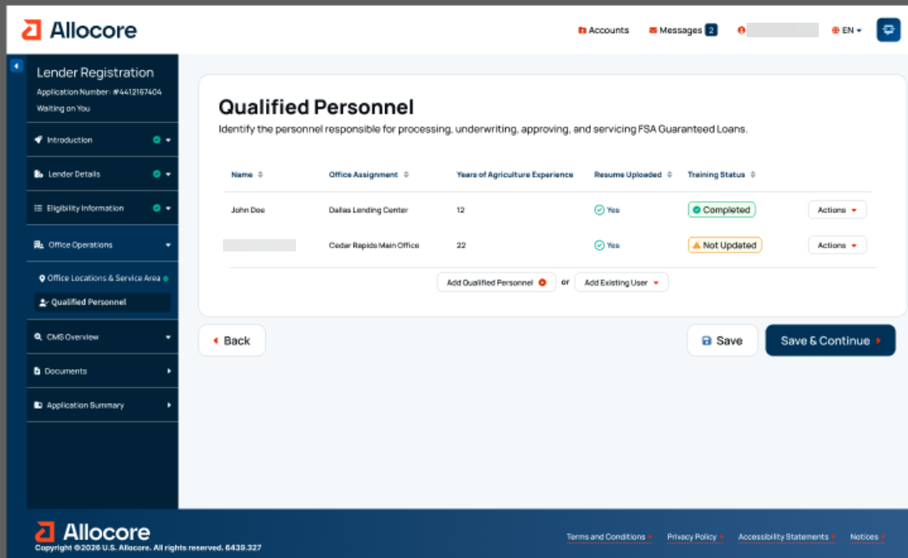

CLP to PLP Upgrade – Add Qualified Personnel

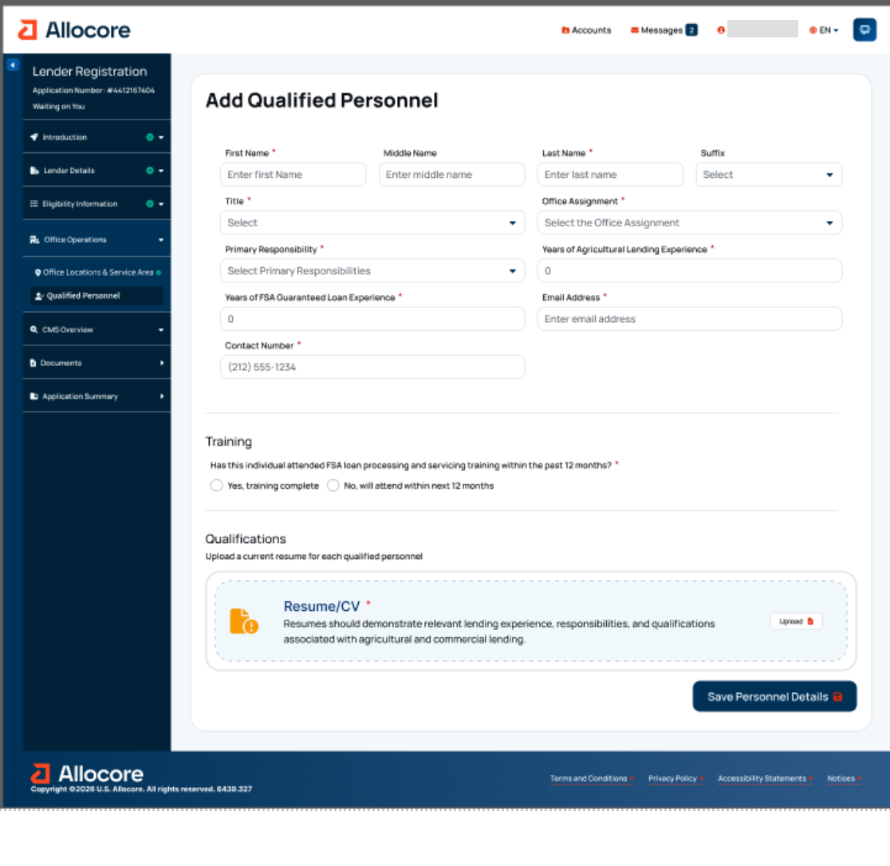

CLP to PLP Upgrade – Add Qualified Personnel (continued)

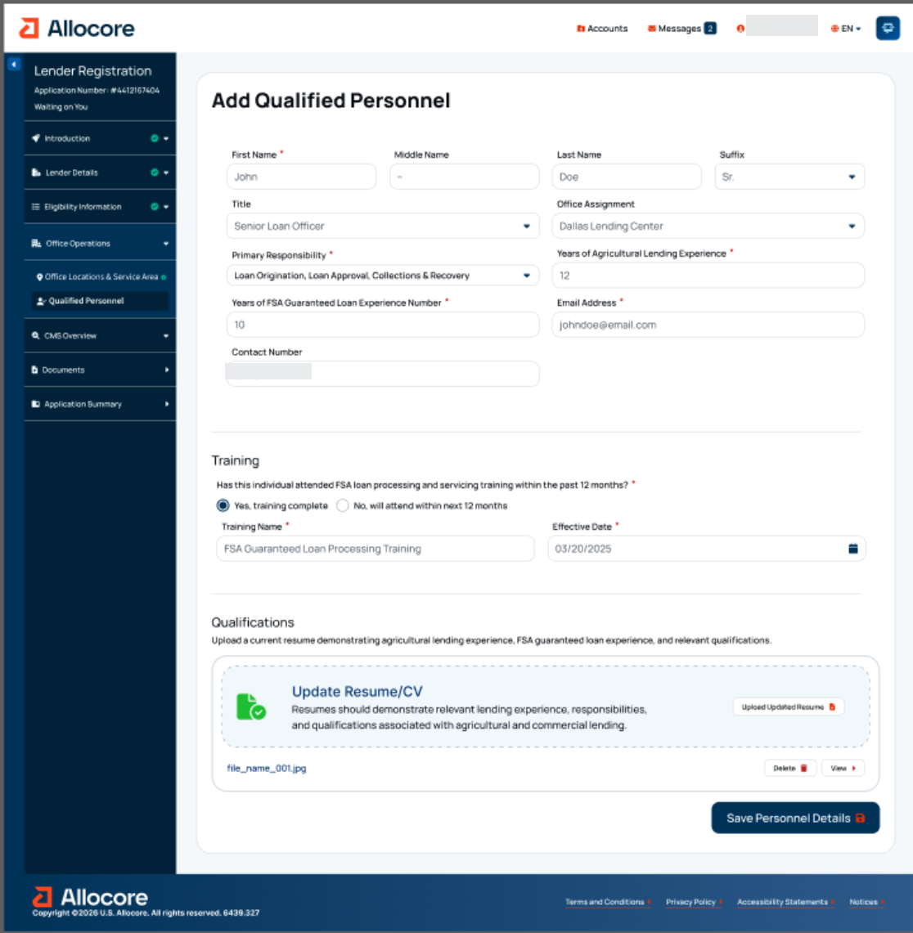

CLP to PLP Upgrade – Add Existing User

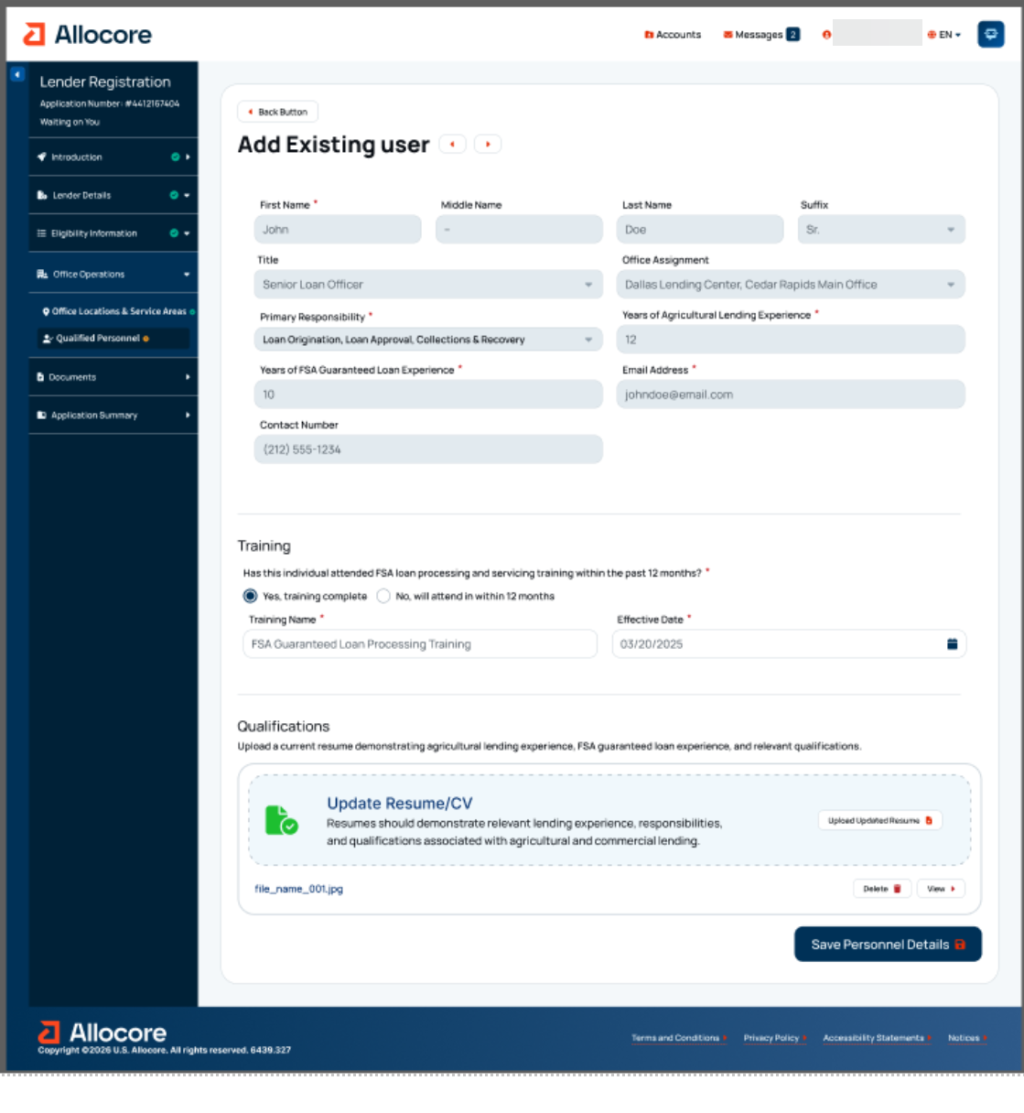

CLP to PLP Upgrade - Credit Management System (CMS) Overview

CLP to PLP Upgrade - Credit Administration & Oversight

CMS Overview - Credit Administration & Oversight (continued)

CMS Overview - Credit Administration & Oversight (continued)

CMS Overview - Credit Administration & Oversight (continued)

CMS Overview - Credit Administration & Oversight (continued)

CMS Overview - Credit Administration & Oversight (continued)

CMS Overview - Credit Administration & Oversight (continued)

CLP to PLP Upgrade - Credit Policy & Underwriting

CMS Overview - Credit Policy & Underwriting (continued)

CMS Overview - Credit Policy & Underwriting (continued)

CMS Overview - Credit Policy & Underwriting (continued)

CMS Overview - Credit Policy & Underwriting (continued)

CMS Overview - Credit Policy & Underwriting (continued)

CMS Overview - Credit Policy & Underwriting (continued)

CMS Overview - Credit Policy & Underwriting (continued)
CMS Overview - Credit Policy & Underwriting (continued)

CMS Overview - Credit Policy & Underwriting (continued)
CMS Overview - Credit Policy & Underwriting (continued)

CLP to PLP Upgrade - Loan Servicing & Monitoring

CMS Overview – Loan Servicing & Monitoring (continued)

CMS Overview – Loan Servicing & Monitoring (continued)

CMS Overview – Loan Servicing & Monitoring (continued)

CMS Overview – Loan Servicing & Monitoring (continued)

CLP to PLP Upgrade - Documents

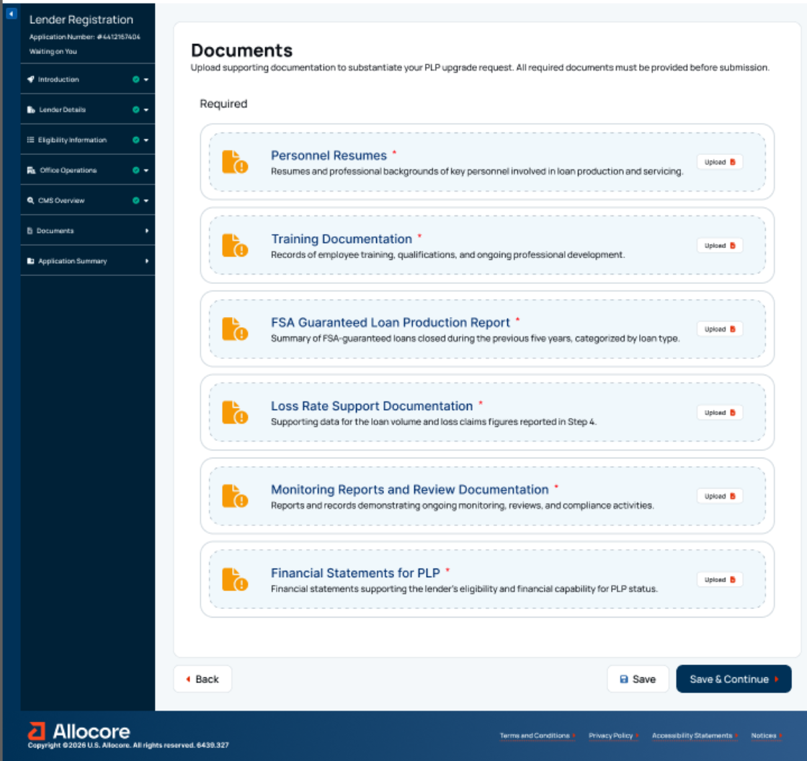

CLP to PLP Upgrade - Application Summary

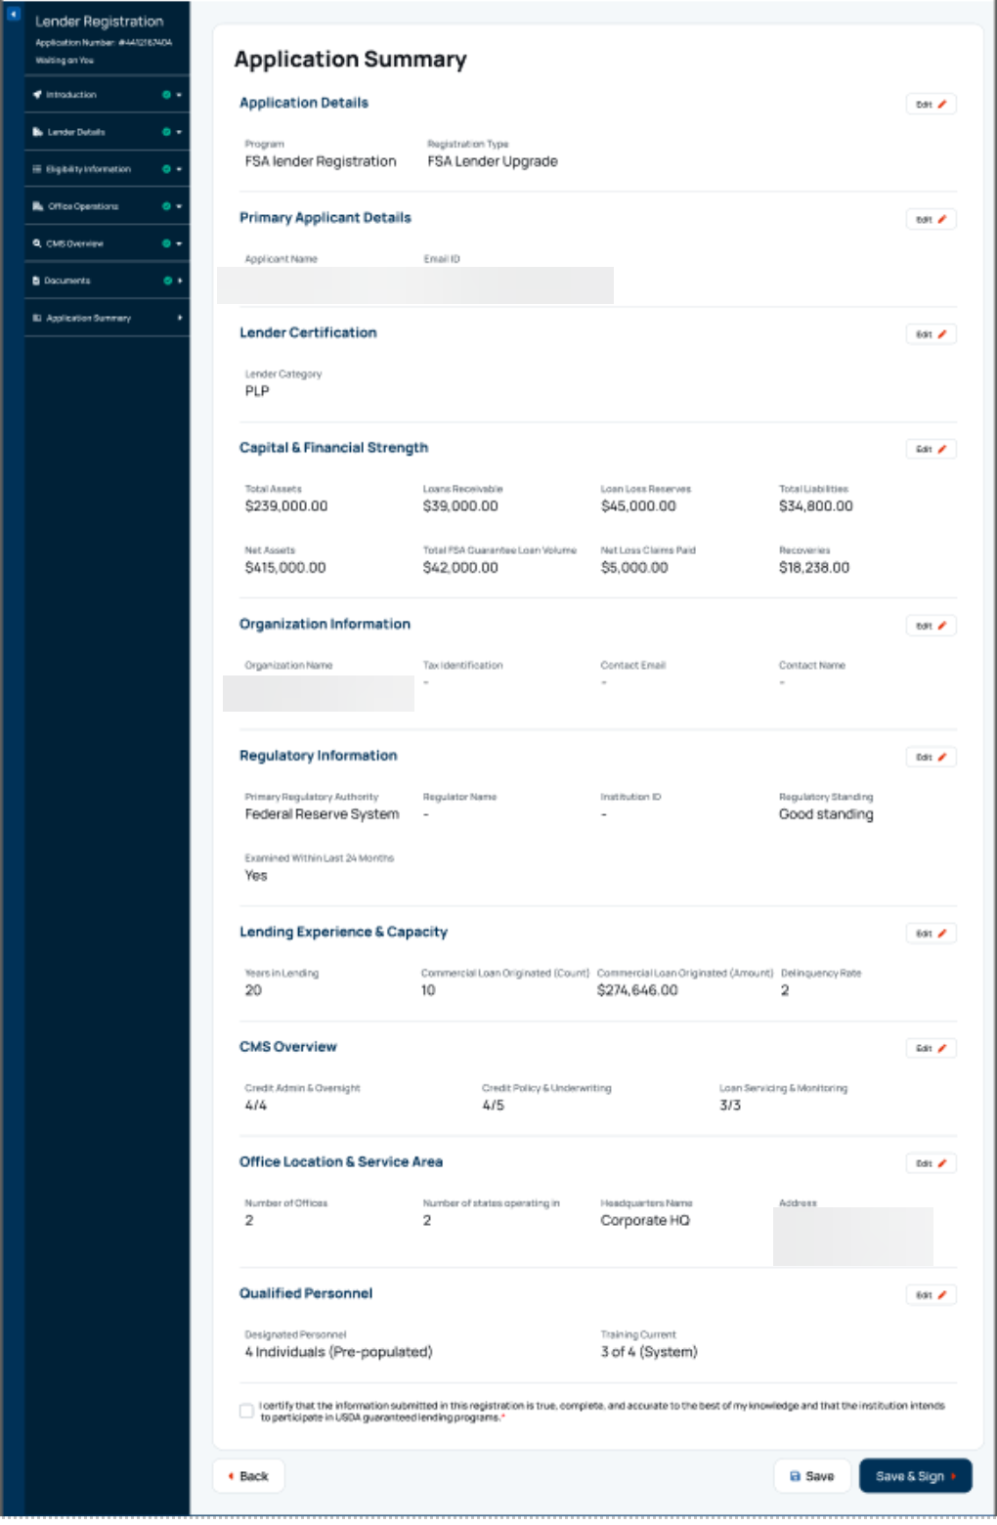

16. Digital Process for SEL to CLP Status Upgrade

SEL to CLP Upgrade - PRA Burden Statement

Non-form

Public Burden Statement (Paperwork Reduction Act):
Public reporting burden for this collection is estimated to average 5 hours per response, including reviewing instructions, gathering and maintaining the data needed, completing (providing the information), and reviewing the collection of information. You are not required to respond to the collection, or FSA may not conduct or sponsor a collection of information unless it displays a valid OMB control number of 0560-0155.

SEL to CLP Upgrade - Programs Landing Page

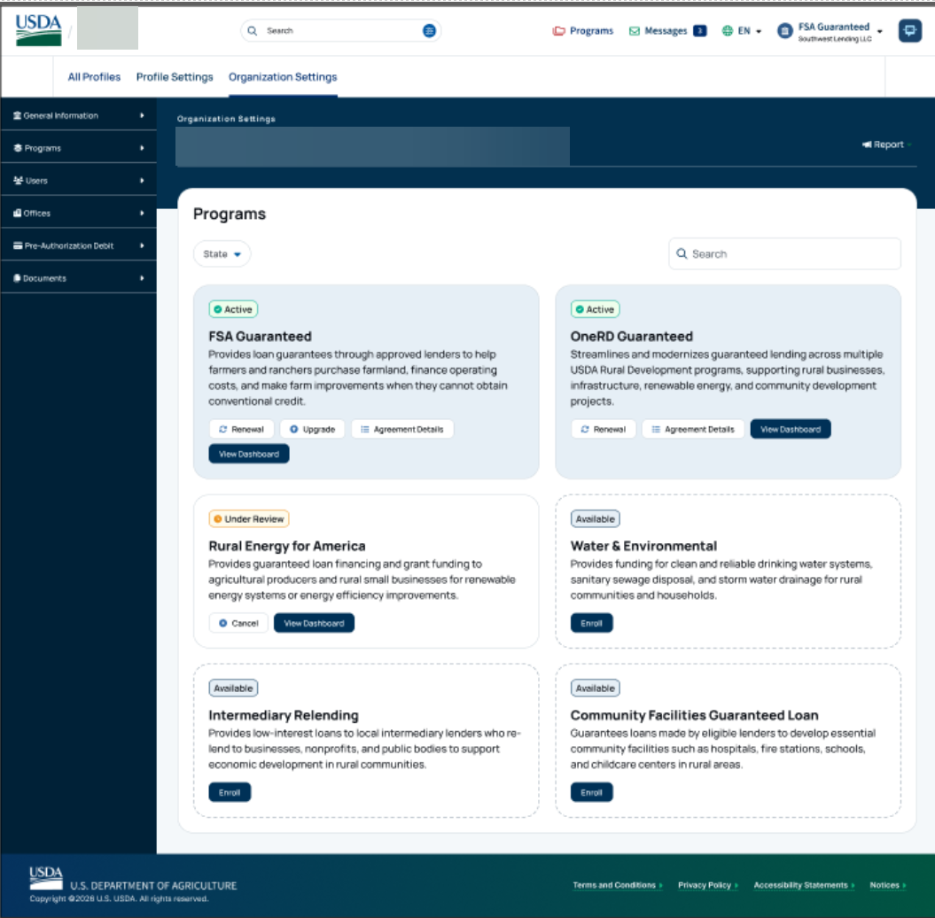

SEL to CLP Upgrade - Introduction

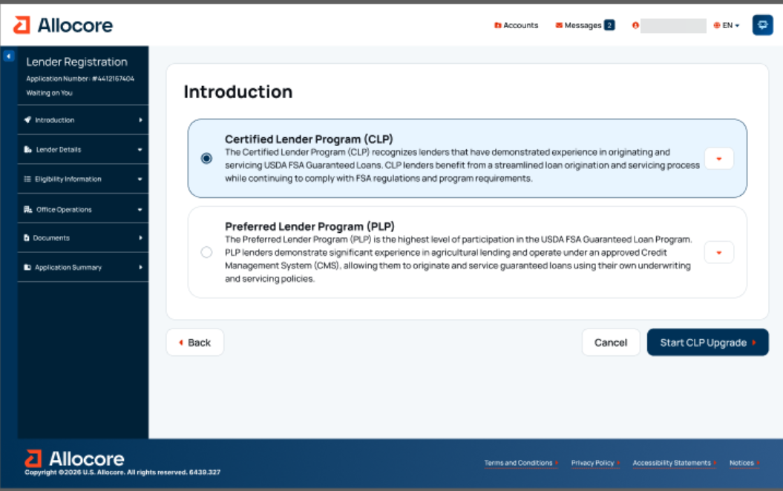

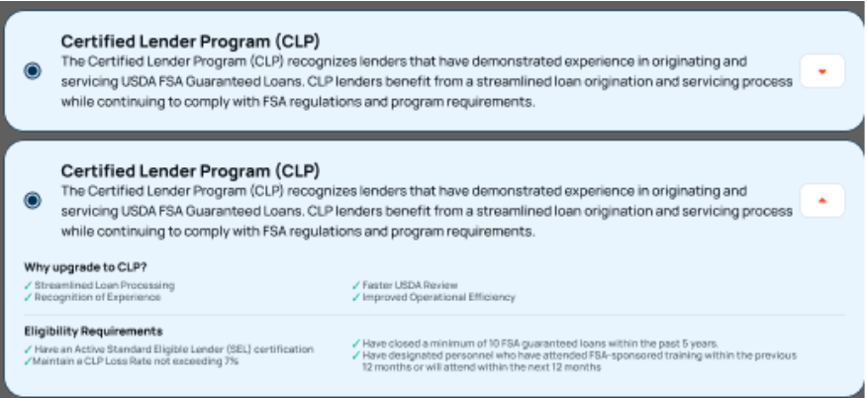

SEL to CLP Upgrade - Organization Information

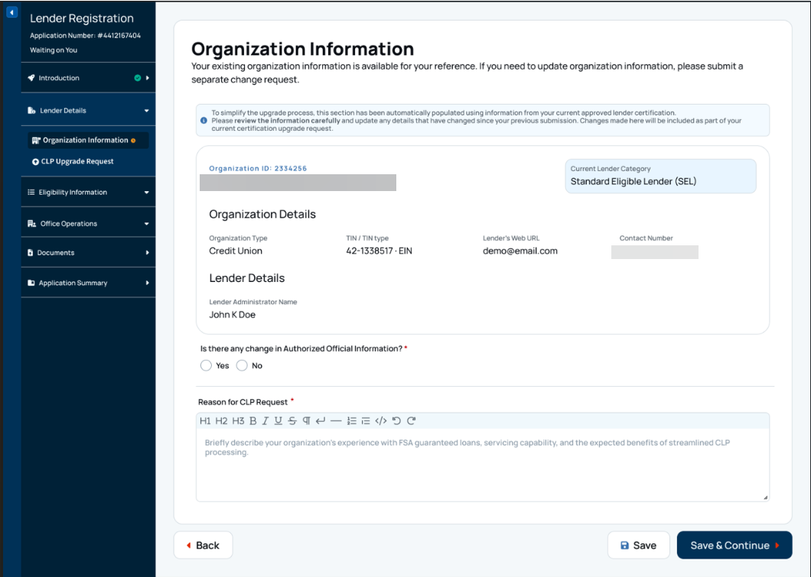

SEL to CLP Upgrade – Organization Information (continued)
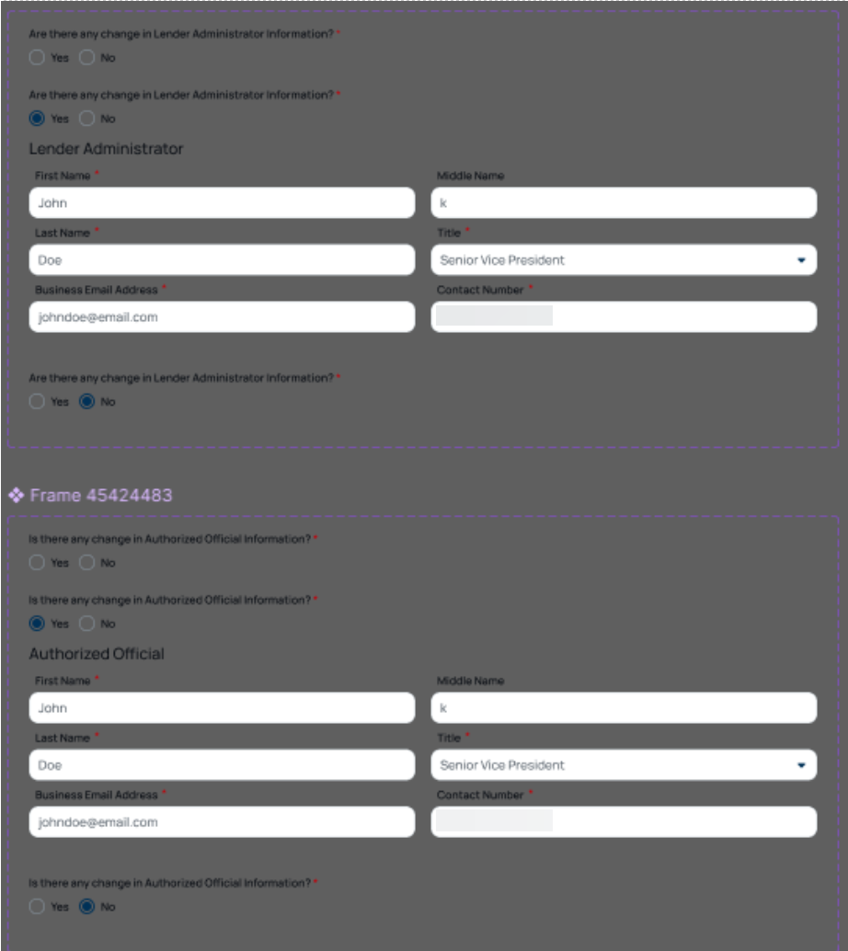

SEL to CLP Upgrade - Regulatory Information

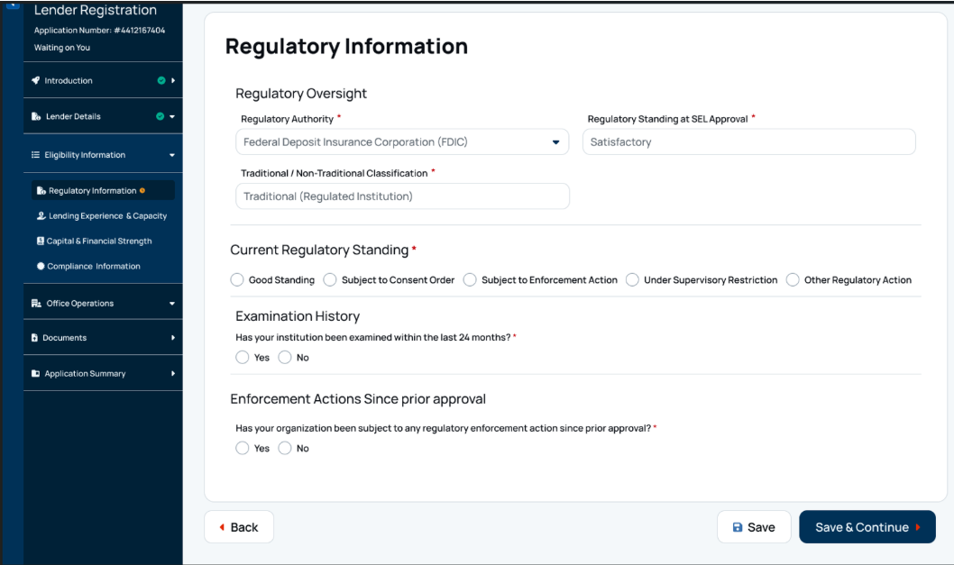

SEL to CLP Upgrade – Regulatory Oversight (continued)

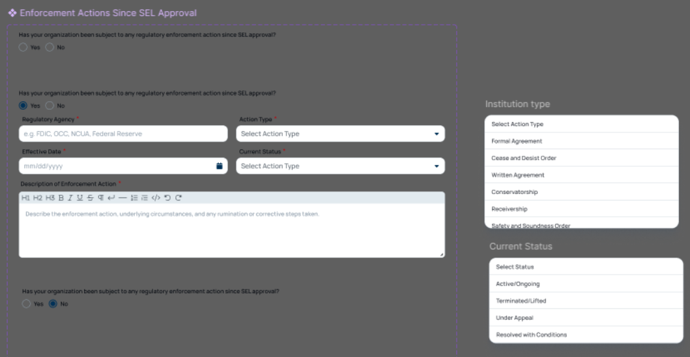

SEL to CLP Upgrade - Lending Experience & Capacity

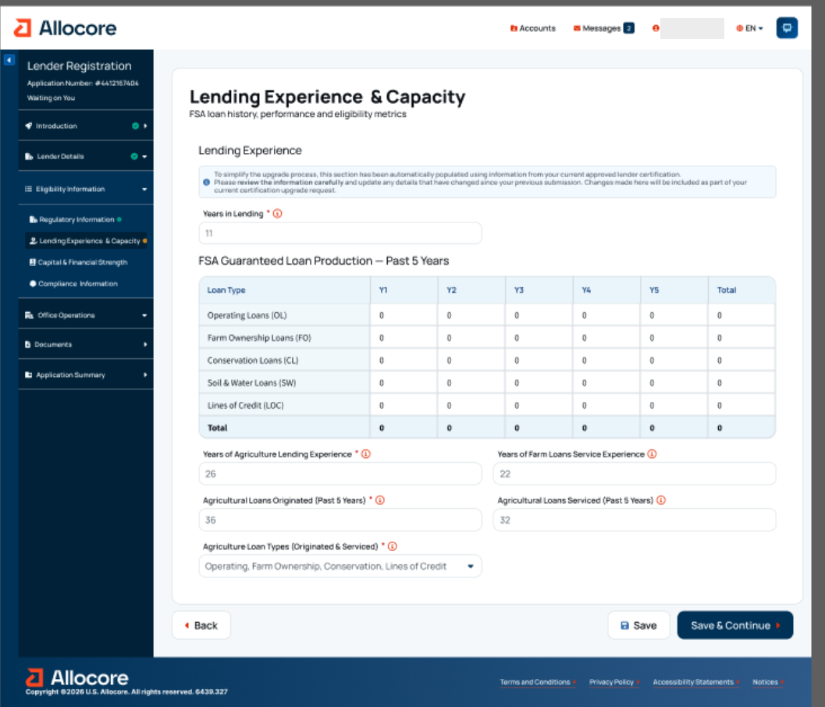
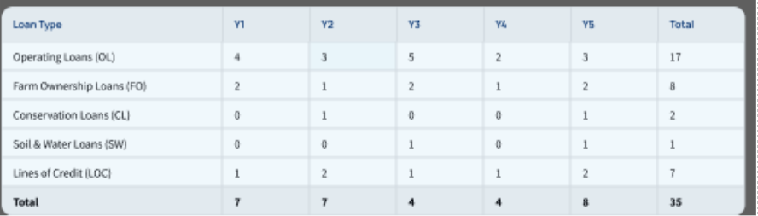

SEL to CLP Upgrade - Capital & Financial Strength

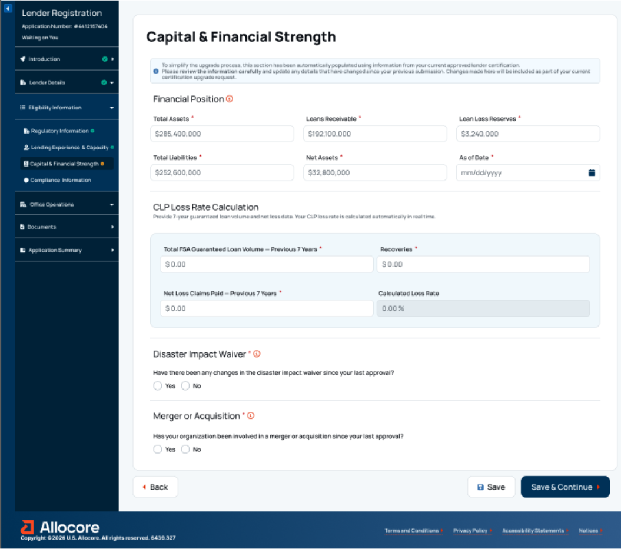

SEL to CLP Upgrade - Capital and Financial Strength (continued)

SEL to CLP Upgrade - Compliance Information

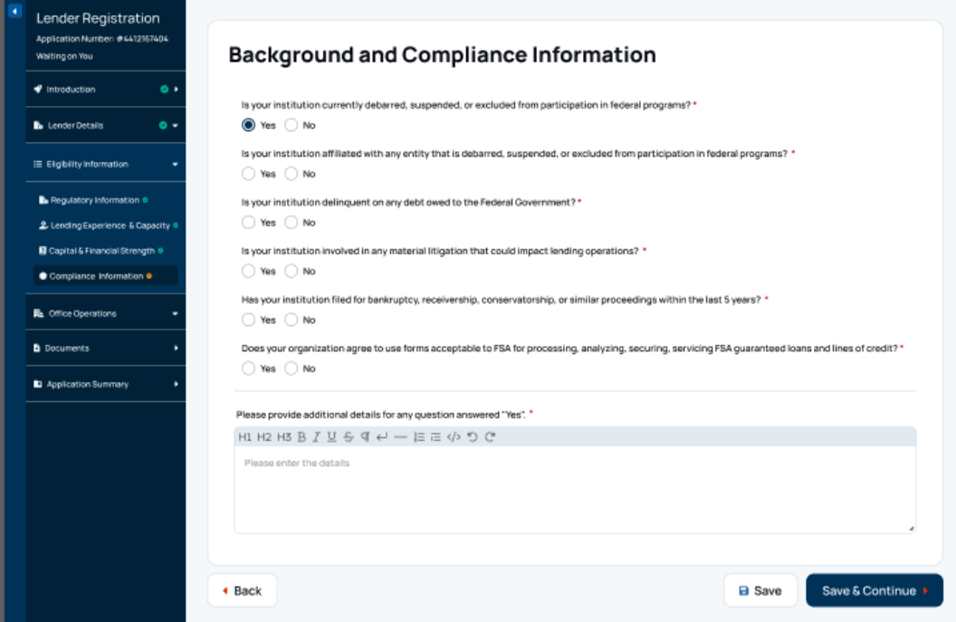
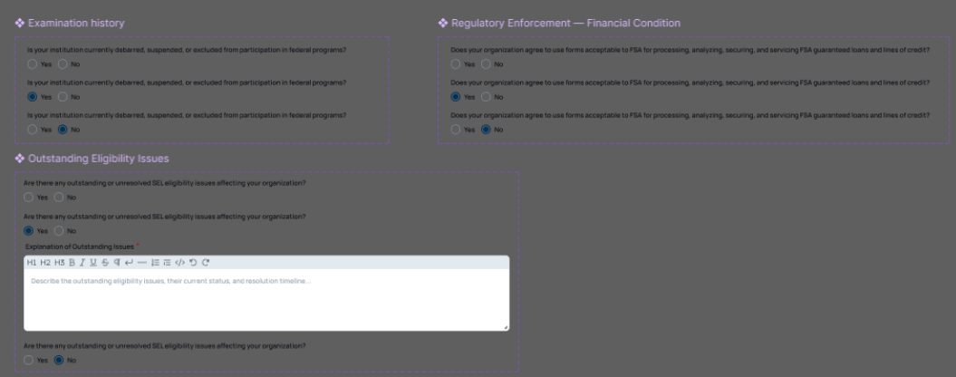

SEL to CLP Upgrade - Office Operations

SEL to CLP Upgrade – Office Locations & Service Areas (continued)

SEL to CLP Upgrade – Office Locations & Service Areas (continued)

SEL to CLP Upgrade – Office Locations & Service Areas (continued)

SEL to CLP Upgrade – Qualified Personnel

SEL to CLP Upgrade – Add Qualified Personnel

SEL to CLP Upgrade – Add Qualified Personnel (continued)

SEL to CLP Upgrade – Add Existing User

SEL to CLP Upgrade - Documents

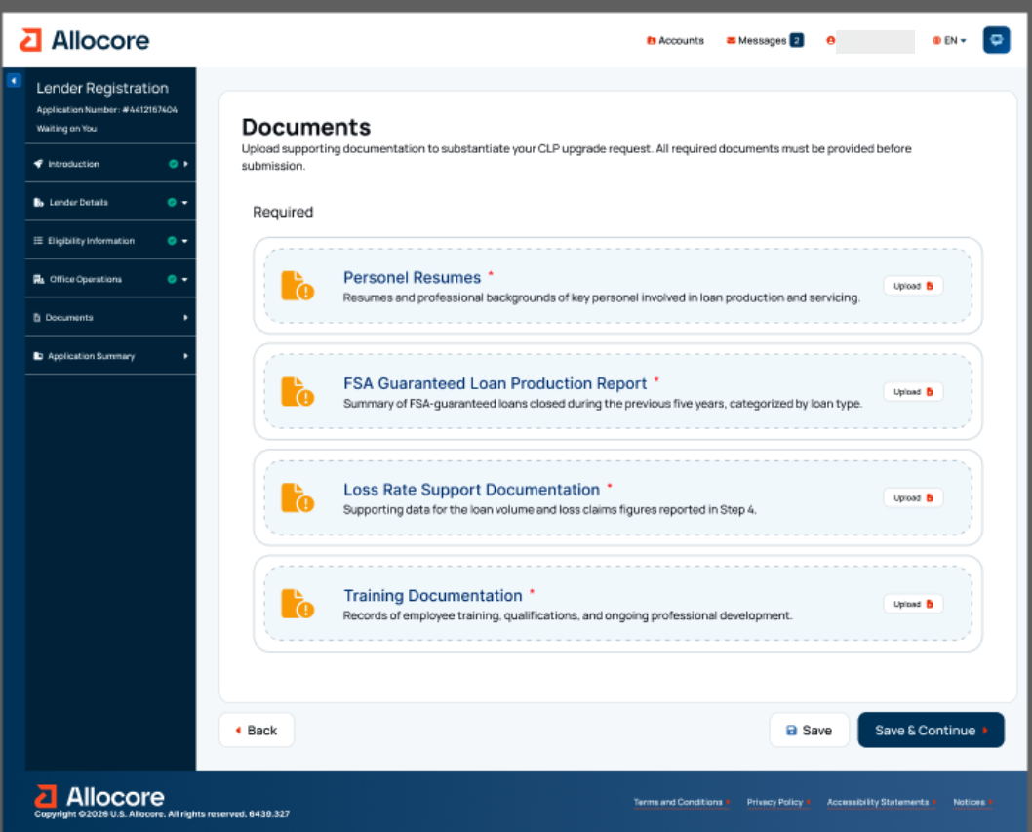

SEL to CLP Upgrade - Application Summary

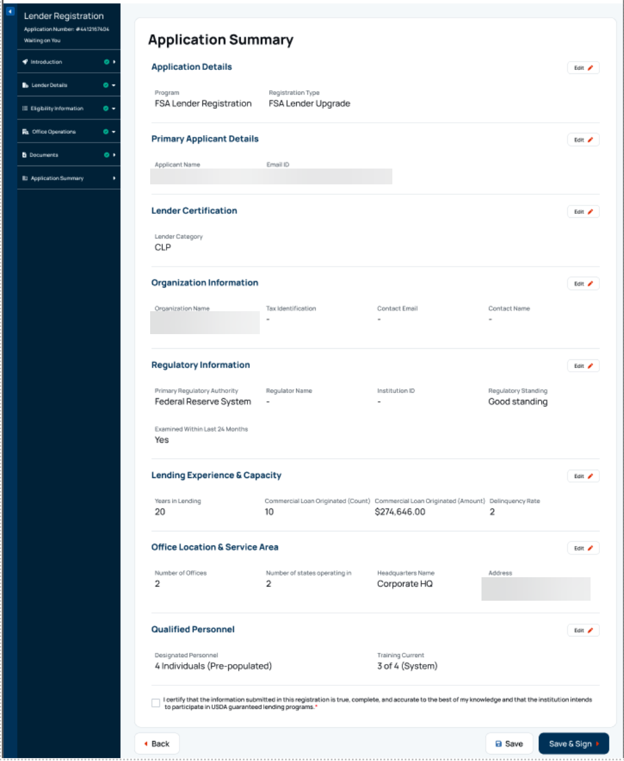

17. Digital Process for PLP Renewal

PLP Renewal - PRA Burden Statement

Non-form

Public Burden Statement (Paperwork Reduction Act):
Public reporting burden for this collection is estimated to average 5 hours per response, including reviewing instructions, gathering and maintaining the data needed, completing (providing the information), and reviewing the collection of information. You are not required to respond to the collection, or FSA may not conduct or sponsor a collection of information unless it displays a valid OMB control number of 0560-0155.

PLP Renewal - Programs Landing Page

PLP Renewal - Lender Information

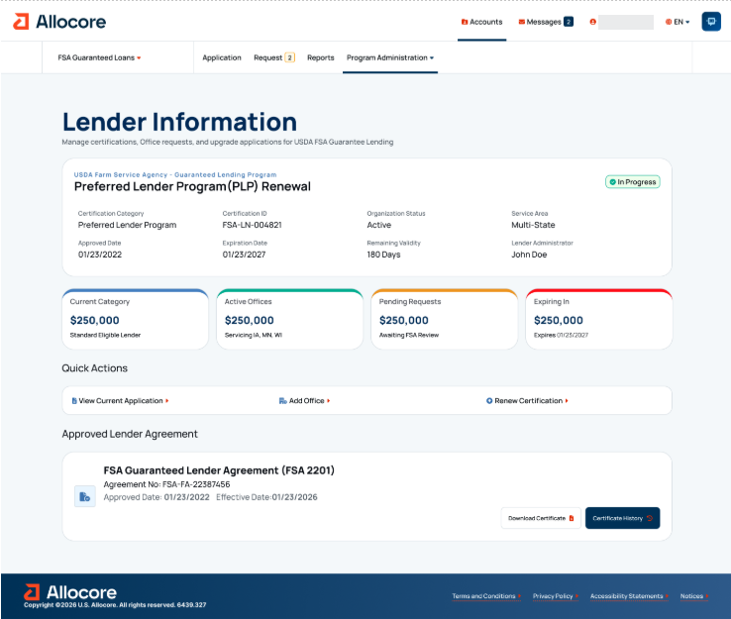

PLP Renewal - Introduction

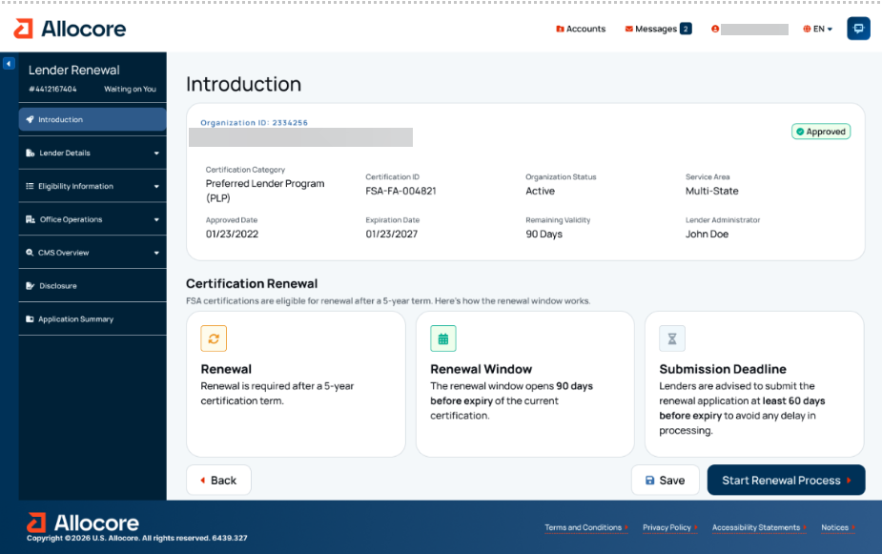

PLP Renewal - Organizational Information

PLP Renewal - Regulatory Information

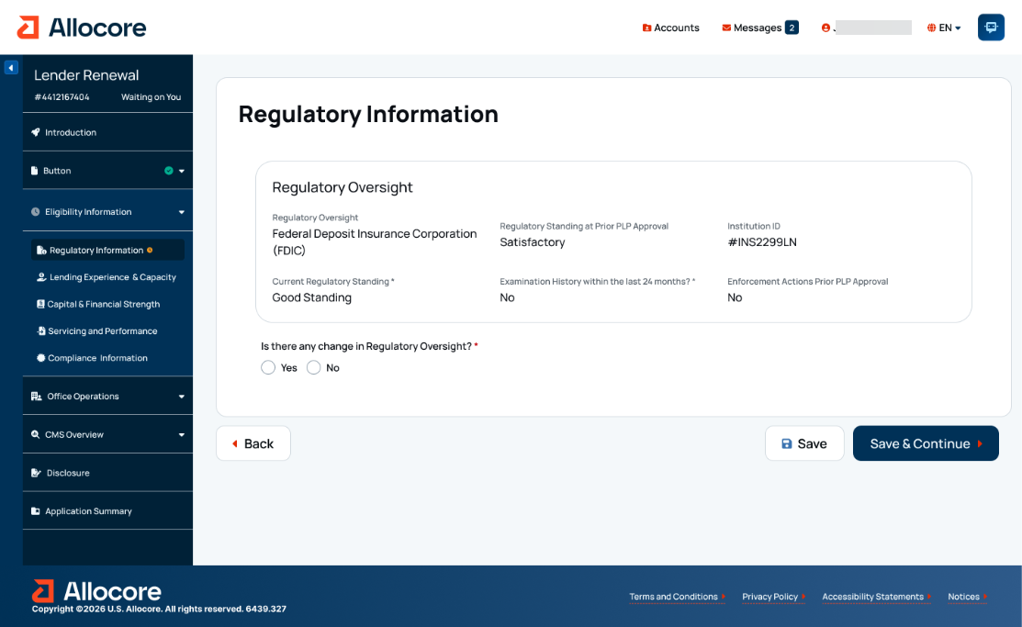

PLP Renewal – Eligibility Information - Regulatory Information – Expanded

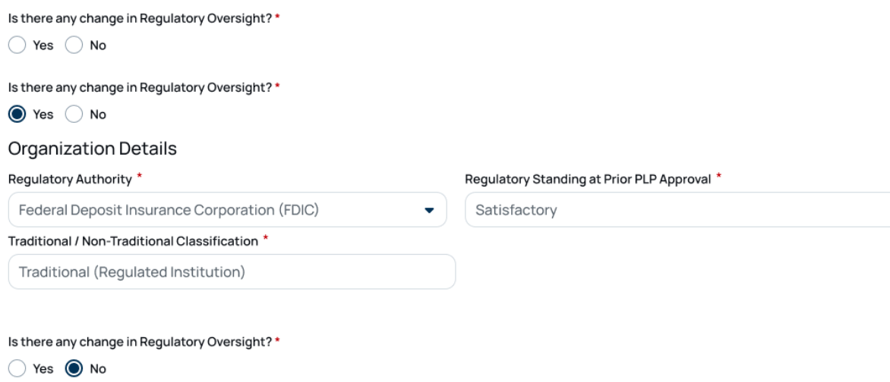

PLP Renewal – Organizational Details (expanded)
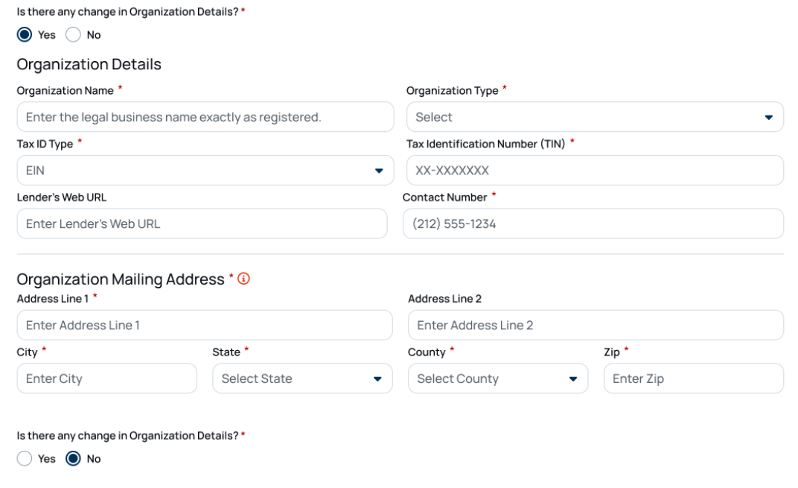
PLP Renewal – Current Regulatory Standing (expanded)
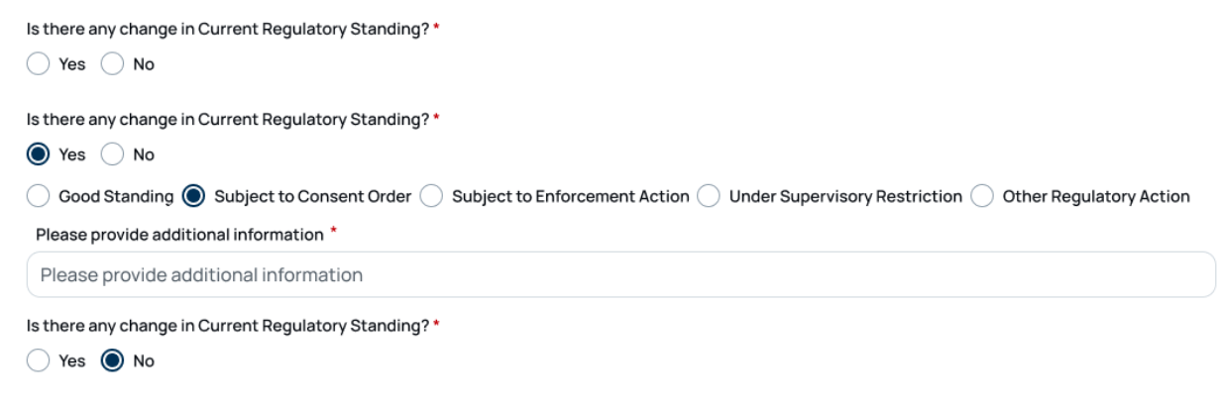

PLP Renewal – Examination History (expanded)

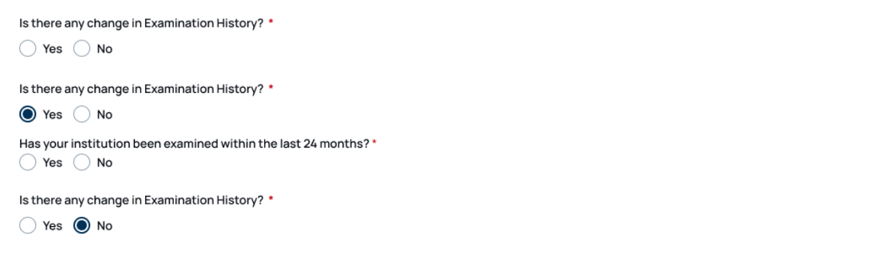
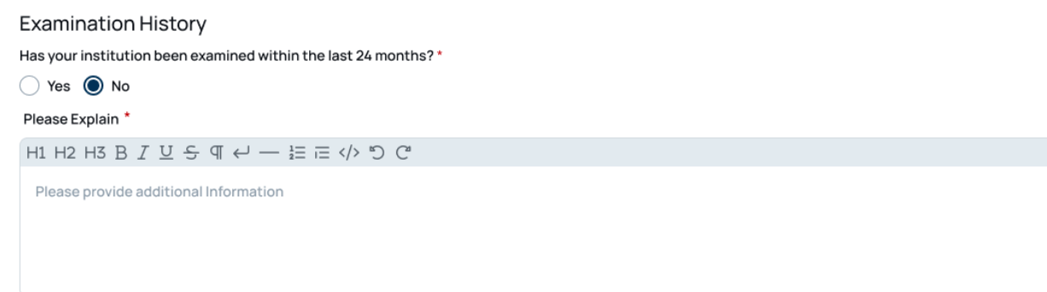

PLP Renewal – Disaster Impact Waiver

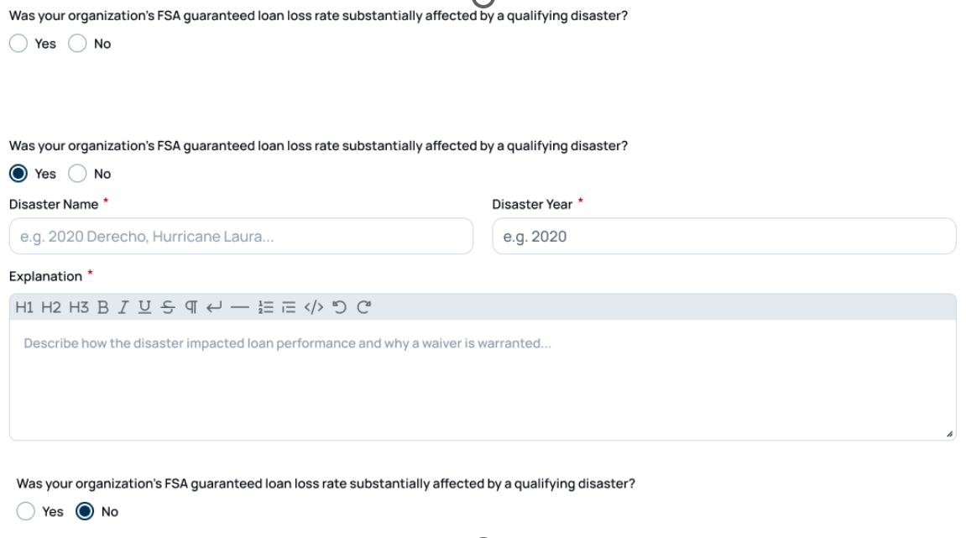
PLP Renewal – Enforcement Actions Prior PLP Approval

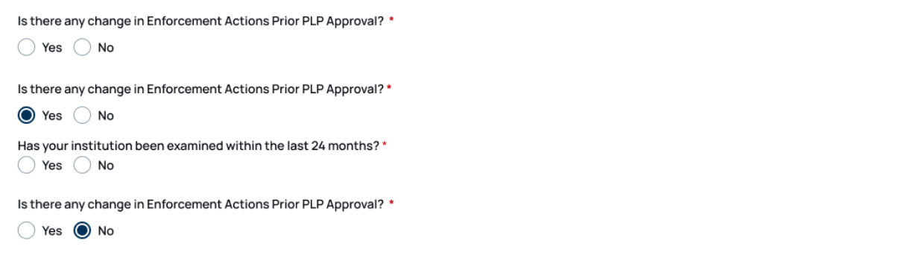

PLP Renewal - Lending Experience & Capacity

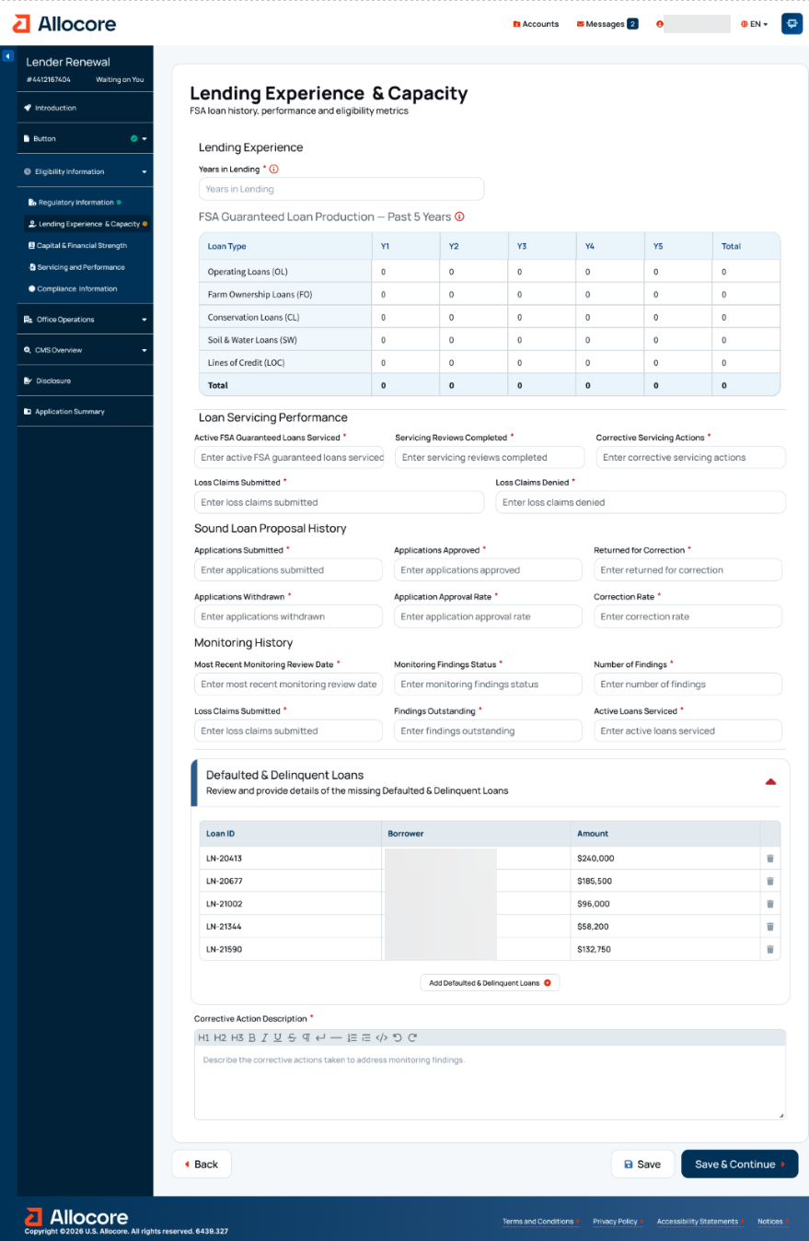
PLP Renewal – Lending Experience & Capacity (warning message)
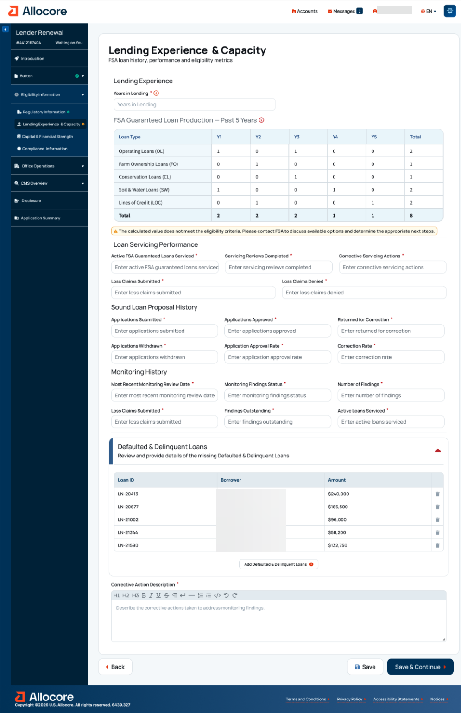

PLP Renewal - Capital & Financial Strength

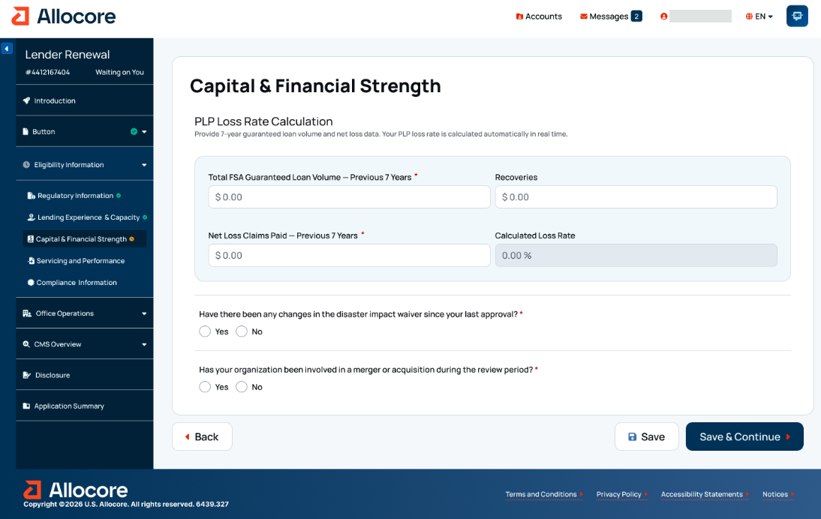

PLP Renewal – Capital and Financial Strength (warning message)

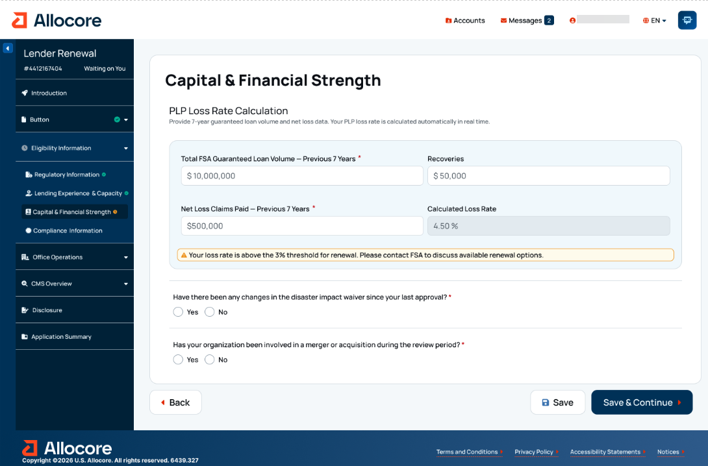

PLP Renewal - Servicing & Performance

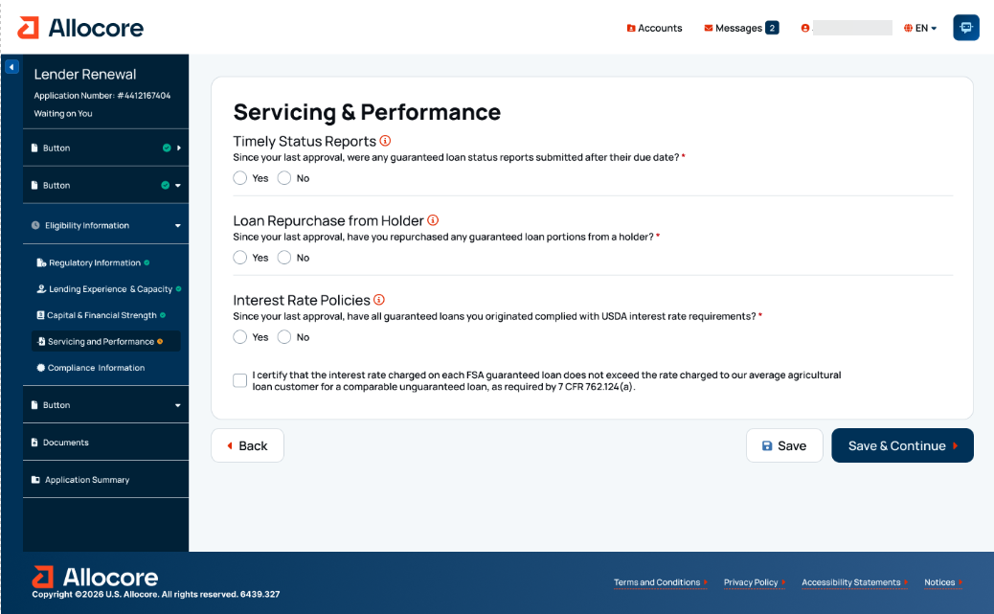

PLP Renewal - Compliance Information

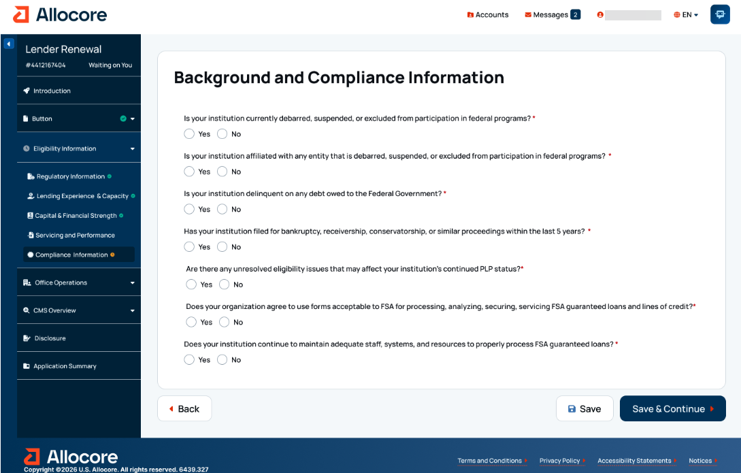

PLP Renewal – Background and Compliance Information (expanded)

PLP Renewal – Office Locations & Service Areas

PLP Renewal – Office Locations & Service Areas (continued)

PLP Renewal – Office Locations & Service Areas (continued)

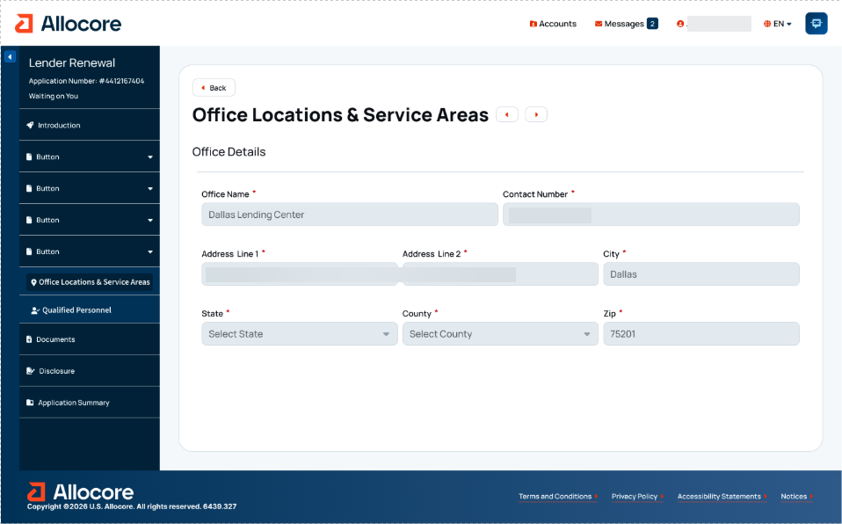

PLP Renewal – New Participating Office

PLP Renewal – Qualified Personnel

PLP Renewal - Qualified Personnel

PLP Renewal – Add Qualified Personnel

PLP Renewal - Credit Management System (CMS) Overview

PLP Renewal - Credit Administration & Oversight

PLP Renewal - Credit Administration & Oversight (continued)

PLP Renewal - Credit Administration & Oversight (continued)

PLP Renewal - Credit Administration & Oversight (continued)

PLP Renewal - Credit Administration & Oversight (continued)

PLP Renewal - Credit Administration & Oversight (continued)

PLP Renewal - Credit Administration & Oversight (continued)

PLP Renewal - Credit Policy & Underwriting

PLP Renewal - Credit Policy & Underwriting (continued)

PLP Renewal - Credit Policy & Underwriting (continued)

PLP Renewal - Credit Policy & Underwriting (continued)

PLP Renewal - Credit Policy & Underwriting (continued)

PLP Renewal - Credit Policy & Underwriting (continued)

PLP Renewal - Credit Policy & Underwriting (continued)

PLP Renewal - Credit Policy & Underwriting (continued)

PLP Renewal - Credit Policy & Underwriting (continued)

PLP Renewal - Credit Policy & Underwriting (continued)

PLP Renewal - Credit Policy & Underwriting (continued)

PLP Renewal - Loan Servicing & Monitoring

PLP Renewal - Loan Servicing & Monitoring (continued)

PLP Renewal - Loan Servicing & Monitoring (continued)

PLP Renewal - Loan Servicing & Monitoring (continued)

PLP Renewal - Documents

PLP Renewal - Application Summary

PLP Renewal - Application Summary (continued)

18. Digital Process for CLP Renewal

CLP Renewal - PRA Burden Statement

Non-form

Public Burden Statement (Paperwork Reduction Act):
Public reporting burden for this collection is estimated to average 5 hours per response, including reviewing instructions, gathering and maintaining the data needed, completing (providing the information), and reviewing the collection of information. You are not required to respond to the collection, or FSA may not conduct or sponsor a collection of information unless it displays a valid OMB control number of 0560-0155.

CLP Renewal - Programs Landing Page

CLP Renewal - Introduction

CLP Renewal - Organization Information

CLP Renewal - Regulatory Information

CLP Renewal - Lending Experience & Capacity

CLP Renewal - Lending Experience & Capacity - Available Tool Tips

CLP Renewal - Capital & Financial Strength

CLP Renewal – Capital and Financial Strength (expanded & tooltips)

CLP Renewal – Capital and Financial Strength (continued)

CLP Renewal - Servicing & Performance

CLP Renewal - Compliance Information

CLP Renewal - Office Locations & Service Areas

CLP Renewal – Office Locations & Service Areas (continued)

CLP Renewal – Office Locations & Service Areas (continued)

CLP Renewal - Office Locations & Service Areas (continued)

CLP Renewal - Qualified Personnel

CLP Renewal – Add Qualified Personnel

CLP Renewal – Add Qualified Personnel (continued)

CLP Renewal - Documents

CLP Renewal - Disclosure

CLP Renewal - Application Summary

CLP Renewal – Application Summary (continued)

19. Digital Process for SEL Renewal

SEL Renewal - PRA Burden Statement

Non-form

Public Burden Statement (Paperwork Reduction Act):
Public reporting burden for this collection is estimated to average 5 hours per response, including reviewing instructions, gathering and maintaining the data needed, completing (providing the information), and reviewing the collection of information. You are not required to respond to the collection, or FSA may not conduct or sponsor a collection of information unless it displays a valid OMB control number of 0560-0155.

SEL Renewal - Programs Landing Page

SEL Renewal - Introduction

SEL Renewal - Organization Information

SEL Renewal - Regulatory Information

SEL Renewal - Lending Experience & Capacity

SEL Renewal – Lending Experience & Capacity (continued)

SEL Renewal - Capital & Financial Strength

SEL Renewal – Eligibility Information - Capital and Financial Strength (continued)

SEL Renewal – Eligibility Information - Capital and Financial Strength (continued)

SEL Renewal - Servicing & Performance

SEL Renewal - Compliance Information

SEL Renewal – Eligibility Information – Deficiencies

SEL Renewal - Office Locations & Service Areas

SEL Renewal – Office Locations & Service Areas (continued)

SEL Renewal – New Participating Office (continued)

SEL Renewal - Qualified Personnel

SEL Renewal – Qualified Personnel - Add Qualified Personnel (continued)

SEL Renewal – Qualified Personnel - Add Qualified Personnel (continued)

SEL Renewal - Documents

SEL Renewal - Disclosure

SEL Renewal - Application Summary

20. Digital Process for MLP Renewal

MLP Renewal - PRA Burden Statement

Non-form

Public Burden Statement (Paperwork Reduction Act):
Public reporting burden for this collection is estimated to average 5 hours per response, including reviewing instructions, gathering and maintaining the data needed, completing (providing the information), and reviewing the collection of information. You are not required to respond to the collection, or FSA may not conduct or sponsor a collection of information unless it displays a valid OMB control number of 0560-0155.

MLP Renewal - Programs Landing Page

MLP Renewal - Introduction

MLP Renewal - Organization Information

MLP Renewal - Regulatory Information

MLP Renewal – Regulatory Information (continued)

MLP Renewal - Lending Experience & Capacity

MLP Renewal - Capital & Financial Strength

MLP Renewal – Capital and Financial Strength (expanded)

MLP Renewal – Eligibility Information - Capital & Financial Strength (continued)

MLP Renewal - Staff Details & Experience

MLP Renewal - Compliance Information

MLP Renewal – Compliance Information (continued)

MLP Renewal - Office Locations & Service Areas

MLP Renewal – Office Locations & Service Areas (continued)

MLP Renewal – Office Operations - New Participating Office

MLP Renewal - Qualified Personnel

MLP Renewal – Qualified Personnel - Add Qualified Personnel (continued)

MLP Renewal – Add Qualified Personnel (continued)

MLP Renewal - Documents

MLP Renewal - Disclosure

MLP Renewal - Application Summary

21. Digital Process for Guaranteed Servicing Requests

Servicing - Landing Page

Servicing - Request Selection

Digital Process for Subordination of Lien

Subordination of Lien - PRA Burden Statement

Non-form

Public Burden Statement (Paperwork Reduction Act):
Public reporting burden for this collection is estimated to average 6 hours per response, including reviewing instructions, gathering and maintaining the data needed, completing (providing the information), and reviewing the collection of information. You are not required to respond to the collection, or FSA may not conduct or sponsor a collection of information unless it displays a valid OMB control number of 0560-0155.

Subordination of Lien - Selection

Subordination of Lien - Request Details

Subordination of Lien - Documents

Digital Process for Substitution of Lender

Substitution of Lender - PRA Burden Statement

Non-form

Public Burden Statement (Paperwork Reduction Act):
Public reporting burden for this collection is estimated to average 5 hours per response, including reviewing instructions, gathering and maintaining the data needed, completing (providing the information), and reviewing the collection of information. You are not required to respond to the collection, or FSA may not conduct or sponsor a collection of information unless it displays a valid OMB control number of 0560-0155.

Substitution of Lender - Selection

Substitution of Lender - Request Details

Substitution of Lender - Documents

Digital Process for Release of Liability

Release of Liability - PRA Burden Statement

Non-form

Public Burden Statement (Paperwork Reduction Act):
Public reporting burden for this collection is estimated to average 5 hours per response, including reviewing instructions, gathering and maintaining the data needed, completing (providing the information), and reviewing the collection of information. You are not required to respond to the collection, or FSA may not conduct or sponsor a collection of information unless it displays a valid OMB control number of 0560-0155.

Release of Liability - Selection

Release of Liability - Request Details

Release of Liability - Documents

Digital Process for Partial Release

Partial Release - PRA Burden Statement

Non-form

Public Burden Statement (Paperwork Reduction Act):
Public reporting burden for this collection is estimated to average 6 hours per response, including reviewing instructions, gathering and maintaining the data needed, completing (providing the information), and reviewing the collection of information. You are not required to respond to the collection, or FSA may not conduct or sponsor a collection of information unless it displays a valid OMB control number of 0560-0155.

Partial Release - About the Request

Partial Release - Request Details

Partial Release - Documents

Digital Process for Emergency Advances

Emergency Advances - PRA Burden Statement

Non-form

Public Burden Statement (Paperwork Reduction Act):
Public reporting burden for this collection is estimated to average 2 hours per response, including reviewing instructions, gathering and maintaining the data needed, completing (providing the information), and reviewing the collection of information. You are not required to respond to the collection, or FSA may not conduct or sponsor a collection of information unless it displays a valid OMB control number of 0560-0155.

Emergency Advances - Selection

Emergency Advances - Request Details

Emergency Advances - Documents

Digital Process for Protective Advances

Protective Advances - PRA Burden Statement

Non-form
Note: Lender requests for protective advances will follow the same process as requests for emergency advances. However, there is a decreased burden for protective advances as they are part of the larger servicing processes being completed by the lender.

Public Burden Statement (Paperwork Reduction Act):
Public reporting burden for this collection is estimated to average 1 hour per response, including reviewing instructions, gathering and maintaining the data needed, completing (providing the information), and reviewing the collection of information. You are not required to respond to the collection, or FSA may not conduct or sponsor a collection of information unless it displays a valid OMB control number of 0560-0155.

Digital Process for Return of Guarantee

Return of Guarantee - PRA Burden Statement

Non-form

Public Burden Statement (Paperwork Reduction Act):
Public reporting burden for this collection is estimated to average 15 minutes per response, including reviewing instructions, gathering and maintaining the data needed, completing (providing the information), and reviewing the collection of information. You are not required to respond to the collection, or FSA may not conduct or sponsor a collection of information unless it displays a valid OMB control number of 0560-0155.

Return of Guarantee - Selection

Return of Guarantee - Request Details

Return of Guarantee - Documents

Digital Process for Transfer & Assumption - Secondary Market Notification

Transfer & Assumption - PRA Burden Statement

Non-form

Note: Lender requests for a Transfer & Assumption will be processed the same as a new loan request. The transferee must apply for a loan in accordance with § 762.110 (Part 5) and provide any other information requested by the Agency to evaluate the transfer and assumption request. The associated burden is the same as Sections 7 & 8 depending on PLP or non-PLP status.
The burden statement below is strictly for transfer & assumption cases where the original guaranteed loan was sold on the secondary market. In those cases, the secondary market holder must be notified if the guaranteed loan is assumed by someone else.

Public Burden Statement (Paperwork Reduction Act):
Public reporting burden for this collection is estimated to average 20 minutes per response, including reviewing instructions, gathering and maintaining the data needed, completing (providing the information), and reviewing the collection of information. You are not required to respond to the collection, or FSA may not conduct or sponsor a collection of information unless it displays a valid OMB control number of 0560-0155.

Digital Process for Lender Request for Restructuring

Request for Restructuring - PRA Burden Statement

Non-form
Note: The burden hours reflect a weighted average across SEL, CLP, and PLP lender types based on annual requests received.

Public Burden Statement (Paperwork Reduction Act):
Public reporting burden for this collection is estimated to average 2 hours and 5 minutes per response, including reviewing instructions, gathering and maintaining the data needed, completing (providing the information), and reviewing the collection of information. You are not required to respond to the collection, or FSA may not conduct or sponsor a collection of information unless it displays a valid OMB control number of 0560-0155.

Request for Restructuring - Landing Page

Actions Drop-Down:

Request for Restructuring - About Your Request

Request for Restructuring - Writedown - “No”

Request for Restructuring - Writedown - “Yes”

Request for Restructuring - All Options Considered - “No”

Request for Restructuring - Present Value Calculations

Request for Restructuring - Net Recovery Value Calculations

Request for Restructuring - Documents

Request for Restructuring - Lender Final Review - Accept

Request for Restructuring - Lender Final Review - Reject

Request for Restructuring - Writedown Loss Claim Calculations

Request for Restructuring - Writedown Loss Claim Details

Request for Restructuring - Writedown Loss Claim Details - Pre-Authorized Debit

Request for Restructuring - Writedown Loss Claim Details - Loan Information

Request for Restructuring - Writedown Loss Claim Details - Guaranteed Loan Items

Request for Restructuring - Writedown Loss Claim Details - Guaranteed Loan Items (continued)

Request for Restructuring - Writedown Loss Claim Details - Guaranteed Loan Items (continued)

Request for Restructuring - Writedown Loss Claim Details - Guaranteed Loan Items (continued)

Request for Restructuring - Writedown Loss Claim Details - Guaranteed Loan Items (continued)

Request for Restructuring - Writedown Loss Claim Details - Guaranteed Loan Items (continued)

Request for Restructuring - Documents

