Enclosure 1: Sharing the survey via email or Webex
For Training events in Webex, the survey link could be shared via chat or it will included in Webex and automatically redirect the customer to the online survey. For other trainings, staff will send link to the survey via email to customers along with a thank you note. The intro to both Webex or link is on figure 1 below.

Via Email
From: U.S. Census Bureau
To: Participants of Training Events
Subject: Let Us Know How We Did
Thank you for participating in our training today. Your feedback is important to us. Please complete this short evaluation for the session "NAME OF TRAINING" held today “DATE.
U.S. Census Bureau - Training Evaluation Form

Via Chat or Webex
Please take a moment to fill out the evaluation by following this link U.S. Census Bureau - Training Evaluation Form. We hope you’ll let us know not only what we can improve on, but what you enjoyed from this session.
Questionnaire Screens
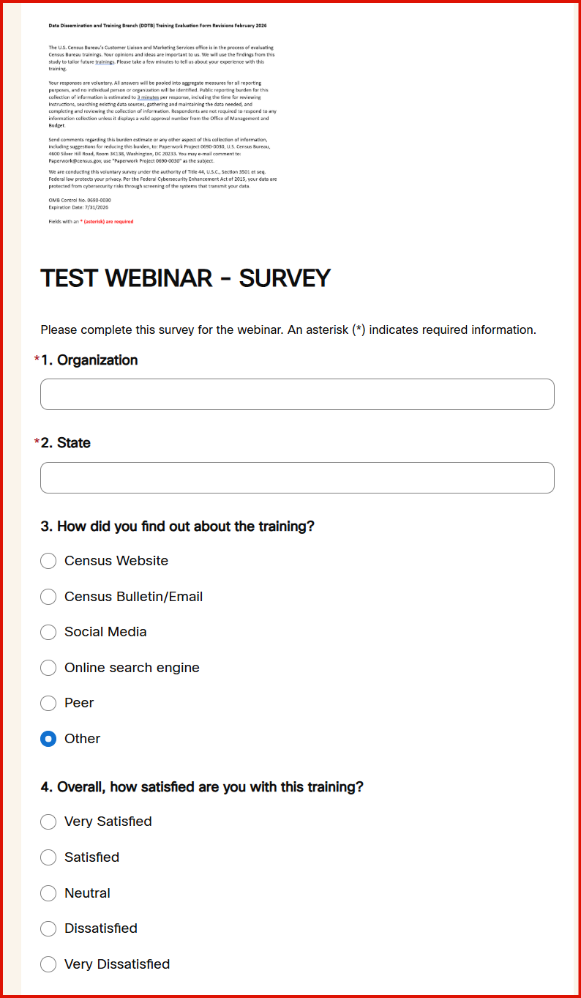
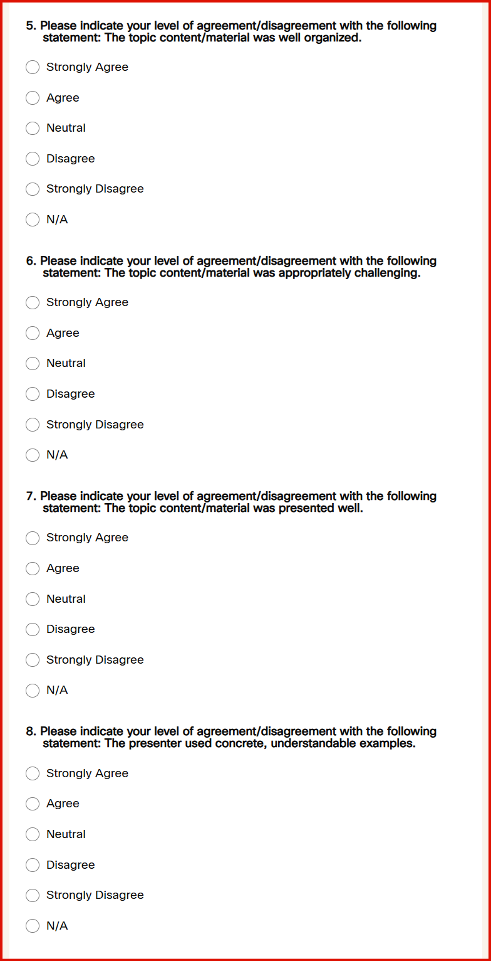
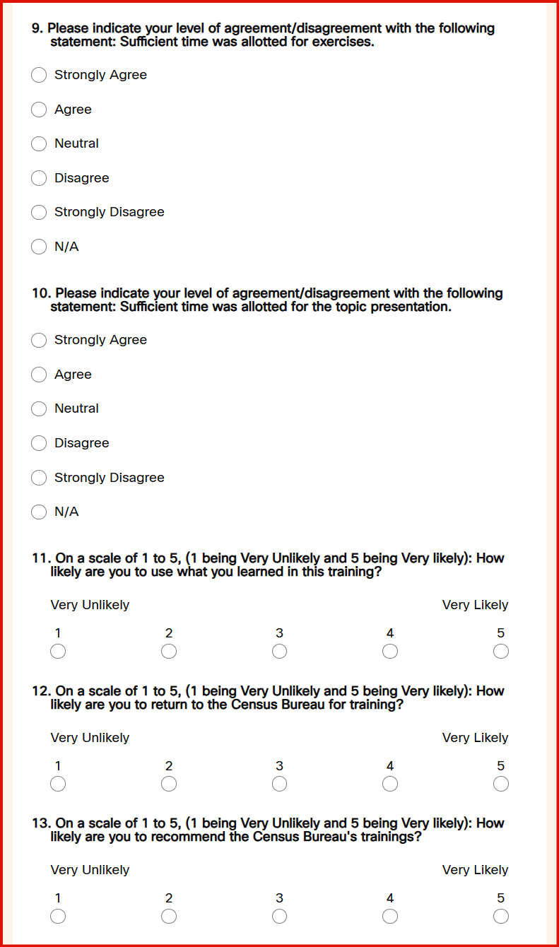
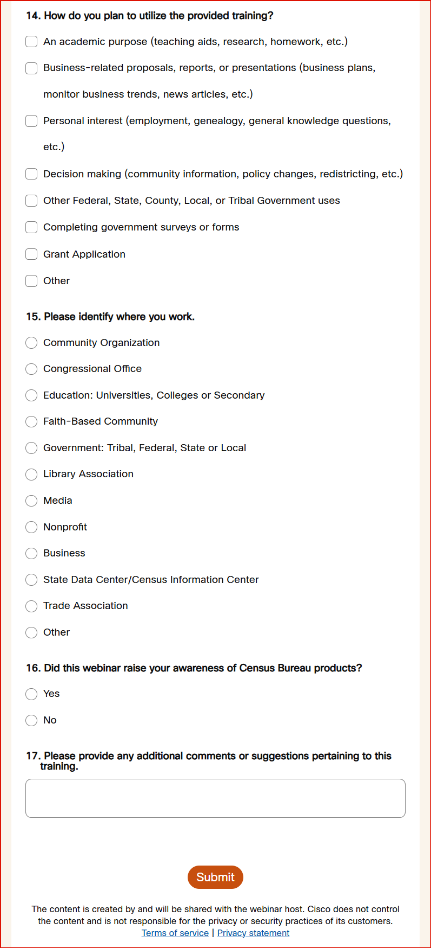

Closing Screen
Thank you for taking the time to complete this form. Your feedback is valuable and helps improve our services. If you would like to find additional resources or request additional training, please visit census.gov/academy.

