IPFQR Program HQR Secure Portal Images
- Data Accuracy and Completeness Acknowledgement (DACA)
After logging in to the HQR Secure Portal, access the DACA by hovering over “Administration” and then “DACA” in the
left menu.
Please see attached Word document for mockup of DACA form that has not been signed.

IPFQR Program HQR Secure Portal Images
- Web-Based Data Submission
Starting with the summer 2023 data submission period, IPFs must submit data via XML file upload into the HQR Secure Portal. The patient-level data submitted for the measures proposed for removal in the FY 2027 proposed rule, SUB-2/2a and TOB-3/3a, are submitted via XML filed upload. IPFs that use the CMS Abstraction & Reporting Tool (CART) to abstract IPFQR Program measure data can only do so for the patient-level measures because the IPF module in CART is not designed to abstract aggregate, facility-level data. Thus, IPFs using CART to create XML files for patient-level reporting must manually enter the non-measure data and the data elements of the Hospital-Based Inpatient Psychiatric Services (HBIPS)-2 and HBIPS-3 denominator value directly into a data entry form in the HQR Secure Portal.
A data collection tool available within the Hospital Quality Reporting system via the Hospital Quality Reporting Secure Portal allows hospitals to submit their PIX Survey data. This document is a representation of the text contained in the measure data form and is for reference purposes only.

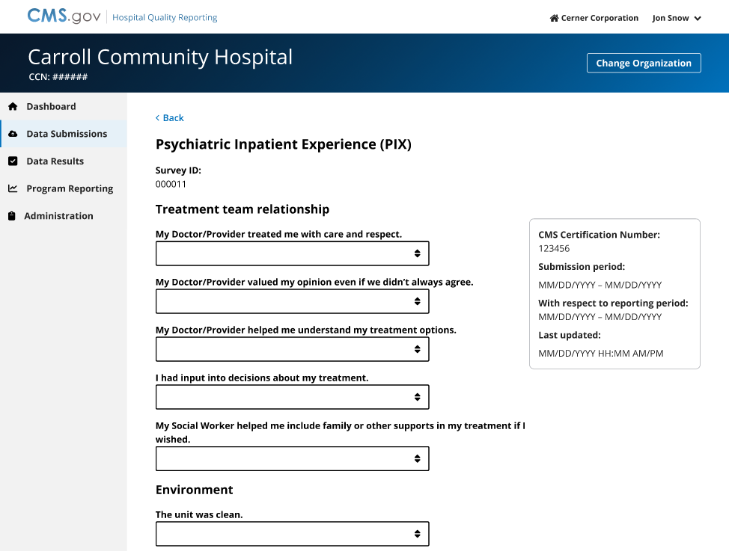
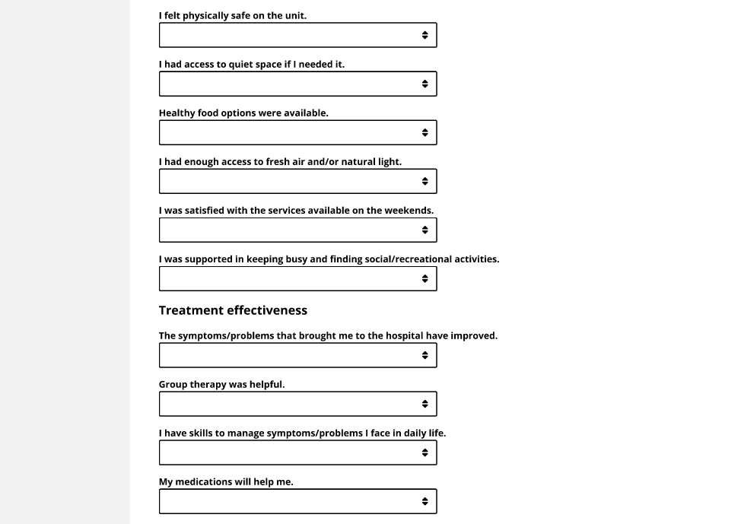
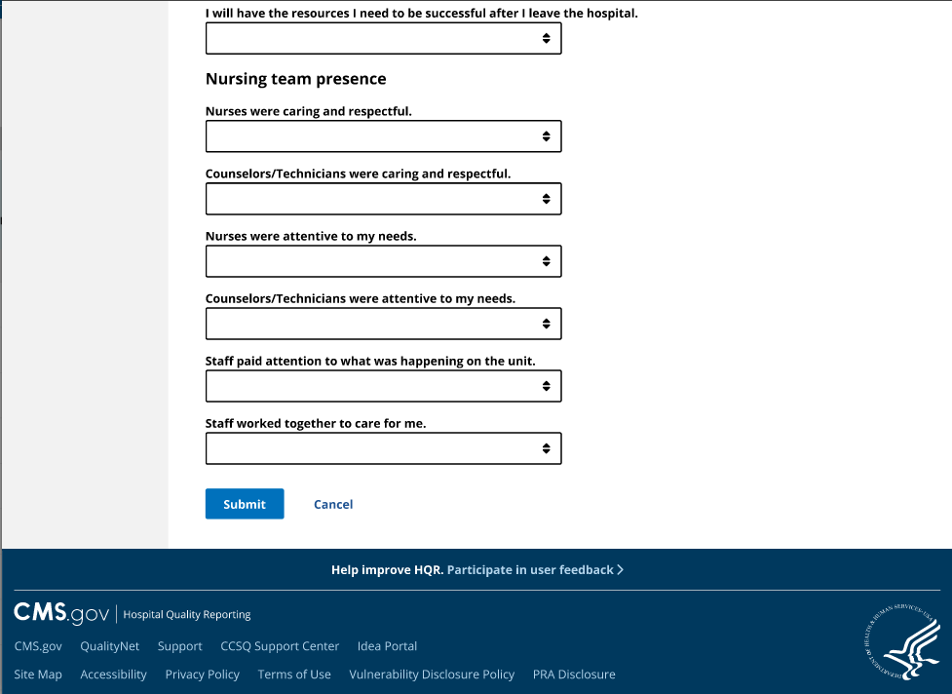

IPFQR Program HQR Secure Portal Images
- Non-Measure Data

IPFQR Program HQR Secure Portal Images
- HBIPS Denominator

5. Zero Patient Attestation

Note: A data collection tool available within the Hospital Quality Reporting system via the Hospital Quality Reporting Secure Portal allows hospitals to complete and submit their Zero Patient Attestation data. This document is a representation of the text contained in the Zero Patient Attestation data and is for reference purposes only.

If you have zero patient event or zero patient discharges for any measure below, select the corresponding checkbox. By default this selection will not be made, and you will need to submit as usual.
HBIPS-2
There are zero patient events to submit
[Grab your reader’s attention with a great quote from the document or use this space to emphasize a key point. To place this text box anywhere on the page, just drag it.]
HBIPS-3
There are zero patient events to submit
[Grab your reader’s attention with a great quote from the document or use this space to emphasize a key point. To place this text box anywhere on the page, just drag it.]
SMD
There are zero patient events to submit
[Grab your reader’s attention with a great quote from the document or use this space to emphasize a key point. To place this text box anywhere on the page, just drag it.]
SUB-2
There are zero patient events to submit
[Grab your reader’s attention with a great quote from the document or use this space to emphasize a key point. To place this text box anywhere on the page, just drag it.]
SUB-2a
There are zero patient events to submit
[Grab your reader’s attention with a great quote from the document or use this space to emphasize a key point. To place this text box anywhere on the page, just drag it.]
SUB-3
There are zero patient events to submit
[Grab your reader’s attention with a great quote from the document or use this space to emphasize a key point. To place this text box anywhere on the page, just drag it.]
SUB-3a
There are zero patient events to submit
[Grab your reader’s attention with a great quote from the document or use this space to emphasize a key point. To place this text box anywhere on the page, just drag it.]
TOB-3
There are zero patient events to submit
[Grab your reader’s attention with a great quote from the document or use this space to emphasize a key point. To place this text box anywhere on the page, just drag it.]
TOB-3a
There are zero patient events to submit
[Grab your reader’s attention with a great quote from the document or use this space to emphasize a key point. To place this text box anywhere on the page, just drag it.]
TR-1
There are zero patient events to submit
[Grab your reader’s attention with a great quote from the document or use this space to emphasize a key point. To place this text box anywhere on the page, just drag it.]
IMM-2
There are zero patient events to submit
[Grab your reader’s attention with a great quote from the document or use this space to emphasize a key point. To place this text box anywhere on the page, just drag it.]
Submit
Cancel

IPFQR Program HQR Secure Portal Images
6. Vendor management

IPFQR Program HQR Secure Portal Images

IPFQR Program HQR Secure Portal Images
7. Notice of Participation
Facilities must submit a Notice of Participation which will remain active unless the IPF withdraws from the program.

