Supporting Statement B

Generic Clearance for the Collection of
Medicare Current Beneficiary Survey (MCBS) Respondent “Pulse” Feedback

OMB Control No: 0938-NEW
Contact Information:
William S. Long
Contracting Officer’s Representative, Medicare Current Beneficiary Survey
Office of Enterprise Data and Analytics/CMS
7500 Security Boulevard, Mail Stop Mailstop B2-04-12
Baltimore, MD 21244
(410) 786-7927
william.long@cms.hhs.gov
(410) 786-5515 (fax)
April 20, 2026

Table of Contents
B. STATISTICAL METHODS 3
B1. Universe and Respondent Selection 3
B2. Procedures for Collecting Information 4
B3. Methods to Maximize Response 5
B4. Testing of Procedures 5
B5. Individuals Consulted on Statistical Aspects and Individuals Collecting/Analyzing Data 5

B. STATISTICAL METHODS
As noted in Supporting Statement Part A, the Centers for Medicare & Medicaid Services (CMS) requests approval for a new generic clearance for the collection of Medicare Current Beneficiary Survey (MCBS) Respondent “Pulse” Feedback. The MCBS Pulse generic clearance is intended for contexts in which CMS stakeholders require time-sensitive data to inform program planning and decision-making. This clearance will allow CMS to improve operational efficiency by establishing a data-driven process to inform emerging program initiatives, develop nascent questionnaire concepts, and obtain rapid insights on evolving beneficiary needs. The MCBS Pulse generic clearance will improve the CMS’s evidence-based program planning and administration and reduce administrative complexity for both the agency and its stakeholders. For each Pulse survey, CMS will submit individual information collections requests (ICRs) under this generic clearance to OMB along with questionnaires, interviewer scripts and any respondent materials in advance of fielding.
Statistical methods for the MCBS Pulse generic clearance are designed to maximize efficiency, minimize respondent burden, and ensure timely data collection and release.
- Efficient design: Leveraging existing MCBS respondents immediately following their MCBS interview will enhance operational efficiency while minimizing respondent burden. The Pulse survey will take advantage of the full MCBS infrastructure, and the questions will be programmed in Voxco, a cost-effective platform that is easy to use.
- Low respondent burden: Each Pulse survey will be a very brief collection that takes no more than two minutes to administer. This limited burden is expected to support high rates of respondent consent at the conclusion of the MCBS interview.
- Rapid implementation and timely internal data availability: Critically, this generic clearance enables a highly accelerated timeline. Pulse data can be designed, fielded, and released within approximately nine weeks, allowing CMS to respond quickly to emerging information needs.

B1. Universe and Respondent Selection
As explained in the main MCBS clearance package (0938-0568, expiration 01/31/2029), the MCBS is a continuous, multi-purpose longitudinal survey, representing the population of beneficiaries aged 65 and over and beneficiaries aged 64 and below with disabilities, residing in the United States. The target universe is current Medicare beneficiaries entitled to hospital and/or supplementary medical insurance and living in the 50 states or the District of Columbia. Both institutionalized and non-institutionalized beneficiaries are represented.
Starting in Summer 2026 Round 105 and each round thereafter, the “Pulse” survey will be conducted with Community-dwelling sampled beneficiaries who participate in the MCBS. There will be no new recruitment or additions to sample; respondents to Pulse surveys will have already been sampled and recruited and are active participants in MCBS data collection.
Each MCBS Pulse survey will be fielded to existing MCBS respondents for up to two weeks during a given data collection round. The Pulse survey will be administered at the conclusion of their regular MCBS interview. The MCBS design includes three rounds a year, each lasting approximately 16 weeks. Given that each Pulse survey is exceptionally brief, a small number of items fielded for up to two weeks, multiple Pulse surveys could be conducted each round. Therefore, the respondent burden estimated in Supporting Statement Part A assumes that most MCBS respondents living in the community may receive a Pulse survey during each MCBS data collection round.
Exhibit 1. MCBS Pulse Data Collection
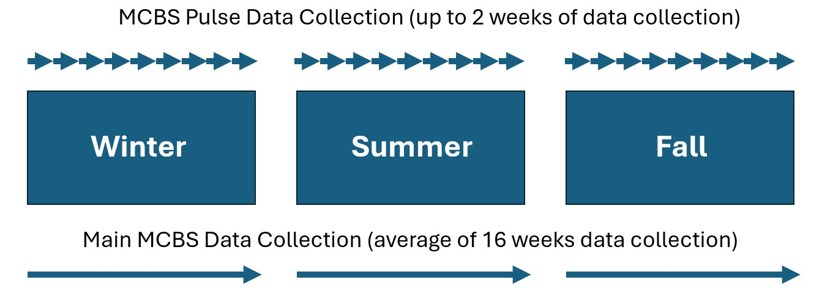
For each ICR submitted under this generic clearance, CMS may use existing MCBS data to identify and interview only those respondents who are most relevant to the specific measures of interest. This allows Pulse questions to be asked of a focused subset of beneficiaries who are most likely to provide meaningful responses (e.g., individuals with diabetes for a Pulse survey that focused only on diabetes prevention-related items). This would also reduce the respondent burden for a given Pulse survey.
In most cases, Pulse data will be analyzed without weights as these estimates will be used to inform program planning as opposed to making population-level inferences. On occasions when inference to the Medicare population may be needed, MCBS Pulse survey data would be weighted using intra-panel probabilities of selection and previously maintained nonresponse-adjusted weights. However, while these weights may be further adjusted based on response to Pulse, this process may not adequately address differential response bias because of the relatively small proportion of respondents who will be eligible for each Pulse and the non-random nature of selection into each survey.

B2. Procedures for Collecting Information
Data collection under this clearance request will primarily be conducted by phone supplemented with in-person interviewing for sampled beneficiaries living in the community (e.g., household). Phone interviews may also be enhanced with video calling when respondents are interested and can easily access this technology. CMS will submit ICRs under this generic clearance to OMB that describe the purpose of the Pulse measures, when the specific Pulse survey will be fielded along with questionnaires, scripts and any respondent materials in advance of fielding.
Pulse interviews will be conducted with the beneficiary or a proxy they have selected. Interviewers will administer Pulse questions as a one-time survey directly following the completion of their main MCBS interview. CMS plans to use Voxco, a software platform well-suited for computer assisted interviewing, for programming of Pulse survey questions. The questions will be administered by the same trained interviewers who are conducting the full MCBS data collection. While the interviewers use laptops programmed for the full MCBS for MCBS administration, they will use Android tablets for Pulse survey administration. The interviewers are deft in integrating both technology solutions during a given interview and have demonstrated in many other projects ease of shifting from their laptop to the tablet. Key technology benefits of using Voxco include programming that fully utilizes sophisticated logic checks, skip patterns, and text fills to ease question administration and reduce respondent burden by shortening the interview.

B3. Methods to Maximize Response
As also explained in the main MCBS clearance package (0938-0568, expiration 01/31/2029), well-honed MCBS methods for maximizing response rates with existing MCBS participants are regularly used. For Pulse surveys, interviewers will administer a brief transition script to obtain respondent consent to continue with the last few minutes of their interview. MCBS interviewers have experience with transition scripts, and prior experience indicates most respondents will agree to a few final questions. The design of the Pulse survey benefits from administering the Pulse questions immediately following the MCBS interview for a given round. Because of the rapport interviewers establish with respondents, CMS anticipates that Pulse questions will be readily answered. Detailed metrics will be tracked on respondents who choose not to continue with Pulse questions to determine what changes if any are needed in the methods to gain their cooperation.

B4. Testing of Procedures
This submission is a request for a generic clearance to conduct short Pulse surveys immediately following the conclusion of MCBS data collection. Pulse questions may inform early question development for potential future topics in the MCBS and provide CMS stakeholders with timely views from the Medicare population on current topics of interest or feedback on the program. Similar research has recently been conducted under the existing MCBS generic clearance 0938-1275. The test conducted (Test of the MCBS Pulse Supplement: Beneficiary Trust GenIC #8) differed in methodology but had similar goals and was administered with success to current and former MCBS respondents using the Voxco survey platform.
All Pulse data will be made available to CMS decision-makers for internal program planning and operational decision-making. Analysis will be conducted at the item level and by merging Pulse responses with other key MCBS variables (such as demographics and health status information) to provide comprehensive, stratified insights. Unweighted data will primarily be used by internal decision-makers to glean insights on program direction or development. Assessments of the quality will be performed for each Pulse survey data collection and will include evaluations of sample size and response rates. If population-level inferences are being made, CMS will also assess weighting and calculations of base of the selected variables.

B5. Individuals Consulted on Statistical Aspects and Individuals Collecting/Analyzing Data
Susan Paddock, Executive Vice President & Chief Scientist
NORC at the University of Chicago
55 East Monroe Street, 30th Floor
Chicago IL 60603
(312) 759-2670
paddock-susan@norc.org

