SUPPORTING STATEMENT: PART B
Pilot Study Examining Interpersonal Violence Experienced By Young Adults

B. COLLECTION OF INFORMATION EMPLOYING STATISTICAL METHODS

This project will develop and pilot test a survey instrument and recruitment methods to examine interpersonal violence (IV) among college-aged persons in order to better understand the risks for, experiences with, and consequences of IV among young adults. An extensive pilot of the procedures for the current study was conducted in the spring of 2019, before the COVID-19 pandemic. Given the time lag, updating recruitment assumptions is prudent. The results will be used to update recruitment rates for each of the sampling strata (see below).

Table 1 summarizes the pilot study data collection. The plan is to send 5,000 letters to individuals sampled for the study. The mailing will include $5, with the bill partially showing through a small window. Eligible respondents will be asked to go to a website that guides them through the request, which includes completing a screening form and enrollment survey that takes approximately 12 minutes. Those who complete the enrollment survey will receive a $20 digital Amazon gift card.

TABLE 1. Pilot Study Overview
Sample Size | 5,000
Number of Mailings to Recruit Respondents | 4
Mode of Survey | Web
Time to Complete the Survey | 12 minutes
Prepaid Incentive for Initial Mailing | $5
Promised Incentive to Complete Survey | $20

1. Sampling and Weighting
The eligible population consists of youth in the birth cohort who will be part of the high school senior class in the spring of 2026, or would be if they had remained in high school. This group includes those who are attending their senior year at this time, as well as anyone who may be behind in school or who has dropped out. To be eligible, the person must be 18 at the time of the survey request.

Sample Frame
A two-phase sampling design will be used to screen and recruit from the target population. The first phase is a large nationally representative random sample of addresses, which will be purchased from Marketing Systems Group (MSG). MSG maintains a list of all addresses in the United States based on U.S. Postal Service (USPS) delivery addresses. The second phase is intended to be a stratified simple random subsample of these addresses, with the strata created based on auxiliary information provided by MSG and ASL Marketing, a commercial vendor of student marketing data.

The auxiliary information provided by MSG consists of flags for households with members aged 18 to 24. While this information is not expected to be 100% accurate, households with this flag are likely to have more eligible household members for this study than those without the flag. Hence, we propose to use this flag as a stratification variable for the second phase. A second stratification variable will be obtained by matching the MSG addresses to ASL Marketing records. ASL Marketing’s proprietary list contains approximately 2.5 million names, ages, and birthdates of high school seniors, as well as other 18-year-olds. Following matching, the MSG addresses will be divided into four groups: addresses with a matching ASL record containing a birthdate (“ASL birthday match”), addresses with a matching ASL record but no birthdate (“ASL no birthday match”), addresses without a matching ASL record but flagged for the presence of an 18-24-year-old (“MSG match”), and addresses without an ASL match and not flagged for the presence of a 18-24-year-old (“unmatched”).

This pilot study aims to investigate the effectiveness of this stratification in creating a representative sample of 18-year-olds compared to an address sample with fewer than four strata and to determine the optimal sample allocation. Therefore, the critical variables to collect in this pilot study are (1) the relative sizes of the four strata and (2) the stratum-specific fractions of addresses yielding an 18-year-old respondent. In the first pilot study, the stratum sizes and the enrollee yields varied greatly between the strata, so obtaining updated estimates of these design parameters is necessary.

A nationally representative random sample of 200,000 addresses will be purchased from MSG, from which the four strata described above will be created. The first row in Table 2 shows the predicted number of MSG addresses that will fall in each of the four strata based on the proportions observed in the prior pilot study. The proposed sample allocation for 5,000 addresses is shown in the second row. The third row shows the yields observed in the previous pilot study, which would result in the number of 18-year-olds in the fourth row if they continue to hold. Finally, the last two rows show the standard deviations and coefficients of variation (CV) expected to be obtained for the estimated yields in the current pilot study.

TABLE 2. Sampling Strata
Stratum | ASL Birthday Match | ASL No Birthday Match | MSG Match | Un-matched | Total
Predicted Number of MSG Addresses | 2,503 | 545 | 12,200 | 184,752 | 200,000
Address Sample Size | 180 | 70 | 250 | 4,500 | 5,000
Yield of 18-year-olds (prior study) | 30.1% | 8.2% | 4.0% | 2.2%
Predicted Recruited Sample Size | 54 | 6 | 10 | 98 | 168
Predicted Standard Deviation | 3.3% | 3.1% | 1.2% | 0.2%
Predicted CV | 10.9% | 37.3% | 30.7% | 9.9%

Weighting and Estimation
The primary analytic outcome is the yield rate for each stratum. With a sample of 5,000, approximately 168 individuals are anticipated to complete the survey for an overall yield rate of 3.4%. Table 3 provides the 95 percent confidence intervals surrounding each estimate.

TABLE 3. Ninety-Five Percent Confidence Intervals for Estimates of Yield Rates
Stratum | Lower Bound | Upper Bound
Match with ASL records that have a birthdate | 23.6 | 36.5
Match with ASL records without a birthdate | 2.2 | 14.2
MSG match+ | 1.6 | 6.4
Unmatched | 1.8 | 2.6

These should provide adequate information to test the sample design and optimize the design to minimize the effects due to weighting and the cost of recruiting the sample. The pilot sample will also be used to calculate estimates of interest. Survey weights will be created to do this. Base weights will be obtained from the original address sample and the allocation of the addresses to the four strata. The base weights will be adjusted for non-response using data from the Current Population Survey, which has data on age, educational status, and several socio-demographic characteristics.

2. Procedures for Collecting Information
The pilot is expected to be in the field in the summer of 2026.

Data collection
The invitation to participate in the study directs the sample members to log on to the study website using a unique access code. Once logged on, respondents are asked to complete a screening form and enrollment survey. Mailing materials and protocols differ by stratum. Table 4 shows the materials included in the four recruitment contacts by stratum. For the two strata that match the provider lists, a letter will be sent via USPS to each named individual. The letter will instruct the individual to log on to the study website using the ID contained in the letter. The respondents will be asked to complete the screening form when signing in. The mailings will be sent out in batches based on whether or not the sampled person is 18 at the time of the mailing. The age will be determined using the birthdate provided on the ASL record. The mailing for those without birthdates (stratum 2) will be the last in the series to maximize the number of eligible sample members. Final eligibility for the study will be determined in the screening form.

For the third and fourth outreach waves, the letter will be addressed to the household, inviting any 18-year-old individuals to visit the website and enroll in the study. A household respondent can also log onto the website and provide data on whether (and how many) 18-year-olds are in the household. If there are any, they are asked to provide the study information to the 18-year-old to take the survey. If there is more than one qualifying person, one person is asked to log onto the website. The other individuals are asked to call the study help desk to get assigned an ID. Once their eligibility has been verified, the person will fill out the survey.

- TABLE 4. Recruitment Materials by Stratum
- Materials and types of mailings | - Stratum 1: Matched to ASL with date of birth | - Stratum 2: Matched to ASL without date of birth | - Strata 3 & 4: MSG Match, Unmatched
1. Initial Invitation
– 1st Class Letter | ü | ü | ü
– Incentive Flyer | ü | ü | ü
2. Postcard Reminder | ü | ü | ü
3. Invitation Letter | ü | ü | ü
-- 1st Class Letter
– Incentive Flyer
4. Parental Letter | ü | ü
– In a sealed envelope
Letter to Youth | ü | ü
Hard Copy Survey | ü
Final Letter |  |  | ü
– Hard Copy Screener Question |  |  | ü

In the fourth and final mailing, the procedures will differ by strata. For Strata 1 and 2, a letter will be sent to the parents of the selected sample member. The parent will be asked to hand the youth a sealed envelope containing the survey request. The request will ask the youth to log onto the website or fill out a paper version of the survey (See Attachments 1 and 2). For those in Stratum 1, a hard copy of the survey will also be included. A prepaid return envelope will be included to return the questionnaire. Sample members in Stratum 2 will not be sent any hard-copy data collection instruments, as we cannot verify their age due to a lack of date of birth information. The samples in strata 3 and 4 (MSG match, unmatched to ASL list) will be sent a hard-copy version of the screening form asking whether any 18-year-old lives at the residence. If there is, the young adult is directed to fill out the survey on the website.

Web Site Design
The website is designed to provide easy access in a highly usable format that appeals to young adults. The website design was created to be equally attractive for mobile devices. Figure 1 illustrates the design and layout of the landing page. Attachment 3 includes the content and flow of the study website.

In the fourth and final mailing, sample members in stratum 1 are sent a hard-copy version of the enrollment survey, along with a prepaid return envelope. Sample members in strata 3 and 4 (MSG match, unmatched to vendor list) are sent a hard-copy version of the screening form asking whether any 18-year-olds live at the residence. The web version of these surveys, available to everyone, can be used to complete these surveys.

Several key features of the recruitment mailing materials were pretested with 18-year-olds. This pretesting aimed to gauge young adults’ usual behaviors around opening their mail and gather insights into what recruitment messaging and themes appeal to them.

Figure 1. Website Landing Page
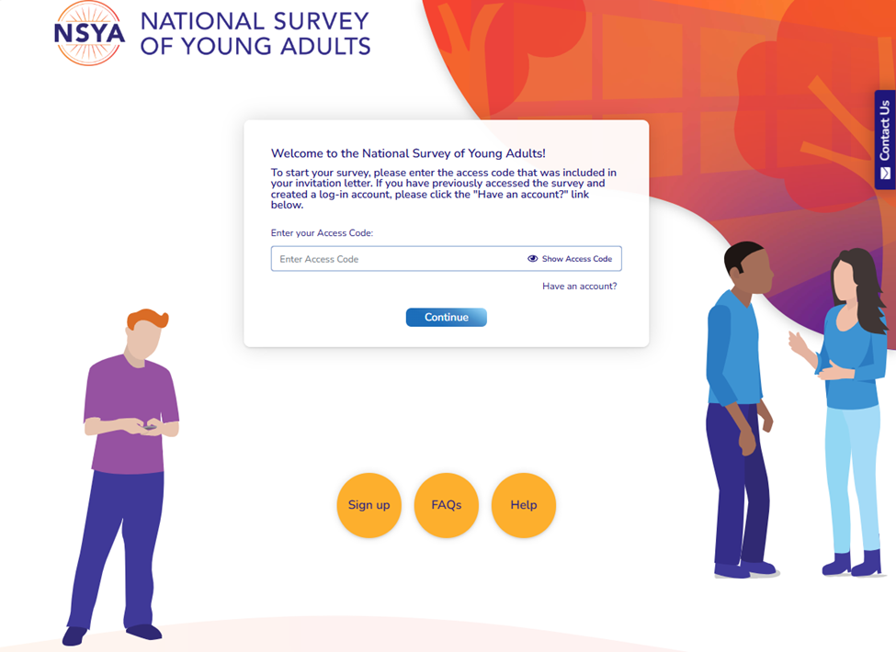

As shown in Figure 1, there are several resources available to participants on the landing page. At the bottom of the screen, the study website has links to the following pages:
- “Sign up”— This page provides step-by-step instructions for completing the sign up process.
- “FAQs”—Lists frequently asked questions about the study’s purpose and content, confidentiality guidelines, and risks and incentives for participation.
- “Help”—Opens a page listing helpdesk contact information.

The “Resources” tab (Figure 2) contains several resources for participants who experience distress due to the study topic. These include phone numbers, text numbers, and websites.

FIGURE 2. Resources & Support Tab
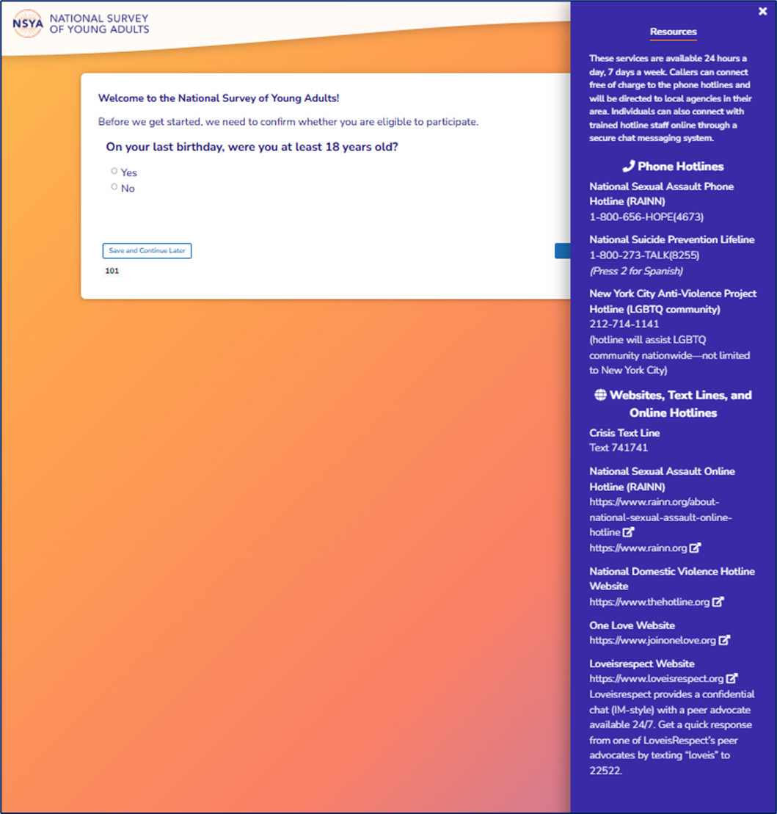

3. Methods to Maximize Response Rates

Contact Strategy
The recruitment strategy includes sending multiple mailings to the sampled person/household, including an initial letter, a reminder postcard, and two additional mailings. Different procedures are used to request participation for each stratum. For households with an individual matched to the ASL list, the letter will be addressed to that individual for the first three mailings. For the final mailing, the letter will be addressed to the parents of the youth. Since young adults in this age range are not likely to be checking the mail as often as adults, the goal is to have one of the parents give our request to the youth. The final mailing includes a hardcopy questionnaire for those who match the ASL list and have a birthdate. This leverages research that has found that response rates are higher if respondents are given the opportunity to complete a paper questionnaire.

Design of Materials
The letters and materials were designed based on extensive feedback from the target audience (i.e., 18-year-olds; see Attachments 4 and 5). The letters are in plain, simple language. They are also organized by questions commonly asked when considering a request to participate in the study.

Use of Incentives
Part A of this submission notes that the survey will use incentives to maximize response rates. These incentives include 1) an unconditional incentive of $5 sent to all sampled respondents/households and 2) a promised incentive of $20 for those completing the survey. Incentives have been found to significantly increase the response to postal surveys, such as those used here. The unconditional incentive will be partially displayed through a window on the envelope. This has been found to significantly increase the effectiveness of the incentive by making respondents more aware of the enclosed incentive.

Nonresponse and Response Rates
It is expected that the response to the mailings will vary by strata. Based on the pilot study conducted in 2019, the return rates are shown in Table 5. The response rate is difficult to calculate because it is unknown which households have an eligible person. To calculate the success of recruiting eligible individuals, the pilot estimated a response ratio by first applying survey-based weights for the 18-year-olds who responded to the background survey. These weights reflect the probability of selection from the national sample frame. Summing these weights for the 18-year-olds provides an estimate of the total number of these individuals in the country represented by those who responded to the survey. Dividing this total by the number of 18-year-olds in the United States estimates the proportion of eligible 18-year-olds who responded to the survey. For the previous pilot study, this ratio was 55 percent. A similar ratio will be calculated for the study proposed.

The sample generally represented the population well. It overrepresented individuals who received a high school diploma and underrepresented high school dropouts. However, a significant portion of the sample (18%) did not have a high school diploma.

TABLE 5. Return Rates by Strata
Stratum | Return
Match with ASL records that have a birthdate | 30.1%
Match with ASL records without a birthdate | 8.2%
MSG match+ | 4.0%
Unmatched | 2.2%

4. Final Testing of Procedures
Before the 2019 pilot test, the contact materials and website were thoroughly tested for content and accuracy. A series of focus groups was administered, and 16 young adults were asked for their reactions and suggestions for improvements. Two rounds of testing were conducted, with revisions to the materials between rounds. The survey includes questions on socio-demographics and prior experiences with different forms of violence. The team’s subject area experts and methodologists developed the questions using validated scales.

In addition, the promised incentives to complete the survey were tested as part of the pilot study. Half the sample was promised $20, while the other was promised $30. The $30 incentive did produce a slightly higher yield rate (12.6 vs. 13.4). However, given the relatively small effect of the incentive and its cost, we adopted the $20 incentive.

The pilot test implemented the recruitment and background survey with a sample of 1,922 respondents. The data were analyzed for quality by reviewing the frequencies, comparing the socio-demographic distributions to population totals from the Current Population Survey, and key outcomes, such as rates of intimate partner abuse, stalking, and nonconsensual sexual contact (see Attachment 6).

5. Study Contacts for Statistical Aspects and Data Collection
U.S. Department of Justice  Office of Justice Programs  National Institute of Justice | Westat®  Headquarters at-  1600 Research Blvd.  Rockville, MD 20850
Erica Howell, Social Science Research Analyst, Office on Violence and Victimization Prevention, National Institute of Justice, 999 N Capitol St NE, Washington, DC 20530 (Overnight 20002)  erica.howell@usdoj.gov  (202) 598-9431 | David Cantor, Ph.D., Vice President  Pilot Study Principal Investigator  DavidCantor@Westat.com  (301) 294-2080
Monica Mean, Ph.D.  Director, Office on Violence and Victimization Prevention, National Institute of Justice, 999 N Capitol St NE, Washington, DC 20530 (Overnight 20002)  monica.mean@usdoj.gov  (202) 305-5599 | Nathan Lowe, Ph.D., Principal Research Associate, Pilot Study Project Director  NathanLowe@Westat.com  (859) 475-6175
Christine Crossland, Senior Social Science Analyst, Office on Violence and Victimization Prevention, National Institute of Justice, 999 N Capitol St NE, Washington, DC 20530 (Overnight 20002)  christine.crossland@usdoj.gov  (202) 616-5166 | Reanne Townsend, Senior Statistical Associate, Methodology, Pilot Study Survey Methodologist  ReanneTownsend@Westat.com  (240) 314-2484
Dr. Jean Opsomer, Vice President, Statistics and Data Science, Pilot Study Senior Statistician
JeanOpsomer@Westat.com
(301) 738-3577
 | Westat Study Partners & Consultant
Bonnie Fisher, Ph.D., Distinguished Research Professor, University of Cincinnati; Pilot Study Senior Investigative Team, Measures Development
fisherbs@ucmail.uc.edu
Richard E. Heyman, Ph.D., Professor, New York University; Pilot Study Senior Investigative Team, Measures Development
Richard.Heyman@nyu.edu
Amy Slep, Ph.D., Professor, New York University; Pilot Study Senior Investigative Team, Methodology
Amy.slep@nyu.edu

LIST OF ATTACHMENTS

Attachment 1. Recruitment Screener, Informed Consent, and Questionnaire (web version)
Attachment 2. Recruitment Screener, Informed Consent, and Questionnaire (paper version)
Attachment 3. Content and Flow of Study Website
Attachment 4. Mailing Materials to Unmatched Sample Group
Attachment 5. Mailing Materials to Matched Sample Group
Attachment 6. National Study of Young Adults, Longitudinal Cohort Pilot Study Report

Final technical report for NIJ award 2016-MU-MU-K074, “National Study of Young Adults, Longitudinal Cohort Pilot Study” available at https://www.ojp.gov/pdffiles1/nij/grants/300704.pdf.
The first question on the web survey has a question asking the respondent’s age. If the person is less than 18 years old, the survey is terminated.
Olson, K., Smyth, J. D., Horwitz, R., Keeter, S., Lesser, V., Marken, S., … Wagner, J. (2019). Report of the AAPOR task force on transitions from telephone surveys to self-administered and mixed-mode surveys. Oakbrook Terrace, IL: American Association for Public Opinion Research.
Mercer, A., Caporaso, A., Cantor, D., and R. Townsend (2015). How much gets you how much? Monetary incentives and response rates in household surveys. Public Opinion Quarterly 79: 105-129.
DeBell, M., Maisel, N., Edwards, B., Amsbary, M., and V. Meldener (2020). Improving survey response rates with visible money. Journal of Survey Statistics and Methodology 8:821-831.

