SUPPORTING STATEMENT FOR
PAPERWORK REDUCTION ACT SUBMISSION
SMART TRAVELER ENROLLMENT PROGRAM (STEP)
OMB Number 1405-0152,
DS-4024, DS-4024e
A. JUSTIFICATION
1. Why is this collection necessary and what are the legal statutes that allow this?
The information solicited on this form is requested in connection with the provisions of 22 U.S.C. § 2715, 22 U.S.C. § 4802(b), 22 U.S.C. 211a note, 22 C.F.R. 71.1.

The Department of State (the Department) provides consular assistance in connection with the protection of U.S. nationals abroad. U.S. nationals, a term which is inclusive of all U.S. citizens, are encouraged to register with U.S. embassies and consulates abroad so that, in the event of an emergency, disaster, or international crisis, U.S. embassies and consulates can provide them with critical information and assistance.

22 U.S.C. § 2715 provides, inter alia, that in the case of a major disaster or incident abroad which affects the health and safety of nationals of the United States residing or traveling abroad, the Secretary of State shall provide prompt and thorough notification of all appropriate information concerning such disaster or incident and its effect on U.S. nationals to the next-of-kin of such individuals.

22 U.S.C. § 4802(b) provides inter alia, that the Secretary of State shall develop and implement policies and programs to provide for the safe and efficient evacuation of private U.S. citizens when their lives are endangered, including by developing a mechanism whereby U.S. citizens can voluntarily request to be placed on a list in order to be contacted in the event of an evacuation, or which, in the event of an evacuation, can maintain information on the location of U.S. citizens in high risk areas submitted by their relatives.

22 U.S.C. §211 note provides, inter alia, that the Department of State shall include on the first three pages of a passport a prominent, clear notice urging all travelers to register with the Department prior to overseas travel.

22 C.F.R. § 71.1 provides for Foreign Service Officers to perform duties in connection with the protection of U.S. nationals abroad, as provided by regulations prescribed by the Secretary of State.

The Department has developed STEP to make it possible for U.S. nationals to submit their travel plans and/or subscribe to travel alerts online by using secure encryption. STEP enables the Department and its embassies and consulates abroad to better assist U.S. nationals in the event of a crisis, disaster, or other emergency by providing contact information about U.S. nationals present in country and as a means of sending targeted messages and alerts to them.

2. What business purpose is the information gathered going to be used for?

The primary purpose for soliciting the information is to enable U.S. nationals to register their travel plans or long-term overseas residence on a voluntary basis, so that they may be contacted in the event of an evacuation or other emergency, in furtherance of the Secretary's role in providing consular assistance to U.S. nationals abroad.

STEP is intended for use by U.S. nationals who may enroll online prior to or during their overseas travel. The service is available on the Department’s Bureau of Consular Affairs web site http://travel.state.gov/ or at https://step.state.gov/step/. The information received is used to provide timely safety and security information and to facilitate locating and contacting U.S. nationals in the event of a disaster or incident abroad.

3. Is this collection able to be completed electronically (e.g. through a website or application)?

This information is primarily collected electronically. However, we anticipate that paper registration will be used occasionally by individuals requiring assistance from embassy or consulate staff to register.

4. Does this collection duplicate any other collection of information?

The information in STEP is not duplicative of information maintained elsewhere or otherwise available. Since U.S. adult passports are issued for a period of 10-years, the information on the passport application regarding intended places to visit and contacts in the event of an emergency are not always current. STEP enables the public to register this information quickly and easily for each trip abroad.

5. Describe any impacts on small business.

The information collection does not involve small businesses or other small entities.

6. What are consequences if this collection is not done?

Providing consular assistance to U.S. nationals, particularly in times of crisis or disaster, is a core function of the Department of State. It is essential that the Department have a reliable mechanism to facilitate communication with citizens in times of emergency. If the collection were not conducted, the negative impact on U.S. nationals abroad during emergencies could be considerable.

7. Are there any special collection circumstances?

No special circumstances exist.

8. Document publication (or intent to publish) a request for public comments in the Federal Register

The Department published a 60-day Federal Register notice for public comment. 91 FR 2821, Vol 91, No. 14, January 22, 2026, Public Notice 12912.

Response to Public Comments:
There was one public comment in response to the 60 day notice. The commenter expressed strong support for the Department of State’s initiative to enable third-party enrollment capability for the Smart Traveler Enrollment Program (STEP), noting that this modernization effort represents an important advancement in protecting U.S. citizens traveling abroad and expanding the reach of consular emergency communications.

9. Are payments or gifts given to the respondents?

No payment or gift is provided to respondents.

10. Describe assurances of privacy/confidentiality

Respondents are informed that release of information obtained in this collection is subject to the restrictions on dissemination contained in the Privacy Act (5 USC 552a). No other promises of confidentiality are made to respondents.

STEP will permit registrants to provide information about other members of their traveling party even if they are not U.S. nationals. This information will also not be shared by the Department of State unless permitted by the Privacy Act.

11. Are any questions of a sensitive nature asked?
No sensitive questions are asked.

12. Describe the hour time burden and the hour cost burden on the respondent needed to complete this collection.

There are, on average, 1,750,000 respondents annually.

The DS-4024 takes five minutes to complete. Therefore, the annual burden is calculated at 145,833 (1,750,000 respondents x 5 mins./60 mins. = 145,833 hrs.). The frequency of response is “on occasion.” The Bureau of Consular Affairs (CA), Overseas Citizens Services (OCS) received two different analytics studies on time burden from CA’s Office of Public and Congressional Affairs (CA/P). One study of over 60,000 users indicated first-time users of the STEP registration website spent just over six minutes on their registration. An additional study showed just over one minute of engagement during registration on what are presumed to be subsequent enrollments (not first time and thus faster). We are confident an estimated time burden of five minutes is accurate based on these metrics.

The annualized cost to all respondents for the hour burden for collections of information, based on appropriate wage rate categories, is $4,762,906. This was determined by multiplying the average Cross-industry, Private, Federal, State, and Local Government Hourly Wage of $32.66/hour (per the U.S. Bureau of Labor Statistics’ May 2024 estimates) by the total number of estimated burden hours.

13. Describe the monetary burden to respondents (out of pocket costs) needed to complete this collection.

STEP registration is free, there is no cost associated with registration which is accomplished online.

14. Describe the cost incurred by the Federal Government to complete this collection.

The costs to the USG have changed because the method for determining the cost estimations has changed since the last renewal. The new methodology is now consistent with cost estimation processes used throughout the Department.

The projected annual cost via FSO and LE Staff wages hours to process STEP registrations is $0 since dedicated STEP software now processes all registrations to the proper country and subscriptions to post’s STEP messaging automatically. Prior annual burden estimates for this labor (for paper) were estimated between $9-10 million annually. The specific labor cost to maintain STEP software is approximately $3,367,000.

15. Explain any changes/adjustments to this collection since the previous submission. List any changes to the information collection:

will be made to both the electronic and paper forms as noted below.
We are updating the time Burden estimate associated with completing the DS-4024e from 20 minutes to five minutes (corresponding image below). This is based on two studies performed by Office of Public and Congressional Affairs CA/P referenced in Section 12.

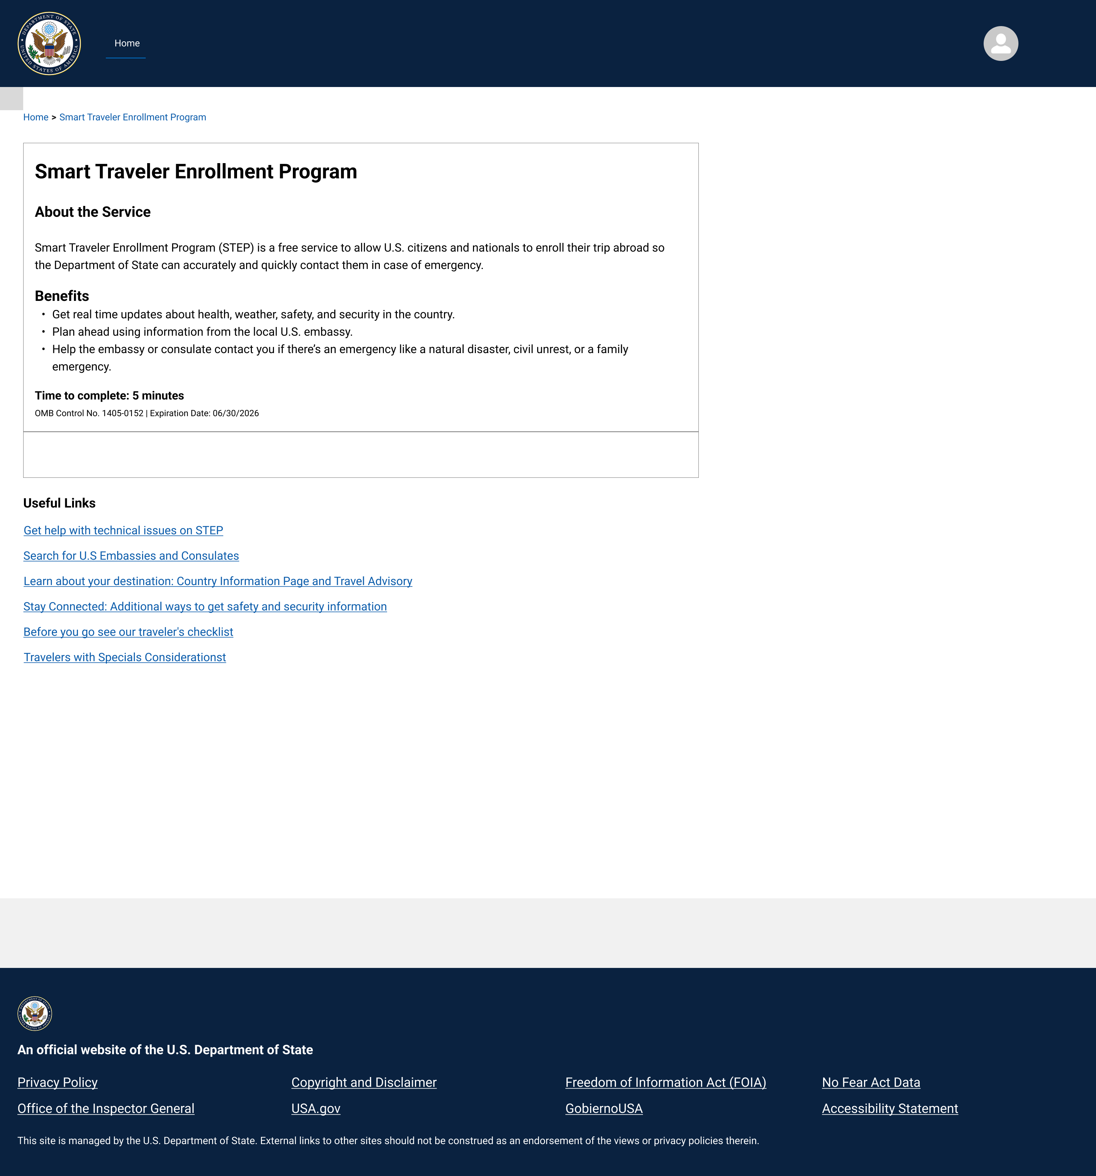

In December 2025, OMB approved adding third-party registration, which existed on the paper version, to the electronic version as a non-substantive change. That additional capability is being integrated into the electronic version and will be live prior to this PRA process being completed. In addition to third-party registration, the new version of the forms—both electronic and paper—contain slight changes to the itinerary and personal information sections, as noted in the screenshots below. Changes are also being made to the Privacy Act Statement to more accurately reflect, in plain language, the purpose of the form and the routine uses which may be applied to the information collected.

On January 31, 2025, the paper version of the STEP form (DS-4024 OMB 1405-0152) was removed from Department and public areas. Since that time, STEP registration has only been available via online registration and only for ‘self-registration. We plan to reintroduce the revised DS-4024 when the PRA process is complete. The paper form is being revised to match changes made to the STEP online platform DS-4024e (OMB 1405-0152) in January 2025, which changed the term “gender” to “sex” and reduced options to only “male” and “female” pursuant to the January 20, 2025 Executive Order 14168 “Defending Women From Gender Ideology Extremism and Restoring Biological Truth to the Federal Government.” We anticipate minimal impact on operations due to this change. The paper version will be used for individuals who are unable to register themselves directly via Login.gov.

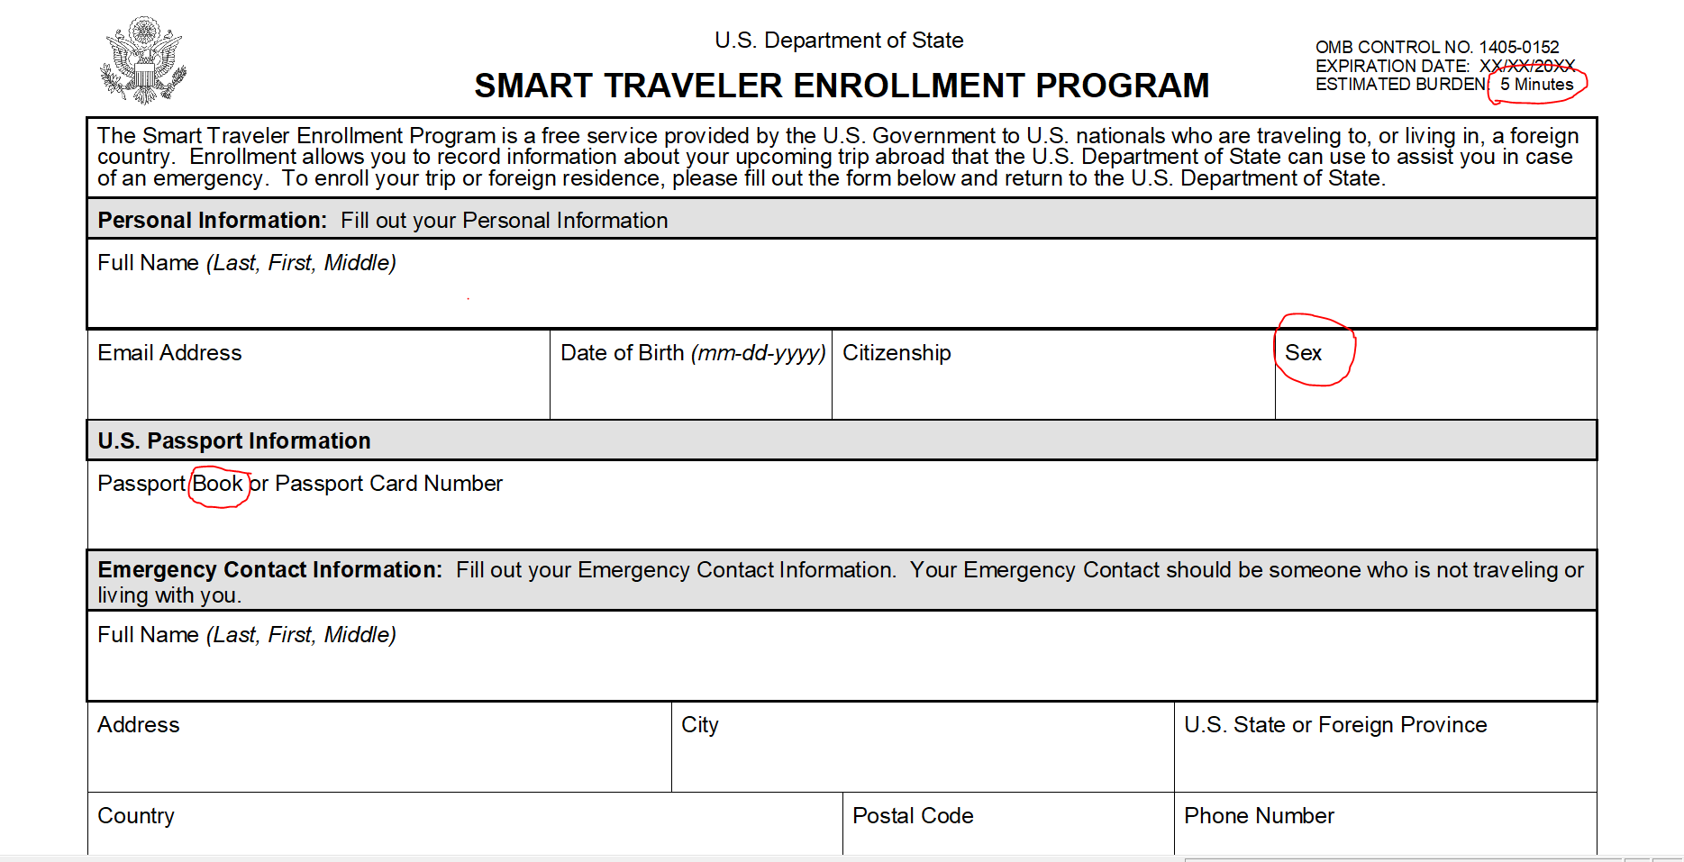

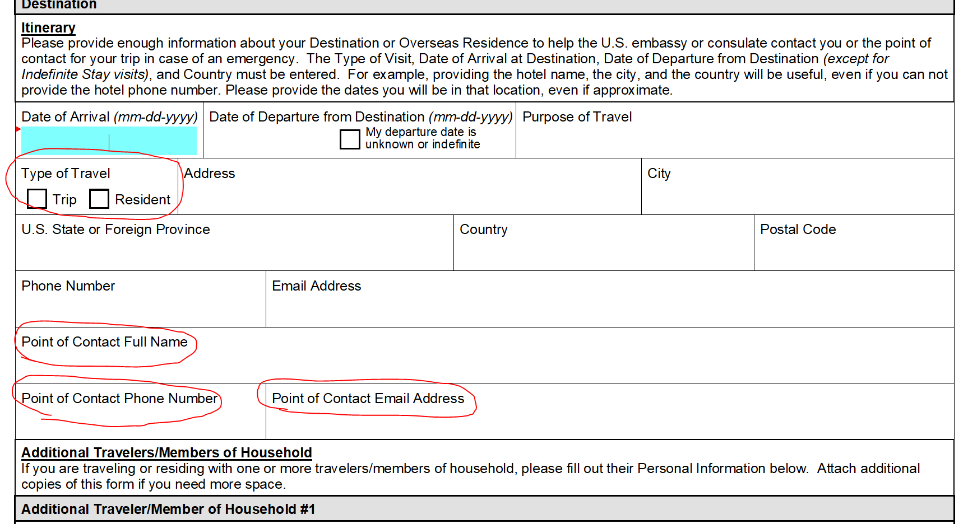

Changes to the ‘Itinerary’ section apply to all additional destination sections on the DS-4024 and DS-4024e.
Changes to the ‘Personal Information’ section were applied to all traveler sections on the DS-4024 and DS-4024e.

16. Specify if the data gathered by this collection will be published.
The information collected will not be published.
17. If applicable, explain the reason(s) for seeking approval to not display the OMB expiration date. Otherwise, write “The Department will display the OMB expiration date.”

The OMB approval information and expiration date for this collection will be displayed.
18. Explain any exceptions to the OMB certification statement below. If there are no exceptions, write “The Department is not seeking exceptions to the certification statement.”
No exceptions are being requested to the certification statement.

B. STATISTICAL METHODS
This collection does not employ statistical methods.

