COLAs Online Access Request (OMB No. 1513–0111)

Clicking on the “New User Registration” link shown below (see the circled instruction) on the TTB website “Register for a New Formulas Online and/or COLAs Online Account” page leads to the COLAs User Registration web form, shown beginning on page 2.

https://www.ttb.gov/online-services/myttb/reg-new-fonl-cola

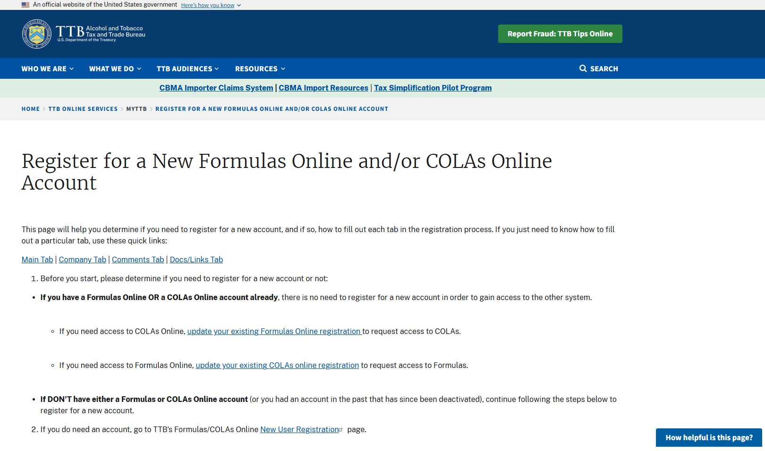

Clicking on the link in the circled instruction (URL shown below) generates the blank COLAs Online User Registration form shown beginning on the next page.

COLAs Online Registration (approved under OMB No. 1513–0111).

https://www.ttbonline.gov/formulasonline/ur.do?submissionName=UR&method=displayMainTab

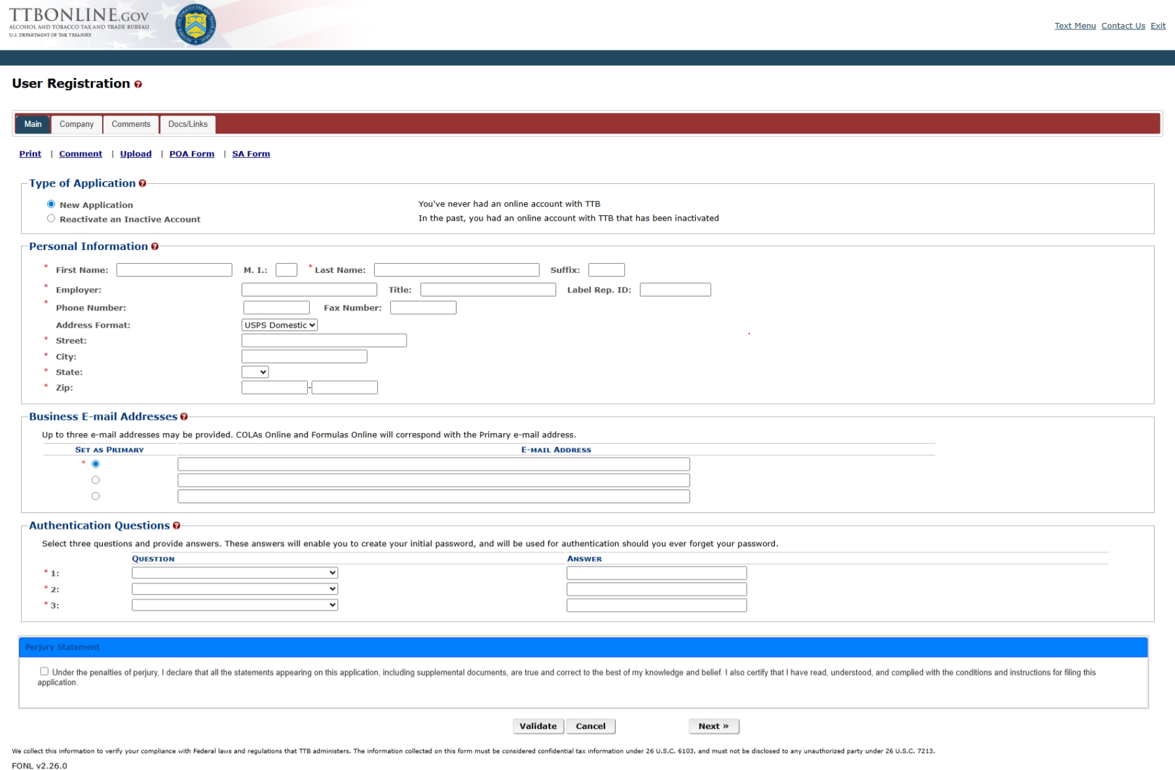

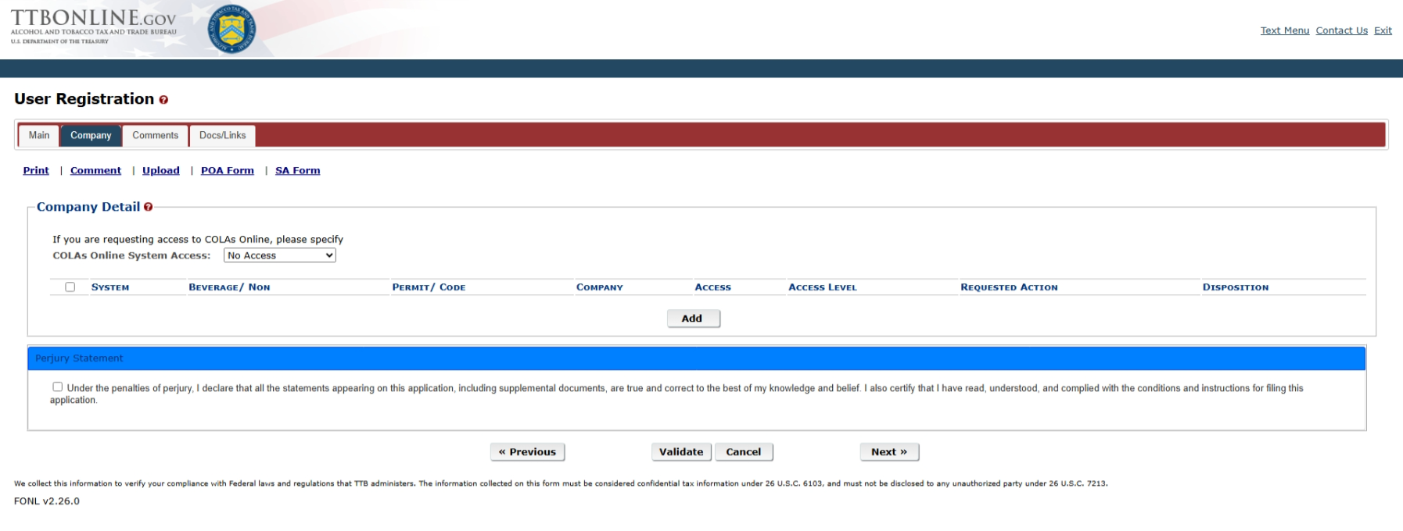

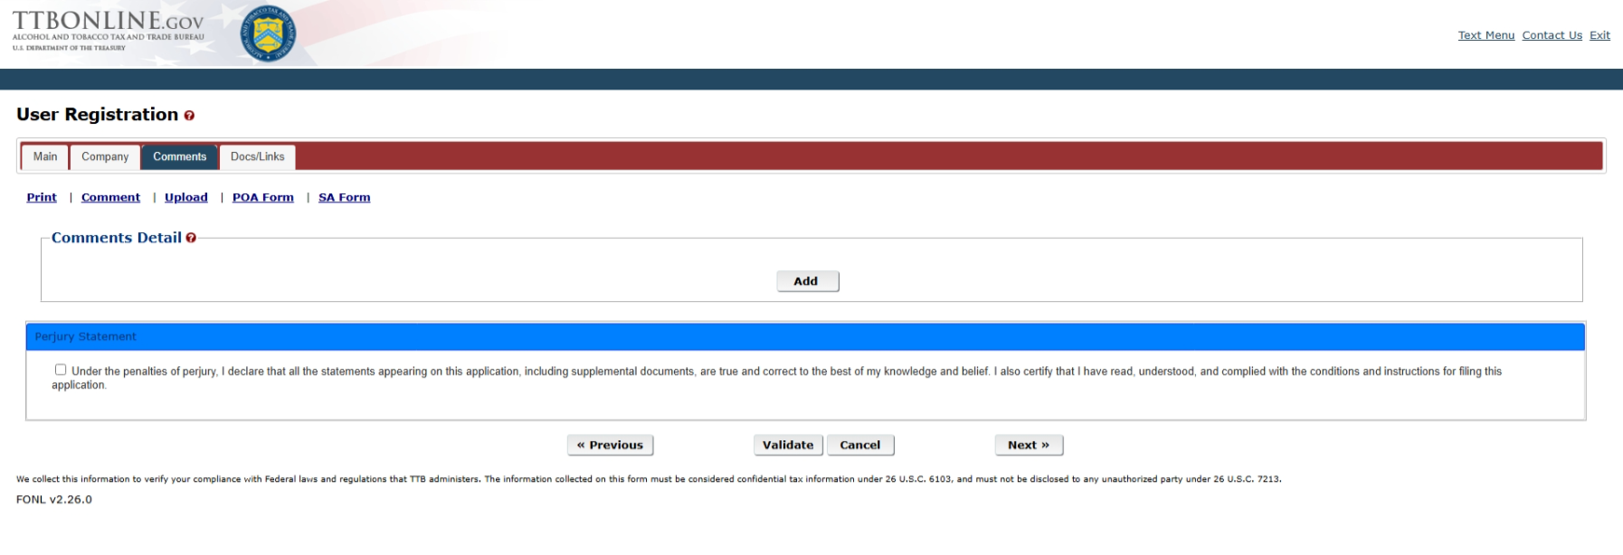

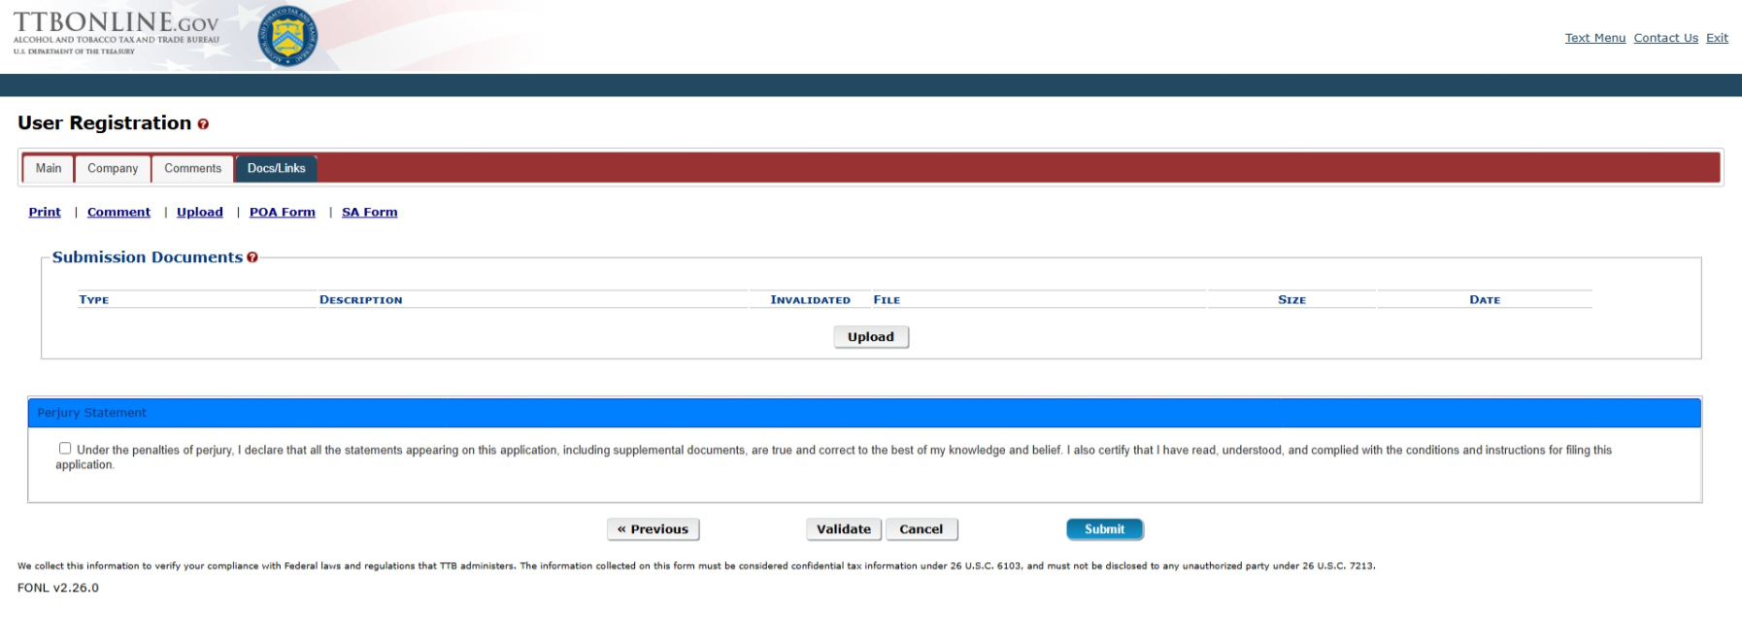
[END OF THE COLLECTION INSTRUMENT]

The instructions for COLAs Online User Registration are located on the “Register for a New Formulas Online and/or COLAs Online Account” web page on the TTB website. See:
https://www.ttb.gov/online-services/myttb/reg-new-fonl-cola.

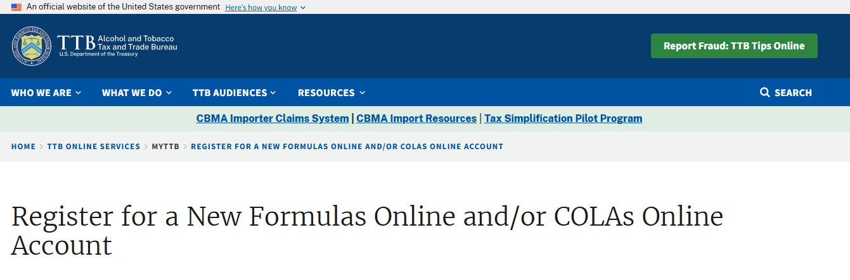
This page will help you determine if you need to register for a new account, and if so, how to fill out each tab in the registration process. If you just need to know how to fill out a particular tab, use these quick links:

Main Tab | Company Tab | Comments Tab | Docs/Links Tab

- Before you start, please determine if you need to register for a new account or not:

  - If you have a Formulas Online OR a COLAs Online account already, there is no need to register for a new account in order to gain access to the other system.

    - If you need access to COLAs Online, update your existing Formulas Online registration to request access to COLAs.

    - If you need access to Formulas Online, update your existing COLAs online registration to request access to Formulas.

  - If DON’T have either a Formulas or COLAs Online account (or you had an account in the past that has since been deactivated), continue following the steps below to register for a new account.
- If you do need an account, go to TTB’s Formulas/COLAs Online New User Registration page.

- Fill out the “Main” tab fields (type of application, personal information, email address(es), authentication questions, and perjury statement), then select “Next.”
  - Note: You may add up to three valid business email addresses, but then you must select which should be used as the primary contact. Email notification will only be sent to the primary contact email address.

  - Note: You are not required to complete the Label Rep ID field unless instructed to do so by your company. Only third party filers such as trade associations, law firms, and consultants are required to complete this field.

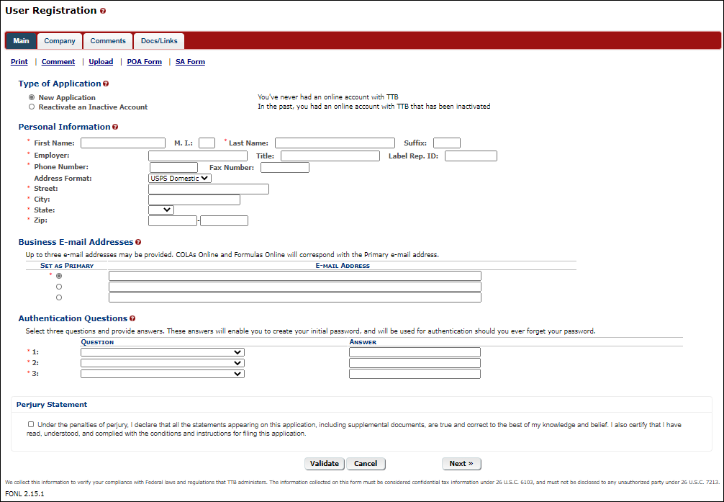

- Fill out the “Company” tab.

Note: You will need to complete a separate entry for each alcohol beverage permit / nonbeverage product company and for each system that you will need to access. For example, if you need access to both COLAs Online and Formulas Online for two permits/companies, you must complete four entries in the Company Tab:

  - Permit/company #1 access to COLAs Online

  - Permit/company #1 access to Formulas Online

  - Permit/company #2 access to COLAs Online

    - Permit/company #2 access to Formulas Online.

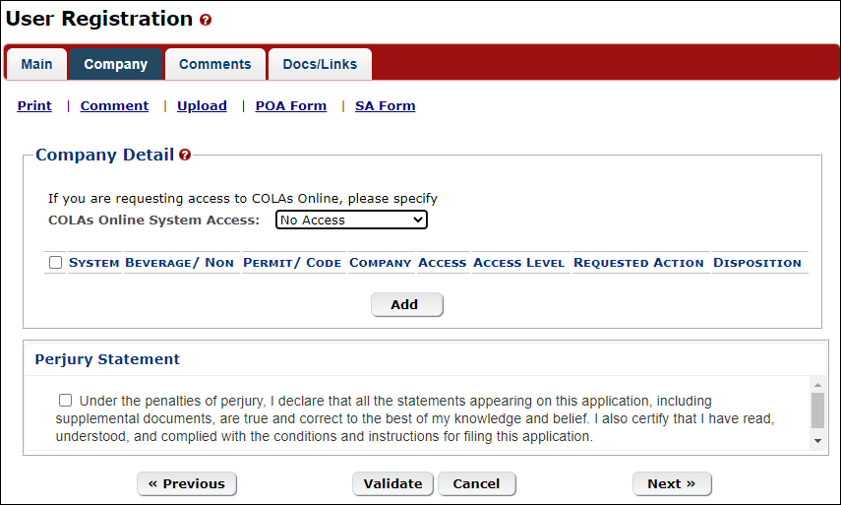

For each COLAs Online entry:

  - Under “Company Detail,” select the type of access from the “COLAs Online System Access” drop-down list, then select “Add.” A modal window will open.

    - Submitters can both prepare and submit applications; Preparer/Reviewers can only prepare applications (they must be submitted to TTB by someone with the Submitter role).

    - You must choose the same role (Submitter or Preparer) for ALL of the COLAs Online entries included in your registration (it is not possible to be a Submitter on one permit and a Preparer on another permit).

  - Important: For the “System Information” section on the “Add Company” modal window that pops up, be sure “System Requested” is “COLAs Online.” If it is not, change it.

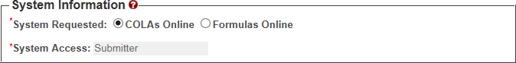

  - Fill out the “Company Information” section:

    - The “Company Code” field only applies to nonbeverage product companies.

    - For Address, please enter the premises address from the permit.
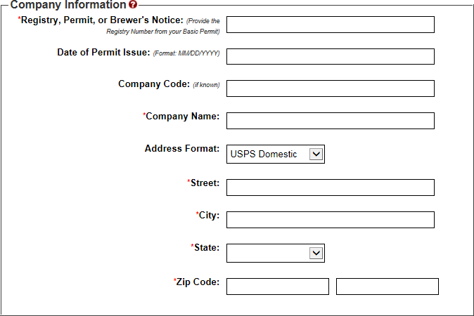
  - Fill out the “Individual Information” section:

    - If you are registering as a Submitter, select the appropriate “Signature Authorization” button (this field doesn’t apply to Preparers).

  - If known, enter the “Title” and “Name of the Company Approval Official” in the available fields.

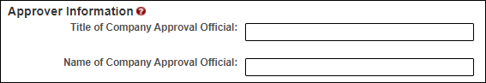
  - If you selected “Signing Authority” or “Power of Attorney” for “Signature Authorization,” an additional section will appear:

    - If you are registering for the first time as a Submitter on behalf of a beverage company, unless you are an owner, you must acknowledge you have a valid Signing Authority or Power of Attorney form on file at TTB’s National Revenue Center for this permit by selecting the “I agree” checkbox. If this is not already on file with us, you must ask an authorized person at the company to file a TTB permit amendment to get one on file for you before proceeding with your registration request.

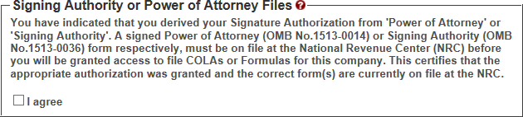

END OF INSTRUCTIONS FOR COLAS ONLINE REGISTRATION

(instructions for Formulas Online registration follows on the same webpage).

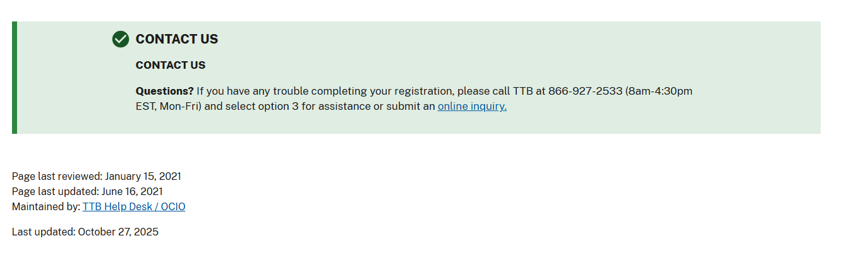
[END]

