OMB Control Number: 0560-NEW
OMB Expiration Date: XX/XX/XXXX

Grant and Cooperative Agreement Profile
This template is meant to serve as an example of the presentation of the information FSA Outreach Office is requiring in the performance reporting system.

One of the primary purposes of recurring reporting is to help FSA and the recipient identify and overcome any barriers to the recipient achieving the project’s intended goals and objectives. The report includes multiple open text boxes for the recipient to provide bullet point summaries of characteristics unique to their project, as well as standardized quantifiable metrics which will be used to measure the Program’s impact. Because of the nature of many projects, some of the metrics will not be realized until near the end of the project.

FSA recognizes that many recipients may have limited experience with reporting. To provide recipients with the tools they need to be successful, FSA plans a multi-tier approach of hosting webinars to review the reporting requirements, providing a software user’s guide, and one-on-one guidance between FSA’s Grant Management Specialists and the recipients.
Grant Profile-One time initialization by recipient
Agreement

FSA Agreement Number: | Enter Agreement Number (e.g., 17FSMIPXX####).
Project Title | Enter Project Title as Stated on the Grant or Cooperative Agreement.
Period of Performance: | Start Date: | Enter Date. | End Date: | Enter Date.
Award Amount: | Enter FSA Funding Amount ($).
Other Program Funds (if applicable): | Enter Non-Federal Matching Amount ($).
Are there Subawards: | Yes/No
Agreement Status: | Pending/Active/Terminated/Closed
Recipient

Recipient Organization Name: | Enter Recipient Organization Name.
Recipient’s Project Contact
Name: | Enter the Project Contact’s Name.
Phone: | Enter the Project Contact’s Phone Number.
Email: | Enter the Project Contact’s Email.
Project Profile Information
Project Summary
[Recipient Name] proposes to assist [XXX No.] [select applicable type(s) of producers: farmers, ranchers, and/or forest landowners] in [states /territories impacted]. The project focuses on [select applicable concern: land, capital, and/or market] access concerns with the objective(s) of [select all that are applicable: increasing access to farm ownership opportunities; increasing access and improving results for heirs’ property and fractionated land; increasing land ownership, land succession, and agricultural business planning; and/or increasing access to markets and capital that affect the ability to access land]. This will be accomplished by [in 150 words or less, summarize scope of work and deliverables, including underserved target audience]

Outcome Measures and INDICATORS The recipient will develop project specific measurable outcomes that address at least one of the following outcomes: For the purpose of this report, FSA defines underserved producers as: Beginning Farmer or Ranchers (An individual who has not operated a farm or ranch for more than 10 cumulative years), Socially Disadvantaged Farmer or Rancher ( Members of a group who have been subjected to racial, ethnic, or gender prejudice because of their identity as members of that group without regard to their individual qualities. Includes the following groups: American Indian or Alaska Native, Asian, Black or African American, Native Hawaiian or other Pacific Islander, Hispanic, and Women), Military Veteran (A person
who has served in the active military, naval, or air service, and/or who was discharged or released from the service under conditions other than dishonorable), Limited Resource Farmer or Rancher (An individual who has direct or indirect gross farm sales not more than the current indexed value in each of the previous 2 years, and: has a total household income at or below the national poverty level for a family of four in each of the previous 2 years; or
has a total household income less than 50 percent of the county median household income in each of the previous 2 years) and farmers, ranchers and forest landowners living in high poverty areas.

Outcome 1: Increase underserved producers’ access to farm ownership opportunities
Outcome 2: Increase underserved producers’ access and improve results for heirs’ property and fractionated land.
Outcome 3: Increase underserved producers’ access to markets and capital that affect the ability to access land.
Outcome 4: Increase underserved producers’ land succession planning
Outcome 5: Increase underserved producers’ business planning that is central to improving farming, ranching or forest land enterprises and operations.
Outcome 6: Underserved producers start farming. For the pupose of this outcome, only include those who had not previosuly been farming. The U.S. Department of Agriculture (USDA) defines a farm as any operation from which $1,000 or more of agricultural products were produced and sold, or normally would have been sold, during a given year. (NASS)
Outcome 7: Increase underserved producers’ farm size or capacity. For the purpose of this outcome, only include those who had previously been farming.
Outcome 8: Increase underserved producers’ farm profits. For the purpose of this outcome, only include those who had previously been farming.
Outcome 9: Underserved producers who seek and partipate in USDA programs
a. Natural Resources Conservation Service prrograms
b. Farm Service Agency farm loan programs
c. Farm Service Agency farm programs, other than loans
d. Rural Development loan or grant programs
e. Any other programs or services administered by USDA
Outcome 10: Improve underserved producers’ profitability of specialty crops through enhancing production knowledge or market development.
Outcome 12: Improve USDA’s approach to providing outreach and technical assistance services to underserved producers by sharing expertise and experience with other cooperators and USDA and by engaging in ongoing collaborative activities with USDA and other cooperators.

# | Describe Outcome/Indicator | Outcome | Estimated Number | How will you verify?  Examples: Producer Surveys, Training Attendance, Producers Receiving Direct Project Benefits
1
2
3
4
PROJECT BENEFICIARIES
Target Group
(SELECT AS MANY AS ARE APPROPRIATE)
☐ Women producers
☐ Youth producers
☐ Beginning farmer or rancher An individual who has not operated a farm or ranch for more than 10 cumulative years (Getstarted-HUFR-2022)
☐ Rural producers
☐ Urban producers
☐ Appalachia producers
☐ Certified organic producers
☐ LGBTQI+ producers

☐ Limited Resource producers An individual who has direct or indirect gross farm sales not more than the current indexed value in each of the previous 2 years, and: has a total household income at or below the national poverty level for a family of four in each of the previous 2 years; or has a total household income less than 50 percent of the county median household income in each of the previous 2 years (Getstarted-HUFR-2022)

☐ Producers living in high poverty areas

☐ Immigrant Producers

☐ Military Veteran A person who has served in the active military, naval, or air service, and/or who was discharged or released from the service under conditions other than dishonorable (Notice of Funding Opportunity)

☐ American Indian or Alaska Native Producers
☐ Retired/ Transitioning Producers
☐ Socially disadvantaged Producers Members of a group who have been subjected to racial, ethnic, or gender prejudice because of their identity as members of that group without regard to their individual qualities. Includes the following groups: American Indian or Alaska Native, Asian, Black or African American, Native Hawaiian or other Pacific Islander, Hispanic, and Women (Getstarted-HUFR-2022)
☐ Small-Farm Producers. A small farm is a Farm or Ranch that is structured as a Family Farm that has averaged $500,000 or less in annual gross sales of agricultural products in the previous three years (7 CFR B XLII Part 4284 Subpart J 4284.902)
☐ Specialty Crop Producers. Specialty crops means most cultivated plants produced in the United States, or the products thereof, except wheat, feed grains, oilseeds, cotton, rice, peanuts, sugar, and tobacco ((7 CFR B XIV Subchapter C Part 1487 1487.2)
☐ Value-added Producers. Value added means any Agricultural Commodity produced in the U.S. that meets one of the following five value-added methodologies: (i) Has undergone a Change in Physical State; (ii) Was Produced in a Manner that Enhances the Value of the Agricultural Commodity; (iii) Is Physically Segregated in a manner that results in the enhancement of the value of the Agricultural Commodity; (iv) Is a source of Farm- or Ranch-based Renewable Energy, including E–85 fuel; or (v) Is aggregated and marketed as a Locally-Produced Agricultural Food Product. AND as a result of the Change in Physical State or the manner in which the Agricultural Commodity was produced, marketed, or segregated, (i) The customer base for the Agricultural Commodity is expanded and (ii) A greater portion of the revenue derived from the marketing, processing, or physical segregation of the Agricultural Commodity is available to the producer of the commodity. (7 CFR B XLII Part 4284 Subpart J 4284.902)
☐ Forest Landowners
OTHER BENEFICIARIES
(SELECT AS MANY AS ARE APPROPRIATE)
Text box

Budget
Fill in Funded Budget amounts to Match awarded SF424A.

Cost Category | Federal Funds Budget  (FEDERAL PORTION ONLY) | Other Program Funds  (IF APPLICABLE)
Personnel
Fringe Benefits
Travel
Equipment
Supplies
Contractual
Construction
Other
Total Direct Charges
Indirect Costs
Total
Program Income (if applicable)

Source/Nature | Amount Anticipated
1.
2.
3.
Total Program Income
Subawarded Projects
If your agreement includes subaward(s), fill in the below chart.
Subaward Information

For each Subaward: List Organization Name, Amount Subawarded, and Period of Work, if different from overall Period of Performance of the award.
1.
2.
3.
4.

Quarterly Performance Report
The appendix is meant to serve as an example of the presentation of the information FSA is requiring in the performance reporting system.
Report Information

Report Type: | Enter the Type of Quarterly Report (e.g., 1st Quarter, 2nd Quarter).
Date Report Submitted: | Enter Date.
Reporting Period: | Start Date: | Enter Date. | End Date: | Enter Date.
Performance Narrative
Activities Performed
Address the below sections as they relate to this reporting period.
Status Of Project
Comparing the schedule of work to what has been completed, is the project ahead of schedule, on schedule, or behind schedule? If behind schedule, please discuss the barriers in the section below. DROP DOWN SELECTION for ahead of schedule, on schedule, and behind schedule.
Risks, Barriers, and Developments
Provide any risks, barriers, issues, or changes to the existing risk to the completion of your project or any positive developments outside of the project’s original intent that you experienced during this reporting period. If those risks or developments resulted or will result in corrective actions and/or changes to the project, include those in the space below.
# | Risk, Barrier, or Development | Corrective Action or Project Change
1
2
3
4
Outcome and Indicator Results to Date
Outcomes/ Indicators and Metrics were selected during project initialization. It is understood that the results may not yet be final at the time that this report is submitted; however, provide an update on the progress achieved during the time period covered by the quarterly report.
# | Outcome/Indicator | Metrics | Quarterly Progress
1 | Will be system generated based on recipient’s initial project set-up
2
3
4
Steps
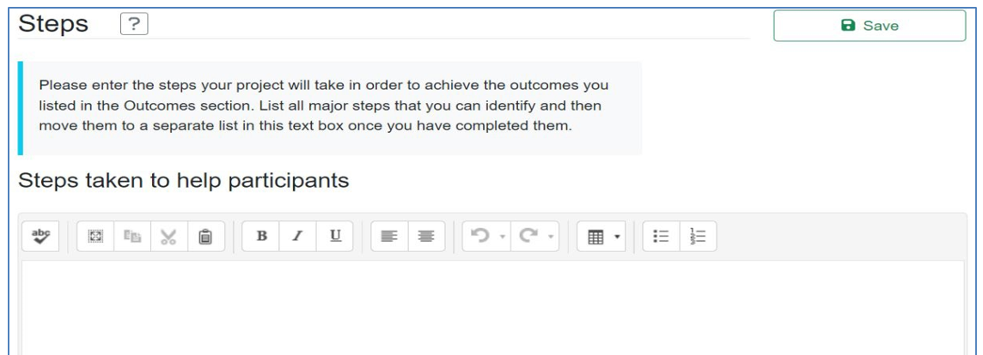
Training or educational materials

For each training or educational material, enter the:
- Title
- Author(s)
- Publisher
- Publication Date
- Abstract – Write a brief abstract describing the educational material.
If you have an electronic copy of the material, select File Upload in response to the “Document Format” question.

Some materials may not be available to upload. In this case, select Website or CD/ROM/DVD in response to the “Document Format” question. If the material is available on a website, you will then be asked to provide a web link to the document, which means that you should enter the URL which will allow viewing of the material. If it is a CD/ROM/DVD, describe how it will be made available.

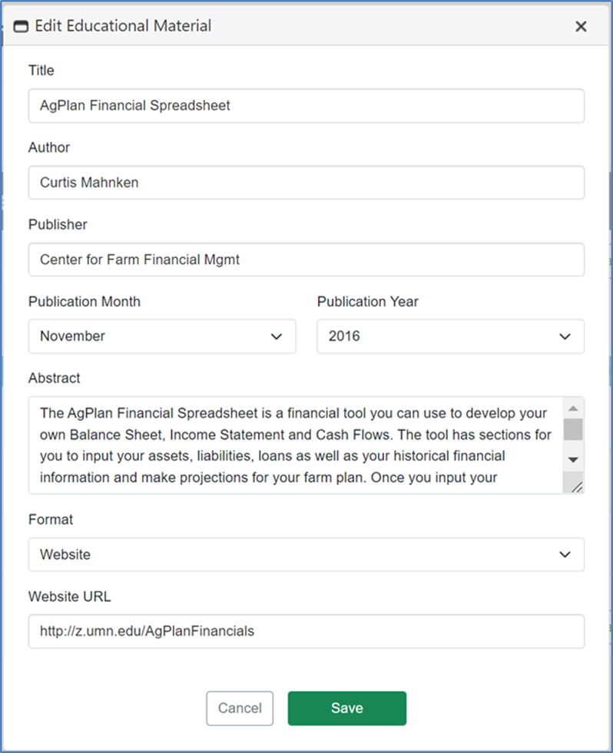

Promotional Materials
Enter the title or description of any promotional material developed and the purpose/audience. Write a brief description of the promotional material, including whether it is a brochure, website, press release, etc., and how it will be used to promote the program.

If you have an electronic copy of the material, select File Upload in response to the “Document Format” question.

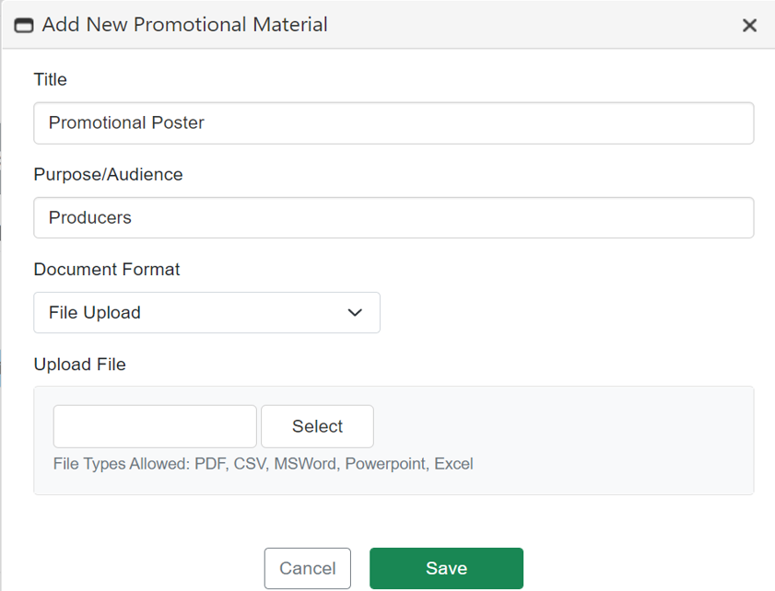

Evaluations and Reports
Projects must describe methods and resources for documenting and evaluating their outcomes and impacts. Upload all evaluations and reports not captured elsewhere in this section.
This section allows project evaluations and reports to be uploaded. 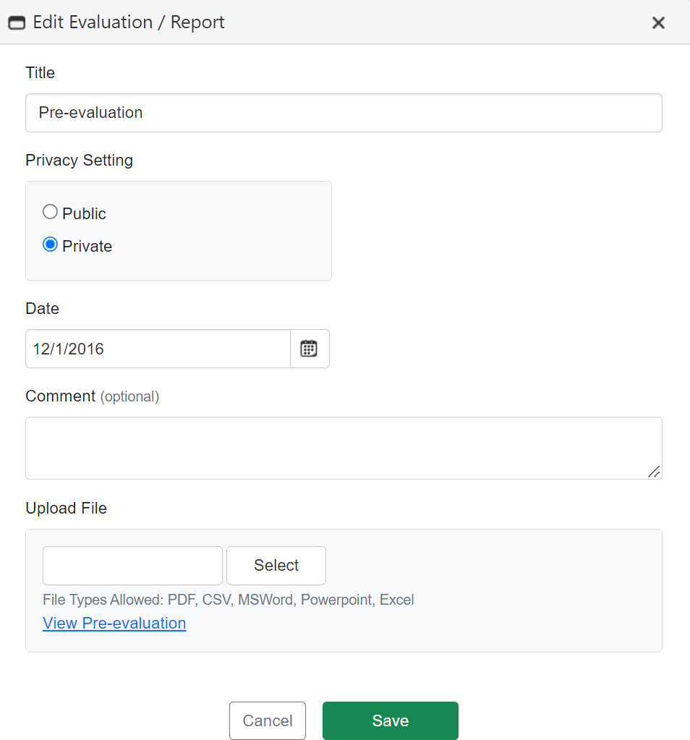
Number of Underserved Producers Served
Performance Metric | Individuals benefited this Quarter
Increased access to farm ownership opportunities
Increased access and improved results for heirs’ property and fractionated land
Increased access to markets and capital that affect the ability to access land
Increased land ownership
Increased land succession planning
Increased business planning
Started farming
Increased farm size or capacity
Increased farm profits
Underserved producers who sought and partipated in USDA programs
a. Natural Resources Conservation Service prrograms
b. Farm Service Agency farm loan programs
1. Applied for a loan
2. Received a loan
c. Farm Service Agency farm programs, other than loans
d. Rural Development loan or grant programs
e. Any other programs or services administered by USDA

Delivery
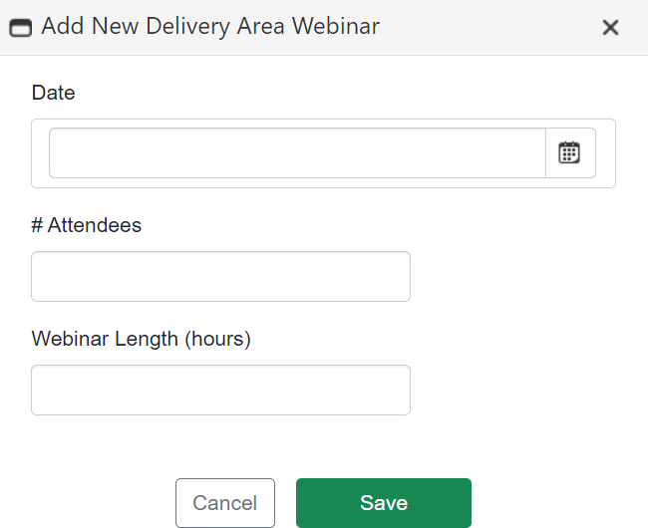
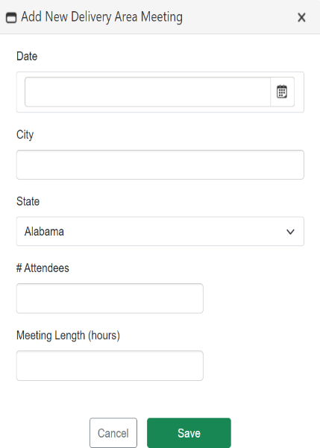
This section captures all meetings, webinars, website visits, online courses, and one to one meetings that have been conducted within the reportable quarter.

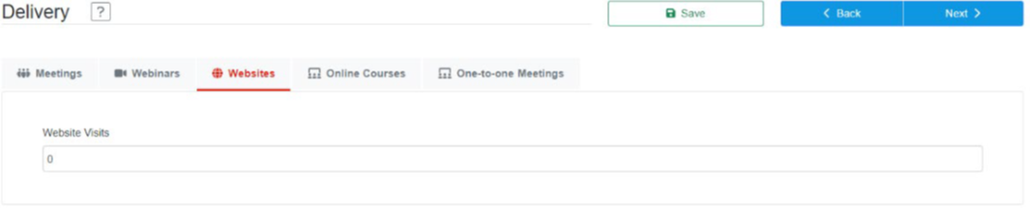

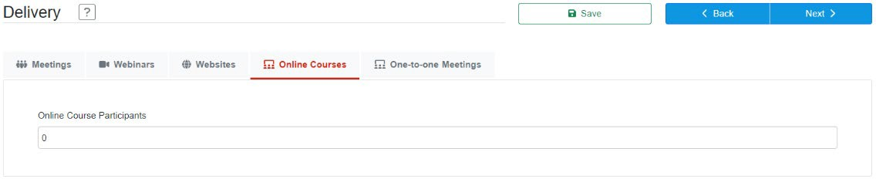

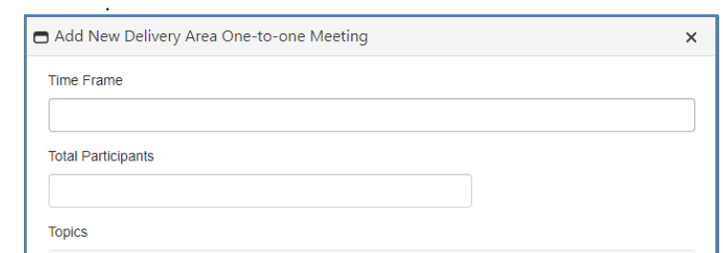
Success Stories/Quotes
Enter any stories, examples, or quotes you collected that help describe the program’s impact on participants. Please include any participant quotes you have. Participant quotes are particularly valuable as a means of helping others understand the value and results of the program.

Discussion of activities performed (If Needed)
Provide any additional information that has not already been covered by Accomplishments, Challenges, and/or Outcomes sections. This section is not required.
Upcoming Activities
Provide a brief description of activities you plan to complete during the next reporting period.
Project Expenditures to Date
Expenditures
Estimate the Total Percentage (%) of Project Funds that have been expended on the Project Enter Percent%
Is project spending behind schedule, on track, or ahead of schedule? Please explain any variances.
Budget

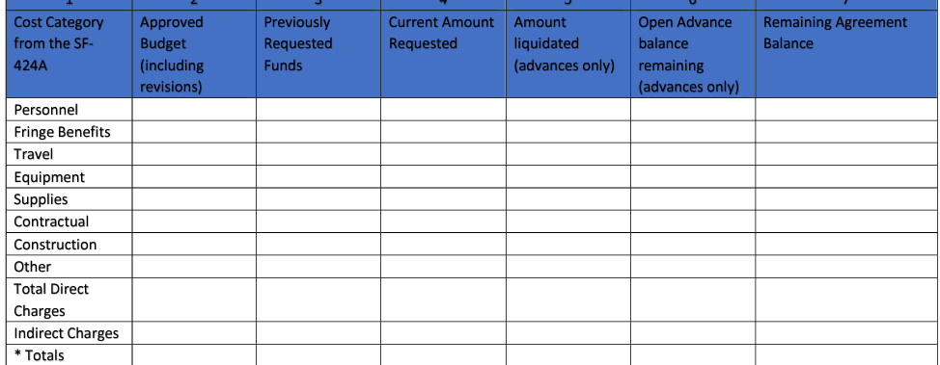
Program Income (if applicable)

Source/Nature | Amount Approved in Budget | Actual Amount Earned
Total Program Income Earned

Use of Program Income
Describe how the earned program income was used to further the objectives of this project.
Subawarded Projects
If project contains subawards, please list your subawards and indicate their progress on subawarded activities. Are they on schedule, behind schedule, or ahead of schedule? Please explain any variances from approved award, including changes in personnel of other risks that may have developed during the reporting period.

Are there any recent, pending, or proposed changes to your subawards?

For Annual Report submitted at the end of each year of the period of performance
Expenditures
For Annual Report Only: If your project is behind schedule, include a statement explaining how the grant funds will be expended and project activities completed as planned by the end date on the grant agreement (For 3-year Project Periods: If amount is less than 33% for Year 1 and 66% for Year 2; For 4-year Project Periods: If the amount is less than 25% for Year 1, 50% for Year 2, 75% for Year 3; For 5-year Project Periods: If the amount is less than 20% in Year 1, 40% in Year 2, 60% in Year 3, and 80% in Year 4):

Lessons Learned
Provide recommendations or advice that others may use to improve their performance in implementing similar projects. Also include recommendations and barrier identification for USDA to improve underserved producers’ access to USDA programs and services.

Data Collection
A Data Management Plan (DMP) is a document that outlines the handling of data generated by projects during and after the completion of the project including details on how the data will be produced or acquired, managed, stored, shared, and protected. Examples may be found at dmptool.org.
DMPs should contain expected data types that will be collected; expected data format; data storage and preservation plan; plan for data sharing, protection, and public access (if applicable); and roles and responsibilities.

Please describe the status of implementing the project’s data management plan.

Final Performance Report
The appendix is meant to serve as an example of the presentation of the information FSA is requesting in the performance reporting system. This report should be more comprehensive than interim quarterly reports.
Report Information

Report Type: | Final
Date Report Submitted: | Enter Date.
Project SUMMARY
Enter a project summary for your project. You wrote a project summary when you submitted your application. It is shown on the bottom half of the page. When reporting, you will usually need to change your summary from future “we will” tense to past tense, “we did.” You may also want to specifically describe what your project accomplished. USDA may make this project summary publicly available to let anyone who is interested know what your project accomplished.
Objectives
# | Objective | Objective met, Yes, No, or NA if objective was not selected at time of project initialization | Number of Producers who benefited
1 | Increased access to farm ownership opportunities.
2 | Increased access and improve results for heirs’ property and fractionated land.
3 | Increased land ownership, land succession, and agricultural business planning.
4 | Increased access to markets and capital that affect the ability to access land.

*If no is selected for any of the listed objectives, you must expand upon this in the challenges and lessons learned sections.
Challenges and Lessons Learned
Provide recommendations or advice that others may use to improve their performance in implementing similar projects. Also include recommendations and barrier identification for USDA to improve access to programs and services.

Underserved Producers Served
Performance Metric | Individuals benefited
Increased access to farm ownership opportunities
Increased access and improved results for heirs’ property and fractionated land
Increased access to markets and capital that affect the ability to access land
Increased land ownership
Increased land succession planning
Increased business planning
Started farming
Of those that started farming, those who are currently farming
Increased farm size or capacity
Increased farm profits
Underserved producers who sought and partipated in USDA programs
a. Natural Resources Conservation Service prrograms
b. Farm Service Agency farm loan programs
1. Applied for a loan
2. Received a loan
c. Farm Service Agency farm programs, other than loans
d. Rural Development loan or grant programs
e. Any other programs or services administered by USDA
Continuation and Dissemination of Results
Describe your plans for continuing the project (sustainability; capacity building) and/or disseminating the project results.
Federal Project Expenditures
Budget

Program Income (if applicable)

Source/Nature | Amount Approved in Budget | Actual Amount Earned
1.
2.
3.
Total Program Income Earned

Use of Program Income
Describe how the earned program income was used to further the objectives of this project.
Additional Information
Provide additional information available (i.e., publications, websites, photographs) that is not applicable to any of the prior sections, including where the deliverables will be stored or can be accessed?

Public Burden Statement (Paperwork Reduction Act): Public reporting burden for this collection is estimated to average 14 hours per response, including reviewing instructions, gathering and maintaining the data needed, completing (providing the information), and reviewing the collection of information. You are not required to respond to the collection or FSA may not conduct or sponsor a collection of information unless it displays a valid OMB control number of 0560 XXXX.

