Current Version-ILA Progress and Final Report Templates

Request for Non-substantive Change
ICR 0560 - 0318
April 29, 2026

Please find below the current version of ILA progress and final report templates that shows the proposed changes for the ICR 0530-0318 non-substantial Request Change.

Page 2: Current Version of Quarterly Progress Report Template
Page 15: Current Version of Final Report Template
Quarterly Progress Report with Changes Indicated
- Removed screenshots and RVS-related language to written instruction are highlighted in yellow and strikethrough or indicated as removed.
- Removed reporting questions are highlighted in yellow with strikethrough.
- Replacement written instruction is in red.

Summary of Progress Report Changes:
Change | Quantity
Change instruction format by replacing screenshots under section headings with written instructions (presented in red) | 10
Remove report template questions. | 3-Upcoming Activities, Expenditures, Data Collection

Agreement

Quarterly Performance Report
Report Information

Report Type: | Enter the Type of Quarterly Report (e.g., 1st Quarter, 2nd Quarter).
Date Report Submitted: | Enter Date.
Reporting Period: | Start Date: | Enter Date. | End Date: | Enter Date.
Performance Narrative
Activities Performed
Address the below sections as they relate to this reporting period.
Status Of Project
Comparing the schedule of work to what has been completed, is the project ahead of schedule, on schedule, or behind schedule? If behind schedule, please discuss the barriers in the section below. DROP DOWN SELECTION for ahead of schedule, on schedule, and behind schedule.
Risks, Barriers, and Developments
Provide any risks, barriers, issues, or changes to the existing risk to the completion of your project or any positive developments outside of the project’s original intent that you experienced during this reporting period. If those risks or developments resulted or will result in corrective actions and/or changes to the project, include those in the space below.
# | Risk, Barrier, or Development | Corrective Action or Project Change
1
2
3
4
Outcome and Indicator Results to Date
Outcomes/ Indicators and Metrics were selected during project initialization. It is understood that the results may not yet be final at the time that this report is submitted; however, Provide an update on the progress achieved during the time period covered by the quarterly report.
# | Outcome/Indicator | Metrics |  | Quarterly Progress
1
2
3
4
Steps
Please enter the steps your project will take to achieve the outcomes you listed in the Outcomes section. List all major steps that you can identify.
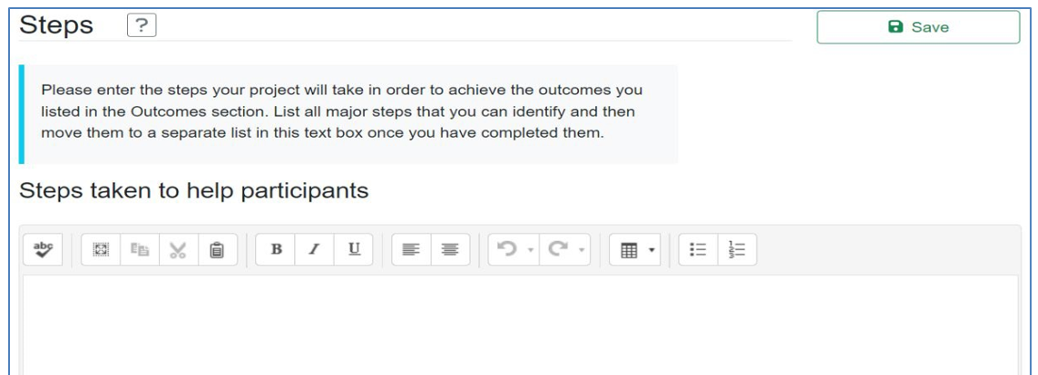
Replace these instructions with the above in red
Training or educational materials

If you have an electronic copy of the training or educational materials, please submit a copy to land.access@usda.gov.

For each training or educational material, enter the:
- Title
- Author(s)
- Publisher
- Publication Date
- Abstract – Write a brief abstract describing the educational material.
If you have an electronic copy of the material, select File Upload in response to the “Document Format” question.

Some materials may not be available to submit by email.

Some materials may not be available to upload. In this case, select Website or CD/ROM/DVD in response to the “Document Format” question. If the material is available on a website, you will then be asked to provide a web link to the document, which means that you should enter provide the URL which will allow viewing of the material. If it is a CD/ROM/DVD, describe how it will be made available.
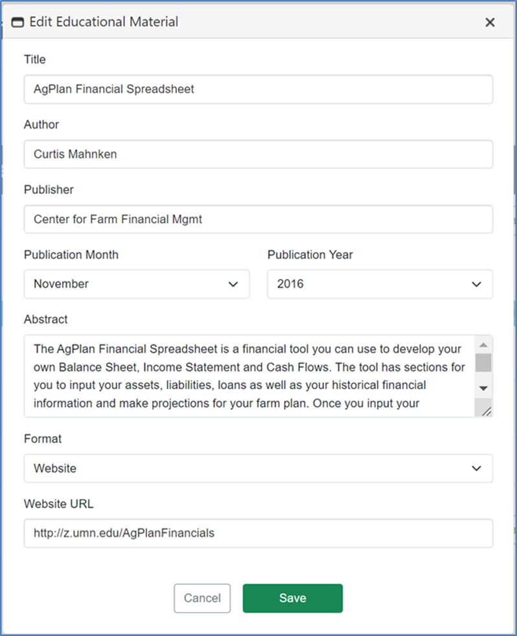
Replace these instructions with the above under section heading.

Promotional Materials
Enter the title or description of any promotional material developed and the purpose/audience. Write a brief description of the promotional material, including whether it is a brochure, website, press release, etc., and how it will be used to promote the program.

If you have an electronic copy of the promotional materials, please submit a copy to land.access@usda.gov.

If you have an electronic copy of the material, select File Upload in response to the “Document Format” question.

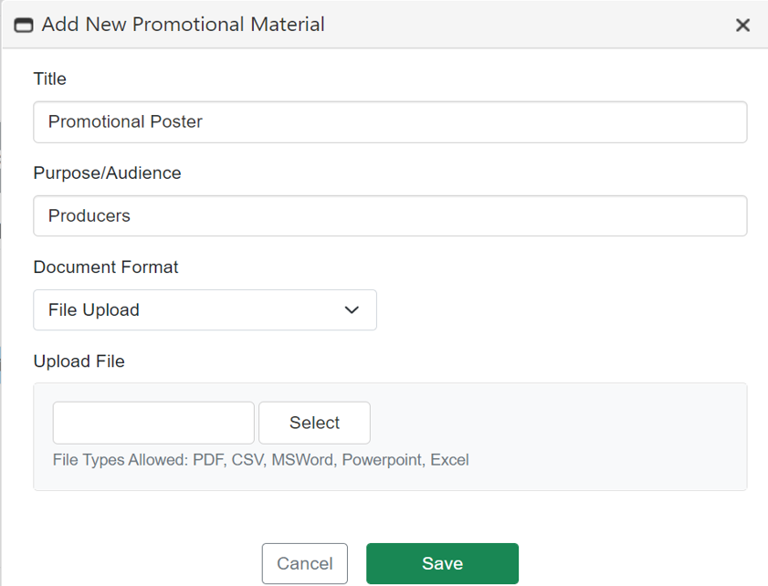
Replace these instructions with the above under section heading.

Evaluations and Reports
Projects must describe methods and resources for documenting and evaluating their outcomes and impacts. Upload all evaluations and reports not captured elsewhere in this section.
Please submit all evaluations and reports not captured elsewhere on the report as attachments to land.access@usda.gov.
This section allows project evaluations and reports to be uploaded. 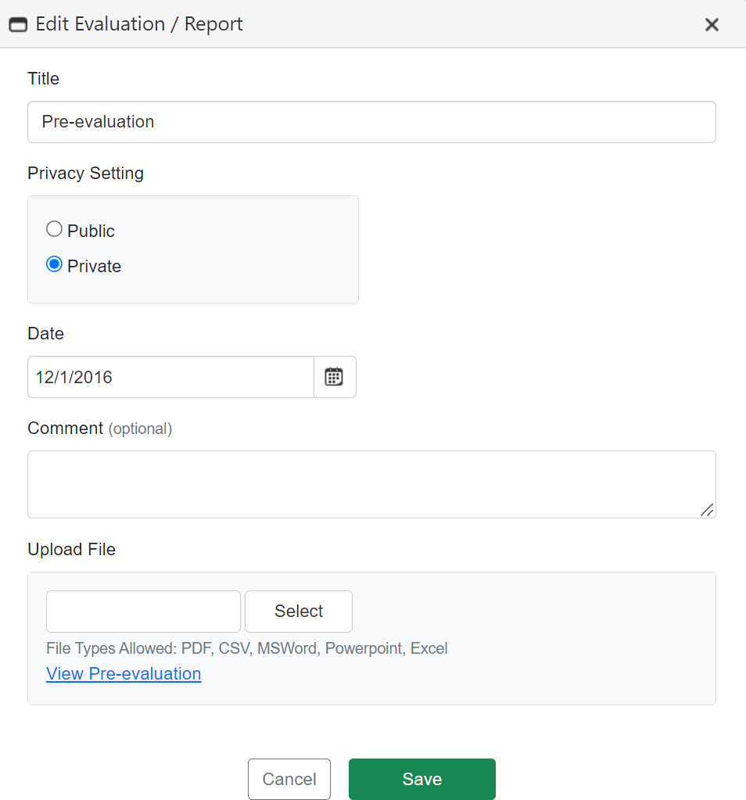
Replace these instructions with the above under section heading.
Number of Underserved Producers Served
Performance Metric | Enter Number of Individuals Served this Quarter
Increased access to farm ownership opportunities
Increased access and improved results for heirs’ property and fractionated land
Increased access to markets and capital that affect the ability to access land
Increased land ownership
Increased land succession planning
Increased business planning
Started farming
Increased farm size or capacity
Increased farm profits
Underserved producers who sought and partipated in USDA programs:
a. Natural Resources Conservation Service prrograms
b. Farm Service Agency farm loan programs
1. Applied for a loan
2. Received a loan
c. Farm Service Agency farm programs, other than loans
d. Rural Development loan or grant programs
e. Any other programs or services administered by USDA

Delivery
This section captures all meetings, webinars, website visits, online courses, and one to one meetings that have been conducted within the reportable quarter. Please fill out the tables below.

Total Meetings:
Total Meeting Participants:
Total Meeting Participant Hours:
Total Webinars:
Total Webinar Participants:
Total Webinar Participant Hours:
Total Website Visits:
Total Online Course Participants:
Total One-to-one Meeting Entries:
Total One-to-one Meeting Participants:

Meetings
Date | City | State | Number of Attendees | Meeting length (hours) | Topic

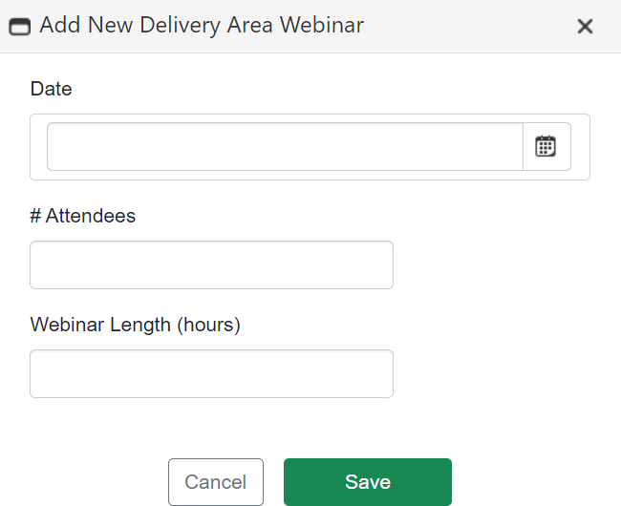
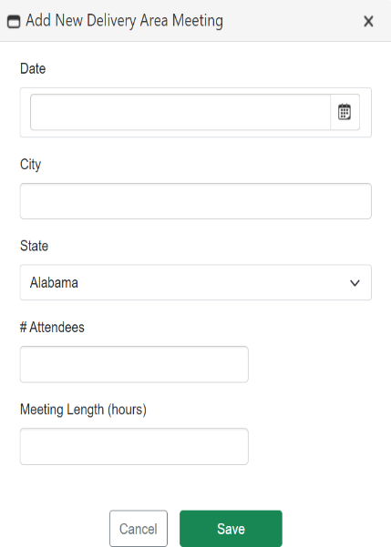
Replace these 3 instructions with the above under section heading.
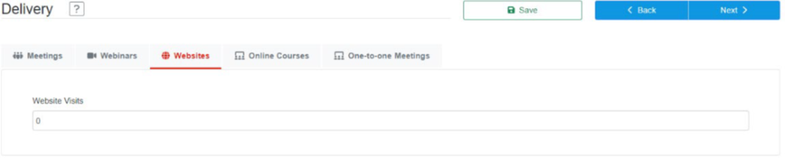

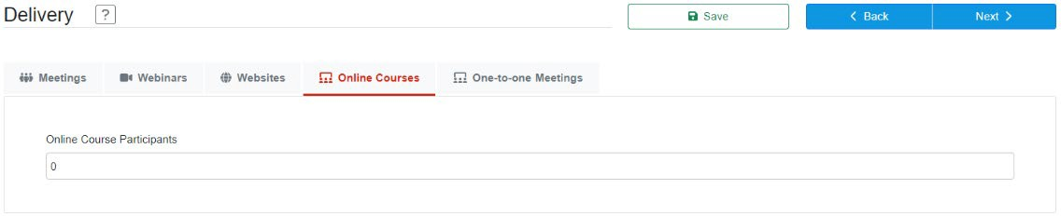
Replace these instructions with the above under section heading

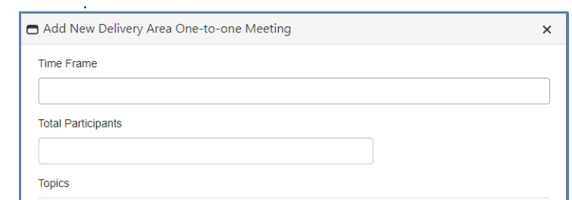

Success Stories/Quotes
Enter any stories, examples, or quotes you collected that help describe the program’s impact on participants. Please include any participant quotes you have. Participant quotes are particularly valuable as a means of helping others understand the value and results of the program.

Discussion of activities performed (If Needed)
Provide any additional information that has not already been covered by Accomplishments, Challenges, and/or Outcomes sections. This section is not required.

Upcoming Activities
Provide a brief description of activities you plan to complete during the next reporting period.
Project Expenditures to Date
Expenditures
Estimate the Total Percentage (%) of Project Funds that have been expended on the Project Enter Percent%
Is project spending behind schedule, on track, or ahead of schedule? Please explain any variances.
Provide the approved amounts and the actual expenditures by cost category.
Cost Category | Amount Approved in Budget | Actual Expenditures
Personnel
Fringe Benefits
Travel
Equipment
Supplies
Contractual
Construction
Other
Total Direct Charges
Indirect Charges
Totals

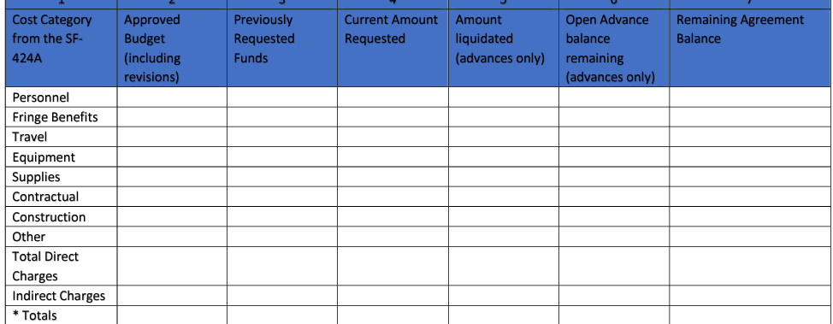
Replace this screenshot with the above fillable table

Program Income (if applicable)

Source/Nature | Amount Approved in Budget | Actual Amount Earned
Total Program Income Earned

Use of Program Income
Describe how the earned program income was used to further the objectives of this project.

Subawarded Projects
If project contains subawards, please list your subawards and indicate their progress on subawarded activities. Are they on schedule, behind schedule, or ahead of schedule? Please explain any variances from approved award, including changes in personnel or other risks that may have developed during the reporting period.

Are there any recent, pending, or proposed changes to your subawards?

For Annual Report submitted at the end of each year of the period of performance
Expenditures
For Annual Report Only: If your project is behind schedule, include a statement explaining how the grant funds will be expended and project activities completed as planned by the end date on the grant agreement (For 3-year Project Periods: If amount is less than 33% for Year 1 and 66% for Year 2; For 4-year Project Periods: If the amount is less than 25% for Year 1, 50% for Year 2, 75% for Year 3; For 5-year Project Periods: If the amount is less than 20% in Year 1, 40% in Year 2, 60% in Year 3, and 80% in Year 4):

Lessons Learned
Provide recommendations or advice that others may use to improve their performance in implementing similar projects. Also include recommendations and barrier identification for USDA to improve underserved producers’ access to USDA programs and services.

Data Collection
A Data Management Plan (DMP) is a document that outlines the handling of data generated by projects during and after the completion of the project including details on how the data will be produced or acquired, managed, stored, shared, and protected. Examples may be found at dmptool.org.
DMPs should contain expected data types that will be collected; expected data format; data storage and preservation plan; plan for data sharing, protection, and public access (if applicable); and roles and responsibilities.

Please describe the status of implementing the project’s data management plan.

Final Report Template with Changes Indicated
- Removed screenshots and RVS-related language to written instruction are highlighted in yellow and strikethrough or indicated as removed.
- Removed reporting questions are highlighted in yellow with strikethrough.
- Replacement written instruction is in red.
Summary of Final Report Changes
Change | Quantity
Remove report template questions. | 1-Continuation and Dissemination of Results
Questions carried over and included from progress reports (Appendix 1) | 2 -Success Stories and Lessons Learned

Final Performance Report
The appendix is meant to serve as an example of the presentation of the information FSA is requesting in the performance reporting system. This report should be more comprehensive than interim quarterly reports.
Agreement #:
Report Information

Report Type: | Final
Date Report Submitted: | Enter Date.
Project SUMMARY
Enter a project summary for your project. Y you wrote a project summary when you submitted your application. It is shown on the bottom half of the page. When reporting, you will usually need to change your summary from future “we will” tense to past tense, “we did.” You may also want to specifically describe what your project accomplished. USDA may make this project summary publicly available to let anyone who is interested know what your project accomplished.
Objectives
# | Objective | Objective met, Yes, No, or NA if objective was not selected at time of project initialization | Number of Producers who benefited
1 | Increased access to farm ownership opportunities.
2 | Increased access and improve results for heirs’ property and fractionated land.
3 | Increased land ownership, land succession, and agricultural business planning.
4 | Increased access to markets and capital that affect the ability to access land.

*If no is selected for any of the listed objectives, you must expand upon this in the challenges and lessons learned sections.

Challenges and Lessons Learned
Provide recommendations or advice that others may use to improve their performance in implementing similar projects. Also include recommendations and barrier identification for USDA to improve access to programs and services.

Underserved Producers Served
Performance Metric | Number of Individuals Served
Increased access to farm ownership opportunities
Increased access and improved results for heirs’ property and fractionated land
Increased access to markets and capital that affect the ability to access land
Increased land ownership
Increased land succession planning
Increased business planning
Started farming
Of those that started farming, those who are currently farming
Increased farm size or capacity
Increased farm profits
Underserved producers who sought and partipated in USDA programs
a. Natural Resources Conservation Service prrograms
b. Farm Service Agency farm loan programs
1. Applied for a loan
2. Received a loan
c. Farm Service Agency farm programs, other than loans
d. Rural Development loan or grant programs
e. Any other programs or services administered by USDA
Continuation and Dissemination of Results
Describe your plans for continuing the project (sustainability; capacity building) and/or disseminating the project results.
Federal Project Expenditures
Budget Expenditures
Provide the approved amounts and the actual expenditures by cost category.

Cost Category | Amount Approved in Budget | Actual Expenditure
Personnel
Fringe Benefits
Travel
Equipment
Supplies
Contractual
Construction
Other
Total Direct Charges
Indirect Charges
Totals

Replace this screenshot with the above table

Program Income (if applicable)

Source/Nature | Amount Approved in Budget | Actual Amount Earned
1.
2.
3.
Total Program Income Earned

Use of Program Income
Describe how the earned program income was used to further the objectives of this project.
Additional Information

Success Stories/Quotes
Enter any stories, examples, or quotes you collected that help describe the program’s impact on participants. Please include any participant quotes you have. Participant quotes are particularly valuable as a means of helping others understand the value and results of the program.

Lessons Learned
Provide recommendations or advice that others may use to improve their performance in implementing similar projects. Also include recommendations and barrier identification for USDA to improve underserved producers’ access to USDA programs and services.

Provide additional information available (i.e., publications, websites, photographs) that is not applicable to any of the prior sections, including where the deliverables will be stored or can be accessed?

Public Burden Statement (Paperwork Reduction Act): Public reporting burden for this collection is estimated to average 14 hours per response, including reviewing instructions, gathering and maintaining the data needed, completing (providing the information), and reviewing the collection of information. You are not required to respond to the collection or FSA may not conduct or sponsor a collection of information unless it displays a valid OMB control number of 0560 0318.

