OMB Control Number: 0560-0317, OMB Expiration Date: XX/XX/XXXX
Public Burden Statement (Paperwork Reduction Act): According to the Paperwork Reduction Act of 1995, an agency may not conduct or sponsor, and a person is not required to respond to, a collection of information unless it displays a valid OMB control number. The valid OMB control number for this information collection is 0563-0317, and the collection is voluntary. The time required to complete this information collection is estimated to average 1.49 hours per response, including the time for reviewing instructions, searching existing data sources, gathering and maintaining the data needed, and completing and reviewing the collection of information. Send comments regarding this burden estimate or any other aspect of this collection of information, including suggestions for reducing this burden by emailing to: askusda@usda.gov.

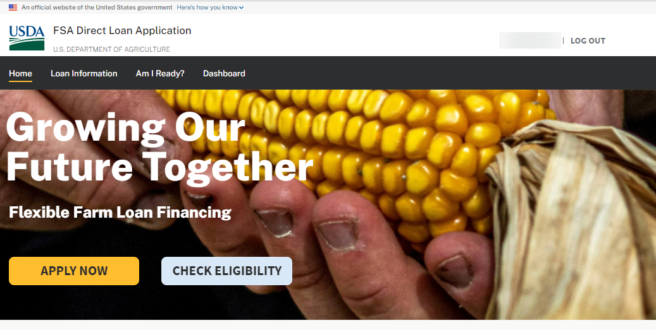
ONLINE LOAN APPLICATION PROCESS FLOW
Paperwork Reduction Act Review Package
Legal Entity Applicant
Prepared: May 6, 2026

LEGAL ENTITY APPLICANT
DASHBOARD
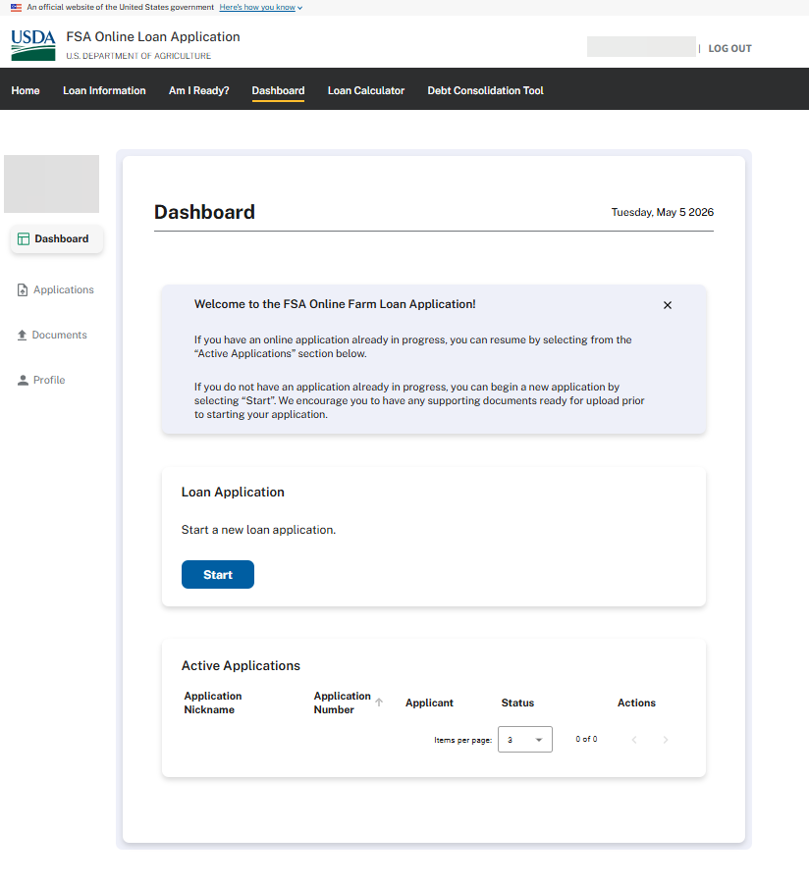

OPERATOR CERTIFICATION
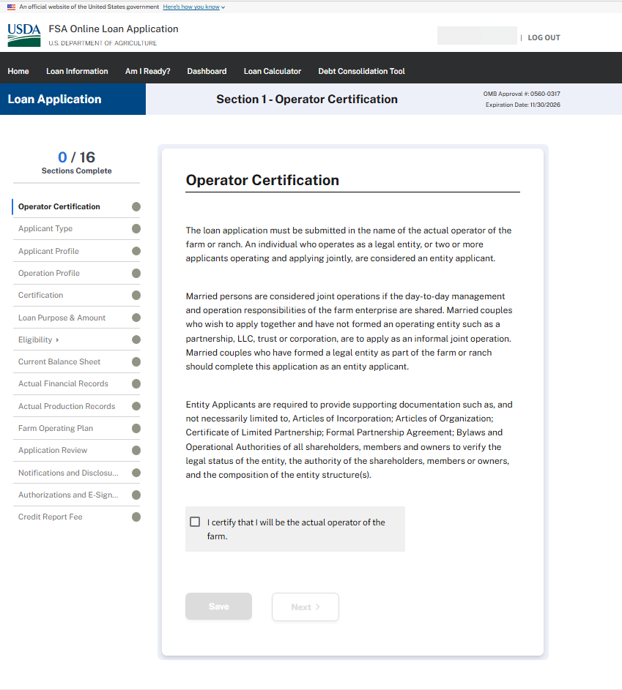
APPLICANT IDENTIFICATION – Legal Entity
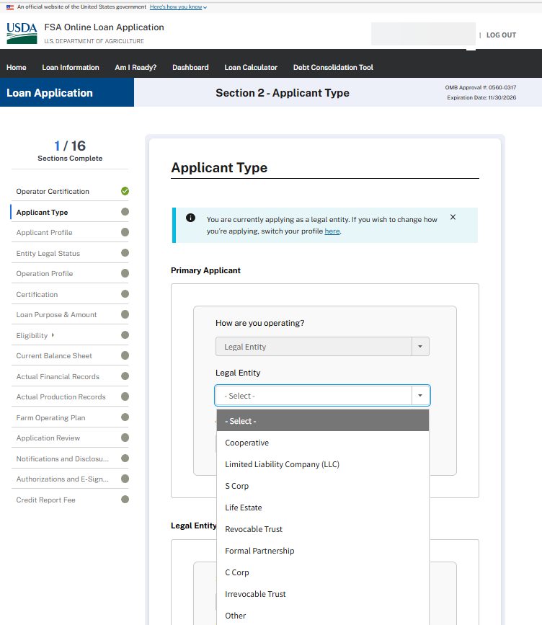

APPLICANT TYPE – Legal Entity (CONTINUED)
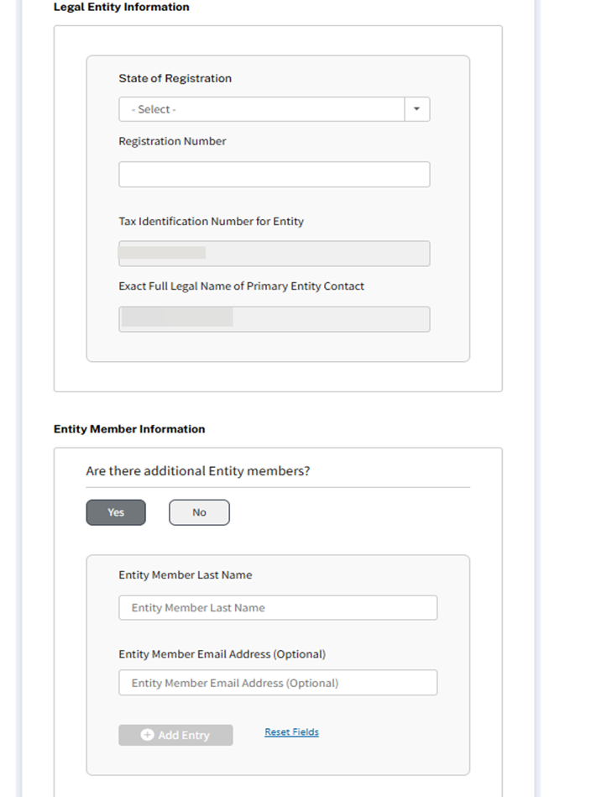

APPLICANT TYPE – Legal Entity (CONTINUED)
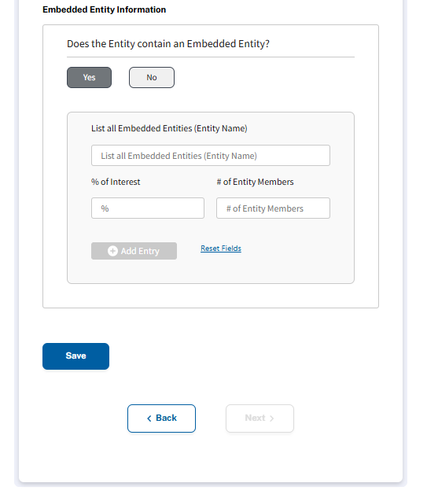

APPLICANT PROFILE
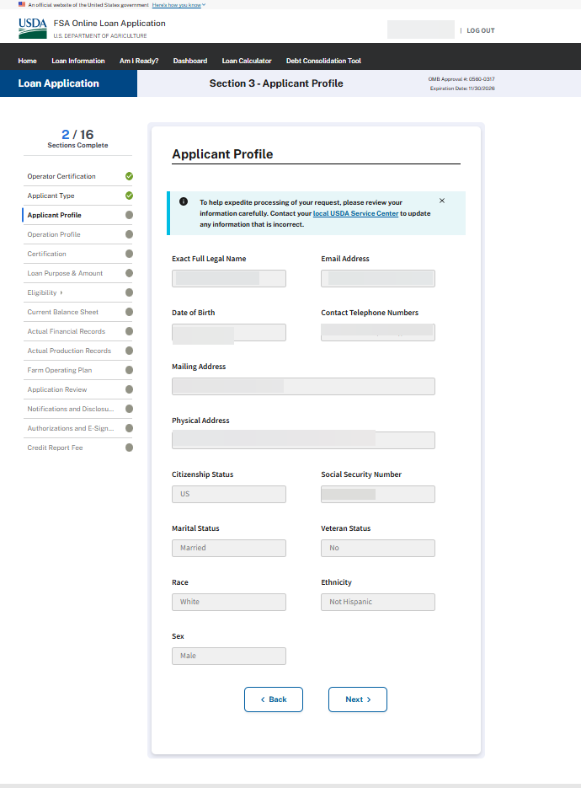
ENTITY LEGAL STATUS
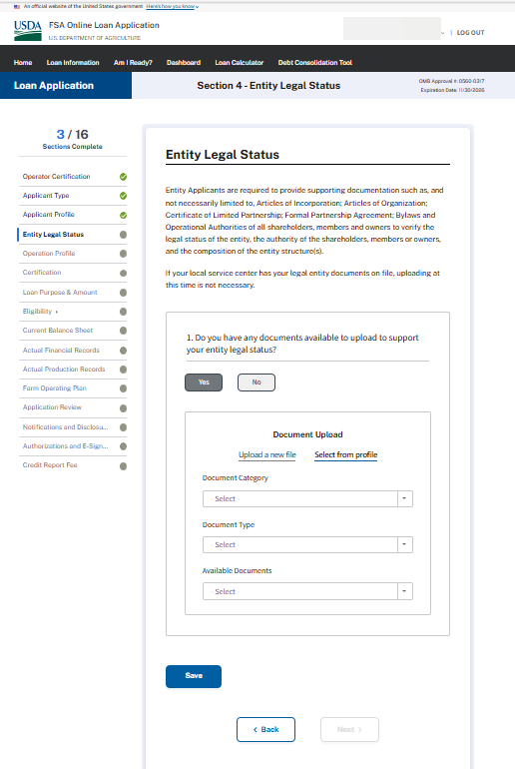
OPERATION PROFILE 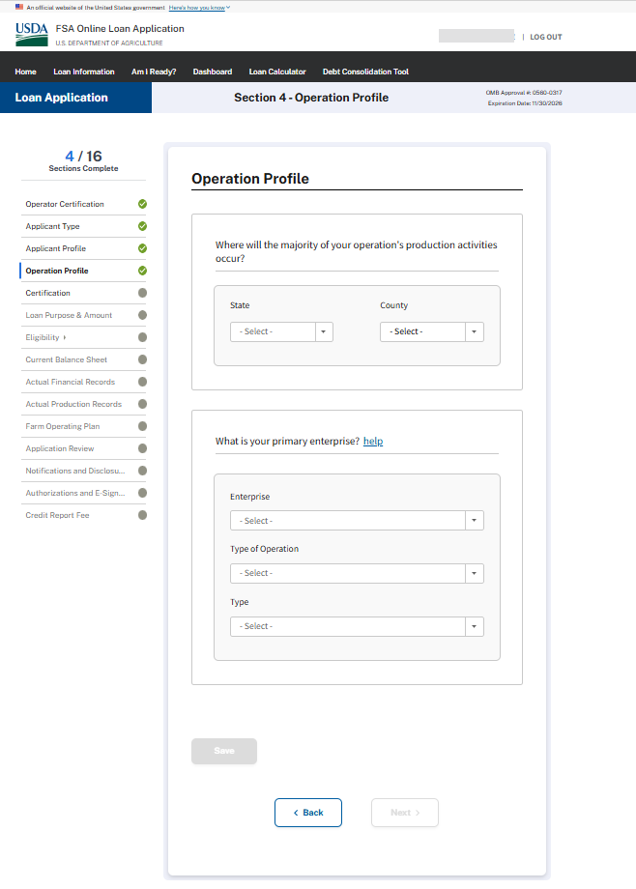
CERTIFICATION (Minimized)
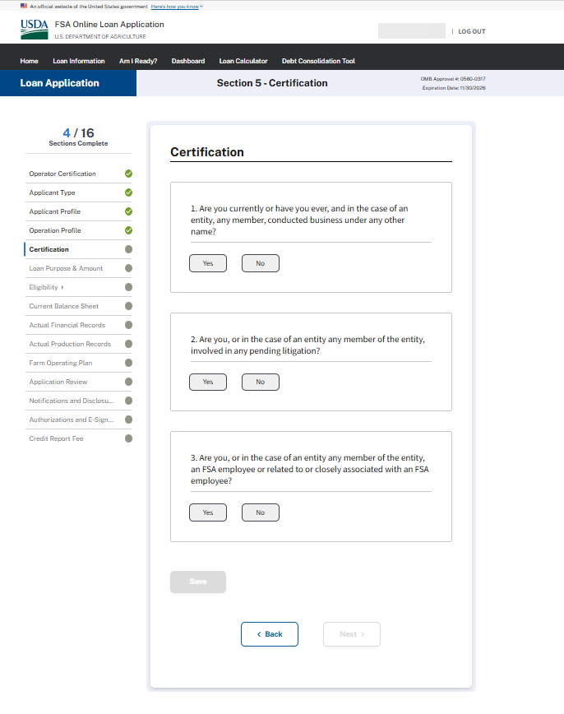

CERTIFICATION (Expanded)
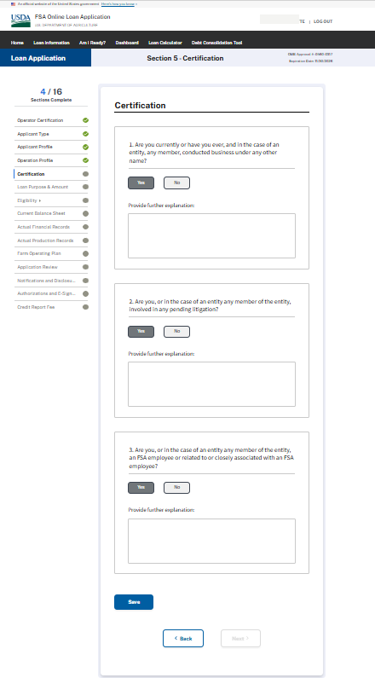
LOAN PURPOSE & AMOUNT
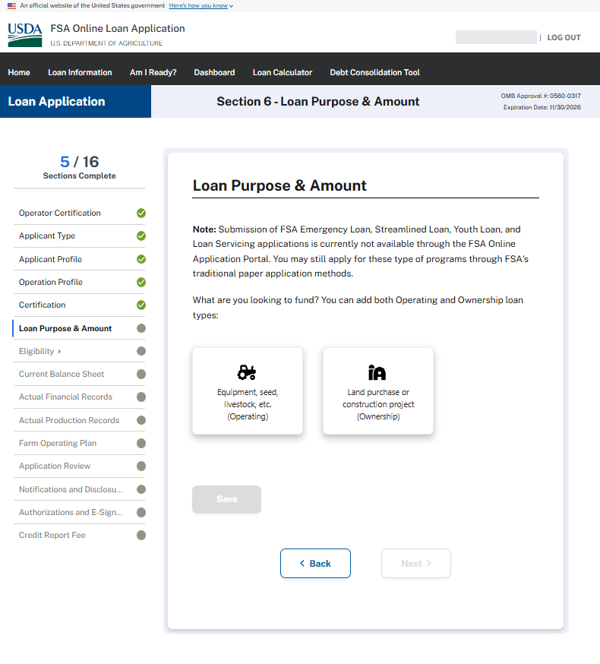
LOAN PURPOSE & AMOUNT (Operating Type Loans)
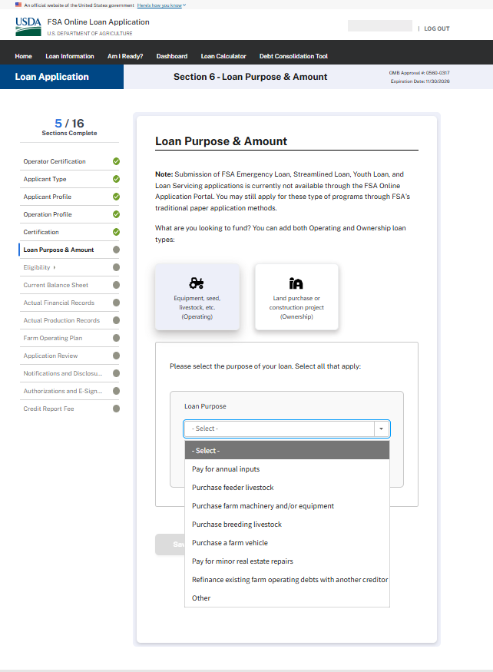
LOAN PURPOSE & AMOUNT (Operating Type Loans – Annual Inputs)
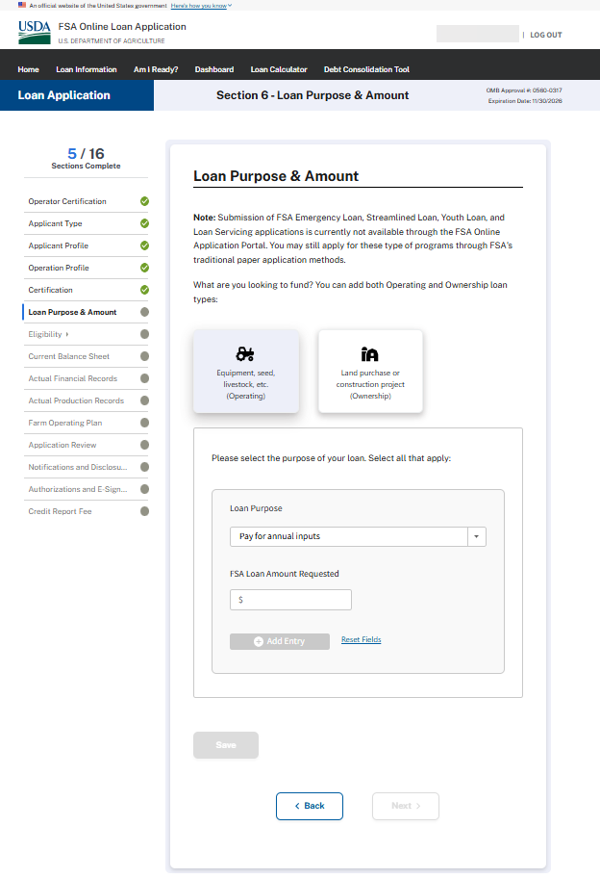

LOAN PURPOSE & AMOUNT (Operating Type Loans – Minor real estate repairs or “Other”)
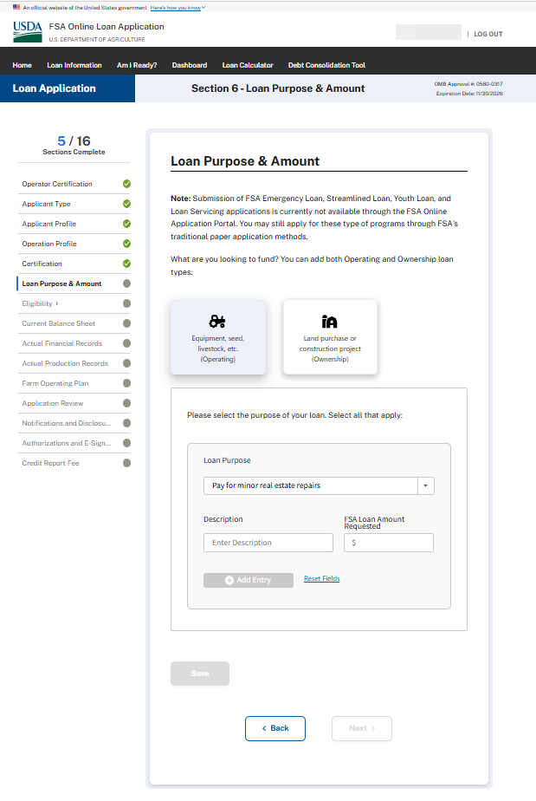
LOAN PURPOSE & AMOUNT (Operating Type Loans – Purchase a farm vehicle, Purchase farm machinery and/or equipment)
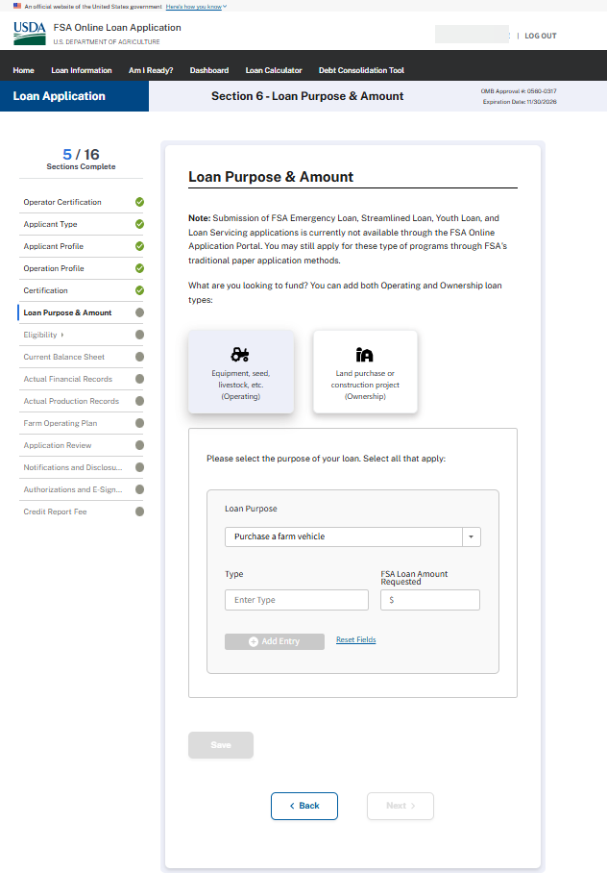
LOAN PURPOSE & AMOUNT (Operating Type Loans – Purchase breeding livestock, Purchase feeder livestock)
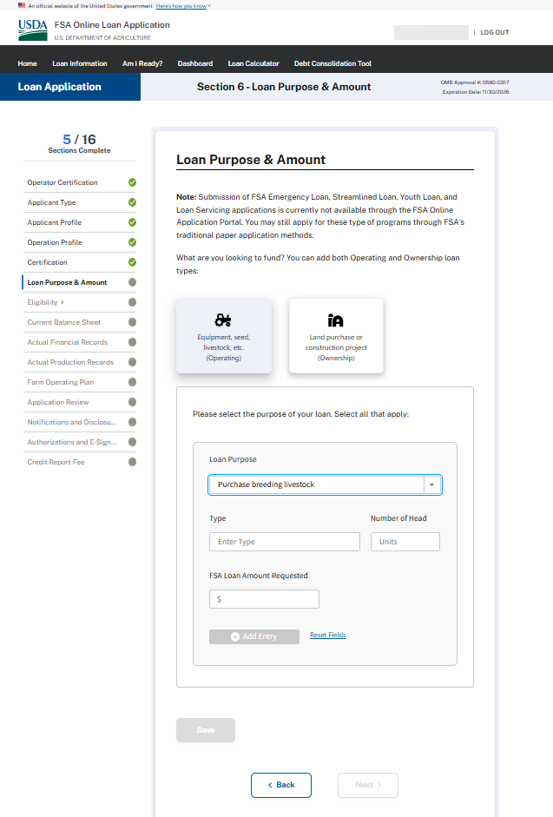
LOAN PURPOSE & AMOUNT (Operating Type Loans – Refinance existing farm operating debts with another creditor)
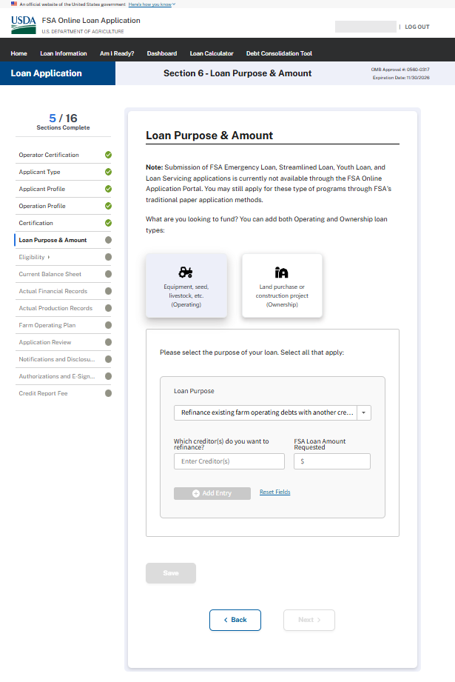

LOAN PURPOSE & AMOUNT (Ownership Loans)
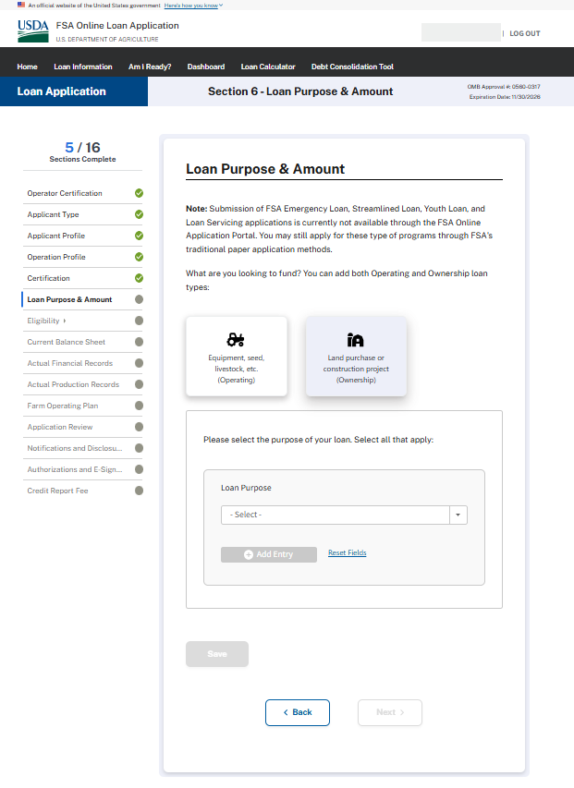

LOAN PURPOSE & AMOUNT (Ownership Loans – Pay for capital improvements, construction, development & Other)
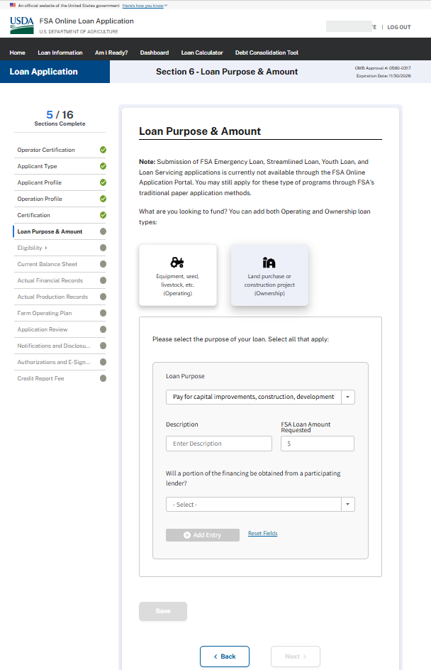
LOAN PURPOSE & AMOUNT (Ownership Loans – Purchase farm real estate)
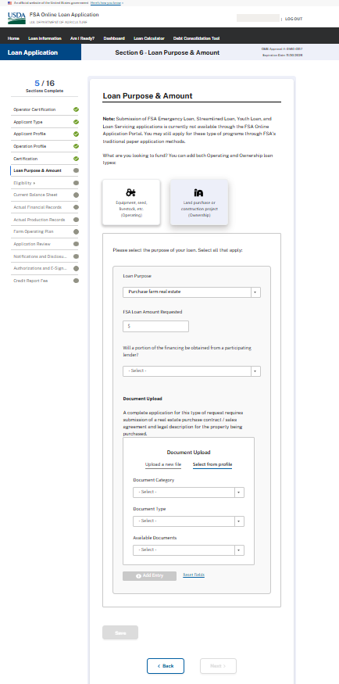
Eligibility (Credit Elsewhere)
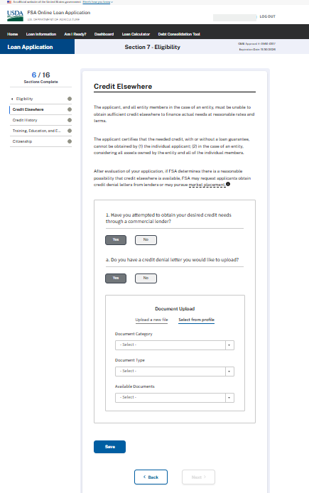

ELIGIBILITY – CREDIT HISTORY - MINIMIZED
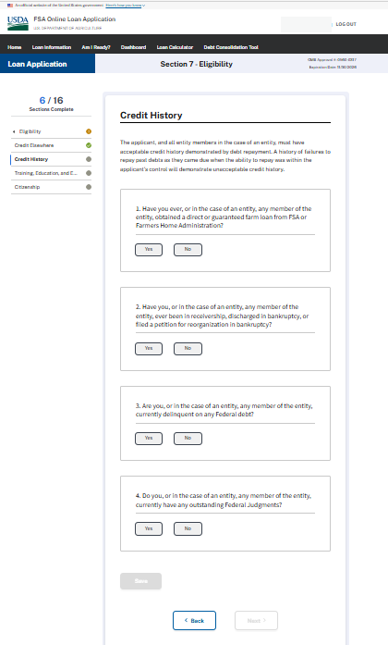

ELIGIBILITY – CREDIT HISTORY – Question 1 & 1a - Expanded
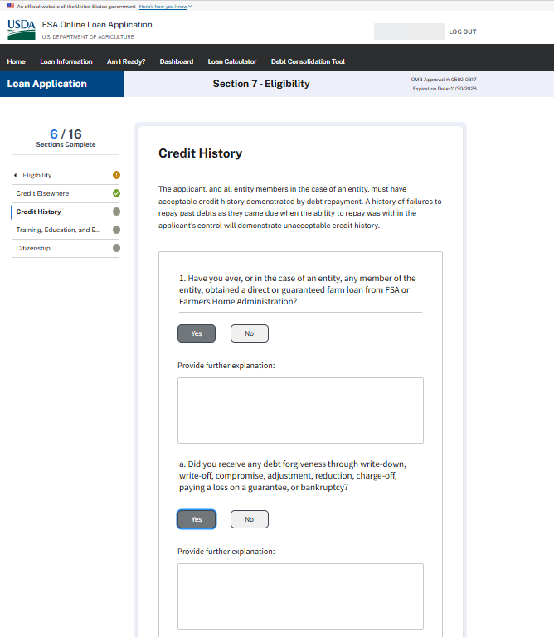

ELIGIBILITY – CREDIT HISTORY – Question 2 - Expanded
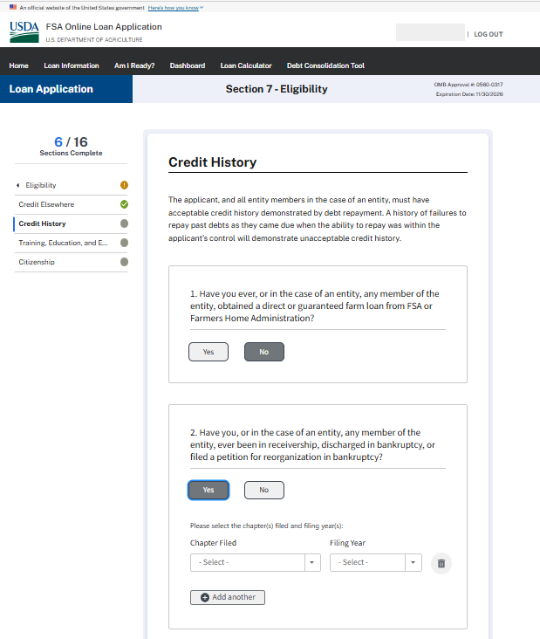

ELIGIBILITY – CREDIT HISTORY – Question 3 & 4 - Expanded
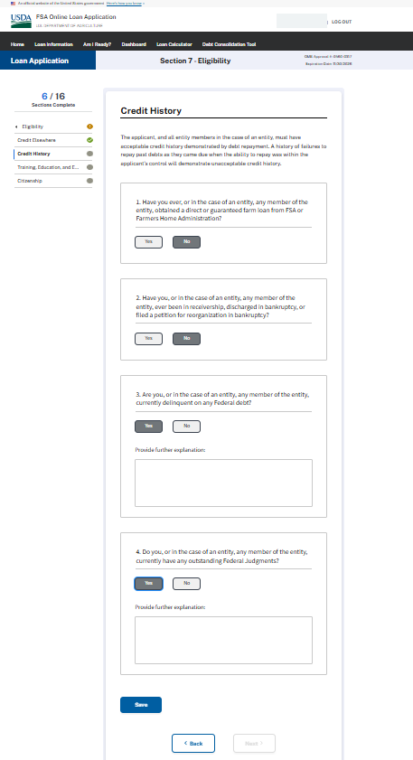
ELIGIBILITY – TRAINING, EDUCATION, & EXPERIENCE (Expanded)
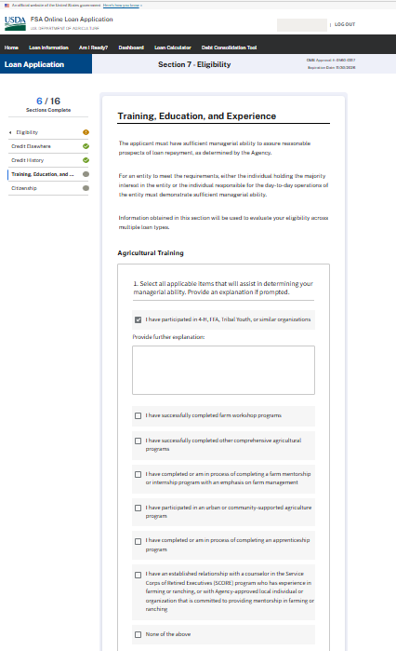

ELIGIBILITY – TRAINING, EDUCATION, & EXPERIENCE (CONTINUED)
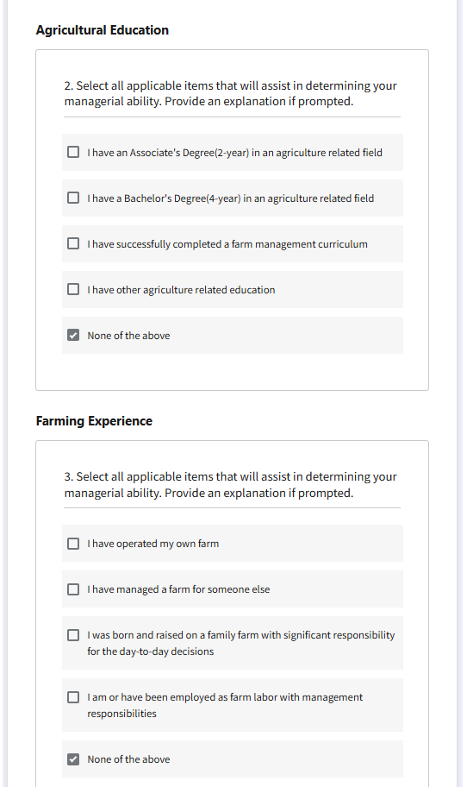

ELIGIBILITY – TRAINING, EDUCATION, & EXPERIENCE (Expanded – “I have operating my own farm” subsequent question)
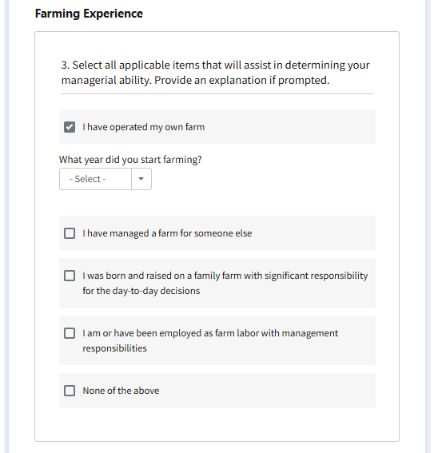

ELIGIBILITY – TRAINING, EDUCATION, & EXPERIENCE (Expanded – All other selections except for “I have operating my own farm” provide same explanation box)
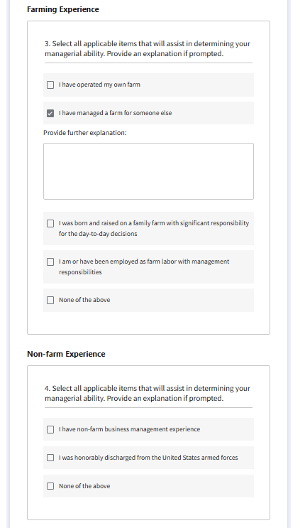

ELIGIBILITY – TRAINING, EDUCATION, & EXPERIENCE (Supporting Documents upload)
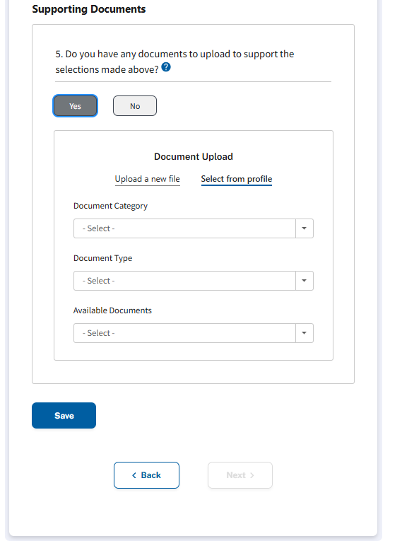

CURRENT BALANCE SHEET – Question 1 – Answered “Yes” – Fully Expanded
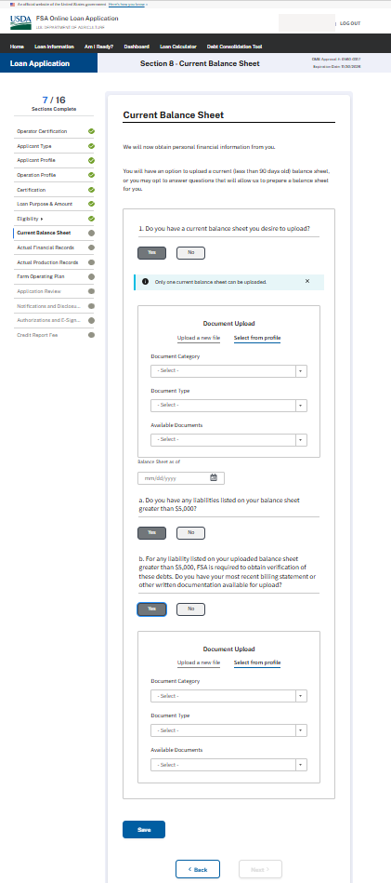
CURRENT BALANCE SHEET – Question 1 – Answered “No”
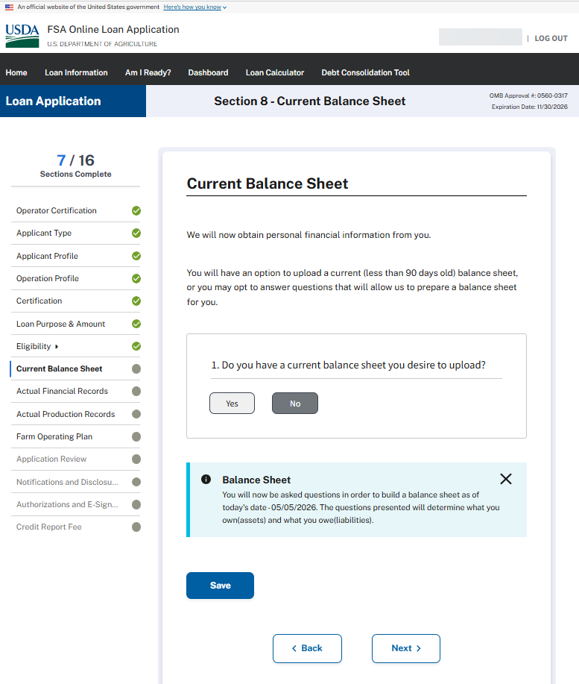

ACTUAL FINANCIAL RECORDS
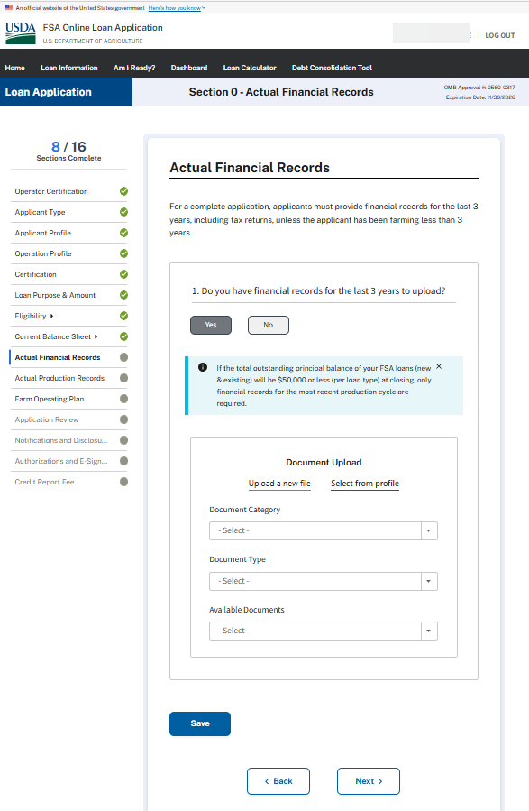
ACTUAL PRODUCTION RECORDS
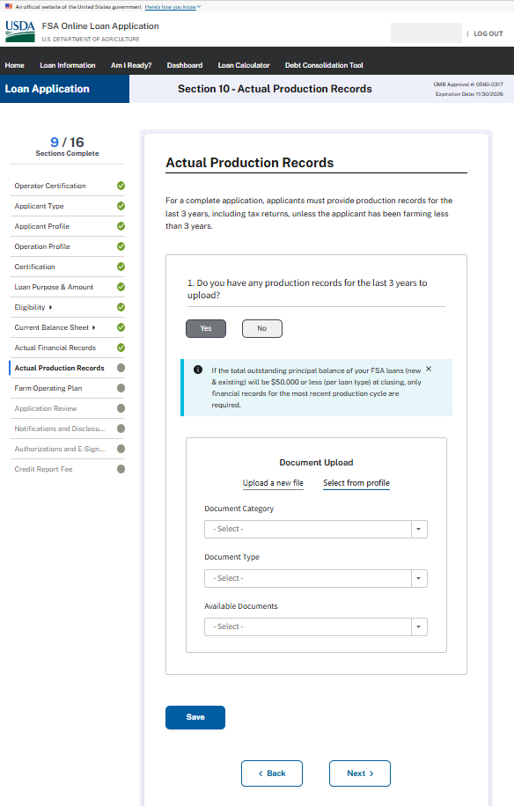
FARM OPERATING PLAN
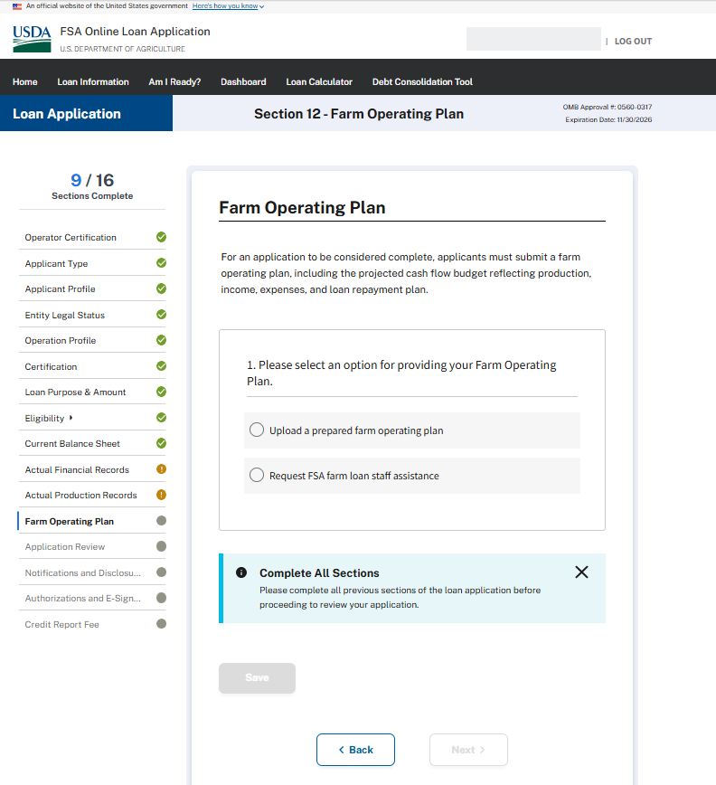

FARM OPERATING PLAN (1a) – When applicant chooses to upload a prepared farm operating plan
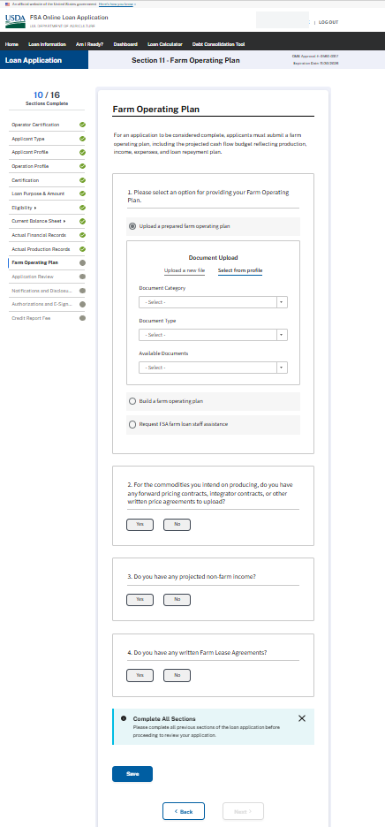

FARM OPERATING PLAN – When the applicant requests FSA farm loan staff assistance
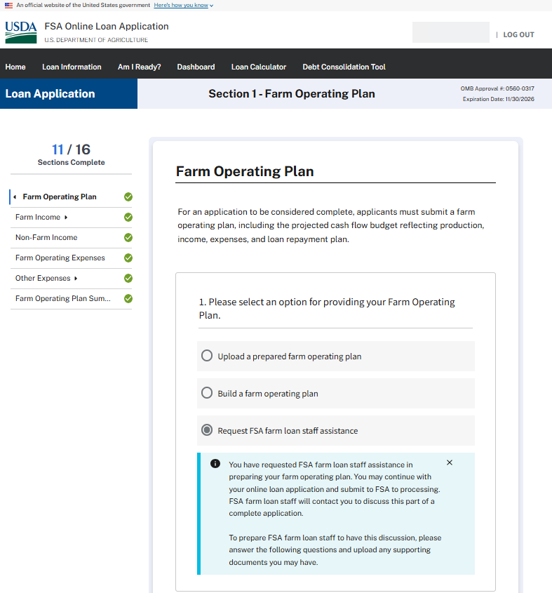

FARM OPERATING PLAN – When the applicant requests FSA farm loan staff assistance (CONTINUED)
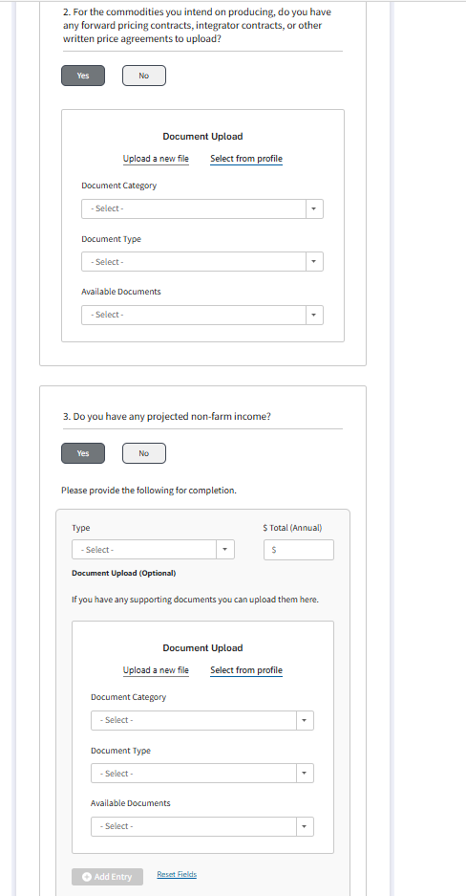

FARM OPERATING PLAN – When the applicant requests FSA farm loan staff assistance (CONTINUED)
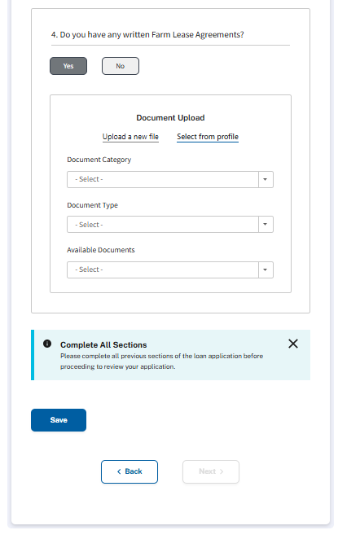

APPLICATION REVIEW
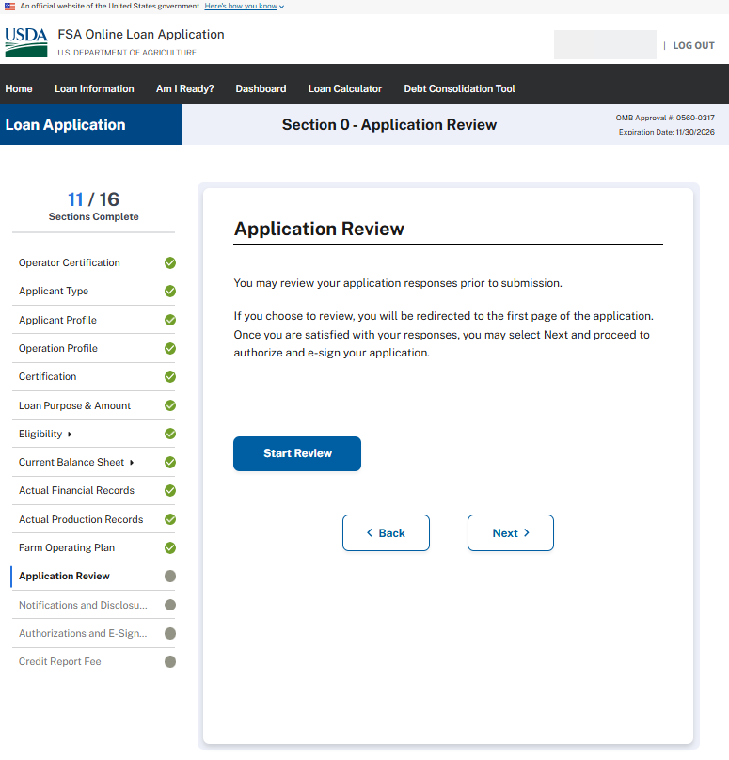
NOTIFICATION & DISCLOSURES - Minimized
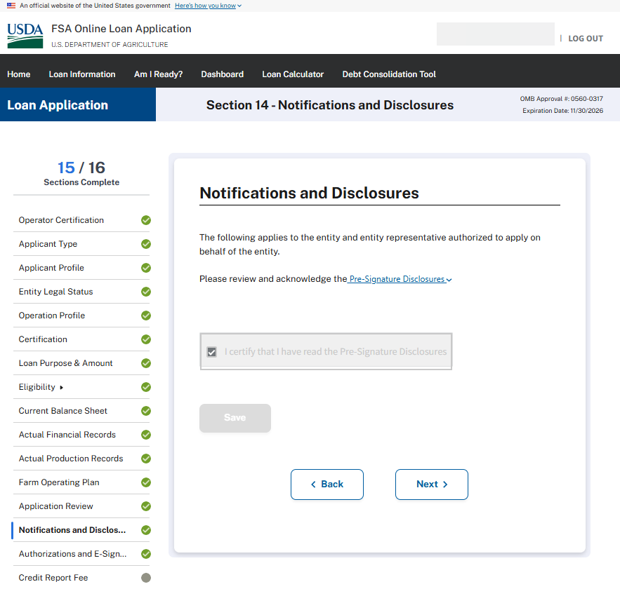

NOTIFICATION & DISCLOSURES - Maximized
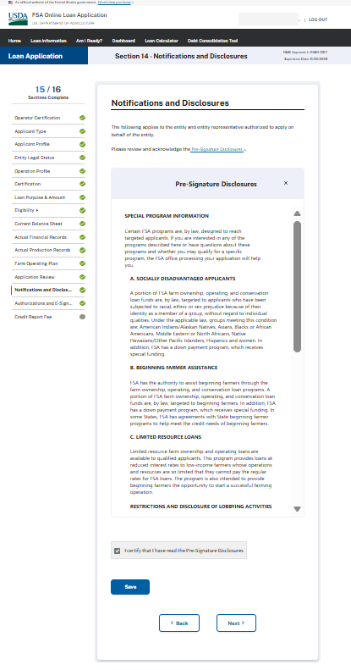

AUTHORIZATIONS AND E-SIGNATURE
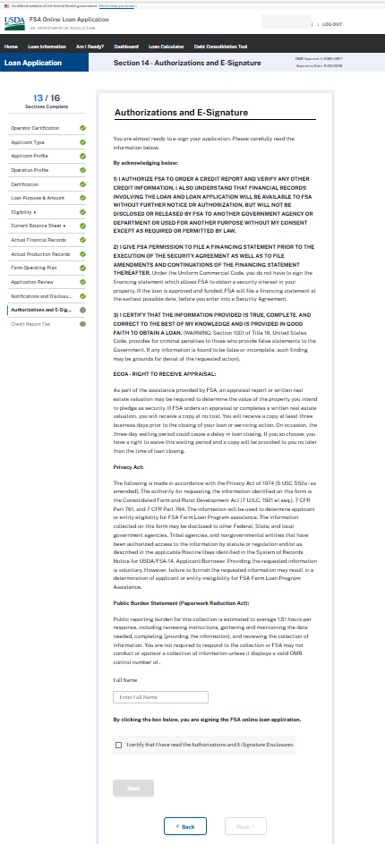

CREDIT REPORT FEE & SUBMISSION
