OMB Control Number: 0560-0317, OMB Expiration Date: XX/XX/XXXX
Public Burden Statement (Paperwork Reduction Act): According to the Paperwork Reduction Act of 1995, an agency may not conduct or sponsor, and a person is not required to respond to, a collection of information unless it displays a valid OMB control number. The valid OMB control number for this information collection is 0563-0317, and the collection is voluntary. The time required to complete this information collection is estimated to average 1.49 hours per response, including the time for reviewing instructions, searching existing data sources, gathering and maintaining the data needed, and completing and reviewing the collection of information. Send comments regarding this burden estimate or any other aspect of this collection of information, including suggestions for reducing this burden by emailing to: askusda@usda.gov.

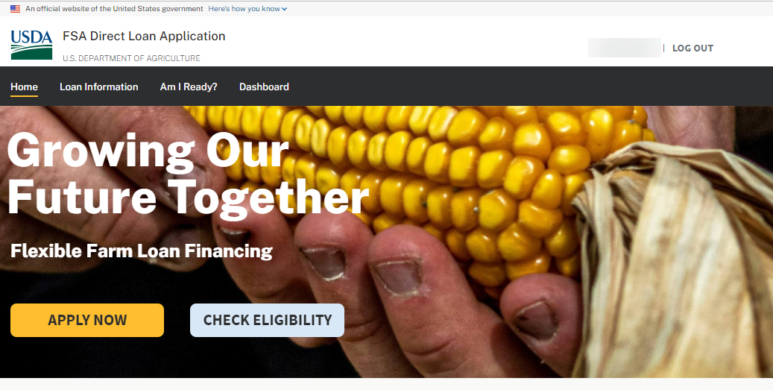
ONLINE LOAN APPLICATION PROCESS FLOW
Paperwork Reduction Act Review Package
Informal Entity Applicant
Prepared: May 6, 2026

Informal Entity Applicant
DASHBOARD
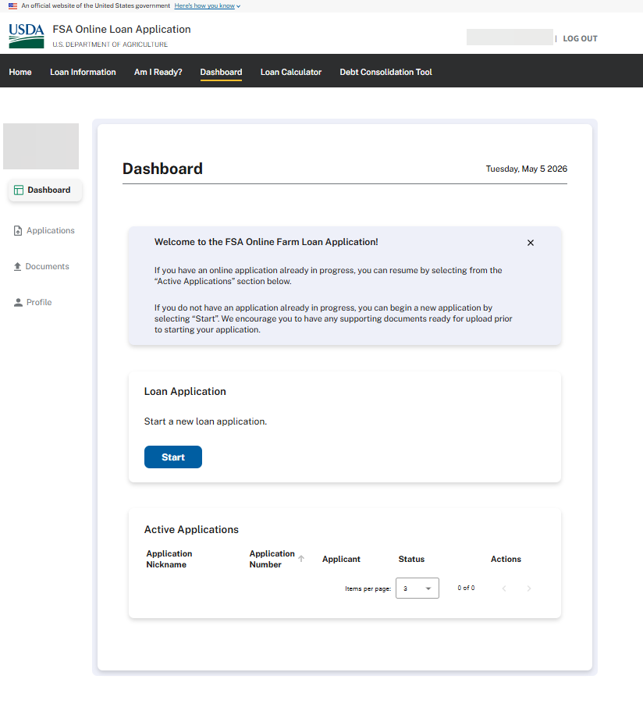

DASHBOARD – Informal Entity Member Linkage Message
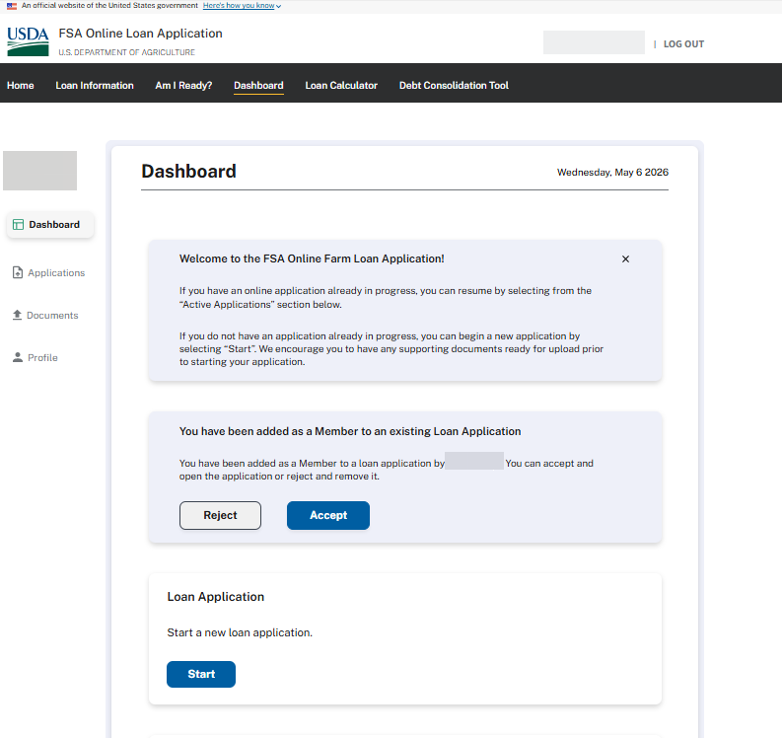
OPERATOR CERTIFICATION
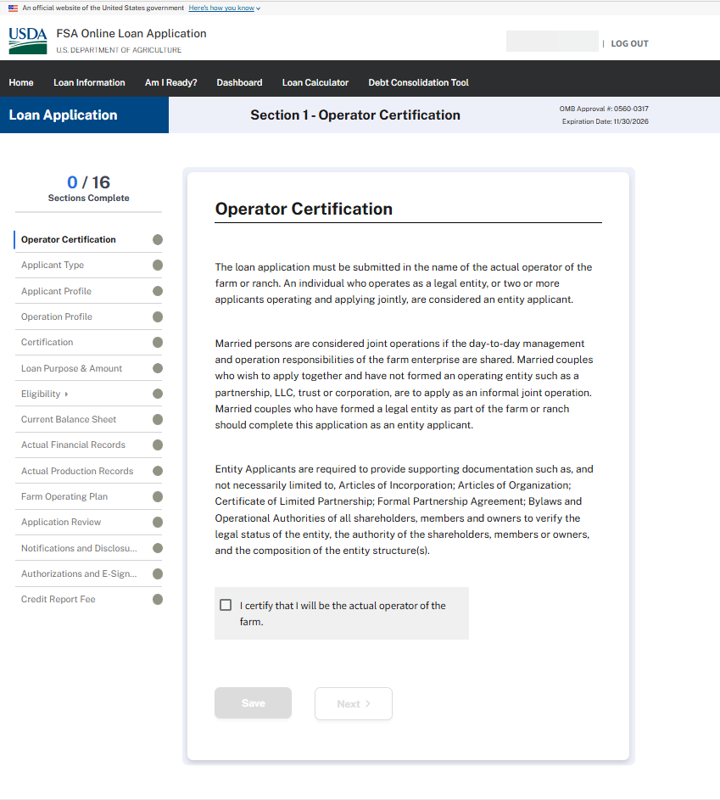
APPLICANT TYPE – Informal Entity (e.g., two or more persons applying jointly, including a married persons)
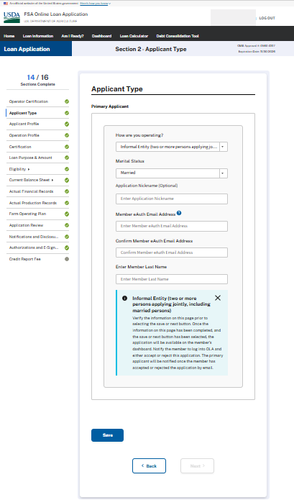

APPLICANT PROFILE
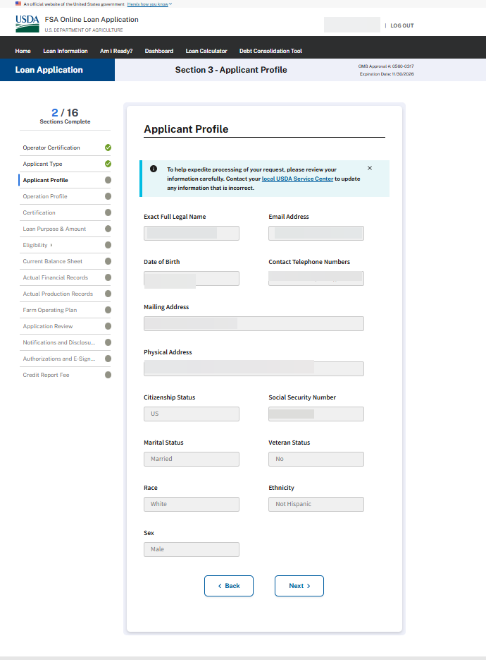
OPERATION PROFILE 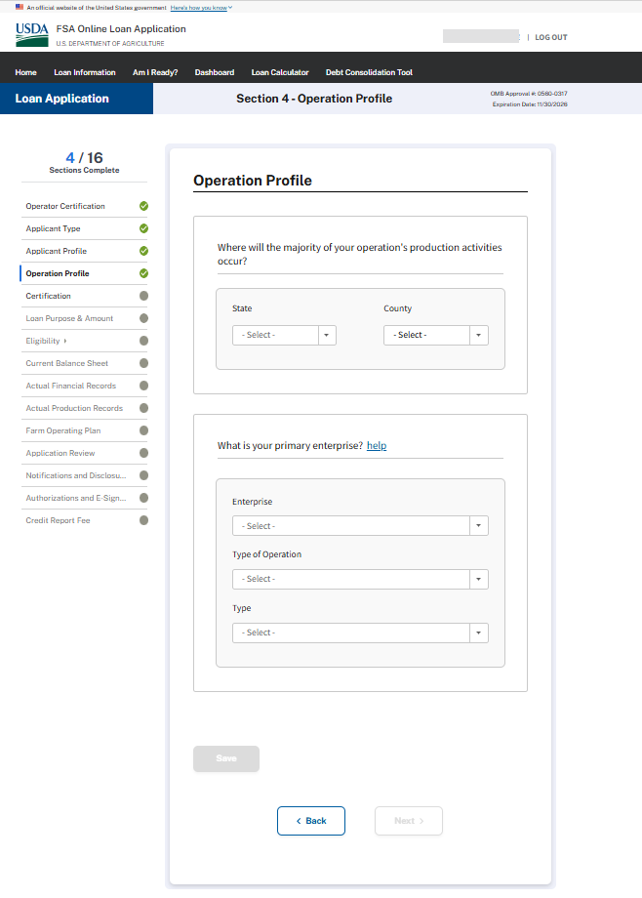
CERTIFICATION (Minimized)
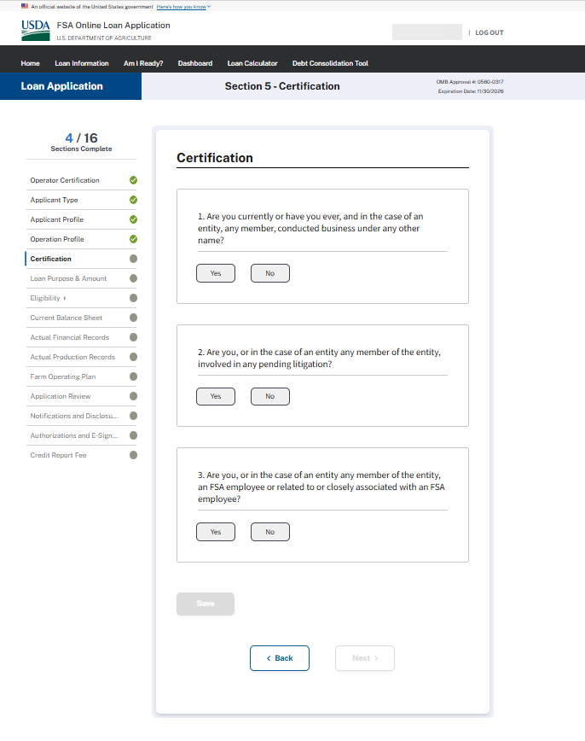

CERTIFICATION (Expanded)
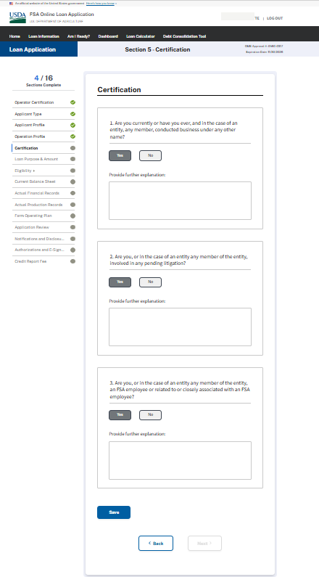
LOAN PURPOSE & AMOUNT
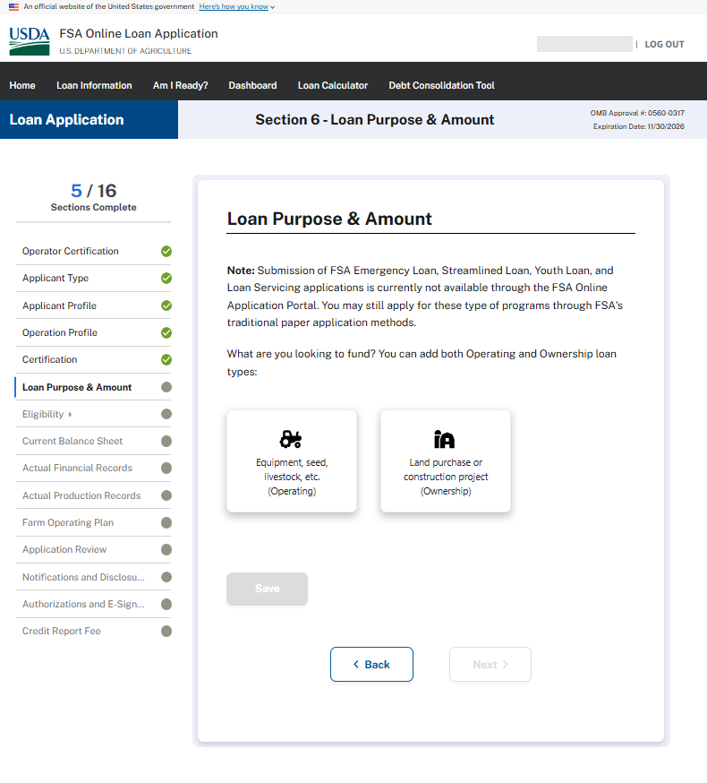
LOAN PURPOSE & AMOUNT (Operating Type Loans)
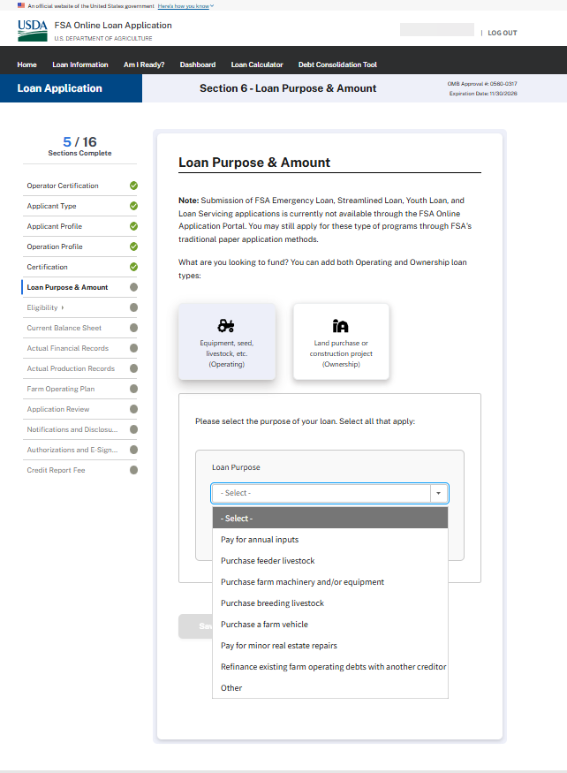
LOAN PURPOSE & AMOUNT (Operating Type Loans – Annual Inputs)
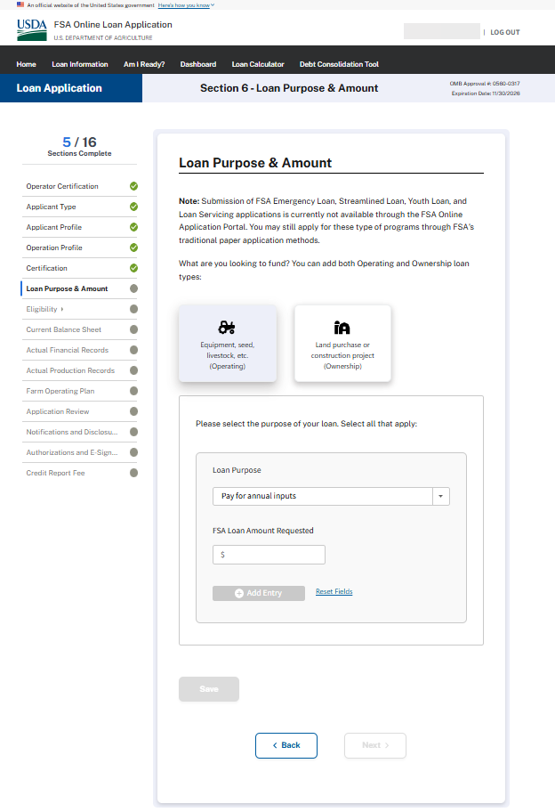

LOAN PURPOSE & AMOUNT (Operating Type Loans – Minor real estate repairs or “Other”)
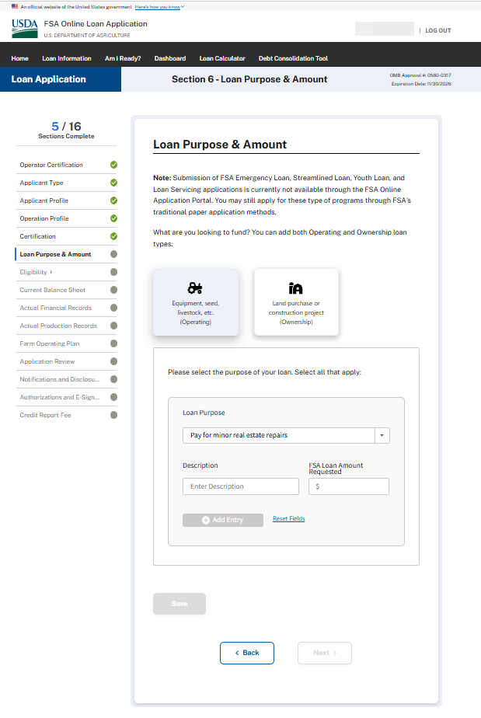
LOAN PURPOSE & AMOUNT (Operating Type Loans – Purchase a farm vehicle, Purchase farm machinery and/or equipment)
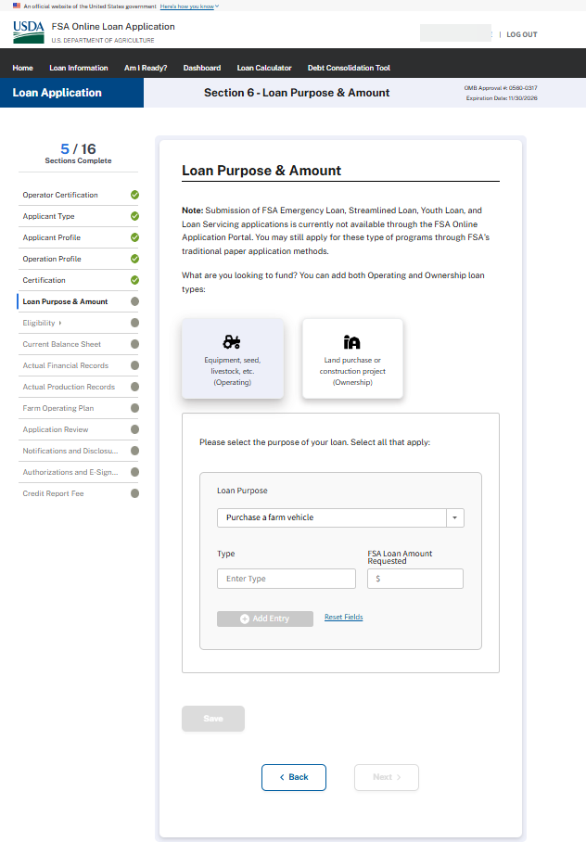
LOAN PURPOSE & AMOUNT (Operating Type Loans – Purchase breeding livestock, Purchase feeder livestock)
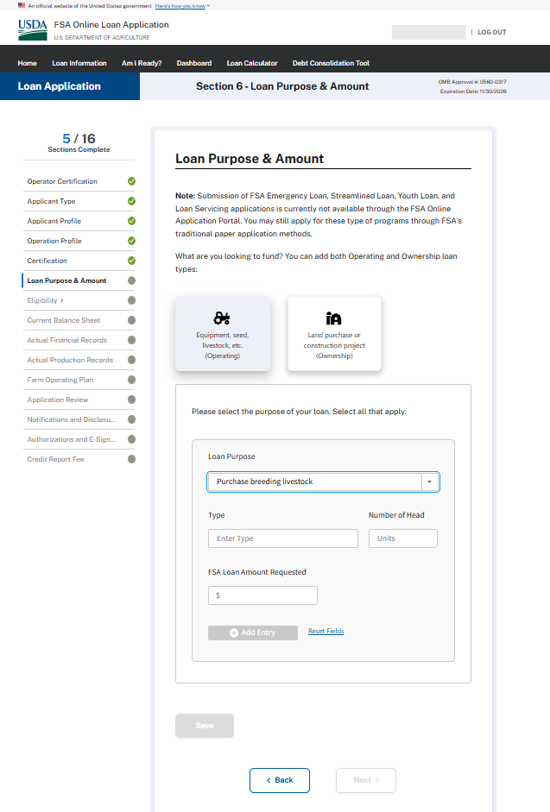
LOAN PURPOSE & AMOUNT (Operating Type Loans – Refinance existing farm operating debts with another creditor)
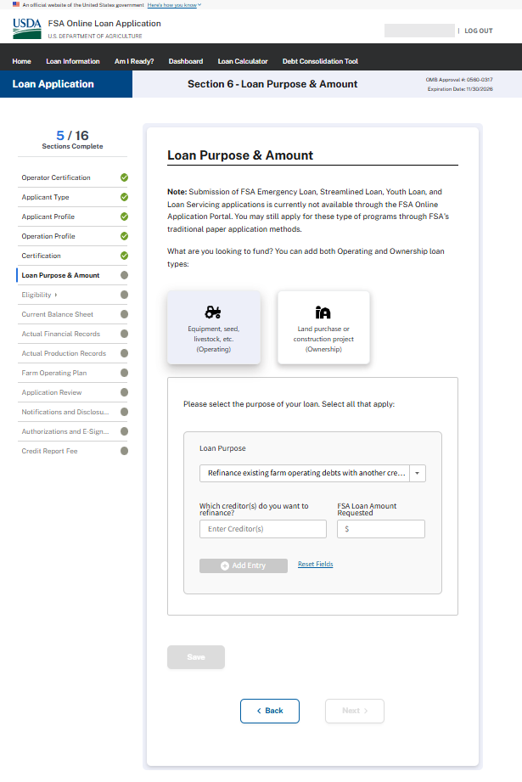

LOAN PURPOSE & AMOUNT (Ownership Loans)
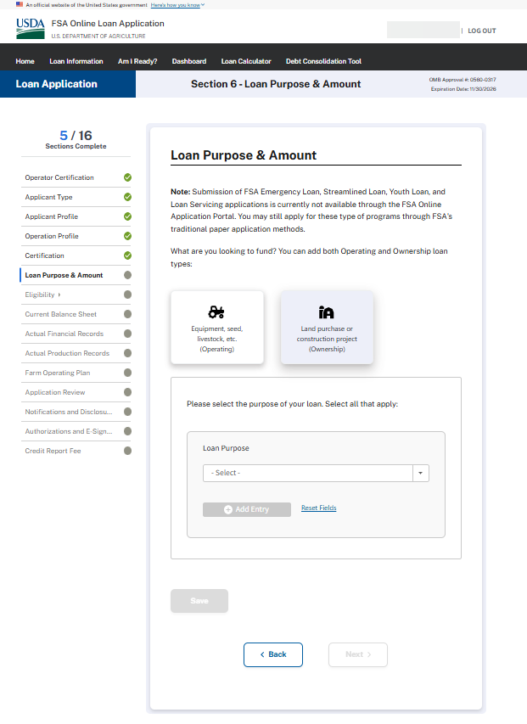

LOAN PURPOSE & AMOUNT (Ownership Loans – Pay for capital improvements, construction, development & Other)
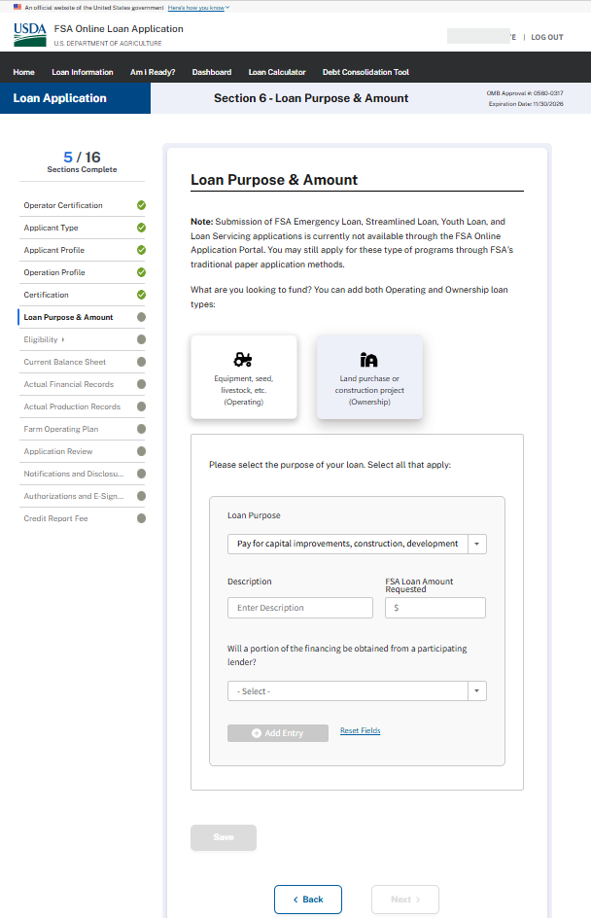
LOAN PURPOSE & AMOUNT (Ownership Loans – Purchase farm real estate)
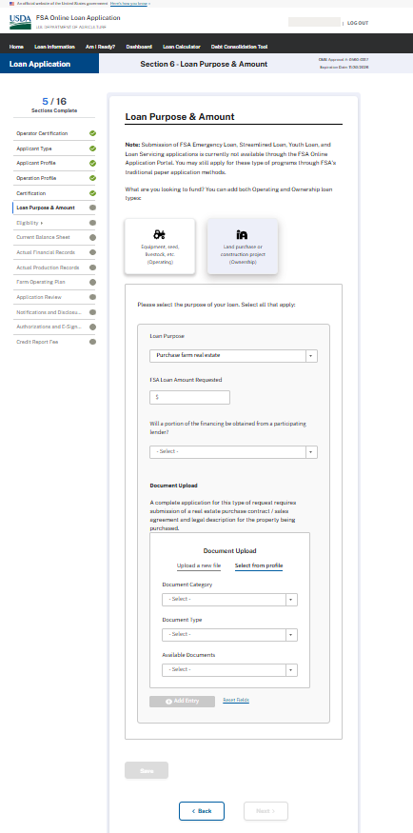
Eligibility (Credit Elsewhere)
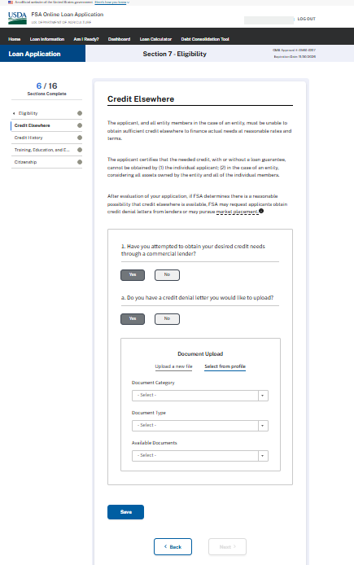

ELIGIBILITY – CREDIT HISTORY
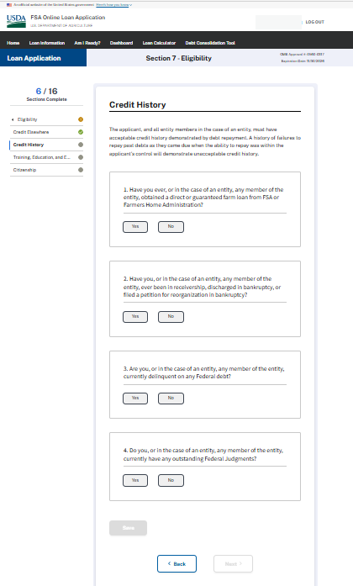

ELIGIBILITY – CREDIT HISTORY – Question 1 & 1a - Expanded
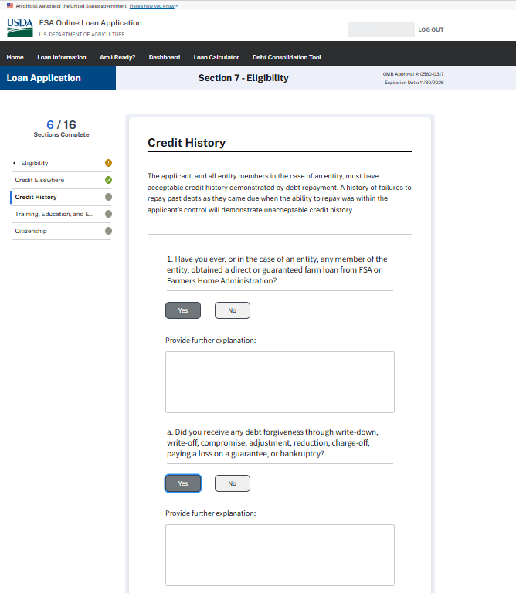

ELIGIBILITY – CREDIT HISTORY – Question 2 - Expanded
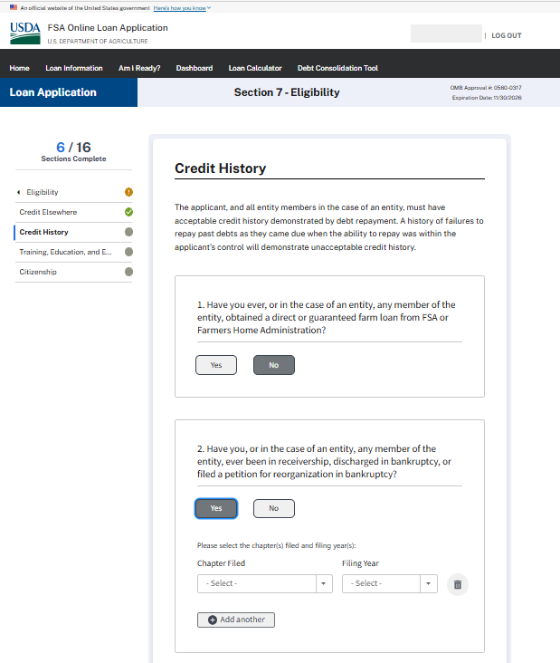

ELIGIBILITY – CREDIT HISTORY – Question 3 & 4 - Expanded
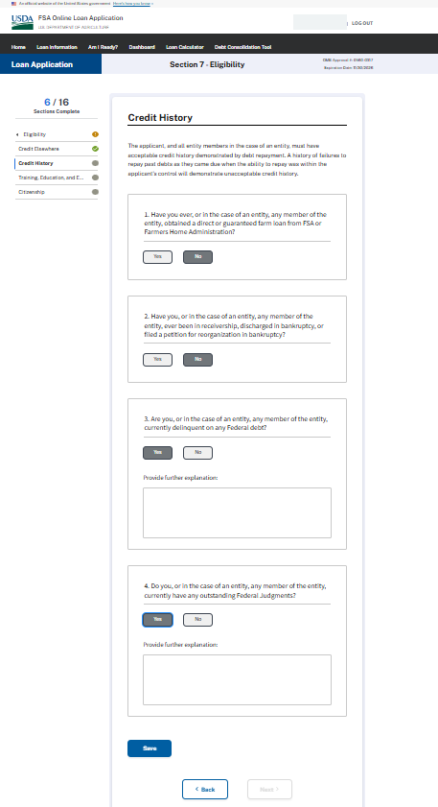
ELIGIBILITY – TRAINING, EDUCATION, & EXPERIENCE (Expanded)
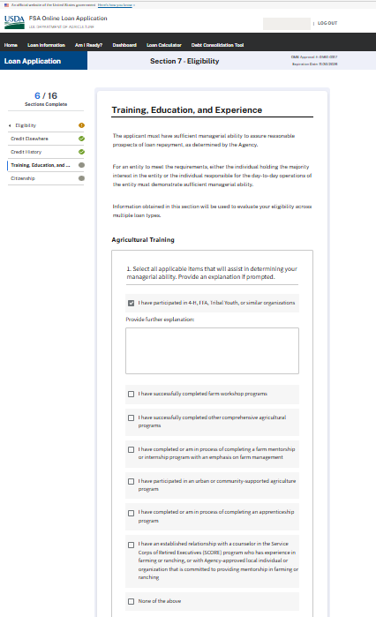

ELIGIBILITY – TRAINING, EDUCATION, & EXPERIENCE (Expanded)
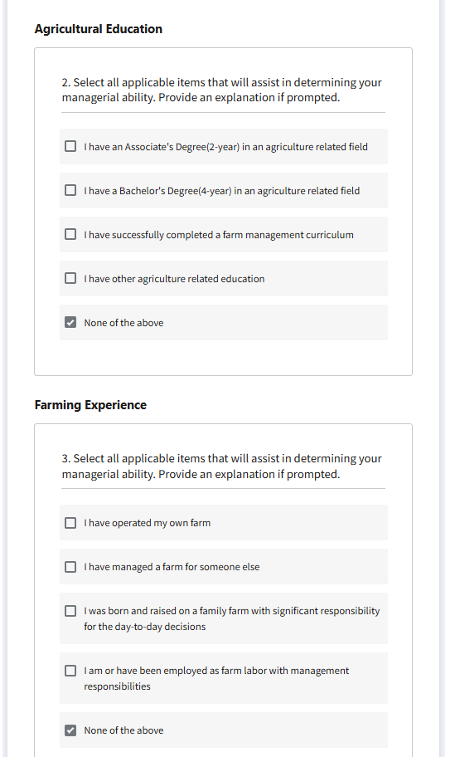

ELIGIBILITY – TRAINING, EDUCATION, & EXPERIENCE (Expanded – “I have operating my own farm” subsequent question)
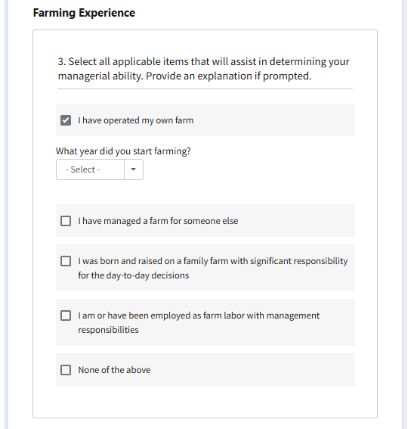

ELIGIBILITY – TRAINING, EDUCATION, & EXPERIENCE (Expanded – All other selections except for “I have operating my own farm” provide same explanation box)
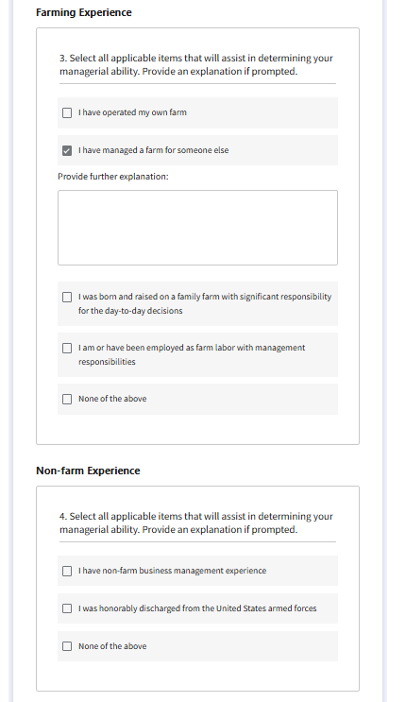

ELIGIBILITY – TRAINING, EDUCATION, & EXPERIENCE (Supporting Documents upload)
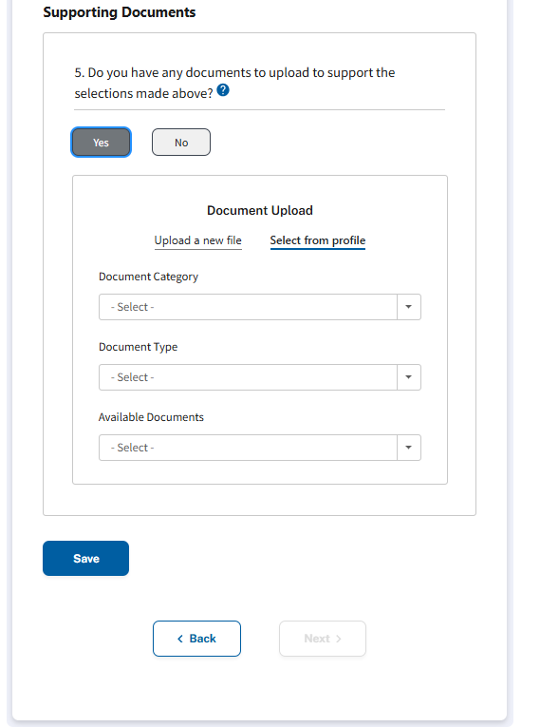

ELIGIBILITY – CITIZENSHIP
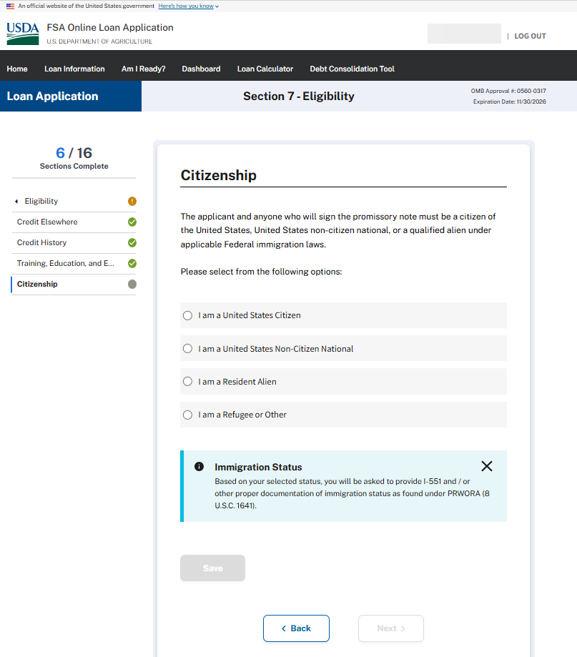

ELIGIBILITY – CITIZENSHIP (Expanded)
If anything besides United States Citizen is selected, the applicant wil be provided ability to upload supporting documents:
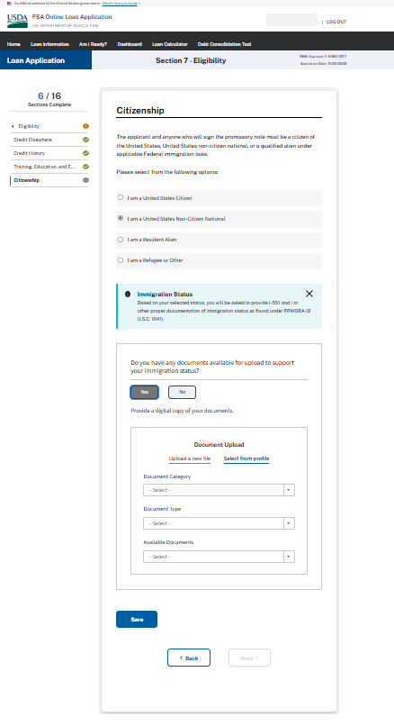
CURRENT BALANCE SHEET – Question 1 – Answered “Yes” – Fully Expanded
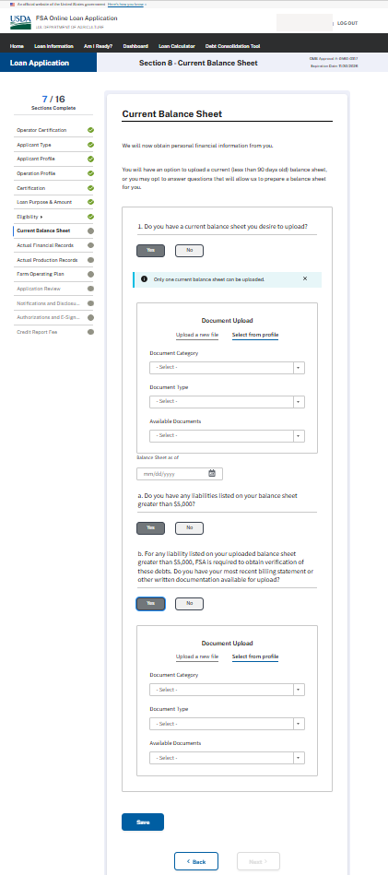
CURRENT BALANCE SHEET – Question 1 – Answered “No”
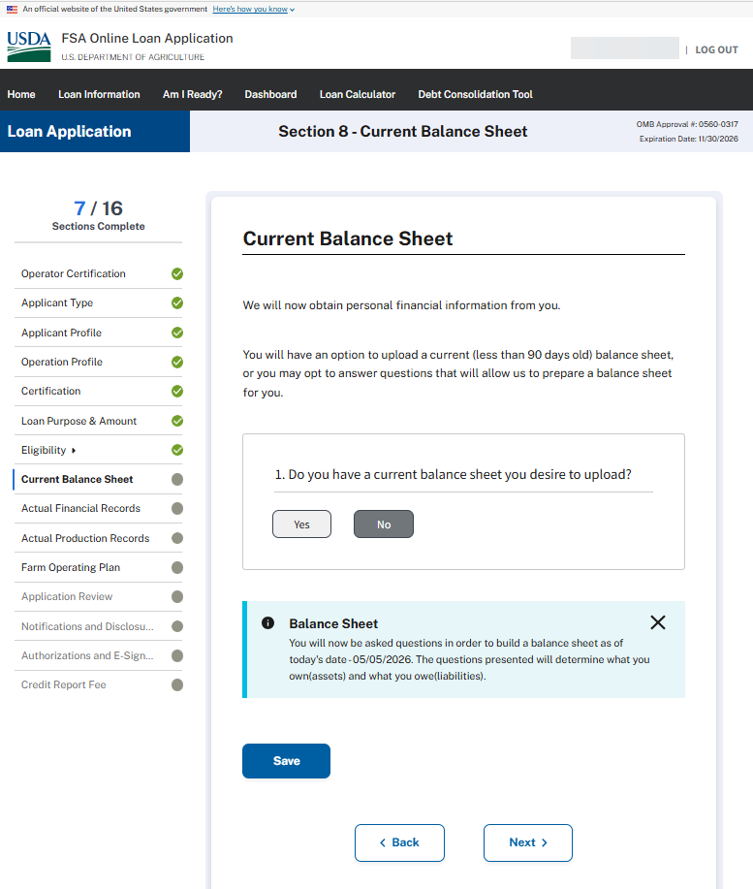

CURRENT BALANCE SHEET – Assets - Question 1
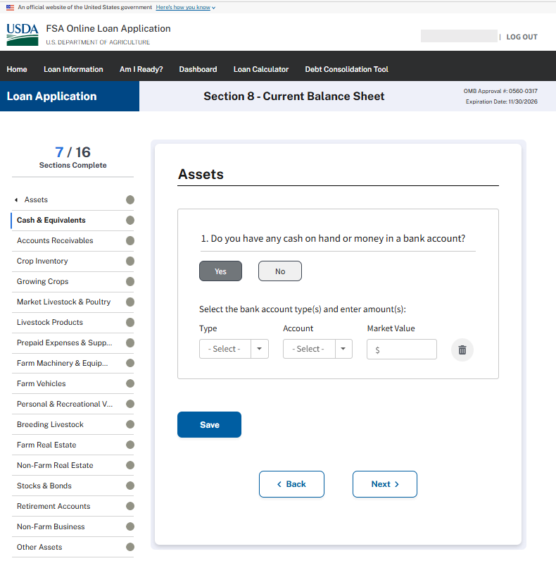

CURRENT BALANCE SHEET – Assets - Question 2
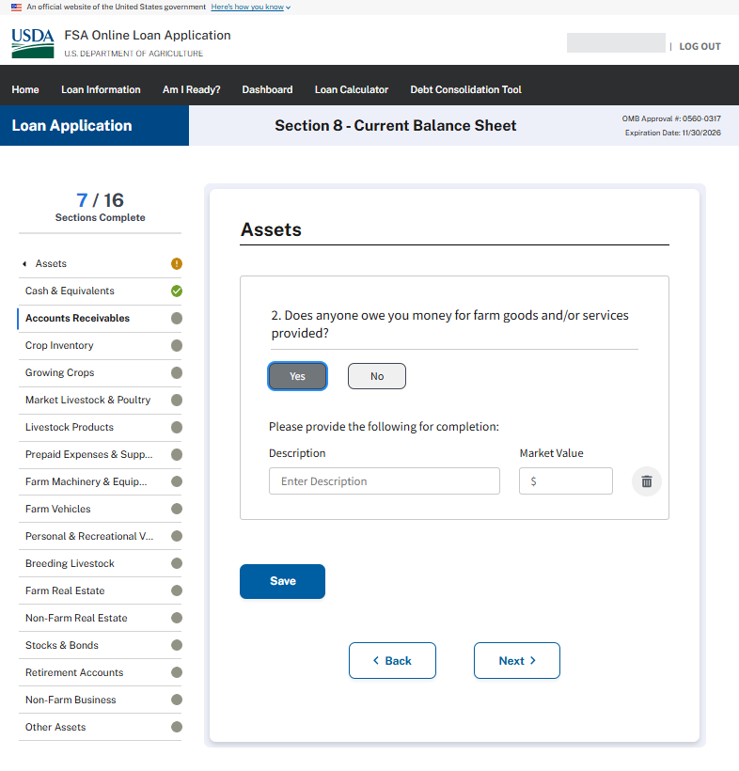

CURRENT BALANCE SHEET – Assets - Question 3
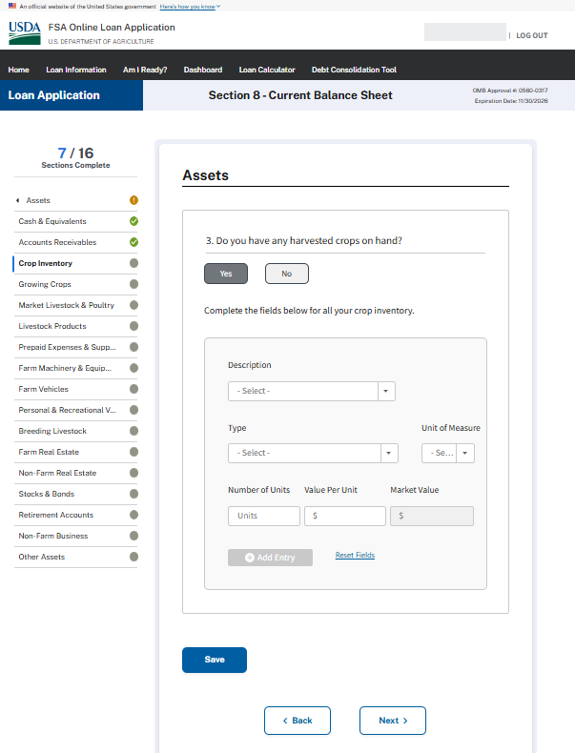

CURRENT BALANCE SHEET – Assets - Question 4
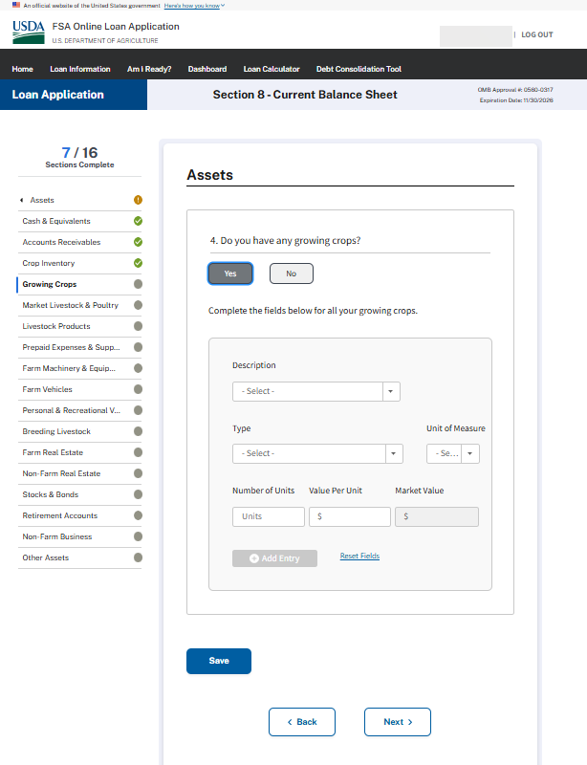

CURRENT BALANCE SHEET – Assets - Question 5
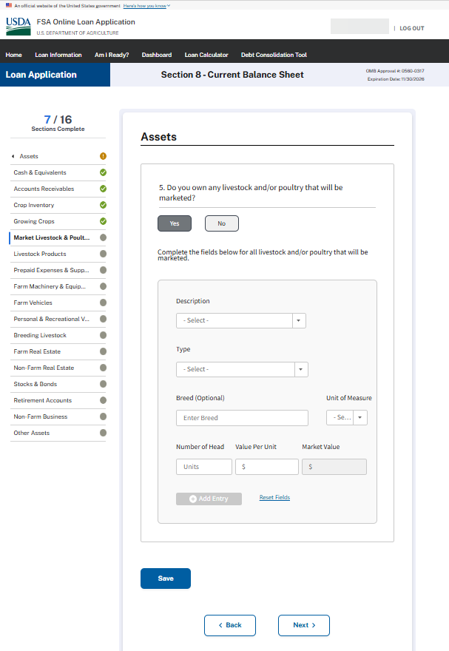

CURRENT BALANCE SHEET – Assets - Question 6
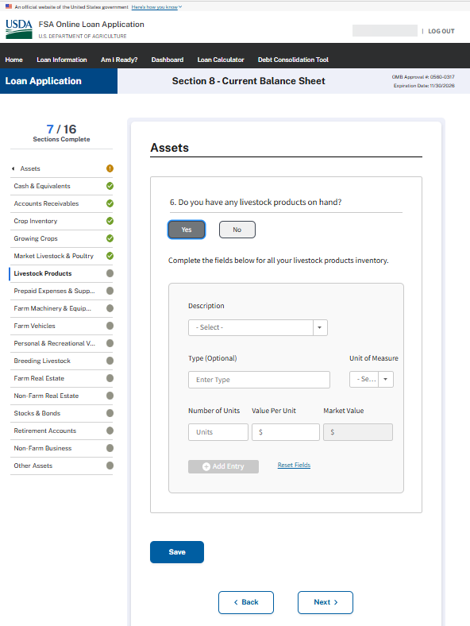

CURRENT BALANCE SHEET – Assets - Question 7
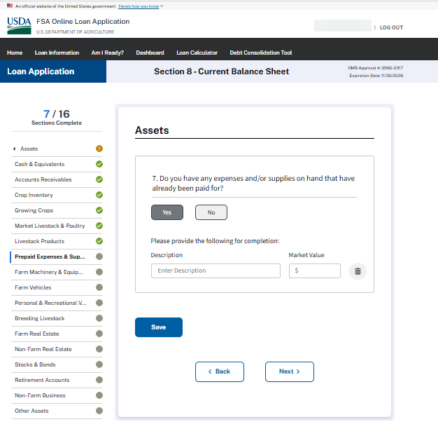

CURRENT BALANCE SHEET – Assets - Question 8
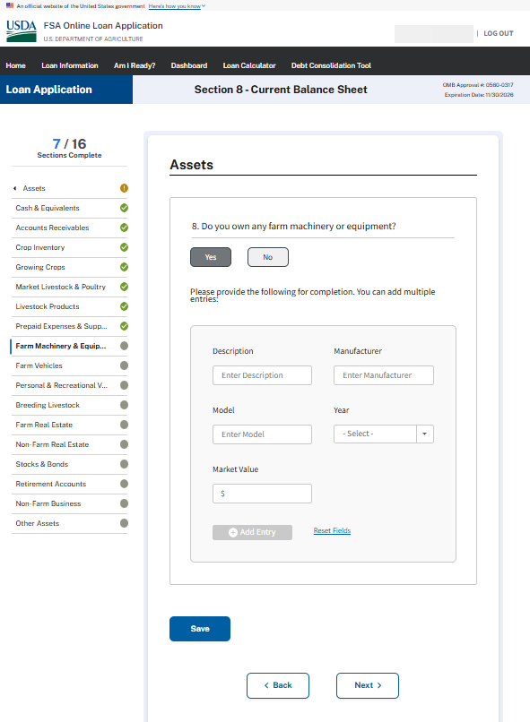
CURRENT BALANCE SHEET – Assets - Question 9
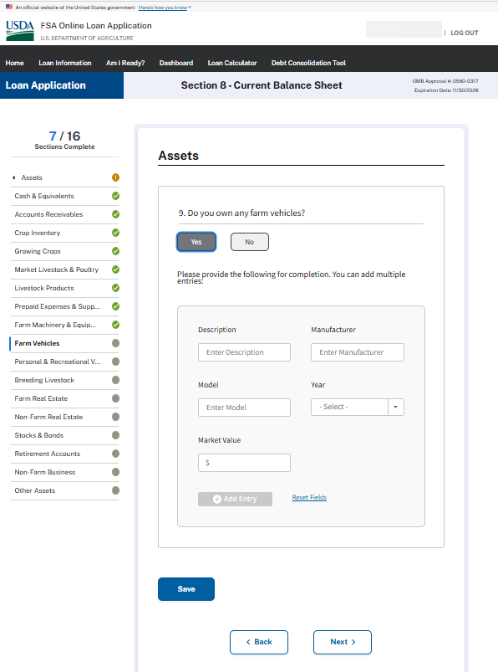

CURRENT BALANCE SHEET – Assets - Question 10
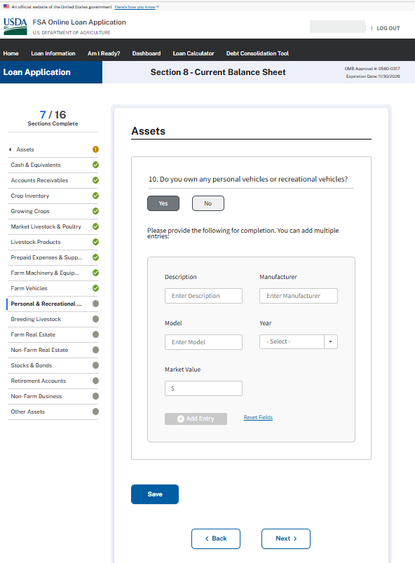

CURRENT BALANCE SHEET – Assets - Question 11
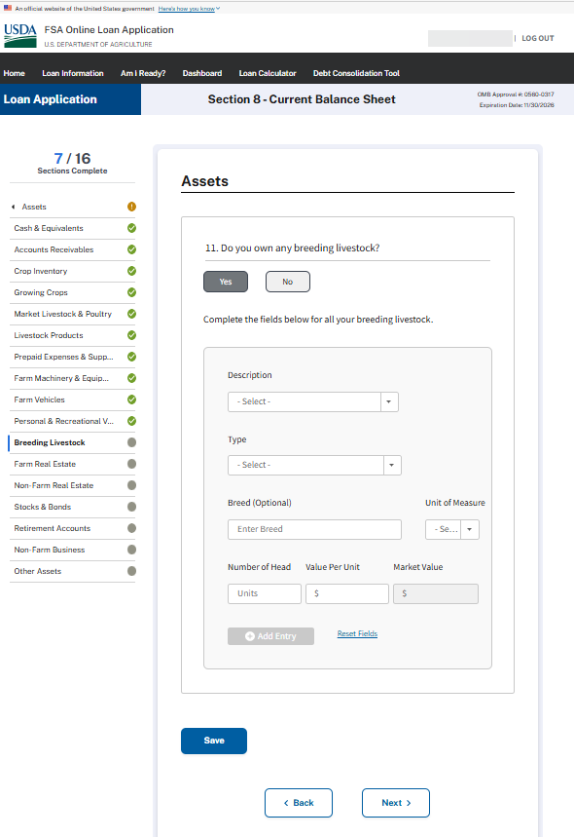
CURRENT BALANCE SHEET – Assets - Question 12
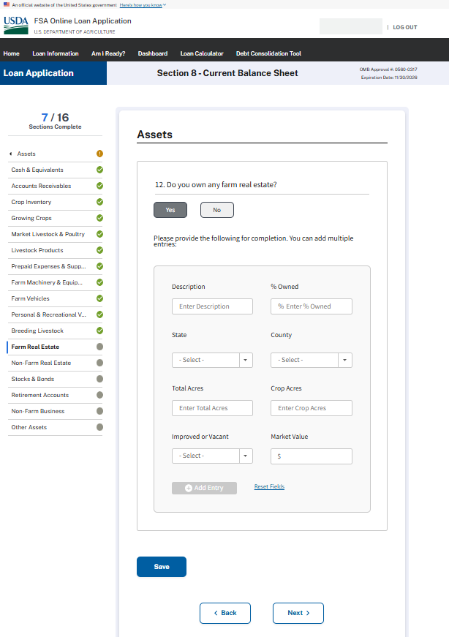

CURRENT BALANCE SHEET – Assets - Question 13
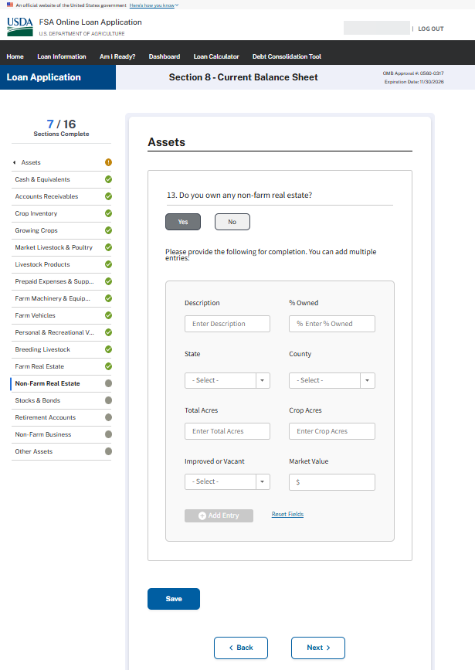

CURRENT BALANCE SHEET – Assets - Question 14
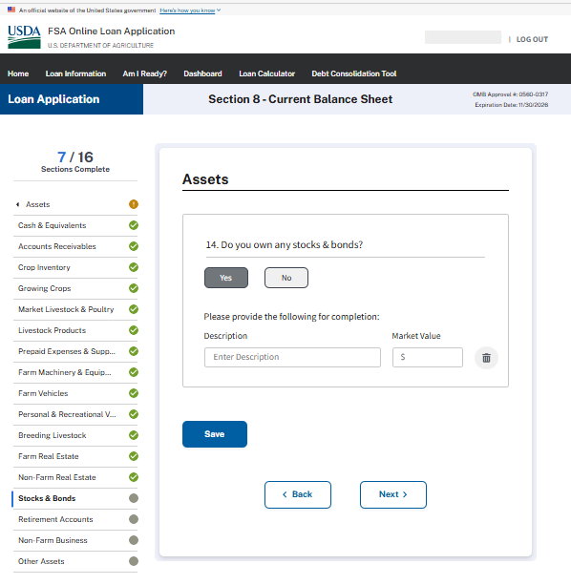

CURRENT BALANCE SHEET – Assets - Question 15
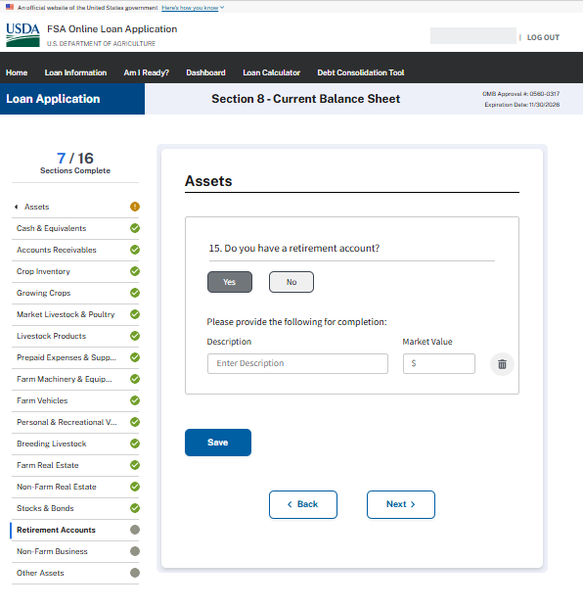

CURRENT BALANCE SHEET – Assets - Question 16
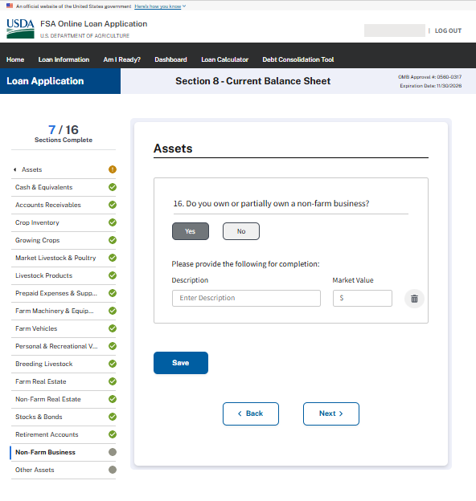

CURRENT BALANCE SHEET – Assets - Question 17
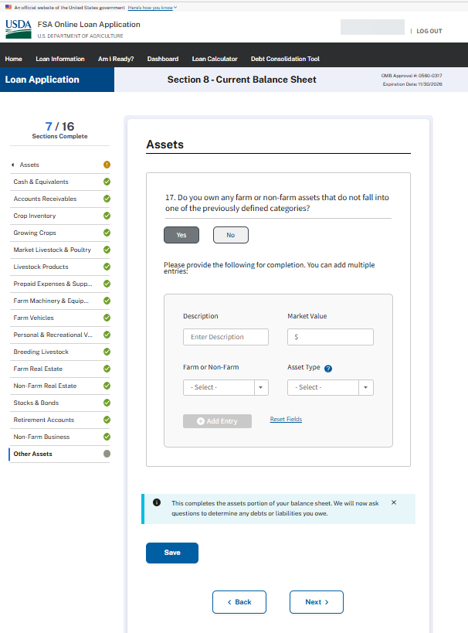
CURRENT BALANCE SHEET – Liabilities - Question 18
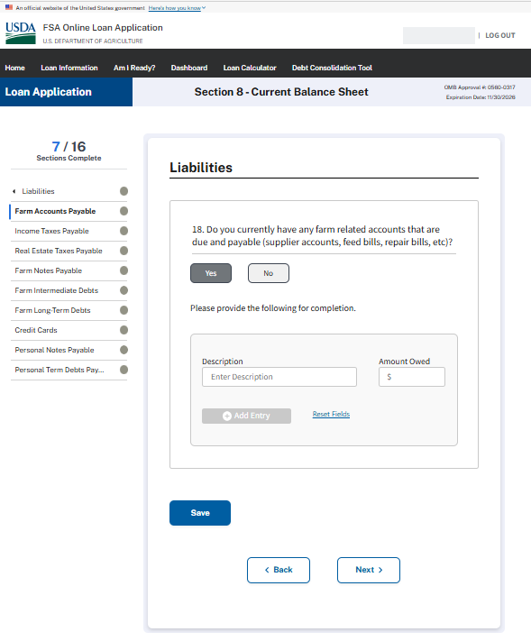

CURRENT BALANCE SHEET – Liabilities - Question 19
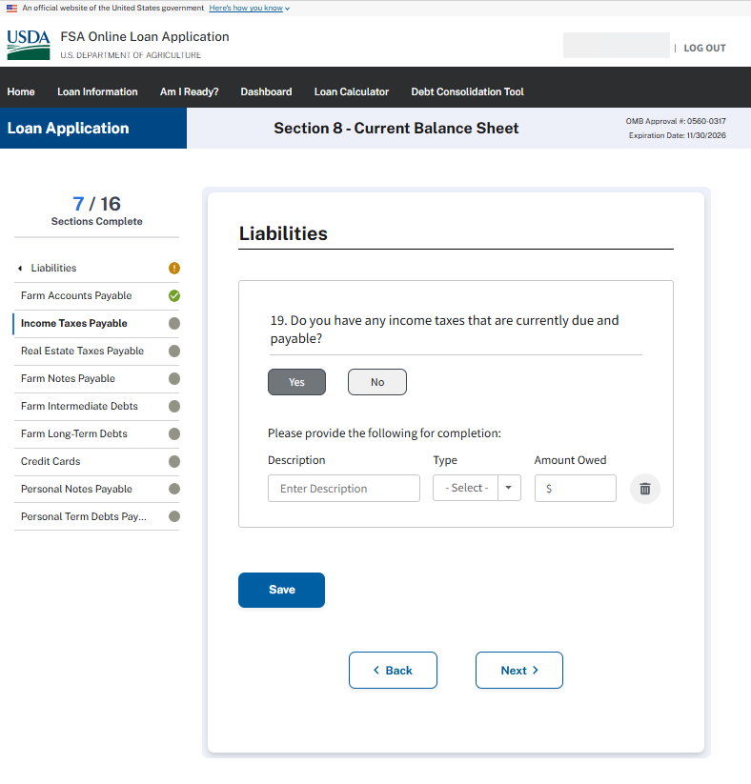

CURRENT BALANCE SHEET – Liabilities - Question 20
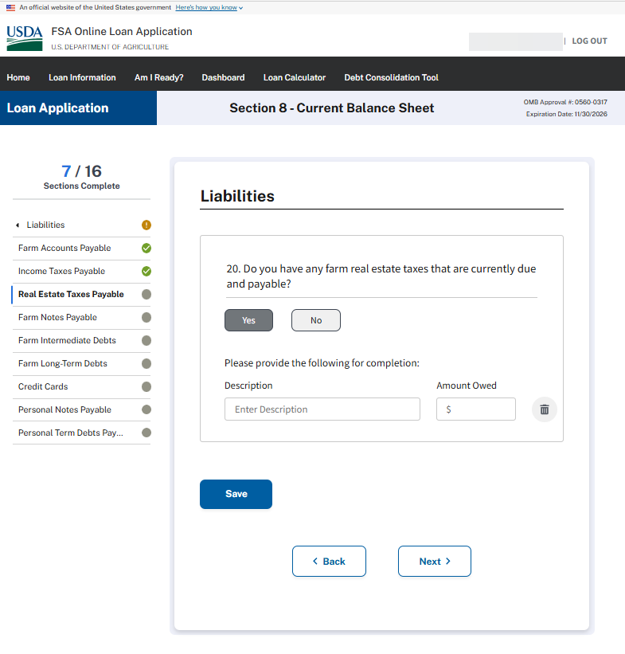

CURRENT BALANCE SHEET – Liabilities - Question 21
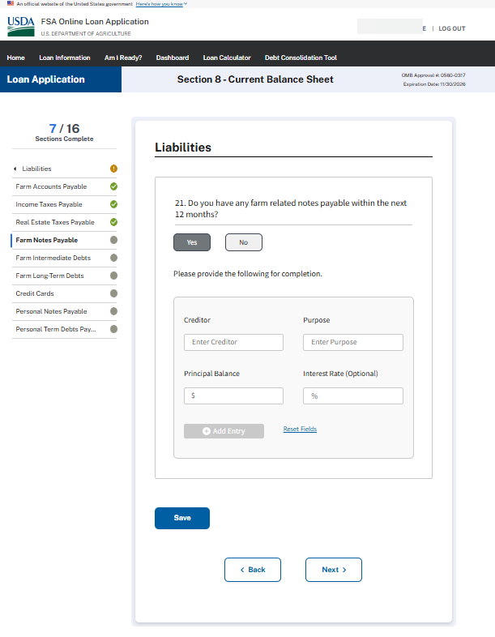

CURRENT BALANCE SHEET – Liabilities - Question 22
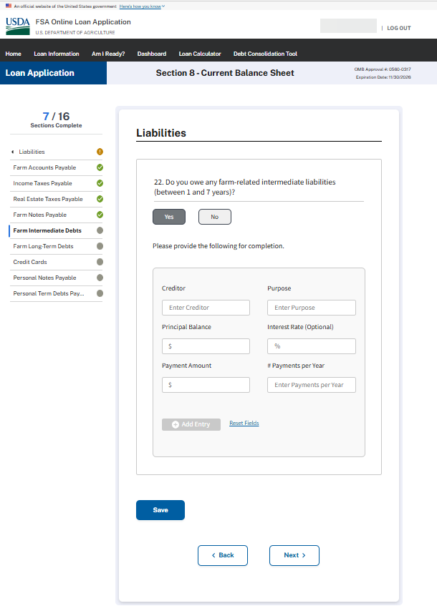
CURRENT BALANCE SHEET – Liabilities - Question 23
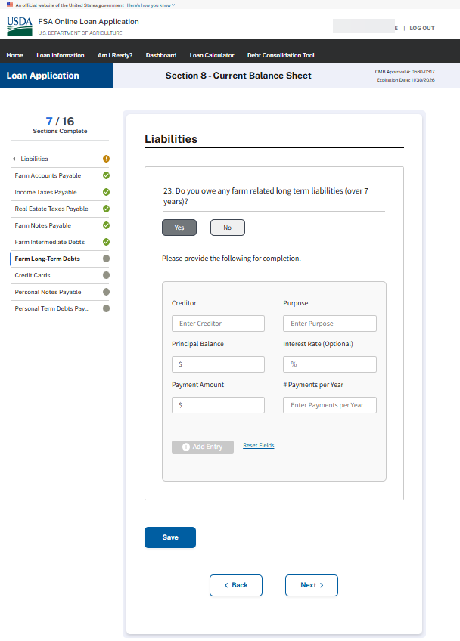
CURRENT BALANCE SHEET – Liabilities - Question 24
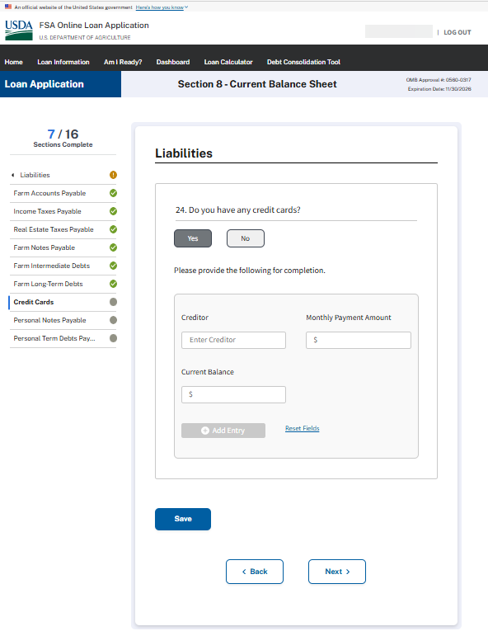

CURRENT BALANCE SHEET – Liabilities - Question 25
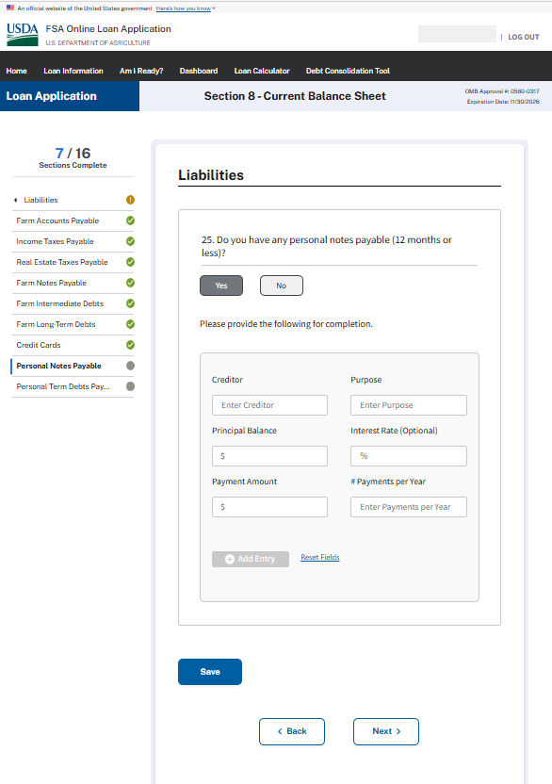
CURRENT BALANCE SHEET – Liabilities - Question 26
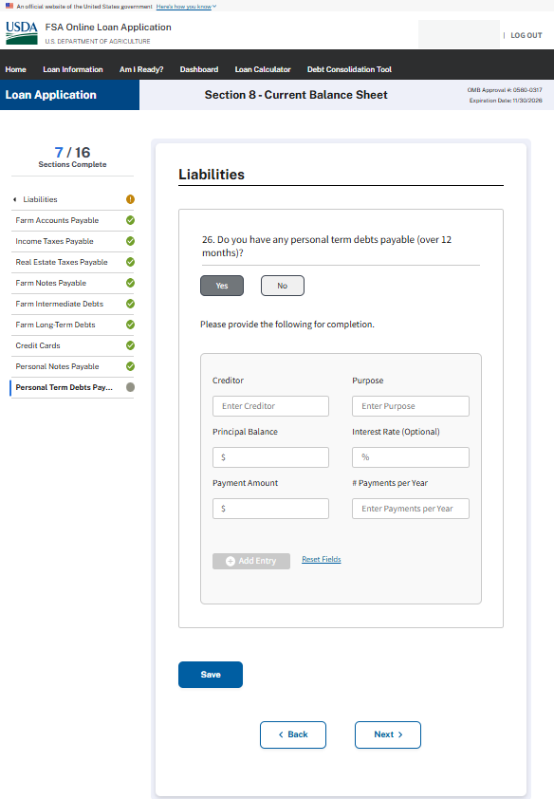

BALANCE SHEET SUMMARY
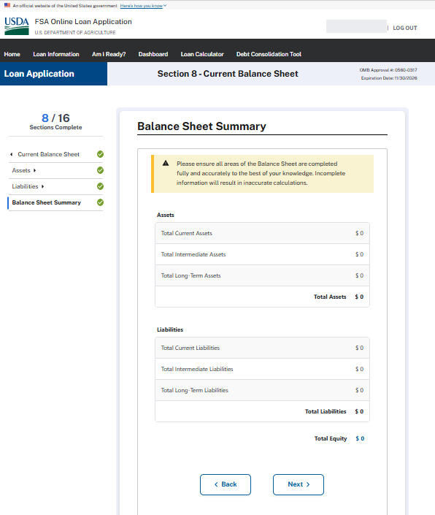

ACTUAL FINANCIAL RECORDS
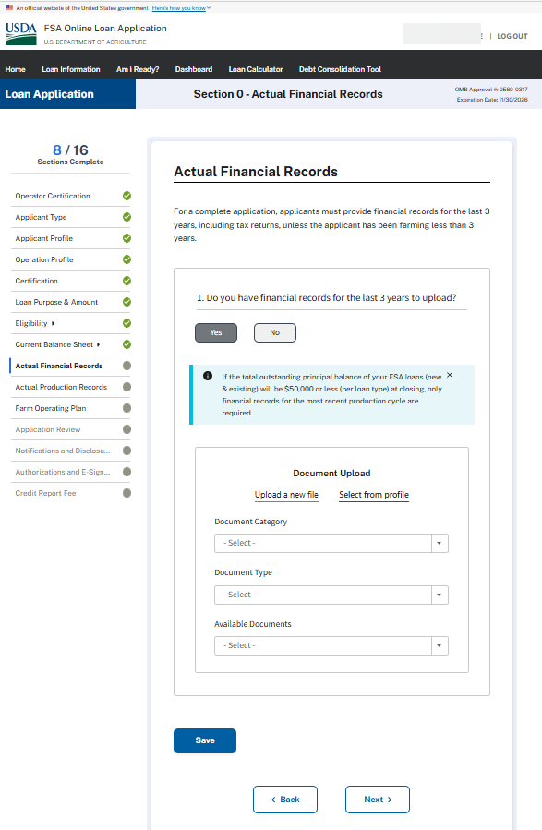
ACTUAL PRODUCTION RECORDS
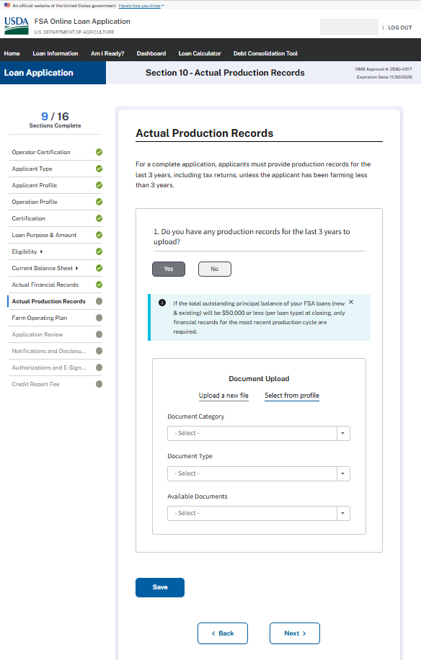
FARM OPERATING PLAN
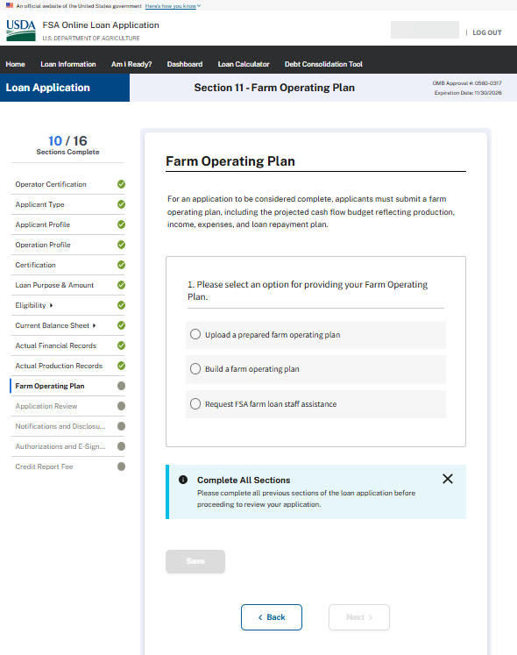

FARM OPERATING PLAN (1a) – When applicant chooses to upload a prepared farm operating plan
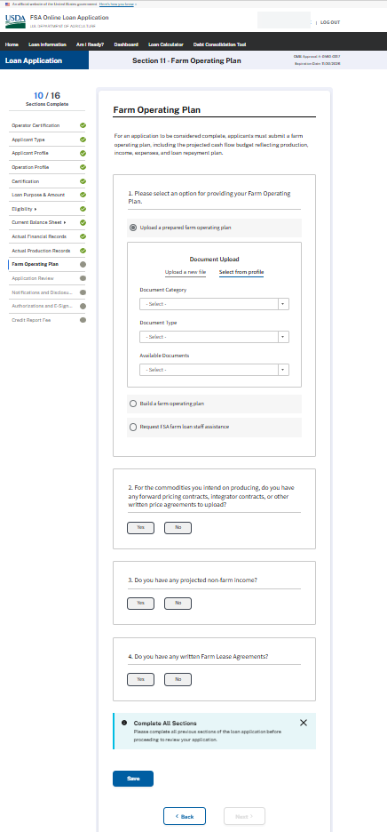

FARM OPERATING PLAN – When the applicant chooses to build a farm operating plan
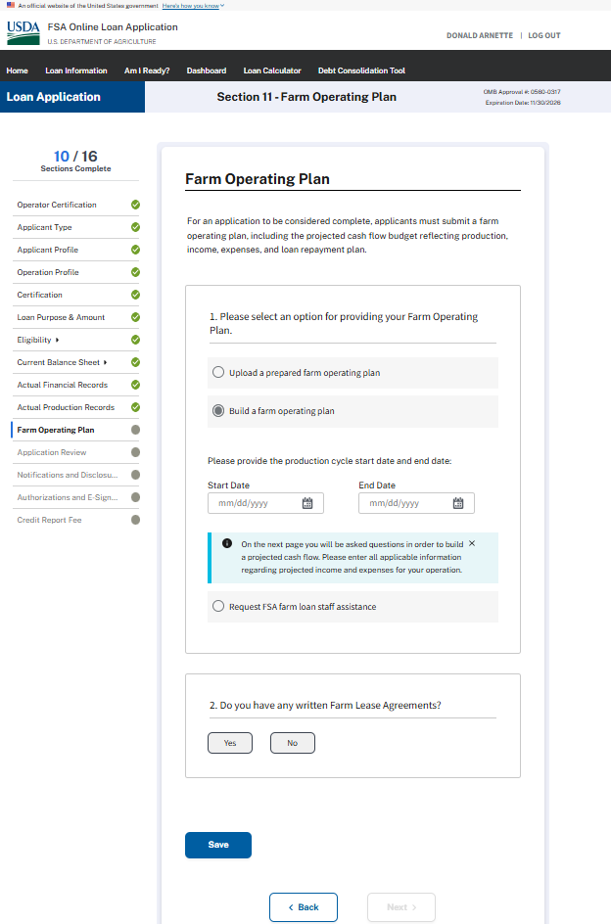

FARM OPERATING PLAN –When the applicant chooses to build a farm operating plan
Farm Income Question #1
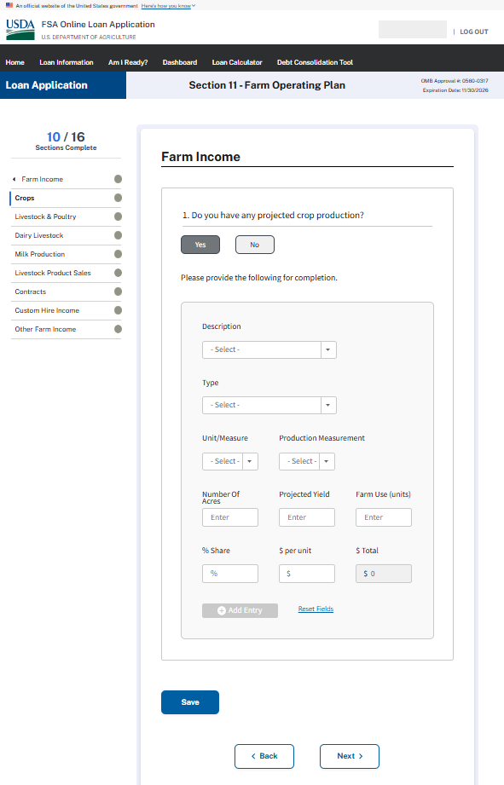
FARM OPERATING PLAN – When the applicant chooses to build a farm operating plan
Farm Income Question #2
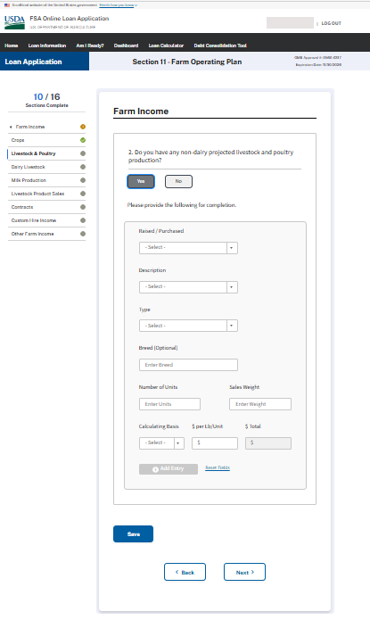

FARM OPERATING PLAN – When the applicant chooses to build a farm operating plan
Farm Income Question #3
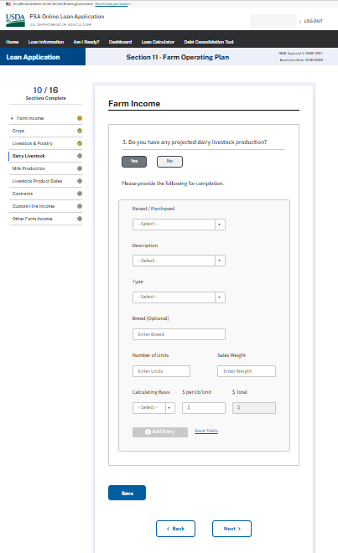

FARM OPERATING PLAN – When the applicant chooses to build a farm operating plan
Farm Income Question #4
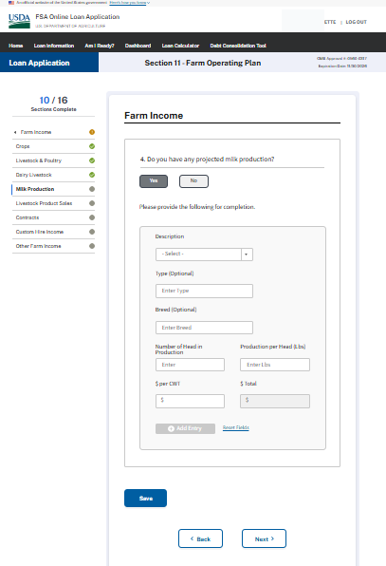

FARM OPERATING PLAN – When the applicant chooses to build a farm operating plan
Farm Income Question #5
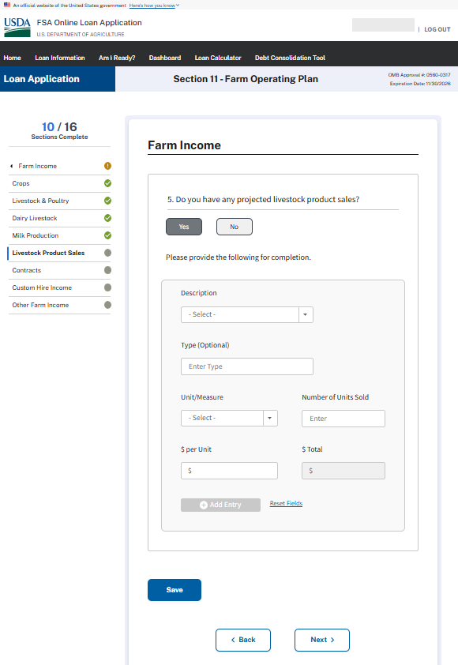
FARM OPERATING PLAN – Wireframe – When the applicant chooses to build a farm operating plan Farm Income Question #6
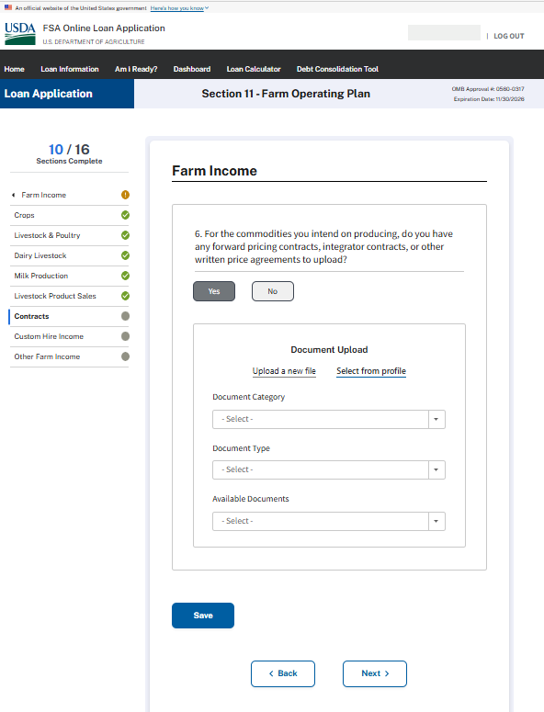

FARM OPERATING PLAN – When the applicant chooses to build a farm operating plan
Farm Income Question #7
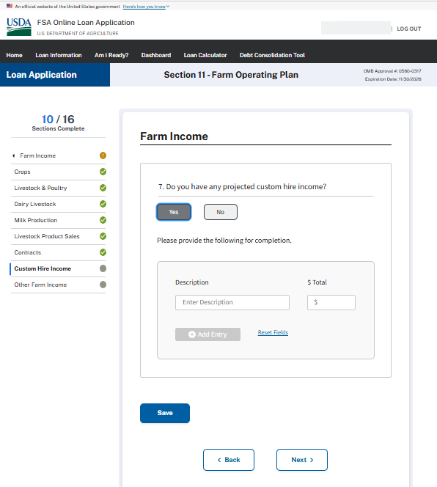

FARM OPERATING PLAN –When the applicant chooses to build a farm operating plan
Farm Income Question #8
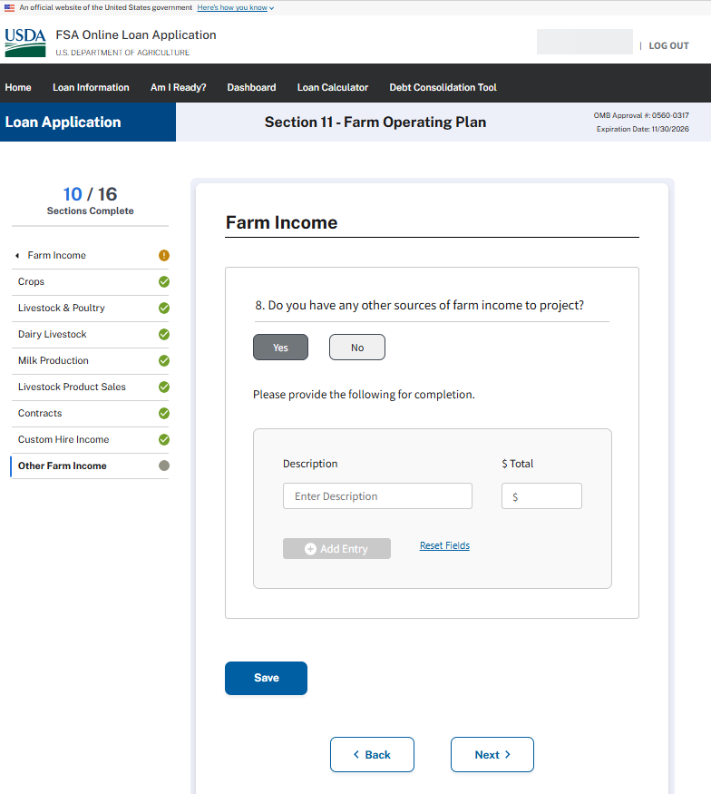

FARM OPERATING PLAN – When the applicant chooses to build a farm operating plan
Non-Farm Income
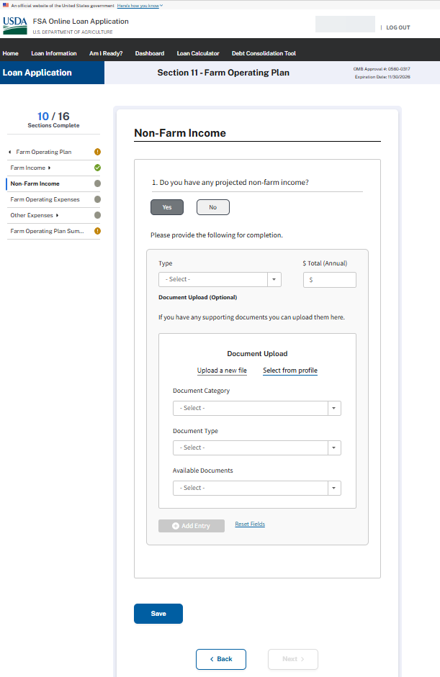

FARM OPERATING PLAN – When the applicant chooses to build a farm operating plan
Operating Expenses
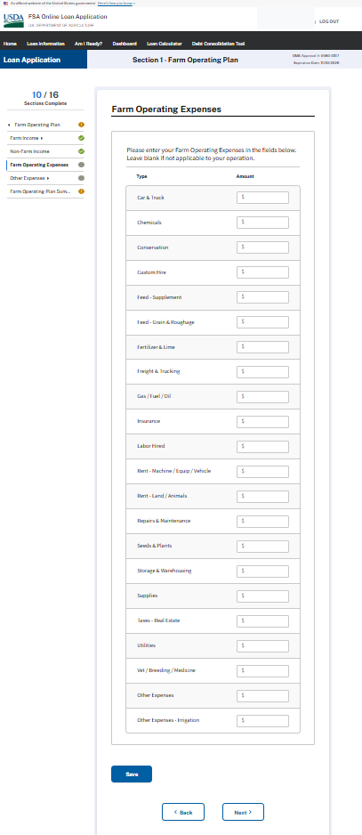
FARM OPERATING PLAN – When the applicant chooses to build a farm operating plan
Other Expenses
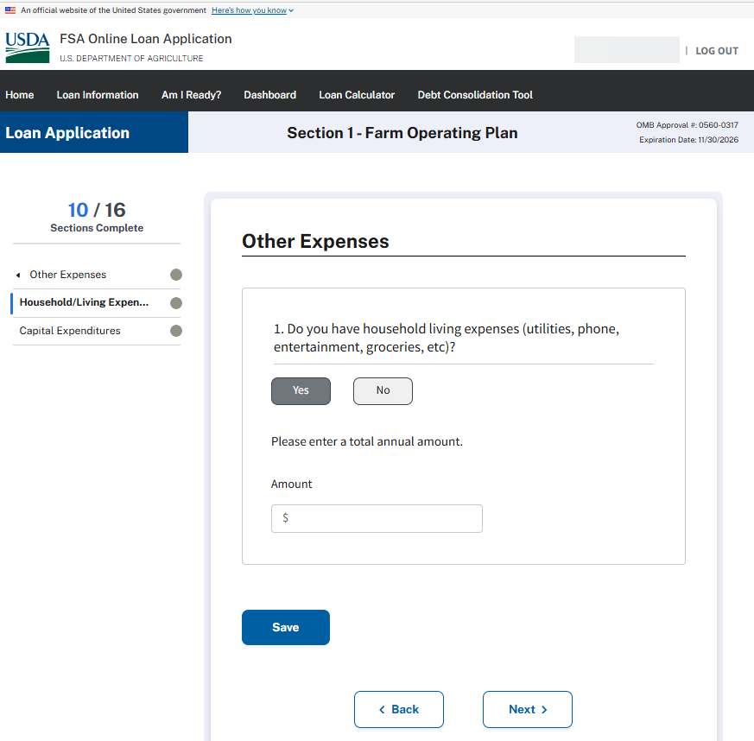

FARM OPERATING PLAN – When the applicant chooses to build a farm operating plan
Capital Expenditures
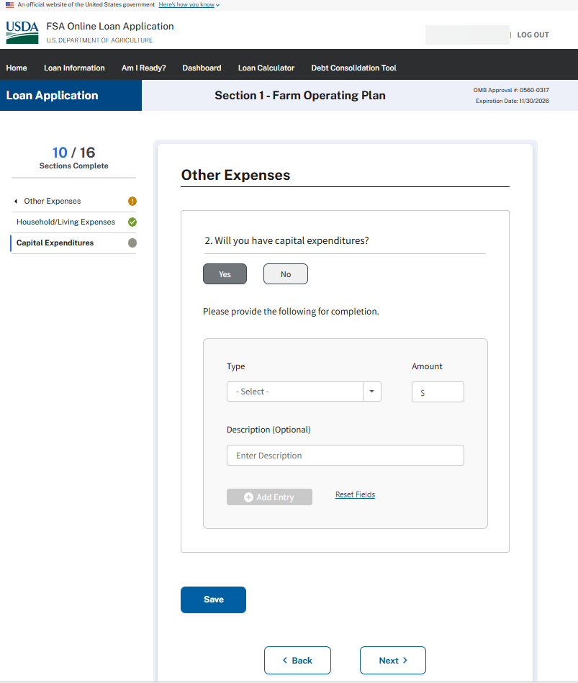

FARM OPERATING PLAN SUMMARY - When the applicant chooses to build a farm operating plan
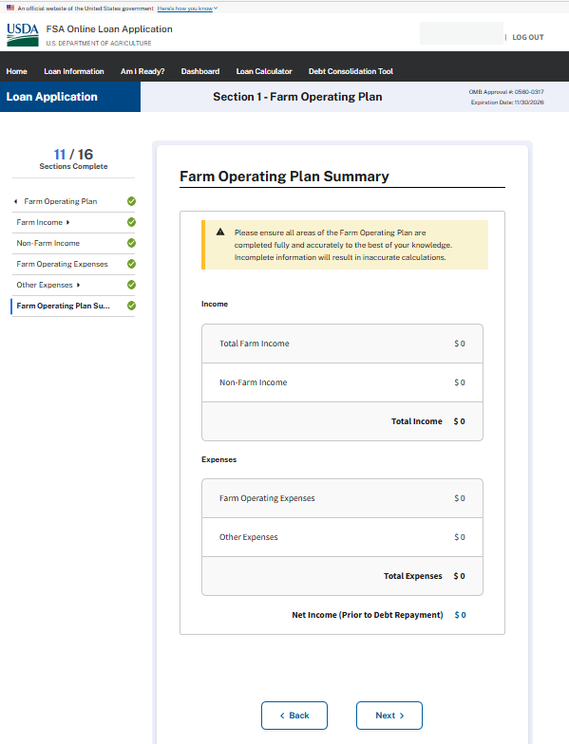

FARM OPERATING PLAN – When the applicant requests FSA farm loan staff assistance
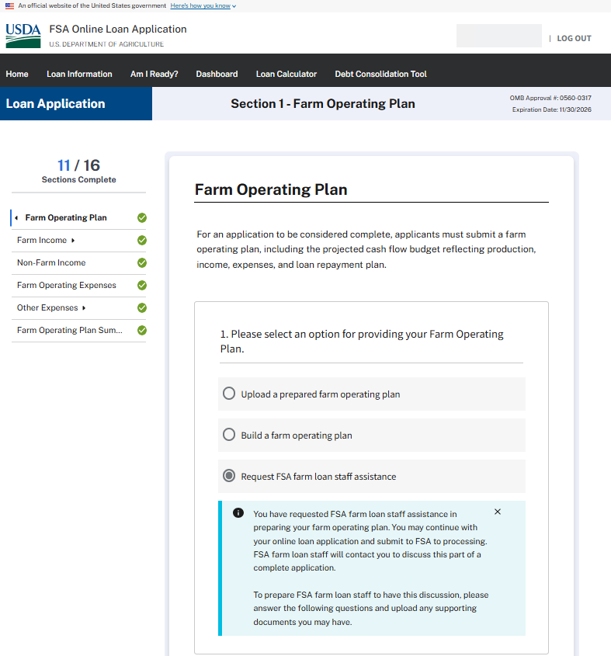

FARM OPERATING PLAN – When the applicant requests FSA farm loan staff assistance (CONTINUED)
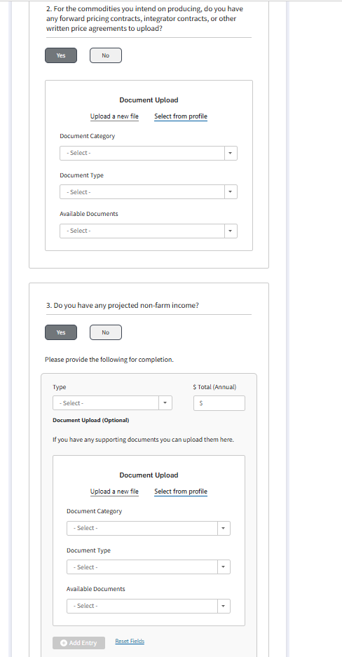

FARM OPERATING PLAN – When the applicant requests FSA farm loan staff assistance (CONTINUED)
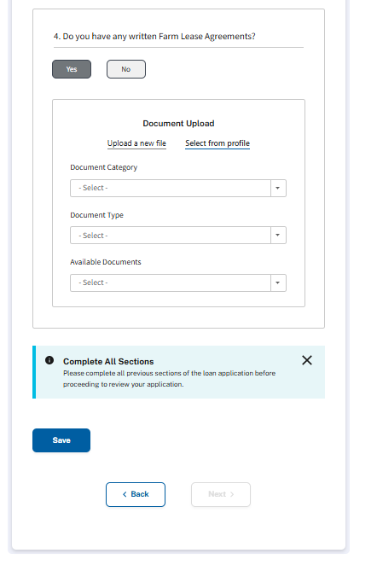

APPLICATION REVIEW
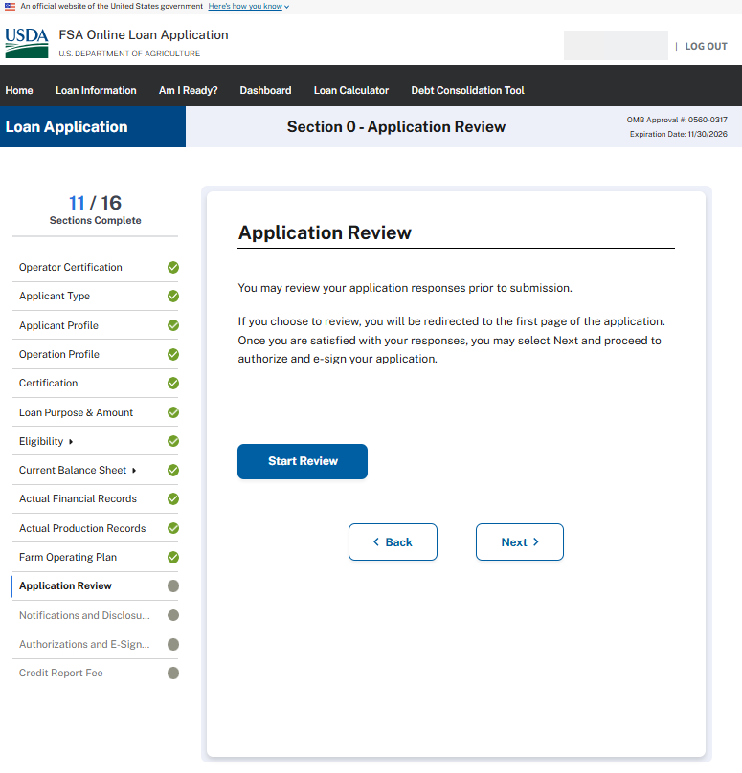
NOTIFICATION & DISCLOSURES - Minimized
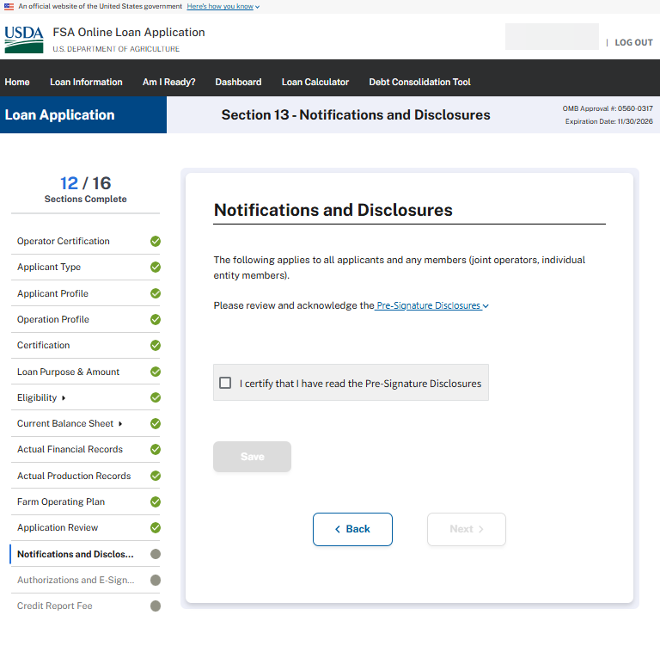

NOTIFICATION & DISCLOSURES - Maximized
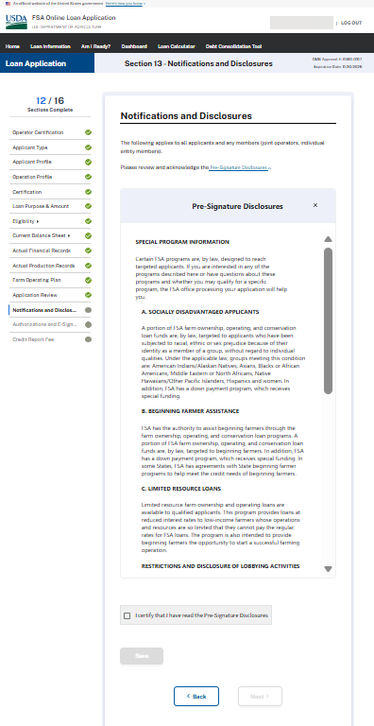

AUTHORIZATIONS AND E-SIGNATURE
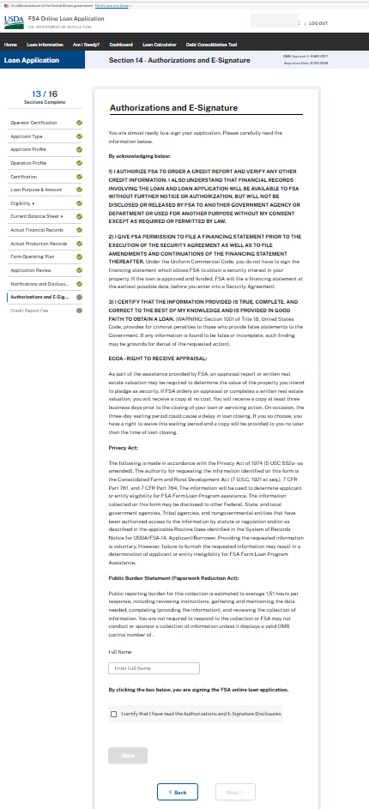

CREDIT REPORT FEE & SUBMISSION
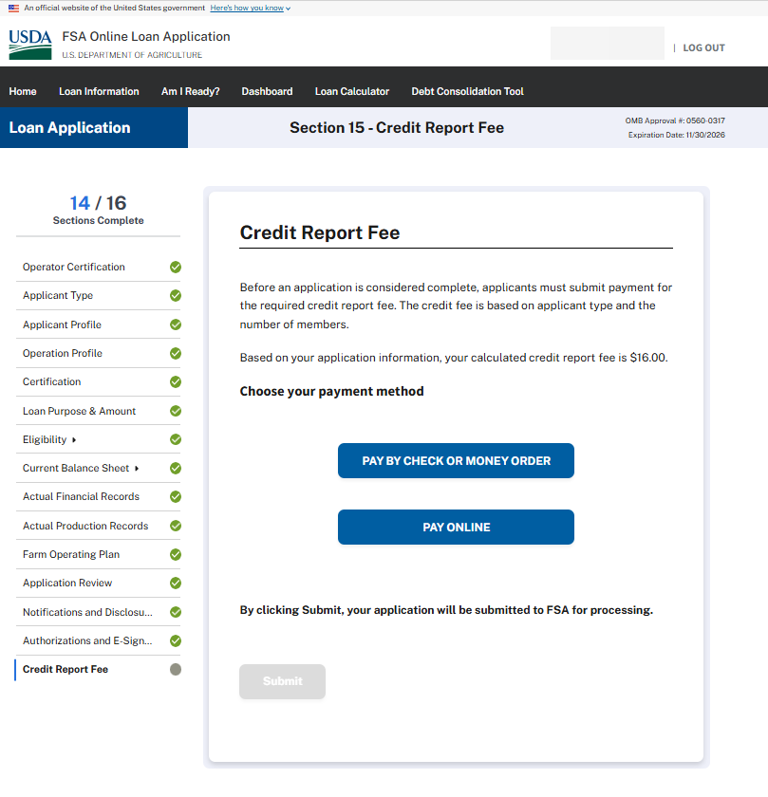

Payment of Credit Report Fee Online
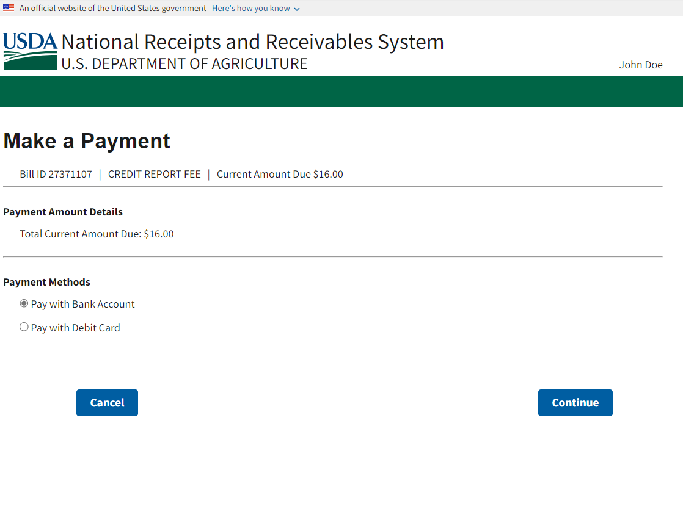

Payment of Credit Report Fee Online (continued - ACH Bank Account option)
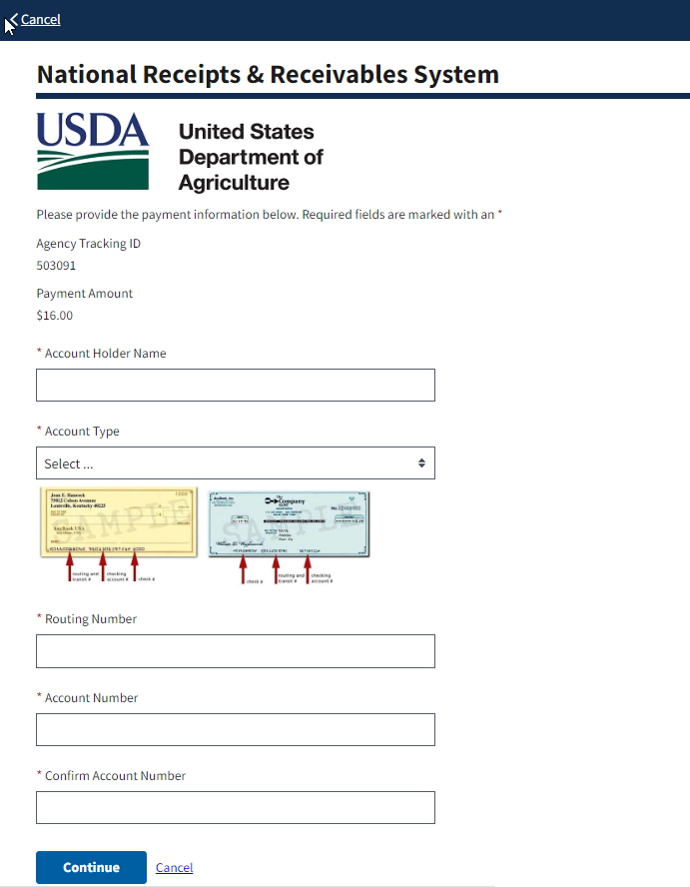

Payment of Credit Report Fee Online (continued – Debt Card option)
