Information Collection Screenshots
  - Online submission form for the Genetic Testing Registry (GTR)

This document provides updated screenshots of the online form for the submission of genetic test information to the Genetic Testing Registry (GTR).
2/12/2025

SECURE LOGIN SYSTEM
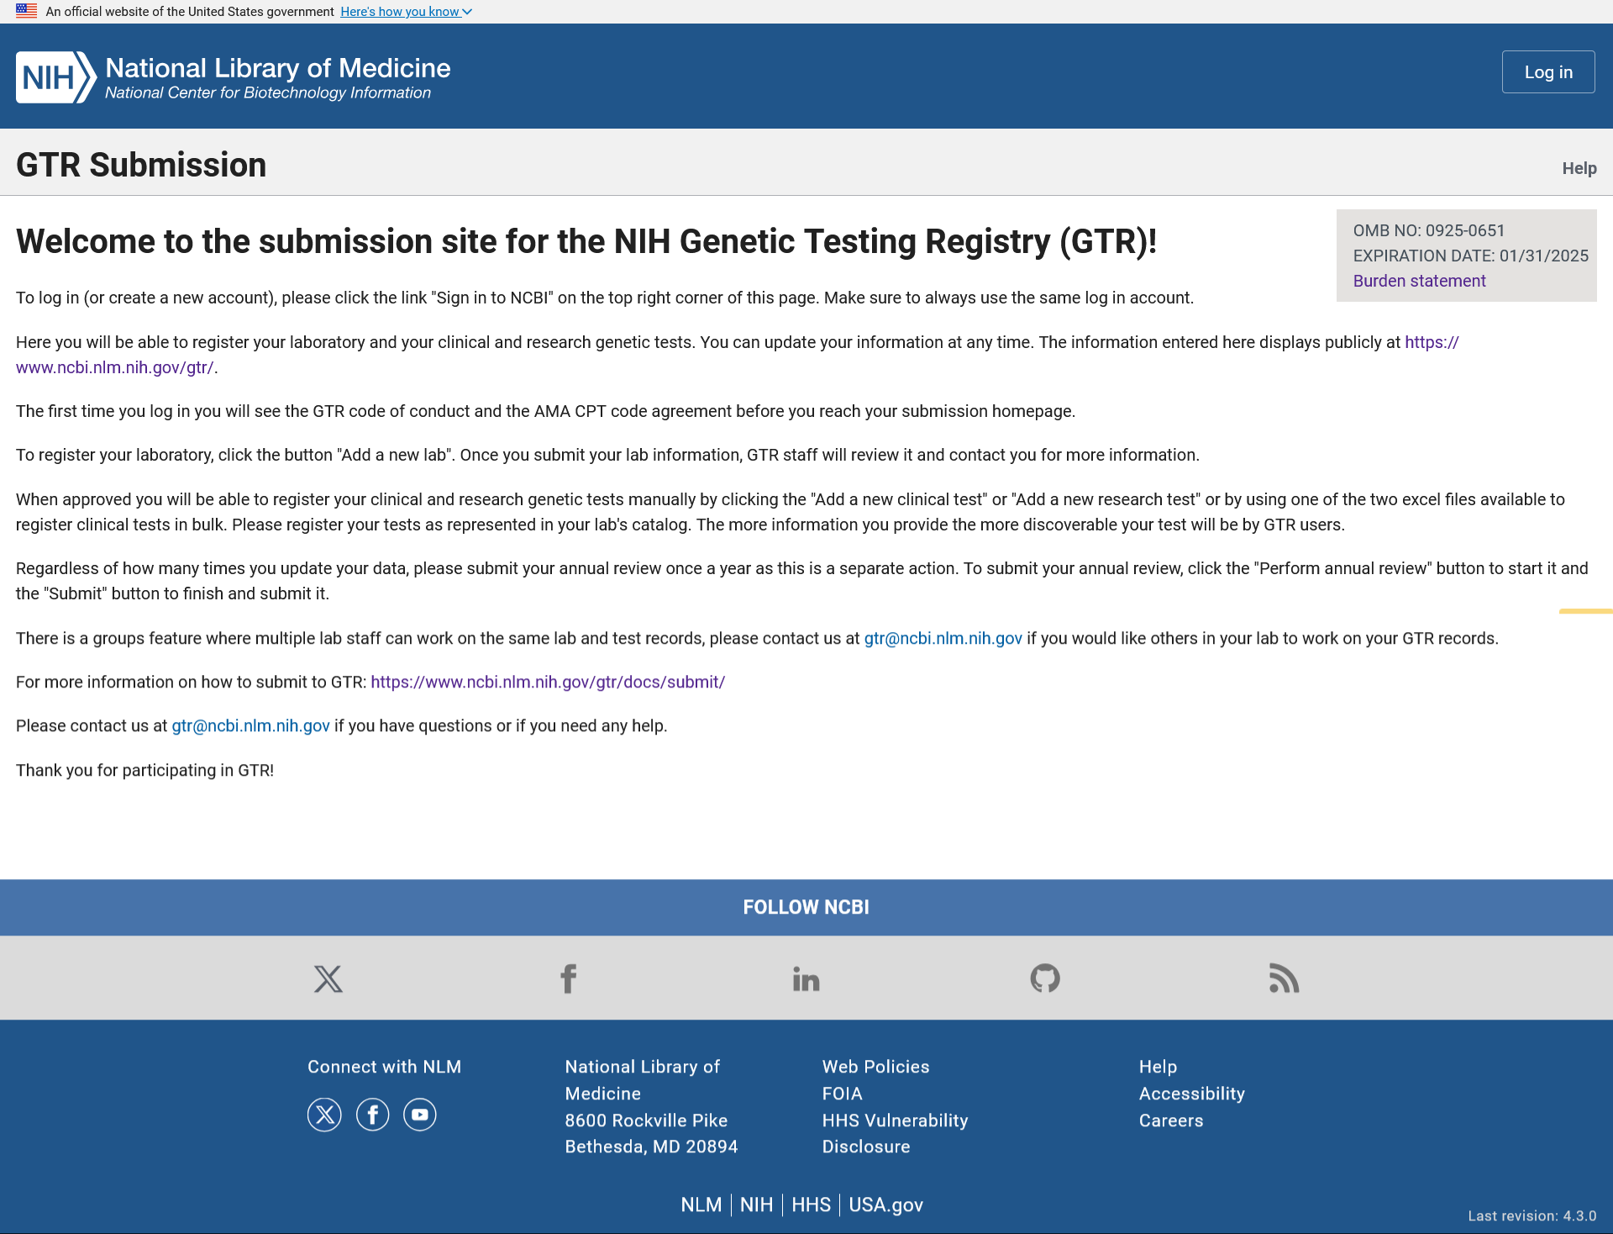

The Genetic Testing Registry (GTR) submission portal log in homepage displays the OMB burden statement information and a link to a page with the statement, instructions on how to log in for returning data submitters or how to create a log in account for new data submitters, instructions on how to submit data to GTR and the GTR contact email.

BURDEN STATEMENT
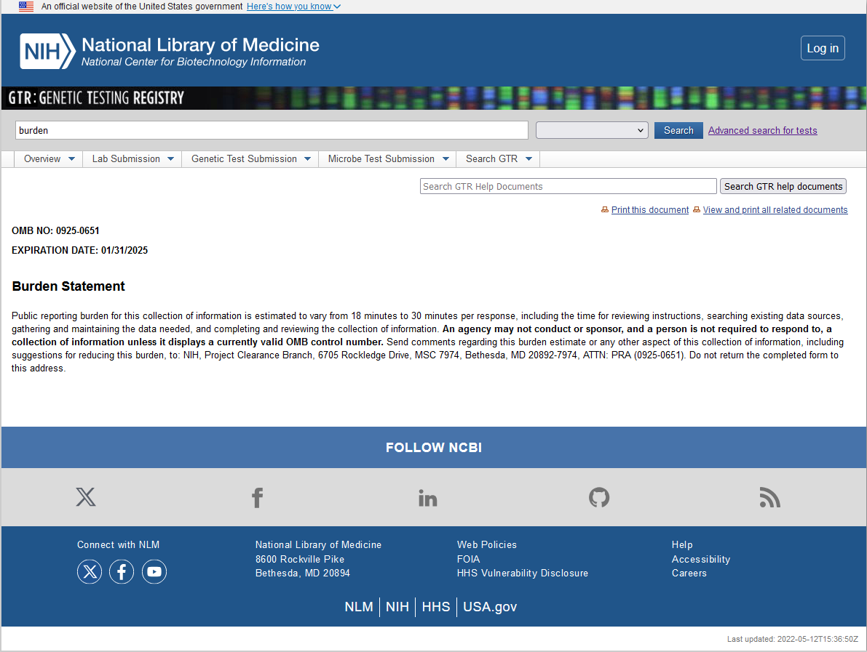

The OMB burden statement page displays the statement and related information.

GTR CODE OF CONDUCT

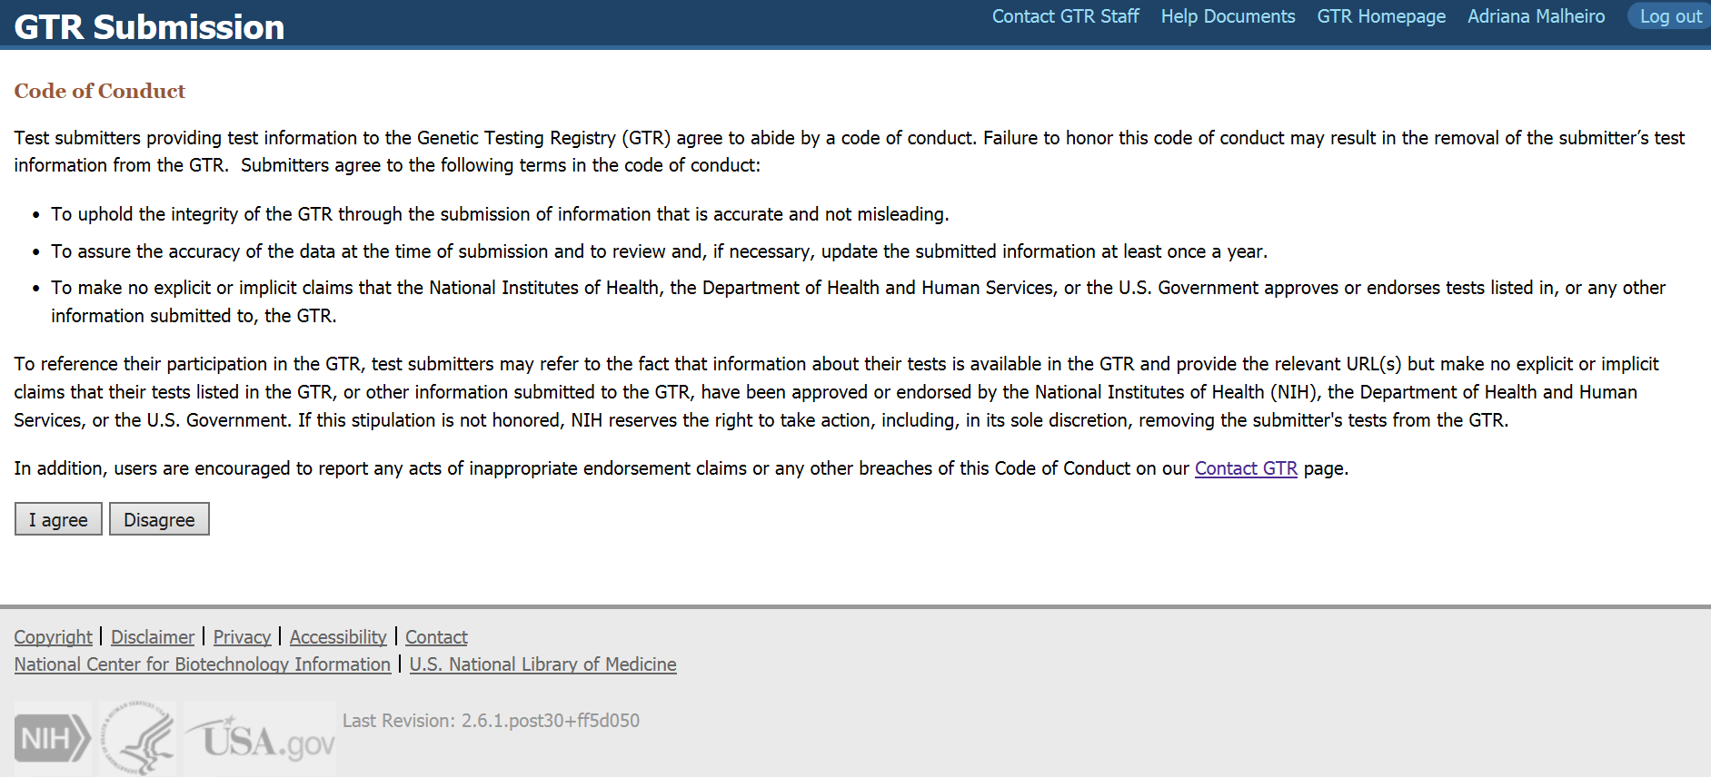

The first time a submitter logs in to the GTR submission portal, the GTR code of conduct displays. To access the submission homepage, the user must agree to the code of conduct.

AMA CPT CODE LICENSE AGREEMENT
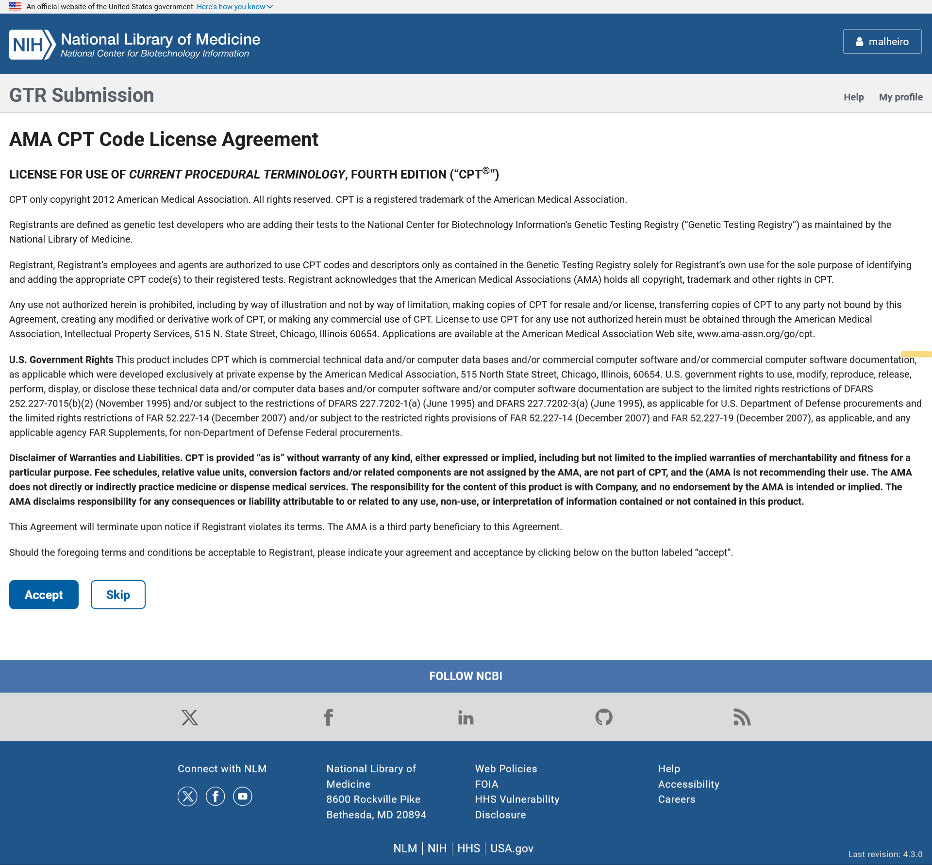

The first time a submitter logs in to the GTR submission portal, the American Medical Association (AMA) Current Procedural Terminology (CPT) code agreement displays. Submitters who want to add the CPT code to their test records, must agree to the AMA CPT code agreement. This agreement is also available from the test codes section of the clinical test input form.

GTR SUBMISSION PORTAL HOMEPAGE

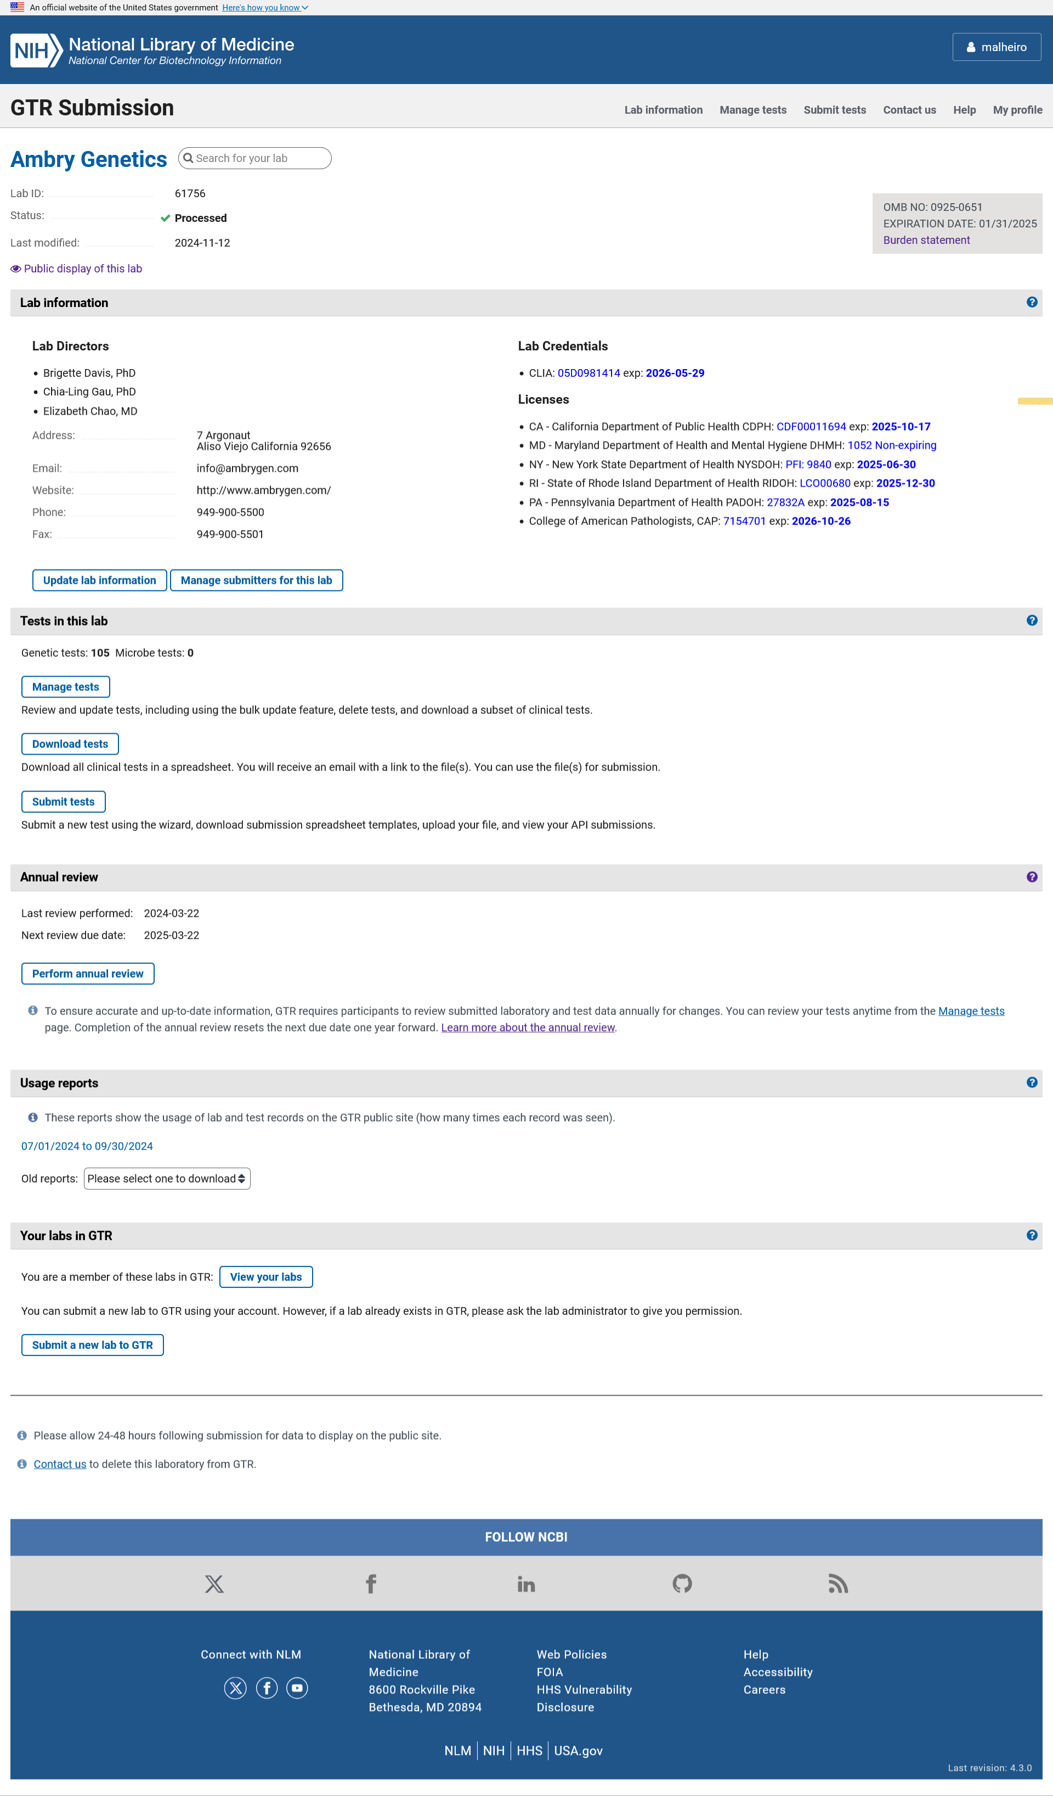

When a submitter logs in to the GTR submission portal, their homepage displays information about the lab record with a link to go to the lab input form to update it, a link to page to manage submitters who can access the information for this lab, links to the manage tests tool, to the page with data download options, to the Submit tests page with data submission options, to the Annual Review wizard, to download usage reports and link to register a new lab in GTR or navigate to other lab records the submitter has previously submitted to GTR.

ADD A NEW LAB: Lab information

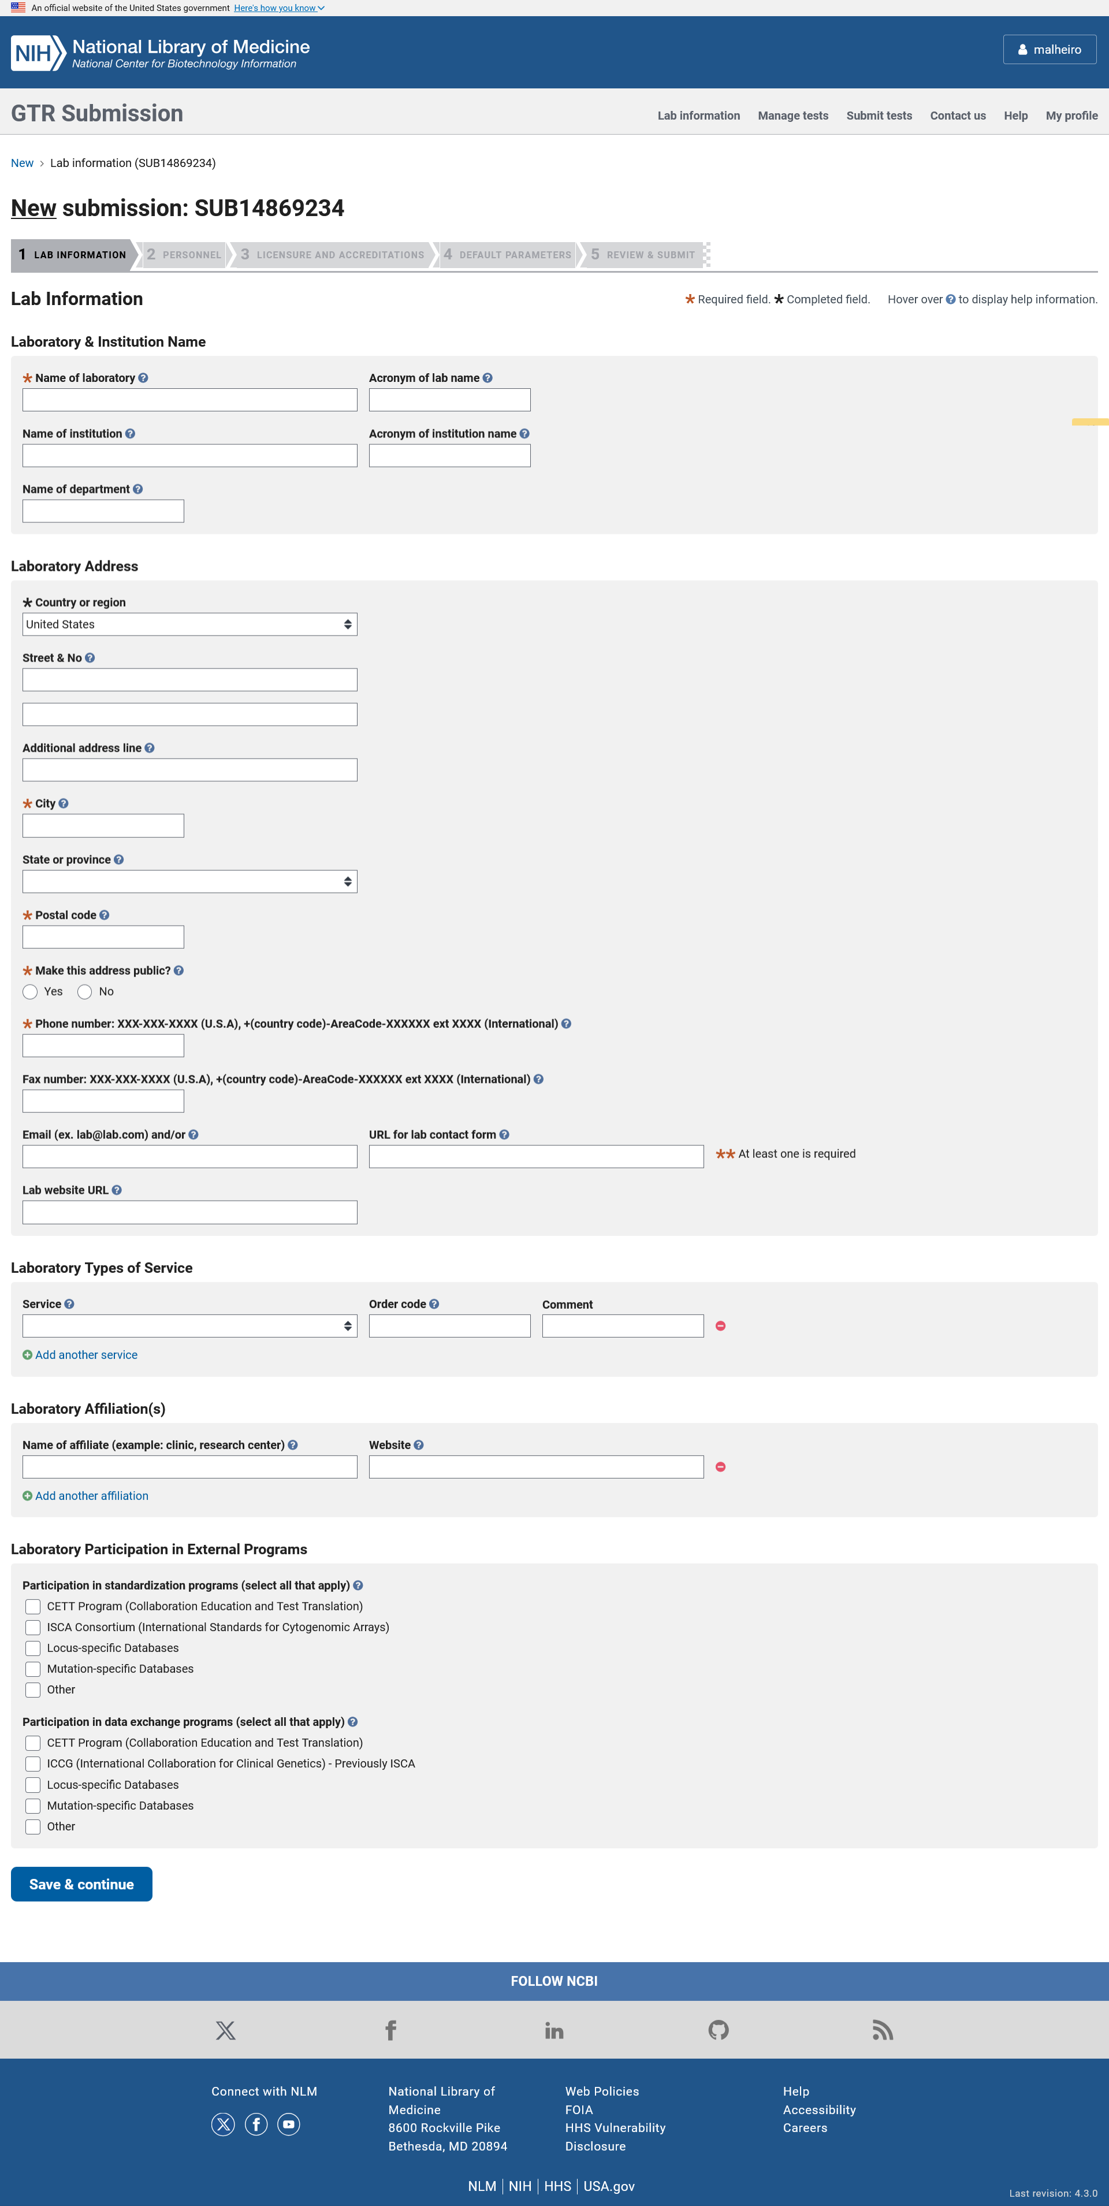

The laboratory submission form has four sections. The minimal fields required for participation in GTR are highlighted with an orange asterisk. In the Laboratory information section, the submitter can enter information including the laboratory name, address, contact information, affiliations and services provided.

ADD A NEW LAB: Personnel

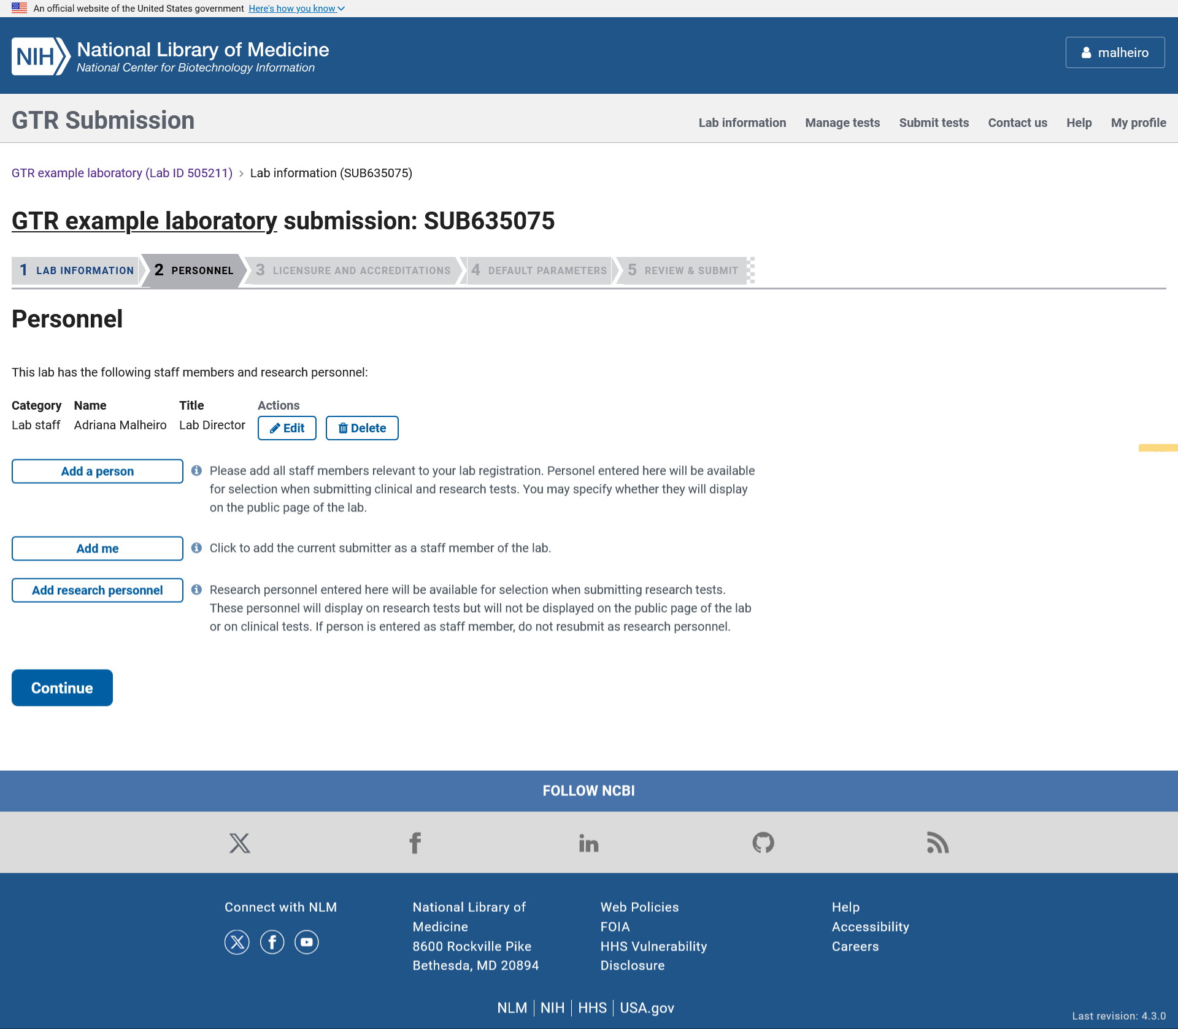

The personnel section collects information about the laboratory clinical and research staff. To enter information for the data submitter, there is an option to “Add me” where the information in the log in account is pre-populated (name and email).

ADD A NEW LAB: Personnel

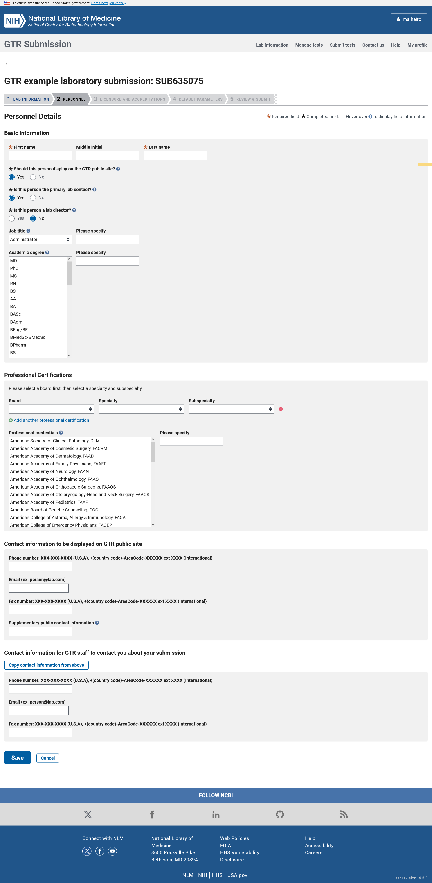

The personnel section collects information about the laboratory director and other staff including the person’s name, role, credentials, and contact information.

ADD A NEW LAB: Licensure and Accreditations

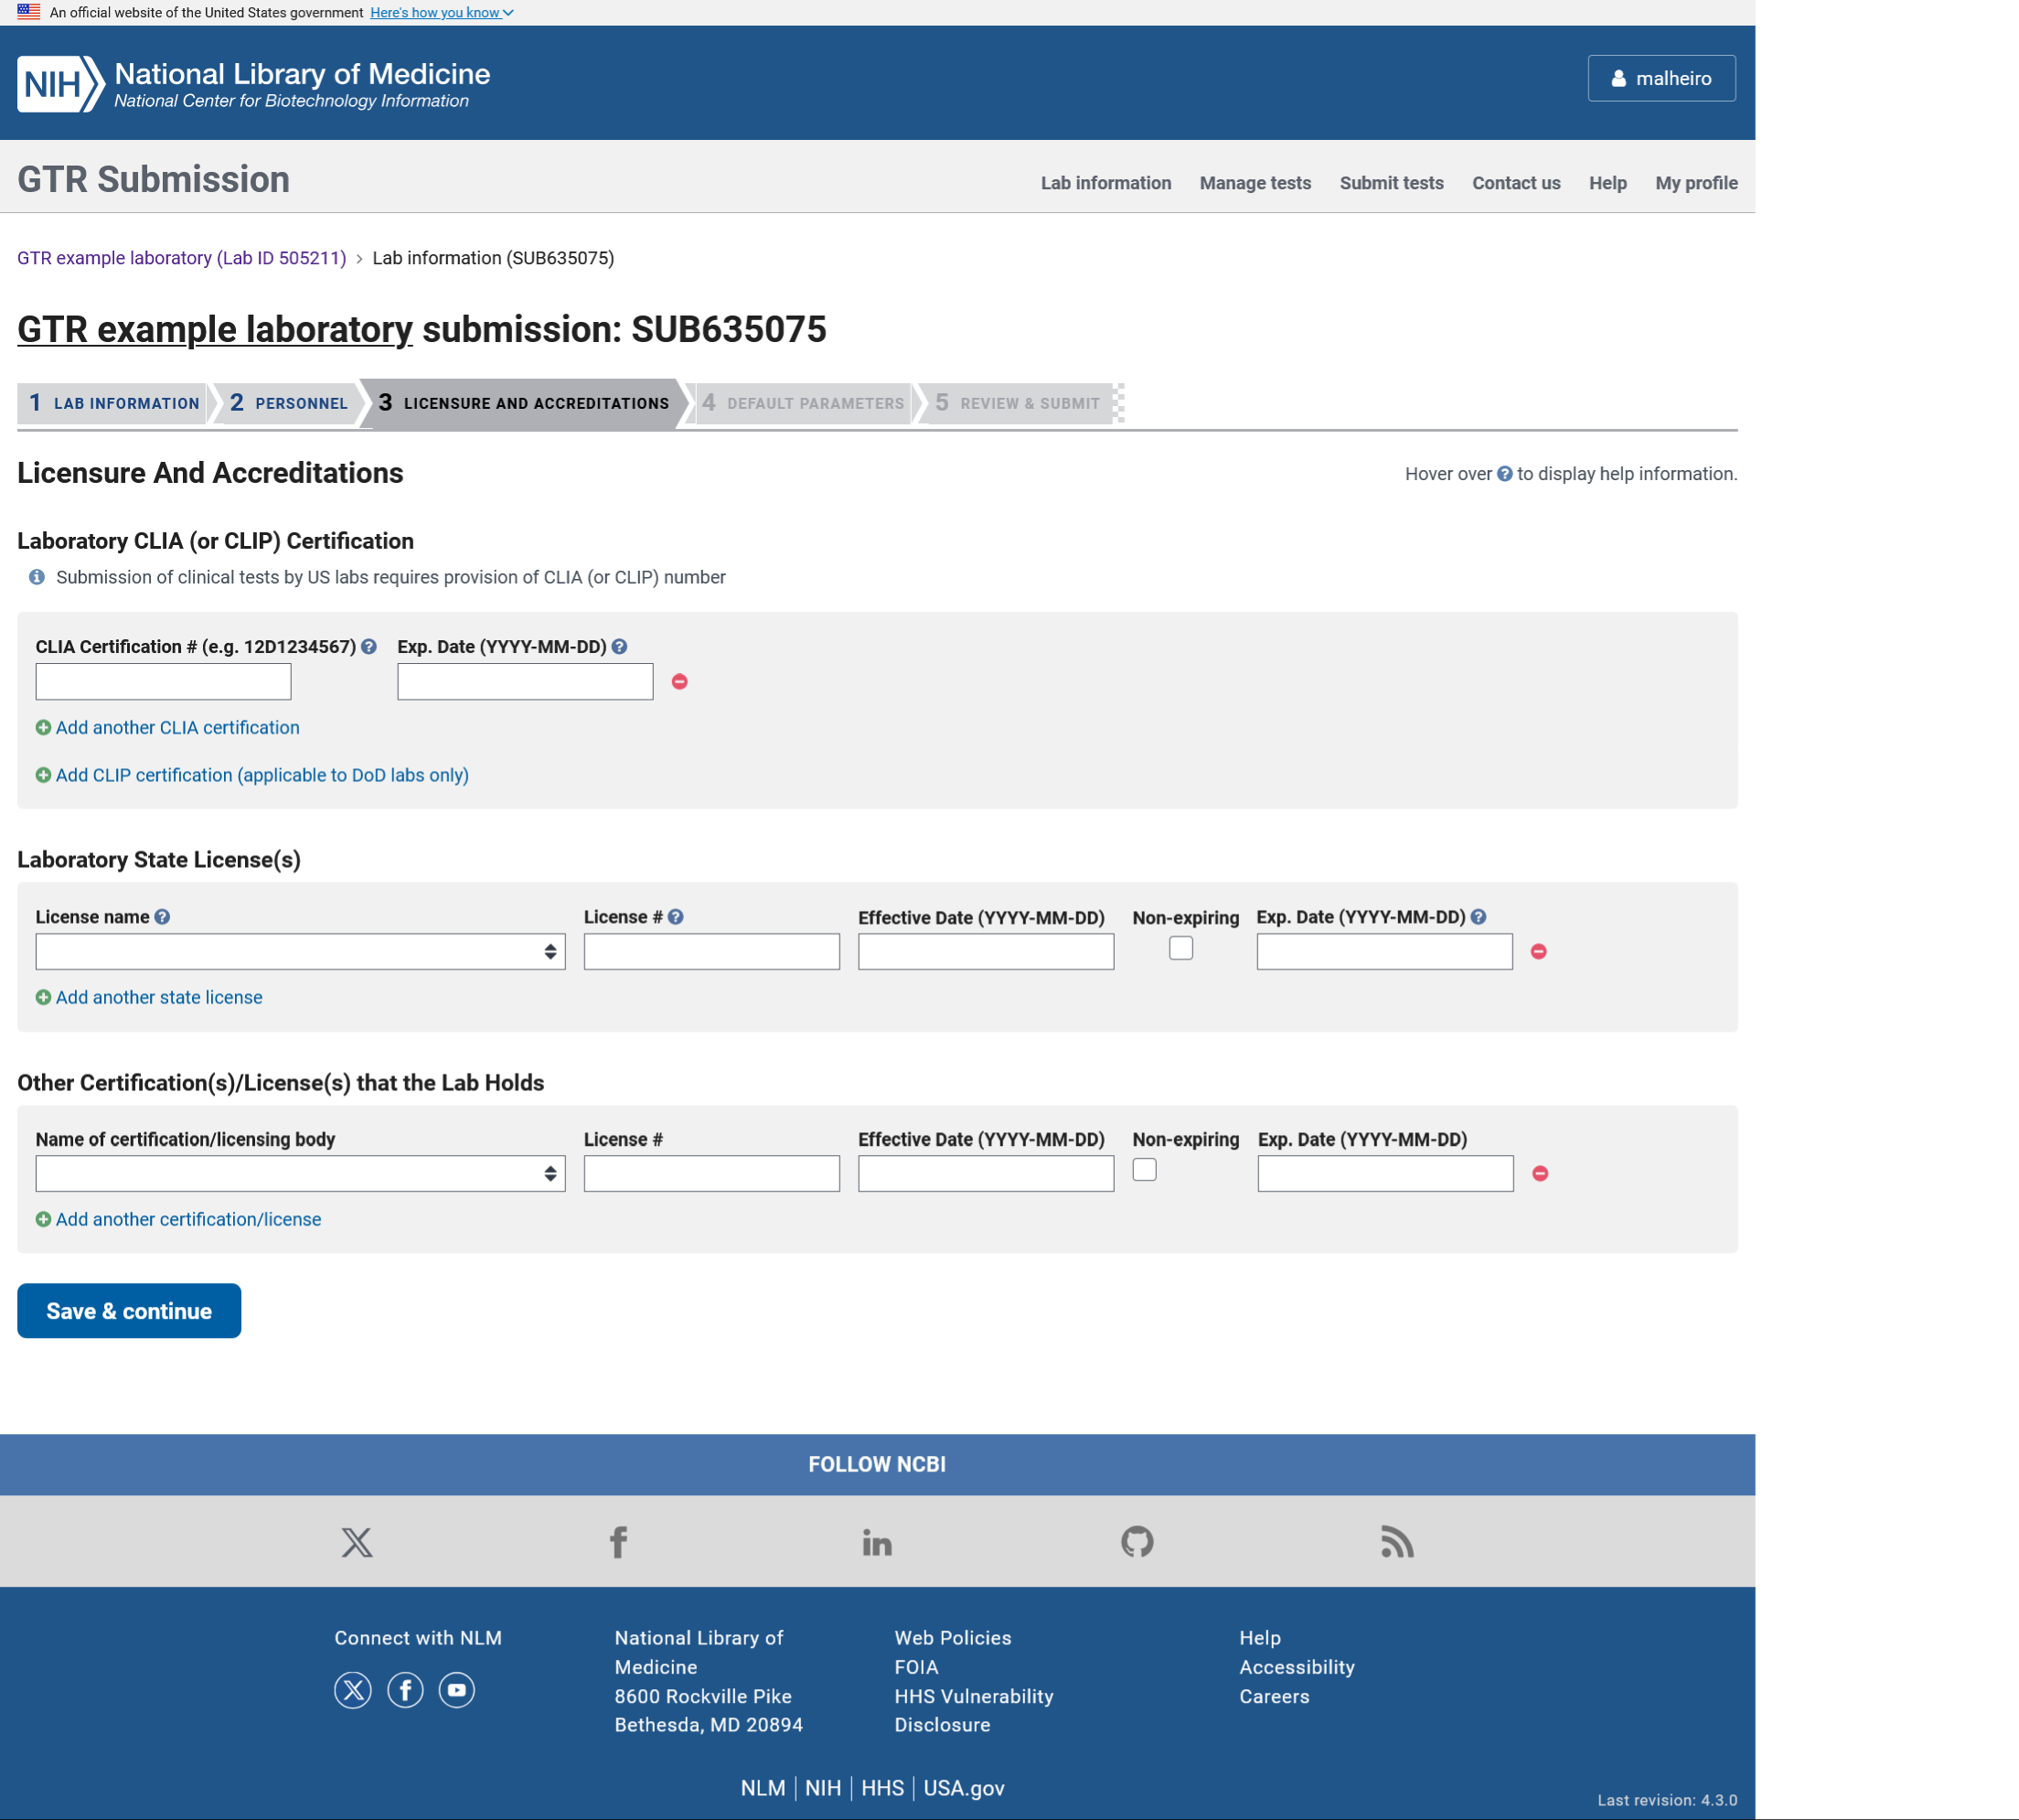

In the Licensure and Accreditations section the submitter can enter the Centers for Medicare and Medicaid Services (CMS), Clinical Laboratory Improvement Amendment (CLIA) or the Clinical Laboratory Improvement Program Certificate (CLIP Certificate) number and expiration date which are required for US labs to register clinical tests. The submitter can also enter information about the state licenses or other certificates the lab holds.

ADD A NEW LAB: Default parameters

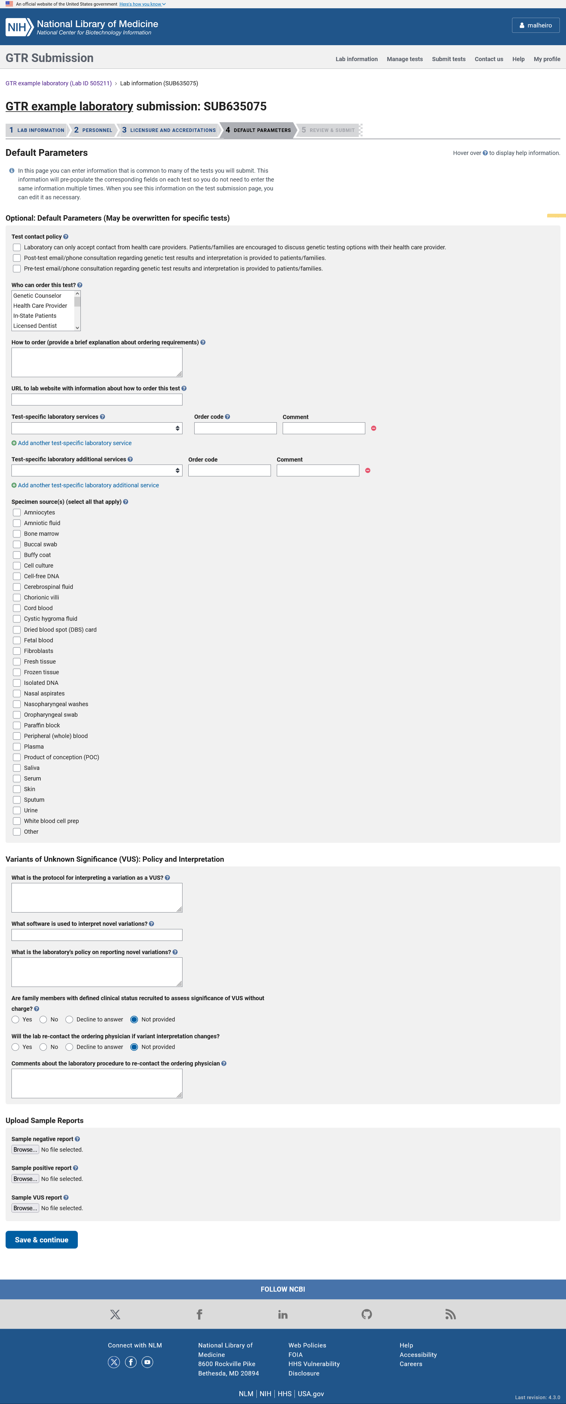
In the defaul parameters section the submitter can enter information about the tests their lab provides that is common to all tests. Fields provided on this form will pre-populate new test forms that are submitted manually. Data that is collected here includes the lab’s contact policy and the person to contact about tests, ordering information, specimen types, test services, information about the lab’s reporting of variants of unknown significance (VUS) and sample reports.

ADD A NEW LAB: Review & Submit

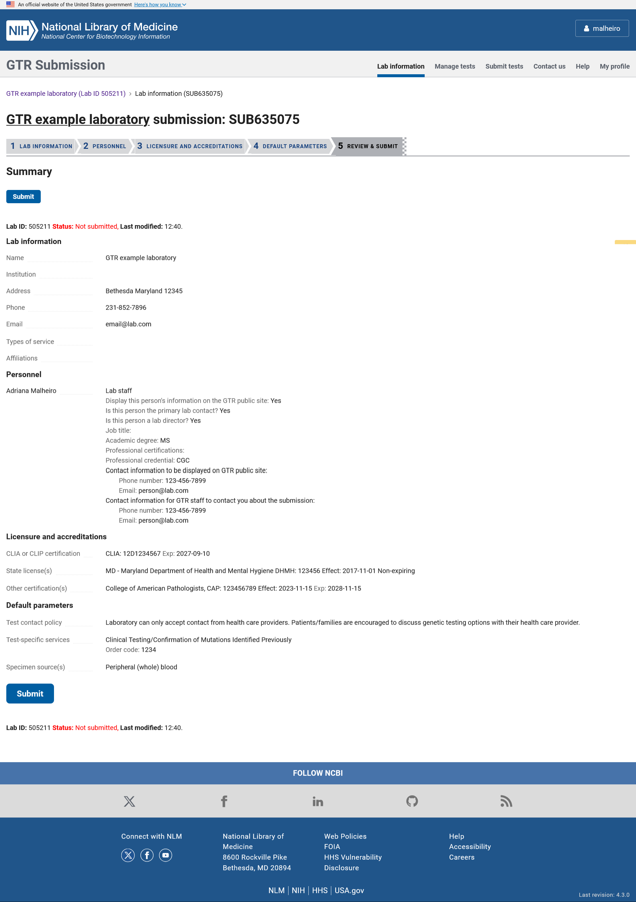

The Review and Submit page displays the data submitted about the lab so the submitter can review it before submitting it. Once the Submit button is clicked, the information is stored and processed automatically. GTR staff reviews the information and ensures the laboratory is valid and in scope before approving it for submission of test information.

SUBMIT TESTS

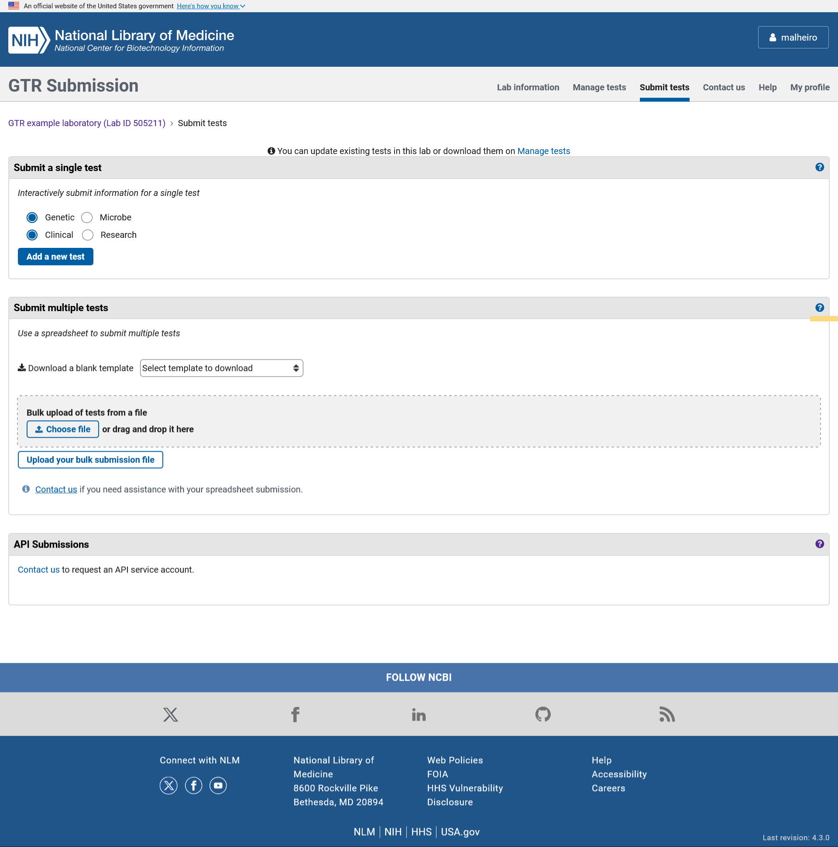

In the Submit tests page, the data submitter can submit new tests using the manual wizard; add new tests, update and delete existing tests in bulk using the excel file or the submission API; and download an excel template.

ADD A NEW CLINICAL GENETIC TEST: Basics

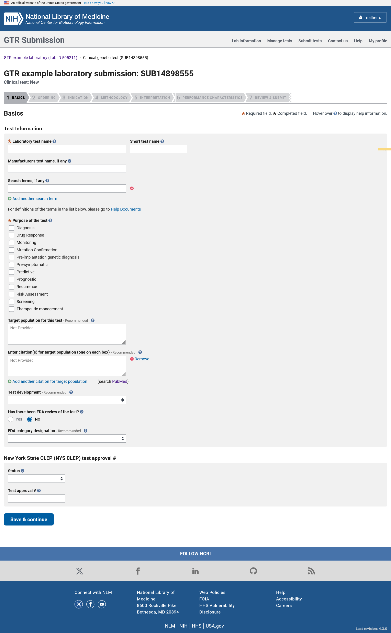
When adding a clinical genetic test via the manual wizard, the input form is divided in to 6 sections. The minimal fields required for registration of the test in GTR are highlighted with an orange asterisk. In the Basics section, the submitter can enter the test name, purpose of the test, target population, and information about the test development, FDA review and approval and NYS CLEP.

ADD A NEW CLINICAL GENETIC TEST: Ordering

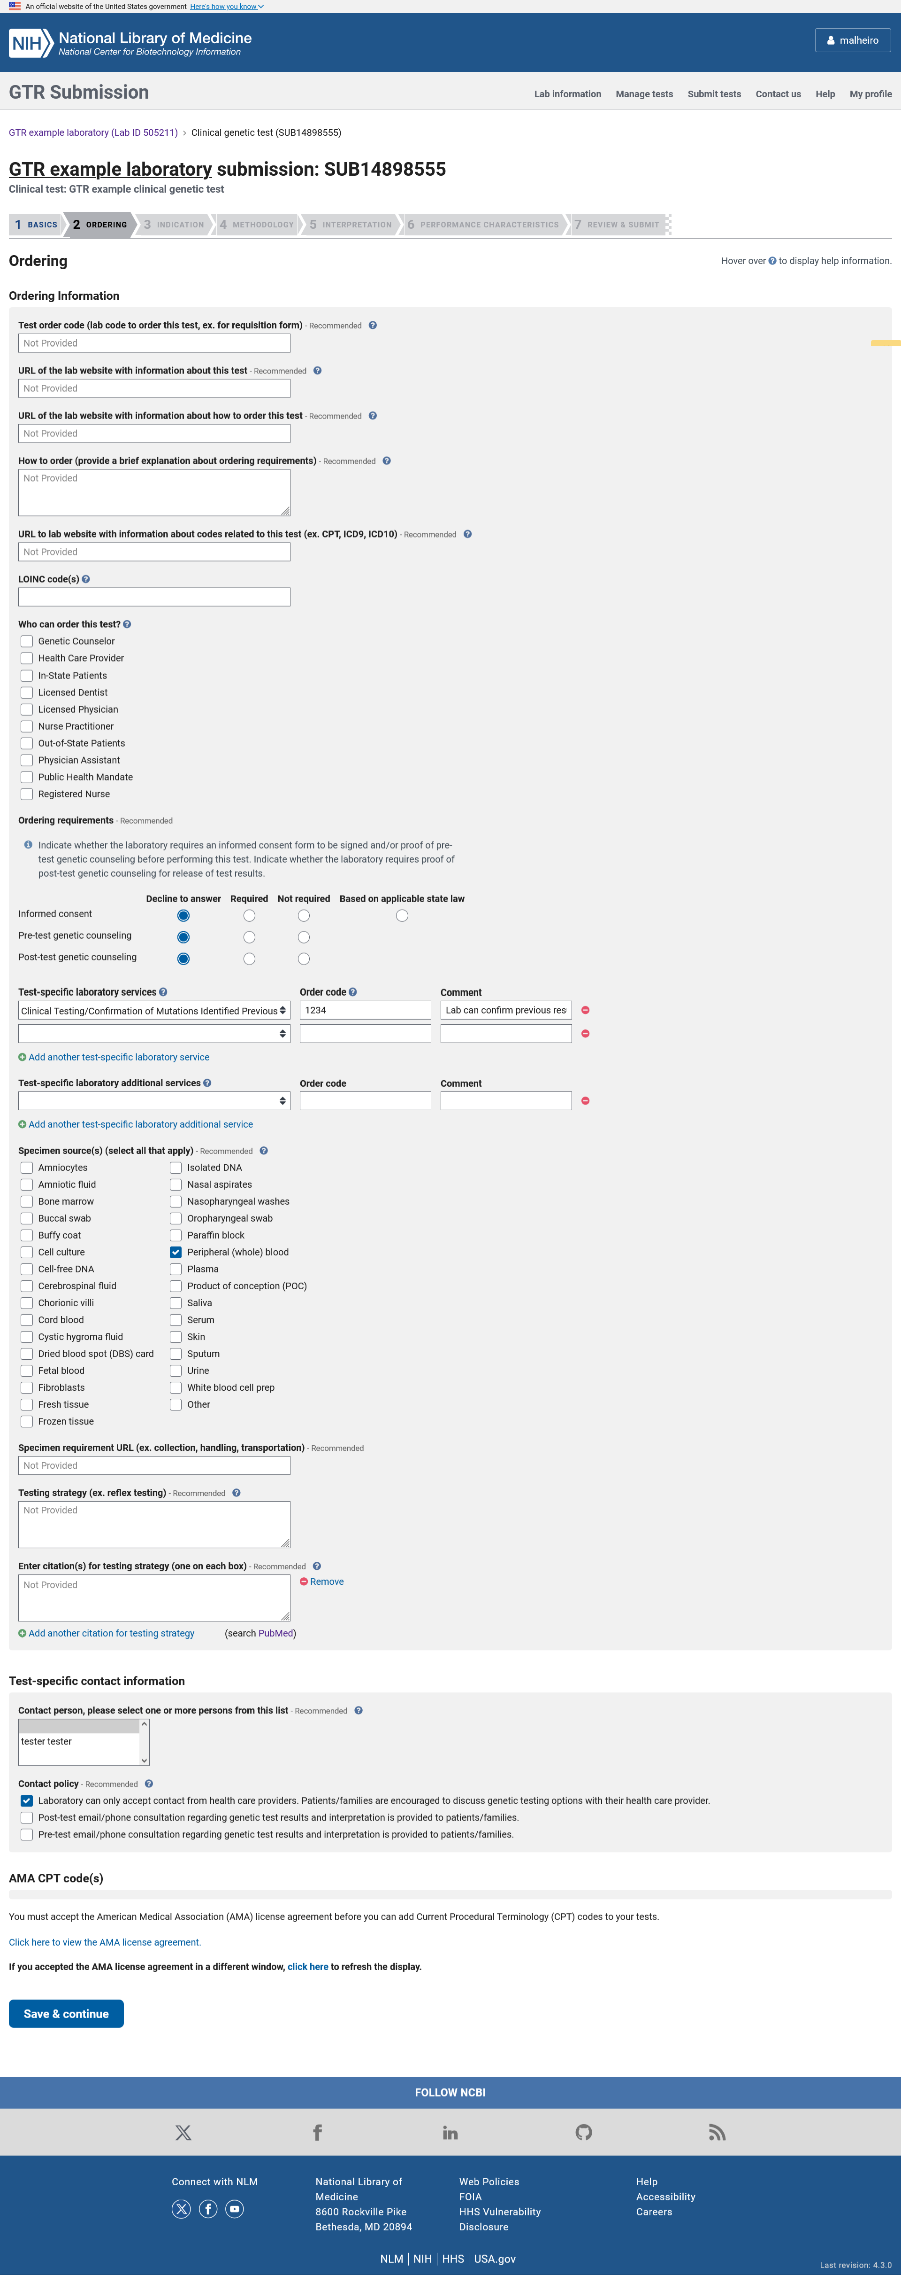
In the Ordering section, the submitter can enter the test order code and other codes related to the test including the AMA CPT codes and LOINC codes, the websites with information about the test and test codes, describe information about how to order the test, specimen types, testing strategy, test services, informed consent and information about how to contact the laboratory including the lab’s point of contact for the test.

ADD A NEW CLINICAL GENETIC TEST: AMA CPT codes

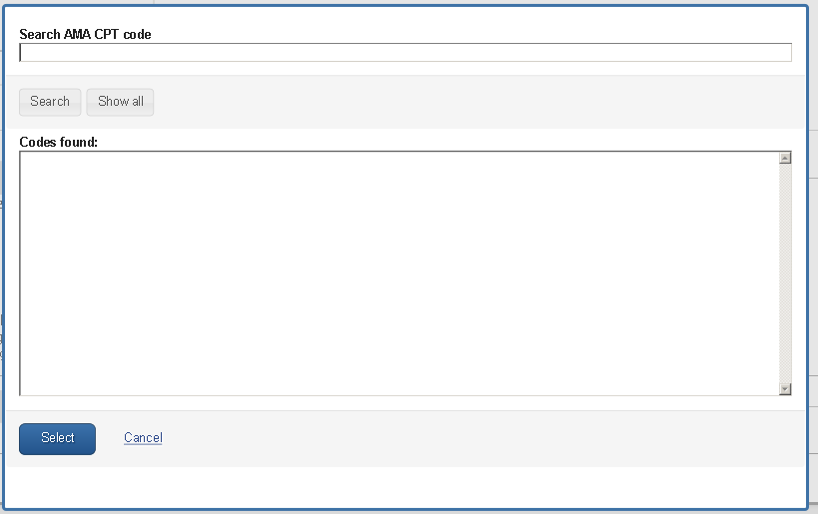

The data submitter has access to the current list of CPT codes to choose from. To access this list, the submitter must accept the AMA CPT code agreement.

ADD A NEW CLINICAL GENETIC TEST: Indication

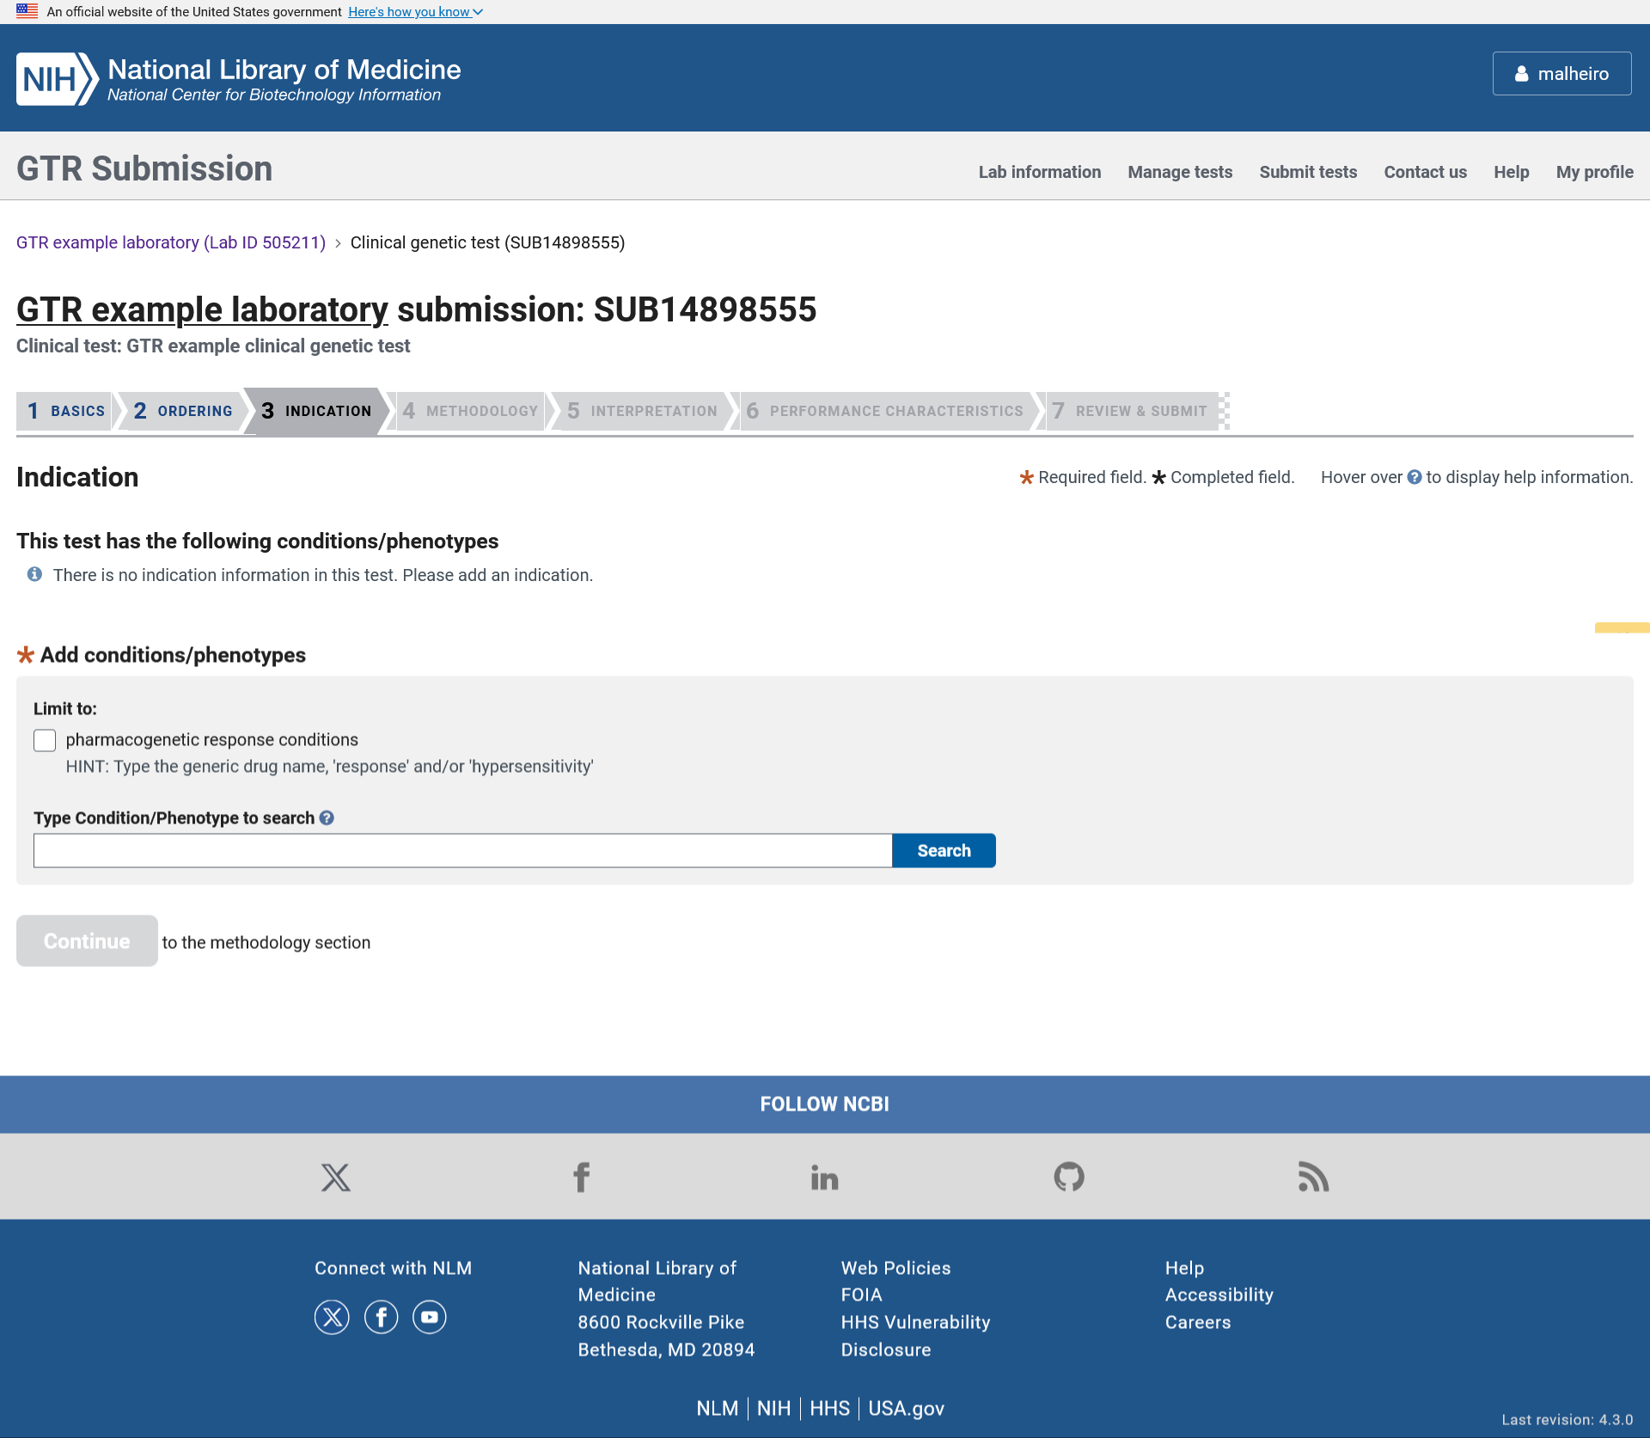

In the indication section, the data submitter enter the disease(s) or phenotype(s) for which the test is indicated for.

ADD A NEW CLINICAL GENETIC TEST: Indication
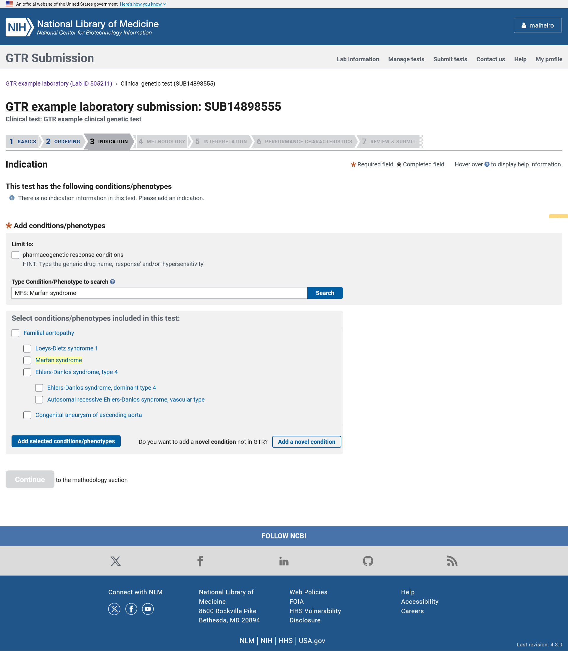

In the Indication section the submitter can select a disease or phenotype from the autocomplete dictionary.

ADD A NEW CLINICAL GENETIC TEST: Novel condition

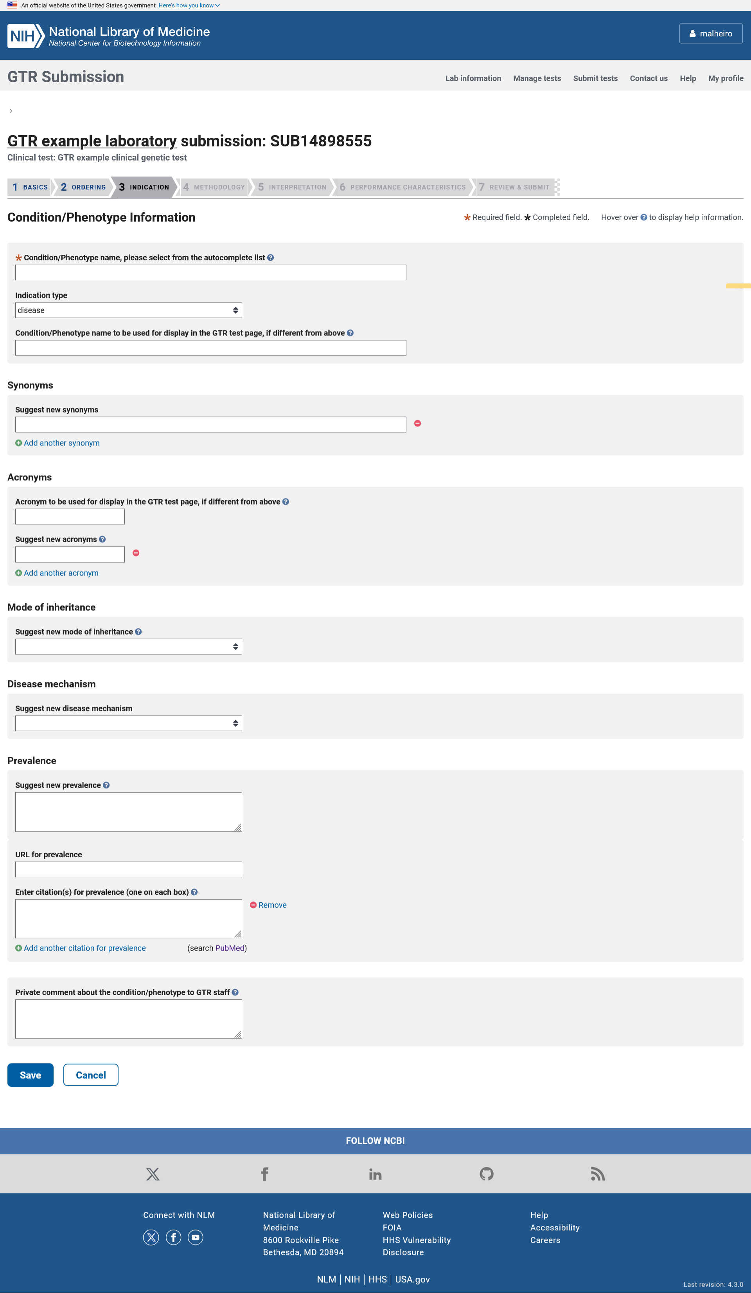
The novel condition page is used when the condition or phenotype does not currently exist in the GTR database. When entering a novel disease or phenotype, the submitter must specify the disease or phenotype name and can enter information like disease type, mode of inheritance, disease mechanism, and prevalence.

ADD A NEW CLINICAL GENETIC TEST: Methodology

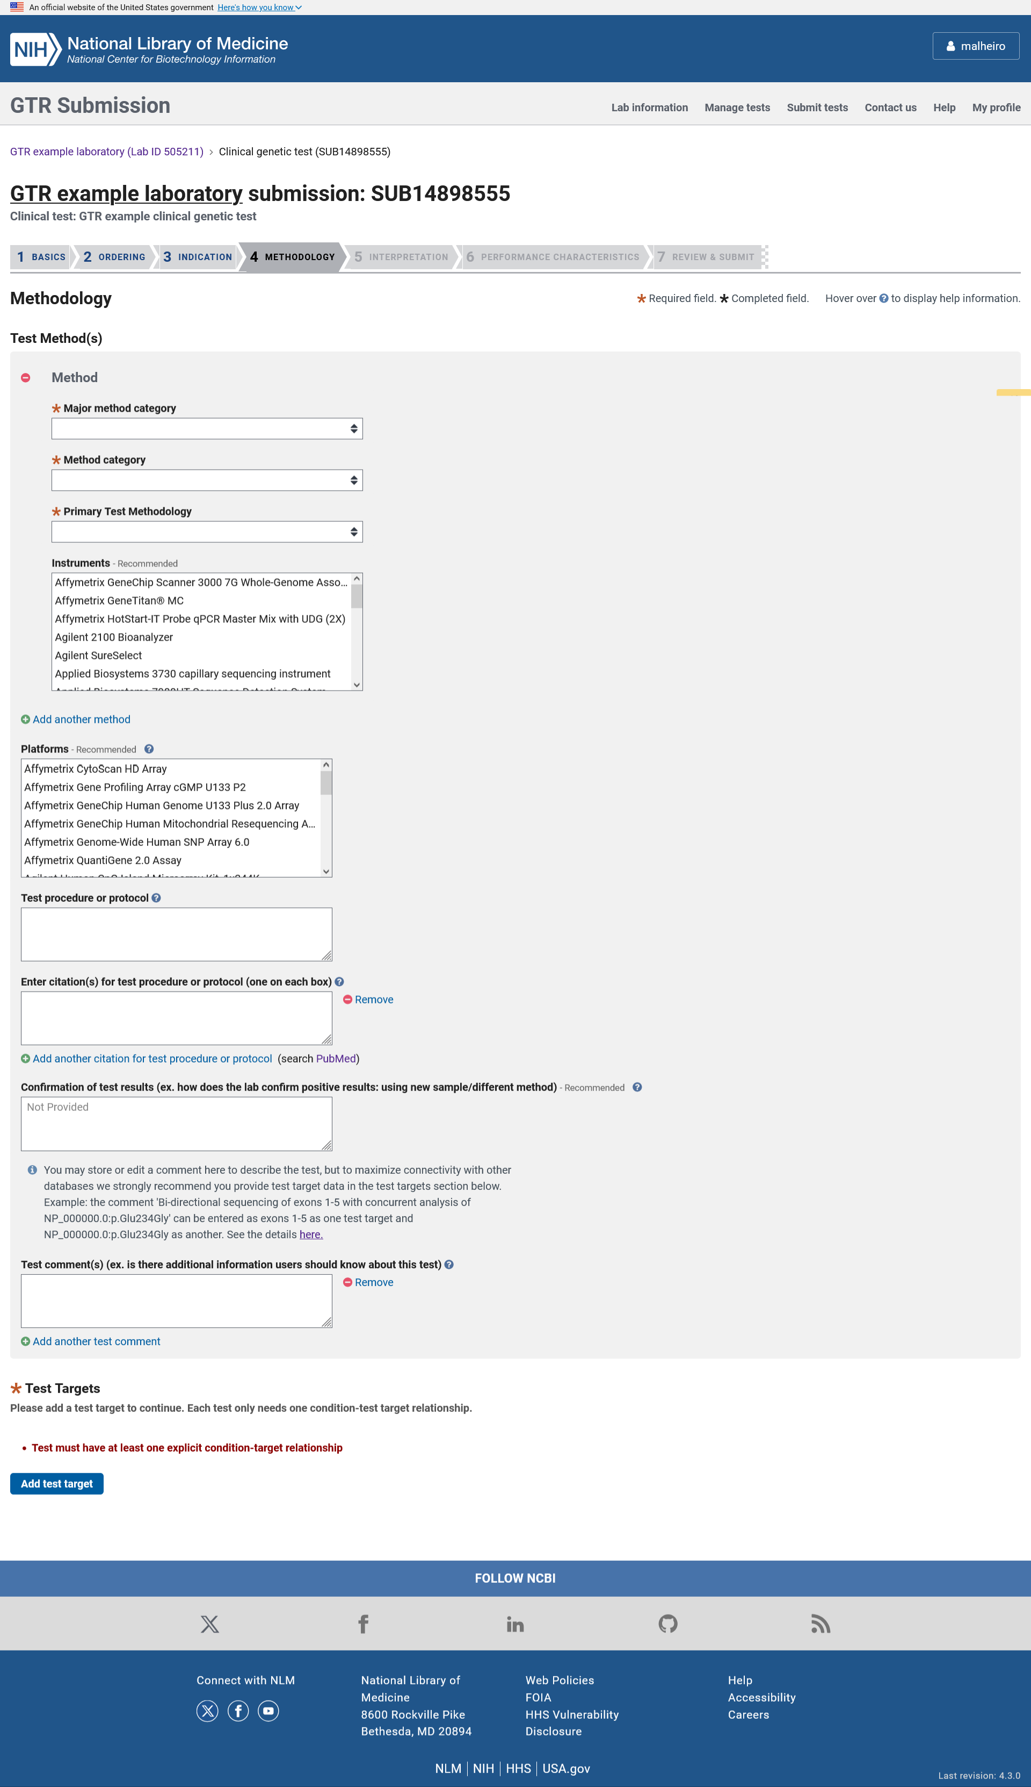
In the Methodology section, the submitter can enter information about the test’s methods, instruments, platforms, description of the test procedure or protocol, confirmation of test results, additional comments and test targets.

ADD A NEW CLINICAL GENETIC TEST: Methodology - Test targets

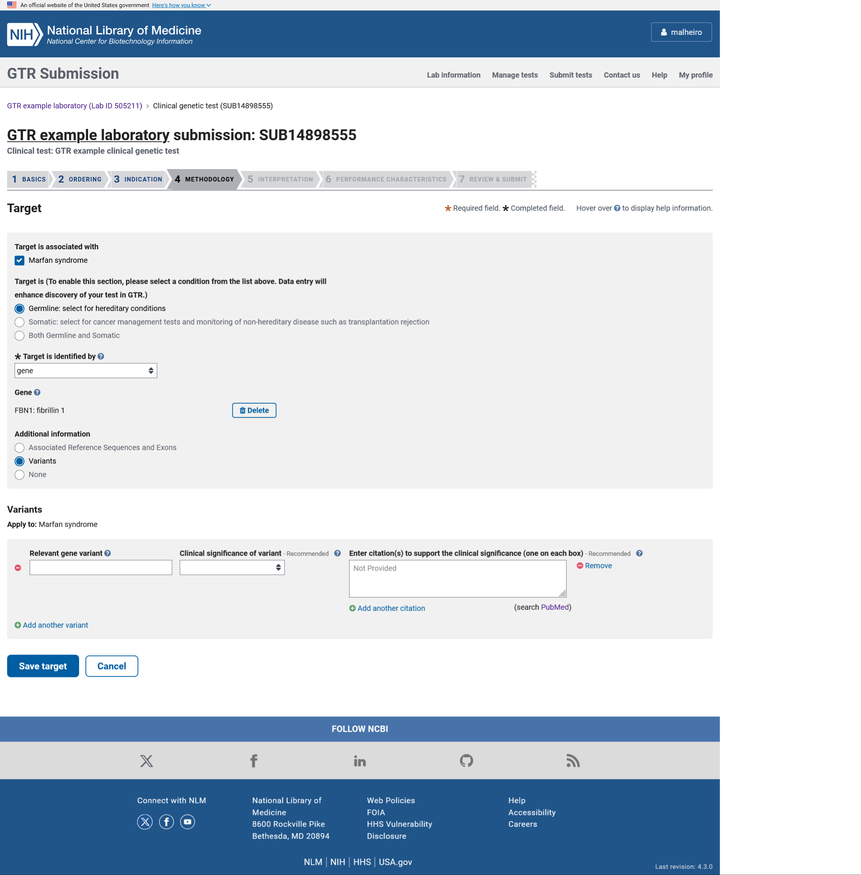

In the Test targets section, the submitter selects the test target type, selects genes from the autocomplete dictionary, selects analytes, chromosomal regions, proteins, enzymes, variants and RefSeqs from the autocomplete dictionary and has the option to enter new terms.

ADD A NEW CLINICAL GENETIC TEST: Interpretation

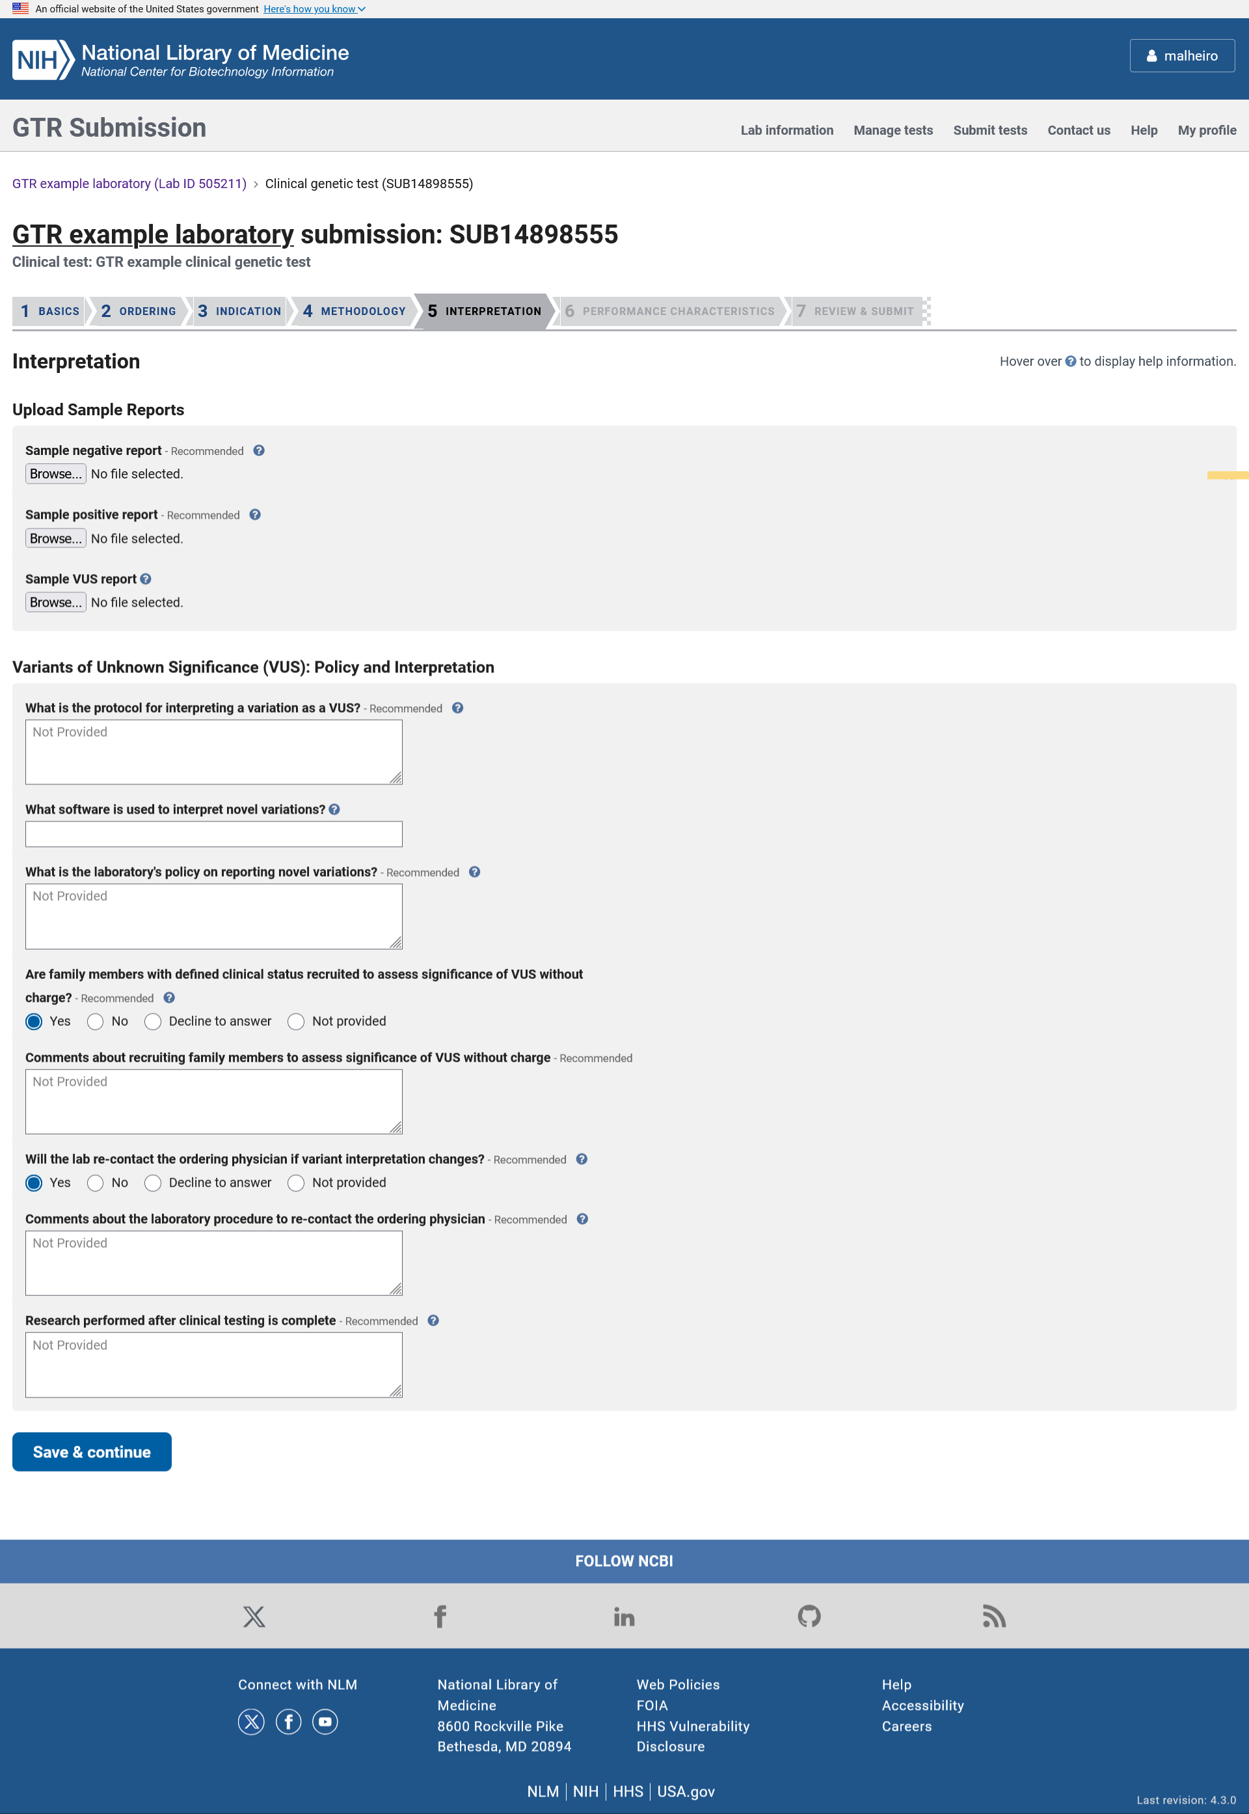

In the Interpretation section the data submitter can upload sample reports, describe the protocols to interpret novel variants and variants of unknown significance (VOUS) and re-contact the ordering clinician if the variant interpretation changes, and whether research is performed on the sample after clinical testing is done.

ADD A NEW CLINICAL GENETIC TEST: Performance characteristics

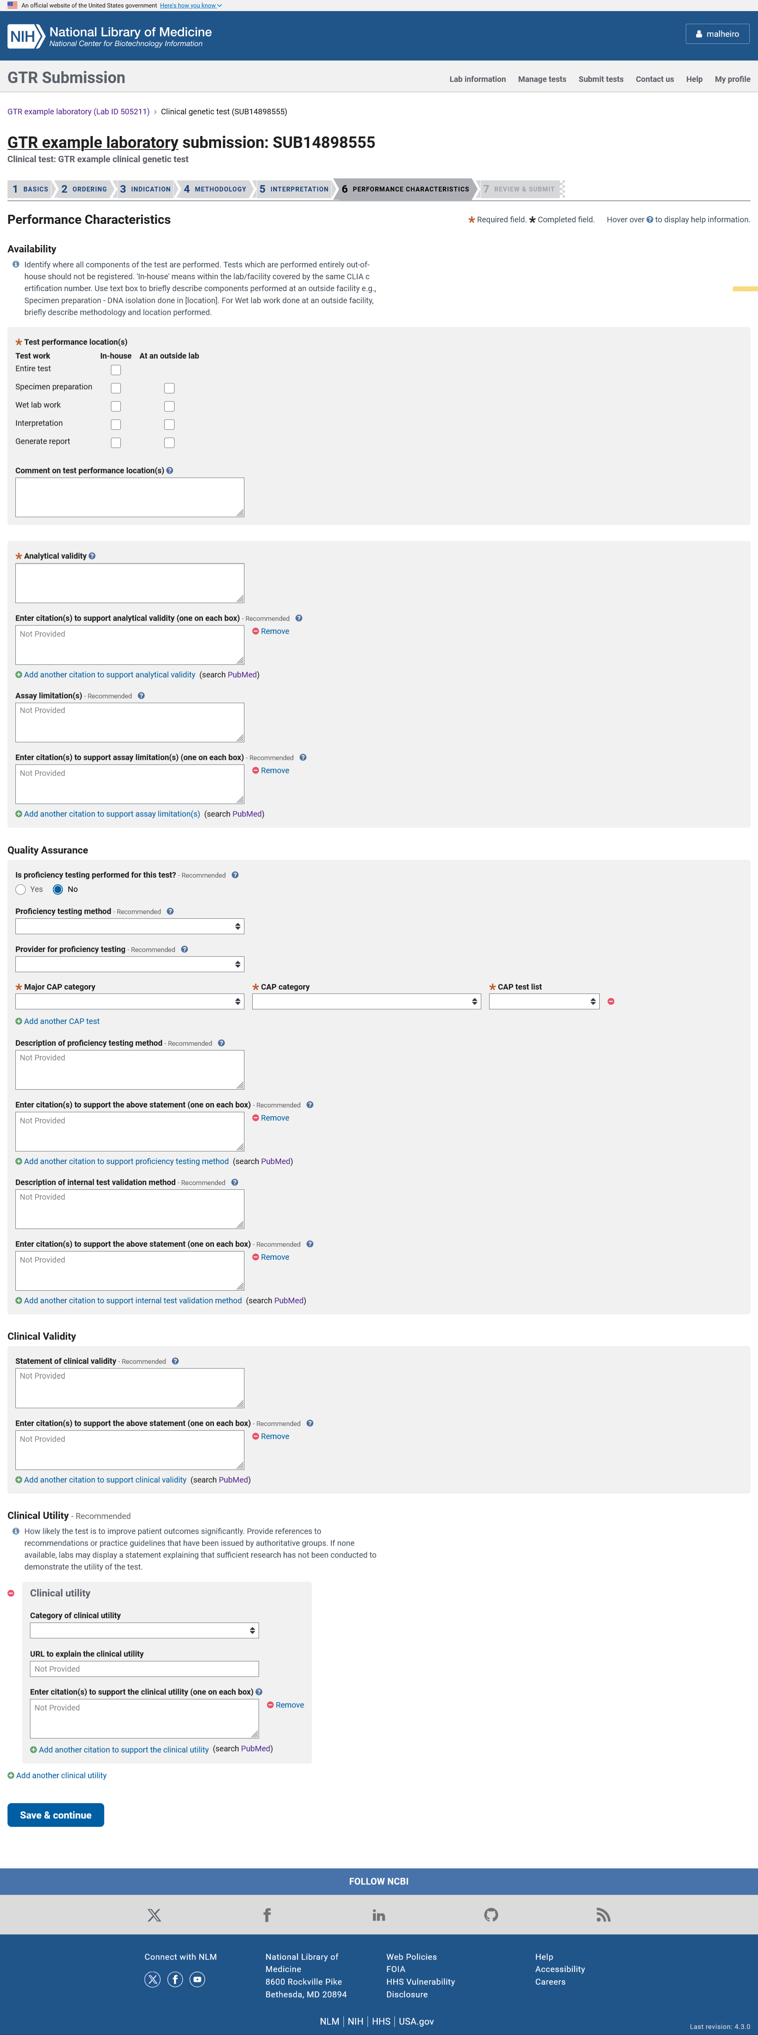
In the Performance characteristics section the submitter identifies if any part of the test is performed outside the lab, and describes the analytical validity, assay limitations, proficiency testing, internal validation methods, clinical validity and clinical utility.

ADD A NEW CLINICAL GENETIC TEST: Review & Submit

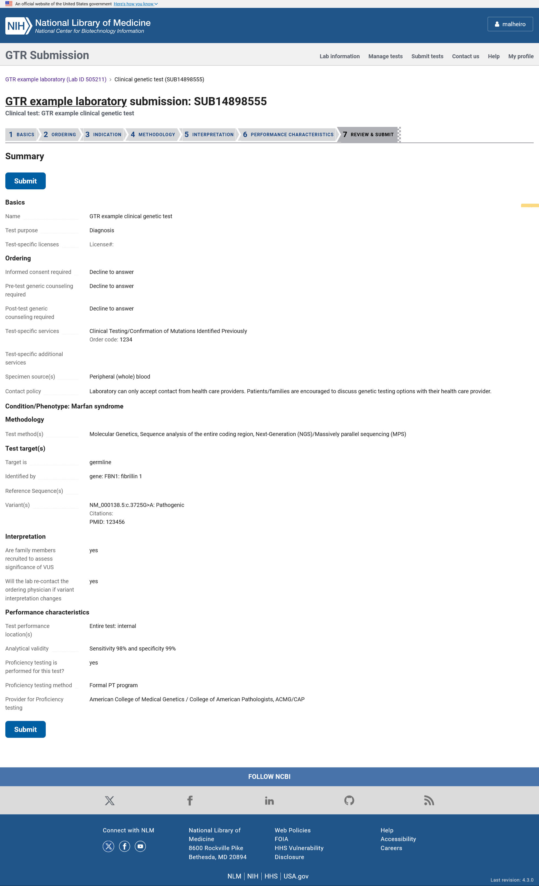

The Review and Submit page displays the data submitted about the test so the submitter can review it before submitting it. Once the Submit button is clicked, the information is stored and processed automatically.

ADD A NEW RESEARCH GENETIC TEST: Basics

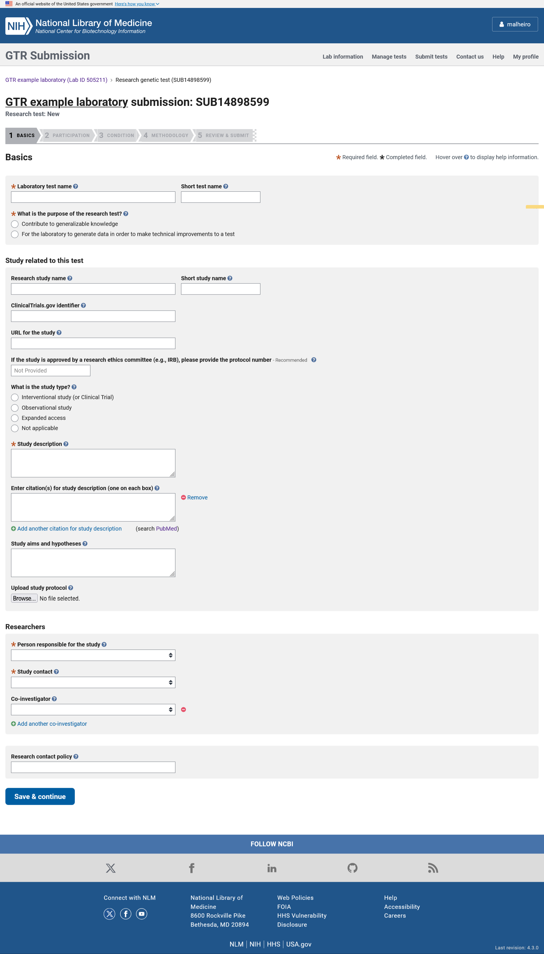

When adding a research genetic test via the manual wizard, the input form is divided in to 4 sections. The minimal fields required for registration of the test in GTR are highlighted with an orange asterisk. In the Basics section, the submitter can enter the test name, provide information about the research study and list the researchers and contact policy.

ADD A NEW RESEARCH TEST: Participation

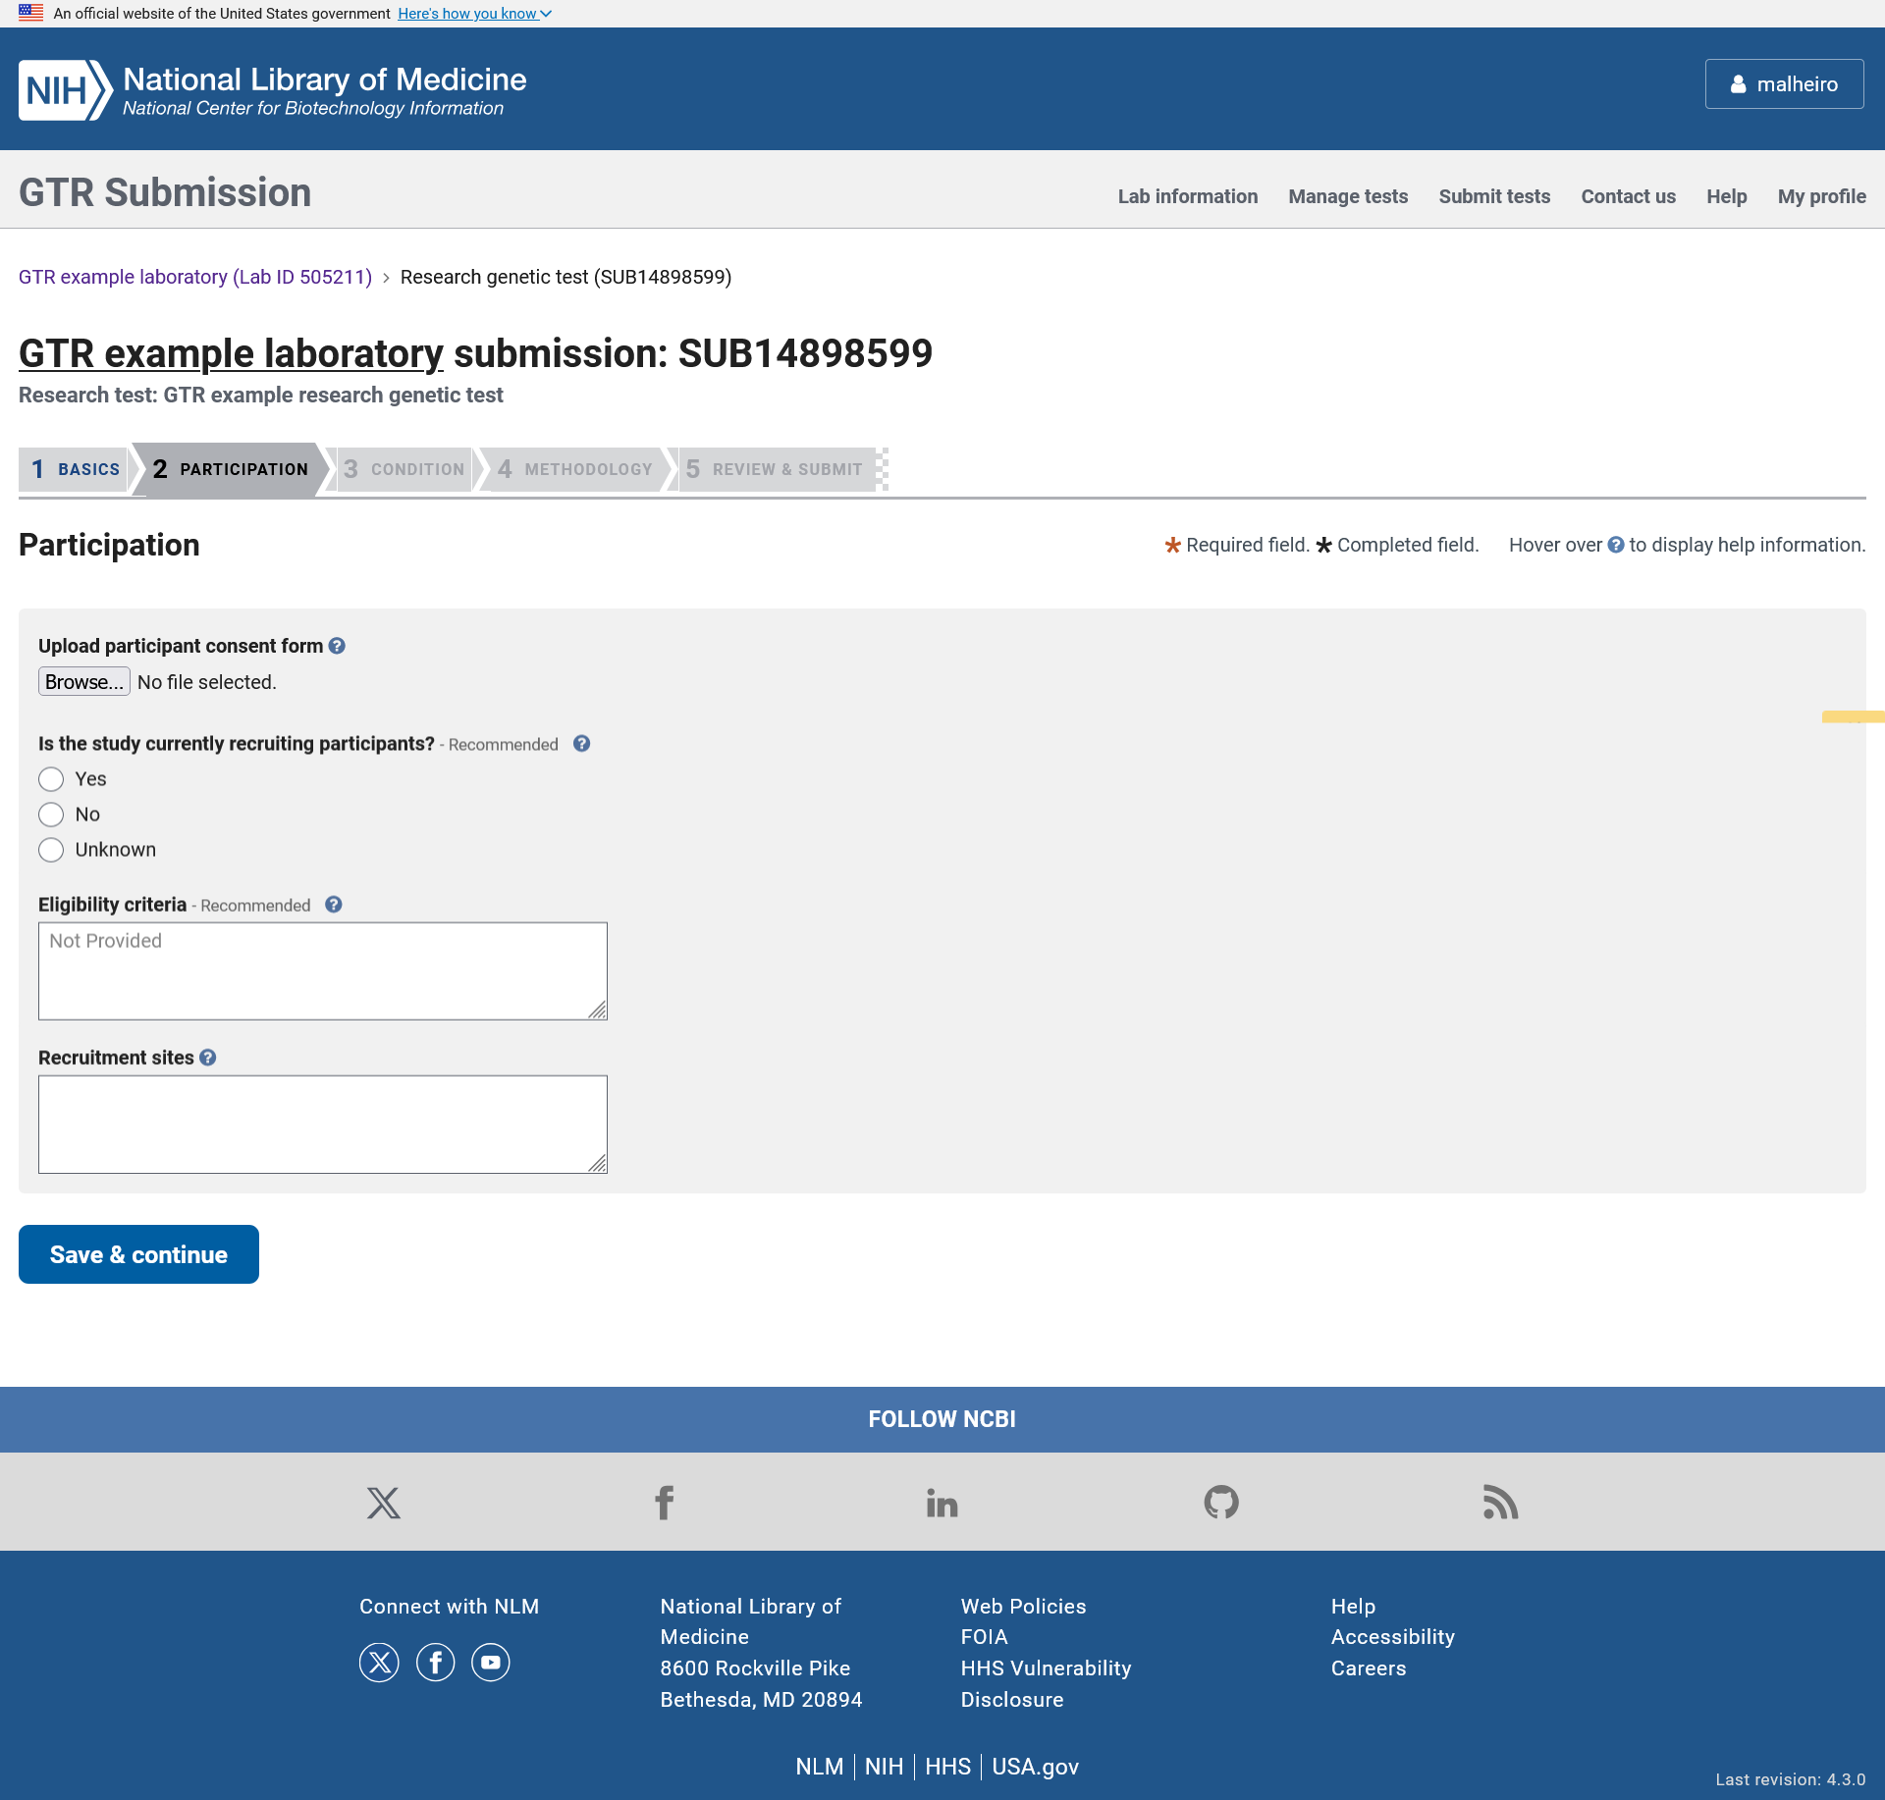

In the Participation section the submitter can upload the patient consent form and provide information about recruitment and eligibility criteria.

ADD A NEW RESEARCH TEST: Condition

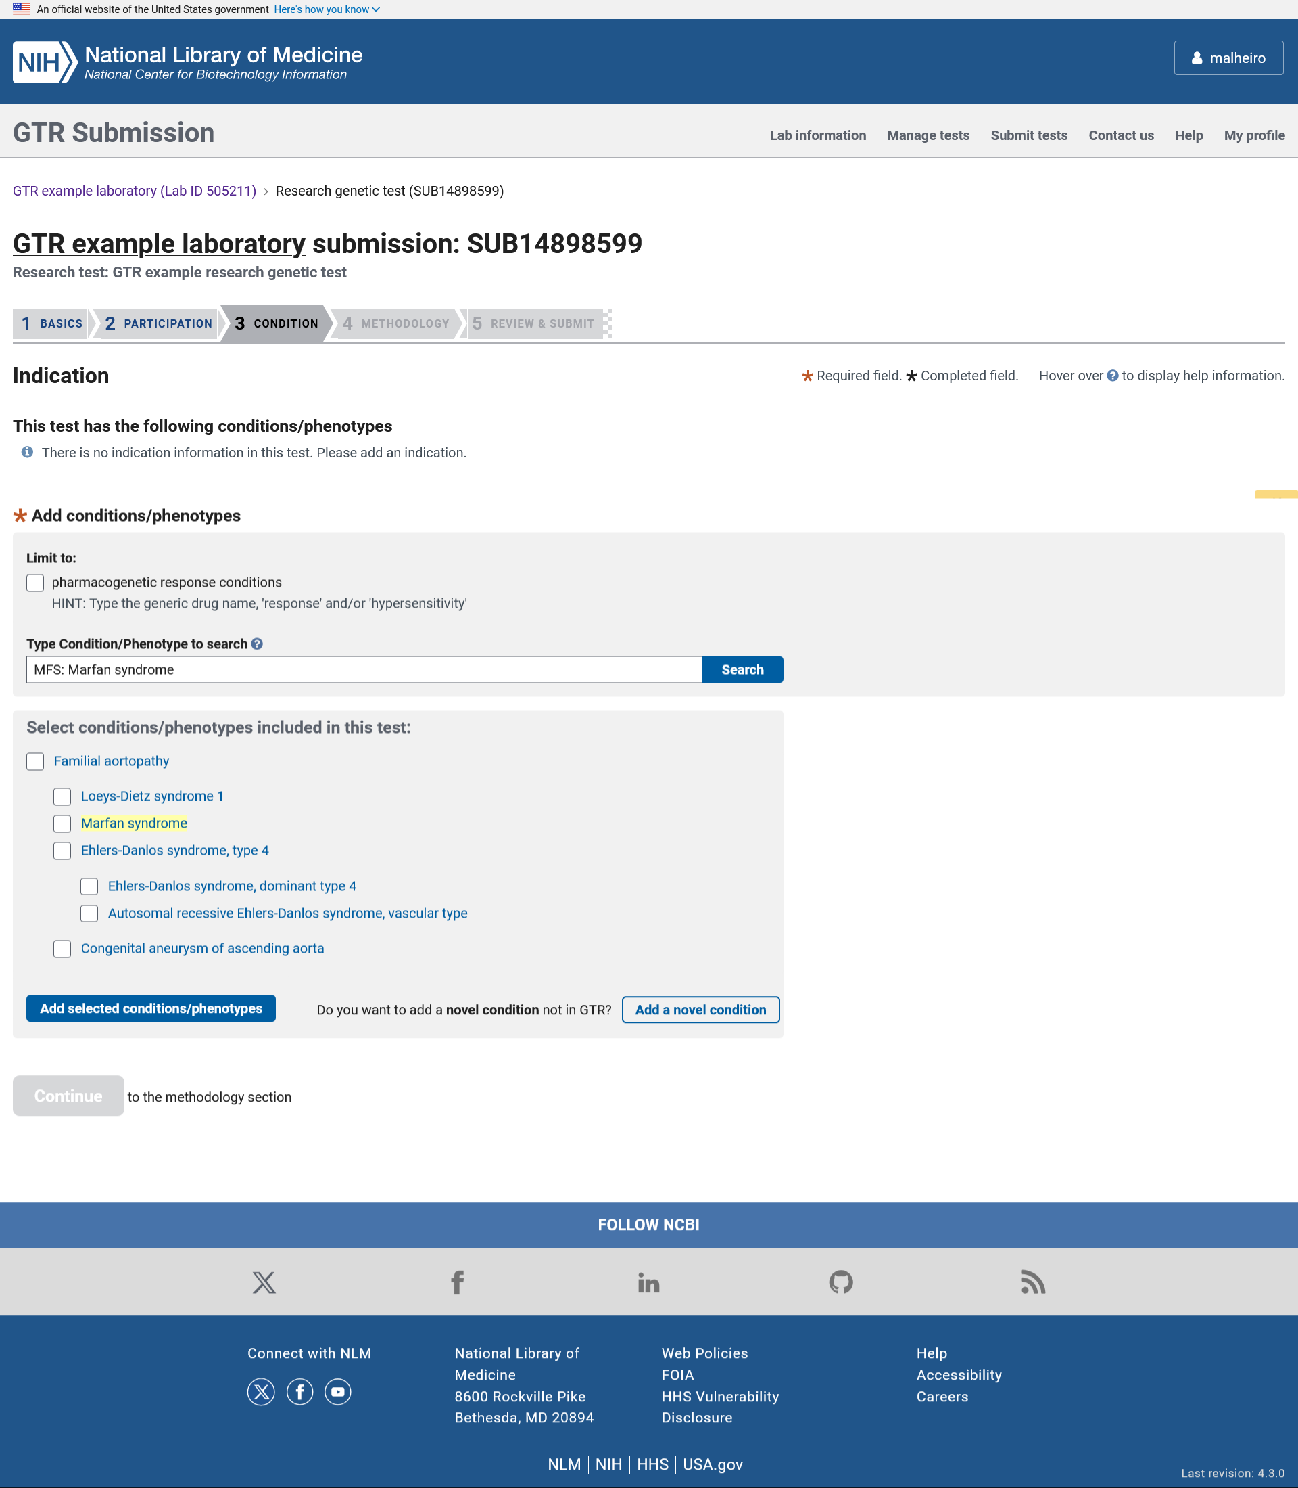

In the Condition section the submitter can select a disease or phenotype from the autocomplete dictionary.

ADD A NEW RESEARCH TEST: Novel condition

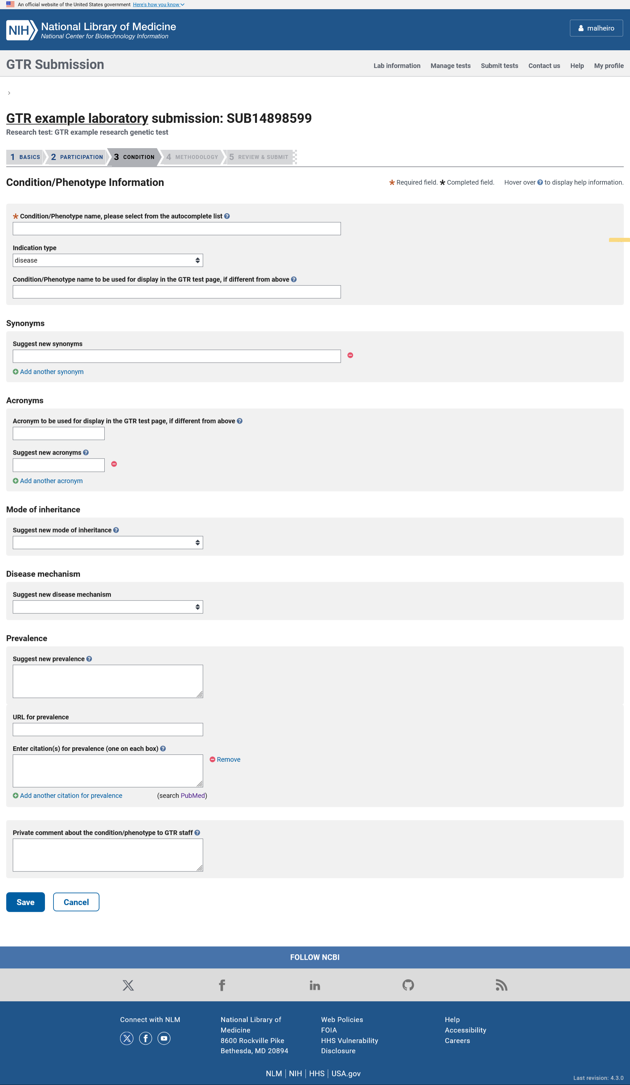

The novel condition page is used when the condition or phenotype does not currently exist in the GTR database. When entering a novel disease or phenotype, the submitter must specify the disease or phenotype name and can enter information like disease type, mode of inheritance, disease mechanism, and prevalence.

ADD A NEW RESEARCH TEST: Methodology

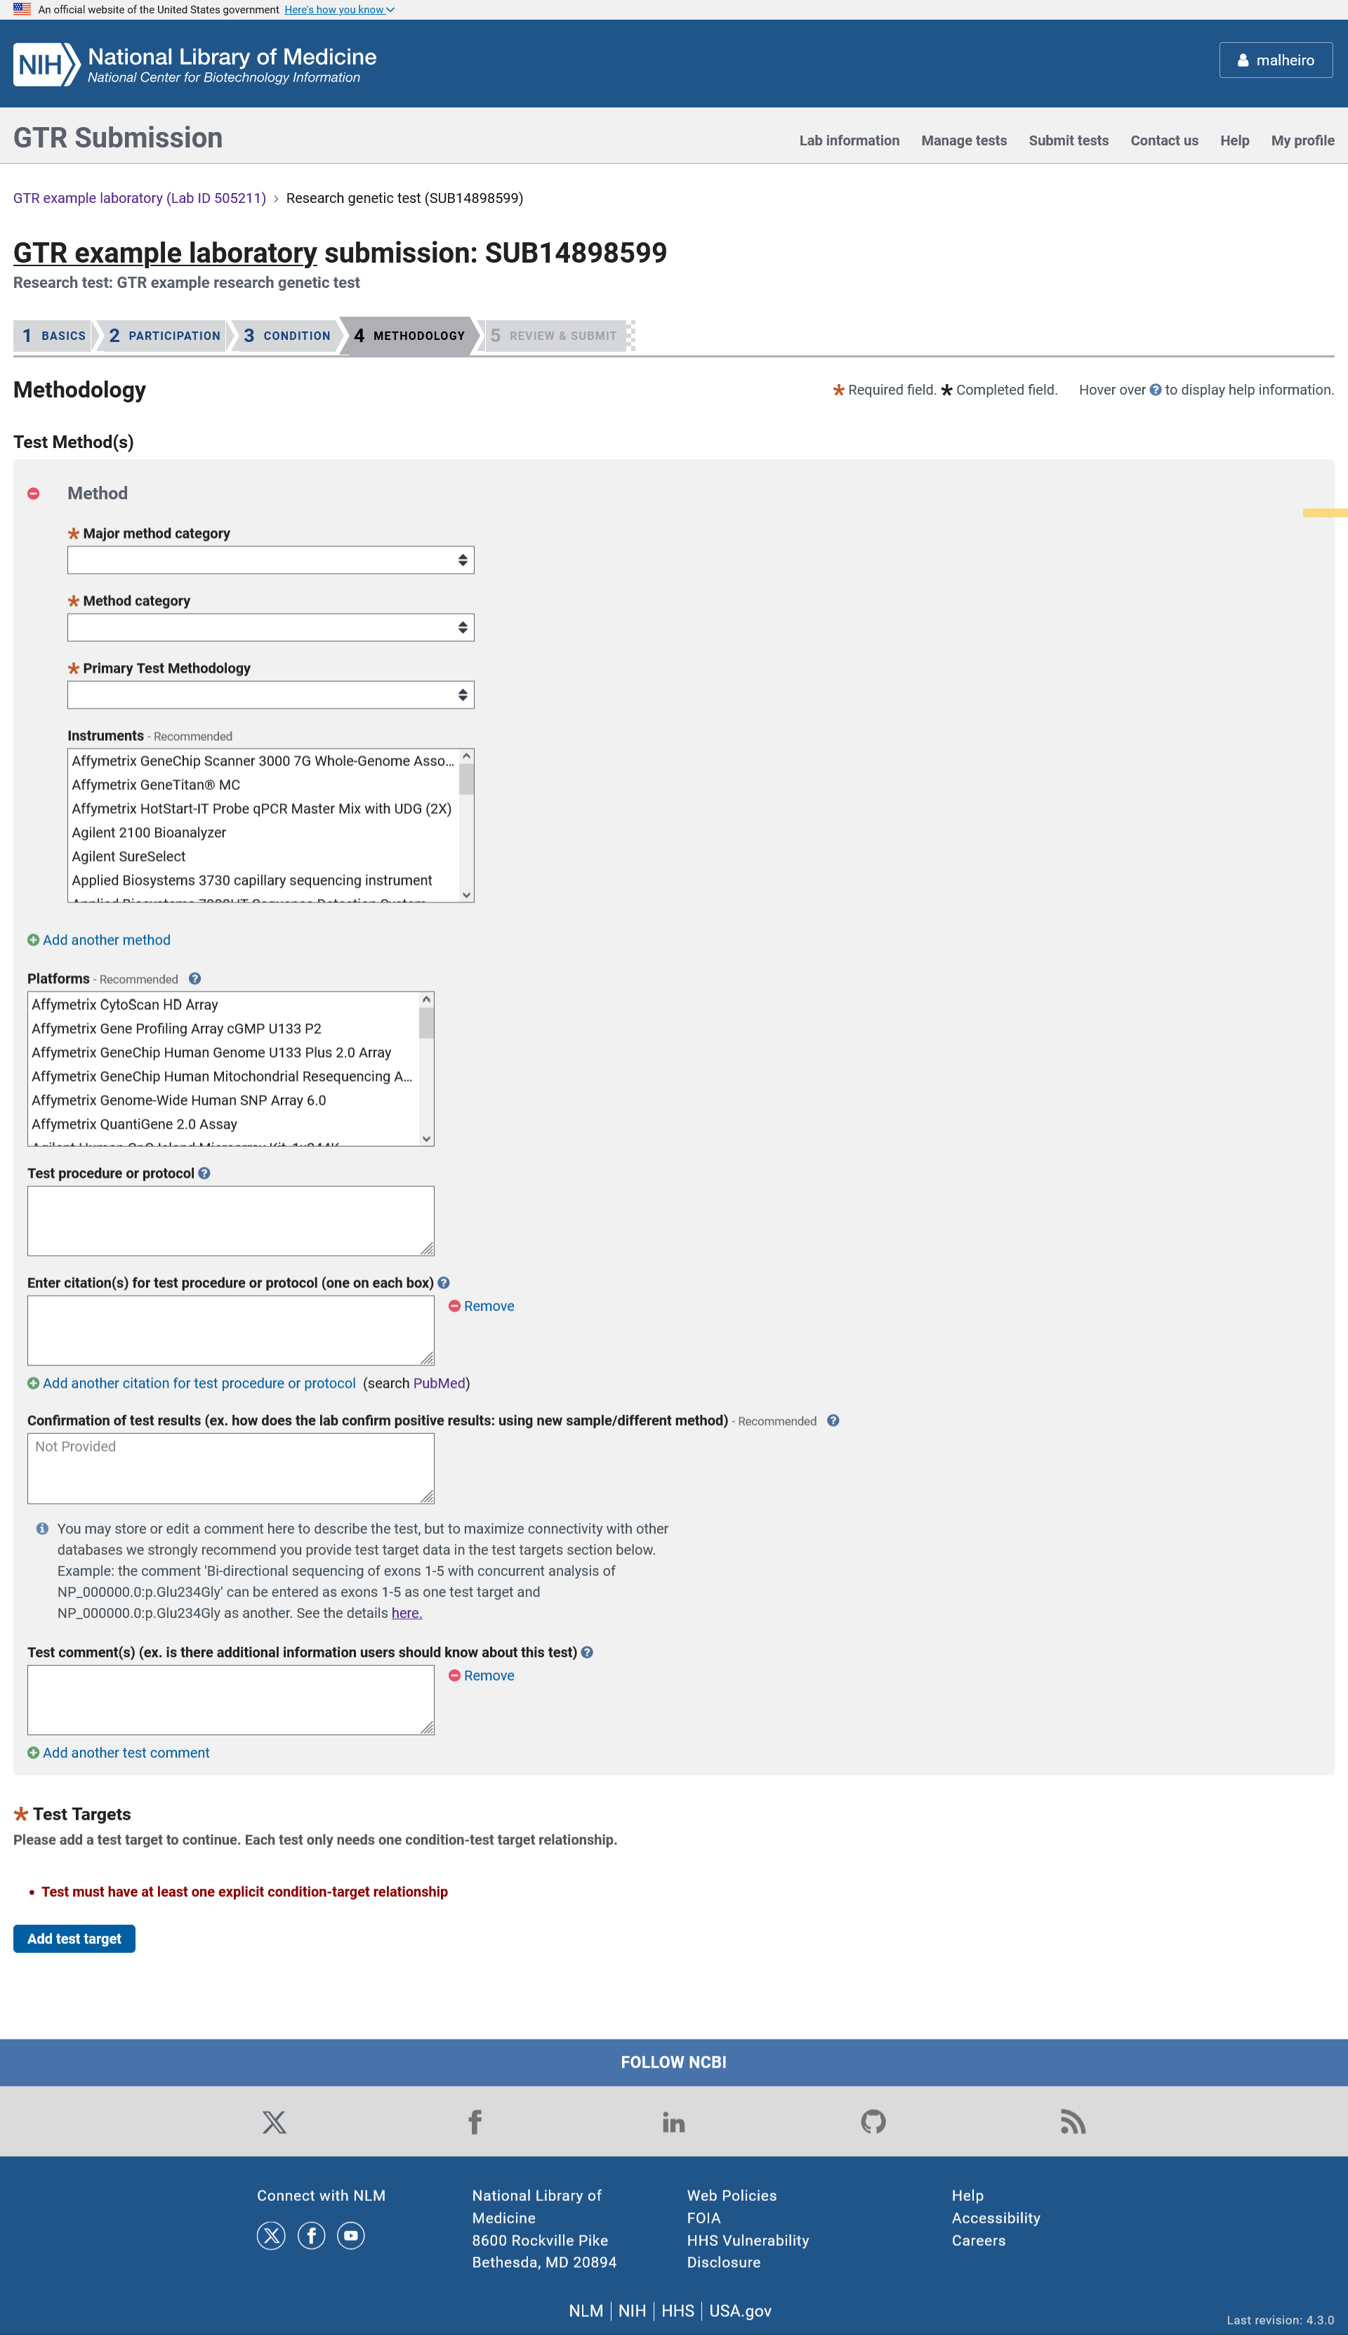

In the Methodology section, the submitter can enter information about the test’s methods, instruments, platforms, description of the test procedure or protocol, confirmation of test results, additional comments and test targets.

ADD A NEW RESEARCH TEST: Test targets
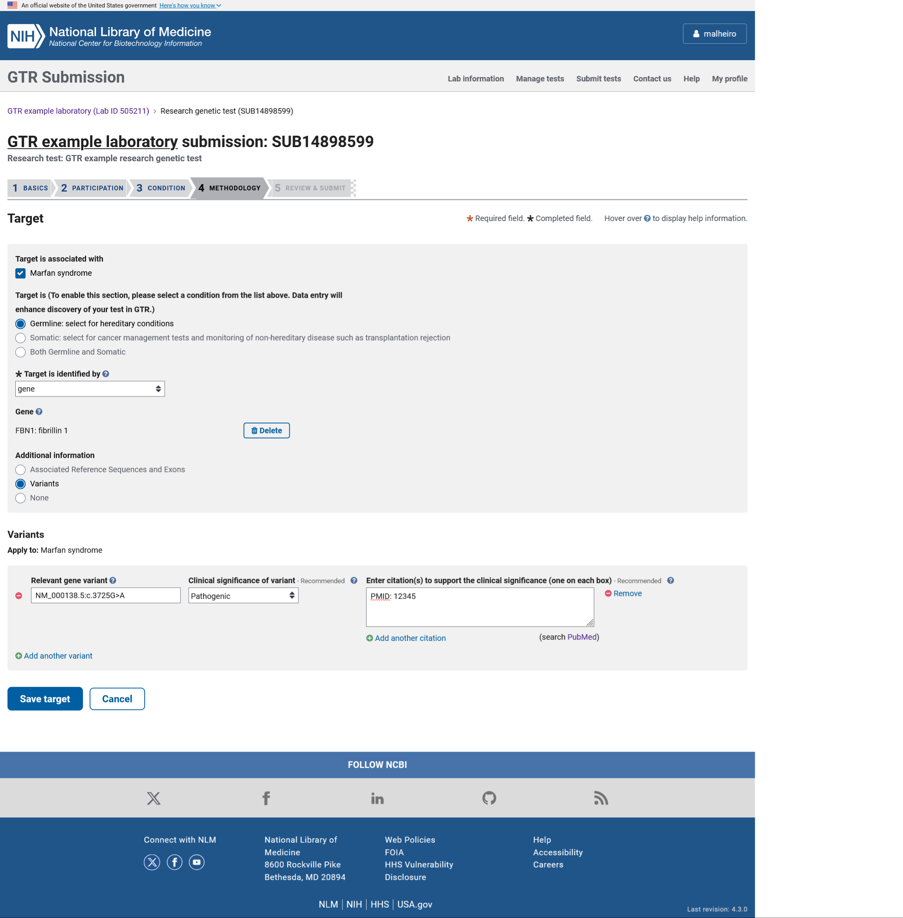

In the Test targets section, the submitter selects the test target type, selects genes from the autocomplete dictionary, selects analytes, chromosomal regions, proteins, enzymes, variants and RefSeqs from the autocomplete dictionary and has the option to enter new terms.

ADD A NEW RESEARCH TEST: Review & Submit

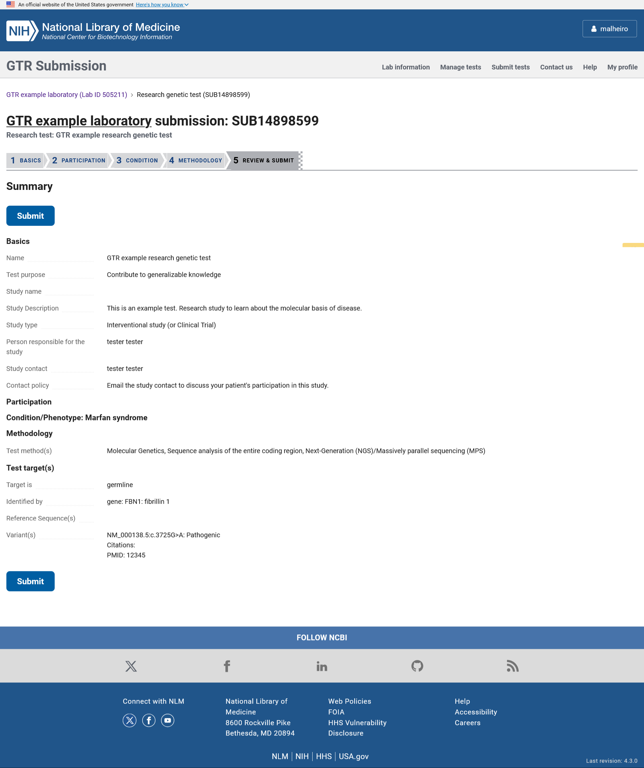

The Review and Submit page displays the data submitted about the test so the submitter can review it before submitting it. Once the Submit button is clicked, the information is stored and processed automatically.

ADD A NEW CLINICAL MICROBE TEST: Basics

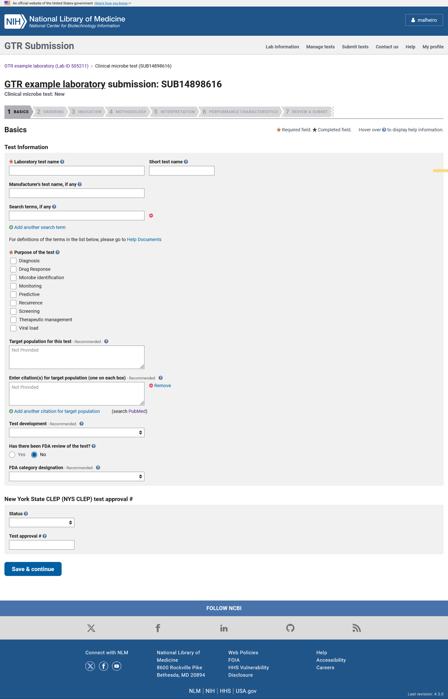

When adding a clinical genetic test via the manual wizard, the input form is divided in to 6 sections. The minimal fields required for registration of the test in GTR are highlighted with an orange asterisk. In the Basics section, the submitter can enter the test name, purpose of the test, target population, and information about the test development, FDA review and approval and NYS CLEP.

ADD A NEW CLINICAL MICROBE TEST: Ordering

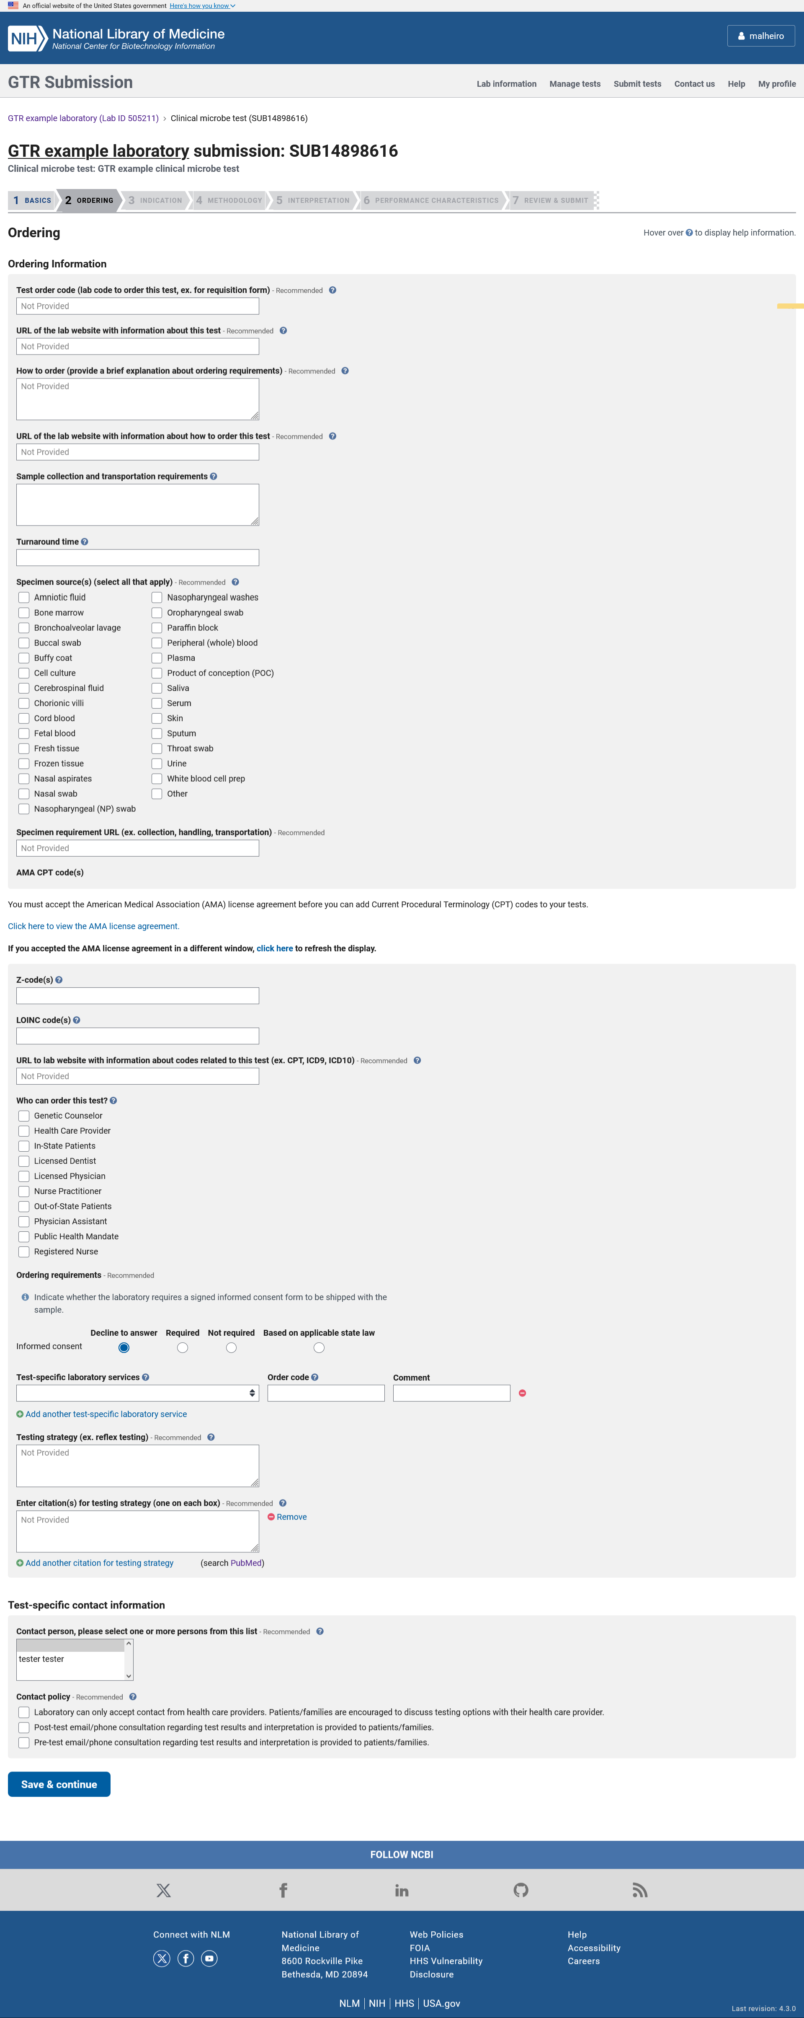

In the Ordering section, the submitter can enter the test order code and other codes related to the test including the AMA CPT codes and LOINC codes, the websites with information about the test and test codes, describe information about how to order the test, specimen types, testing strategy, test services, informed consent and information about how to contact the laboratory including the lab’s point of contact for the test.

ADD A NEW CLINICAL MICROBE TEST: Indication

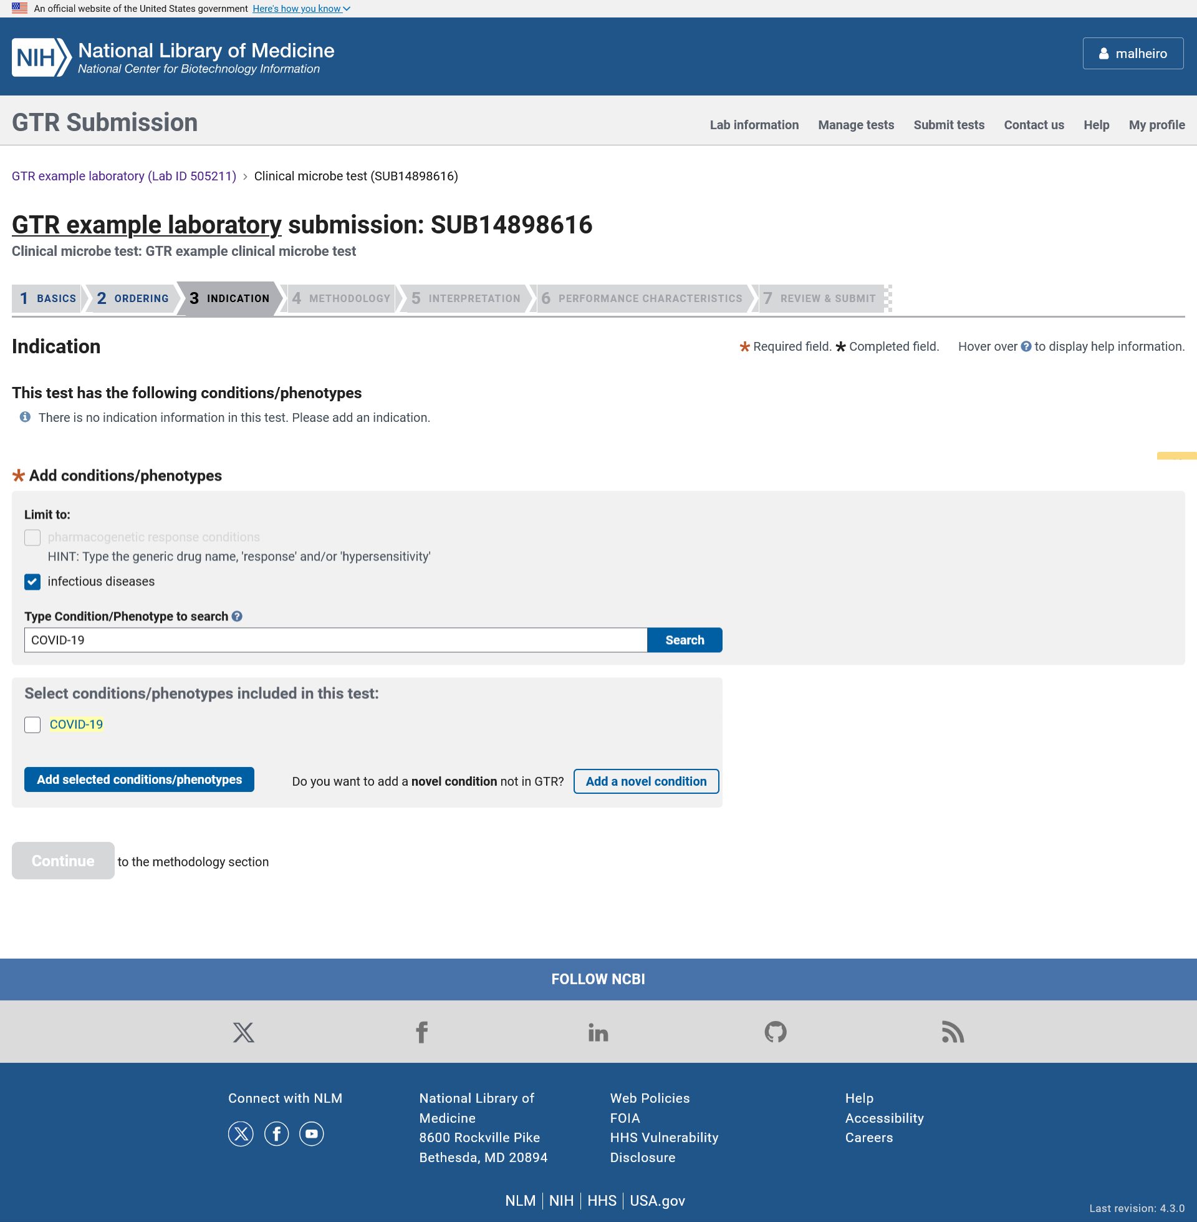

In the Indication section the submitter can select a disease or phenotype from the autocomplete dictionary.

ADD A NEW CLINICAL MICROBE TEST: Novel condition

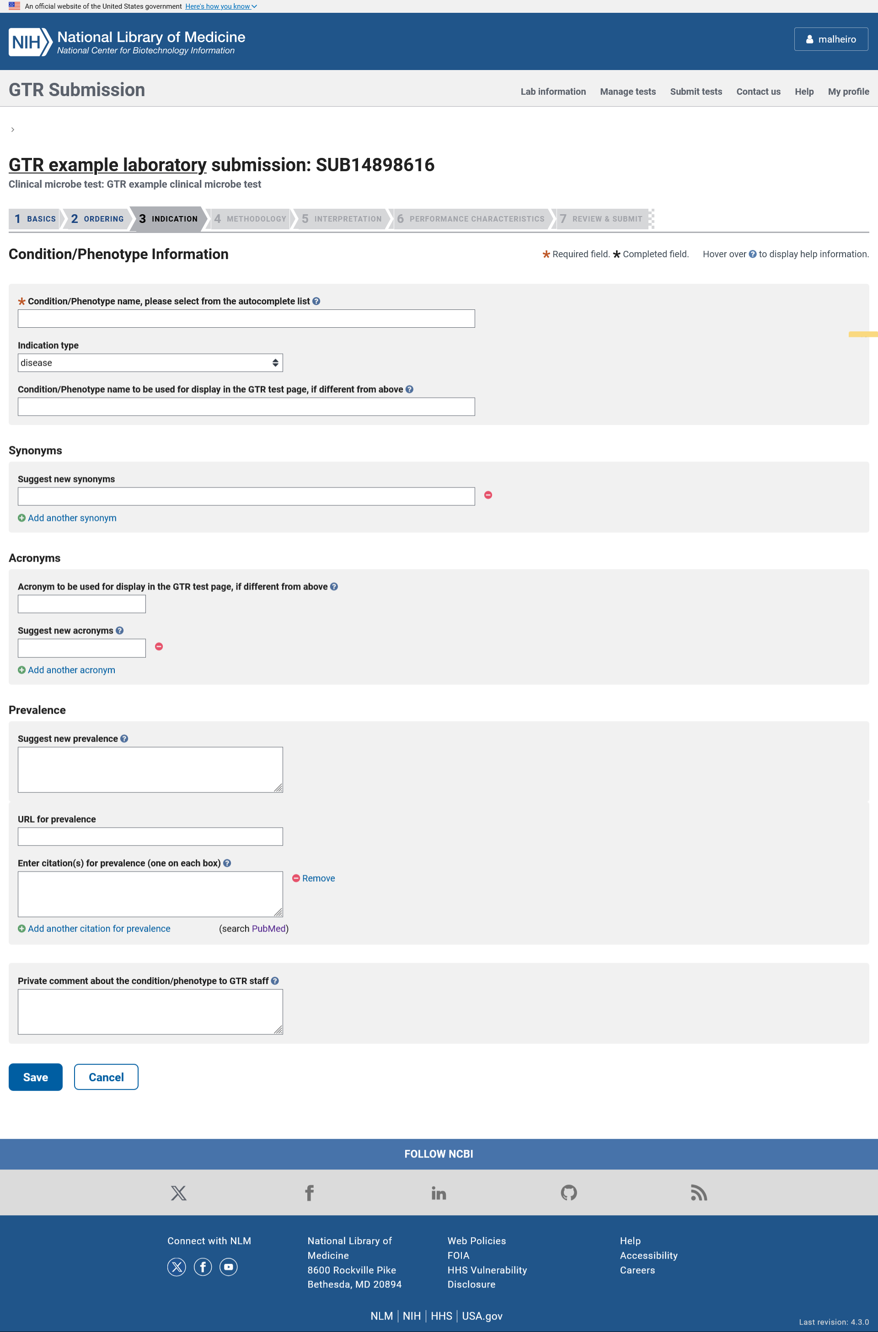

The novel condition page is used when the condition or phenotype does not currently exist in the GTR database. When entering a novel disease or phenotype, the submitter must specify the disease or phenotype name and can enter information like disease type, mode of inheritance, disease mechanism, and prevalence.

ADD A NEW CLINICAL MICROBE TEST: Methodology

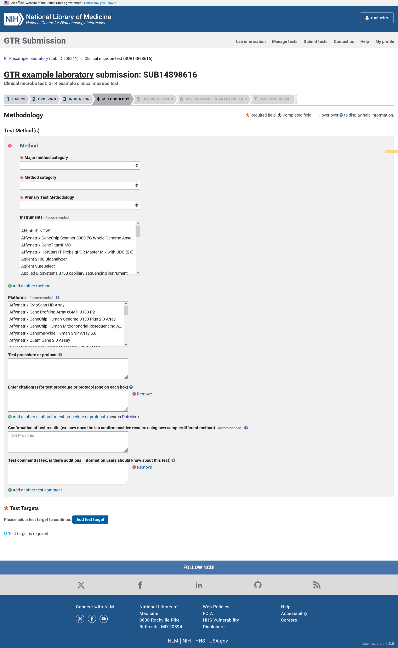

In the Methodology section, the submitter can enter information about the test’s methods, instruments, platforms, description of the test procedure or protocol, confirmation of test results, additional comments and test targets.

ADD A NEW CLINICAL MICROBE TEST: Test targets

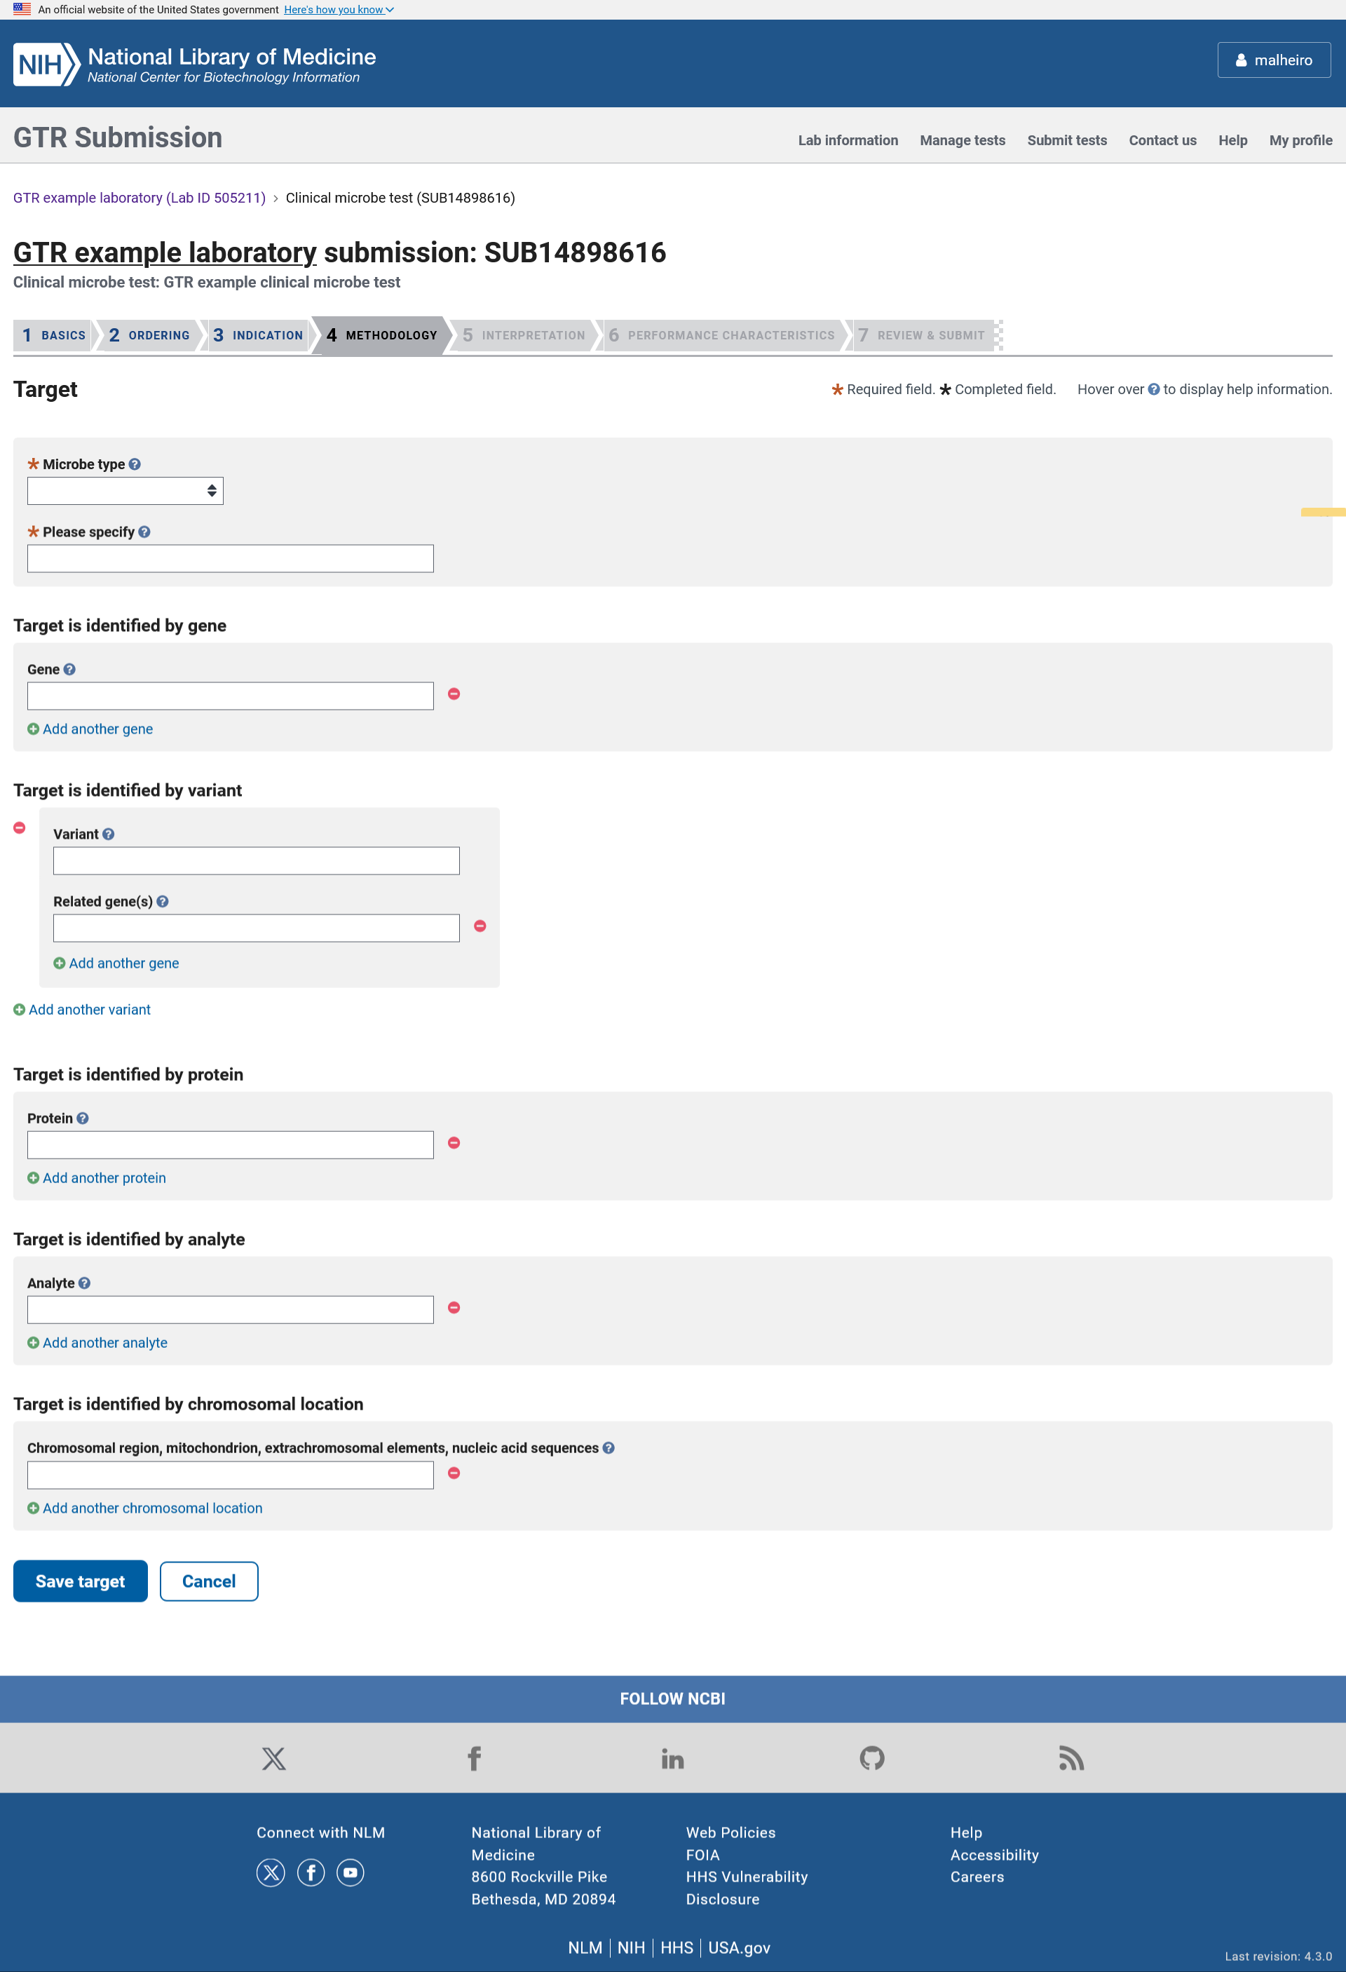

In the Test target section, the submitter can enter information about the name and type of microbe and what the test interrogates.

ADD A NEW CLINICAL MICROBE TEST: Interpretation

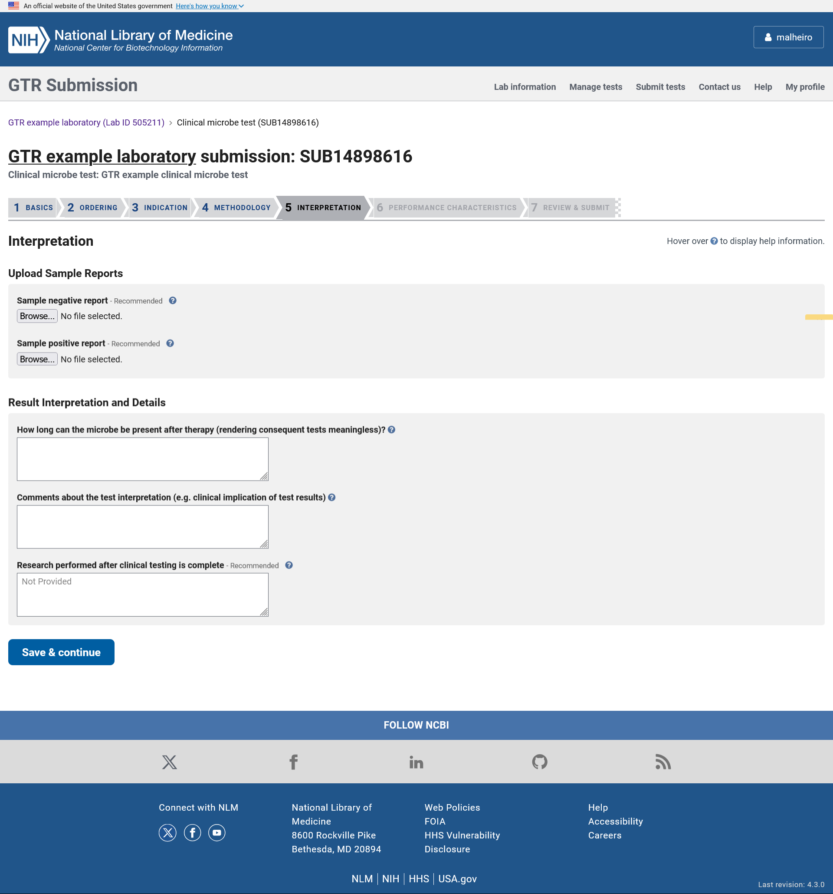

In the interpretation section the submitter can upload sample reports, describe the timeframe the microbe may be present after therapy, enter comments about test interpretation and whether research is performed on the sample after clinical testing is done.

ADD A NEW CLINICAL MICROBE TEST: Performance characteristics

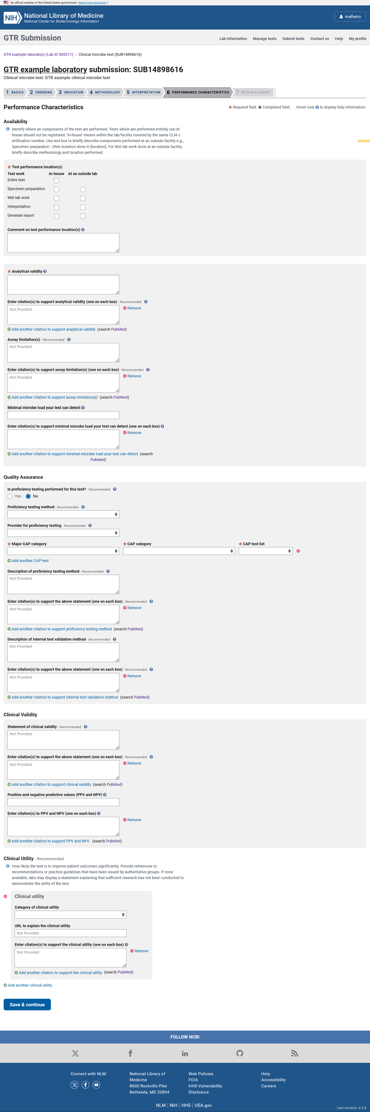

In the Performance characteristics section the submitter identifies if any part of the test is performed outside the lab, and describes the analytical validity, assay limitations, proficiency testing, internal validation methods, clinical validity and clinical utility and the minimal viral load the test can detect.

ADD A NEW CLINICAL MICROBE TEST: Review & Submit

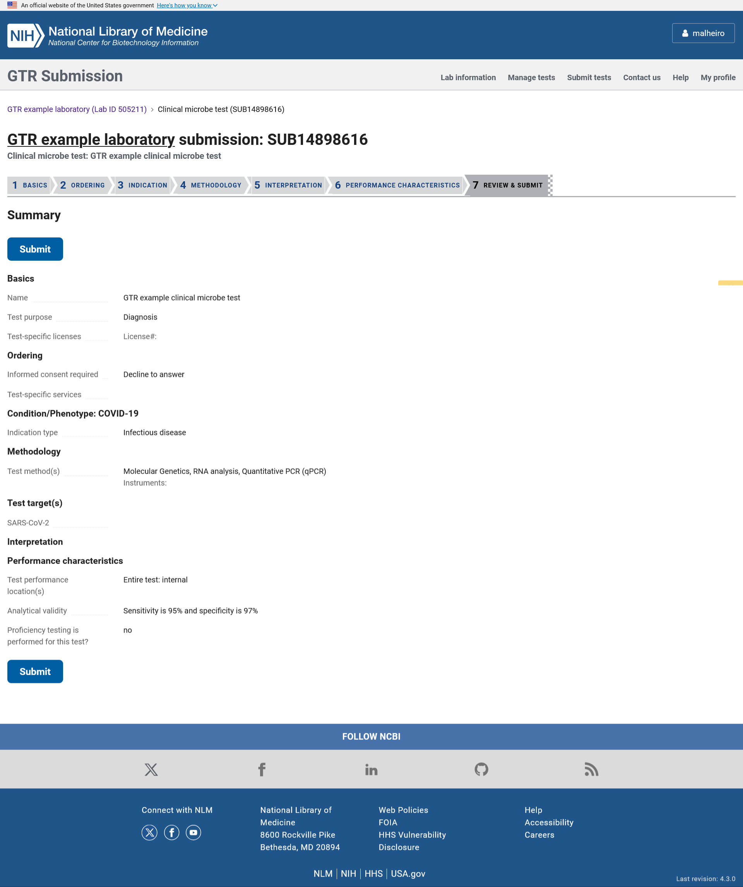

The Review and Submit page displays the data submitted about the test so the submitter can review it before submitting it. Once the Submit button is clicked, the information is stored and processed automatically.

ADD A NEW RESEARCH MICROBE TEST: Basics

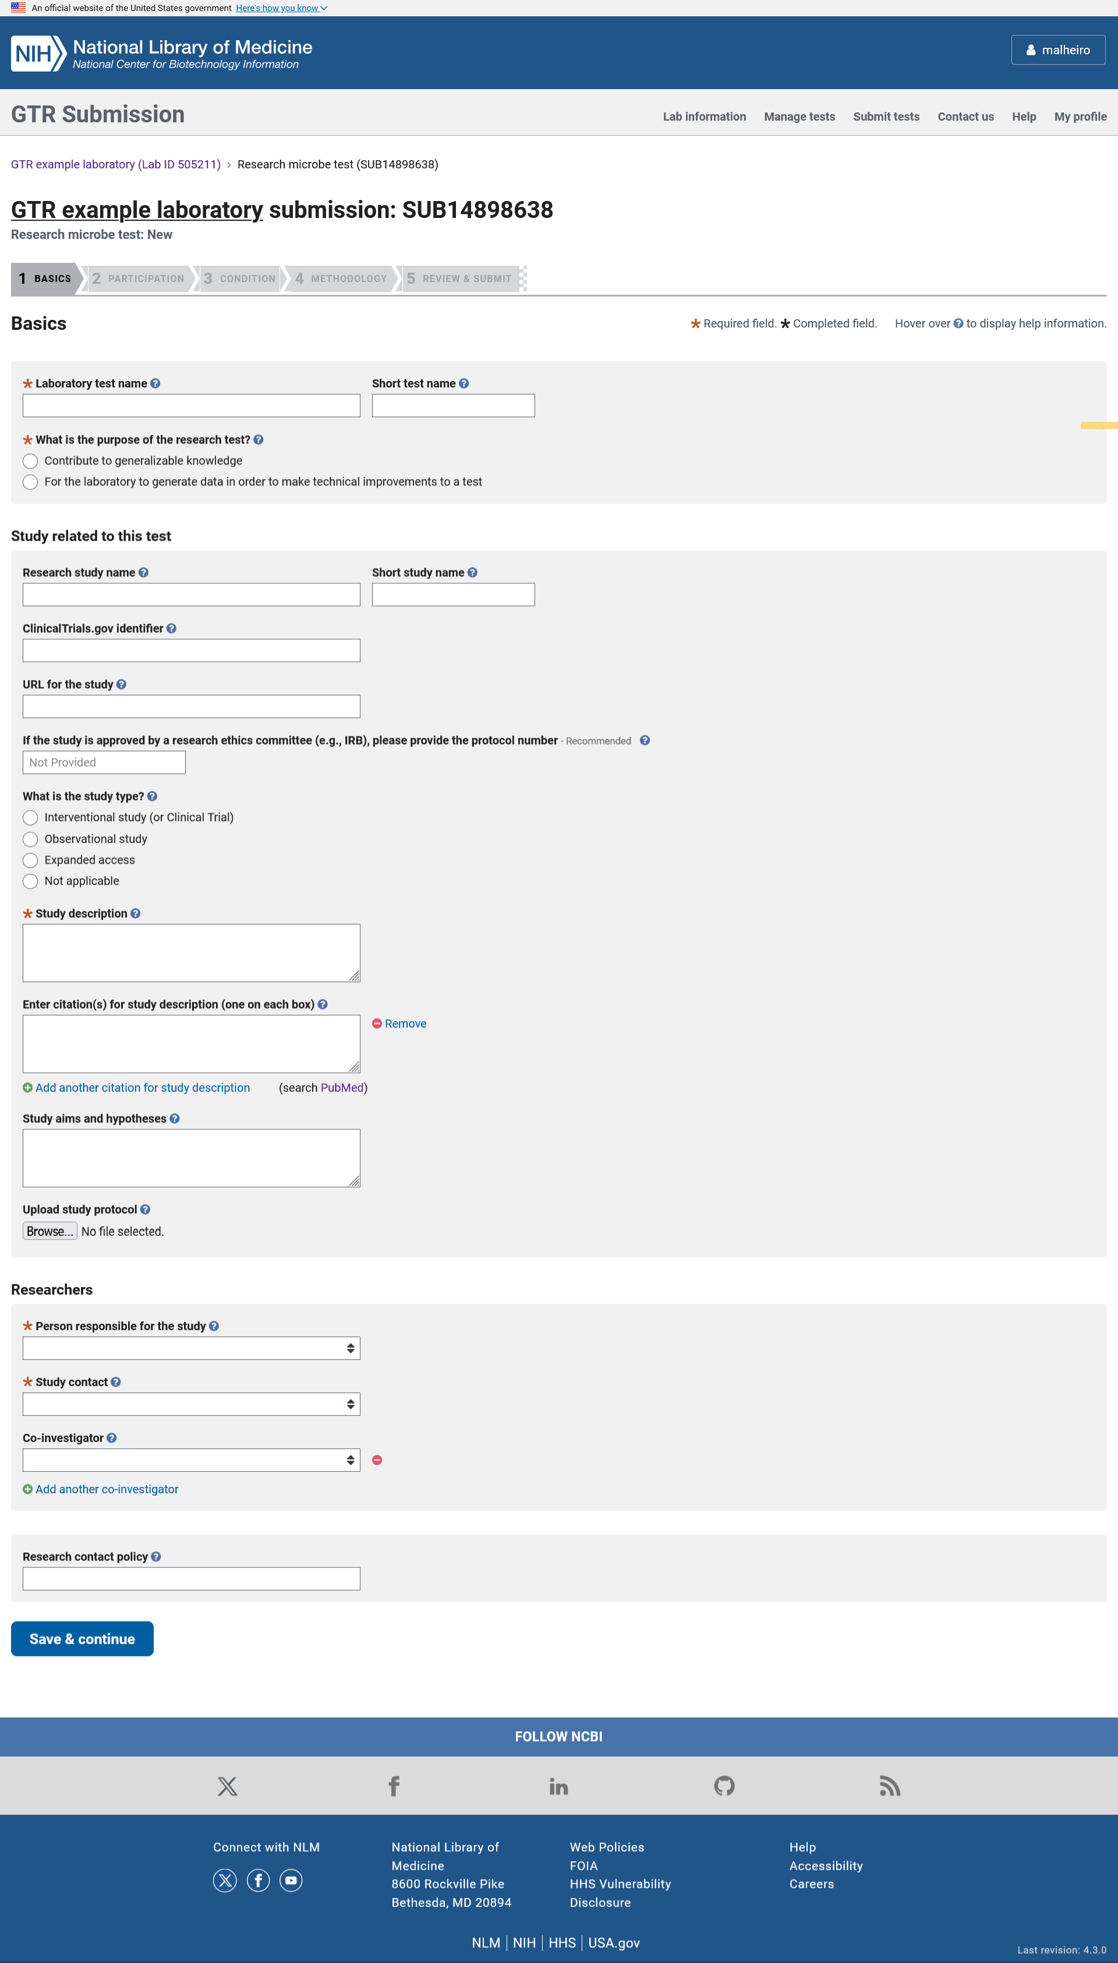

When adding a research microbe test via the manual wizard, the input form is divided in to 4 sections. The minimal fields required for registration of the test in GTR are highlighted with an orange asterisk. In the Basics section, the submitter can enter the test name, provide information about the research study and list the researchers and contact policy.

ADD A NEW RESEARCH MICROBE TEST: Participation

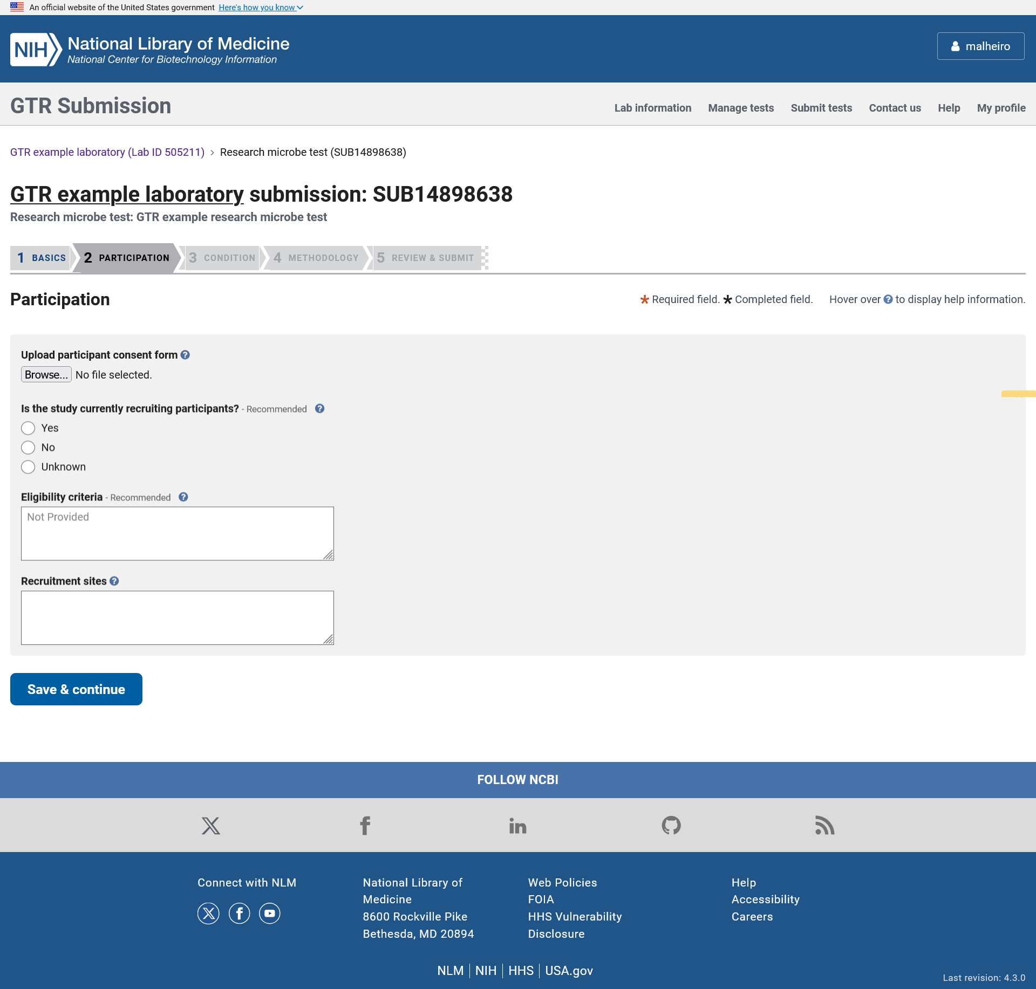

In the Participation section the submitter can upload the patient consent form and provide information about recruitment and eligibility criteria.

ADD A NEW RESEARCH MICROBE TEST: Condition

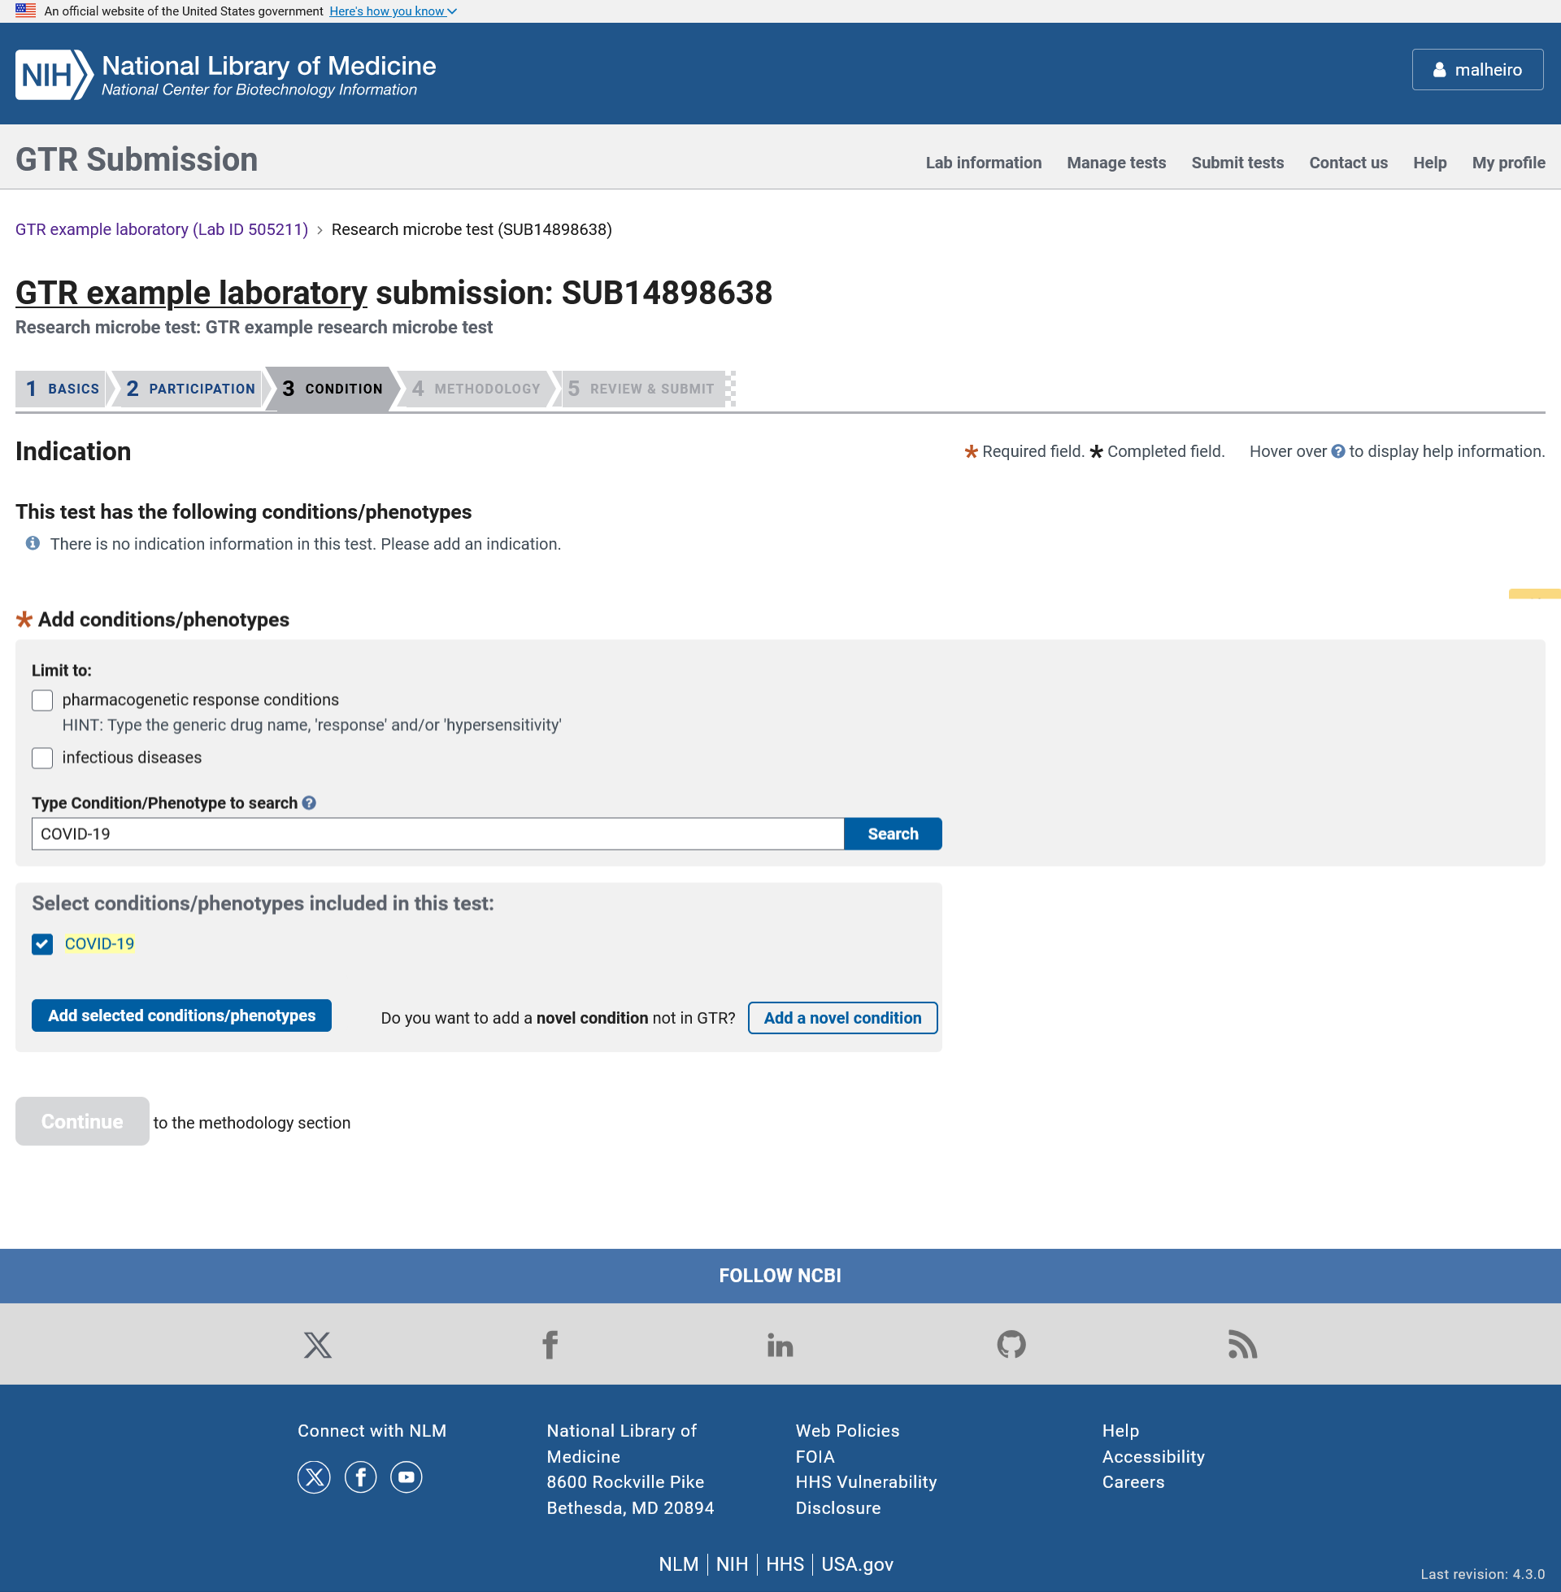

In the Condition section the submitter can select a disease or phenotype from the autocomplete dictionary.

ADD A NEW RESEARCH MICROBE TEST: Novel condition

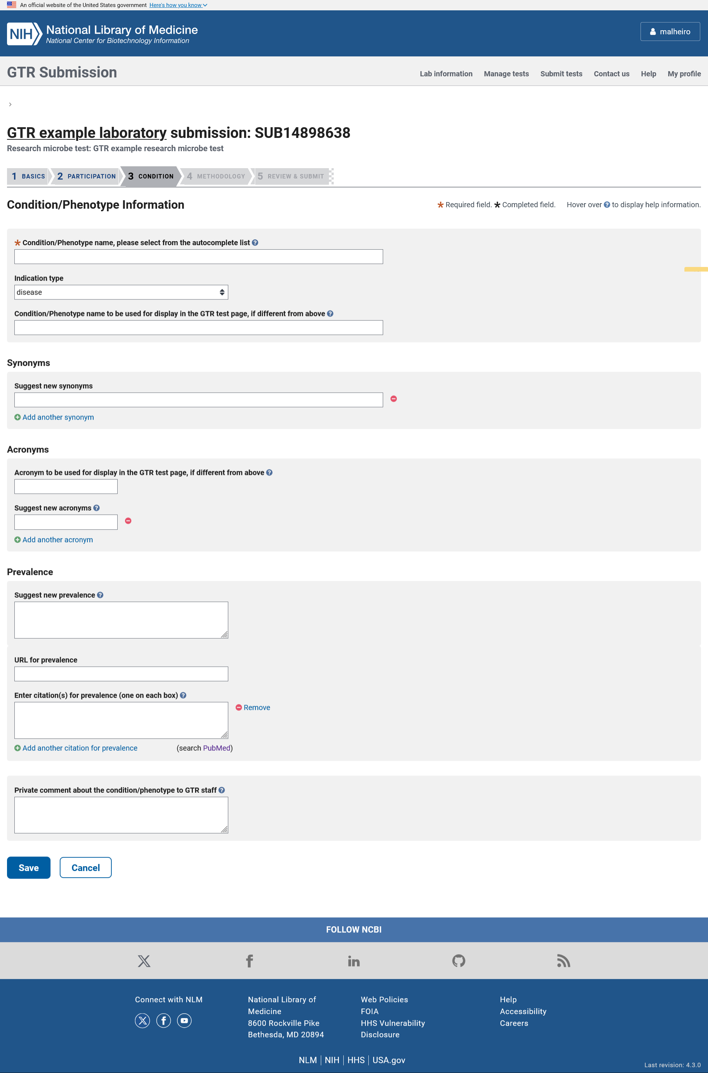

The novel condition page is used when the condition or phenotype does not currently exist in the GTR database. When entering a novel disease or phenotype, the submitter must specify the disease or phenotype name and can enter information like disease type, mode of inheritance, disease mechanism, and prevalence.

ADD A NEW RESEARCH MICROBE TEST: Methodology

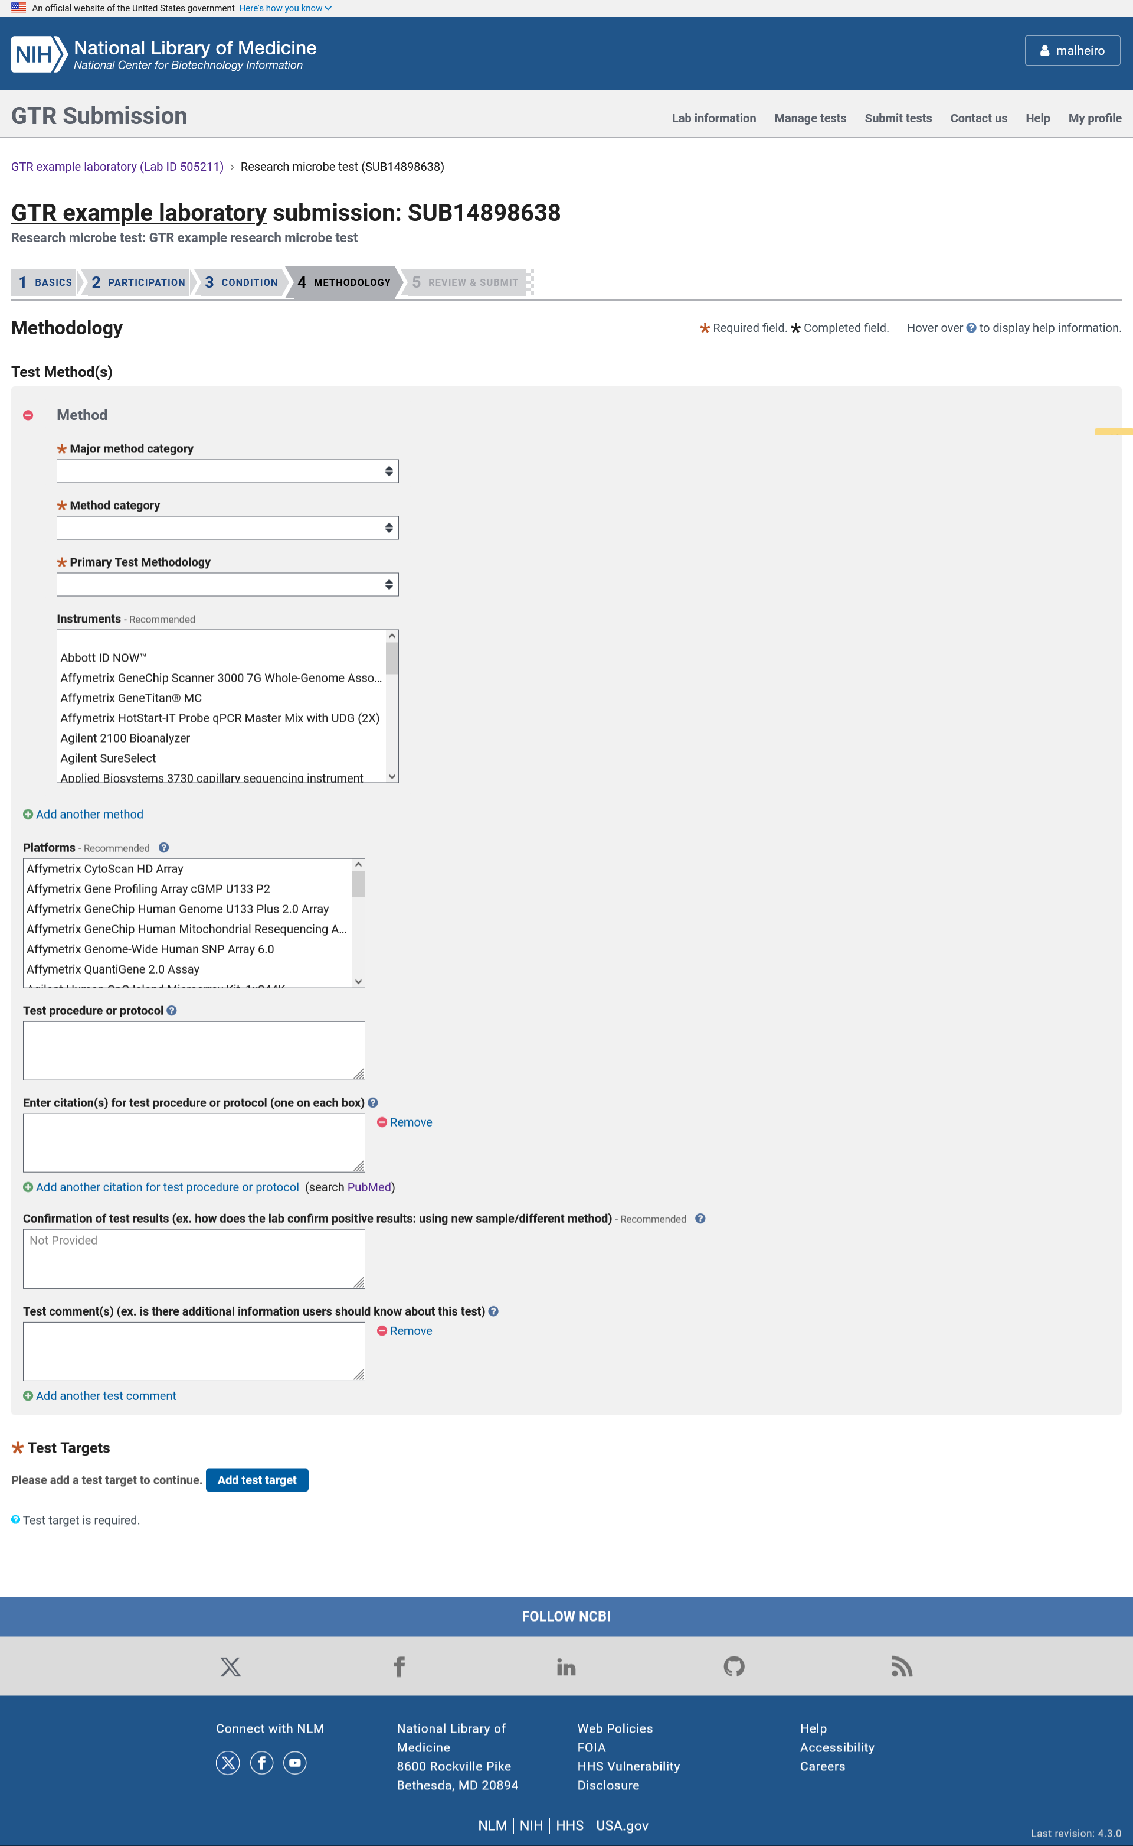

In the Methodology section, the submitter can enter information about the test’s methods, instruments, platforms, description of the test procedure or protocol, confirmation of test results, additional comments and test targets.

ADD A NEW RESEARCH MICROBE TEST: Test targets

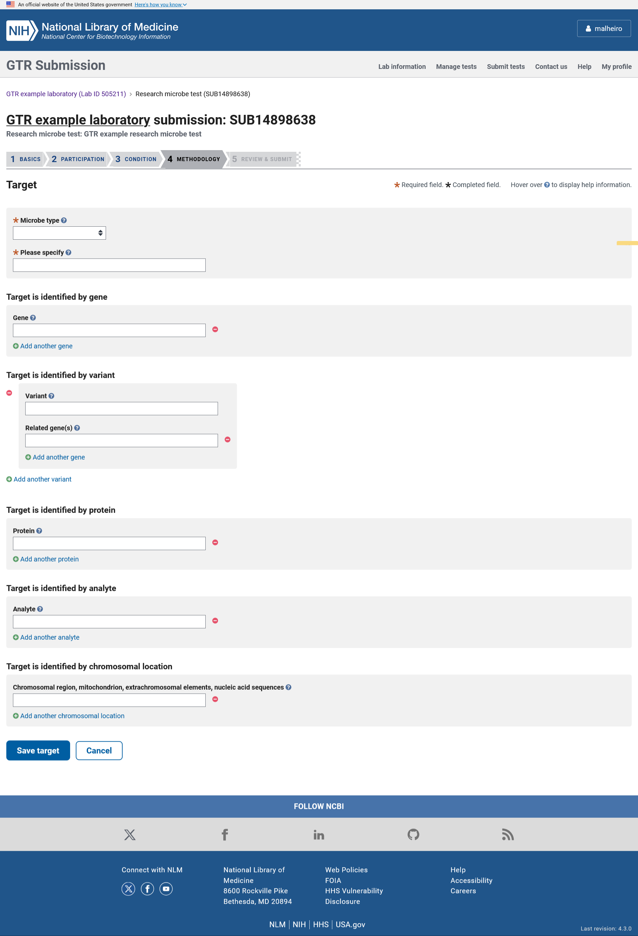

In the Test target section, the submitter can enter information about the name and type of microbe and what the test interrogates.

ADD A NEW RESEARCH MICROBE TEST: Review & Submit

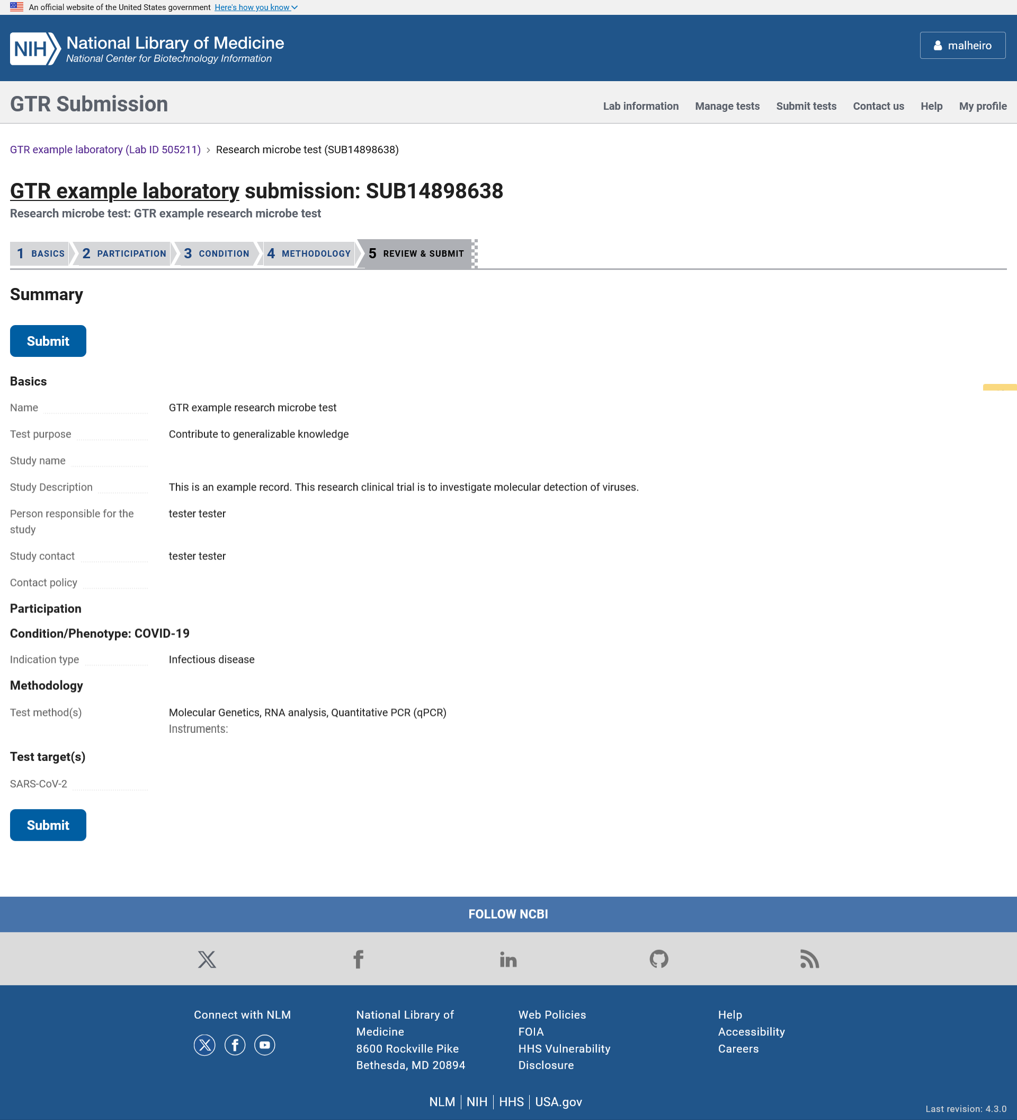

The Review and Submit page displays the data submitted about the test so the submitter can review it before submitting it. Once the Submit button is clicked, the information is stored and processed automatically.

ANNUAL REVIEW

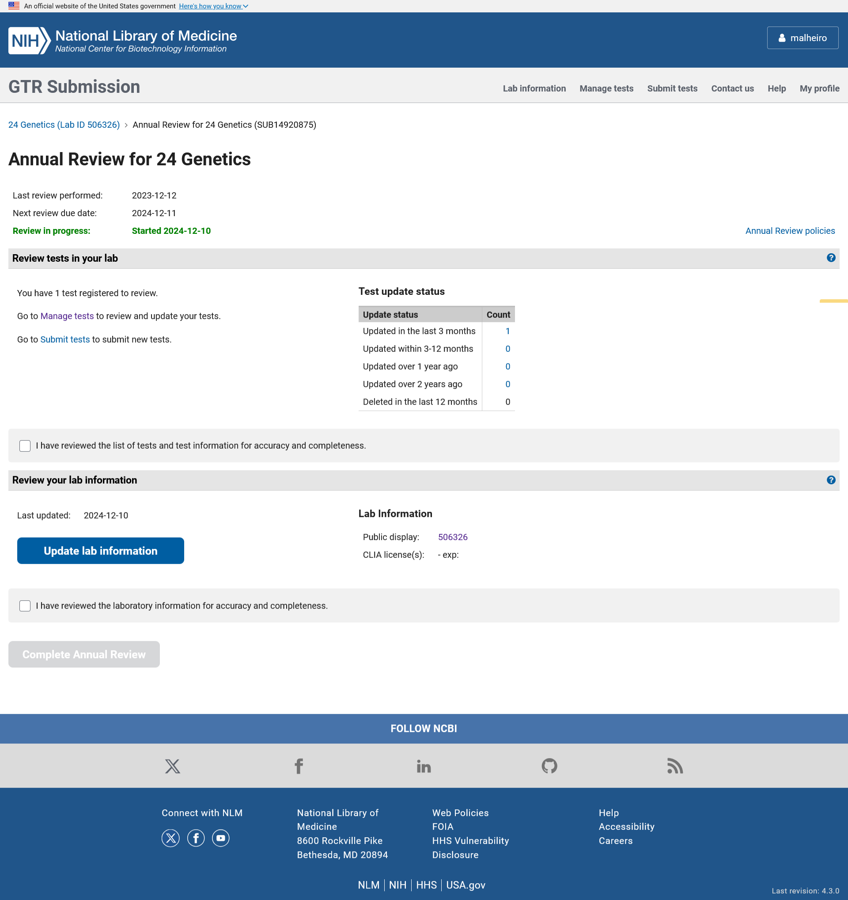

In the Annual Review wizard, the data submitter can check a box attesting that their test information is up-to-date and check a box attesting that their laboratory information is up-to-date.

LIST OF TESTS (MANAGE TESTS TOOL)
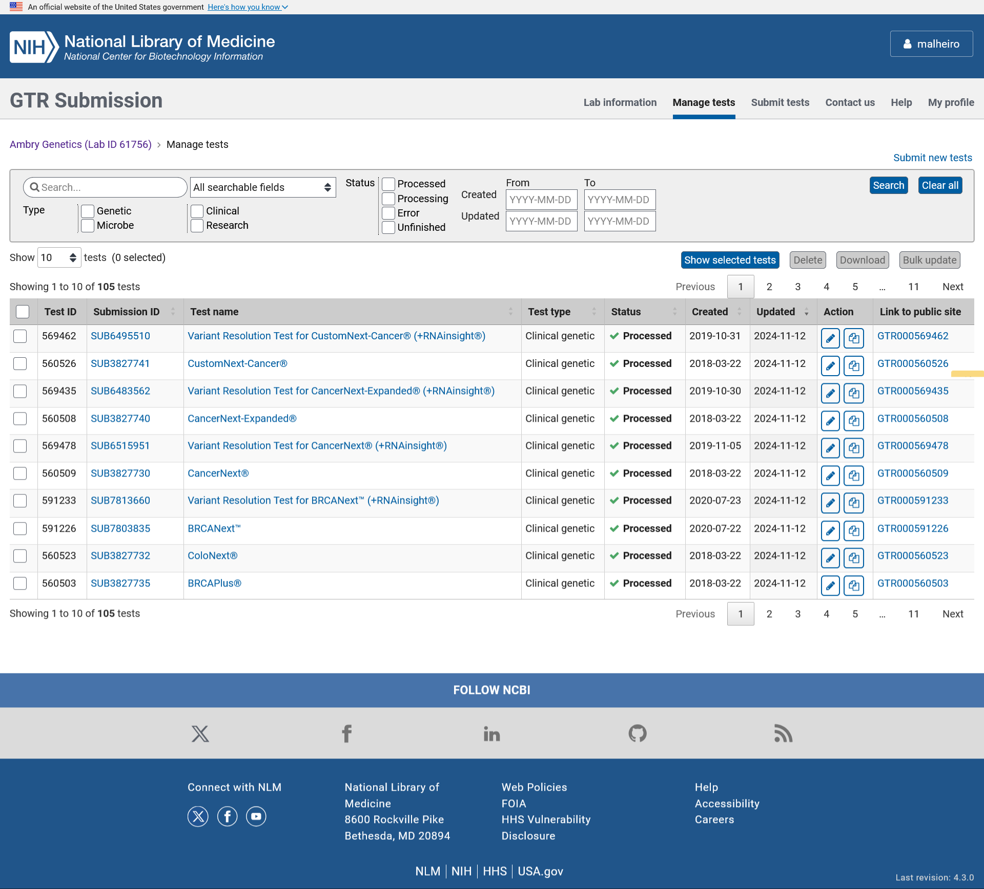

The Manage Tests Tool is a resource for data submitters to search their tests, see when the test record was created and last updated and access actions edit and copy the test record. Test records can be downloaded in excel templates that can be edited and reuploaded with updates. This page provides access to the bulk edits tool.

BULK UPDATE: MANUAL WIZARD – Select fields to update

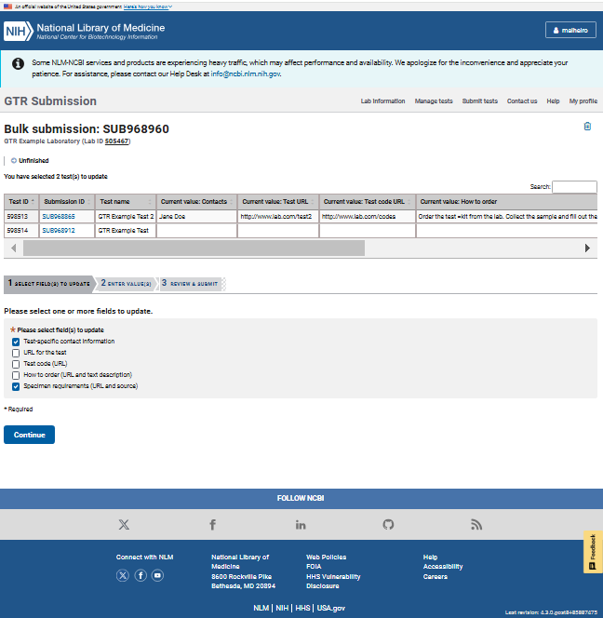

In the Bulk update tool, the data submitter can select the tests they want to update and edit the test-specific contact information, URL for the test, test code URL, how to order and/or specimen requirements information. In the Select fields to update section, the submitters clicks the checkbox of the fields they want to update. The current field values displays for each test.

BULK UPDATE: MANUAL WIZARD – Enter value(s)

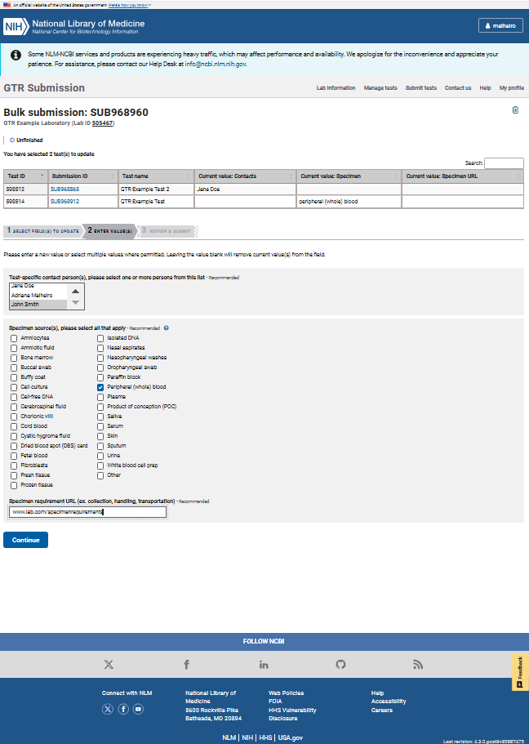

In the Enter values section, the data submitter can enter the data they want to update on all tests selected.

BULK UPDATE: MANUAL WIZARD – Review & Submit

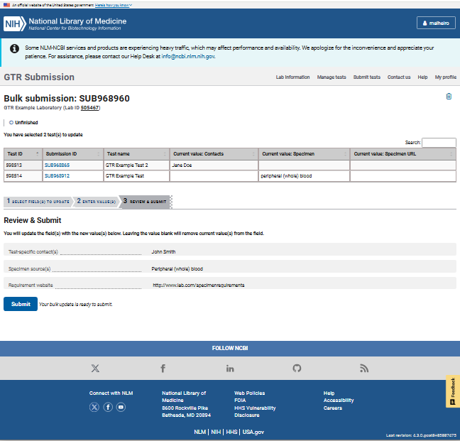

The Review and Submit page displays the data submitted about the tests so the submitter can review it before submitting it. Once the Submit button is clicked, the information is stored and processed automatically for all the selected tests.

