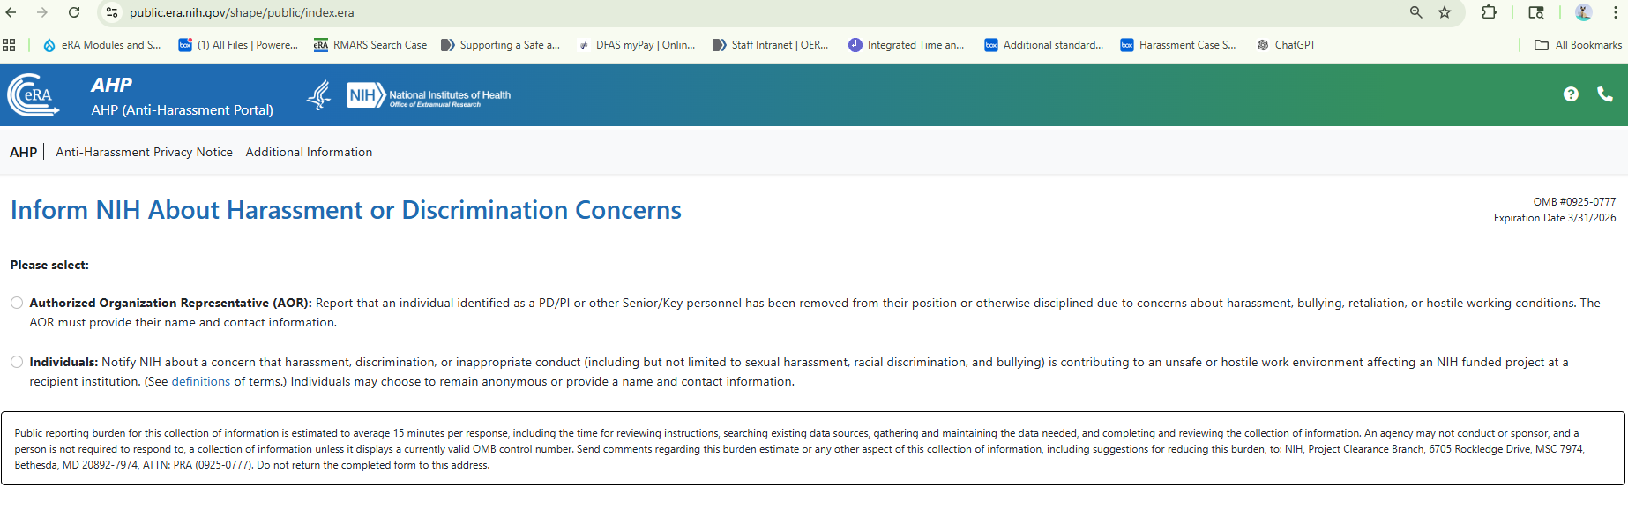
Entrance screen

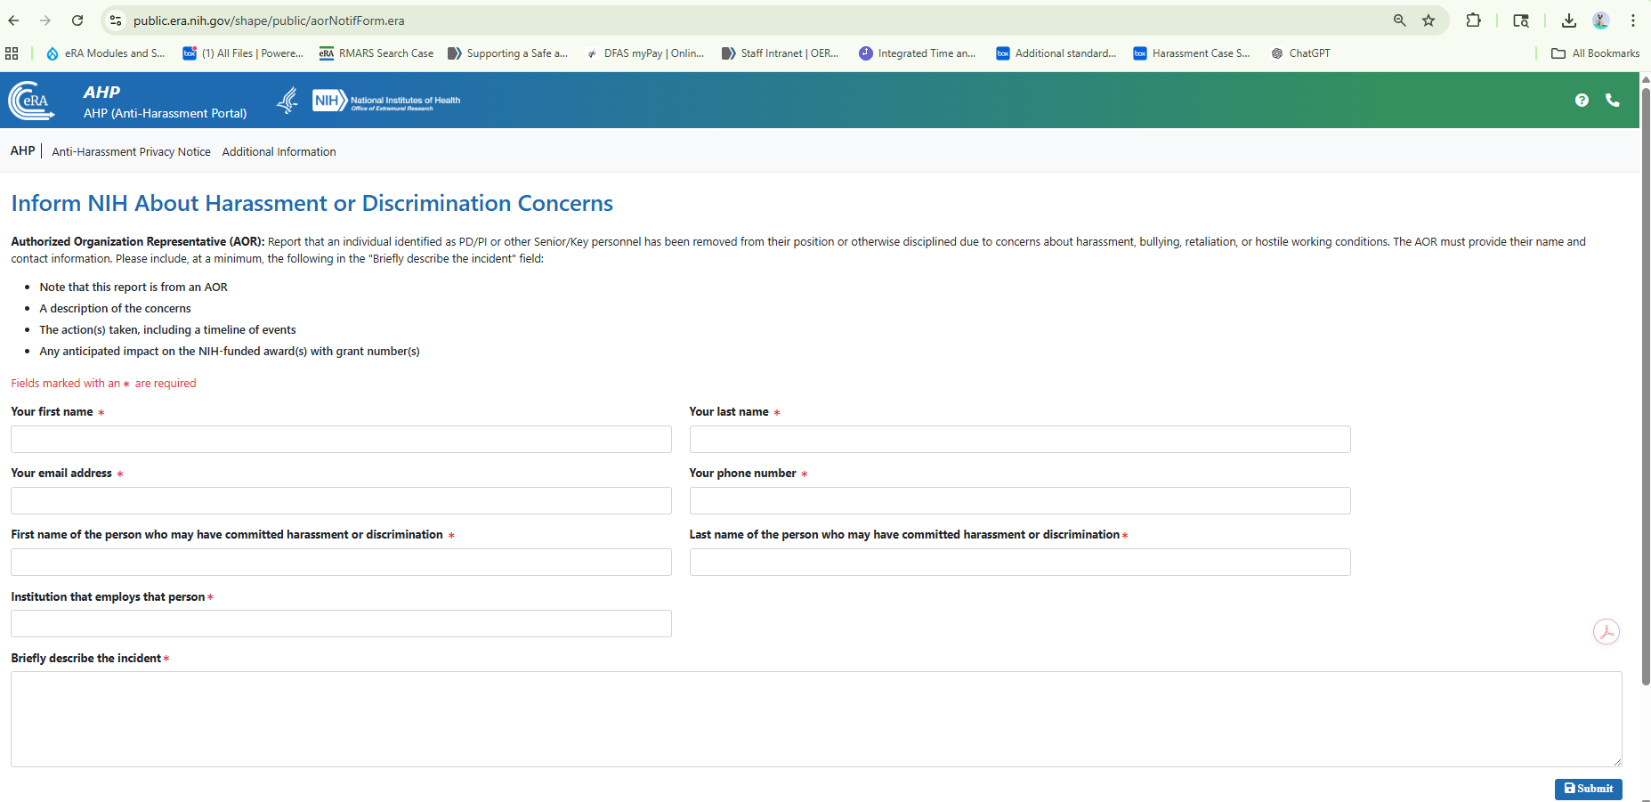
Screen for Authorized Organization Representative:

Screen for Individuals: 