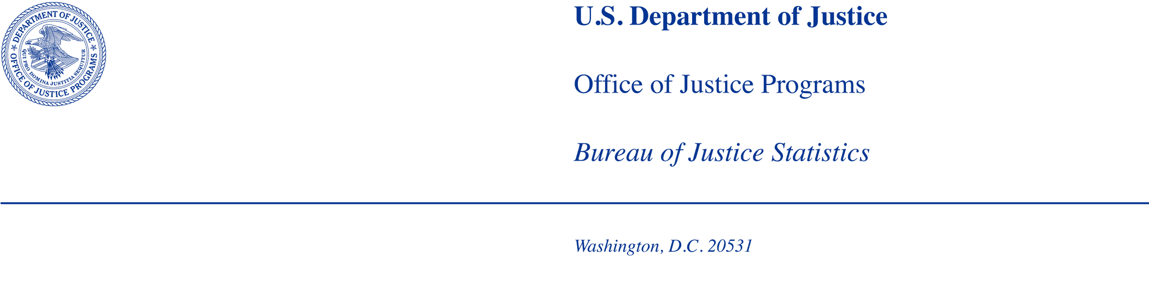
I would but then I wI’m sorr

MEMORANDUM

TO: Office of the Chief Statistician of the United States
Office of Management and Budget

FROM: Bureau of Justice Statistics

DATE: May 29, 2025

SUBJECT: BJS requests to conduct cognitive testing for the Understanding Maternal Health in Local Jails data collection, under the OMB generic clearance agreement (OMB Number 1121-0339).

Summary of Current Request
The Bureau of Justice Statistics (BJS) is requesting clearance under the OMB generic clearance agreement (OMB Control #1121-0339, exp. 01/31/2028) to conduct cognitive testing of a maternal health data collection instrument, called Understanding Maternal Health in Local Jails, to understand the issues involved in measuring health, health services, and health outcomes of incarcerated pregnant women in jails.

Introduction
BJS requests clearance to: 1) contact up to 30 leaders of jails to complete and return a survey on maternal health; 2) contact up to 30 replacement jails to replace refusals; and 3) conduct debriefing interviews with up to 30 jails from that sample. The results of this study will be used to develop recommendations for how BJS can obtain complete and accurate data on maternal health for females in jail facilities, including counts of pregnancies, information on services provided, and pregnancy outcomes. Data collection strategies will be assessed in terms of burden placed on data providers, data quality, and potential to inform a range of related policy questions. The goal of the cognitive testing is to better understand the data availability and instrument design to pursue a national collection.

BJS’s data collection agent for this project, RTI International (RTI), will conduct the cognitive testing August through approximately November of 2025. BJS will work together with RTI to recruit up to 30 jails across varying types of sizes and locations to participate in the survey and follow-up interviews to learn about the quality and challenges related to providing maternal health data to BJS. The total burden is estimated at a maximum of 60 minutes per interview, and an additional estimated 2 hours and 30 minutes for completing the initial survey form.

Justification
This cognitive test is in response to the following request made to BJS from the House Committee on Appropriations:

The Bureau of Justice Statistics shall include in the National Prisoner Statistics Program and Annual Survey of Jails statistics relating to the health needs of incarcerated pregnant women in the criminal justice system, including, but not limited to, the number of pregnant women in custody, outcomes of pregnancies, the provision of pregnancy care and services, health status of pregnant women, and racial and ethnic disparities in maternal health, at the Federal, State, tribal, and local levels. The Committee directs BJS to provide a publicly accessible report, not later than 180 days after enactment of this Act, which summarizes this data.

BJS has collected information about pregnancy at admission and the receipt of prenatal care over numerous iterations of surveys from female inmates through the Survey of Prison Inmates (SPI – OMB Control #1121-0152), the Survey of Inmates in Local Jails (SILJ – OMB Control #1121-0098) and pregnancy questions in the 2021 Departments of Corrections COVID-19 Special Data Collection (NPS-CPan – OMB Control #1121-0373). The NPS-CPan obtained a count of total pregnant females in custody of state-operated and private prisons facilities between March 1, 2020 and February 28, 2021 and the number of females who died from COVID-19 and were pregnant. BJS also collects data on pregnancy outcomes and use of restraints on female prisoners during pregnancy, labor, and postpartum recovery from the Federal Bureau of Prisons as required by the First Step Act Report (P.L. 115-391), Section 610, signed into law on December 21, 2018. These data collections do not collect the data requested by the House Committee on Appropriations specific to jail facilities.

To meet this request, BJS first conducted a feasibility study to examine the availability and quality of data and the challenges of collecting data on the health and health care of pregnant women in custody. This current cognitive test leverages what was learned from the feasibility study by asking for specific information across several topics that will assess the quality of and challenges associated with collecting complete and accurate maternal health data from jails.

Survey Instrument
Using results from the feasibility study and Maternal Healthcare and Pregnancy Prevalence and Outcomes in Prisons, 2023 project report on U.S. jails, lessons learned from the NPS-MatHealth, a review of relevant literature including recommendations and guidelines for the care of incarcerated pregnant and postpartum women, and input from BJS, the project team assembled a list of potential survey topics and items for inclusion. Topics and items included in the prison survey on maternal health were assessed for applicability to a jail facility setting and revised or replaced as appropriate. Topics and survey items were reviewed by internal experts with significant experience working with and within jail facilities for relevance and expected accessibility of required data.

The project team considered potential respondent burden and data validity, expected sample sizes and the rarity of events, concerns related to question clarity, and ultimately relevance to the topic and directive in selection of the survey items to be included in cognitive testing.

The Understanding Maternal Health in Local Jails instrument has 2 sections (Attachment A):
- Section 1: Policy and Procedures: This section of the survey includes a series of yes/no questions about facility capabilities related to pregnant inmates, including staff training, pregnancy screening procedures, and standard medical care. This section also includes questions about pregnancy accommodations, support programs, and postpartum policies.
- Section 2: Pregnancy Screening and Outcomes: This section of the survey collects enumerations of pregnancy screenings, including annual and one-month admissions, screenings, and positive tests. The final set of questions ask for a breakdown of positive tests by race and pregnancy outcome, including live birth, miscarriage, stillbirth, and other outcomes.

Testing Procedures

Selecting Participants
RTI will identify eligible respondents using the frame file from the 2024 Census of Jails provided by BJS. Jails ineligible for the Understanding Maternal Health in Local Jails data collection include jails in Indian Country and facilities in states with combined jail-prison systems (Connecticut, Delaware, Hawaii, Rhode Island, Vermont, and Alaska).

Using a stratified quota sampling method, we will stratify by jail size, census region, and percentage of incarcerated females. Sheriff’s offices that are included in the ongoing 2024 Law Enforcement Management and Administrative Statistics (LEMAS) survey will be excluded where possible to minimize their response burden. Specific quotas will be set for each stratum, and participant selection will continue within each stratum until the quota is reached for that stratum—contacting a maximum of 60 jails and yielding a maximum of 30 cognitive interviews.

If a contact attempt is unsuccessful (e.g., an email bounces back or a call goes to a disconnected phone number), we will verify that all contact information, such as phone numbers and email addresses, are correct and routed to the appropriate contacts for each agency. All research will be done online using publicly sourced information. Sources will include (1) webpages, (2) official governmental reports, and (3) news reports/articles from reputable sources.

To determine the targeted distribution of completed interviews, we first examined the distribution of jails by size (peak population), geography (census region), and percentage of female inmates (percentage female incarcerated). These distributions are provided below in Table 1. Note the relative even distribution by size category, the over-representation in the South and Midwest, and the high prevalence of 11 percent or more incarcerated females by institution.

Table 1: Distributions of Eligible Jails by Variables of Interest, Number and Percentage
Peak Population
 | Number of Jails  (N) | Percent of Jails*  (%)
0-24 | 648 | 22.2
25-100 | 850 | 29.1
101-249 | 669 | 22.9
250 or above | 757 | 25.9
Total | 2,924 | 100.0
Census Region
 | Number of Jails  (N) | Percent of Jails*  (%)
Northeast | 197 | 6.7
Midwest | 926 | 31.7
South | 1,356 | 46.4
West | 445 | 15.2
Total | 2,924 | 100.0
Percentage Female Incarcerated
 | Number of Jails  (N) | Percent of Jails*  (%)
0-10% | 799 | 27.3
11% or more | 2,125 | 72.7
Total | 2,924 | 100.0
*May sum to more than 100 due to rounding
Source: Census of Jails, 2019.

With these distributions in mind, this project will use a recruitment matrix that reflects the overrepresentation by region and percentage of incarcerated females, presented in Table 2. This matrix represents an ideal recruitment outcome, however, qualitative collections are dependent upon participant consent. While every effort will be made to ensure representation from each type of institution, we cannot guarantee that the distribution of completed interviews will exactly match this matrix.

Table 2: Recruitment Matrix of Completed Interviews by Variables of Interest, Number and Percentage
Peak Population
 | Number of Targeted Completed Interviews | Percentage of Targeted Completed Interviews*
0-24 | 7 | 23.3
25-100 | 8 | 26.7
101-249 | 7 | 23.3
250 or above | 8 | 26.7
Total | 30 | 100
Census Region
 | Number of Targeted Completed Interviews | Percentage of Targeted Completed Interviews*
Northeast | 4 | 13.3
Midwest | 10 | 33.3
South | 12 | 40.0
West | 4 | 13.3
Total | 30 | 100
Percentage of Female Incarcerated
 | Number of Targeted Completed Interviews | Percentage of Targeted Completed Interviews*
0-10% | 10 | 33.3
11% or more | 20 | 66.7
Total | 30 | 100
*May sum to more than 100 due to rounding.

Recruitment
Participant recruitment will be conducted by email and telephone to reach recruitment goals. First, we will send an initial recruitment email outlining the purpose of the contact and inviting the recipient to schedule a cognitive interview (Attachment B). This initial contact will also include a series of Frequently Asked Questions and answers to encourage participation, and inform recipients that participation is voluntary. Those recipients that do not respond to the initial recruitment email will be researched to ensure that the email was addressed to the appropriate person, as described above. Up to five follow-up contact attempts will be made to these facilities by email and by phone. See Attachment C for non-response follow-up emails and phone scripts designed to address various nonresponse scenarios and provide answers to any questions facilities may have. As agencies/facilities refuse or remain nonresponsive, replacement facilities will be invited to participate.
Those participants who agree to an interview will receive a confirmation email including instructions for completing the survey and a request to submit the survey 24 hours before the scheduled cognitive interview (Attachment B). This email will also contain the participant informed consent (Attachment D) with an instruction to read, sign, and return the form prior to the interview. If an agency has not completed their survey or returned their informed consent form 48 hours before their scheduled interview, the assigned interviewer will send an email reminding the agency to complete these tasks. See Figure 1 for an overview of the recruitment strategy.

Figure 1: Recruitment Strategy for Cognitive Interviews

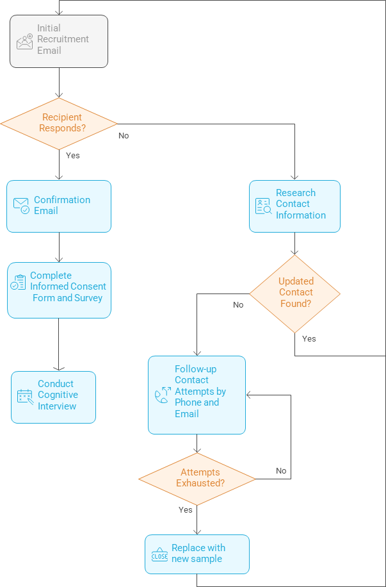

The proposed recruitment schedule is shown in Table 3. Throughout the collection period, as recipients refuse or are non-responsive, and updated contacts or replacement sample are added, the recruitment cycle will restart beginning with the initial recruitment contact.
Table 3: Proposed Recruitment and Interviewing Timeline
Task # | Task Description | Number of participants contacted | Method of contact | Timing of contact
1 | Contact potential cognitive test participants via email | 30 | Email | Day 1
2 | Phone call to request participation from nonrespondents | TBD | Phone | Day 5-20
3 | Contacts to replace participants who decline | TBD | Email | Up to day 21
4 | Recruited participants complete and return survey | TBD | Email | Up to day 35
5 | Email to schedule cognitive interview | TBD | Email | Up to day 35
6 | Cognitive interviews | 30 total completed | Video Conference | Day 5-day 60

Cognitive Interviewing
We will conduct cognitive interviews with up to 30 participants lasting no more than 60 minutes each in order to evaluate and refine the maternal health questionnaire. These interviews will be conducted via Microsoft Teams by trained RTI interviewers with optional BJS observers.
At the start of the cognitive interview, the interviewer will introduce themself to the participant, confirm the participant’s name, and confirm that the participant is on video and can hear the interviewer well. The interviewer will then confirm with the participant their submission of the consent form previously provided with the meeting details of the cognitive interview (see Attachment D). The interviewer will maintain the document indicating the respondent’s decision to participate, including the respondent’s willingness to have the interview recorded.
The interviewers will follow a semi-structured interviewing protocol (Attachment E). Interviews will be recorded if the participant consents. During the interview, interviewers may ask additional probing questions for clarification depending on a participant’s responses.

Burden Hours
The burden hour estimates for the participants are provided in Table 4. The project team expects the initial contact for recruitment and scheduling the cognitive interview to take ten minutes per participant. Up to 60 jail jurisdictions may be contacted to secure 30 cognitive interviews. The estimated burden to complete the 2025 instrument prior to the interview is 2 hours and 30 minutes per respondent. The cognitive interview will require up to a 60-minute video conference interview with each participant.

Table 4: Burden Estimate for Recruitment, Survey Completion, and Interviewing
Task Description | Number of respondents | Participation time  (in minutes) | Total burden (in hours)
State, Local, or Tribal Governments  --Jail recruitment outreach (email or mail) | Up to 60 | 10 | 10
State, Local, or Tribal Governments  --Pre-interview survey completion | Up to 30 | 150 | 75
State, Local, or Tribal Governments  --Cognitive interview | Up to 30 | 60 | 30
Total | 60 |  | 115

Cost
The estimated cost to the Federal Government is $51,461 for RTI’s portion of the work and an estimated $16,760 for the GS-15 Project manager’s work (10% of salary) resulting in a total estimated cost of $68,221 [$51,461 + $16,760].

Project Timeline
Milestone | Start Date | End Date
Submit OMB generic clearance | 06/30/25 | TBD
Recruitment and cognitive testing period | 8/4/2025 | 11/7/2025
Analyze data and develop instrument recommendations | 11/10/2025 | 12/08/2025
Final report and final instrument | 12/08/2025 | 2/11/2026

Data Confidentiality and Security
BJS is authorized to conduct this data collection under 34 U.S.C. § 10132. BJS may use the information it collects only for statistical and research purposes and must gather it in a manner that precludes its use for law enforcement or any purpose relating to a private person or public agency other than statistical or research purposes [Title 34 U.S.C. Section 10134]. By law, BJS is required to protect the confidentiality of information identifiable to a private person and safeguard it against unauthorized disclosure or misuse. [Title 34 United States Code Sections 10134 and 10231]

The testing will collect identifying information including the name of the testing organization, address, email, and telephone number. All information related to the cognitive interviews, including the recordings of interviews, will be stored on a secure drive at RTI International with restricted access to those staff members who are directly involved in cognitive testing. Draft reports will be shared, via email, with all project team members. To protect the identities of the participants, no identifying information will be kept in the final data file. In addition, the recorded conversations of the interviews will be erased one month after completion of the cognitive testing report. Once the instrument is revised and the summary report completed, all copies of the cognitive interview data will be destroyed. The responses to the survey will be entered electronically for incorporation into the full collection. Any paper copies of the survey responses will be retained until the end of the project and destroyed in accordance with the project’s data destruction guidelines.

The BJS Data Protection Guidelines provide more detailed information on how BJS and its data collection agents will use and protect data collected under BJS’s authority. All project staff are required to sign a pledge of confidentiality and privacy certificate which confirms the maintaining of data and following the procedures outlined above. All cognitive interviews will be conducted by project staff at RTI International.

Consent Procedure

At the start of the cognitive interview, the interviewer will introduce themself to the participant, confirm the participant’s name, and confirm that the participant is on video and can hear the interviewer well. The interviewer will then confirm with participant their submission of the consent form previously provided with the meeting details of the cognitive interview (see Attachment D for Informed Consent). The interviewer will maintain the document indicating the respondent’s decision to participate, including the respondent’s willingness to have the interview recorded.

Protection of Human Subjects
The protocol described in this OMB Generic Clearance was submitted for review by the RTI institutional review board and it was determined that the activities as described by the protocol do not meet the definition of human subjects’ research (Attachment F). The research was certified as not meeting the definition of human subjects’ research as described under Department of Justice regulations at 28 CFR 46.

Reporting
Upon completion of the cognitive interviewing, summaries will be combined and analyzed to identify common themes. RTI will provide BJS with a report describing the findings including final recommendations. It will also include any suggested changes to existing data collections and instruments based on the cognitive interviewing. The report will provide detailed information on the testing methodology, respondent characteristics, and findings related to the new questions tested. If BJS decides to post the results of this testing publicly, the report will go through disclosure avoidance review.

Contact Information
Questions regarding any aspect of this project can be directed to:

Todd Minton
Chief
Jails and Community Corrections Statistics Unit
Bureau of Justice Statistics
U.S. Department of Justice
999 North Capitol Street
Washington, DC 20531
Office Phone: (202) 598-7226
E-mail: todd.minton@usdoj.gov

Attachments

Attachment A: Understanding Maternal Health in Local Jails Instrument
Attachment B: Recruitment Email, FAQs, and Confirmation Email
Attachment C: Non-response emails and phone scripts
Attachment D: Informed Consent Form
Attachment E: Cognitive interview protocol
Attachment F: RTI IRB approval

