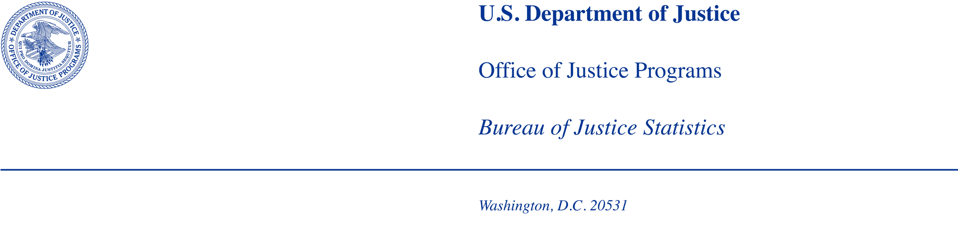
I would but then I wI’m sorr

MEMORANDUM

TO: Office of the Chief Statistician of the United States
Office of Management and Budget

FROM: Bureau of Justice Statistics

DATE: August 29, 2025

SUBJECT: BJS requests to conduct Cognitive Testing of 2024 Statistical Policy Directive No. 15 (SPD 15) Standards in Establishment Surveys, under the OMB generic clearance agreement (OMB Number 1121-0339).

Summary of Current Request
The Bureau of Justice Statistics (BJS) is requesting clearance under the OMB generic clearance agreement (OMB Control #1121-0339, exp. 01/31/2028) to conduct cognitive testing of updated race and ethnicity items developed for law enforcement and correctional establishment surveys in response to the 2024 revisions to OMB’s Statistical Policy Directive No. 15 (SPD 15). This testing will provide guidance on how to implement the 2024 SPD 15 updates to collect aggregate counts on establishment surveys and facilitate an understanding of the issues involved in measuring race and ethnicity in BJS’ portfolio of establishment surveys.

Introduction
BJS requests clearance to 1) contact up to 192 agencies (81 participants with up to 81 alternative contacts for refusals or non-contacts) to participate in the project; 2) allow 81 respondents from law enforcement and corrections agencies to complete a survey designed to test options for collecting staff and/or incarcerated population race and ethnicity data; and 3) conduct cognitive interviews with the 81 respondents that completed the survey. This study will be used to develop recommendations for how BJS will collect aggregated race and ethnicity data in establishment surveys to comply with 2024 SPD 15. Data collection strategies will be assessed in terms of burden placed on data providers and data quality. The goals of cognitive testing are to provide recommendations on how to collect 2024 SPD 15 compliant data in establishment surveys and to understand the challenges with collecting these data.

BJS’s data collection agent for this project, RTI International (RTI), will conduct the cognitive testing November 2025 through March 2026. BJS will work with RTI to recruit up to 81 respondents in law enforcement and correctional agencies of various sizes and types to participate in the survey and follow-up interviews to learn about the quality of and challenges related to providing race and ethnicity data to BJS. The total burden per respondent is estimated to be a total of 80 minutes: 10 minutes for outreach, a maximum 25 minutes for completing the initial survey, and a maximum of 45 minutes per interview.

Study Rationale and Research Questions
BJS has several establishment surveys that collect aggregate counts of individuals by race and ethnicity. However, there is little guidance on how to incorporate the 2024 SPD 15 updates for this type of data. Example items in OMB’s guidance were applicable to data collections about individuals rather than aggregated counts. Results from cognitive testing will inform how to collect race and ethnicity in a way that conforms to the 2024 SPD 15 updates while still being low burden on the respondent.

Using guidance from the policy directive, existing survey items, and input from BJS, the project team assembled a list of potential SPD 15 compliant survey items for testing. The project team revised the OMB examples for applicability to the cumulative reporting used in establishment surveys while still maintaining a combined race and ethnicity item structure, including Middle Eastern and North African (MENA) as a main category, and including detailed categories as examples. Topics and survey items were reviewed by internal experts with significant experience working with correctional facilities and law enforcement agencies.

The project team considered potential respondent burden and data validity, expected sample sizes and availability of records, concerns related to question clarity, and definitions of terms with the goal of assessing the following research questions:
- Is agency-held data available in the formats required by 2024 SPD 15?
- How well do establishment survey respondents understand the 2024 SPD 15 terminology and standards?
- How motivated are respondents to provide accurate race and ethnicity data using revised standards?
- What barriers do respondents experience in collecting and reporting race and ethnicity data in 2024 SPD 15 compliant questions?
- How practical is it to implement the combined race/ethnicity question and detailed categories on establishment surveys?
  - How does an agencies’ ability to provide a response change based on whether the 2024 SPD 15 compliant question uses detailed categories vs. the minimum standard?
- Are agencies able to provide data on people who identify as more than one race or ethnicity in a 2024 SPD 15 compliant question that collects data in the aggregate?
  - What specific challenges do they encounter?
  - What were their successes?
- Should BJS include “not of Hispanic origin” next to race categories or exclude? (see below)

The interviews will test draft items designed to collect 2024 SPD 15 minimum standard data on the racial and ethnic breakdowns of employees and incarcerated populations in several BJS data collections (Attachment A). Race and ethnicity items will be tested from the following BJS data collections:

Law enforcement:
- Census of Federal Law Enforcement Officers (CFLEO)
- Census of Law Enforcement Training Academies (CLETA) (OMB Control # 1121-0255)
- Census of State and Local Law Enforcement Agencies (CSLLEA) (OMB Control # 1121-0246)
- Law Enforcement Management and Administrative Statistics (LEMAS) (OMB Control # 1121-0240)
- Survey of Campus Law Enforcement Agencies (SCLEA) (OMB Control # 1121-0334)
Corrections:
- Annual Probation Survey & Annual Survey of Parole (ASPP) (OMB Control # 1121-0064)
- Census of Jails (COJ) (OMB Control # 1121-0100)
- Census of State and Federal Adult Correctional Facilities (CCF) (OMB Control # 1121-0147)
- National Prisoner Statistics (NPS) (OMB Control # 1121-0102)

Historically, BJS has included “not of Hispanic origin” after each race when collecting aggregate counts. OMB guidance does not include this as an option and removal of this detail could impact continuity over time. For cognitive testing, the default format for the revised items will be to exclude “not of Hispanic origin” after each race. However, to determine the impact of this removal, the study team will present both a version without the language and one with the language for one law enforcement collection (CSLLEA) and two corrections collections (ASPP: Probation survey and CCF: Confinement questionnaire).

Testing Procedures

Frame and Sample Selection
Since the proposed project involves multiple BJS data collections across law enforcement and corrections, RTI will use various frames to pull sampled agencies. For law enforcement agencies (LEAs), the Law Enforcement Agency Roster (LEAR) will be used. The LEAR was created in 2016 to serve as a frame for BJS’s core law enforcement collections. For correctional agencies, the frame from the most recent data collection will be used. For example, parole and probation agencies will be pulled from the 2024 ASPP frame and prisons will be pulled from the 2024 NPS. Table 1 lists the frame for the proposed strata, agency counts on the frame, and the maximum number of respondents per strata.

Table 1. Primary strata, sample source, and anticipated number of respondents
Primary Strata | Frame | Number of Agencies (based on most current frame) | Maximum Number of Respondents
Law enforcement agencies (LEAs)
Large General Purpose LEAs (100+ FTE Sworn) | LEAR | 1,067 | 9
Small General Purpose LEAs (1-99.9 FTE Sworn) | LEAR | 13,390 | 9
Campus LEAs | LEAR | 1,954 | 9
Federal LEAs | LEAR | 141 | 9
Law Enforcement Training Academies | LEAR | 857 | 9
Probation Agencies | 2024 ASPP frame | 776 | 9
Parole Agencies | 2024 ASPP frame | 52 | 9
Jails | 2024 COJ frame | 2,763 | 9
Prisons | 2024 NPS frame | 51 | 9
Total |  | 21,051 | 81

RTI will use a sampling strategy that supports BJS’s need to collect data from a variety of different establishment types and sizes that have different record keeping systems/protocols. The strategy will utilize a purposive stratified quota sampling method, with establishments stratified by type and/or size (depending on the establishment type and anticipated variability in agency reporting within type). For each stratum, RTI will use a quota of 9 interviews per stratum based on the assumption that there will still be some variation within each stratum. Fewer cognitive interviews may not yield a full understanding of the challenges respondents could face when completing the 2024 SPD 15 compliant race and ethnicity questions. The anticipated stratum and number of cognitive interviews are noted in Table 1.

While these will be the primary strata, secondary strata have been identified where participants may vary in their ability to provide race and ethnicity data within the primary strata (Table 2). As needed, additional replacement agencies will be identified in each stratum as agencies refuse or are unresponsive to outreach. Additional agencies will be drawn in order from the sorted strata in the draft sample file. For example, privately operated and state operated prisons may keep different types of records on race and ethnicity of staff and incarcerated people.

Table 2. Primary and secondary strata
Primary Strata | Secondary Strata
Law enforcement agencies (LEAs)
Large General Purpose LEAs (100+ FTE Sworn) | - Local police  - Sheriff’s offices
Small General Purpose LEAs (1-99.9 FTE Sworn) | - Local police  - Sheriff’s offices
Campus LEAs | - Private  - Public
Federal LEAs | N/A
Law Enforcement Training Academies | - Agency operated  - University/college operated
Probation Agencies | - Centralized  - Decentralized
Parole Agencies | N/A
Jails | - Small (<100 held)  - All other jails
Prisons | - Federal Bureau of Prisons  - State  - Private

Since the primary/secondary sampling strata are not mutually exclusive, BJS and RTI will identify and prioritize selecting agencies that could provide responses for multiple collections. For example, a sheriff’s office may operate a jail and training academy in addition to being a general-purpose LEA, which means they could provide feedback on 2024 SPD 15 compliant race and ethnicity questions for LEMAS, CSLLEA, CLETA, and COJ. We will plan to use this overlap to increase the diversity of agency types sampled. The sampling plan and data collection protocols will account for the fact that a different agency representative may reply to different items (e.g., within a sheriff’s office the sheriff may reply to CSLLEA, the jail administrator to COJ, and the training academy lead to CLETA). See Attachment B for a table that provides all possible combinations of eligible survey items by primary/secondary strata.

RTI will identify respondents using the most recent frame files as shown in Table 1. Testing and participant selection will continue within each stratum until the quota is reached for that stratum. In addition to the primary sample, a replacement sample containing 81 additional participants will be used to replace agencies that refuse to participate or do not respond within 21 days of receiving their initial invitation.

If a contact attempt is unsuccessful at any point during recruitment (e.g., an email bounces back or a call goes to a disconnected phone number), all contact information will be verified, such as phone numbers and email addresses, are correct and routed to the appropriate contacts for each agency. All research will be done online using publicly sourced information. Sources will include (1) webpages, (2) official governmental reports, and (3) news reports/articles from reputable sources.

Recruitment and Screening
Participant recruitment will be conducted by email and telephone. First, an initial recruitment email outlining the purpose of the contact and inviting the recipient to schedule a cognitive interview will be sent (Attachment C). This initial contact will include a series of Frequently Asked Questions and answers to encourage participation, and inform recipients that participation is voluntary. Those recipients that do not respond to the initial recruitment email will be researched to ensure that the email was addressed to the appropriate person, as described above. Follow-up contact attempts will be made to these respondents by email and by phone. See Attachment C for non-response follow-up emails and phone scripts designed to address various nonresponse scenarios and provide answers to any questions. As agencies refuse or remain nonresponsive, replacement respondents will be invited to participate.

Agencies who agree to participate will receive a confirmation email including instructions for completing the survey (Attachment C). The email will also request the respondent to submit the survey 24 hours before the scheduled cognitive interview, record the time it took to complete the survey, and retain any records used to complete the survey. Additionally, the email will also contain the participant informed consent (Attachment D) with an instruction to read the form prior to the interview. If a respondent has not completed their survey 48 hours before their scheduled interview, the assigned interviewer will send an email reminding the respondent to complete these tasks. See Figure 1 for an overview of the recruitment strategy.
Figure 1. Recruitment strategy for cognitive interviews

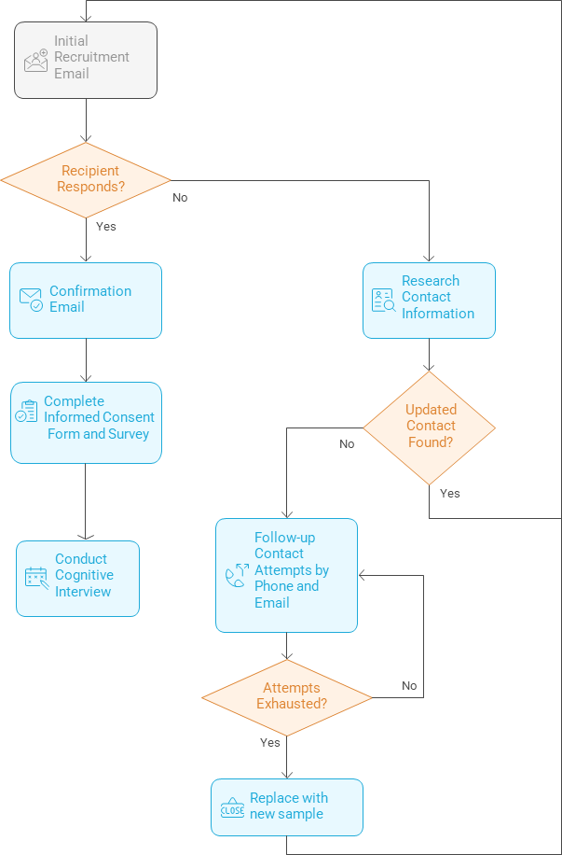

The proposed recruitment schedule is shown in Table 3. Throughout the data collection period, as recipients refuse or are non-responsive and updated contacts or replacement sample are added, the recruitment cycle will restart beginning with the initial recruitment contact.
Table 3. Proposed recruitment and interviewing timeline
Task # | Task Description | Number of participants contacted | Method of contact | Timing of contact
1 | Contact potential cognitive test participants via email | 81 | Email | Day 1
2 | Phone call to request participation from nonrespondents | Up to 81 | Phone | Day 5-20
3 | Contacts to replace participants who decline | Up to 81 additional | Email | Up to day 21
4 | Respondents complete and return survey | 81 | Email | Up to day 35
5 | Email to schedule cognitive interview | 81 | Email | Up to day 35
6 | Cognitive interviews | 81 total completed | Video Conference | Day 5-day 60

Data Collection Process
Participants will be asked to complete the relevant minimum standard race and ethnicity questions for their agency in advance of their scheduled cognitive interview (Attachment A). The number of items asked will vary based on the number of collections the agency is eligible for and the number of race and ethnicity items on each data collection (Table 4). The data collections with alternative language including “not of Hispanic origin” after each race are marked with an X in table 4.

Table 4. BJS data collections, primary strata, number of applicable race and ethnicity items, and collections with alternate Hispanic origin language
Data Collection | Primary Strata | Number of Items | Hispanic Origin Alt. Language
Law enforcement
CFLEO | Federal LEAs | 2
CLETA | Law enforcement training academies | 1
CSLLEA | Large & small general-purpose LEAs; campus LEAs | 1 | X
LEMAS | Large & small general-purpose LEAs | 2
SCLEA | Campus LEAs | 1
Corrections
ASPP | - Parole  - Probation | - 1  - 1 | X
COJ | Jails | 1
CCF | Prisons | 2 | X (confinement only)
NPS | Prisons | 2
The project team will conduct cognitive interviews with up to 81 participants lasting no more than 45 minutes each to evaluate and refine the combined race and ethnicity survey questions. These interviews will be conducted by trained RTI interviewers with optional BJS observers. The cognitive interviews will be conducted virtually via Microsoft Teams and recorded with participant’s permission. If a participant does not want to be recorded, a member of the RTI team will take notes.

Interviewers will follow a semi-structured interviewing protocol (Attachment E). During the interview, interviewers may ask additional probing questions for clarification depending on a participant’s responses. In addition, RTI will ask the respondent to review detailed versions of the race and ethnicity questions and provide an assessment of how feasible it would be for their agency to respond to the more detailed race and ethnicity categories.

Language
The survey items and cognitive interviewing will be conducted only in English.

Informed Consent
At the start of cognitive interviewing, the interviewer will introduce themself to the participant, confirm the participant’s name, and confirm that the participant is on video and can hear the interviewer well. The interviewer will then confirm with the participant their submission of the consent form previously provided (Attachment D). The interviewer will maintain the document indicating the respondent’s decision to participate, including the respondent’s willingness to have the interview recorded. If the informed consent form was not returned prior to the cognitive interview, the interviewer will read through the form and obtain verbal consent from the respondent.

Justification for Sensitive Questions
The data collection does not include questions of a sensitive nature.

Timeline
Milestone | Start Date | End Date
Submit OMB generic clearance | 08/29/25 | TBD
Recruitment and cognitive testing period | 11/24/25 | 03/06/26
Analyze data and develop instrument recommendations | 03/09/26 | 03/27/26
Final report and final instrument items | 03/30/26 | 05/08/26

Burden Hours
The burden hour estimates for participants are provided in Table 5. The project team expects the initial contact for recruitment and scheduling the cognitive interview to take ten minutes per participant. Up to 192 agencies (174 from governments + 18 from private sector) may be contacted to secure 81 cognitive interviews. The estimated burden to complete the instrument prior to the interview is a maximum of 25 minutes per respondent. The cognitive interview will require up to a 45-minute video conference interview with each participant. The total burden is 127 hours.

Table 5. Burden estimate for recruitment, survey completion, and interviewing
Task Description | Maximum # of Respondents | Participation Time  (minutes) | Total Burden (in hours)
State, Local, or Tribal Governments  --Recruitment outreach (email or mail) | 174 | 10 | 29
State, Local, or Tribal Governments  --Pre-interview survey completion | 72 | 25 | 30
State, Local, or Tribal Governments  --Cognitive interview | 72 | 45 | 54
Private sector  --Recruitment outreach (email or mail) | 18 | 10 | 3
Private sector  --Pre-interview survey completion | 9 | 25 | 4
Private sector  --Cognitive interview | 9 | 45 | 7
Total | 192 |  | 127

Paying Respondents/Participants

Respondents/participants will not be compensated for their involvement in this research.

Cost to the Federal Government
The estimated cost to the Federal Government is $51,461 for RTI’s portion of the work and an estimated $16,760 for the GS-15 Project manager’s work (10% of salary) resulting in a total estimated cost of $68,221 [$51,461 + $16,760].

Analysis and Reporting
Upon completion of the cognitive interviewing, summaries will be combined and analyzed to identify common themes. RTI will provide BJS with a report describing the findings including final recommendations. The report will also include any suggested changes to existing data collections and instruments based on the cognitive interviewing. The report will provide detailed information on the testing methodology, respondent characteristics, and findings related to the new questions tested. If BJS decides to post the results of this testing publicly, the report will go through disclosure avoidance review.

Data Confidentiality and Security
BJS is authorized to conduct this data collection under 34 U.S.C. § 10132. BJS may use the information it collects only for statistical and research purposes and must gather it in a manner that precludes its use for law enforcement or any purpose relating to a private person or public agency other than statistical or research purposes [Title 34 U.S.C. Section 10134]. By law, BJS is required to protect the confidentiality of information identifiable to a private person and safeguard it against unauthorized disclosure or misuse. [Title 34 United States Code Sections 10134 and 10231]

The testing will collect identifying information including the name of the testing organization, address, email, and telephone number. All information related to the cognitive interviews, including the recordings of interviews, will be stored on a secure drive at RTI International with restricted access to those staff members who are directly involved in cognitive testing. Draft reports will be shared, via email, with all project team members. To protect the identities of the participants, no identifying information will be kept in the final data file. In addition, the recorded conversations of the interviews will be erased upon completion of the cognitive testing report (about three months after interviewing has ended). Once the instrument is revised and the summary report completed, all copies of the cognitive interview data will be destroyed.

The BJS Data Protection Guidelines provide more detailed information on how BJS and its data collection agents will use and protect data collected under BJS’s authority. All project staff are required to sign a pledge of confidentiality and privacy certificate which confirms the maintaining of data and following the procedures outlined above. All cognitive interviews will be conducted by project staff at RTI International.

Protection of Human Subjects
The protocol described in this OMB Generic Clearance was submitted for review by the RTI institutional review board and it was determined that the activities as described by the protocol do not meet the definition of human subjects’ research (Attachment F). The research was certified as not meeting the definition of human subjects’ research as described under Department of Justice regulations at 28 CFR 46.

Contact Information
Questions regarding any aspect of this project can be directed to:

Statistical Methods Unit
Bureau of Justice Statistics
U.S. Department of Justice
999 N Capitol St NE
Washington, DC 20002
Office Phone: (202) 307-0765
E-mail: ASKBJS@usdoj.gov

Attachments
Attachment A: Cognitive Testing of 2024 Statistical Policy Directive No. 15 (SPD 15) Standards in Establishment Surveys instrument
Attachment B: Strata by survey items
Attachment C: Recruitment & Non-Response Follow-Up
Attachment D: Informed consent form
Attachment E: Cognitive interview protocol
Attachment F: RTI IRB non-human subjects exemption

