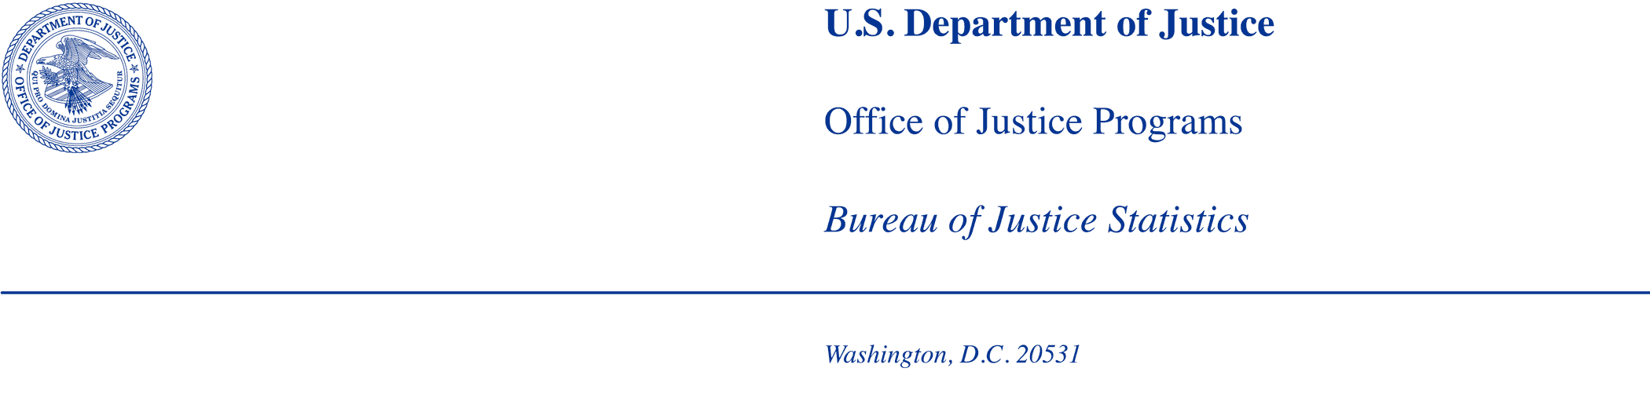

MEMORANDUM

TO: Office of Statistical and Science Policy
Office of Management and Budget

FROM: Bureau of Justice Statistics

DATE: May 6, 2026

SUBJECT: Non-substantive change request for the BJS generic clearance agreement and Statistical Policy Directive No. 15 cognitive testing (OMB Number 1121-0339)

This memo requests non-substantive changes to the 1) Generic Clearance for Cognitive, Pilot and Field Studies for Bureau of Justice Statistics Data Collection Activities which is approved through 1/31/2028 under OMB Control No. 1121-0339, and 2) Statistical Policy Directive No. 15 (SPD 15) cognitive testing task being conducted under the BJS generic clearance (OMB Control No. 1121-0339). For the first request, the Bureau of Justice Statistics (BJS) is proposing to revise text under Part A, such that data collected from research and development activities can be released in a public-use format for data users to access. For the second request, BJS is asking to increase the reserve sample of law enforcement agencies invited to cognitive testing due to low response.
Changes to BJS Generic Clearance (OMB Control No. 1121-0339)
Description of changes to Part A
BJS proposes the following revision under section #1:
Pilot testing – defined, for purposes of this clearance, as data collection efforts that are conducted among purposive or statistically representative samples for evaluative purposes. BJS conducts pilot testing to evaluate its data collection instruments and/or procedures. Pilot tests are an essential component of this clearance package because they serve as the vehicle for investigating basic item properties for new or redesigned data collection efforts, such as reliability, validity, and difficulty. Pilot tests can also be used to assess the feasibility of methods for standardizing the administration of data collection instruments and to test procedures regarding data procurement as well as comparability of data across sites. BJS will use results from pilot tests to publish research and development (R&D) and methodological reports. BJS will not publish official statistics through statistical reports based on these findings. BJS may publish public-use or restricted datasets from these pilot tests that meet the agency’s disclosure and quality standards.
•Split-sample experiments – involve testing alternative versions of questionnaires, and other collection methods, at least some of which have been designed to address problems identified in draft questionnaires or questionnaires from previous surveys. The use of multiple questionnaires, randomly assigned to permit statistical comparisons, is the critical component here. Data collection can include mail, telephone, Internet, or personal visit interviews or group sessions at which self-administered questionnaires are completed. Comparison of revised questionnaires against a control version, preferably, or against each other, facilitates statistical evaluation of the performance of alternative versions of the questionnaire. Split-sample tests that incorporate questionnaire design experiments are likely to have a larger maximum sample size than field tests using other methodologies. Larger sample sizes will enable the detection of statistically significant differences and facilitate methodological experiments that can extend questionnaire design knowledge more generally for use in a variety of BJS data collection instruments. BJS will not publish official statistics through statistical reports based on these findings. BJS may publish public-use or restricted datasets from these split-sample experiments that meet the agency’s disclosure and quality standards.
BJS proposes the following revisions at the end of section #2:
Because the data collection instruments being tested under this clearance are still in the process of development, the data that result from these collections are not considered official BJS or other federal statistics. If the datasets meet agency disclosure and quality standards, public-use or restricted datasets may be published. The data will be used only to inform statistical activities and data quality improvement efforts. The data may be used for presentations related to survey methodology at professional meetings or publications in professional journals. BJS will not disclose individual-level information that could result in the identification of a specific respondent, or use the information for compliance, benefits determinations, or enforcement purposes.
Impact of these revisions:
These proposed modifications are expected to have a negligible impact on burden and cost. Publishing these datasets will increase transparency and accessibility of information.
Changes to 2024 Statistical Policy Directive No. 15 Cognitive Testing Task (OMB Control No. 1121-0339)
Description of changes to generic clearance memo
On September 30, 2025, OMB approved “Cognitive Testing of 2024 Statistical Policy Directive No. 15 (SPD 15) Standards in Establishment Surveys” under the BJS generic clearance. BJS was approved to cognitively interview up to 81 law enforcement and correctional agencies with a reserve sample of 81 agencies for a total outreach to 174 public agencies and 18 private agencies. Among the law enforcement agencies, BJS proposed outreach to 90 agencies (local police departments, sheriffs’ offices, campus, federal, and training academies) with up to 45 agencies (41 public, 4 private) being cognitively interviewed. After two months of recruitment, only 12 law enforcement agencies have responded to the survey only (and not yet interviewed) or completed both the survey and cognitive interview. Due to the low response, BJS proposes to increase the outreach (reserve) sample by an additional 106 public law enforcement agencies (total = 196 law enforcement agencies with 180 public and 16 private agencies) to get a target of 45 cognitive interviews in law enforcement agencies.
Impact of these revisions:
The proposed modification increases the total number of respondents to 298 but does not increase the number of burden hours or cost. The burden hours did not increase because cognitive interviews take less time (about 25 minutes) than originally estimated (45 minutes). The distribution of cognitive interviews between public and private agencies also changed (fewer private agencies are expected to be contacted and participate).
Revised burden estimate for recruitment, survey completion, and interviewing
Task Description | Maximum # of Respondents | Participation Time  (minutes) | Total Burden (in hours)
State, Local, or Tribal Governments  --Recruitment outreach (email or mail) | 282 | 10 | 47
State, Local, or Tribal Governments  --Pre-interview survey completion | 77 | 25 | 32
State, Local, or Tribal Governments  --Cognitive interview | 77 | 25 | 32
Private sector  --Recruitment outreach (email or mail) | 16 | 10 | 3
Private sector  --Pre-interview survey completion | 4 | 25 | 2
Private sector  --Cognitive interview | 4 | 25 | 2
Total | 298 |  | 118

Attachments:
Attachment 1. Generic Clearance Part A with highlighted changes

