OMB Control# 1660-0072
Expiration Date: XX/XX/20XX
PAPERWORK BURDEN DISCLOSURE NOTICE

Public reporting burden for this data collection is estimated to average 5 hours per response. The burden estimate includes the time for reviewing instructions, searching existing data sources, gathering and maintaining the needed data, and completing, and submitting this form. This collection of information is required to obtain or retain benefits. You are not required to respond to this collection of information unless it displays a valid OMB control number. Send comments regarding the accuracy of the burden estimate and any suggestions for reducing this burden to: Information Collections Management, Department of Homeland Security, Federal Emergency Management Agency, 500 C Street, SW, Washington, DC, 20472, and Paperwork Reduction Project (1660-0072). NOTE: Do not send your completed form to the above address.

The Benefit Cost Analysis (BCA) is a decision-making tool that Federal Emergency Management Agency (FEMA) uses to evaluate the cost effectiveness of hazard mitigation projects. This toolkit is found within users’ Excel application and is accessed by clicking on the “FEMA BCA v6.0” icon within the open application.

The BCA Toolkit icon in Excel looks this in the upper right corner:

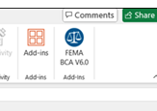

The first screenshot is from the add-in sidebar window with the PRA information highlighted with a red box..

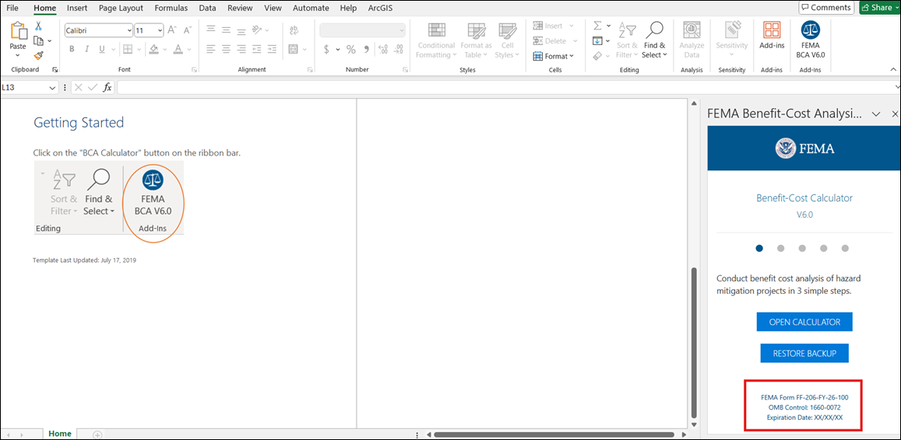

The second screenshot is the static banner inside the Toolkit with the PRA information highlighted with a red box.

