OMB Control# 1660-0072
Expiration Date: XX/XX/20XX
PAPERWORK BURDEN DISCLOSURE NOTICE

Public reporting burden for this data collection is estimated to average 7.5 hours per response. The burden estimate includes the time for reviewing instructions, searching existing data sources, gathering and maintaining the needed data, and completing, and submitting this form. This collection of information is required to obtain or retain benefits. You are not required to respond to this collection of information unless it displays a valid OMB control number. Send comments regarding the accuracy of the burden estimate and any suggestions for reducing this burden to: Information Collections Management, Department of Homeland Security, Federal Emergency Management Agency, 500 C Street, SW, Washington, DC, 20472, and Paperwork Reduction Project (1660-0072). NOTE: Do not send your completed form to the above address.

Environmental/Historic Preservation Information:

This is an example of what is displayed for all questions with a “No” selection.
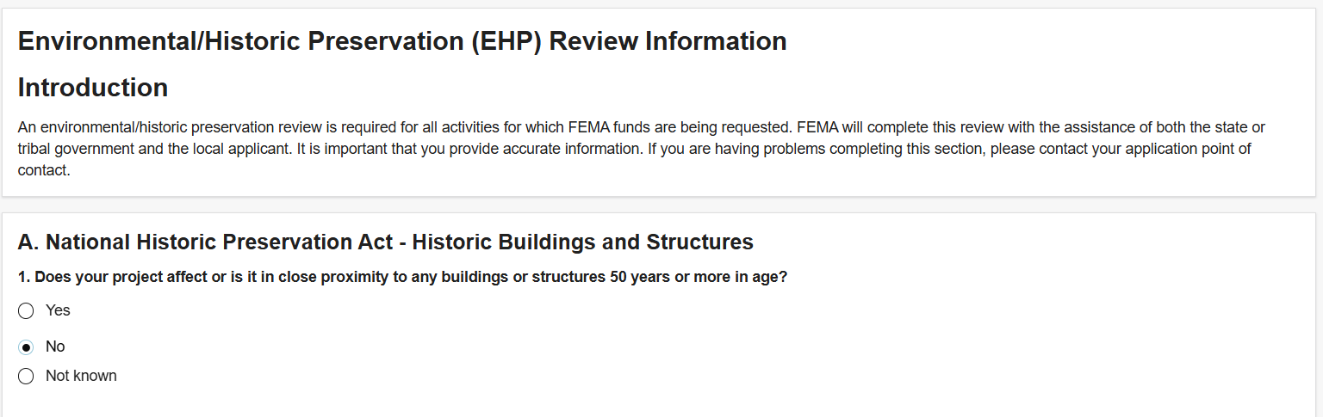
This is an example of what the test box would display for all questions with a “Not known” selection.
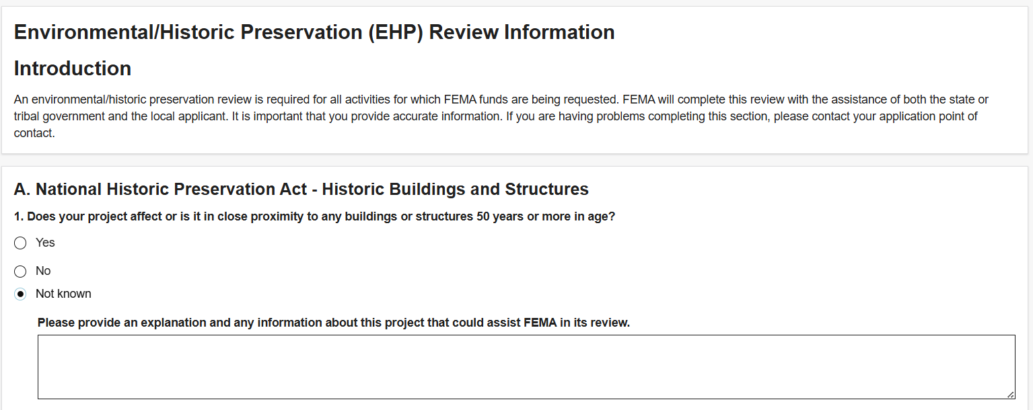

A. National Historic Preservation Act – Historic Buildings and Structures

This is an example of what is display for question A with a “Yes” selection: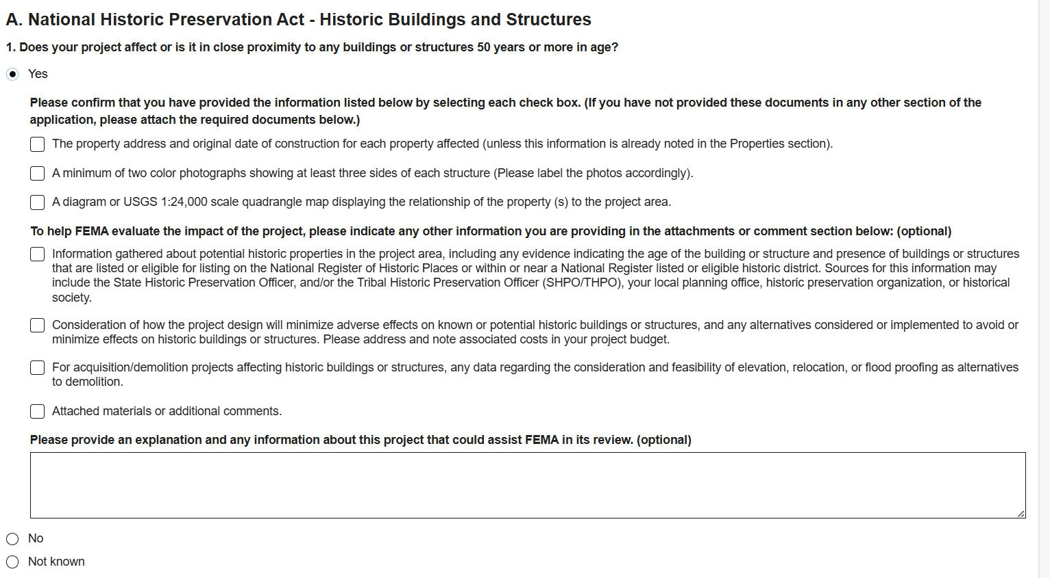
If you select Yes you must place a check mark in all three blocks as shown below.
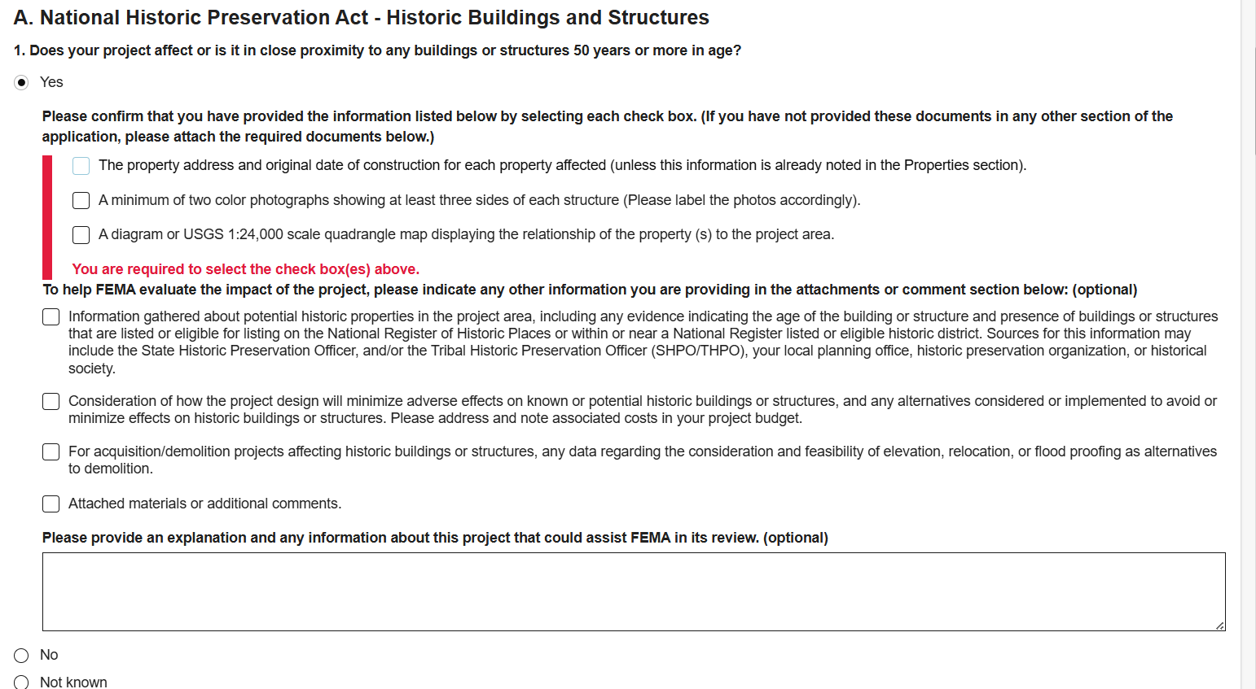

B. National Historic Preservation Act – Archeological Resources

This is an example of what is display for question B with a “Yes” selection. If you select Yes you must place a check mark in all three blocks as shown below.
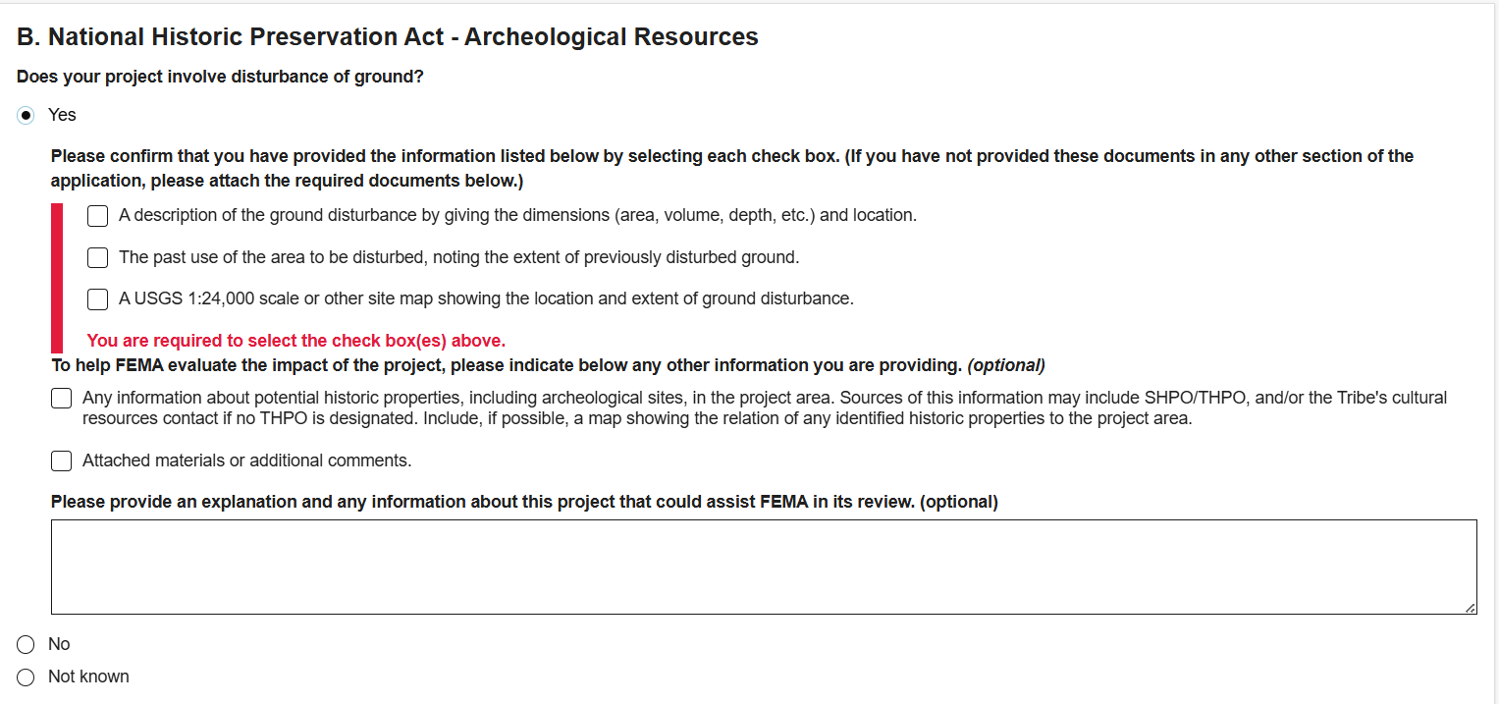
C. Endangered Species Act and Wildlife Coordination Act

Question C has 3 questions that need to be addressed separately as shown below.
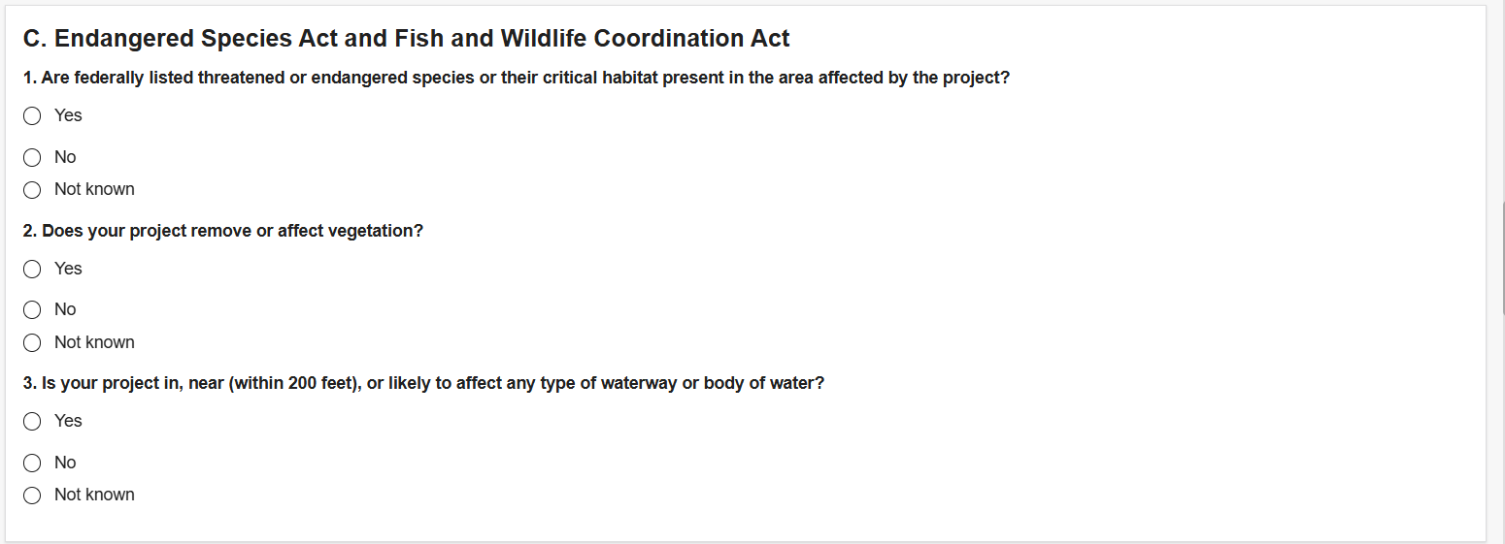
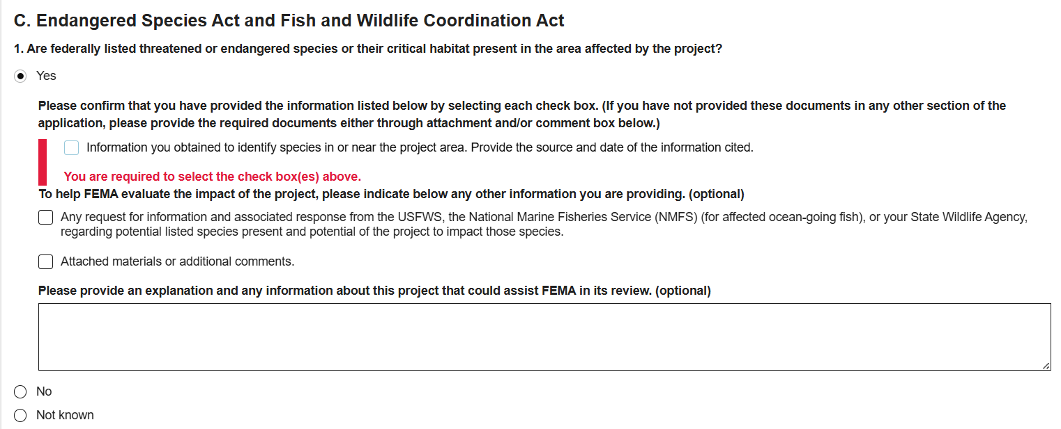
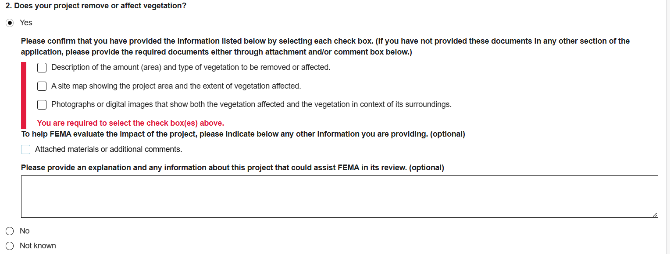
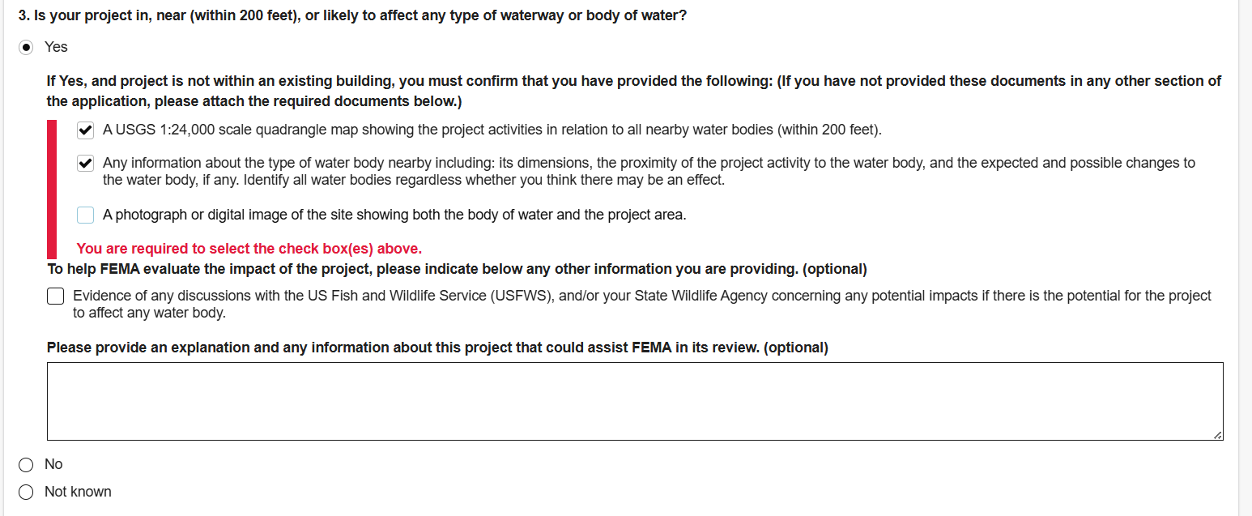
D. Clean Water Act, Rivers and Harbors Act, and Executive Order 11990 (Protection of Wetlands)

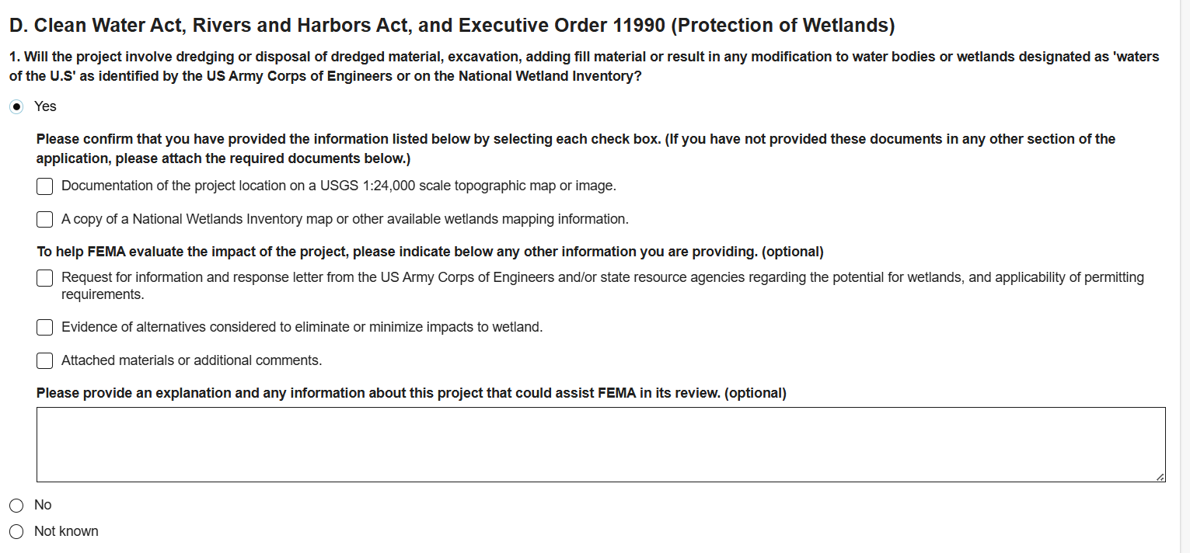
E. Executive Order 11988 (Floodplain Management)

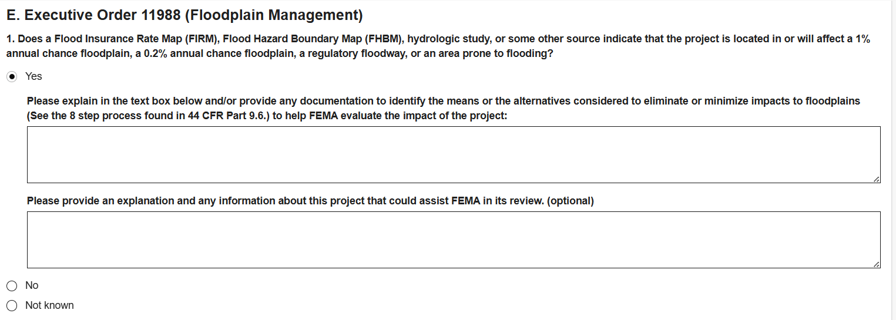
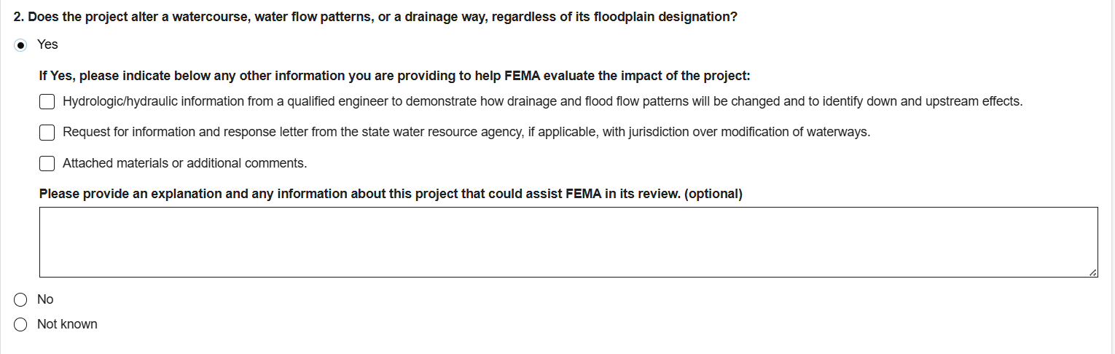
F. Coastal Zone Management Act

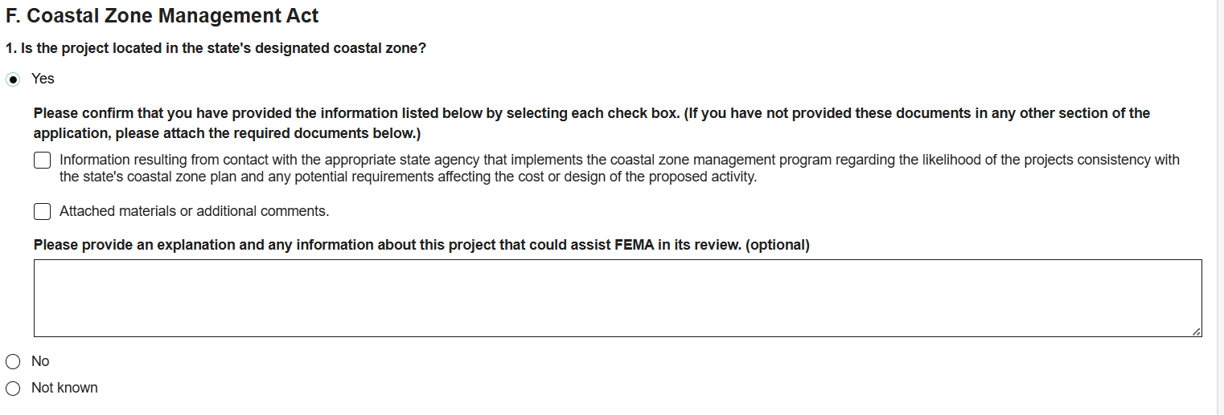
G. Farmland Protection Policy Act

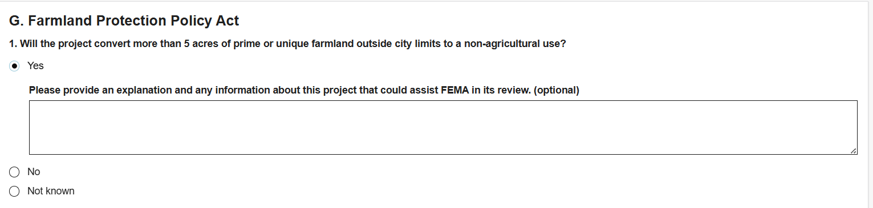

H. Resource Conservation and Recovery Act (RCRA) and Comprehensive Environmental Response Compensation and Liability Act (CERCLA) (Hazardous and Toxic Materials)

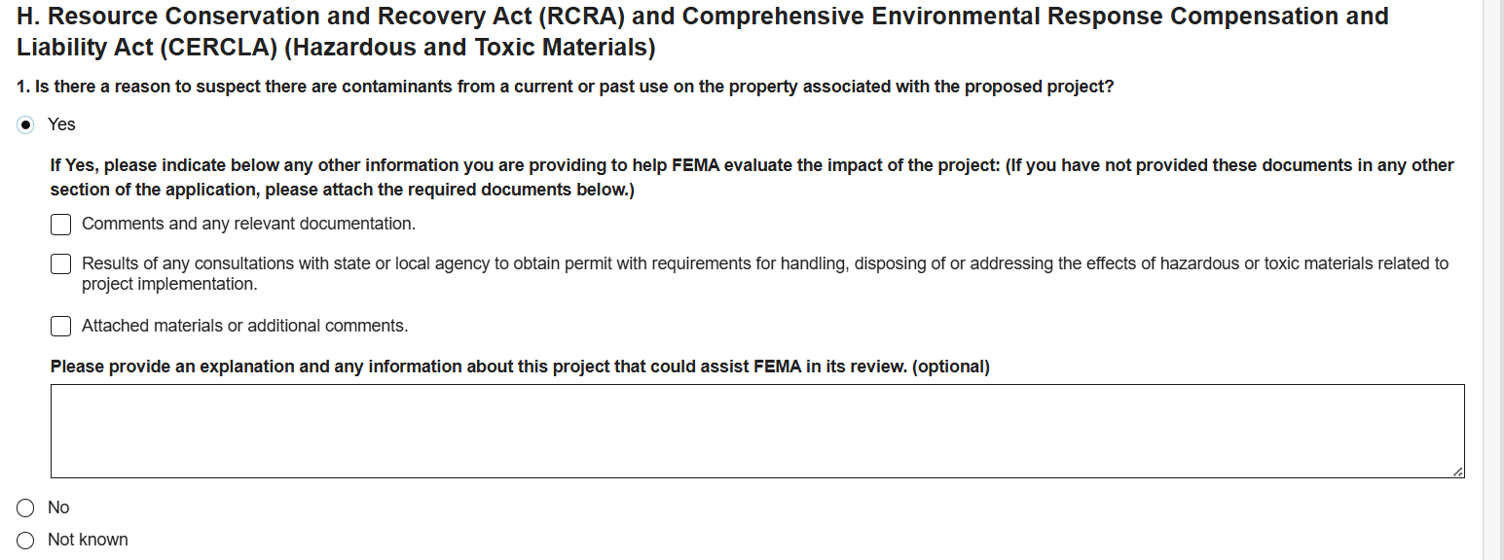
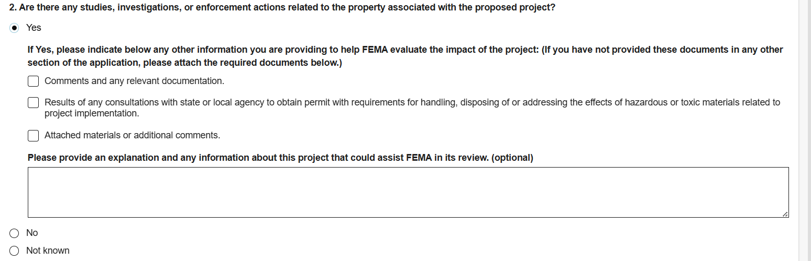
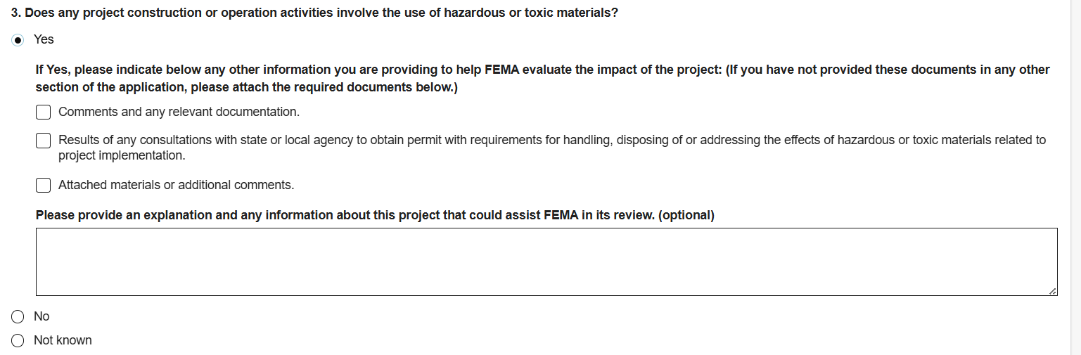
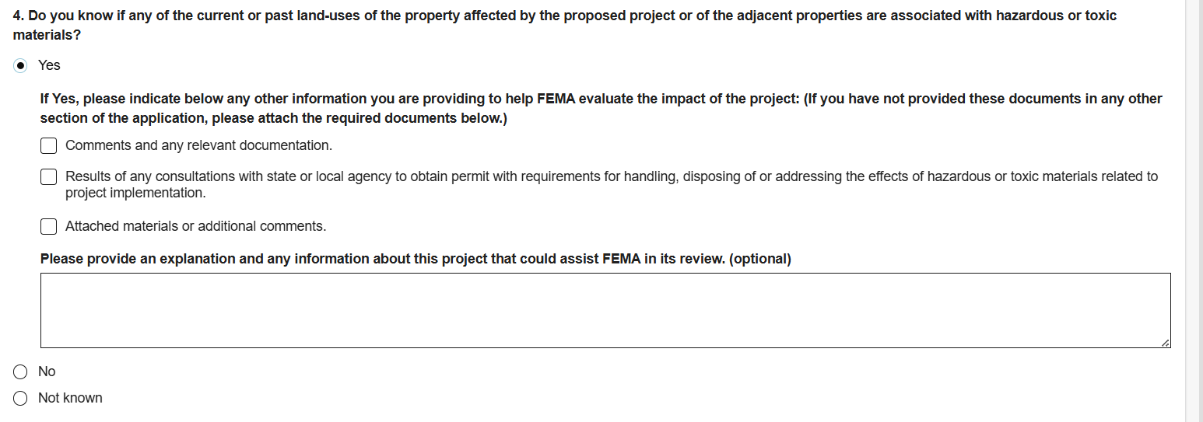
I. Other Environmental Historic Preservation Laws or Issues

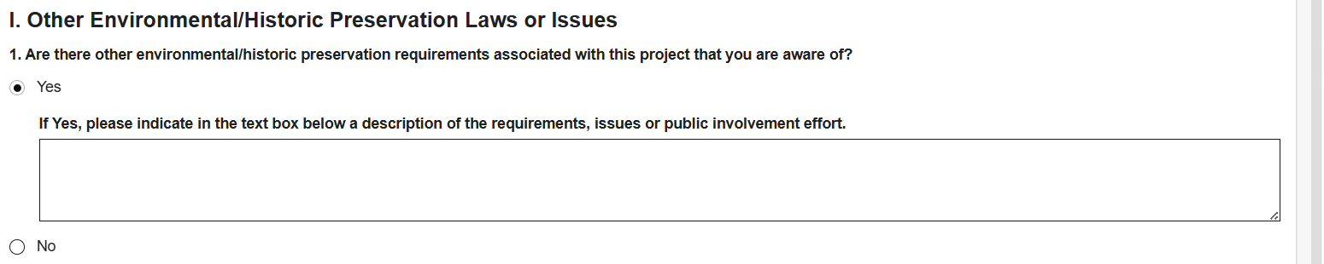
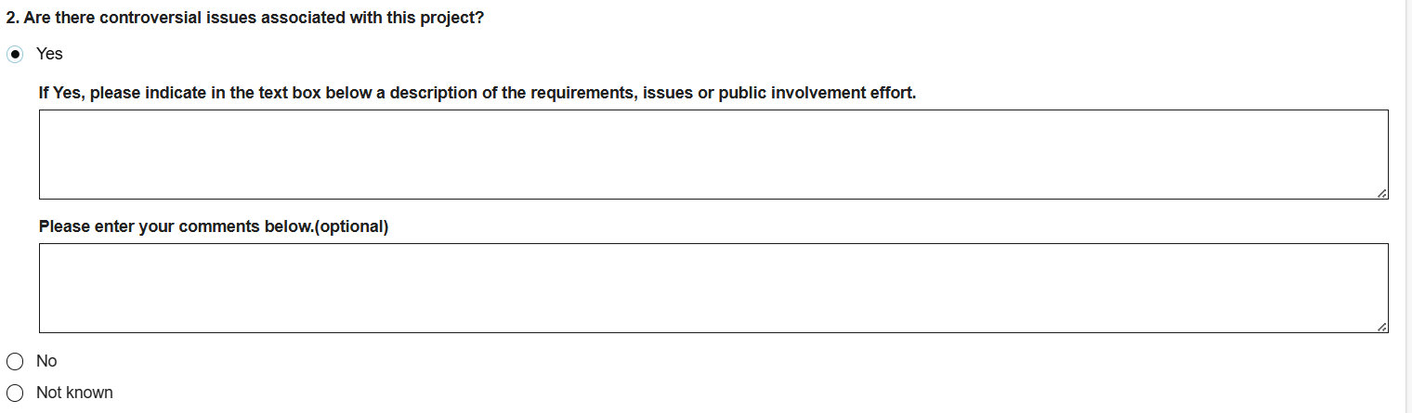
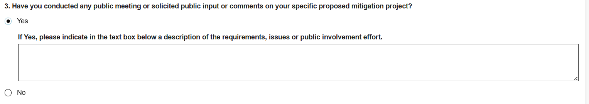

J. Summary and Cost of Potential Impacts

