Appendix C – Comments and Response to Comments Received on the First Federal Register Notice

EPA-HQ-OW-2024-0561-0005: Unleaded Kids
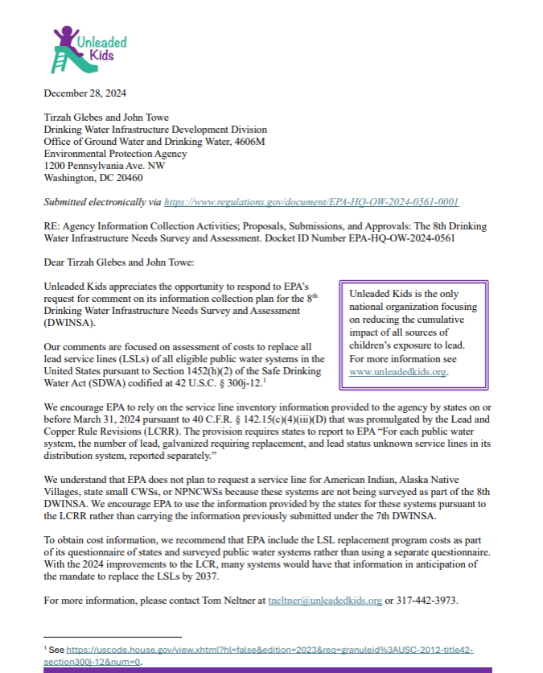
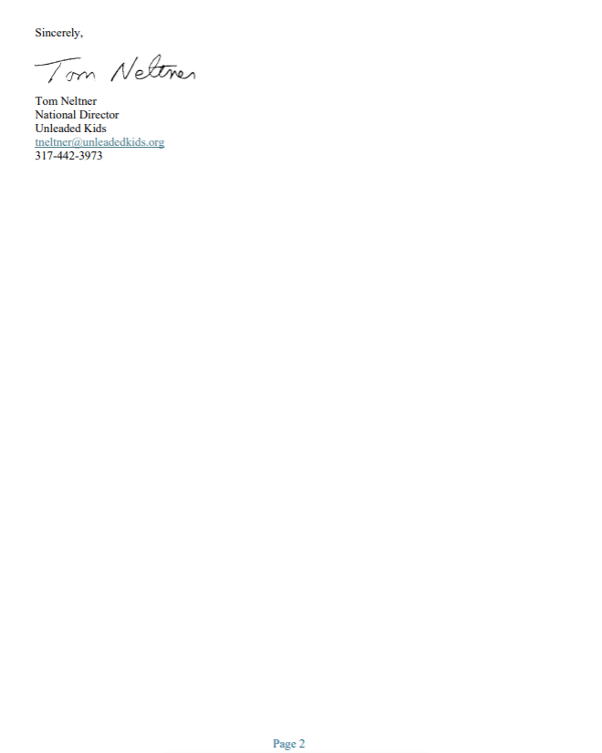

Below is a summary of the December 28, 2024, comments received from Unleaded Kids regarding the Draft Information Collection Request for the 8th DWINSA and the EPA response to each comment.
- Unleaded Kids encouraged the use of Lead and Copper Rule Revisions (LCRR) data for the 8th DWINSA as the basis to assess the costs to replace all lead service lines (LSLs) as mandated by Section 1452(h)(2) of the Safe Drinking Water Act (SDWA), codified at 42 U.S.C §300j-12 (the AWIA amendments). Unleaded Kids cited 40 C.F.R 142.15(c)(4)(iii)(D) – a section requiring quarterly reporting by states of information related to optimized corrosion control designation – as the basis for the dataset. Because Unleaded Kids referred to the LCRR, the EPA believes Unleaded Kids intended to have referenced 40CFR 141.84(a) Service line inventory and replacement requirements, which requires submittal of an initial inventory to the State by October 16, 2024.
EPA Response: The EPA plans to use LCRR service line inventory data for the 8th DWINSA to estimate the cost to replace all lead service lines. The EPA considers that the LCRR data will be the best available data at the time of data collection and will minimize the burden on water systems and states to collect and report similar data. In the EPA’s recent engagements with states and DWINSA state coordinators, the majority of DWINSA state coordinators expressed greater confidence in the LCRR inventory data compared to other options as the best available information for estimating the number of lead service lines to apply to the cost model for the 8th DWINSA.
- Unleaded Kids encouraged EPA to use for the 8th DWINSA the LCRR inventory information provided by the states for American Indian, Alaska Native Village, non-profit noncommunity water systems (NPNCWS) and small community water systems (CWS) rather than adjusting the information used for the 7th DWINSA.
EPA Response: The EPA agrees with the commenter and plans to use the LCRR data to estimate lead service line replacement costs for small water systems and Tribal water systems of all sizes. With the water systems submitted LCRR inventory data, the EPA is proposing that the replacement cost as estimated by these counts and the 8th DWINSA cost model will appropriately reflect these water systems’ needs. For more information on how EPA is accommodating the specific concerns of small systems, see Supporting Statement A.
- Unleaded Kids recommended that the EPA collect information on Lead Service Line replacement costs as part of the 8th DWINSA questionnaire rather than using a separate questionnaire.
EPA Response: The EPA plans to update the DWINSA lead service line replacement cost model to the extent possible. The cost model is based on a per-service-line cost. The EPA is proposing to collect cost data to update the model to the extent possible by gathering project-specific cost information during the survey. The EPA plans to use the LCRR inventory data in lieu of the questionnaire previously used for the 7th DWINSA. Additionally, the EPA may use otherwise available information for cost model development, for example, the Drinking Water State Revolving Fund project database.

EPA-HQ-OW-2024-0561-0006: Vermont Department of Environmental Conservation
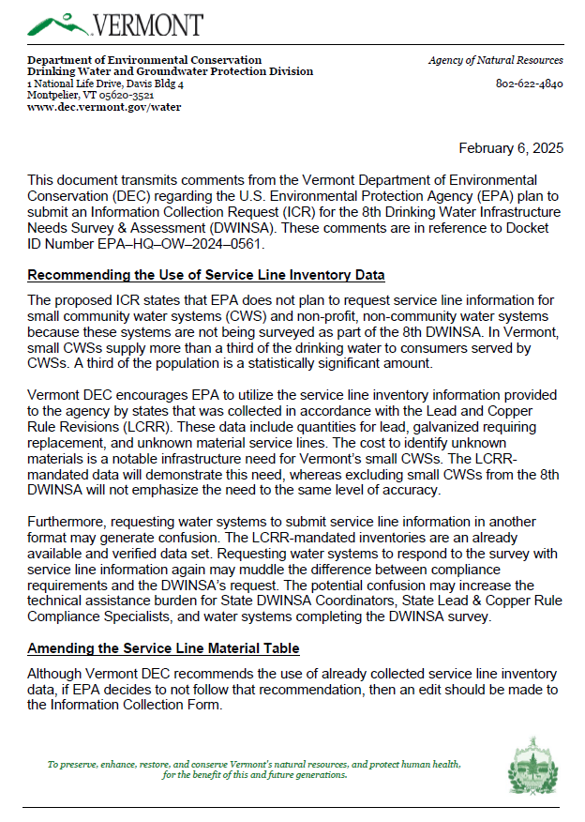
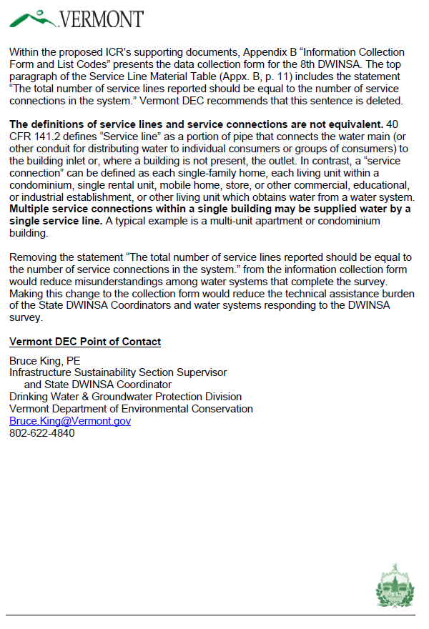
Below is a summary of the February 6, 2025, comments received from the Vermont Department of Environmental Conservation (DEC) regarding the Draft Information Collection Request for the 8th DWINSA and the EPA response to each comment.
- Vermont DEC noted the significant reliance of Vermont’s population on small systems and expressed concern over the proposal to not collect service line information from small CWSs and NPNCWSs for the 8th DWINSA. Vermont DEC encouraged the EPA to use LCRR data for these systems.
EPA Response: The EPA agrees with the commenter and plans to use the LCRR data to estimate lead service line replacement costs for small water systems and Tribal water systems of all sizes. With the water systems submitted LCRR inventory data, the EPA is proposing that the replacement cost as estimated with these counts and the 8th DWINSA cost model will appropriately reflect these water systems’ needs. For more information on how EPA is accommodating the specific concerns of small systems, see Supporting Statement A.
- Vermont DEC encouraged the use of LCRR-mandated inventories for systems that are included in the 8th DWINSA and to not request the same or similar service line information be submitted by systems.
EPA Response: The EPA plans to use LCRR service line inventory data for the 8th DWINSA to estimate the cost to replace all lead service lines. The EPA considers that the LCRR data will be the best available data at the time of data collection and will minimize the burden on water systems and states to collect and report similar data. In the EPA’s recent engagements with states and DWINSA state coordinators, the majority of DWINSA state coordinators expressed greater confidence in the LCRR inventory data compared to other options as the best available information for estimating the number of lead service lines to apply to the cost model for the 8th DWINSA.
- If EPA decides to not follow the recommendation to use LCRR data, then Vermont DEC recommends an edit to the Information Collection Form to remove the statement: “The total number of service lines reported should be equal to the number of service connections in the system.” Vermont DEC offered the following as the reason for this recommendation, “Multiple service connections within a single building may be supplied water by a single service line. A typical example is a multi-unit apartment or condominium building.”
EPA Response: The EPA intends to incorporate the LCRR initial inventory summary counts into the 8th DWINSA, so a change to the form to address this comment will not be necessary.

EPA-HQ-OW-2024-0561-0007: Council of Infrastructure Financing Authorities (CIFA)
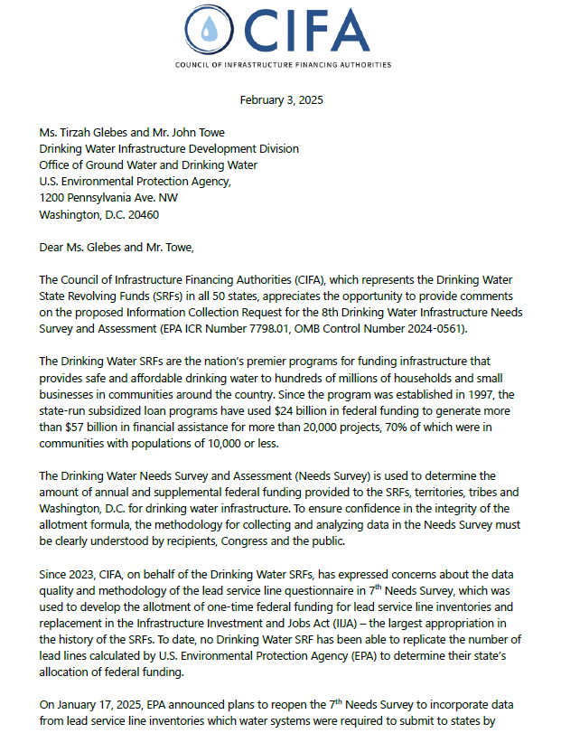
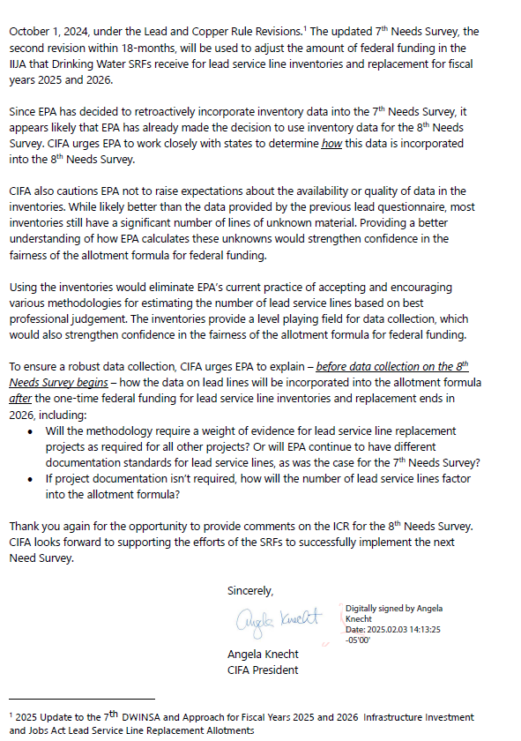
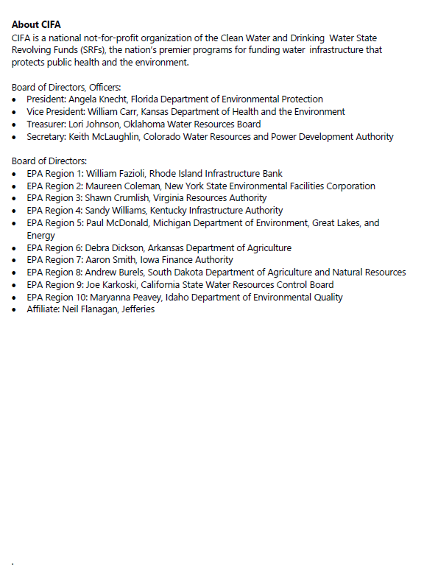

Below is a summary of the February 3, 2025, comments received from the Council of Infrastructure Financing Authorities (CIFA) regarding the Draft Information Collection Request for the 8th DWINSA and the EPA response to each comment.
- CIFA encouraged the EPA to work with states to develop the best approach to utilize LCRR lead service line data for the 8th DWINSA. CIFA noted that there may be LCRR data availability and data quality issues and there are concerns with how the anticipated significant number of unknown lines will be addressed. CIFA urged state engagement and transparency in the EPA’s approach to LSL replacement calculations and determining how they will be incorporated into the DWSRF allotment formula.
EPA Response: The EPA held a DWINSA workgroup call on March 27, 2025, to summarize comments received on the 8th DWINSA ICR first Federal Register Notice related to lead service lines and to gather timely, actionable feedback on lead service line considerations for the 8th DWINSA. The workgroup call covered four aspects: using LCRR inventories or survey responses; if using the LCRR inventory, whether a census or DWINSA statistical sample should be used; approaches to address services lines of unknown material; and approaches for collecting lead service line replacement costs. Polling questions were used to obtain input and supporting rationale for the expressed opinions. In the March 27, 2025, call with DWINSA state coordinators, the majority indicated that LCRR census data will represent a more complete service line inventory dataset, encompassing data from systems that will not be surveyed in the 8th DWINSA. The quality of the LCRR initial inventory data is supported by EPA’s Guidance for Developing and Maintaining a Service Line Inventory (August 2022). This guidance includes an optional inventory template for water systems, states, and Tribes to use or adapt to create their own inventory. The EPA used this feedback in revisions for this Information Collection Request and will continue to maintain transparency for 8th DWINSA implementation.
- CIFA indicated their support for use of the LCRR Inventory data for the 8th DWINSA as a way to provide a national dataset with consistent quality control measures across all states.
EPA Response: The EPA plans to use LCRR service line inventory data for the 8th DWINSA to estimate the cost to replace all lead service lines. The EPA considers that the LCRR data will be the best available data at the time of data collection and will minimize the burden on water systems and states to collect and report similar data. In the EPA’s recent engagements with states and DWINSA state coordinators, the majority of DWINSA state coordinators expressed greater confidence in the LCRR inventory data compared to other options as the best available information for estimating the number of lead service lines to apply to the cost model for the 8th DWINSA.

- CIFA asked the EPA to share its approach to lead service line replacement projects for the DWSRF Base allotments. In particular, CIFA requested information on the project documentation standards to be applied to lead service line replacement projects.
EPA Response: The EPA plans to update the DWINSA lead service line replacement cost model to the extent possible. The cost model is based on a per-service line cost. The EPA is proposing to collect cost data to update the model to the extent possible by gathering project-specific cost information via the project table on the survey form. The EPA plans to use the LCRR inventory data in lieu of the questionnaire previously used for the 7th DWINSA. The proposed approach includes collecting project-specific cost information, similar to other types of projects, via the project table that can be used to update the 8th DWINSA’s cost model. Additionally, the EPA may use otherwise available information for cost model development, for example, the Drinking Water State Revolving Fund project database.

EPA-HQ-OW-2024-0561-0008: Blue Conduit
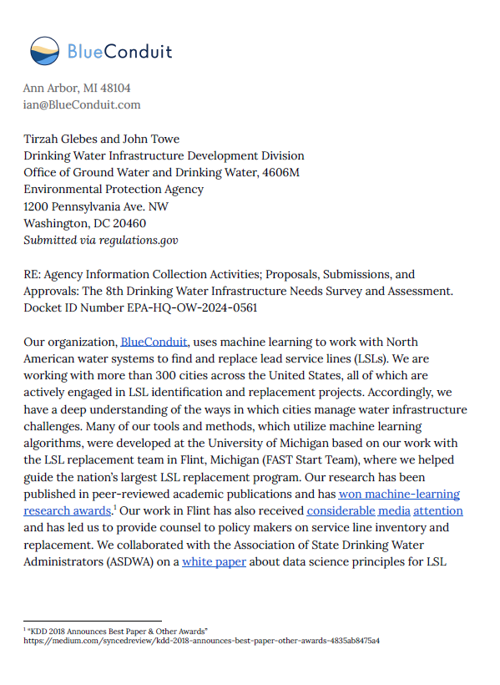
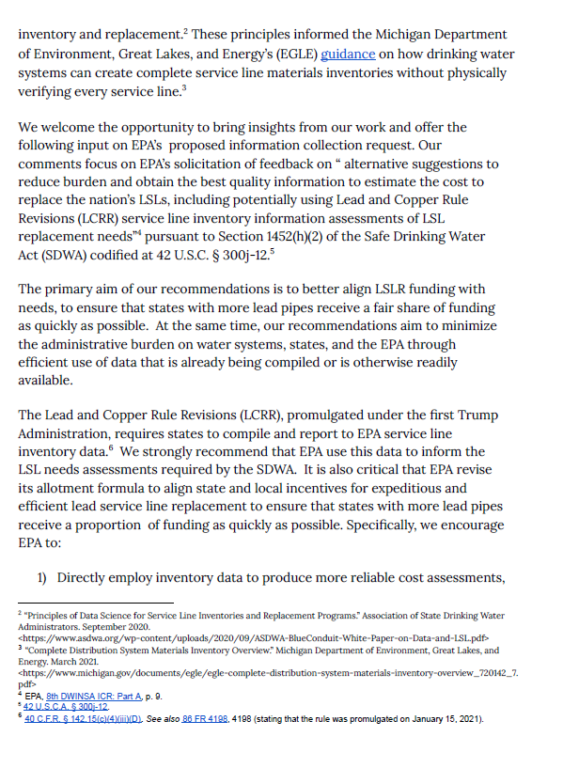
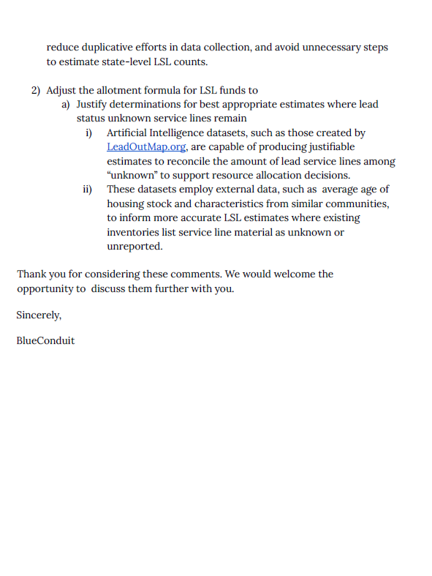

Below is a summary of the February 19, 2025, comments received from BlueConduit regarding the Draft Information Collection Request for the 8th DWINSA and the EPA response to each comment.
- BlueConduit encouraged the EPA to utilize the inventory service line data collected as part of the LCRR to produce data that can be used without the need to estimate state-level LSL counts and to minimize burden for data collection. BlueConduit’s comments were directed at LSLR funding. BlueConduit’s comments also referred to “lead service line needs assessments required by the SDWA.”

EPA Response: The results of the 8th DWINSA will not be available in time to influence the remaining Infrastructure Investment and Jobs Act Lead Service Line Replacement (LSLR) allotments. The EPA plans to use LCRR service line inventory data for the 8th DWINSA to estimate the cost to replace all lead service lines. The EPA considers that the LCRR data will be the best available data at the time of data collection and will minimize the burden on water systems and states to collect and report similar data. In the EPA’s recent engagements with states and DWINSA state coordinators, the majority of DWINSA state coordinators expressed greater confidence in the LCRR inventory data compared to other options as the best available information for estimating the number of lead service lines to apply to the cost model for the 8th DWINSA. The EPA proposes that the result of the LCRR inventory data with the 8th DWINSA’s cost model will address the SDWA requirement.

- BlueConduit recommended the EPA adjust the allotment formula for LSL funds utilizing technologies available that can provide supplementary information, such as Artificial Intelligence datasets, to help fill in data gaps for service lines with an unknown material designation.
EPA Response: The results of the 8th DWINSA will not be available in time to influence the remaining Infrastructure Investment and Jobs Act Lead Service Line Replacement (LSLR) allotments. However, the EPA plans to use the LCRR data to identify lead service line replacement projects for the 8th DWINSA. The quality of the LCRR initial inventory data is supported by EPA’s Guidance for Developing and Maintaining a Service Line Inventory (August 2022). This guidance includes an optional inventory template for water systems, states, and Tribes to use or adapt to create their own inventory. Beyond the list of acceptable methods for service line identification specified in the LCRR, additional sources and new technologies that can be used to aid in determining service line material may be employed if approved or required by the state. Water systems may use the age of the service line and the date of the applicable lead ban to categorize service lines because such records fall under the sources of information that systems must review as described in § 141.84(b)(2)(ii). Water systems may use any sources that are or previously have been approved or required by their States. Water systems may use predictive modeling, machine learning, and other statistical modeling applications if they are approved or required by the States. The States are best suited to determine methods, beyond those specified by the EPA, that are appropriate for a system.

EPA-HQ-OW-2024-0561-0009: Association of Metropolitan Water Agencies (AMWA)
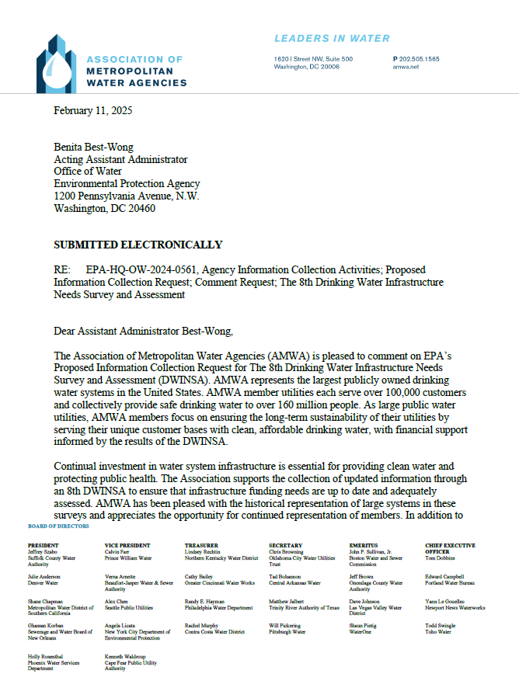
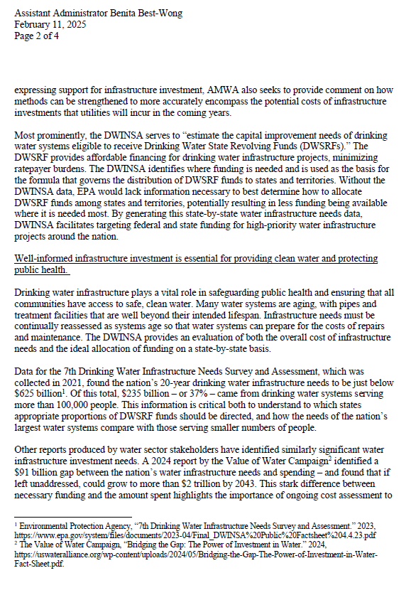
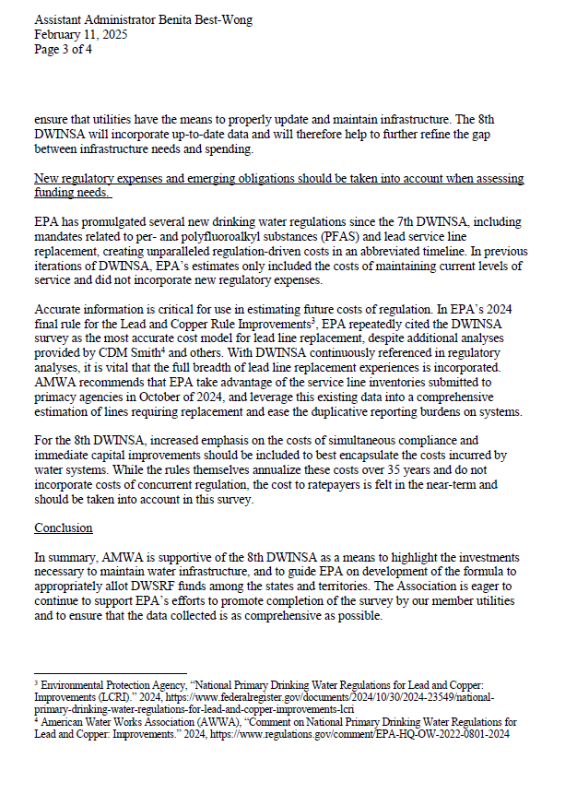
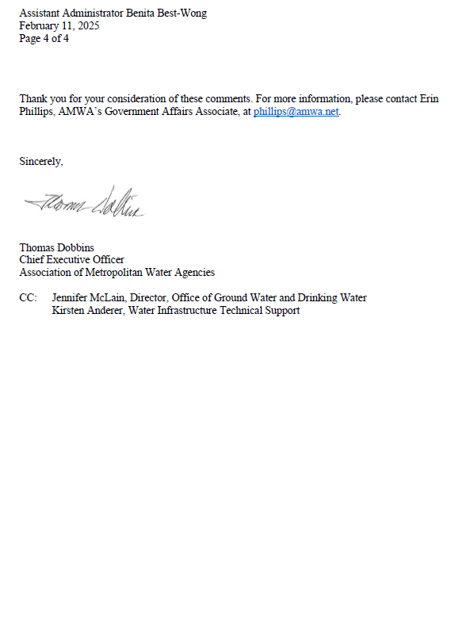

Below is a summary of the February 11, 2025, comments received from Association of Metropolitan Water Agencies (AMWA) regarding the Draft Information Collection Request for the 8th DWINSA and the EPA response to each comment.
- AMWA urged the EPA to incorporate into the DWINSA the cost of new regulatory actions and emerging obligations that may lead to water system infrastructure expenses. AMWA’s comments included the statement: “In previous iterations of DWINSA, EPA’s estimates only included the costs of maintaining current levels of service and did not incorporate new regulatory expenses.
EPA Response: The EPA disagrees with the comment that the DWINSAs did not incorporate new regulatory expenses. Since the first DWINSA in 1995, the EPA has included estimates of the capital costs of proposed and recently promulgated regulations that applied at the time of each survey. The capital costs were allotted at the state level if supported by contaminant occurrence data or other criteria such as the number of surface water treatment plants in each state. If the capital costs could not be fairly distributed amongst the states, the costs from the economic analyses were added to the national total. If projects to address a contaminant were already planned and implemented by systems regardless of the regulatory schedule, such as for per- and polyfluoroalkyl substances (PFAS), they were included on a system-by-system basis and the costs from the economic analyses were not used. This approach captured these emerging needs while preventing double-counting of needs and ensuring all states had equivalent opportunity to have their projects included. Capturing 20-year needs for obtaining or maintaining compliance through additional treatment, treatment facility rehabilitation, replacement of deteriorated pipe, and other projects is inherent to the projects accepted for the DWINSA because they are in furtherance of the public health objectives of the Safe Drinking Water Act. Projects for new treatment to address PFAS were accepted as part of the 7th DWINSA and will be accepted for the 8th DWINSA if they meet the documentation standards. Lead service line replacement projects were also accepted for the 7th DWINSA and will be included in the 8th DWINSA using the LCRR service line inventory data.
- AMWA noted the importance of accurate and comprehensive lead service line replacement cost data from the DWINSA, as it has been the data cited in economic analysis for other regulatory actions (i.e., the 2024 Lead and Copper Rule Improvements). AMWA emphasized the importance of using “the full breadth of lead line replacement experiences” in the DWINSA cost models.
EPA Response: The EPA plans to update the DWINSA lead service line replacement cost model to the extent possible. The cost model is based on a per-service line cost. The EPA is proposing to collect cost data to update the model to the extent possible by gathering project-specific cost information during the survey. The EPA plans to use the LCRR inventory data in lieu of the questionnaire previously used for the 7th DWINSA. Additionally, the EPA may use otherwise available information for cost model development, for example, the Drinking Water State Revolving Fund project database.
- AMWA recommended the EPA use the LCRR Inventory Data submitted to primacy agencies in October 2024 as the primary source of service line data for the 8th DWINSA.
EPA Response: The EPA plans to use LCRR service line inventory data for the 8th DWINSA to estimate the cost to replace all lead service lines. The EPA considers that the LCRR data will be the best available data at the time of data collection and will minimize the burden on water systems and states to collect and report similar data. In the EPA’s recent engagements with states and DWINSA state coordinators, the majority of DWINSA state coordinators expressed greater confidence in the LCRR inventory data compared to other options as the best available information for estimating the number of lead service lines to apply to the cost model for the 8th DWINSA.
- AMWA encouraged the EPA to increase the emphasis on the costs to water systems for simultaneous compliance and immediate capital improvements.
EPA Response: Water systems are encouraged to submit projects that capture the full 20-year timeframe addressed by each DWINSA. A comprehensive approach to project identification that addresses all infrastructure assets is recommended in DWINSA technical assistance and instructions, whether the needs are current or anticipated at a future date. Simultaneous compliance and obtaining or maintaining compliance are included as important project identifiers. Because the DWINSA captures projects that are in furtherance of the public health objectives of the Safe Drinking Water Act, simultaneous compliance is an inherent part of the projects reported in the DWINSA. Project funding prioritization is addressed at the state-level through state DWSRF programs, while the DWINSA is intended to capture 20-year needs independent of each projects’ timeframe.
- AMWA expressed support for the 8th DWINSA as a means to highlight necessary water system infrastructure needs and investment, and as a suitable way to distribute DWSRF capitalization grants to states.
EPA Response: The EPA would like to acknowledge and thank the AMWA’s assistance in encouraging participation by their members in the DWINSA.

EPA-HQ-OW-2024-0561-0010: American Water Works Association (AWWA)
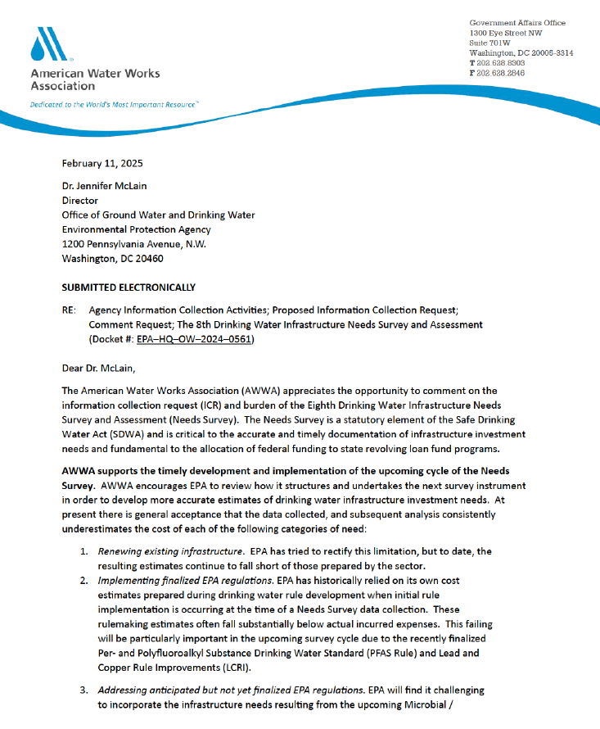
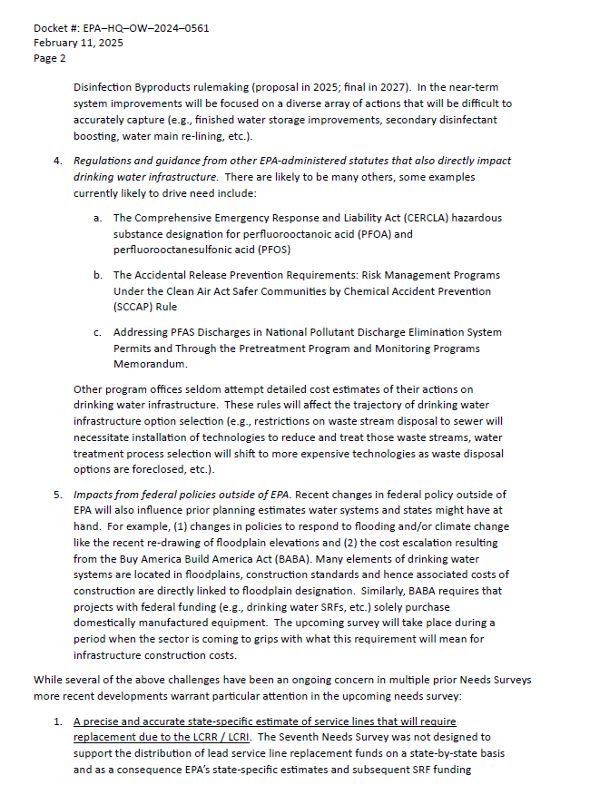
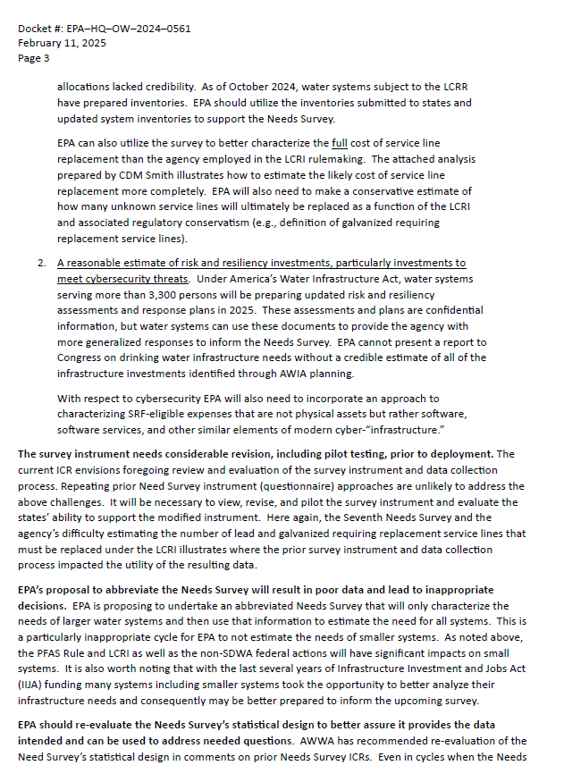
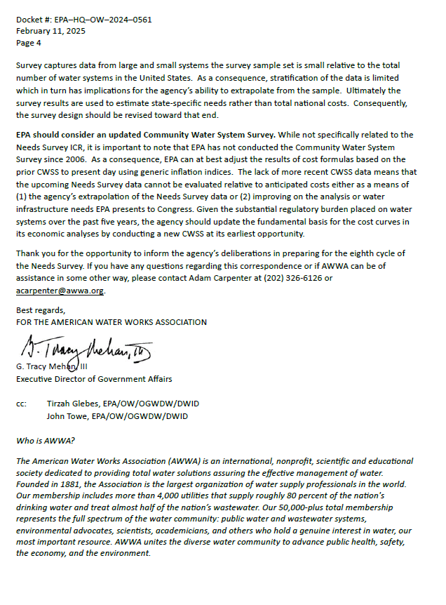
Below is a summary of the February 11, 2025, comments received from American Water Works Association (AWWA) regarding the Draft Information Collection Request for the 8th DWINSA and the EPA response to each comment. Attachment A to AWWA’s comments, “Final Report – Considerations when costing lead service line identification and replacement, CDM-Smith, November 2022” can be found in the docket EPA-HQ-OW-2024-0561 at regulations.gov.
- AWWA encouraged the EPA to review how it structures and undertakes the DWINSA survey instrument and asserted that the data collected for the DWINSA and the analysis of this data underestimates the cost of renewal of existing infrastructure.
EPA Response: The 8th DWINSA uses a statistical sample designed around a precision target of 95 percent confidence that the true need for each state lies within an interval of plus or minus 15 percent of the estimated need (see Supporting Statement Part B for details). This general approach has been used throughout recurring cycles of the DWINSA to effectively and efficiently balance the burden of data collection with the intended use of the information. Because the DWINSA is used to allocate funds to state DWSRF programs, only DWSRF-eligible projects are included in the survey. This eliminates projects intended to accommodate future growth or are primarily for fire protection, although these are also typical needs of water systems and area often reported in other studies. The focus of the DWINSA is infrastructure needs in furtherance of the public health objectives of the SDWA. To thoroughly capture DWSRF-eligible projects based on each surveyed system’s needs, the EPA highly recommends an inventory approach to capture new, replacement, or rehabilitation projects for every asset. The vast majority of survey respondents use this approach. The stratified random sample statistical approach to the survey results and the exceptional response rate (over 97%) further contribute to the validity of the findings.
- AWWA encouraged the EPA to evaluate costs associated with regulatory compliance, particularly for recently promulgated rules such as the PFAS Rule and the Lead and Copper Rule Improvements (LCRI) where the Economic Analyses for the regulations are typically used. AWWA asserted that actual compliance costs are more than the costs reported in the Economic Analyses.
EPA Response: For the 8th DWINSA, the EPA plans to receive project submissions for capital projects related to PFAS, and lead service line replacement estimates are proposed to be based on the LCRR initial service line inventories. Therefore, the EPA is not proposing to use capital costs from these rules’ Economic Analyses for the 8th DWINSA. The EPA recognizes the cost of SDWA compliance is inherent to the capital costs that ensure safe and reliable supplies of drinking water. The DWINSA requests respondents to code their projects based on the regulatory need, enabling a view at the need associated with specific regulations (see Appendix B, List of Codes and survey form for reference).
- AWWA encouraged the EPA to take into consideration anticipated infrastructure needs based on future regulatory compliance as part of reporting infrastructure needs for the 8th DWINSA. AWWA provided the upcoming Microbial/Disinfection Byproducts rulemaking (proposal in 2025; final in 2027) as an example.
EPA Response: The SDWA requires that the EPA examine the evolving needs for infrastructure improvements and maintenance at public water systems through the DWINSA on a four-year cycle. Infrastructure needs related to future rule revisions under development will likely be captured under future DWINSA efforts.
- AWWA noted that other, non-SDWA regulatory statutes that impact drinking water infrastructure such as the Comprehensive Emergency Response, Compensation, and Liability Act (CERCLA), the Risk Management Programs under the Clean Air Act, the Safer Communities by Chemical Accident Prevention (SCCAP) Rule, the PFAS Discharges in National Pollutant Discharge Elimination System Permits and through the Pretreatment Program and Monitoring Programs Memorandum, and the Build America Buy America Act (BABA) requirements should be considered as part of the DWINSA.
EPA Response: The SDWA requires that the EPA examine the evolving needs for capital improvement projects at public water systems through the DWINSA on a four-year cycle. Respondents can submit any project they deem required that meets the DWINSA’s documentation standards and is a DWSRF-eligible capital improvement project.
- AWWA expressed support in favor of using the initial LCRR service line inventory data to determine the need for lead service line replacement.
EPA Response: The EPA plans to use LCRR service line inventory data for the 8th DWINSA to estimate the cost to replace all lead service lines. The EPA considers that the LCRR data will be the best available data at the time of data collection and will minimize the burden on water systems and states to collect and report similar data. In the EPA’s recent engagements with states and DWINSA state coordinators, the majority of DWINSA state coordinators expressed greater confidence in the LCRR inventory data compared to other options as the best available information for estimating the number of lead service lines to apply to the cost model for the 8th DWINSA.
- AWWA encourages the EPA to utilize the 2022 CDM Smith report on “Considerations when Costing Lead Service Line Identification and Replacement to estimate LSLR unit cost” to develop a cost model that reflects what they believe is the full cost of lead service line replacement. The CDM Smith report was submitted as Appendix A to this comment and can be found in the docket.

EPA Response: As was noted in the Economic Analysis for the Final Lead and Copper Rule Improvements (LCRI), the EPA used the 7th DWINSA as cost model inputs to the LCRI Economic Analysis (EA) to estimate unit costs of lead service line replacement. While the EPA acknowledges the effort of the 2022 CDM Smith report, the EPA also notes that the findings may not be nationally representative compared to what the EPA could gain from collecting updated cost information from the 8th DWINSA’s surveyed water systems and other available resources like the Drinking Water State Revolving Fund project database.

- AWWA commented that EPA will need to estimate the cost of replacing service lines of materials that are currently unknown.
EPA Response: The EPA proposes to use the LCRR initial inventory summary counts and updated cost model to estimate the number of lead and galvanized requiring replacement service lines at the state level. The EPA will continue to maintain transparency for 8th DWINSA implementation and estimations via its coordination with the DWINSA Coordinator Workgroup.
- AWWA encouraged the EPA to consider projects for SRF-eligible water system cybersecurity resilience; projects that are not physical assets but rather relate to software and services and other components of cyber “infrastructure.”
EPA Response: Cybersecurity projects that facilitate a water system’s compliance with National Primary Drinking Water Regulations or significantly further the health protection objectives of the SDWA are DWSRF-eligible. The DWINSA accepts projects to implement capital improvements for cybersecurity. Examples include the installation of cyber-related infrastructure, which may include upgrading information technology and operational technology. SCADA projects, for which cybersecurity upgrade investments are assumed to be included, are DWINSA-accepted projects.
- AWWA commented that the EPA needs to undertake revision and pilot testing of the DWINSA survey instrument and data collection process. They noted that this process is important in light of AWWA’s other comments for revisions to the DWINSA data collection and in light of the service line inventory data collected as part of the 7th DWINSA.
EPA Response: As stated previously, the EPA plans to use the Lead and Copper Rule Revisions initial inventories in lieu of the questionnaire previously used for the 7th DWINSA. In general, the data collection instrument to be used for the 8th DWINSA is generally the same form as used for the past four DWINSAs. The DWINSA form and data collection process were pilot tested initially and again each time significant changes were proposed. Additionally, changes to the survey instrument are not anticipated to alter the process by which states and water systems support the survey. The EPA also engaged and solicited feedback from the DWINSA Coordinator Workgroup when formulating the supplemental questions.
- AWWA encouraged the EPA to include small systems as part of the 8th DWINSA. AWWA noted that recent regulatory actions such as the LCRI will have significant impact on small systems. AWWA also expressed that with recent funding opportunities, many small systems may have taken the opportunity to better analyze their infrastructure and should therefore be offered the opportunity to include this data as part of the 8th DWINSA.
EPA Response: EPA acknowledges the importance of thoroughly capturing current capital infrastructure needs for small and rural systems. Therefore, for the 8th DWINSA, EPA will re‑survey the 7th DWINSA small systems (those serving 3,300 or fewer people) via phone to collect updated capital improvement project information and will engage key stakeholders, including AWWA, to better understand and incorporate the differential in infrastructure costs faced by small community water systems. EPA will use LCRR inventories for all small systems to estimate lead service line replacement needs. For more information on how EPA is accommodating the specific concerns of small systems, see Supporting Statement A.
- AWWA also expressed concern that the statistical validity of the sampling methodology, particularly the resulting number of sampled water systems based on the stratification of the data, limits capture of state-specific needs rather than total national costs.
EPA Response: The 8th DWINSA is designed to achieve a desired level of precision for state-level estimates of total infrastructure needs. Because it would be prohibitively expensive to collect information from every system, the EPA collects information about the infrastructure investment needs from a sample of Community Water Systems. All large CWSs are sampled as well as a state-level statistically significant sample of medium CWSs. The sample is randomly selected, which ensures that it is representative and unbiased. Algorithms that have been tested, validated, and published are used to select the random samples. A stratified random sample is used to capture the diverse needs of public water systems. Systems are divided into several categories, and the sampling approach selected for each maximizes the data quality objectives of the survey while remaining within the survey’s budget. This approach proposed here has been peer-reviewed as implemented in past DWINSA cycles. The approach is fully documented in Part B of the Supporting Statement.
- AWWA encouraged the EPA to conduct an updated Community Water System Survey as a means to evaluate and update the anticipated water infrastructure costs.
EPA Response: Thank you for the feedback. The comments in this section are beyond the scope of this Information Collection Request for the 8th DWINSA.

EPA-HQ-OW-2024-0561-0011: Environmental Policy Innovation Center (EPIC)
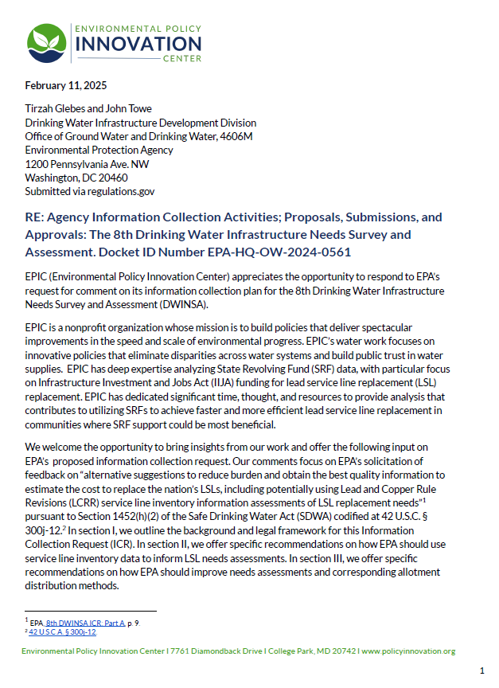
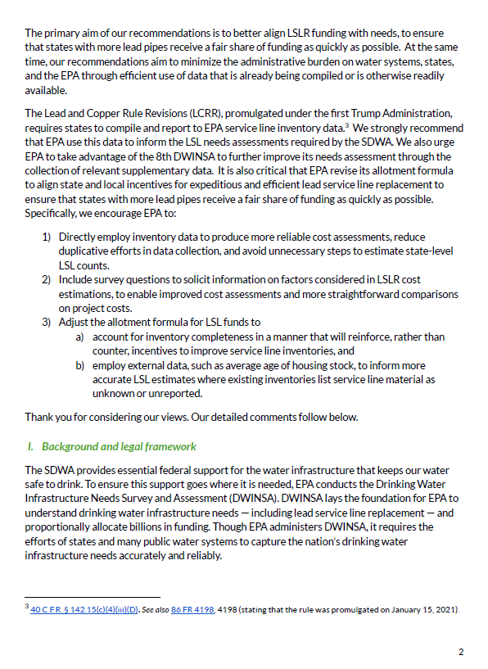

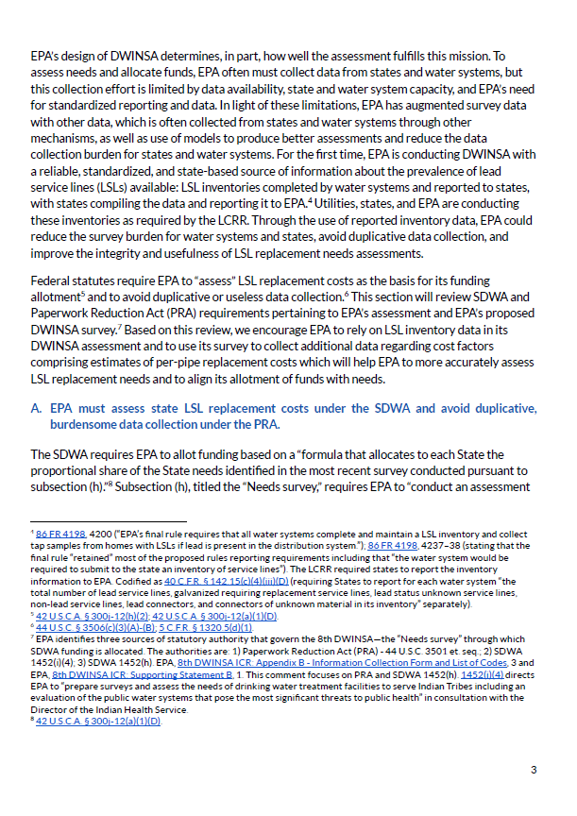
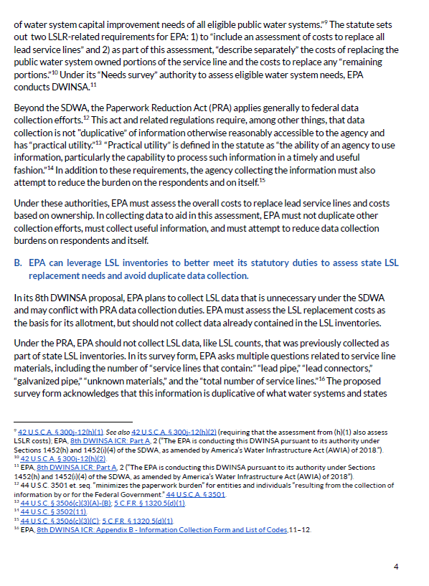

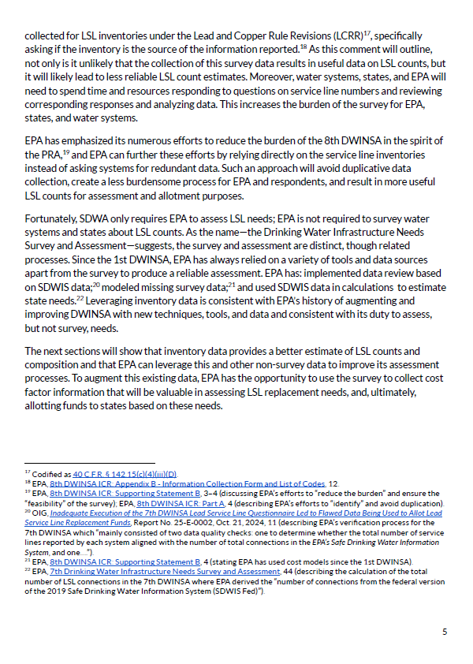
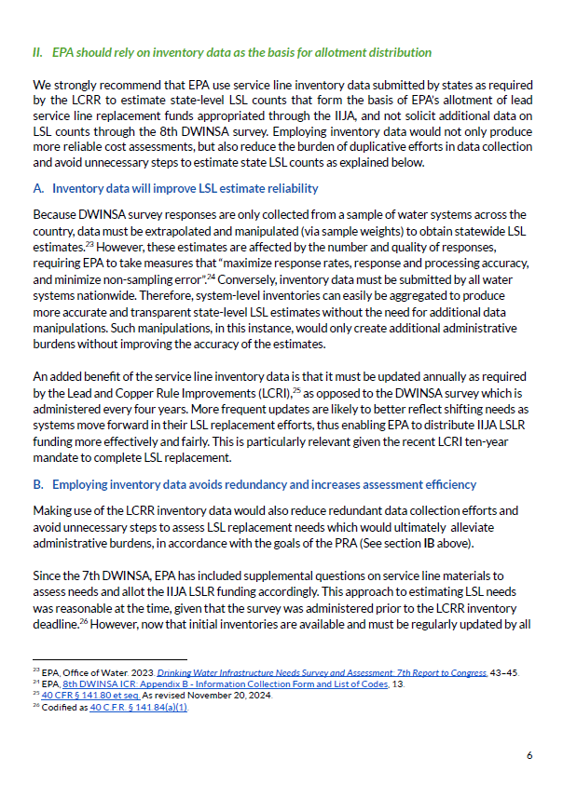
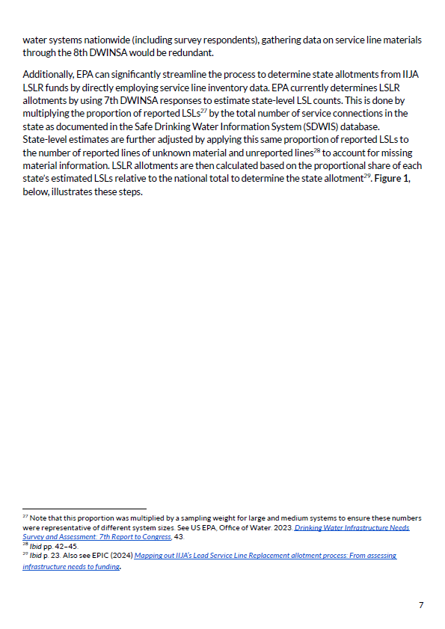
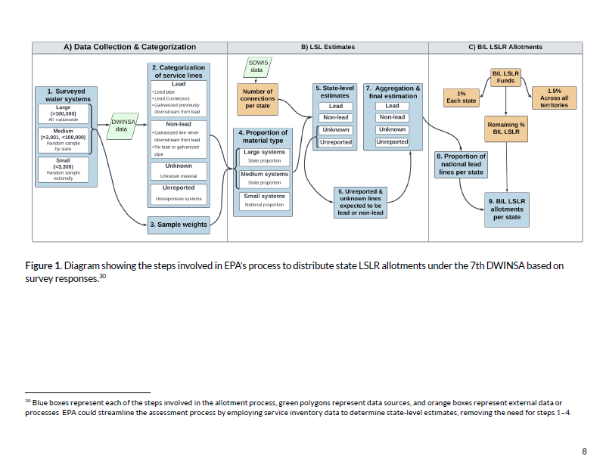
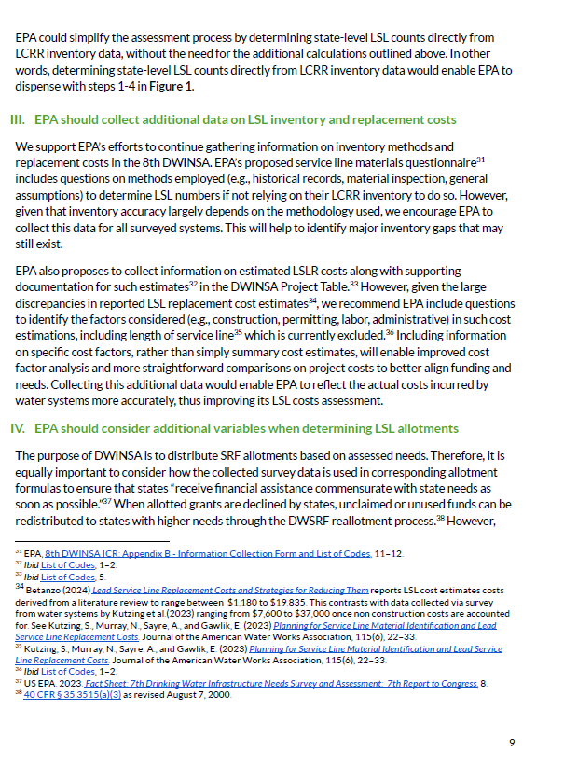
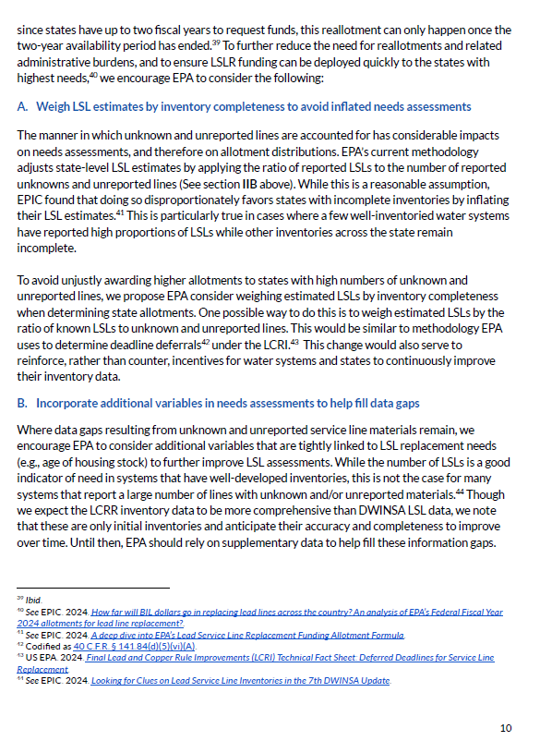
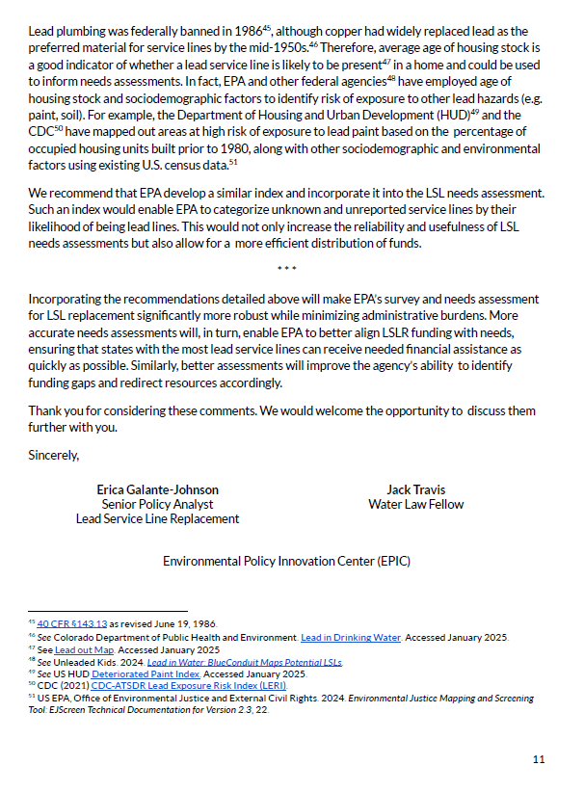

Below is a summary of the February 11, 2025, comments received from Environmental Policy Innovation Center (EPIC) regarding the Draft Information Collection Request for the 8th DWINSA and the EPA response to each comment.
- EPIC recommended the use of Lead and Copper Rule Revisions (LCRR) data for the 8th DWINSA as the basis to assess the costs to replace all lead service lines (LSLs). EPIC points to a standardized, state-based dataset and reduction in survey burden for water systems and states as factors that lend a reliable, accurate capture of LSLR need. EPIC also recommended using only LCRR data and not projecting lead service lines from unknown and unreported lines.
EPA Response: The EPA plans to use LCRR service line inventory data for the 8th DWINSA to estimate the cost to replace all lead service lines. The EPA considers that the LCRR data will be the best available data at the time of data collection and will minimize the burden on water systems and states to collect and report similar data. In the EPA’s recent engagements with states and DWINSA state coordinators, the majority of DWINSA state coordinators expressed greater confidence in the LCRR inventory data compared to other options as the best available information for estimating the number of lead service lines to apply to the cost model for the 8th DWINSA. The EPA will continue to maintain transparency for 8th DWINSA implementation and estimations via its coordination with the DWINSA Coordinator Workgroup.
- EPIC encouraged collection of information on LSLR cost estimation factors, such as service line length, to aid in modeling data.
EPA Response: The EPA is proposing to use the LCRR initial inventory summary counts as the documentation standard to establish a water system’s and the overall state’s number of service lines needing replacement. Details such as service line length are not part of the LCRR service line inventory dataset, would be burdensome to obtain, and are often unavailable. The EPA also proposes to update the DWINSA lead service line replacement cost model to the extent possible. The cost model is based on a per-service line cost. The EPA is proposing to collect cost data to update the model for project-specific submissions from survey respondents. Additionally, the EPA may use otherwise available information, for example, like from the Drinking Water State Revolving Fund project database.
- EPIC encouraged the EPA to adjust the allotment formula for LSL funds to account for inventory completeness, and using housing stock or other data sources to identify materials for unknown and unreported lines. EPIC also encouraged the use of the LCRR inventory data to form the basis of EPA’s allotment of LSLR funds appropriated through Infrastructure Investment and Jobs Act (IIJA) funding.
EPA Response: The results of the 8th DWINSA will not be available in time to influence the remaining Infrastructure Investment and Jobs Act Lead Service Line Replacement (LSLR) allotments. However, the EPA plans to use the LCRR data to identify lead service line replacement projects for the 8th DWINSA. The quality of the LCRR initial inventory data is supported by the EPA’s Guidance for Developing and Maintaining a Service Line Inventory (August 2022). This guidance includes an optional inventory template for water systems, states, and Tribes to use or adapt to create their own inventory.
- EPIC encouraged EPA to use the census of LCRR inventory information provided by the states for American Indian, Alaska Native Village, non-profit noncommunity water systems (NPNCWS) and small community water systems (CWS) rather than adjusting the information used for the 7th DWINSA.

EPA Response: The EPA agrees with the commenter and plans to use the LCRR data to estimate lead service line replacement costs for small water systems and Tribal water systems of all sizes. With the water systems submitted LCRR inventory data, the EPA is proposing that the replacement cost as estimated with these counts and the 8th DWINSA cost model will appropriately reflect the overall national need.

- EPIC encouraged the EPA to continue gathering information on inventory methods and replacement costs in the 8th DWINSA, even if LCRR data are used. EPIC also recommended EPA include questions on factors considered in reported replacement costs, such as construction, permitting, labor and administrative costs, and length of the service line. EPIC maintains the information will help identify gaps that remain in inventory completeness and more straightforward comparisons of project costs.
EPA Response: The EPA agrees with the commenter that there are a number of site-specific circumstances that can impact lead service line replacement costs. The EPA proposes to update the DWINSA lead service line replacement cost model to the extent possible. The cost model is based on a per-service line cost. The EPA is proposing to collect cost data to update the model for project-specific submissions from survey respondents. Additionally, the EPA may use otherwise available information, for example, the Drinking Water State Revolving Fund project database.
- EPIC recommended that the EPA utilize inventory completeness as a component in estimating LSLs. They offered that the EPA could weigh estimated LSLs by the ratio of known LSLs to unknown and unreported service lines. EPIC advocates that this approach could serve as an incentive for water systems to improve the accuracy of their inventories.
EPA Response: The EPA plans to use LCRR service line inventory data for the 8th DWINSA to estimate the cost to replace all lead service lines. The EPA considers that the LCRR data will be the best available data at the time of data collection and will minimize the burden on water systems and states to collect and report similar data. The EPA will continue to maintain transparency for 8th DWINSA implementation and estimations via its coordination with the DWINSA Coordinator Workgroup.

