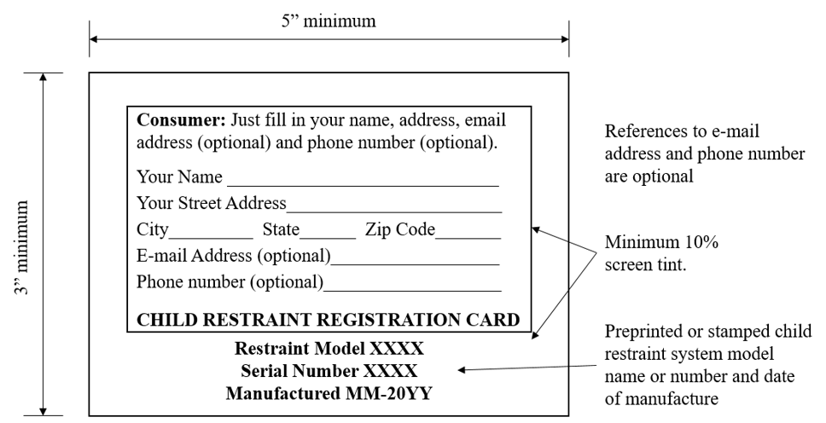 Registration form for child restraint systems – product identification number and purchaser information side

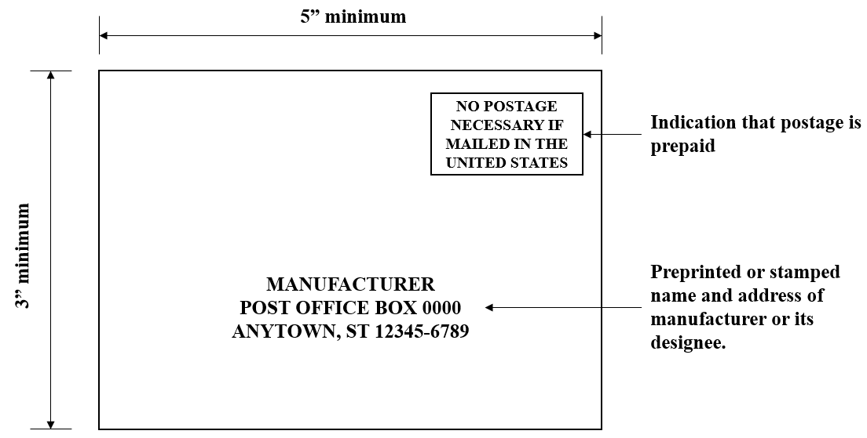
Registration form for child restraint systems – address side

