SUPPORTING STATEMENT– PART A

Veterans Employment Through High Technology Education Courses (VET TEC 2.0) Employment or Further Educational Pursuit Certification
VA Form 22-10299 - OMB # 2900-NEW

Summary of Changes from Previously Approved Collection
- Employment Certification.
- The Instrument is a NEW ICR.
- There is no burden change as this is a new collection.
- Three comments received on the 60-day comment period.

A. Justification
1. Explain the circumstances that make the collection of information necessary. Identify legal or administrative requirements that necessitate the collection of information.
On January 2, 2025, the Elizabeth Dole Field and Community Based Services for Veterans and Caregivers Act (Pub. L. 118-210) was signed into law. The program can be identified as the DOLE Act. The legislation established a new Veteran Technology program titled “Veterans Education Through High Technology Education Courses (VET TEC 2.0) program”. This program authorizes VA to provide educational assistance for high technology programs of education that begin prior to September 30, 2027.
The eligibility requirements to qualify for the program apply to a Veteran who is under the age of 62, has served at least 3 years (36 months) on Active Duty; or a Service member who is within 180 days of discharge who has or will serve 3 years (36 months) by their discharge date; and who has received a discharge under conditions other than dishonorable. Individuals that meet this age requirement upon approval will maintain their eligibility for the Veterans Education Through High Technology Education Courses (VET TEC 2.0) program throughout the completion of their program.
The DOLE Act requires VA to verify the Veteran obtained successful employment or furthered educational pursuit in the same field as their VET TEC 2.0 program within 180 days of program completion. Additionally, subsequent verification of continued employment for 180 days (or 365 days if the Veteran is hired by the Training Provider through which they completed their VET TEC 2.0 program) in that position is required.
This verification requires VA to develop practices to collect information from covered Veterans about their employment or educational pursuit after program completion. To release the final payment due to the Training Provider, School Certifying Officials (SCOs) of training providers of VET TEC 2.0 approved programs of education must also provide certification of successful employment or further educational pursuit by the Veteran and submission of documentation supporting their certification. Veterans and Training Provider SCOs will certify, through attestation on the Veterans Employment Through High Technology Courses (VET TEC 2.0) Employment or Further Educational Pursuit Certification (VA Form 22-10299), that the Veteran has found successful employment or is furthering their education in a field related to their VET TEC 2.0 program of education. Lastly, VA must submit a report to Congress no later than January 2, 2026, and each year thereafter on the operation of the program.
2. Indicate how, by whom, and for what purposes the information is to be used; indicate actual use the agency has made of the information received from current collection.
The Veterans Employment Through High Technology Courses (VET TEC 2.0) Employment or Further Educational Pursuit Certification (VA Form 22-10299) is used by SCOs for Veterans who have established eligibility to participate in the VET TEC 2.0 program to certify employment obtained or further educational pursuit, and for Training Providers of VET TEC 2.0 programs to provide proof of such employment or education; via, an offer letter, pay stub, promotion offer, note from an employment manager, or marketing material(s) showing expansion in scope of level of services for Veteran owned businesses or registration at an educational facility. The information collected on the certification must be completed to conform to the requirements of section 212 of Pub. L. 118-210.
3. Describe whether, and to what extent, the collection of information involves the use of automated, electronic, mechanical, or other technological collection techniques or other forms of information technology, e.g. Permitting electronic submission of responses, and the basis for the decision for adopting this means of collection. Also describe any consideration of using information technology to reduce burden.
The collection of information instrument will initially be submitted to VA electronically, via email, directly to the Buffalo Regional Processing Office at VETTECH.VBABUF@VA.GOV. Upson successful system updates, the collection of information instrument will submitted via Enrollment Manager, allowing VA payment systems to fully automate processing and payment actions.
4. Describe efforts to identify duplication. Show specifically why any similar information already available cannot be used or modified for use for the purposes described in Item 2 above.
The information obtained through this collection is unique and is not already available for use or adaptation from another cleared source.
5. If the collection of information impacts small businesses or other small entities, describe any methods used to minimize burden.
This information collection does not impose a significant economic impact on a substantial number of small businesses or entities.
6. Describe the consequences to Federal program or policy activities if the collection is not conducted or is conducted less frequently as well as any technical or legal obstacles to reducing burden.
If the VA Form 22-10299 is not collected, VA will failing to offer a means for which School Certifying Officials and Veterans certify to VA the Veteran’s employment or educational status after program completion, and to ensure the employment or educational pursuit aligns with the skills acquired during the Veteran’s training in the Veterans Employment Through High Technology Education Courses (VET TEC 2.0) program, as required by section 212, Pub. L. 118-210. In addition, VA will be unable to release the final 50% tuition and fee payment to the Training Provider.
7. Explain any special circumstances that would cause an Information collection to be conducted more often than quarterly or require respondents to prepare written responses to a collection of information in fewer than 30 days after receipt of it; submit more than an original and two copies of any document; retain records, other than health, medical, government contract, grant-in-aid, or tax records for more than three years; in connection with a statistical survey that is not designed to produce valid and reliable results that can be generalized to the universe of study and require the use of a statistical data classification that has not been reviewed and approved by OMB.
This collection of information does not require collection to be conducted in a manner inconsistent with the guidelines delineated in 5 CFR 1320.5(d)(2).
8. If applicable, provide a copy and identify the date and page number of publication in the Federal Register of the sponsor's notice, required by 5 CFR 1320.8(d), soliciting comments on the information collection prior to submission to OMB. Summarize public comments received in response to that notice and describe actions taken by the sponsor in responses to these comments. Specifically address comments received on cost and hour burden.
A 60-Day Federal Register Notice (FRN) for the collection published on Friday July 10, 2026. The 60-Day FRN citation is Volume 91, FRN Pages 42791 and 41792.
Three comments received during the 60-day comment period.
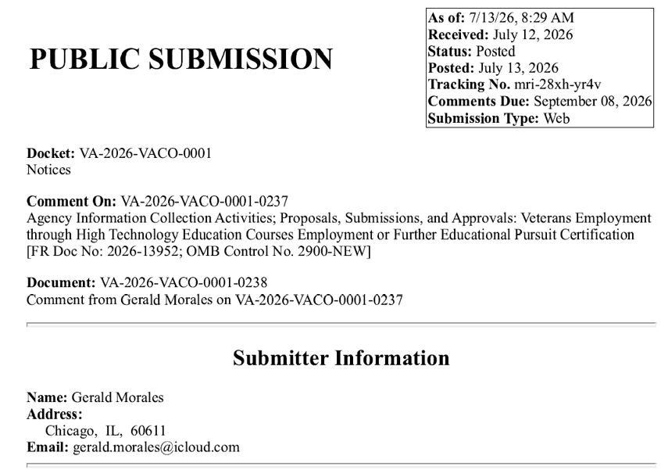
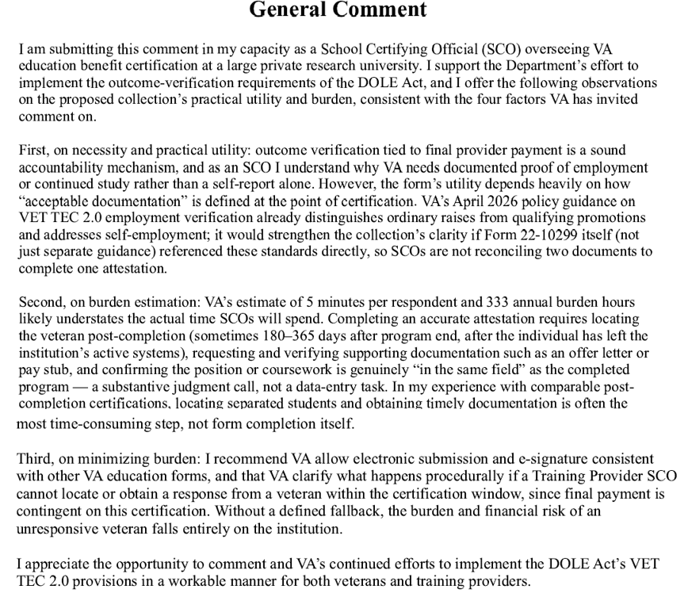

VA RESPONSE:
The Department of Veterans Affairs (VA) appreciates your thoughtful feedback on VA Form 22-10299, Veterans Employment Through High Technology Education Courses (VET TEC 2.0) Employment or Further Educational Pursuit Certification. We value your recommendations regarding improving the clarity of the successful employment requirements, reassessing the estimated time burden based on practical experience, reducing administrative workload through the use of electronic submission, and enhancing procedural guidance to address challenges schools may face in obtaining documentation of successful employment from students.
Your recommendation to incorporate the April 2026 employment guidance directly into the form has been elevated to VA leadership for consideration. While including the full guidance within the form is not practical, improving the connection between the form and the policy guidance is a sound suggestion and aligns with our efforts to enhance clarity for users.
When new information collections are developed, the estimated time burden is not always fully accurate. Based on your recommendation and the real-world experience associated with gathering the required documentation, VA leadership has decided to revise the burden estimate. We appreciate the insight you have provided, as it will help us develop a more accurate and reliable estimate of the time required to complete this information collection.
VA is in the process of integrating the successful employment verification into Enrollment Manager (EM) and enhancing our processing system to enable automated workflows, eliminating the need for submission of the PDF version of this form. Once automation is complete, VET TEC 2.0 School Certifying Officials (SCOs) will be able to retain documentation obtained from students rather than submitting it to VA with the successful employment certification. Additionally, VA has determined that an enrollment certification submitted through EM showing enrollment in acceptable further education can serve as sufficient proof for meeting that milestone.
The way Congress designed the VET TEC 2.0 program, the burden and financial risk for payment with an unresponsive Veteran do fall on the school. In addition to that risk, VET TEC 2.0 participating schools also face substantial financial risk of a student not completing the program or not obtaining successful employment or further education. Due to this financial risk, VA has advised schools interested in participating in VET TEC 2.0 to carefully consider these risks and fully assess potential student success when admitting a student into a VET TEC 2.0 program. VA acknowledges your concerns; however, regarding lack of defined procedures should a school find they are unable to obtain successful employment verification and/or documentation for a student.
Under the statutory framework established by Congress for the VET TEC 2.0 program, participating schools do bear the responsibility and significant financial risk associated with final payment when a Veteran becomes unresponsive. Schools also assume financial risk if a Veteran does not complete the program, does not obtain successful employment, or does not pursue further education instead of employment. Given these statutory requirements, VA encourages institutions considering participation in VET TEC 2.0 to carefully evaluate these risks before choosing to participate and thoroughly assess each prospective student's likelihood of success before enrollment. Because these provisions are established by law, VA has no authority to provide relief or recourse when student outcomes do not meet the program’s payment requirements.
We hope you find this information useful. VA appreciates your commitment to enhancing the VET TEC 2.0 Program and supporting our nation’s Veterans. Your feedback is invaluable in streamlining processing and ensuring program integrity and effectiveness.
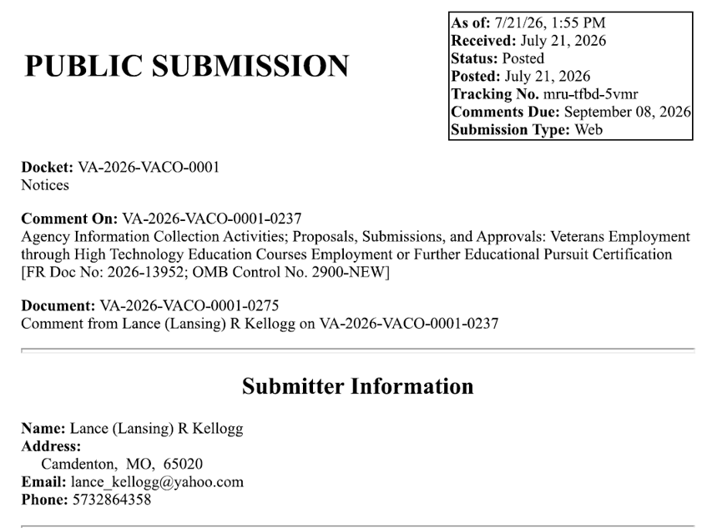
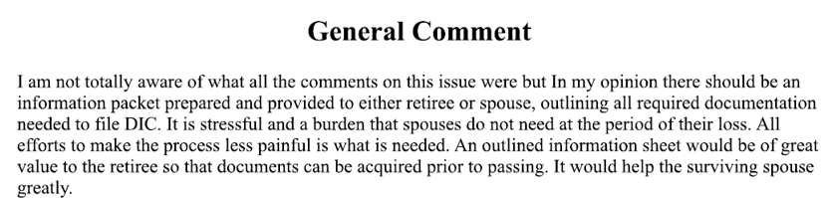

VA RESPONSE:
Thank you for taking the time to submit your comment on VA Form 22-10299, Veterans Employment Through High Technology Education Courses (VET TEC 2.0) Employment or Further Educational Pursuit Certification. We appreciate you reaching out but based on the content of your submission, it appears that your comment may have been intended for a different form, as it is not related to VA Form 22-10299 or the VET TEC 2.0 program. Because of this, we are unable to provide a response through this comment process.
We appreciate your support of our nation's Veteran community and thank you for taking the time to contact VA.

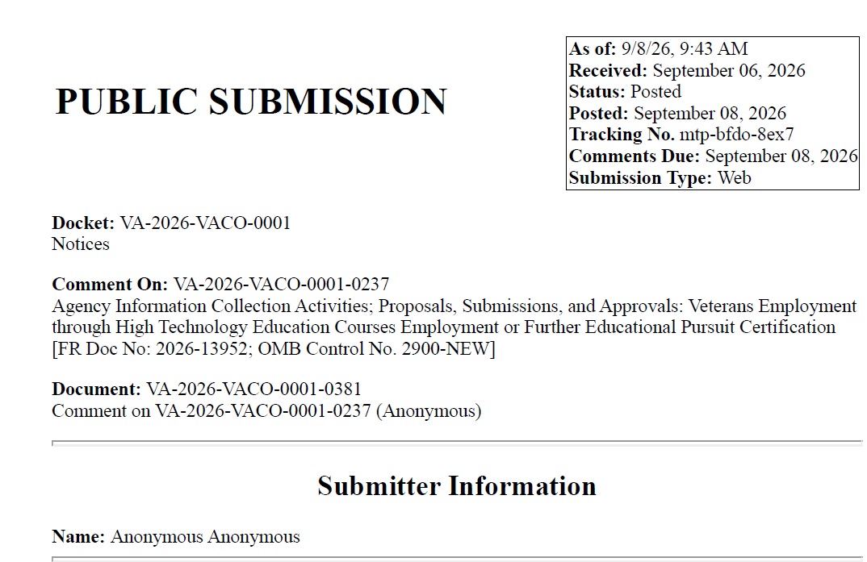
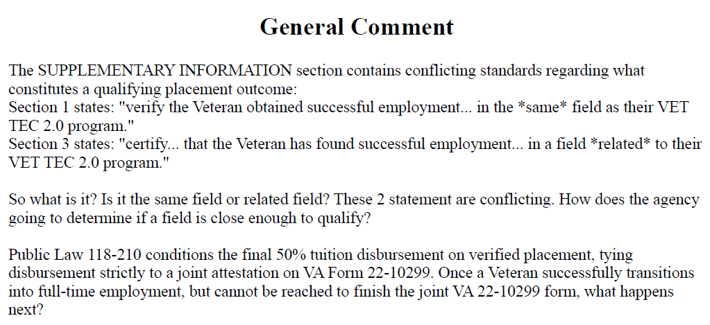
VA RESONSE:
The Department of Veterans Affairs (VA) appreciates your feedback on VA Form 22-10299, Veterans Employment Through High Technology Education Courses (VET TEC 2.0) Employment or Further Educational Pursuit Certification. We value your recommendations on improving the clarity of the successful employment requirements, as well as your concerns regarding the challenges schools may face in obtaining documentation of successful employment from students.
38 U.S.C. § 3699C(c)(2)(C) and § 3699C(c)(6)(A)–(B) use employment-based outcomes in determining final payment to providers and provider preference. Section 3699C(c)(2)(C) provides for final payment upon (i) the successful employment of the covered individual for a period of 180 days in the field of study of the program, beginning not later than 180 days following graduation; (ii) the employment of the individual by the provider for a period of one year; or (iii) the enrollment of the individual in a program of education to continue education in such field of study.
Because the meaning of “employment” in these provisions is ambiguous, and the statute does not detail the evidentiary standards for the meaning of “field of study,” VA is exercising its interpretive authority to define the phrase “field of study” for purposes of the pathways to successful employment.
For purposes of 38 U.S.C. § 3699C(c)(2)(C), VA has determined that “field of study” means the occupational, technical, or academic area reflected by the content of the completed VET TEC 2.0 program. Whether employment, provider employment, self-employment, or further education is in the field of study will be determined based on the substance of the duties performed, the business activity conducted, or the educational content pursued—not solely on the job title, business industry or name, credential, or program.
Accordingly, a job, business activity, or subsequent program of education may be considered to be in the field of study when it directly uses, advances, or is grounded in the knowledge, skills, and abilities taught in the completed VET TEC 2.0 program. Conversely, a job, business activity, or subsequent program of education will not be considered to be in the field of study when the relationship to the completed VET TEC 2.0 program is merely incidental, tangential, or unrelated. This is VA’s interpretive standard for applying the statutory phrase “field of study” in 38 U.S.C. § 3699C(c)(2)(C).
Example: A covered individual who completes a software development program and then works as a junior developer, performs paid contract coding work, or enrolls in a more advanced software engineering program would generally be considered to be in the field of study. Conversely, a covered individual who completes a software development program and then opens an unrelated retail business or enrolls in an unrelated program of education would generally not be considered to be in the field of study merely because the individual occasionally uses general computer skills.
Based on VA’s interpretation, your question regarding the language surrounding the field of employment has been taken into consideration. To preserve the integrity and success of the program, VA will clarify the language on VA Form 22-10299, Veterans Employment Through High Technology Education Courses (VET TEC 2.0) Employment or Further Educational Pursuit Certification, to consistently state “within the field of study.”
VA acknowledges your concerns regarding unresponsive Veterans; however, providers are required by law to maintain documentation or certification sufficient for VA to determine that the applicable statutory pathway in 38 U.S.C. § 3699C(c)(2)(C) has been met, including documentation obtained from the Veteran where appropriate. Under the statutory framework established by Congress for the VET TEC 2.0 program, participating providers bear both the responsibility and the significant financial risk associated with final payment when a Veteran becomes unresponsive. In addition, providers also assume substantial financial risk if a Veteran does not complete the program, does not obtain successful employment, or does not pursue further education instead of employment.
Given these statutory requirements and associated financial risks, VA encourages institutions considering participation in VET TEC 2.0 to carefully evaluate these risks before choosing to participate and to thoroughly assess each prospective student’s likelihood of success before enrollment. Because these provisions are established by law, VA has no authority to provide relief or recourse when student outcomes do not meet the program’s payment requirements.
We hope you find this information useful. VA appreciates your commitment to enhancing the VET TEC 2.0 Program and supporting our nation’s Veterans. Your feedback is invaluable in streamlining processing and ensuring program integrity and effectiveness.
A 30-Day Federal Register Notice (FRN) for the collection published on Wednesday, September 23, 2026. The 30-Day FRN citation is Volume 91, FRN No 60491.
9. Explain any decision to provide any payment or gift to respondents, other than remuneration of contractors or grantees.
No payments or gifts are being offered to respondents as an incentive to participate in the collection.
10. Describe any assurance of privacy, to the extent permitted by law, provided to respondents and the basis for the assurance in statute, regulation, or agency policy.
The records are maintained in the appropriate Privacy Act System of Records identified as Compensation, Pension, Education, and Veteran Readiness and Employment Records – VA (58VA/21/22/28), published at 74 FR 29275 on June 19, 2009, and last amended at 87 FR 8740 (February 16, 2022).
11. Provide additional justification for any questions of a sensitive nature (Information that, with a reasonable degree of medical certainty, is likely to have a serious adverse effect on an individual's mental or physical health if revealed to him or her), such as sexual behavior and attitudes, religious beliefs, and other matters that are commonly considered private; include specific uses to be made of the information, the explanation to be given to persons from whom the information is requested, and any steps to be taken to obtain their consent.
No questions considered sensitive are being asked in this collection.
12. Estimate of the hour burden of the collection of information. If this request for approval covers more than one form, provide separate hour burden estimates for each form, and aggregate the hour burdens in Item 13 of OMB 83-I. Provide estimates of annual cost to respondents for the hour burdens for collections of information. The cost of contracting out or paying outside parties for information collection activities should not be included here. Instead, this cost should be included in Item 14 of the OMB 83-I.
VA Form 22-10299
Veterans Employment Through High Technology Education Courses (VET TEC 2.0) Employment of Further Educational Pursuit Certification
The estimated annual burden to the public for this information collection is projected at 333 hours. The total number of respondents for this information collection is estimated to be 4,000 respondents per year, as that is the approval limit each year for the associated with the VET TEC 2.0 program.
- Number of Respondents: 4,000.
- Frequency of Response: Once.
- Annual Burden Hours: 333 hours (4,000 X 5 minutes / 60 minutes).
- Estimated Completion Time for Respondent: 5 minutes.
e. The respondent population for this new Veterans Employment Through High Technology Education Courses (VET TEC 2.0) Employment of Further Educational Pursuit Certification, VA Form 22-10299 consists of School Certifying Officials and Veterans to certify to VA a Veteran’s employment or educational status after completion of a VET TEC 2.0 program, and to ensure the employment or educational pursuit aligns with the skills acquired during the Veteran’s VET TEC 2.0 training in the program. VBA cannot make further assumptions about the population of respondents because of the variability of factors such as educational background and wage potential of respondents. Therefore, VBA used general wage data for "All Occupations" to estimate the respondents' costs associated with completing the information collection.
The Bureau of Labor Statistics gathers information on full-time wage and salary workers. According to the latest available BLS data, the median weekly earnings of full-time wage and salary workers is $1341.60. Assuming a forty (40) hour work week, the median hourly wage is $33.54 based on the BLS wage code of "00-000-0000 for "All Occupations." This information was taken from the following website https://data.bls.gov/oes/#/industry/000000, May 2025.
Legally, respondents may not pay a person or business for assistance in completing the information collection and a person or business may not accept payment for assisting a respondent in completing the information collection. Therefore, there are no expected overhead costs for completing the information collection. VBA estimates the total cost to all respondents to be $11,168.82 (333 burden hours X $33.54 per hour).
13. Provide an estimate of the total annual cost burden to respondents or recordkeeping resulting from the collection of information. (Do not include the cost of any hour burden shown in Items 12 and 14).
There are no questions of a sensitive nature.
14. Provide estimates of annual cost to the Federal Government. Also, provide a description of the method used to estimate cost, which should include quantification of hours, operation expenses (such as equipment, overhead, printing, and support staff), and any other expense that would not have been incurred without this collection of information. Agencies also may aggregate cost estimates from Items 12, 13, and 14 in a single table.
Estimated Costs to the Federal Government: $24,720.00.
Grade | Step | Burden Time  Employee | Hourly Rate | Cost Per Response | Total Responses | Total
09 | 05 | 15 min | $24.72 | $6.18 | 4,000 | $24,720 (4,000 X $33.19 X 15min/60min)
Overhead at 100% Salary |  |  |  |  |  | $24,720.00
Overhead costs are 100% of salary and are the same as the wage listed above; and the amount is included in the total. |  |  |  |  |  | $24,720.00
Processing I Analyzing Costs |  |  |  |  |  | $24,720.00
Printing and Production Cost |  |  |  |  |  | $0
Total Cost to Government |  |  |  |  |  | $24,720.00
Note: The hourly wage information above is based on the hourly 2025 General Schedule (Base) Locality Pay Area for the Rest of USA. https://www.opm.gov/policy-data-oversight/pay-leave/salaries-wages/salary-tables/pdf/2026/RUS_h.pdf
The processing time estimates above are based on the actual amount of time VA employees of the grade level will spend processing the VA Form 22-10299.
15. Explain the reason for any burden hour changes since the last submission.
There is no change in burden, as this is a NEW collection.
16. For collections of information whose results will be published, outline plans for tabulation and publication. Address any complex analytical techniques that will be used. Provide the time schedule for the entire project, including beginning and ending dates of the collection of information, completion of report, publication dates, and other actions.
The information collection is not for publication or tabulation use.
17. If seeking approval to not display the expiration date for OMB approval of the information collection, explain the reasons that display would be inappropriate.
We are not seeking approval to omit the display of the expiration date of the OMB approval on the collection instrument.
18. Explain each exception to the certification statement identified in
Item 19, "Certification for Paperwork Reduction Act Submissions," of
OMB 83-1.
We are not requesting any exemptions to the provisions stated in 5 CFR 1320.9.

