
DEPARTMENT OF VETERANS AFFAIRS
Veterans Benefits Administration
Washington, DC 20420

TO: Office of Mission Support (OMS)

FROM: VA Education Service (225)

DATE: March 18, 2026

RE: Response to Public Comments for ICR 202523-2900-003

COMMENT 1
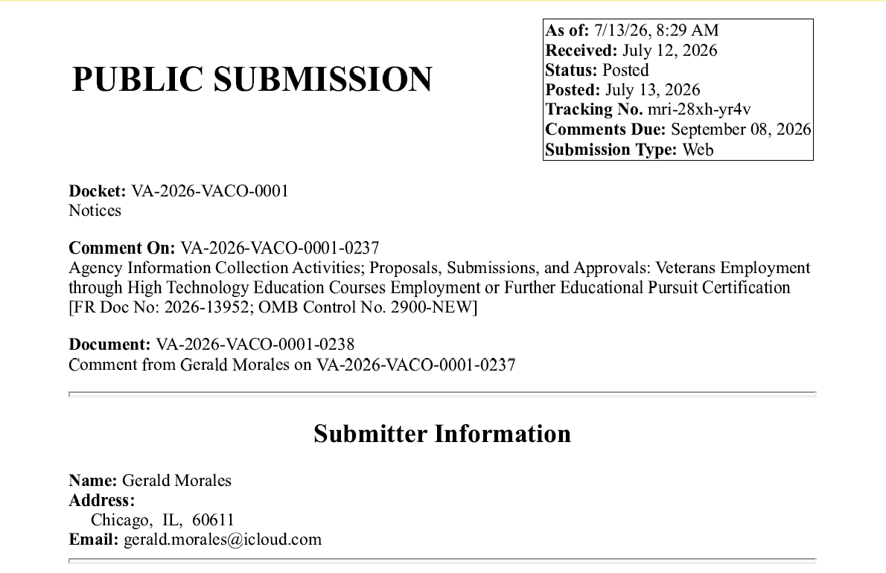
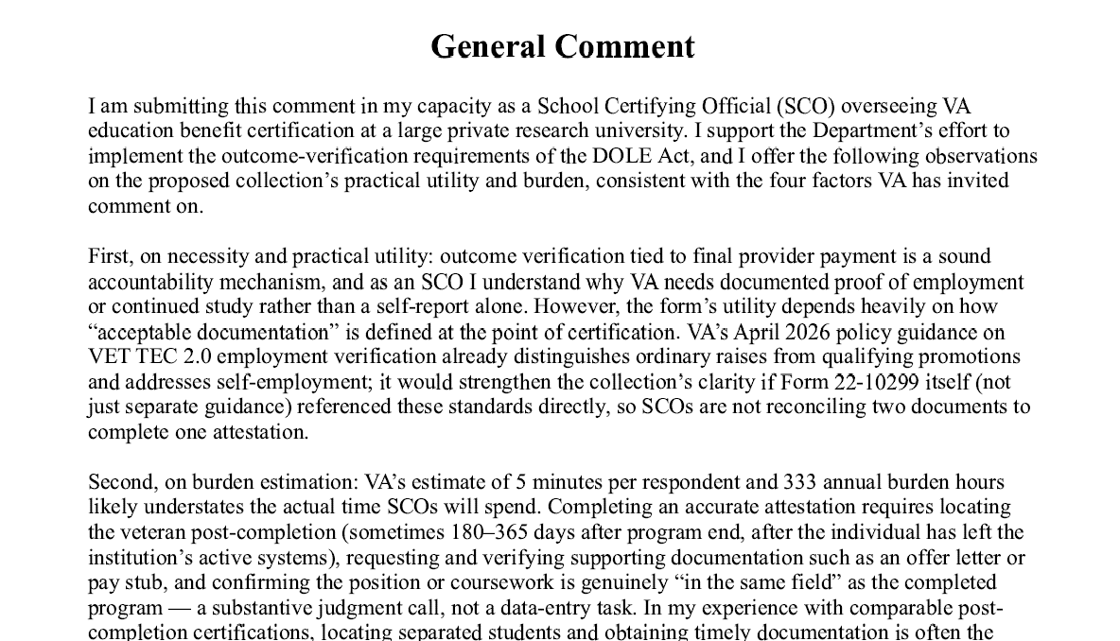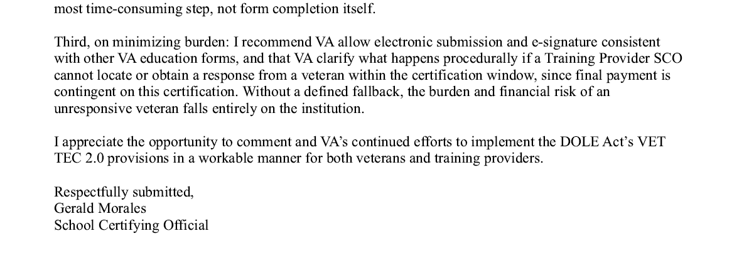

VA RESPONSE:
The Department of Veterans Affairs (VA) appreciates your thoughtful feedback on VA Form 22-10299, Veterans Employment Through High Technology Education Courses (VET TEC 2.0) Employment or Further Educational Pursuit Certification. We value your recommendations regarding improving the clarity of the successful employment requirements, reassessing the estimated time burden based on practical experience, reducing administrative workload through the use of electronic submission, and enhancing procedural guidance to address challenges schools may face in obtaining documentation of successful employment from students.
Your recommendation to incorporate the April 2026 employment guidance directly into the form has been elevated to VA leadership for consideration. While including the full guidance within the form is not practical, improving the connection between the form and the policy guidance is a sound suggestion and aligns with our efforts to enhance clarity for users.
When new information collections are developed, the estimated time burden is not always fully accurate. Based on your recommendation and the real-world experience associated with gathering the required documentation, VA leadership has decided to revise the burden estimate. We appreciate the insight you have provided, as it will help us develop a more accurate and reliable estimate of the time required to complete this information collection.
VA is in the process of integrating the successful employment verification into Enrollment Manager (EM) and enhancing our processing system to enable automated workflows, eliminating the need for submission of the PDF version of this form. Once automation is complete, VET TEC 2.0 School Certifying Officials (SCOs) will be able to retain documentation obtained from students rather than submitting it to VA with the successful employment certification. Additionally, VA has determined that an enrollment certification submitted through EM showing enrollment in acceptable further education can serve as sufficient proof for meeting that milestone.
The way Congress designed the VET TEC 2.0 program, the burden and financial risk for payment with an unresponsive Veteran do fall on the school. In addition to that risk, VET TEC 2.0 participating schools also face substantial financial risk of a student not completing the program or not obtaining successful employment or further education. Due to this financial risk, VA has advised schools interested in participating in VET TEC 2.0 to carefully consider these risks and fully assess potential student success when admitting a student into a VET TEC 2.0 program. VA acknowledges your concerns; however, regarding lack of defined procedures should a school find they are unable to obtain successful employment verification and/or documentation for a student.
Under the statutory framework established by Congress for the VET TEC 2.0 program, participating schools do bear the responsibility and significant financial risk associated with final payment when a Veteran becomes unresponsive. Schools also assume financial risk if a Veteran does not complete the program, does not obtain successful employment, or does not pursue further education instead of employment. Given these statutory requirements, VA encourages institutions considering participation in VET TEC 2.0 to carefully evaluate these risks before choosing to participate and thoroughly assess each prospective student's likelihood of success before enrollment. Because these provisions are established by law, VA has no authority to provide relief or recourse when student outcomes do not meet the program’s payment requirements.
We hope you find this information useful. VA appreciates your commitment to enhancing the VET TEC 2.0 Program and supporting our nation’s Veterans. Your feedback is invaluable in streamlining processing and ensuring program integrity and effectiveness.
COMMENT 2
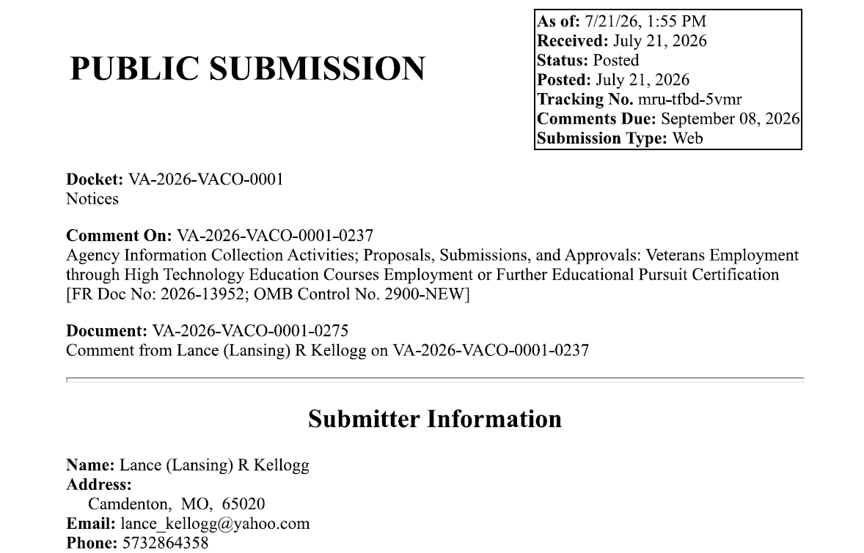
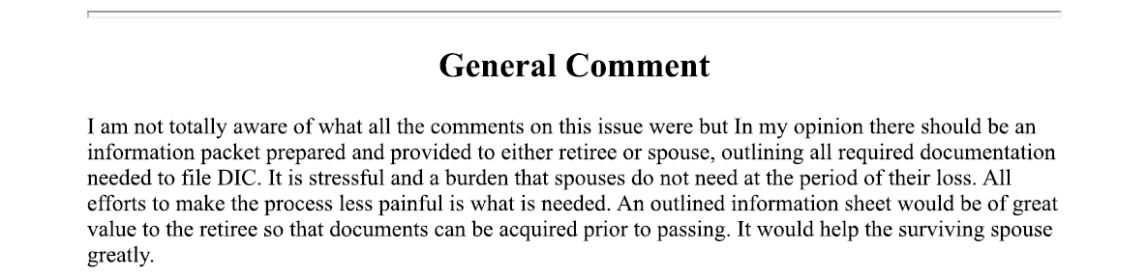
VA RESPONSE:
Thank you for taking the time to submit your comment on VA Form 22-10299, Veterans Employment Through High Technology Education Courses (VET TEC 2.0) Employment or Further Educational Pursuit Certification. We appreciate you reaching out but based on the content of your submission, it appears that your comment may have been intended for a different form, as it is not related to VA Form 22-10299 or the VET TEC 2.0 program. Because of this, we are unable to provide a response through this comment process.
We appreciate your support of our nation's Veteran community and thank you for taking the time to contact VA.

