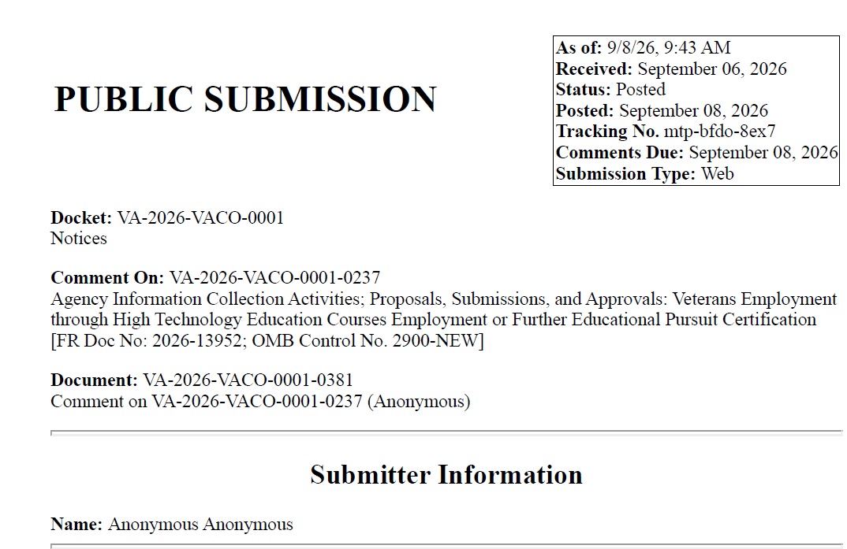
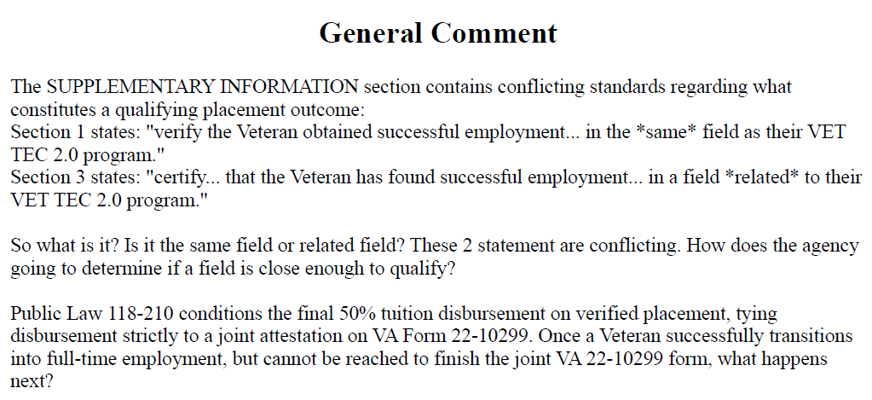
VA RESONSE:
The Department of Veterans Affairs (VA) appreciates your feedback on VA Form 22-10299, Veterans Employment Through High Technology Education Courses (VET TEC 2.0) Employment or Further Educational Pursuit Certification. We value your recommendations on improving the clarity of the successful employment requirements, as well as your concerns regarding the challenges schools may face in obtaining documentation of successful employment from students.
38 U.S.C. § 3699C(c)(2)(C) and § 3699C(c)(6)(A)–(B) use employment-based outcomes in determining final payment to providers and provider preference. Section 3699C(c)(2)(C) provides for final payment upon:
(i) the successful employment of the covered individual for a period of 180 days in the field of study of the program, beginning not later than 180 days following graduation;
(ii) the employment of the individual by the provider for a period of one year; or
(iii) the enrollment of the individual in a program of education to continue education in such field of study.
Because the meaning of “employment” in these provisions is ambiguous, and the statute does not detail the evidentiary standards for the meaning of “field of study,” VA is exercising its interpretive authority to define the phrase “field of study” for purposes of the pathways to successful employment.
For purposes of 38 U.S.C. § 3699C(c)(2)(C), VA has determined that “field of study” means the occupational, technical, or academic area reflected by the content of the completed VET TEC 2.0 program. Whether employment, provider employment, self-employment, or further education is in the field of study will be determined based on the substance of the duties performed, the business activity conducted, or the educational content pursued—not solely on the job title, business industry or name, credential, or program.
Accordingly, a job, business activity, or subsequent program of education may be considered to be in the field of study when it directly uses, advances, or is grounded in the knowledge, skills, and abilities taught in the completed VET TEC 2.0 program. Conversely, a job, business activity, or subsequent program of education will not be considered to be in the field of study when the relationship to the completed VET TEC 2.0 program is merely incidental, tangential, or unrelated. This is VA’s interpretive standard for applying the statutory phrase “field of study” in 38 U.S.C. § 3699C(c)(2)(C).
Example: A covered individual who completes a software development program and then works as a junior developer, performs paid contract coding work, or enrolls in a more advanced software engineering program would generally be considered to be in the field of study. Conversely, a covered individual who completes a software development program and then opens an unrelated retail business or enrolls in an unrelated program of education would generally not be considered to be in the field of study merely because the individual occasionally uses general computer skills.
Based on VA’s interpretation, your question regarding the language surrounding the field of employment has been taken into consideration. To preserve the integrity and success of the program, VA will clarify the language on VA Form 22-10299, Veterans Employment Through High Technology Education Courses (VET TEC 2.0) Employment or Further Educational Pursuit Certification, to consistently state “within the field of study.”
VA acknowledges your concerns regarding unresponsive Veterans; however, providers are required by law to maintain documentation or certification sufficient for VA to determine that the applicable statutory pathway in 38 U.S.C. § 3699C(c)(2)(C) has been met, including documentation obtained from the Veteran where appropriate. Under the statutory framework established by Congress for the VET TEC 2.0 program, participating providers bear both the responsibility and the significant financial risk associated with final payment when a Veteran becomes unresponsive. In addition, providers also assume substantial financial risk if a Veteran does not complete the program, does not obtain successful employment, or does not pursue further education instead of employment.
Given these statutory requirements and associated financial risks, VA encourages institutions considering participation in VET TEC 2.0 to carefully evaluate these risks before choosing to participate and to thoroughly assess each prospective student’s likelihood of success before enrollment. Because these provisions are established by law, VA has no authority to provide relief or recourse when student outcomes do not meet the program’s payment requirements.
We hope you find this information useful. VA appreciates your commitment to enhancing the VET TEC 2.0 Program and supporting our nation’s Veterans. Your feedback is invaluable in streamlining processing and ensuring program integrity and effectiveness.

