Wednesday, June 24, 2026
9:28 AM

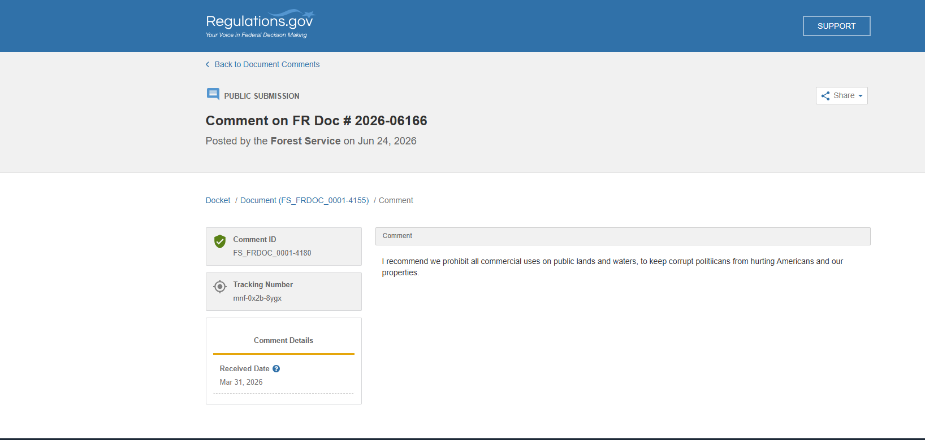

Screen clipping taken: 6/24/2026 9:28 AM

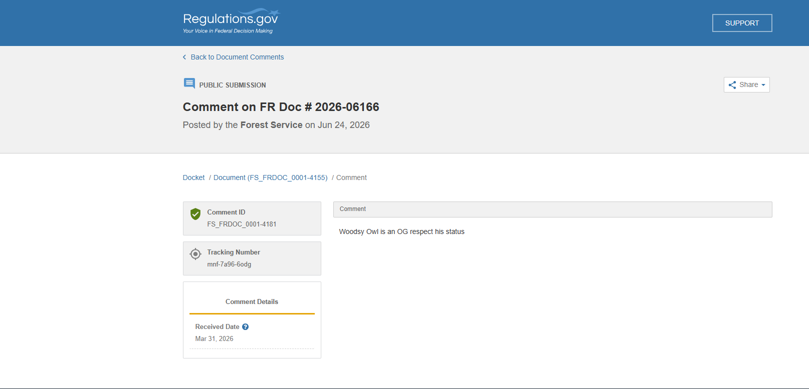

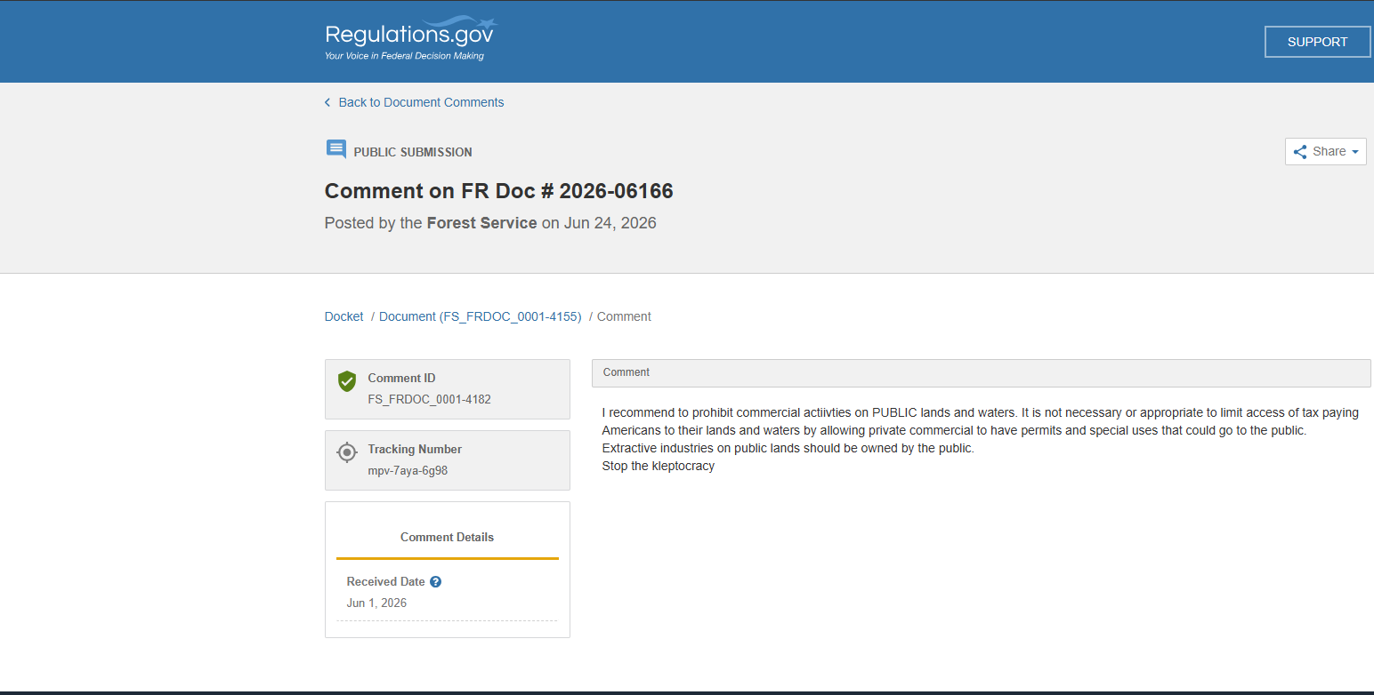

Screen clipping taken: 6/24/2026 9:38 AM

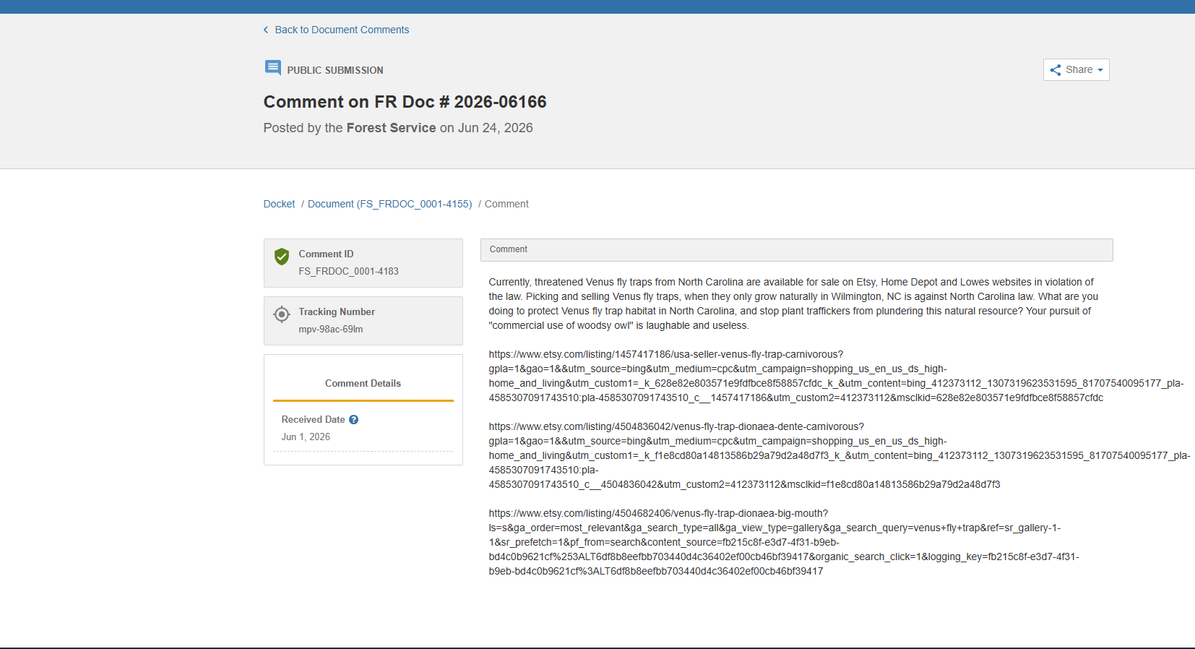

Screen clipping taken: 6/24/2026 9:39 AM

Screen clipping taken: 6/24/2026 9:28 AM

