Forest Service, U.S. Department of Agriculture Form Approved
160 Holdsworth Way OMB 0596-0010
Amherst, MA 01003 Expires [OMB EXP DATE]
[YEAR] PRIMARY WOOD USING MILL QUESTIONNAIRE
Paperwork Reduction Act Notice: A Federal agency may not conduct or sponsor, and a person is not required to respond to, nor shall a person be subject to a penalty for failure to comply with an information collection subject to the requirements of the Paperwork Reduction Act of 1995, unless the information collection has a currently valid OMB Control Number. The approved OMB Control Number for this information collection is 0596-0010. Without this approval, we could not conduct this information collection. Public reporting for this information collection is estimated to be approximately 30 minutes per response, including the time for reviewing instructions, searching existing data sources, gathering, and maintaining the data needed, and completing and reviewing the information collection. All responses to this information collection are voluntary. Send comments regarding this burden estimate or any other aspect of this information collection, including suggestions for reducing this burden to the U.S.D.A. Forest Service email address SM.FS.InfoCollect@usda.gov and include the OMB Control Number in the subject line.

Mill Location
1. What is the location of the mill? Please enter[/correct] the information below.
A. Street: __________________________________________________________________________
B. City: _____________________________ D. State: _____ E. Zip code: _____________________

Contact Information
2. Who is the best person to contact about this mill? Please enter[/correct] the information below.
A. Contact name: ________________________________________________
B. Contact email: _________________________ C. Contact phone: _________________________

Mill Type
3. What type of mill is this? If more than one mill type operates at this site, complete a separate form for each type.
□ Sawmill □ Veneer mill □ Industrial fuelwood □ Cabin/house mill □ Pole mill □ Post mill □ Piling mill
□ Other mill type (please specify): ___________________________________

Mill Status
4. A. What was the status of the mill in [YEAR]?
□ Active □ Idle □ Closed/Out of Business □ Dismantled
B. Did the mill receive any raw material (logs/roundwood) in [YEAR]?
□ Yes □ No If no, there are no additional questions for you. Please just return the form in the postage-paid envelope provided.

Mill Employment
5. How many people were employed at this mill in [YEAR]? ___________________

Mill Capacity
6. What is the annual output capacity of finished product for this mill when it is operating at full capacity?
Please round to a whole number and specify units.
Total volume: ___________________ Units: □ Thousand board feet □ Standard cords
□ Green tons □ Thousand pieces
□ Other (please specify): ___________________

Products Produced
7. What types of products were produced in [YEAR]? And what were their percentages of total production?
Do not include products made from the residues from processing the mills primary product.
Examples: Rough lumber, grade lumber, pallet lumber, railroad ties, flooring, plywood, face veneer, industrial fuelwood, residential firewood, cabin logs, pilings, utility poles, fence posts, shavings excelsior.
Product Percent
_______________________________ ______%
_______________________________ ______%
_______________________________ ______%
_______________________________ ______%
_______________________________ ______%

Volume of Roundwood Received
8. What is the total volume of roundwood received for the mill indicated in Question 3?
Please round to a whole number and specify units. Exclude unprocessed logs, bolts sold/transferred to other domestic primary processing plants, and logs or bolts exported out of the country.
Total volume: ___________________ Units: □ MBF Doyle □ MBF Scribner □ MBF International 1/4-inch rule
□ MBF Lumber tally □ Standard cords (4’x4’x8’) □ Green tons
□ Thousand pieces □ Other (please specify): ___________________

Log Dimensions
9. A. What is the average log length (in feet) of wood received at the mill?
_____________.___ feet
B. What is the average top diameter (in inches) of wood received at the mill?
_____________.___ inches

Species of Roundwood Received
10. What was the species composition of the roundwood received in [YEAR]?
Please round to a whole percent and include additional sheets if necessary.
Species Percent Species Percent
[REGIONAL_SP_1] _____% [REGIONAL_SP_6] _____%
[REGIONAL_SP_2] _____% [REGIONAL_SP_7] _____%
[REGIONAL_SP_3] _____% [REGIONAL_SP_8] _____%
[REGIONAL_SP_4] _____% [REGIONAL_SP_9] _____%
[REGIONAL_SP_5] _____% [REGIONAL_SP_10] _____%
Other species _____% Other species _____%
Please specify species: _________________ Please specify species: _________________

Origin of Roundwood Received
11. A. What was the average procurement radius (in miles) for roundwood received at the mill in [YEAR]?
___________________ miles
B. From what county, state, or country did the roundwood originate? If from within [MILL_STATE], please list the counties. If from outside of [MILL_STATE], please list the state or country. Add additional sheets as needed.
County, State, or Country Percent County, State, or Country Percent
_______________________________ _____% _______________________________ _____%
_______________________________ _____% _______________________________ _____%
_______________________________ _____% _______________________________ _____%
_______________________________ _____% _______________________________ _____%
_______________________________ _____% _______________________________ _____%

Non-forest Sources
12. A. Did you process any logs from cities or towns (urban areas) at your mill in [YEAR]?
□ Yes □ No
B. If yes, what percentage of the total roundwood received was urban wood? Please round to a whole percent.
_______%
Disposal of Bark and Wood Residues
13. A. How were the bark residues used or not used?
Please include all mill residues regardless of whether they were sold, given away, or paid to dispose.
_______% Manufacture of pulp/paper/composite products _______% Small dimension and other sawn products
_______% Charcoal or chemical wood _______% Industrial fuel at this plant
_______% Industrial fuel at other locations _______%Bio-energy pellets
_______% Residential fuelwood _______% Mulch/soil additives (including biochar)
_______% Animal bedding _______% Not used (land fill, burned, etc.)
_______% Other/misc. uses (please specify): ________________________________
13. B. How were the coarse wood residues used or not used?
Please include all mill residues regardless of whether they were sold, given away, or paid to dispose.
_______% Manufacture of pulp/paper/composite products _______% Small dimension and other sawn products
_______% Charcoal or chemical wood _______% Industrial fuel at this plant
_______% Industrial fuel at other locations _______%Bio-energy pellets
_______% Residential fuelwood _______% Mulch/soil additives (including biochar)
_______% Animal bedding _______% Not used (land fill, burned, etc.)
_______% Other/misc. uses (please specify): ________________________________
13. C. How were the fine wood residues (e.g., shavings and sawdust) used or not used?
Please include all mill residues regardless of whether they were sold, given away, or paid to dispose.
_______% Manufacture of pulp/paper/composite products _______% Small dimension and other sawn products
_______% Charcoal or chemical wood _______% Industrial fuel at this plant
_______% Industrial fuel at other locations _______%Bio-energy pellets
_______% Residential fuelwood _______% Mulch/soil additives (including biochar)
_______% Animal bedding _______% Not used (land fill, burned, etc.)
_______% Other/misc. uses (please specify): ________________________________

International Exports
14. A. Did the mill export any unprocessed logs out of the country in [YEAR]?
□ Yes □ No
B. If yes, what were the species and volumes exported? Please round to a whole number and specify units.
Species Volume/Amount
Unit of Measurement:
□ MBF Doyle
□ MBF Scribner
□ MBF International 1/4-inch
□ MBF Lumber tally
□ Standard cords (4’x4’x8’)
□ Green tons
□ Thousand pieces
□ Other (please specify):
___________________
[REG_EXPORT_SP_1] ___________________
[REG_EXPORT _SP_2] ___________________
[REG_EXPORT _SP_3] ___________________
[REG_EXPORT _SP_4] ___________________
[REG_EXPORT _SP_5] ___________________
Other species ___________________
Please specify species: ______________________
Other species ___________________
Please specify species: ______________________
C. What types of materials were exports? Please enter percentages and round to whole numbers.
_______% Saw logs
_______% Veneer logs
_______% Other (please specify): _____________
_______% Other (please specify): _____________
Directory Inclusion & Results
15. A. Would you like to omit the mill contact information from Regional/Statewide Industry Directories?
(This will not remove you from the list of mills that may be surveyed in the future)
□ Yes □ No
B. Would you like to receive a copy of the report resulting from this survey?
□ Yes □ No If yes, please provide an email address: ________________________________________
Notes/Comments
Please use the box below to record any information about the mill that may be helpful for interpreting your responses. Also, please use this space to add comments on any questions/sections that needed more instructions or were confusing, or if you have any suggestions on improving this questionnaire.

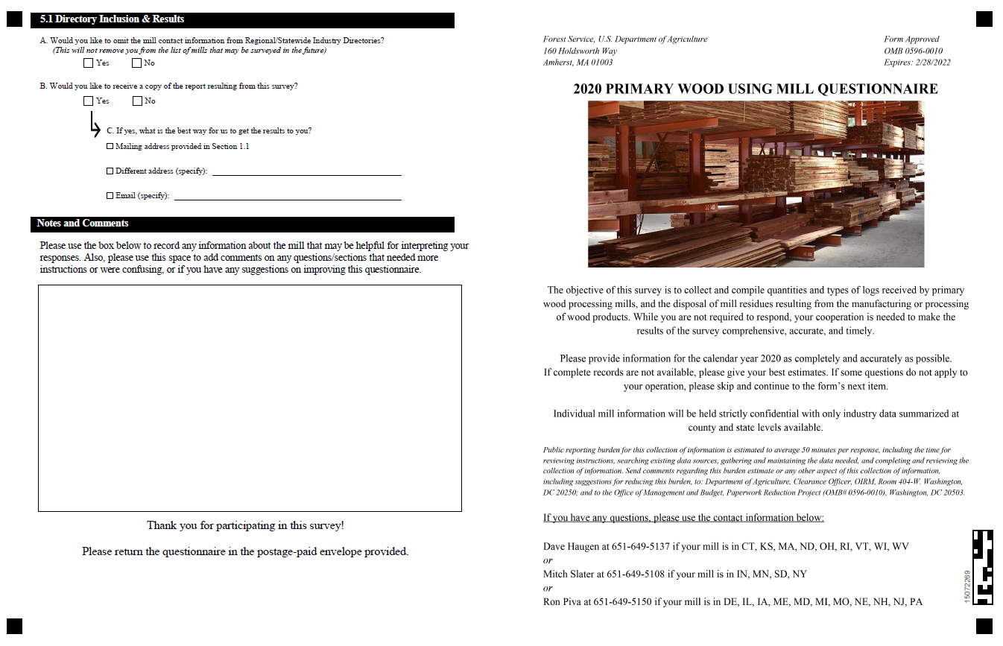
Thank you for participating in this survey!
Please return the questionnaire in the postage-paid envelope provided.

