Appendix A: Screenshots of APPS Online Application System Redesign
The APPS redesign separates large text boxes that previously required multiple pieces of information into individual questions or fields (such as for the Project Purpose shown here), making it easier to ensure applicants provide all required details.
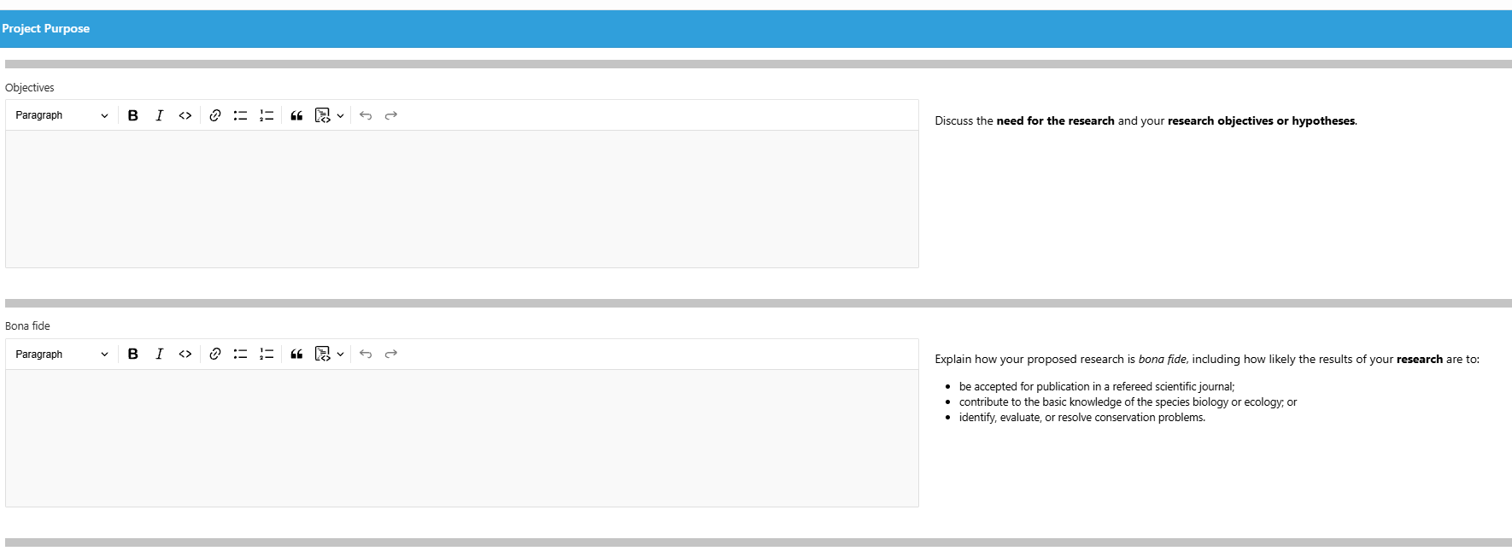
The APPS redesign also provides enhanced help (shown below) that includes the guidance from the instructions directly onscreen to the right of each information field.
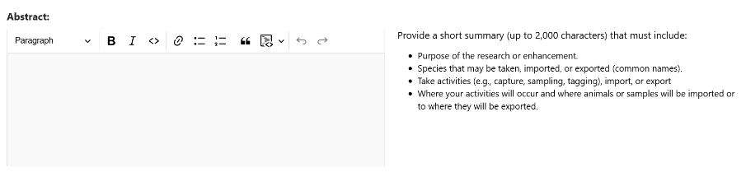

Below are two examples of information fields for an MMPA public display permit application for importation.
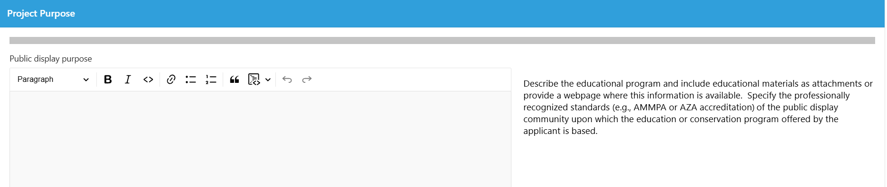

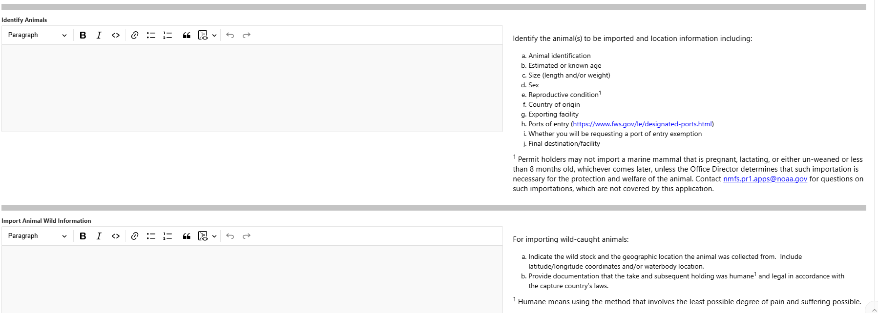

The below image shows the enhanced help within the Project Description section that has categories of methods that expand with more information to guide the user on the type of details to provide for each category.
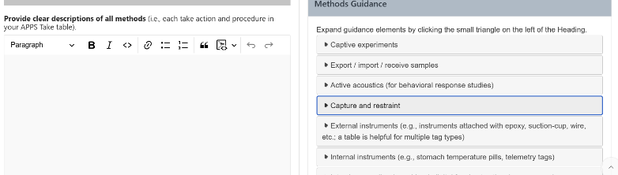
Another example of enhanced help with hyperlinks (in blue font) to other websites to help applicants find information to complete their application.
