OMB Control No. 0648-0148
Expiration Date: 12/31/2027

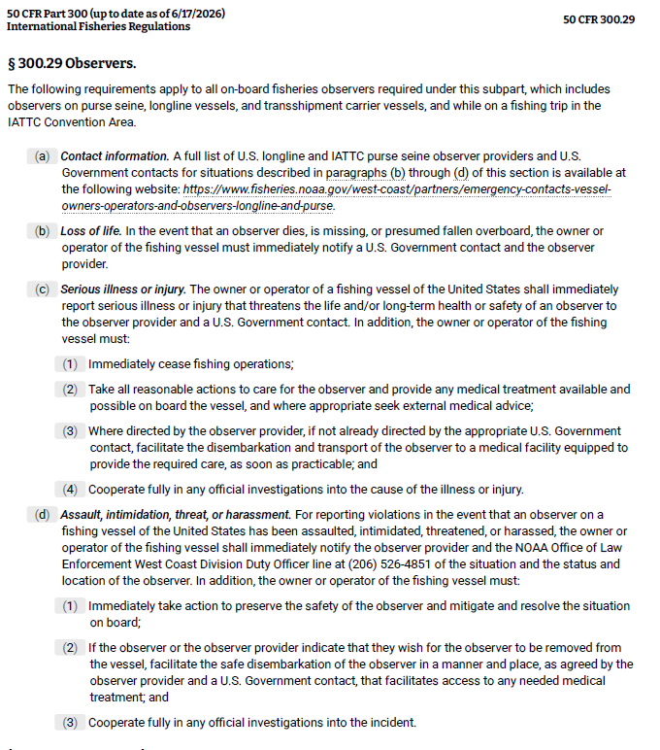

Paperwork Reduction Act Statement for Observer Safety Reporting

A Federal agency may not conduct or sponsor, and a person is not required to respond to, nor shall a person be subject to a penalty for failure to comply with an information collection subject to the requirements of the Paperwork Reduction Act of 1995 unless the information collection has a currently valid OMB Control Number. The approved OMB Control Number for this information collection is 0648-0148. Without this approval, we could not conduct this information collection. Public reporting for this information collection is estimated to be approximately 5 minutes per response, including the time for reviewing instructions, searching existing data sources, gathering and maintaining the data needed, and completing and reviewing the information collection. All responses to this information collection are mandatory. Send comments regarding this burden estimate or any other aspect of this information collection, including suggestions for reducing this burden to the NMFS West Coast Regional Office, 501 W. Ocean Blvd., Suite 4200, Long Beach, CA 90802.

