ITA Meeting Request Questionnaire
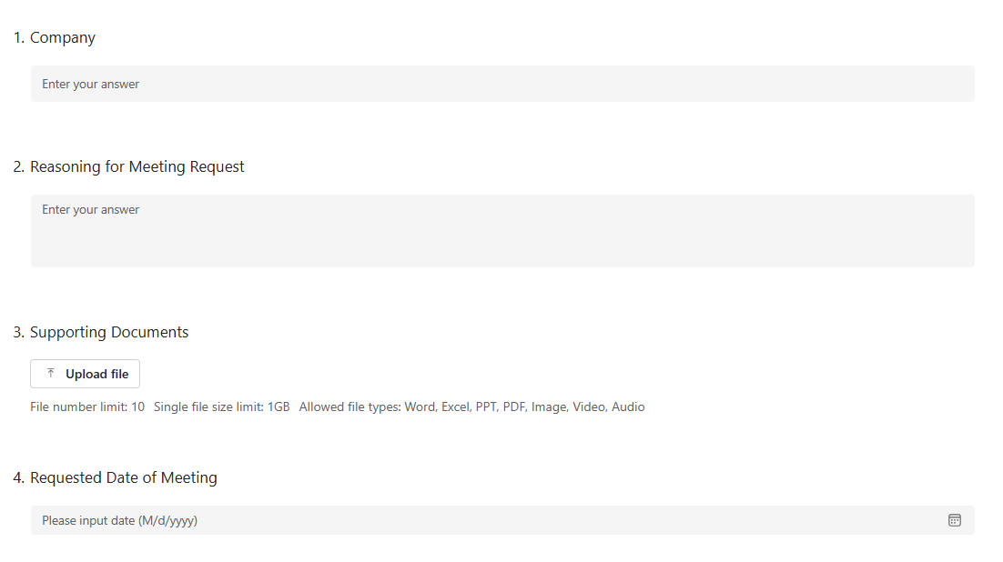
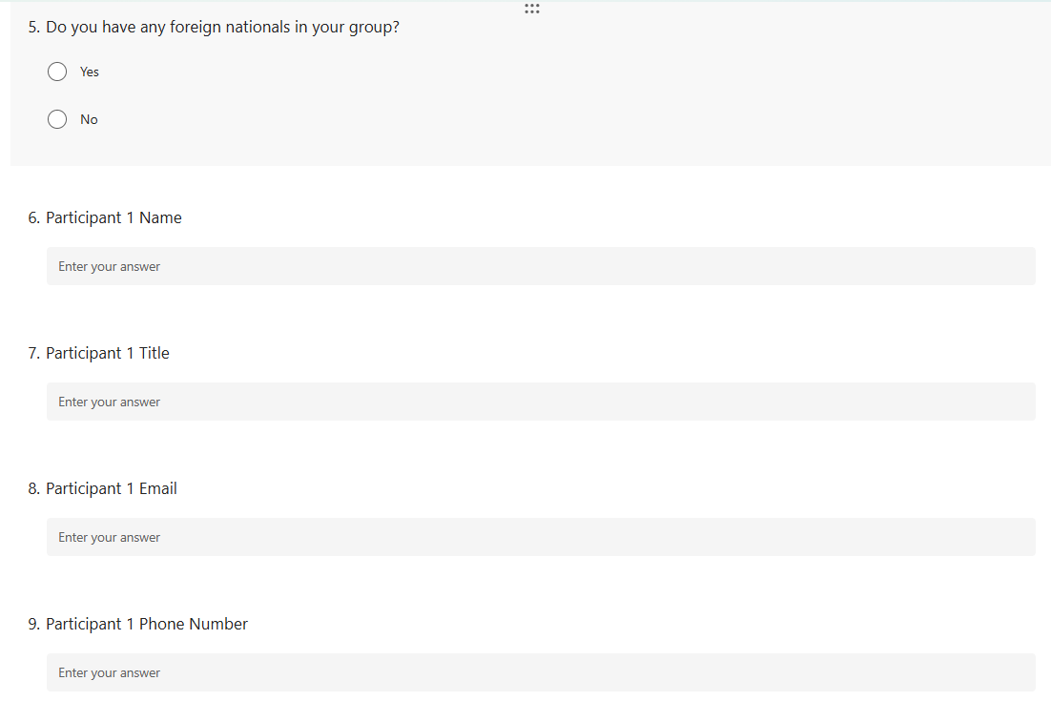
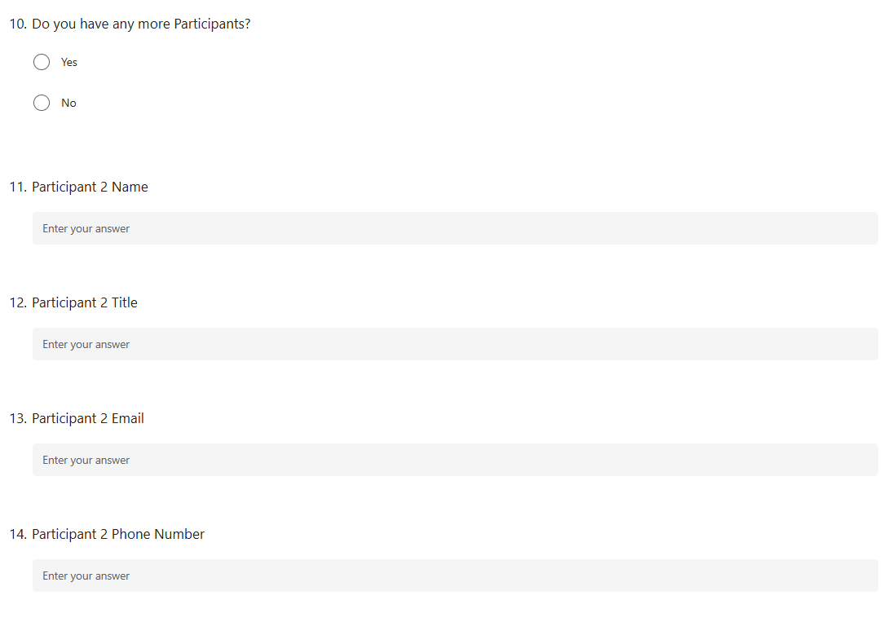
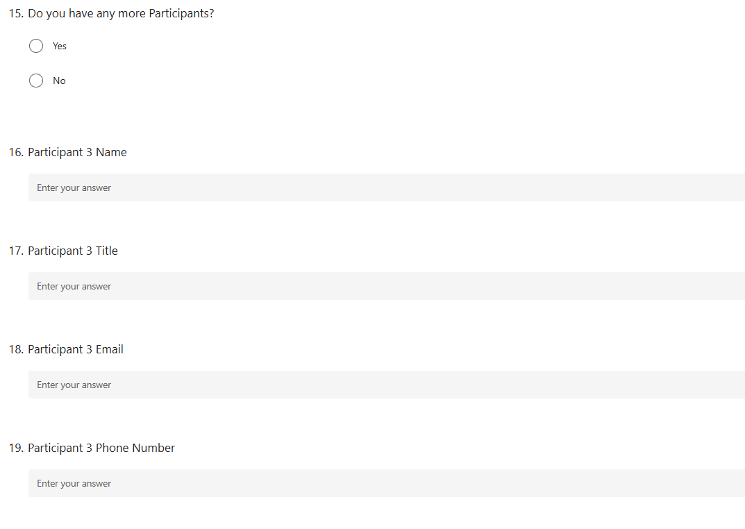
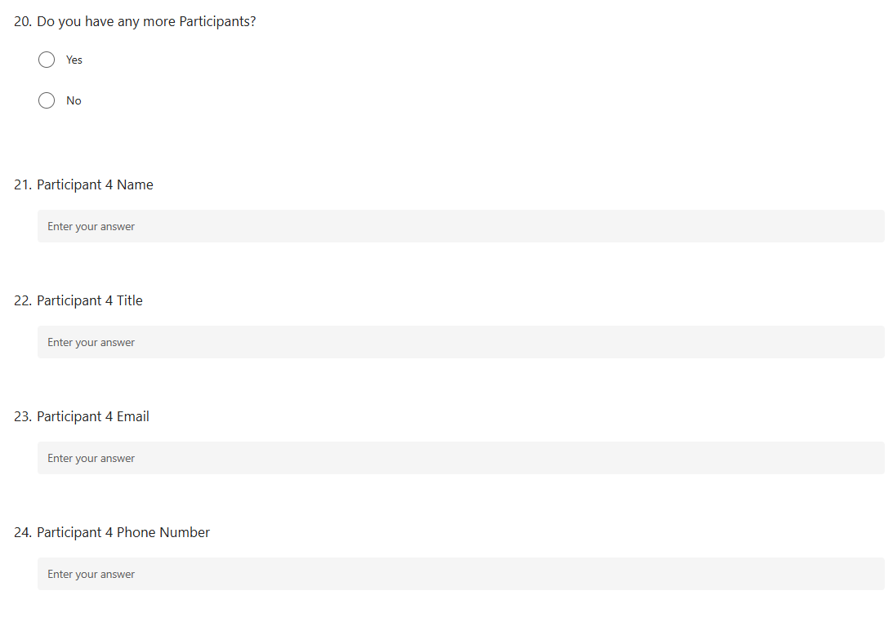
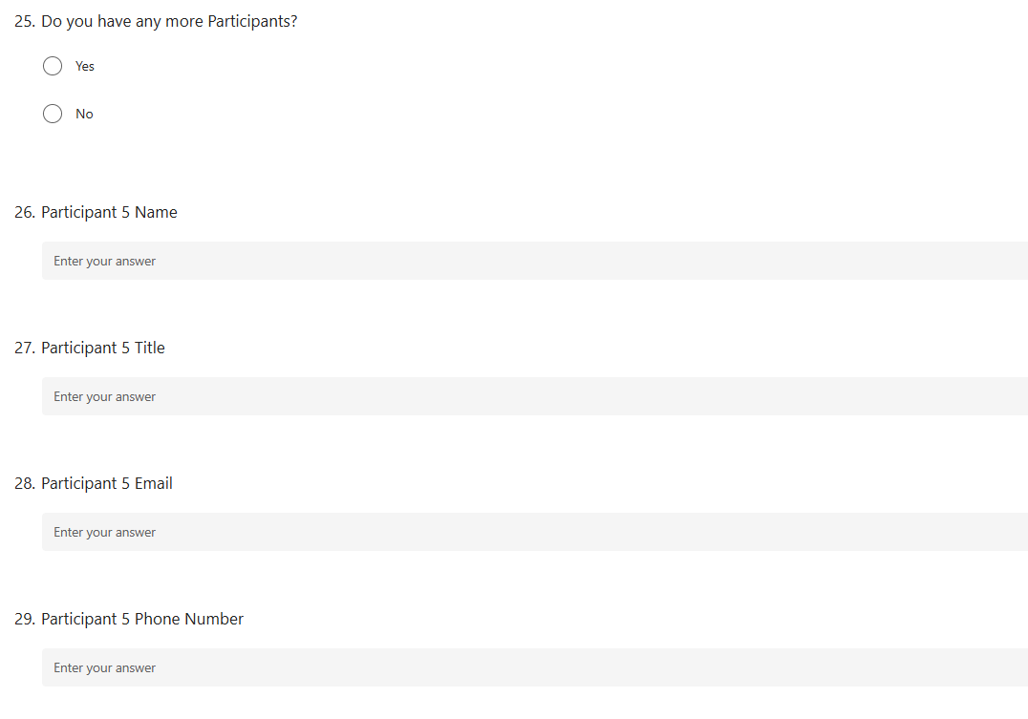
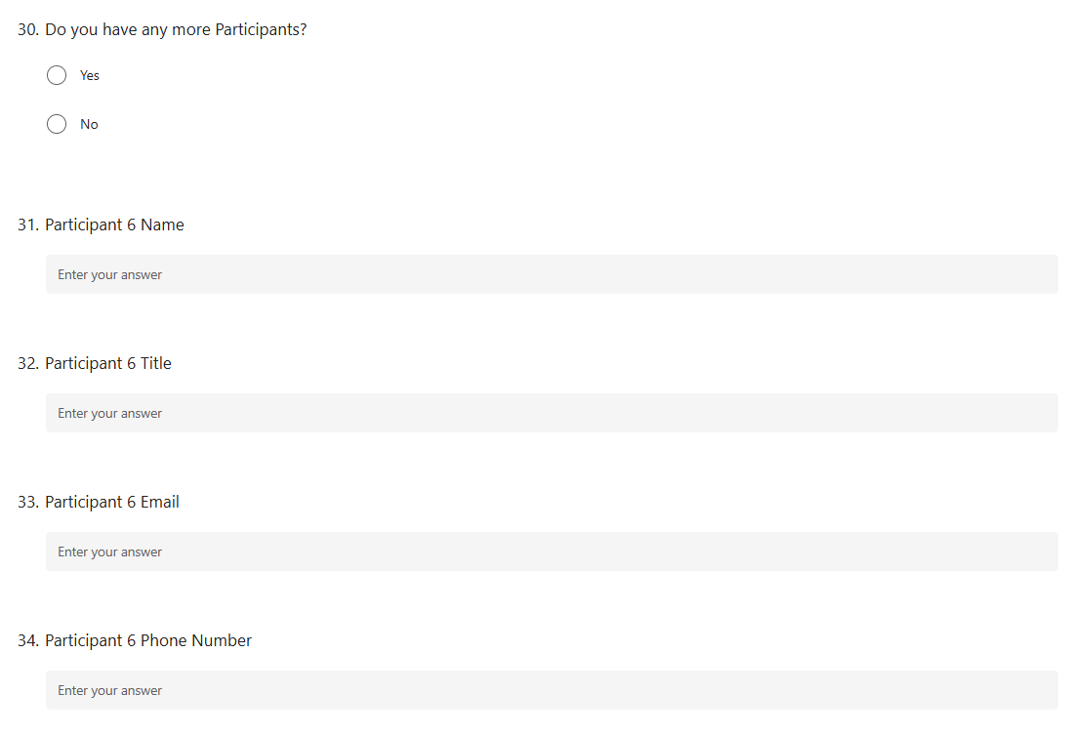
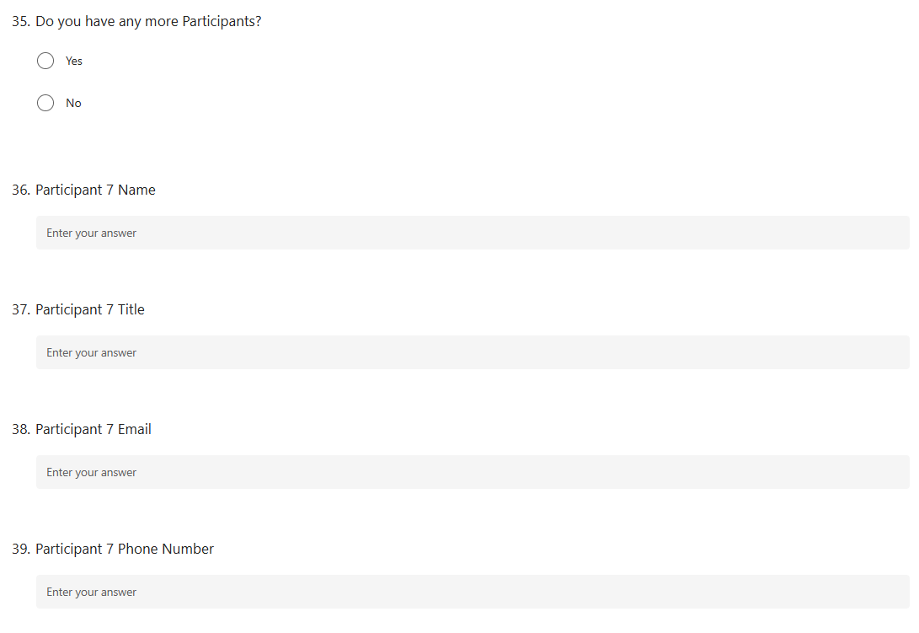
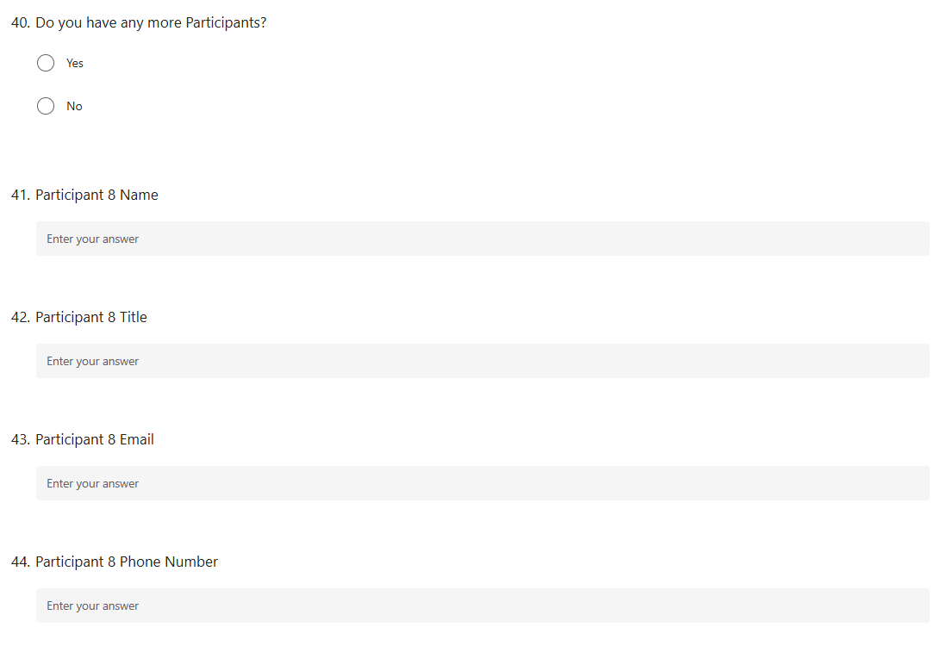
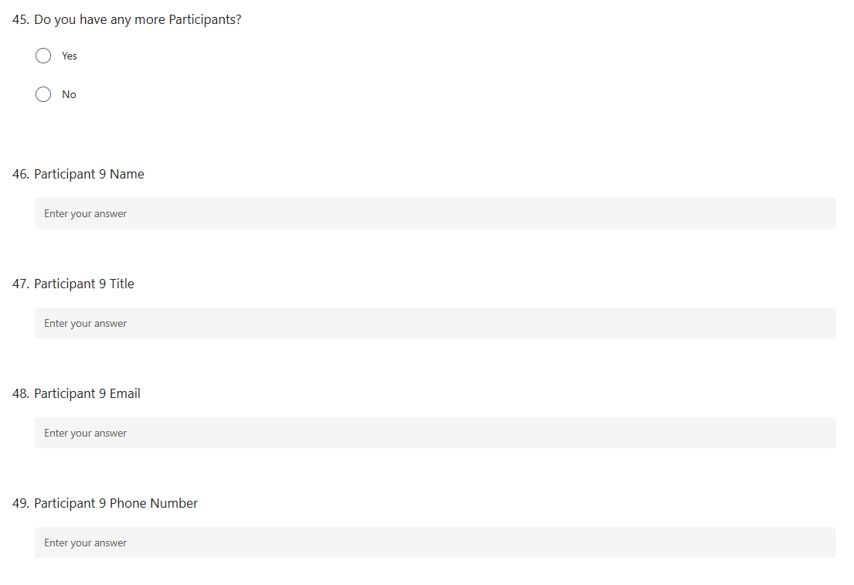
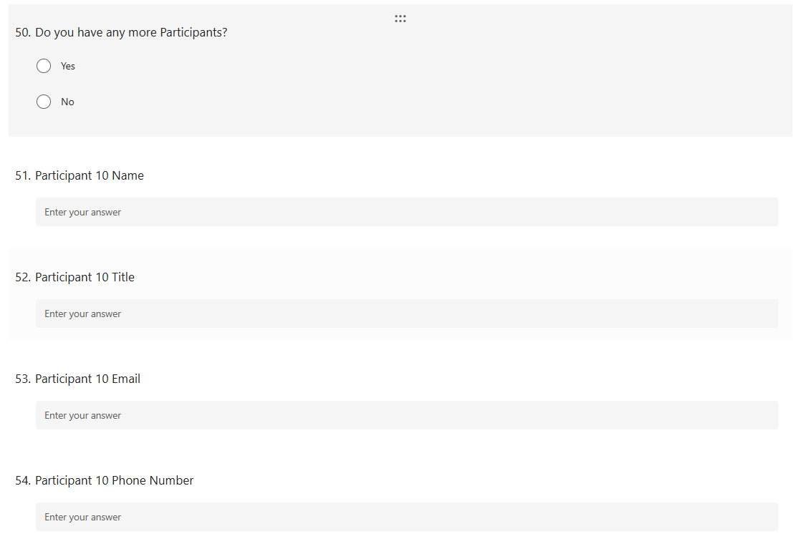
Public Burden Statement
A Federal agency may not conduct or sponsor, and a person is not required to respond to, nor shall a person be subject to a penalty for failure to comply with an information collection subject to the requirements of the Paperwork Reduction Act of 1995 unless the information collection has a currently valid OMB Control Number. The approved OMB Control Number for this information collection is 0690-0038. Without this approval, we could not conduct this information collection. Public reporting for this information collection is estimated to be approximately 10 minutes per response, including the time for reviewing instructions, searching existing data sources, gathering and maintaining the data needed, and completing and reviewing the information collection. All responses to this information collection are voluntary. Send comments regarding this burden estimate or any other aspect of this information collection, including suggestions for reducing this burden to the International Trade Administration Paperwork Reduction Act Program: PRA@trade.gov.

Privacy Act Statement
This information is collected under the authority of the Privacy Act of 1974 (5 U.S.C. § 552a) and 15 U.S.C. § 1512. It will be used by the International Trade Administration (ITA) to provide services, process requests, and support ITA’s trade promotion and enforcement mission. Routine uses may include disclosure to other federal, state, local, or foreign government agencies, and authorized contractors, as described in the applicable Department of Commerce System of Records Notices (SORNs) at https://www.commerce.gov/opog/privacy/SORN . Providing this information is voluntary, but not doing so may limit our ability to respond to your request.

