
UNITED STATES DEPARTMENT OF COMMERCE
Bureau of Industry and Security
Information and Communications Technology and Services
Washington, D.C. 20230

SUBJECT: PAPERWORK REDUCTION ACT – INFORMATION COLLECTION FOR RULEMAKING
INTRODUCTION
The new information collection for this rule will primarily take the form of Declarations of Conformity, specific authorizations applications, approved supplier applications, and advisory opinion requests. OICTS will electronically intake Declarations of Conformity, specific authorization applications, approved supplier applications, and advisory opinion requests through the Compliance Application and Reporting System (CARS), a web-based submission portal owned by BIS.
Certain forms will appear for certain entities based on entity registration type. Declarations of conformity, specific authorization applications, and advisory opinion requests are only available to entities regulated by the Connected Vehicles rule, connected vehicle manufacturers and VCS hardware importers (entity registration type: Regulated Party). Approved supplier applications are only available to certain suppliers of connected vehicle manufacturers and VCS hardware importers (entity registration type: Third Party).
The following disclaimers appear at the beginning of the Declaration of Conformity submission, specific authorization application, approved supplier application, and advisory opinion request.
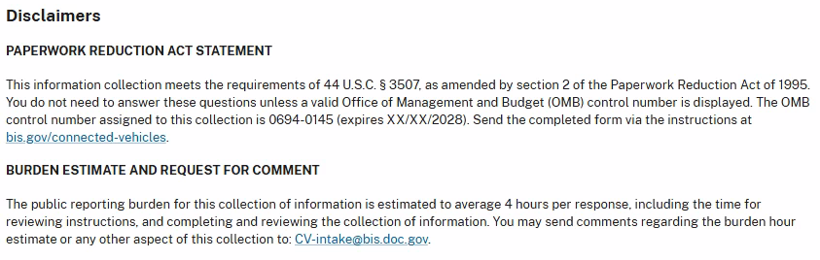

DECLARATIONS OF CONFORMITY
[Entity type: Regulated party]
- Company Information
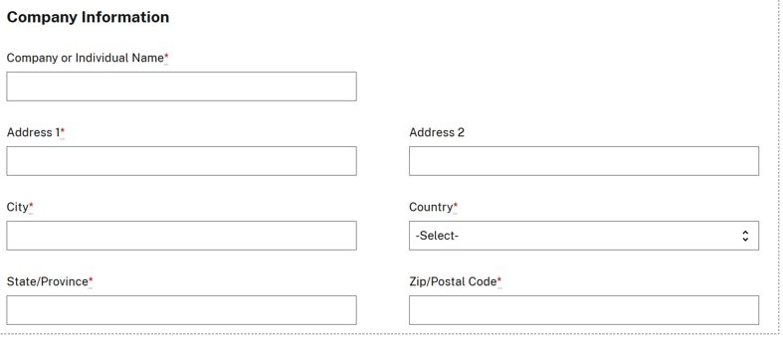

- Point of Contact Information
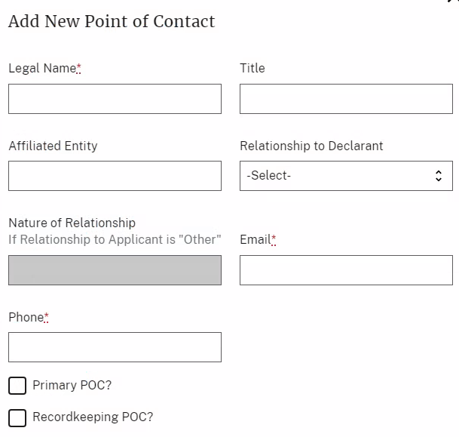
- Declaration Purpose
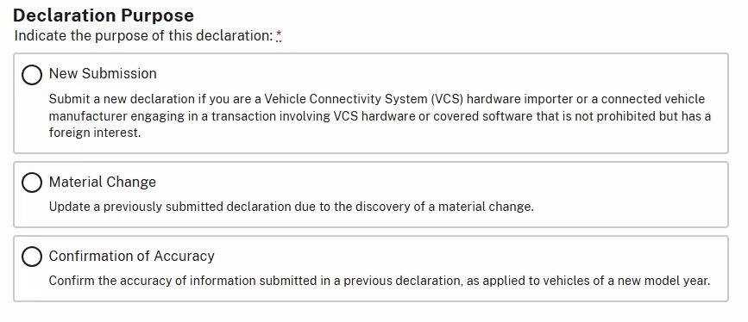

- Transaction Information – Adding a VCS Hardware Transaction
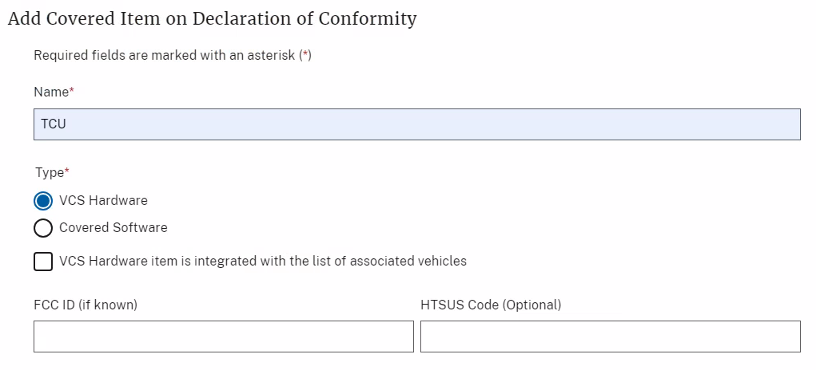
- Transaction Information – Adding a Covered Software Transaction
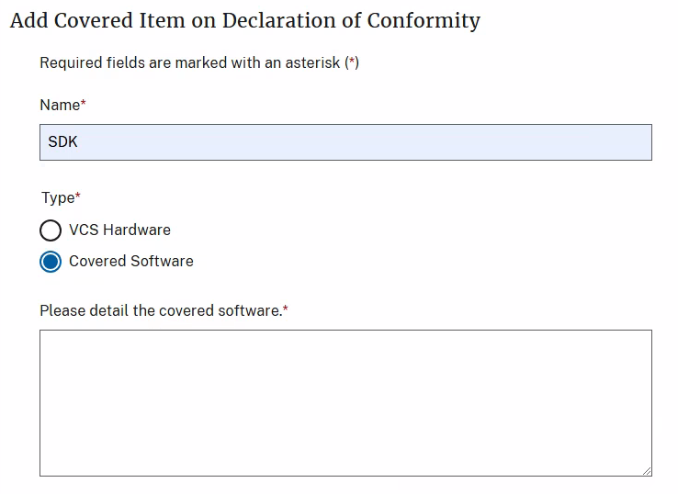

- Transaction Information – Associating a Make and Model to the VCS Hardware or Covered Software
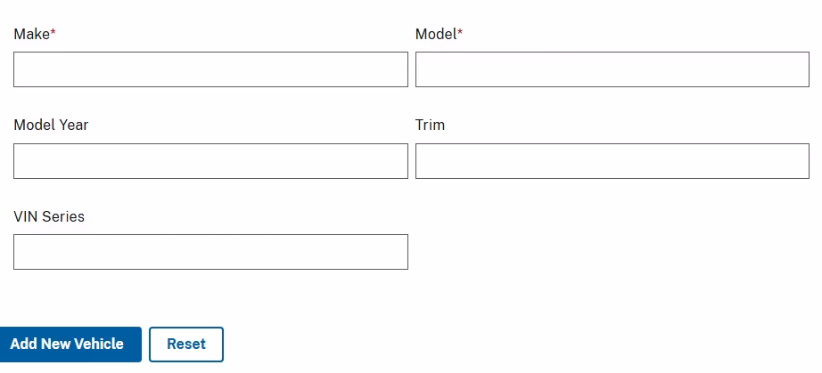
- Voluntarily Provided Information
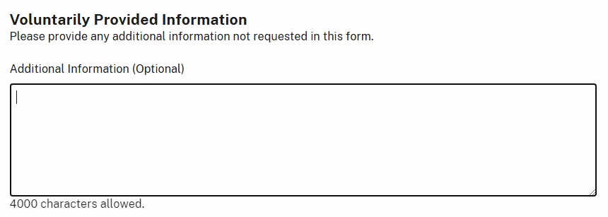

- Related Documentation
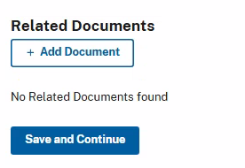

- Certifications
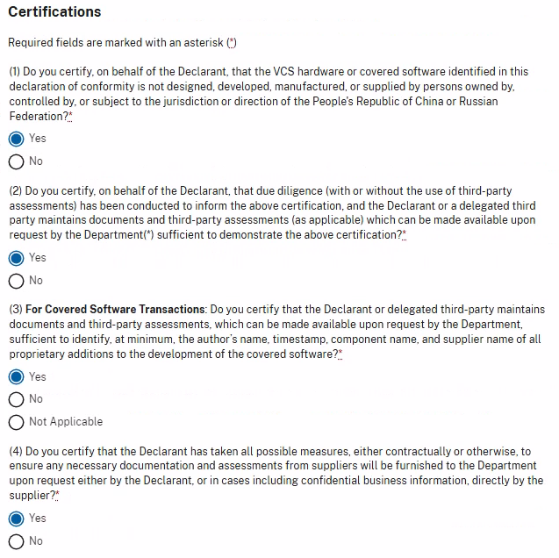

SPECIFIC AUTHORIZATION or APPROVED SUPPLIER APPLICATION
[Entity type for Specific Authorization Application: Regulated party]
- [Entity type for Approved Supplier Application: Third party]Company Information

- Company Corporate Ownership

Additional Directions: For examples of helpful documentation you can submit in relation to a description of ownership, refer to the What documentation should I submit in support of my Specific Authorization Application? FAQ here: https://www.bis.gov/oicts/connected-vehicles/specific-authorizations.
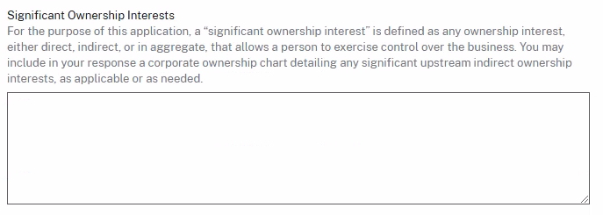
- Point of Contact Information

- Whether the Specific Authorization Relates to a Previously Submitted Declaration of Conformity
[Not applicable for Approved Supplier Application]
Additional Directions: Pursuant to 15 CFR Part 791.305(f), if a connected vehicle manufacturer or VCS hardware importer determines that articles subject to a Declaration of Conformity are no longer eligible, it must, within 30 days, cease any prohibited conduct and submit a specific authorization application. If this is the reason for your specific authorization application, please associate the previous Declaration of Conformity below.
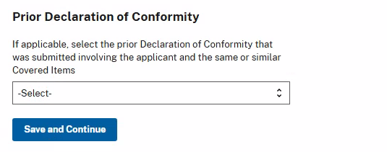

- Application Type

[Not applicable for Approved Supplier Application]

- Is the entity filing this Specific Authorization Application engaged in related prohibited transactions with respect to 15 CFR § 791.304?
  - Yes
  - No
By selecting “Yes,” you are required to list all covered software and VCS hardware that is designed, developed, manufactured, or supplied by you or a third-party. Please ensure to list all parties that are engaged in the otherwise prohibited transactions, including yourself, and associate the relevant covered software or VCS hardware item to each party.

- Party Engaged in an Otherwise Prohibited Transaction – Relevant Corporate Identifiers
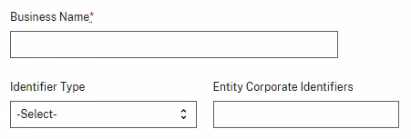

- Party Engaged in an Otherwise Prohibited Transaction – Information Sufficient to Identify Ultimate Beneficial Ownership & Point of Contact Information

[Approved supplier applicants:
-If known, provide identifying information for the VCS hardware importers or connected vehicle manufacturers you are supplying or plan to supply (both existing and future planned customers).
-If the VCS hardware importers or connected vehicle manufacturers that are supplied with your VCS hardware or connected software are not known, provide identifying information for your immediate customers.
-When adding any customers as Parties, you may select “Other” for Transaction Role, and specify “Customer” in the Transaction Role Notes.]

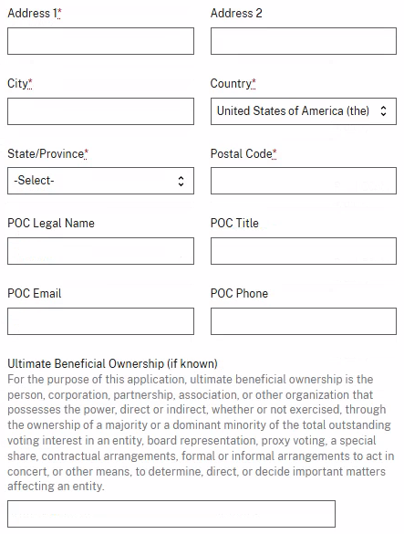
- Transaction Information – Party Transaction Role and Associated Covered Items
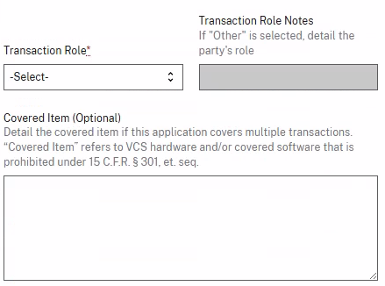
- Transaction Information – Adding a VCS Hardware Transaction
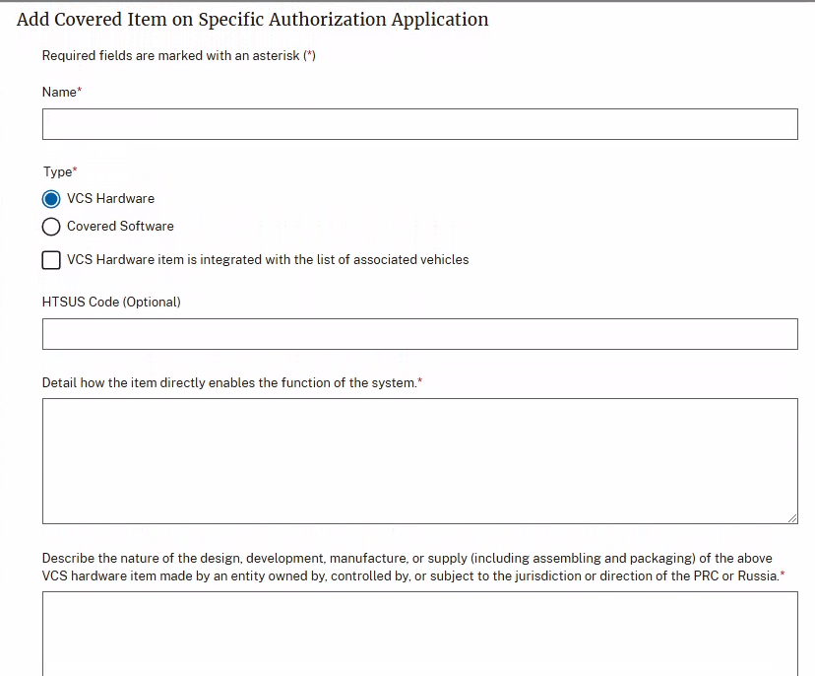

- Transaction Information – Adding a Covered Software Transaction
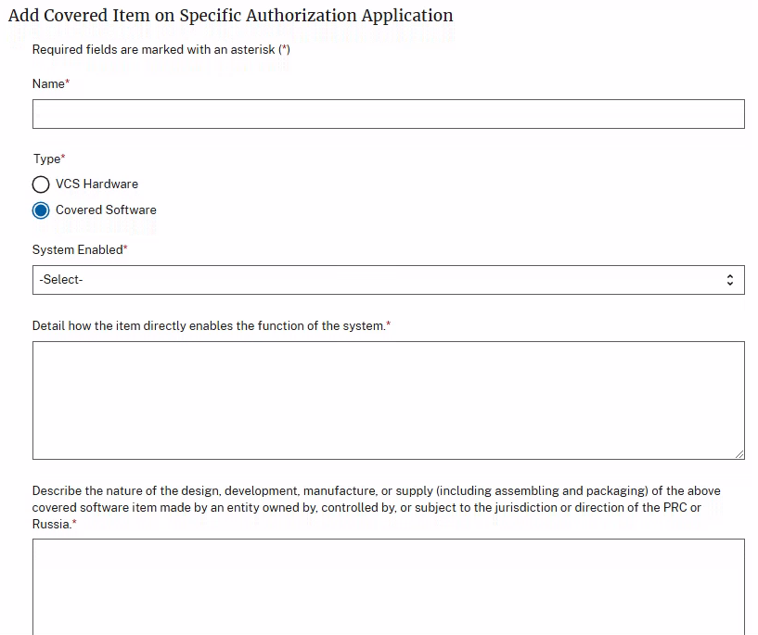

- Transaction Information – Associating a Make and Model to the VCS Hardware or Covered Software

- Internal Controls Assessment
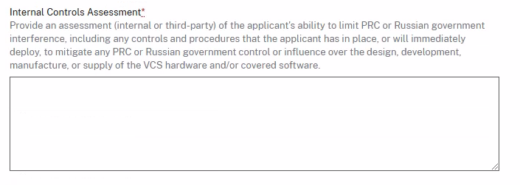
- Security Standards Used
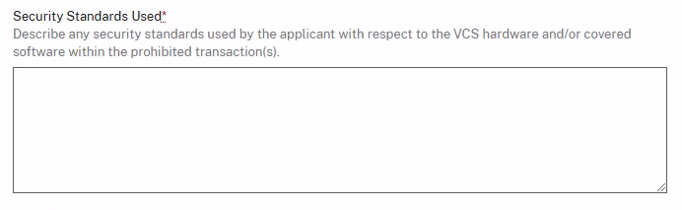

- Other Actions and Proposals
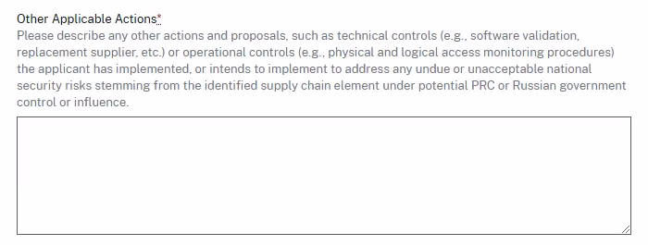

- Voluntarily Provided Information
[Approved supplier applicants:
- Use this field to provide a detailed statement explaining why the supplier should be added to the Approved Supplier Registry.
-Provide proposed entries for the supplier name and covered item name/description for inclusion in the published Approved Supplier Registry. By submitting your application, you are authorizing BIS to publish this supplier name and covered item name/description if your application is approved. If BIS, in its discretion, determines that it must change the proposed supplier name or covered item name/description for the published Approved Supplier Registry, it will notify you.]

- Related Documentation

ADVISORY OPINION REQUESTS
[Entity type: Regulated party]
- Company Information

- Point of Contact Information
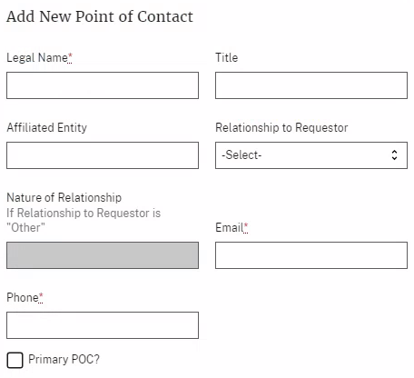

- Party Engaged in Prospective Transaction – Relevant Corporate Identifiers
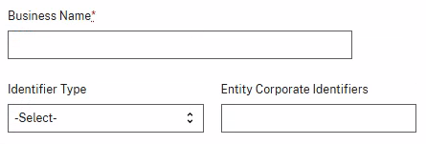

- Party Engaged in Prospective Transaction – Identifying Information
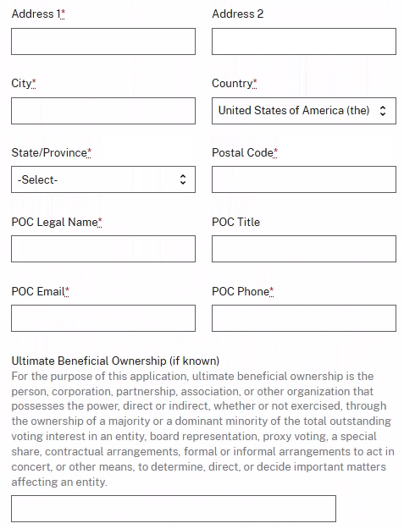

- Transaction Information – Party Transaction Role and Associated Covered Items
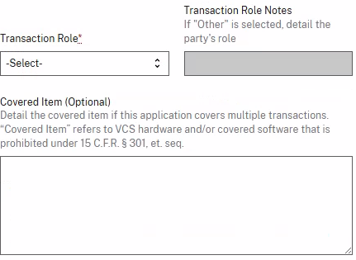

- Transaction Information – Information Regarding VCS Hardware
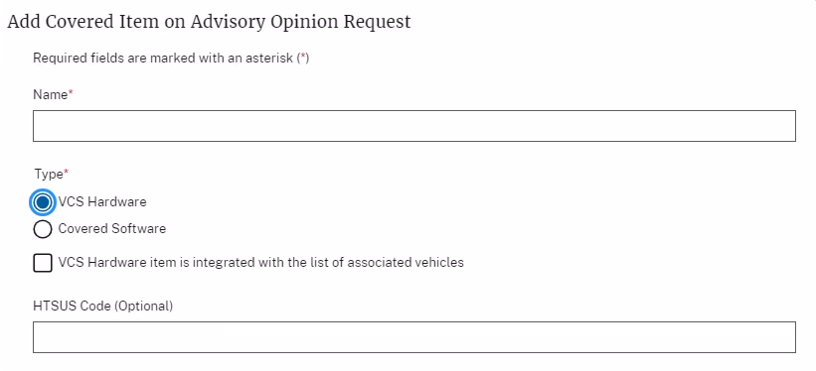

- Transaction Information – Information Regarding Covered Software
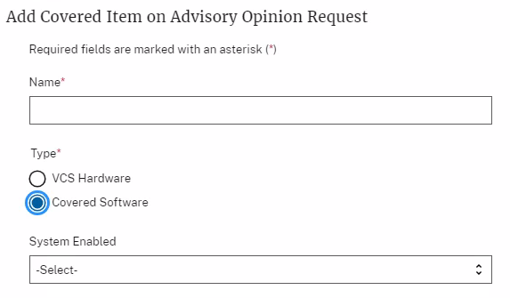

- Transaction Information – Associating a Make and Model to the VCS Hardware or Covered Software

- Advisory Opinion Request
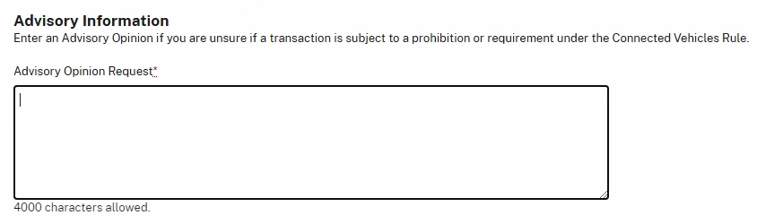

- Related Documentation

