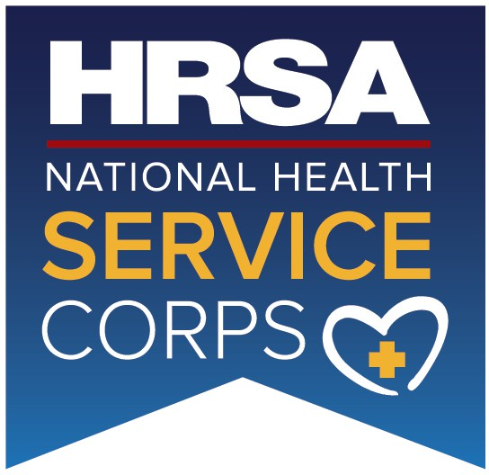
OMB Number: 0915-0146
Expiration Date: xx/xx/xxxx

National Health Service Corps Scholarship Program
U.S. Department of Health and Human Services Health Resources and Services Administration

ACCEPTANCEREPORT/VERIFICATIONOFGOODSTANDING
This Acceptance Report/Verification of Good Standing certifies that the student identified below has been accepted for full- time admission or is enrolled in full-time and in good standing for the 202x-202x school year (i.e., July 1, 202x – June 30, 202x) as indicated. Please note all information will be verified for accuracy. (To be completed by a school official only). If the applicant is newly accepted to the program, complete sections A and C. For continuing students complete sections B and C.
Section A – Newly Accepted Students
1. Student’s Name (Last, First, Middle):  3. Is the student in good standing? Yes | 2. Student’s SSN (Last 4 digits):  No

(If NO, please explain.)
- Degree/certificate the student will receive upon completion of the program:
- Student year in program as of the 202x-202x school year: 1st 2nd 3rd 4th

- Is there a contingency to the student’s acceptance to the program other than standard contingencies that apply to all admitted applicants? Examples include the student needing to repeat a course or the student receiving an “Incomplete” status for a course.
Yes No
If YES, please explain:
(All contingencies must be met by June 30, 202x)

- What schedule/system does the school year operate on? Semester Quarter Trimester
Other (Please explain)
- Length of the full-time program (months or years)
- Date class begins for the school year 202x-202x (mm/dd/yyyy):

- Anticipated date of graduation (mm/dd/yyyy):
Section B – Continuing Students
- Student’s Name (Last, First, Middle): 2. Student’s SSN (Last 4 digits):
3. What program is the student admitted to? (Please specify if the program is a dual degree or bridge program.)

- Is the student in good standing? Yes No
(If No, please explain.)

- Degree/certificate the student will receive upon completion of the program:

OMB Number: 0915-0146
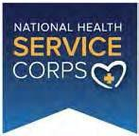
Expiration Date: XX/XX/20XX

National Health Service Corps Scholarship Program
U.S. Department of Health and Human Services Health Resources and Services Administration

ACCEPTANCEREPORT/VERIFICATIONOFGOODSTANDING
This Acceptance Report/Verification of Good Standing certifies that the student identified below has been accepted for full- time admission or is enrolled in full-time and in good standing for the 202x-202x school year (i.e., July 1, 202x – June 30, 202x) as indicated. Please note all information will be verified for accuracy. (To be completed by a school official only). If the applicant is newly accepted to the program, complete sections A and C. For continuing students complete sections B and C.
- Student classification as of the 202x-202x school year: 1st 2nd 3rd 4th

- Student Status (check all that is applicable): Full-Time Enrollment Part-Time Enrollment
Repeating Coursework On Academic Probation On a Leave of Absence Withdrawn Other (please explain)

- What schedule/system does the school year operate on? Semester Quarter Trimester Other (Please explain)
- Length of the full-time program (months or years)
- Date student began the program (mm/dd/yyyy)
- Anticipated date of graduation (mm/dd/yyyy):
Section C

By signing my name below, I certify that the current status of the student listed above has been correctly identified. I further certify that, where necessary, I have corrected the “Year in Program” and “Date of Graduation” for the student to accurately reflect the anticipated graduation date given the current enrollment. I understand that any willfully false information may be punishable as a felony under U.S. Code, Title 18, Section 1001.
Submitted by:
Signature: Date:
Name: Title: Phone Number: E-Mail Address:
Name of School:

Student may upload hand signed form to the NHSC SP Online Application: https://programportal.hrsa.gov/
For questions on how/where to submit this form please contact the Customer Care Center at: 1-800-221-9393.

Public Burden Statement: The purpose of this information collection is to obtain information through the National Health Service Corps Scholarship Program (NHSC SP), which is used to assess an applicant’s eligibility and qualifications for the NHSC SP. Clinicians interested in participating in the NHSC SP must submit an application to the NHSC SP through the My BHW online portal. An agency may not conduct or sponsor, and a person is not required to respond to, a collection of information unless it displays a currently valid Office of Management and Budget control number. The Office of Management and Budget control number for this information collection is 0915-0146 and it is valid until xx/xx/xxxx. This information collection is required to obtain or retain a benefit (National Health Service Corps Scholarship Program: Section 338A of the Public Health Service Act and Section 338C-H of Public Health Service Act.). The information is protected by the Privacy Act, but it may be disclosed outside the U.S. Department of Health and Human Services, as permitted by the Privacy Act and Freedom of Information Act, to Congress, the National Archives, and the Government Accountability Office, and pursuant to court order and various routine uses as described in the System of Record Notice 09-15-0037. Public reporting burden for this collection of information is estimated to average xx hours per response, including the time for reviewing instructions, searching existing data sources, and completing and reviewing the collection of information. Send comments regarding this burden estimate or any other aspect of this collection of information, including suggestions for reducing this burden, to Health Resources and Services Administration Reports Clearance Officer, 5600 Fishers Lane, Room 14NWH04, Rockville, Maryland 20857.

