NHSC SP Essay
APG Language:
Essay. Applicants are required to respond to an essay question. The essay response should be limited to a 500-word count or less (about a half of an 8.5 x 11 page with single spacing).
- Essay Question: The mission of the National Health Service Corps is to build healthy communities by supporting qualified health care providers dedicated to working in areas of the United States with limited access to care. With this mission, we know that patients often need health care providers to better understand them as a whole person. This is particularly important among underserved populations receiving care. Please describe an experience in which you have contributed to the well-being of an underserved community and the impact/result of your contribution.
BMISS Screen Shots:
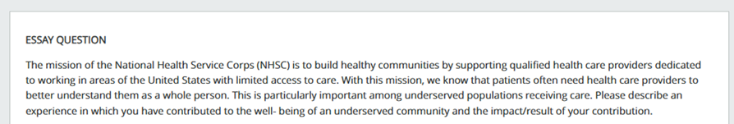

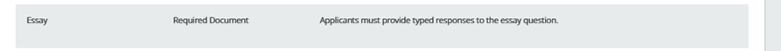

Public Burden Statement: The purpose of this information collection is to obtain information through the National Health Service Corps Scholarship Program (NHSC SP) that is used to assess a scholarship applicant’s eligibility and qualifications. Clinicians interested in participating in the NHSC SP must submit an application to the NHSC SP. An agency may not conduct or sponsor, and a person is not required to respond to, a collection of information unless it displays a currently valid OMB control number. The OMB control number for this information collection is 0915-0146 and it is valid until xx/xx/xxxx. This information collection is required to obtain or retain a benefit (NHSC SP: Section 338A of the Public Health Service Act and Section 338C-H of Public Health Service Act.). The information is protected by the Privacy Act, but it may be disclosed outside the U.S. Department of Health and Human Services, as permitted by the Privacy Act and Freedom of Information Act, to Congress, the National Archives, and the Government Accountability Office, and pursuant to court order and various routine uses as described in the System of Record Notice 09-15-0037. Public reporting burden for this collection of information is estimated to average xx hours per response, including the time for reviewing instructions, searching existing data sources, and completing and reviewing the collection of information. Send comments regarding this burden estimate or any other aspect of this collection of information, including suggestions for reducing this burden, to HRSA Reports Clearance Officer, 5600 Fishers Lane, Room 14NWH04, Rockville, Maryland, 20857.

