Proof of Citizenship Screenshot
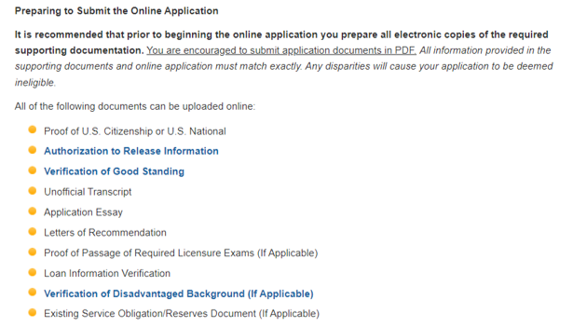

Question on Eligibility section
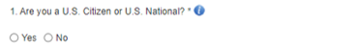

Tool tip on question
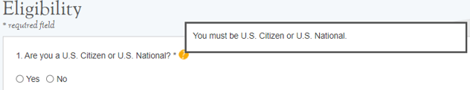

Supporting Document Section
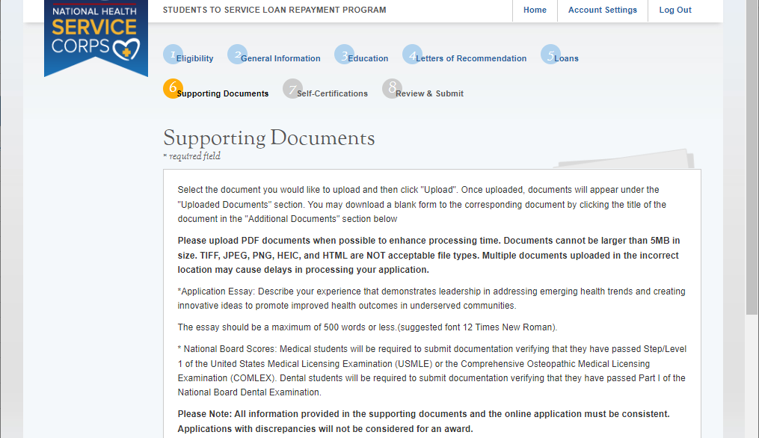

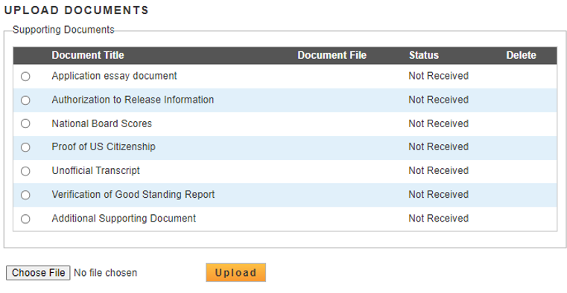

Public Burden Statement: The purpose of this information collection is to obtain information through the National Health Service Corps Students to Service Loan Repayment Program (NHSC S2S LRP) that is used to assess a loan repayment applicant’s eligibility and qualifications. Clinicians interested in participating in the NHSC S2S LRP must submit an application to the NHSC S2S LRP through the My BHW online portal. An agency may not conduct or sponsor, and a person is not required to respond to, a collection of information unless it displays a currently valid OMB control number. The OMB control number for this information collection is 0915-0146 and it is valid until xx/xx/xxxx. This information collection is required to obtain or retain a benefit [Section 338B of the Public Health Service Act (42 USC 254l-1), as amended; Section 331(i) of the Public Health Service Act (42 USC 254d(i)), as amended)]. The information is protected by the Privacy Act, but it may be disclosed outside the U.S. Department of Health and Human Services, as permitted by the Privacy Act and Freedom of Information Act, to Congress, the National Archives, and the Government Accountability Office, and pursuant to court order and various routine uses as described in the System of Record Notice 09-15-0037. Public reporting burden for this collection of information is estimated to average xx hours per response, including the time for reviewing instructions, searching existing data sources, and completing and reviewing the collection of information. Send comments regarding this burden estimate or any other aspect of this collection of information, including suggestions for reducing this burden, to HRSA Reports Clearance Officer, 5600 Fishers Lane, Room 14NWH04, Rockville, Maryland, 20857.

