[To be shown to participant on first digital page
before they fill out a questionnaire or provide a sample]

(Image is current consent form and will be updated upon CDC clearance)
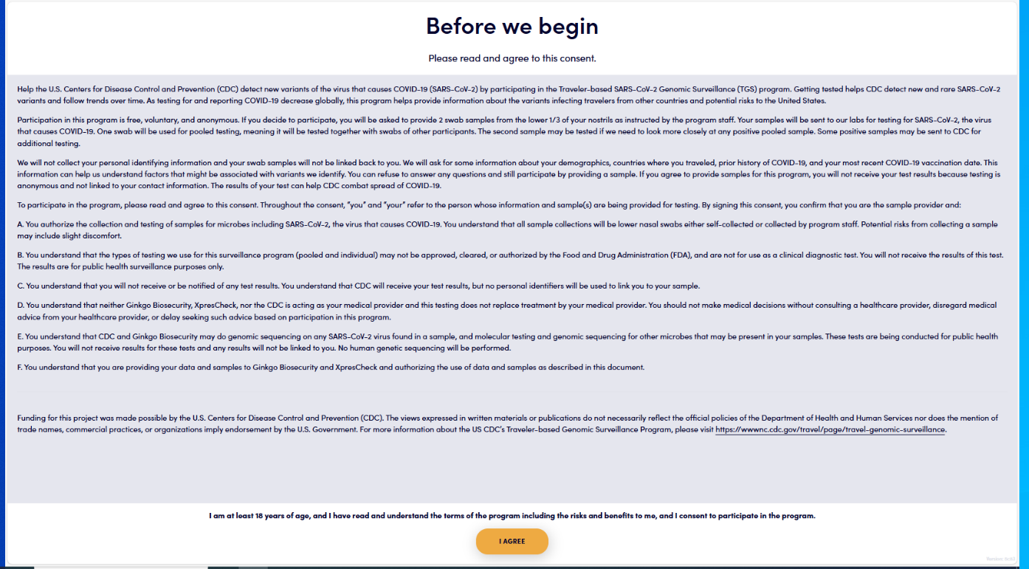
Help the U.S. Centers for Disease Control and Prevention (CDC) detect new variants of the virus that causes COVID-19 (SARS-CoV-2) and other microbes by participating in the Traveler-Based Genomic Surveillance (TGS) program. This program helps provide information about new and rare infectious diseases, including variants, in travelers arriving in the United States from other countries.

Participation in this program is free, voluntary, and anonymous. If you choose to participate, you will be asked to provide 2 nasal swab samples and answer a brief questionnaire. Your swabs will be sent for laboratory testing for respiratory viruses and other microbes. One swab will be combined (pooled) with swabs of other participants for testing. The second swab will be tested individually if the pool of swabs has any positive test results. Some swabs with positive test results will undergo additional testing to provide more information about the microbes in those samples.

We will not collect your personal identifying information, and your swab samples and information cannot be linked back to you. We will ask for some information about your demographics and places where you traveled. This information can help us understand factors that might be associated with microbes we identify. You can refuse to answer individual questions and still participate by providing samples. If you agree to provide samples for this program, you will not receive your test results because testing is anonymous. The results of your tests help public health combat the spread of infectious diseases and contribute to prevention efforts.

To participate in the program, please read and agree to this consent. Throughout the consent, “you” and “your” refer to the person whose information and sample(s) are being provided for testing. By signing this consent, you confirm that you are the sample provider and:

A. You authorize the collection and testing of samples for infectious diseases of public health concern. You understand that all sample collections will be nasal swabs that you collect yourself. Collecting a sample may cause slight discomfort.

B. You understand that the types of testing we use for this public health program (pooled and individual) might not be approved, cleared, or authorized by the Food and Drug Administration (FDA), and are not for use as a clinical diagnostic test. You will not receive the results of this test. The results are for public health monitoring only.

C. You understand that CDC will receive test results, but no personal identifiers will be collected, making it impossible to link you to your sample.

D. You understand that neither Ginkgo Biosecurity, XpresCheck, nor the CDC is acting as your medical provider, and this testing does not replace treatment by your medical provider. You should not make medical decisions without consulting a healthcare provider, disregard medical advice from your healthcare provider, or delay seeking such advice based on participation in this program.

E. You understand that CDC and Ginkgo Biosecurity may do molecular testing and genomic sequencing for microbes that may be present in your samples. No human genetic sequencing will be performed.

F. You understand that you are providing your data and samples to Ginkgo Biosecurity and XpresCheck on behalf of the U.S. CDC and authorizing the use of data and samples as described in this consent statement.

I am at least 18 years of age, and I have read and understand the terms of the free, voluntary, anonymous program, including the risks and benefits to me, and I consent to participate in the program. I understand that my consent can be withdrawn at any time.
- [Participant to select button to proceed]
___________________________________________________________________________
Funding for this project was made possible by the U.S. Centers for Disease Control and Prevention (CDC). The views expressed in written materials or publications do not necessarily reflect the official policies of the Department of Health and Human Services nor does the mention of trade names, commercial practices, or organizations imply endorsement by the U.S. Government. For more information about the U.S. CDC’s Traveler-based Genomic Surveillance Program, please visit: About Traveler-based Genomic Surveillance | Traveler-based Genomic Surveillance | CDC or Home | Ginkgo Biosecurity

