

Medicare Part C and Part D Compliance Program Effectiveness (CPE)

PROGRAM AUDIT PROTOCOL AND DATA

REQUEST



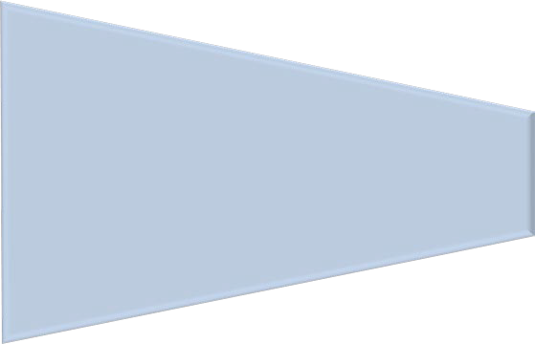
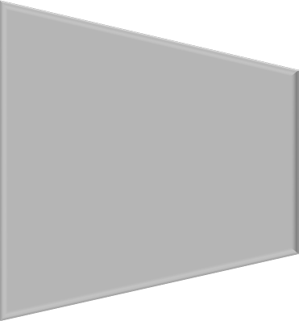

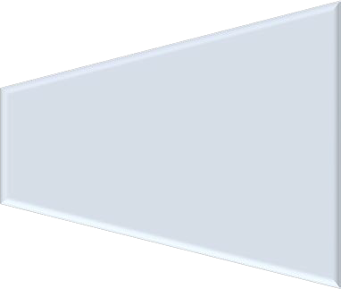
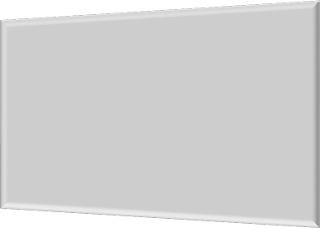




Table of Contents
Program Audit Protocol 4
Purpose 4
Program Audit Data Request 5
Audit Engagement and Universe Submission Phase 5
Universe Submissions 5
Universe Requests 5
Please use the guidance below for the following record layout: 5
Universe Table 1: Compliance Oversight Activities (COA) Record Layout 5
Supplemental Documentation Submissions 9
Supplemental Documentation Requests 9
Pre-Audit Field Work Phase 9
Preliminary Compliance Officer Interview 9
Audit Field Work Phase 9
Oversight Review Activities 9
Second Compliance Officer Interview 9

Program Audit Protocol

Purpose
To inform CMS of the Sponsoring organization’s oversight activities that support the adoption and implementation of an effective compliance program. CMS and the Sponsoring organization’s compliance officer will collaborate to discuss measures used to prevent, detect, and correct noncompliance as it relates to other audited program areas, specifically, formulary administration (FA), coverage determinations, appeals, and grievances (CDAG), organization determinations, appeals, and grievances (ODAG), and special needs plans care coordination (SNPCC). This protocol may also be used in conjunction with any focused audit conducted by CMS in other areas not already identified.

While CMS will collect a universe of compliance oversight activities, there will no longer be a standalone program area evaluation of compliance program effectiveness. Instead, CMS and the Sponsoring organization will collaborate in the review of the compliance program, and the impact of compliance on the other audited areas, to ensure correction of any identified issues of noncompliance in the program areas being audited.

Program Audit Data Request

Audit Engagement and Universe Submission Phase

Universe Submissions
Sponsoring organizations must submit the universe, comprehensive of all contracts and Plan Benefit Packages (PBP) identified in the audit engagement letter, in either Microsoft Excel (.xlsx) file format with a header row or Text (.txt) file format without a header row. Descriptions and clarifications of what must be included in each submission and data field are outlined in the universe record layout below. Characters are required in all requested fields, unless otherwise specified, and data must be limited to the request specified in the record layout. Sponsoring organizations must provide accurate and timely universe submissions within 15 business days of the audit engagement letter date. Submissions that do not strictly adhere to the record layout specifications will be rejected.

Universe Requests
  - Universe Table 1: Compliance Oversight Activities (COA) Record Layout
Universe Record Layout | Scope of Universe Request*
Table 1 | Submit a list of compliance oversight activities related to all program audit areas included in the audit engagement letter (e.g., FA, ODAG, CDAG, and SNPCC that the Sponsoring organization conducted or completed during the 6-month period preceding and including the date of the audit engagement letter. Sponsoring organizations may choose to include monitoring or auditing activities performed by outside entities, including delegated entities, that are relevant to the audited areas.
* CMS reserves the right to expand the review period to ensure sufficient universe size.

Please use the guidance below for the following record layout:

Universe Table 1: Compliance Oversight Activities (COA) Record Layout
- Include auditing, monitoring, and investigation activities that were initiated, performed, or closed by the Sponsoring organization, related to FA, ODAG, CDAG, and/or SNPCC during the universe request period. Include the activity if the Activity Start Date (Column ID F) or Activity Completion Date (Column ID G) falls within the universe request period.
- Daily activities should be rolled up into an aggregate time period of one month and included in the universe as a separate line item for each month the activities occurred.
- Use consistent naming conventions throughout the submitted universe. For instance, when the name of the Sponsoring organization’s component (e.g., department, operational area, business unit) is requested, a consistent response (e.g., PBM versus pharmacy benefit manager) must be used.
- Ensure that all fields are populated; do not leave any fields blank (e.g. if there are no deficiencies enter “0” for Number of Deficiencies in Column ID H, and Column ID I (Description of Deficiencies) would be “NA”.

Column ID | Field Name | Description
A | Component | Enter the name of the Sponsoring organization’s department, operational area, or First Tier Entity (FTE) that is the focus  of the oversight activity.
B | Activity Type | Enter the activity type as:  - Auditing  - Monitoring  - Investigation
C | Activity Frequency | Enter the frequency of the oversight activity. Valid values include but are not limited to:  - Daily  - Weekly  - Bi-monthly  - Monthly  - Quarterly  - Semi-annually  - Annually  - Ad-hoc
D | Activity Rationale | Enter the rationale for conducting the activity (e.g., routine audit stemming from risk assessment and/or work plan, referral from FTE, or hotline complaint, operational failure/metric outlier/etc., or audit activity was implemented because the function has an immediate impact on  enrollees’ access to immediate medical care and prescription drugs).

Column ID | Field Name | Description
E | Activity Description | Provide a description of the activity (e.g., operational area, timeliness, accuracy of organization determinations and notifications, messaging errors, contractual agreements, unannounced or onsite audits, spot checks, compliance  monitoring, targeted or stratified sampling, audit protocols).
F | Activity Start Date | Enter the date that the specific activity was initiated. For example, if the Sponsoring organization started an audit of the appeals process/ function within the Sponsoring organization on January 1, 2027, that is the date that would be used for the date the activity started.  Submit in CCYY/MM/DD format (e.g., 2027/01/01).
G | Activity Completion Date | Enter the date that the specific activity was completed. For example, if the Sponsoring organization completed an audit of the appeals process/function within the Sponsoring organization on January 31, 2027, that is the date that would be used for the date the activity ended.  Submit in CCYY/MM/DD format (e.g., 2027/01/01).  Enter TBD (To Be Determined) if the activity is currently in progress.

Column ID | Field Name | Description
H | Number of Deficiencies | Enter the number of deficiencies, findings, or issues identified.  Enter Zero if no deficiencies have been identified (including for any ongoing oversight efforts where deficiencies have not been noted at the time of audit engagement).
I | Description of Deficiencies | Provide a summary of all deficiencies, findings or issues identified during the oversight activity. If the oversight activity is identified in the pre-audit issue summary submitted to CMS, please include the issue number.  Enter NA if no deficiencies have been identified.
J | Corrective Action Required | Enter:  - Y (for Yes) if any identified deficiencies required correction.  - N (for No) if none of the deficiencies required correction or if there were no deficiencies identified.  - Enter TBD if the compliance department is still assessing whether correction is needed.
K | Description of Corrective Action Required | If a corrective action was required, provide a summary of the corrective action taken.  If no corrective action was required or has not yet been started, put NA.
L | Related Program Area | Enter the related program audit area that this compliance activity corresponds to (i.e., FA, CDAG, ODAG, SNPCC)  Enter as many program areas as applicable (e.g.; if the compliance activity related to FA and CDAG enter both).

Supplemental Documentation Submissions
Sponsoring organizations must submit the requested documentation identified below in either a Microsoft Word (.docx), or Adobe Portable Document File (.pdf). Sponsoring organizations must submit this documentation within 15 business days of the audit engagement letter date, unless otherwise specified.

Supplemental Documentation Requests
- Compliance Questionnaire

Pre-Audit Field Work Phase

Preliminary Compliance Officer Interview
Prior to audit field work, CMS compliance staff will conduct an interview with the Sponsoring organization’s compliance officer. This interview provides contextual background on the sponsor’s compliance program and internal oversight infrastructure and helps inform the audit team’s understanding of how operational risks have been managed. This interview will also be used to discuss the submitted COA universe and compliance questionnaire, including focused discussions on specific monitoring or auditing activities that may relate to the upcoming audit field work in the other program areas.
Additional discussion topics may include:
- Risk assessment and monitoring strategies related to Medicare Parts C and D
- FDR oversight
- Internal audit practices and oversight mechanisms
- Historical or ongoing areas of concern relevant to the applicable program areas
- Compliance and reporting structures
- Accountability and disciplinary measures

Audit Field Work Phase

Oversight Review Activities
During audit field work, CMS compliance staff and the Sponsoring organization’s compliance officer will engage in ongoing conversations as the program audit reviews are conducted. The purpose of these discussions will be to discuss any findings identified in the different program areas and how they may overlap or relate to any of the compliance oversight activities identified in the COA universe. As needed, the CMS compliance staff and the Sponsoring organization’s compliance officer will collaborate with program area audit teams on ensuring root causes analyses are thorough and accurate.

Second Compliance Officer Interview
CMS will conduct a second interview with the Sponsoring organization’s compliance officer at the end of field work, or shortly thereafter, to debrief from the audit, discuss any remaining findings, and discuss the root cause investigations. This interview will also be used to collaborate on future corrective action plans to ensure noncompliance is corrected promptly, including how to effectively incorporate the compliance program oversight into program area specific corrective action plans.

Verification of Information Collected:
CMS may conduct integrity tests to validate the accuracy of all universes, impact analyses, and other related documentation submitted in furtherance of the audit. If data integrity issues are noted, Sponsoring organizations may be required to resubmit their data.
According to the Paperwork Reduction Act of 1995, no persons are required to respond to a collection of information unless it displays a valid OMB control number. The valid OMB control number for this information collection is 0938-1395 (Expires MM/DD/CCYY). This is a mandatory information collection. The time required to complete this information collection is estimated to average 390 hours per response, including the time to review instructions, search existing data resources, gather the data needed, and complete and review the information collection. If you have comments concerning the accuracy of the time estimate(s) or suggestions for improving this form, please write to: CMS, 7500 Security Boulevard, Attn: PRA Reports Clearance Officer, Mail Stop C4-26-05, Baltimore, Maryland 21244-1850. ****CMS Disclosure**** Please do not send applications, claims, payments, medical records or any documents containing sensitive information to the PRA Reports Clearance Office. Please note that any correspondence not pertaining to the information collection burden approved under the associated OMB control number listed on this form will not be reviewed, forwarded, or retained. If you have questions or concerns regarding where to submit your documents, please contact part_c_part_d_audit@cms.hhs.gov.

