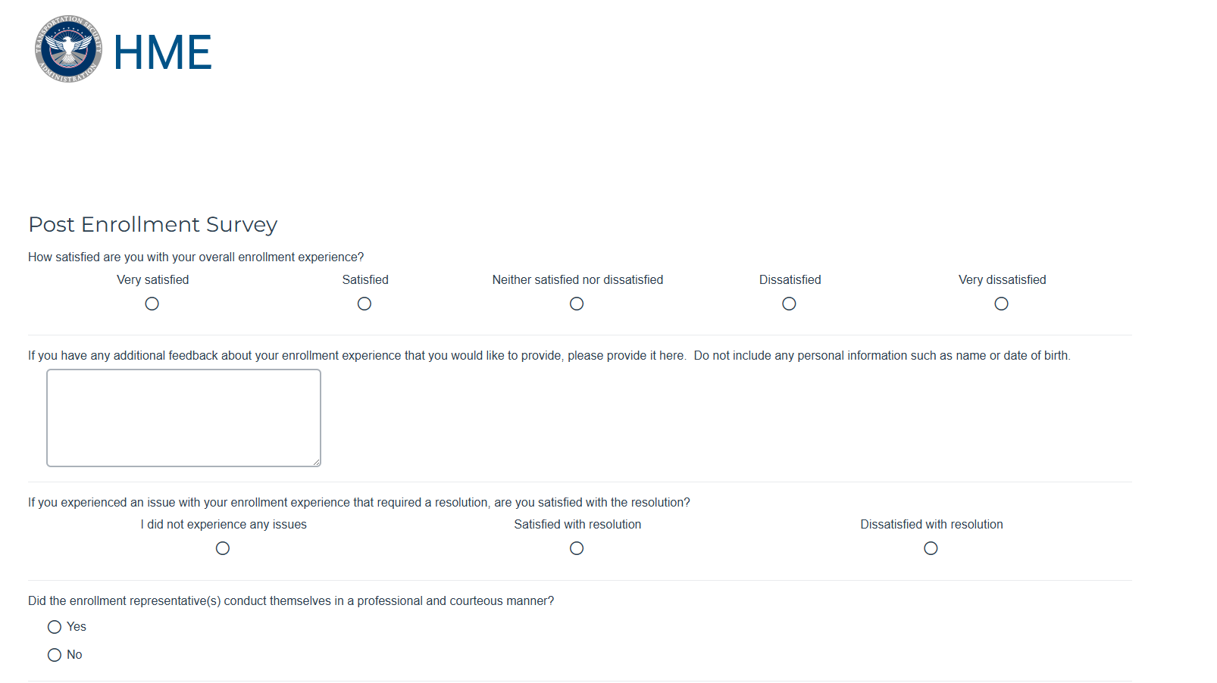

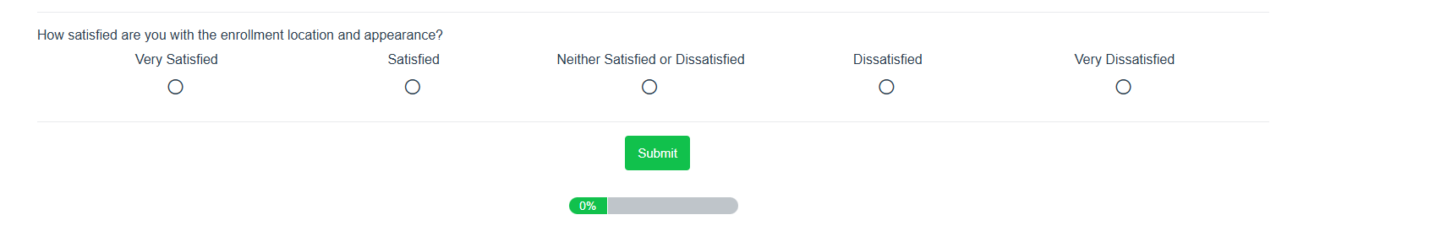
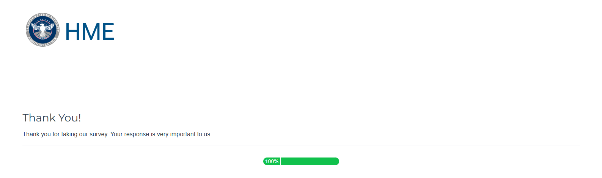
PAPERWORK REDUCTION ACT STATEMENT
Statement of Public Burden: This is a voluntary collection of information, but failure to provide the information may result in an inability to approve your eligibility for the requested TSA program or benefit. TSA estimates that the total average burden per response associated with the information collection is approximately 2 minutes for online survey. An agency may not conduct or sponsor, and a person is not required to respond to, a collection of information unless it displays a valid OMB control number. The control number for this collection is OMB 1652-0027, which expires 08/31/2026. Send comments regarding this burden estimate or collection to: TSA-11, Attention: PRA 1652-0027 Security Threat Assessment for Individuals Applying for a Hazardous Materials Endorsement for a Commercial Driver’s License, 6565 Springfield Center Drive, Springfield, VA 20598-6011.

