Supporting Statement A
Federal Aviation Administration
Fueling Aviation's Sustainable Transition Grant Program
OMB 2120-0817

The renewed information collection differs from the original information collection in that it no longer includes collecting proposals in response to a Notice of Funding Opportunity for the FAST Grant Program. The renewal only covers the collection of information to monitor the performance of awarded FAST grants.

1. Explain the circumstances that make the collection of information necessary. Identify any legal or administrative requirements that necessitate the collection.
Section 40007 of P.L. 117-169 directed the Secretary of Transportation to implement a “competitive grant program for eligible entities to carry out projects located in the United States that produce, transport, blend, or store sustainable aviation fuel, or develop, demonstrate, or apply low-emission aviation technologies.” Per this direction, the Department of Transportation (DOT), Federal Aviation Administration (FAA) established the Fueling Aviation’s Sustainable Transition (FAST) Grant Program in 2024. This information collection request renewal is necessary to monitor performance of the awarded FAST grants.

2. Indicate how, by whom, and for what purpose the information is to be used. Except for a new collection, indicate the actual use the agency has made of the information received from the current collection.
The FAA is collecting information to monitor and evaluate the performance of awarded FAST grants. Since the FAST grants were awarded in late 2024 and early 2025, the FAA has used the information to ensure projects are performing according to their project plan and are within schedule and budget. The collection also allows for dissemination of select project performance information to the public.
Responding to the collection is mandatory for grant recipients as part of the terms and conditions of their grant awards. Entities who must respond are the 17 awarded FAST grant recipients. The frequency of the collection is quarterly, consisting of quarterly and annual written reports and semi-annual review meeting materials. The annual reports are public documents that are disseminated via a public FAA FAST grants website. Quarterly reports and semi-annual review meeting materials are government-only documents. The FAA Office of Environment and Energy will retain control over the information and safeguard it from improper access, modification, and destruction, consistent with FAA standards for confidentiality, privacy, and electronic information.

3. Describe whether, and to what extent, the collection of information involves the use of automated, electronic, mechanical, or other technological collection techniques or other forms of information technology.
The FAA Office of Environment & Energy (AEE) will retain control over the information and safeguard it from improper access, modification, and destruction, consistent with FAA standards for confidentiality, privacy, and electronic information. Performance information collected includes written quarterly and annual reports and semi-annual review meeting materials. These deliverables are submitted and stored on the FAA’s secure Knowledge Services Network (KSN) Sharepoint.

4. Describe efforts to identify duplication. Show specifically why any similar information already available cannot be used or modified for use for the purposes described in Item 2 above.

There is no other source of information for awarded FAST grants that could fit the need of this information collection. The frequency of reporting is necessary to monitor project progress and maturation.

5. If the collection of information involves small businesses or other small entities, describe the methods used to minimize burden.
The FAA is collecting the minimum amount of information needed so as not to overburden small entities. The reporting requirements are written into the Terms and Conditions of each award. All of the grant recipients have thus agreed to provide the required information.

6. Describe the consequence to Federal program or policy activities if the collection is not conducted or is conducted less frequently, as well as any technical or legal obstacles to reducing burden.
Failure to collect this information for the FAST Grant Program would result in an inability to properly monitor project progress, milestones, spend plans and any associated emergent issues or changes.

7. Explain any special circumstances that would cause an information collection to be conducted in a manner:
- requiring respondents to report information to the agency more often than quarterly;
- requiring respondents to prepare a written response to a collection of information in fewer than 30 days after receipt of it;
- requiring respondents to submit more than an original and two copies of any document; requiring respondents to retain records, other than health, medical, government contract, grant-in-aid, or tax records, for more than three years;
- in connection with a statistical survey, that is not designed to produce valid and reliable results that can be generalized to the universe of study;
- requiring the use of a statistical data classification that has not been reviewed and approved by OMB;
- that includes a pledge of confidentiality that is not supported by authority established in statute or regulation, that is not supported by disclosure and data security policies that are consistent with the pledge, or which unnecessarily impedes sharing of data with other agencies for compatible confidential use; or
- requiring respondents to submit proprietary trade secrets, or other confidential information unless the agency can demonstrate that it has instituted procedures to protect the information's confidentiality to the extent permitted by law.

There are no special circumstances associated with this collection.

8. Provide information on the PRA Federal Register Notice that solicited public comments on the information collection prior to this submission. Summarize the public comments received in response to that notice and describe the actions taken by the agency in response to those comments. Describe the efforts to consult with persons outside the agency to obtain their views on the availability of data, frequency of collection, the clarity of instructions and recordkeeping, disclosure, or reporting format (if any), and on the data elements to be recorded, disclosed, or reported.

A Federal Register Notice published on April 23, 2026 (91 FR 21860) solicited public comments. No comments were received. Since this is a renewal of a collection for an ongoing grant program, there is no need to consult further with persons outside the agency.

9. Explain any decisions to provide payments or gifts to respondents, other than remuneration of contractors or grantees.
The FAA will not provide gifts or remuneration.

10. Describe any assurance of confidentiality provided to respondents and the basis for assurance in statute, regulation, or agency policy.
No assurance of confidentiality is given to respondents.

11. Provide additional justification for any questions of a sensitive nature, such as sexual behavior and attitudes, religious beliefs, and other matters that are commonly considered private.
The FAA will not ask questions of a sensitive nature.

12. Provide estimates of the hour burden of the collection of performance information. The statement should:
- Indicate the number of respondents, frequency of response, annual hour burden, and an explanation of how the burden was estimated. Unless directed to do so, agencies should not conduct special surveys to obtain information on which to base hour burden estimates. Consultation with a sample (fewer than 10) of potential respondents is desirable. If the hour burden on respondents is expected to vary widely because of differences in activity, size, or complexity, show the range of estimated hour burden, and explain the reasons for the variance. Generally, estimates should not include burden hours for customary and usual business practices. * If this request for approval covers more than one form, provide separate hour burden estimates for each form and aggregate the hour burdens.
- Provide estimates of annualized cost to respondents for the hour burdens for collections of information, identifying and using appropriate wage rate categories. The cost of contracting out or paying outside parties for information collection activities should not be included here. Instead, this cost should be included under item 13.

Grant recipients must meet the performance reporting requirements as outlined in the Terms and Conditions of their award agreements. This consists of quarterly reports, annual reports, and semiannual briefings. The burden of this reporting is estimated to be approximately 134 hours per grant recipient at a cost of $7,689.08 to the recipient per year. Given that there are 14 grant recipients, the total burden of the information collection is 1,876 hours at a cost of $107,647.12 per year.

Reporting is likely to be completed by engineering and management staff. The below tables provides estimates for the average hourly and cost burden for different job categories to generate and submit required reports. Mean hourly wage values are derived from the U.S. Bureau of Labor Statistics Occupational Employment and Wage Statistics (https://www.bls.gov/oes/current/oes_nat.htm#17-0000).

Table 1: Grantee Reporting Burden Calculation
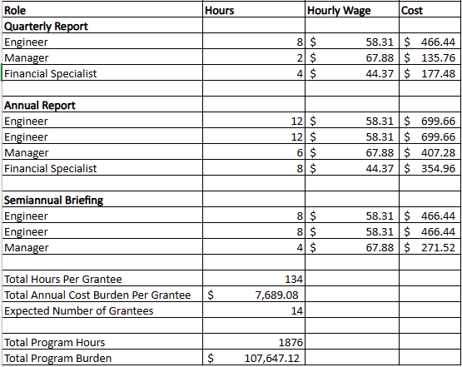

13. Provide an estimate for the total annual cost burden to respondents or record keepers resulting from the collection of information.

Estimated labor costs for grant recipients are included in Section 12. There should be no other costs to recipients.

14. Provide estimates of annualized costs to the Federal government. Also, provide a description of the method used to estimate cost, which should include quantification of hours, operational expenses (such as equipment, overhead, printing, and support staff), and any other expense that would not have been incurred without this collection of information.
The estimated annual cost to the Federal government is $24,100.16 for performance reporting review.

Review of reporting information by the government is expected to be conducted by general engineers. Reviewing these materials should not require significant time, per the below table.

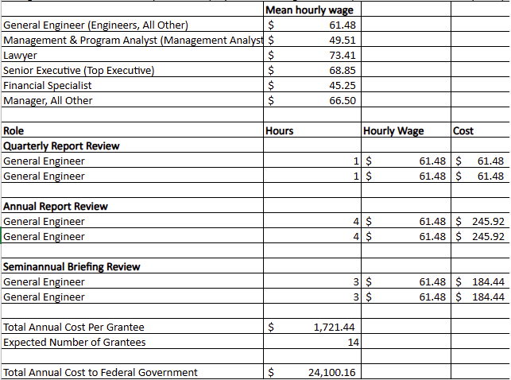
15. Explain the reasons for any program changes or adjustments.
This information collection no longer requires the collection of application information in response to a Notice of Funding Opportunity. The program was fully awarded in 2025. No future solicitations are expected. The renewal only covers the collection of information to monitor the performance of awarded FAST grants.

16. For collections of information whose results will be published, outline plans for tabulation and publication. Address any complex analytical techniques that will be used. Provide the time schedule for the entire project, including beginning and ending dates of the collection of information, completion of report, publication dates, and other actions.

FAA will use this renewed collection to continue to monitor and evaluate the performance of awarded FAST grants. Annual report submissions must be publicly releasable. FAA may publish these reports at FAA’s discretion. Annual reports are due within 60 days of the end of the calendar year through the period of performance of the award. The collection will start from the date of collection approval through the end of the period of performance for the award. The period of performance is different for each award, with some concluding in 2026 and the longest running award concluding in 2030.

17. If seeking approval to not display the expiration date for OMB approval of the information collection, explain the reasons why display would be inappropriate.
We are not seeking approval to not display the expiration date.

18. Explain each exception to the topics of the certification statement identified in “Certification for Paperwork Reduction Act Submissions.”

There are no exceptions.

