NASA To Research, Evaluate, Assess, and Treat (TREAT) Astronauts Act – Screenshot Documentation
Johnson Space Center (JSC) Flight Medicine Clinic (FMC) Information Collection electronic forms are presented are used to collect information in the Electronic Medical Health Records software used.
1. Privacy and Paperwork Reduction Act (PRA) Statements pop up to all users when they access the system.
2. Screenshots of Patient Registration tabs

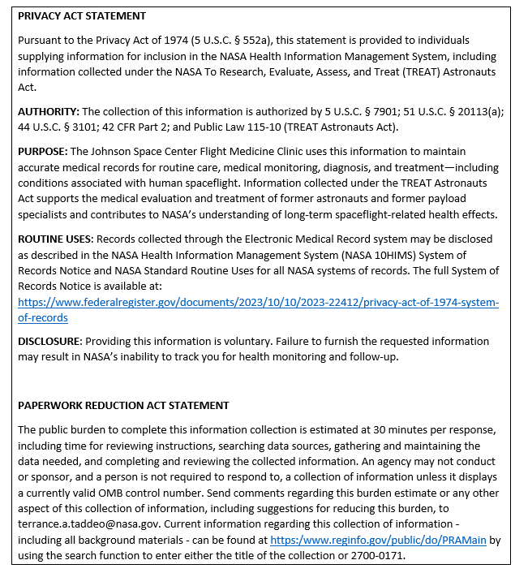

Patient Registration screen views
- This screenshot is of the first electronic form to collect information by authorized clinic staff as former astronauts and/or former payload specialists arrive at the JSC clinic and are checked in by clinic staff. This form is labeled Patient and is part of the Electronic Medical Health Record software used by JSC FMC.
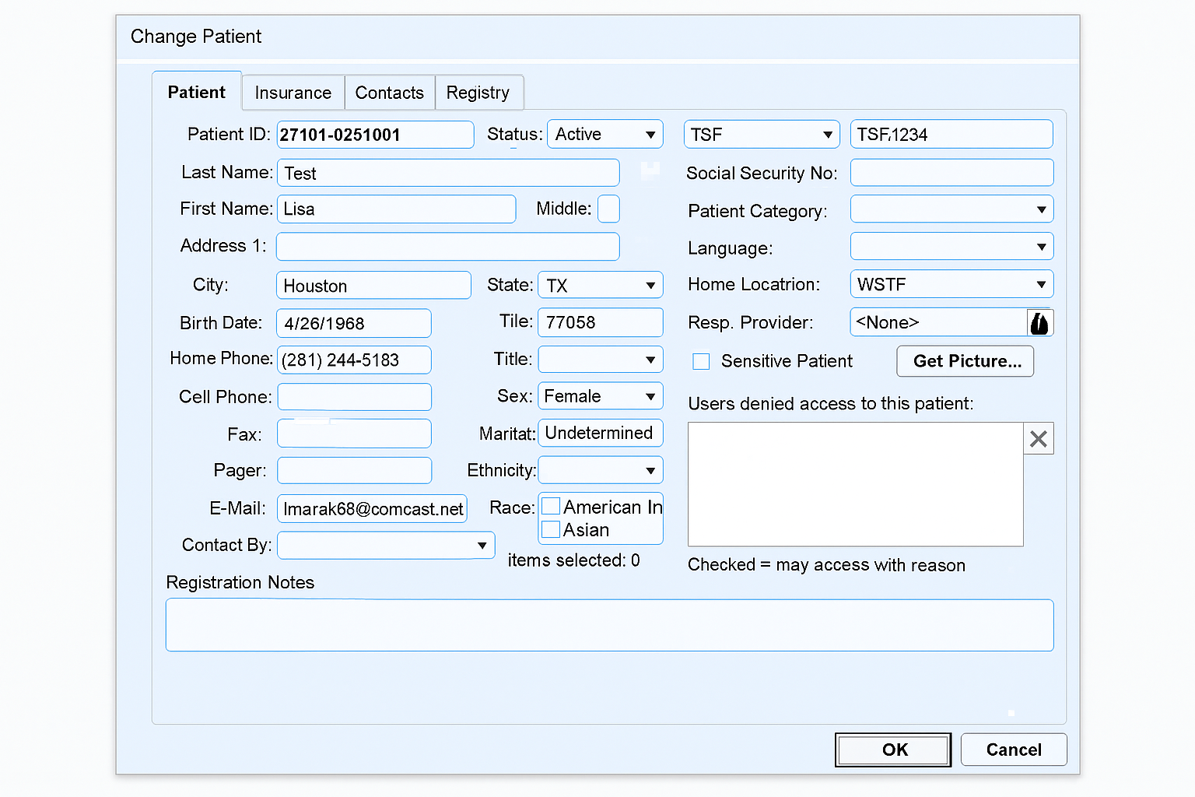

- This second screenshot, titled Insurance, is used to collect information by authorized clinic staff from former astronauts and/ or former payload specialists regarding their insurance coverage. This form is a built-in part of the system software used by JSC FMC.

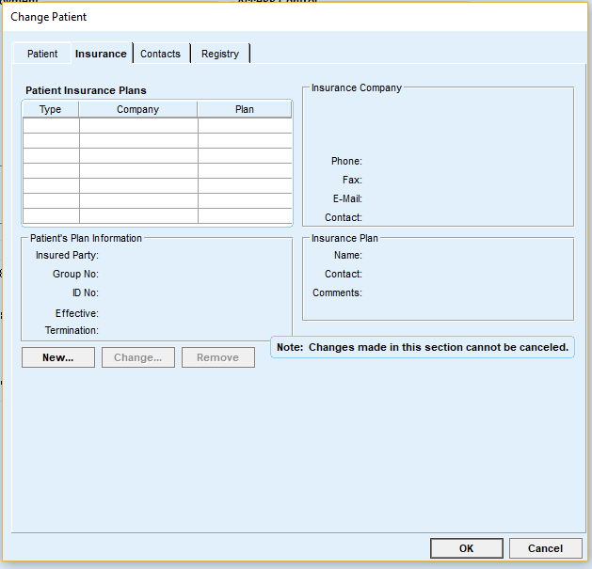
- This third screenshot is of the electronic form titled Contacts. This form is used to collect information by authorized clinic staff as former astronauts and/ or former payload specialists at the JSC clinic about their emergency contacts.
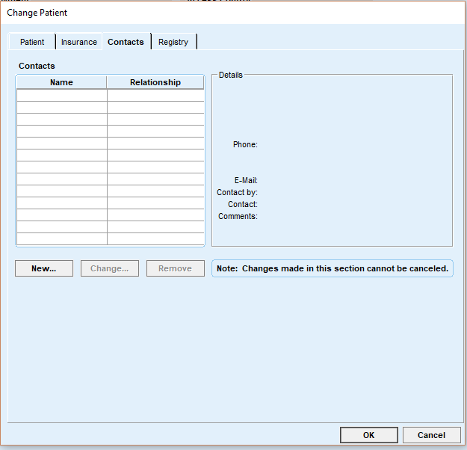

- The fourth and last screen shot is regarding the tab titled Registry. JSC FMC staff do not use this electronic information collection form. In the software design by the vendor, this form is for registry with outside databases, such as the national immunization registry for children. The JSC FMC operations do not connect to any of these types of registries and thus, it is an unused tab in the clinic.
